**Stickiness:**

**A method for dramatically increasing the recognition, recall, and unsolicited sharing of an idea or expression.**

Some lessons last a lifetime. They contain bits of information we never forget. Perhaps it was a simple phrase recited by a respected mentor, or an unpleasant surprise that changed your perspective, as different as these examples may be, unforgettable lessons all have one thing in common, they stick. As a design principle, stickiness is defined as a method for dramatically increasing the recognition, recall, and unsolicited sharing of an idea or expression. It incorporates six different factors that work to determine how memorable an item, concept, or data-point will be. These factors are simplicity, surprise, concreteness, credibility, emotion, and story. Each of the six elements of stickiness has its own lines of research, correlations, and consequential behaviors, but they were first published as a cohesive idea by Chip and Dan Heath in the book [*Made to Stick: Why Some Ideas Survive and Others Die*](https://heathbrothers.com/books/made-to-stick/). These concepts have been used since the dawn of civilization, and the impact of their reach [spans time and industry](https://www.neh.gov/humanities/2012/julyaugust/feature/lessons-demigod). As designers and educators, we can also use the principle of stickiness to create memorable products and lessons that help students learn and remain with them for years to come.

Any concept worth teaching should be one worth remembering. If we are going to spend the time and resources, the product should be both memorable and effective. Stickiness concepts can help us do both, and they do so by tapping into the tendencies of the human heart and mind. Simplicity, for example, would have concepts conveyed succinctly and holistically likely using archetypes, iconic imagery, or mental models while reducing cognitive load. This gets to the heart of the matter without extra baggage, making the point easy to understand and ideally easier to remember. Additionally, story is another stickiness variable that can have a significant bang for the buck, especially when combined with emotion or surprise. Humans love stories. They are [core to our condition](https://hbr.org/2014/10/why-your-brain-loves-good-storytelling). Few things help a new concept resonate with a student more than a compelling and relatable narrative. Yet it’s a concept often overlooked in some education and training settings. It requires a type of creative engagement by the designer or facilitator, but the results can be worth it. Of note here is to ensure the story is salient to the audience and the topic. We need to be able to draw direct correlations between the narrative and the desired learning outcome. I.e. “our hero was able to solve the problem because they followed the same steps we are covering today”. Finally, credibility, concreteness, and surprise are all concepts that can work together, or independently, to illustrate significance, hammer home a concept, or to help the student take notice. As an innately [hierarchical species](https://www.sciencedaily.com/releases/2008/04/080423121430.htm), we are predisposed to pay attention to status. As designers and educators, we can use this to relay the significance or applicability of a point. By using someone the audience views with position or standing, we can make the point either more relatable or noteworthy, especially if the example is from a surprising source and speaks to their concerns. Ultimately, stickiness increases the effectiveness of any training or education product or program while meeting [UDL](http://udlguidelines.cast.org/) guidelines of Recruiting Interest and Comprehension by providing content that is palatable, relatable, and memorable.

**Story with surprise**

Compelling stories stick and have the added benefit of being multi-use tools. The same story can be used across an array of potential topics, which helps to create connection and context. Historical stories regarding the Boston Tea Party for example can bring life to a history lesson, an economics class, or a social sciences topic, just to name a few. It's a unique event in American History that involved a memorable act, famous figures, relatable emotion, and surprise behavior.

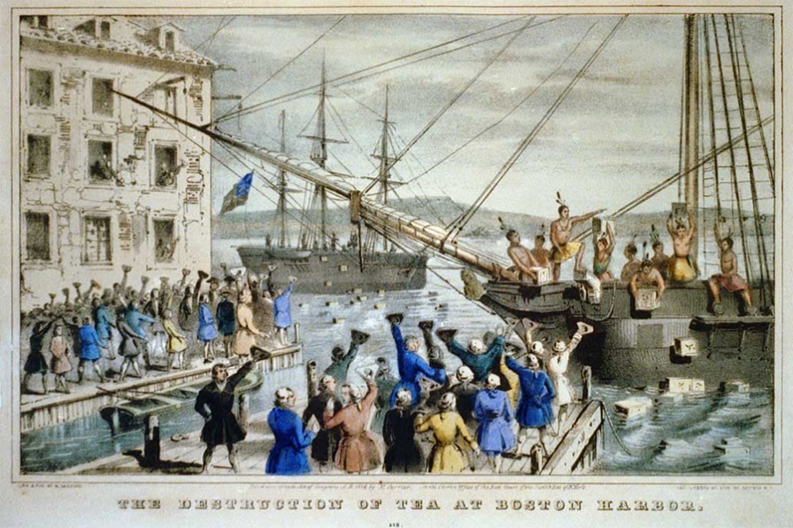

**Simplicity**

With Occam's razor in mind, sometimes we need to relay a nuanced concept succinctly and memorably. Jonathan Haidt’s analogy of the elephant and the rider does just that. It simply relays the idea that our brain has two mental processes that may or may not work together. It's a profound concept illustrated in a way that both adults and children can understand.

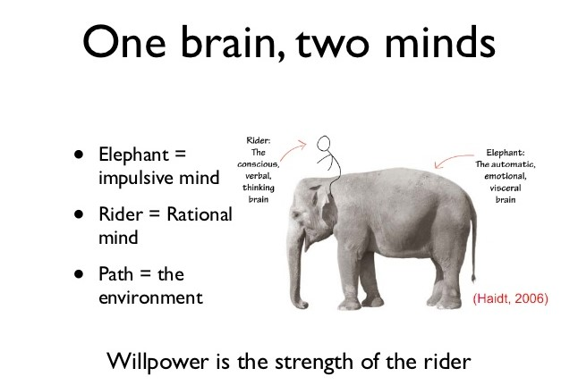

**Surprising facts**

Surprise is a fantastic way to gain attention and make something memorable. Take for instance the somewhat surprising statement that many animals avoid power lines because they can see the ultraviolet flash is coming off of it that we cannot. This could be a useful lead into a lesson on the electromagnetic spectrum. Or, to bring into perspective the age of the pyramids we might reveal that some mammoths were still alive when they were being constructed.

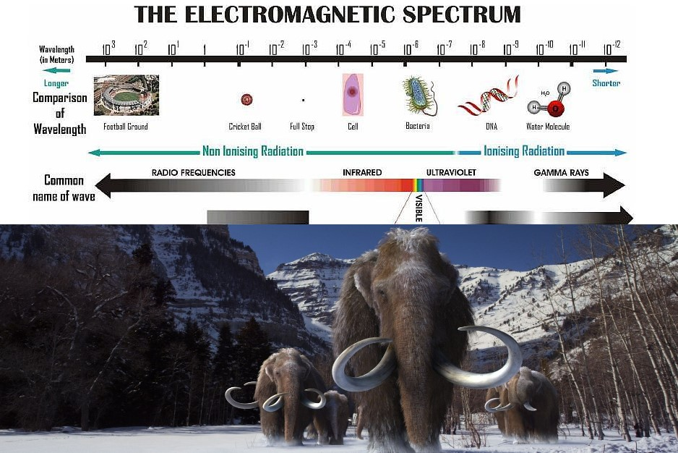

**Credibility**

We live in a unique time when credibility exists on a distorted sliding scale. To utilize the credibility variable of stickiness we need to assess who the target audience deems credible on a given topic. For example, the image of the white male doctor has been historically effective for endorsing health-related ideas and products. Conversely, some behaviors or personal care type products might be more successfully sold by using a different interpretation of credibility or relatability, such as a celebrity or respected member of the audience cohort, as we see in this Goop image.



**Story with emotion**

Man’s Search for Meaning is an example of a powerful story that holds lessons of history, perseverance, philosophy, and psychology. It has components that could be related to all age groups and can be told in both professional and academic settings. It has content on the heavier side but for certain subjects, it can really help make a point stick.



Duane Gregory - WTAMU course 6310 - Summer II - 2020