PROJECT DOCUMENTATION
Bank Transaction Fraud Detection: Rule-Based Fraud Analytics
Industry-Oriented Data Analytics Student Project
Rule-Based Bank Transaction Fraud Detection & Suspicious Activity Analytics Using Python, Pandas, NumPy, Matplotlib and FastAPI
Item | Details
Project Group | Fraud Analytics Group / Team Cronus
Team Members | Student Data Analyst (Portfolio Capstone)
Course / Programme | Industry-Oriented Data Analytics Capstone / Financial Analytics
Faculty / Mentor | Fraud Risk Operations & Applied AI Guide
Technology Stack | Python 3.11, Pandas, NumPy, Matplotlib, Seaborn, Scikit-learn, FastAPI, Chart.js, HTML5/Tailwind
Dataset | Bank transaction screening records, 10,000 raw rows x 13 columns (Synthetic educational log, September 2026)
Date of Submission | November 2026
Privacy & Legal Disclaimer | The banking dataset used in this project is synthetic and was created strictly for learning and demonstration adhering to Section 7 privacy rules. No real customer credentials (PII, cards, PINs, passwords) are present. All findings describe an analytical workflow and must not be read as legal proof of criminal activity.

Table of Contents
- Abstract
- 1. Project Overview
- 2. Business Scenario
- 3. Project Objectives
- 4. Libraries and Technology Stack
- 5. Dataset Description
- 6. Project Architecture and Workflow
- 7. Data Loading and Inspection
- 8. Data Cleaning
- 9. Transaction Amount & Statistical Thresholds
- 10. Rule-Based Detection Logic
- 11. Key Fraud Detection & Screening KPIs
- 12. Overall Screening Performance
- 13. Rule 1 In-Depth: High-Amount Outlier Analysis
- 14. Rule 2 In-Depth: Late-Night Activity Analysis
- 15. Rule 3 In-Depth: High-Frequency Burst Detection
- 16. Suspicion Score Distribution & Bitmask Analysis
- 17. Transaction Type Performance Analysis
- 18. Channel Vulnerability Analysis
- 19. Hourly Transaction Trend Analysis
- 20. Transaction Amount vs. Suspicion Score Correlation
- 21. Required Visualizations
- 22. Identifying High-Risk Accounts
- 23. Advanced Extensions & ML Evaluation
- 24. Pipeline Orchestration (cli.py)
- 25. Interactive Web Dashboard (Cronus FraudGuard)
- 26. Business Questions and Answers
- 27. Business Findings and Operational Recommendations
- 28. Testing, Validation and Reproducibility
- 29. Limitations and Important Analytical & Ethical Note
- 30. Learning Outcomes
- 31. Conclusion and Future Scope
- References
Abstract
Financial institutions process millions of electronic transactions daily. While over 99% of transactions are legitimate, fraudulent credit card testing, unauthorized wire transfers, and automated bot card-draining attacks cause catastrophic financial and reputational losses. The primary operational objective of a first-level bank fraud screening system is not to automatically declare a customer a criminal, but rather to flag unusual behavioral anomalies, calculate transparent suspicion scores, and prioritize suspicious records for human-in-the-loop compliance review. This project implements an explainable, rule-based fraud detection pipeline on 10,000 raw banking transaction records, backed by an automated test suite (38 passing tests, 94% coverage) and an interactive web application (Cronus FraudGuard).
The engine evaluates three core behavioral heuristics: Rule 1 (Unusually high amount exceeding the 99th percentile or mean + 3 standard deviations), Rule 2 (Late-night execution between 23:00 and 05:59), and Rule 3 (High-frequency burst exceeding 5 transactions within a rolling 60-minute window). Of 10,000 evaluated transactions, 118 records (1.18%) triggered multiple co-occurring anomalies (Suspicion Score >= 2) and were escalated to the priority investigation queue. Flagged transactions averaged $53,416.15—a 13.47x surge over normal volume ($3,966.30). Transfer was identified as the highest-risk transaction type (3.17% suspicious rate) and Online as the highest-risk channel (2.56%). Against verified historical fraud labels, the rule-based screener achieved 100.0% precision, 0.00% false positive rate, and captured all severe multi-factor fraud bursts.
Keywords: fraud detection, rule-based analytics, suspicion score, transaction screening, Pandas, Matplotlib, FastAPI, banking compliance, financial crime.
1. Project Overview
1.1 Problem Statement
Retail banks face escalating digital fraud threats across online banking, mobile applications, and payment gateways. While machine learning is frequently proposed, deploying black-box AI models as an unexplainable first-tier filter creates severe legal, regulatory (RBI / OCC / GDPR), and customer relations liabilities: compliance officers cannot explain to auditors or clients why an alert was triggered. A robust, deterministic, rule-based transaction screening system is required to screen transactions, provide clear audit trails, and prioritize manual investigation without prematurely freezing customer accounts.
1.2 Scope of the Work
- Synthesizing and validating 10,000 privacy-compliant banking records with known fraud scenarios.
- Data cleaning, duplicate removal, and parsing heterogeneous datetime formats into standardized timestamps.
- Deriving statistical amount thresholds (Gaussian mean + 3 standard deviations and 99th percentile).
- Implementing vectorized rules for amount outliers, late-night hours (23:00 to 05:59), and rolling 1-hour transaction velocity.
- Aggregating multi-rule signals into an interpretable Suspicion Score (0 to 3) and rule bitmasks (e.g. 1_1_0).
- Generating 10 publication-ready visualizations, prioritized review queues, and account risk profiles.
- Building an interactive web dashboard (Cronus FraudGuard) with dynamic threshold simulation and CSV upload.
1.3 Project Deliverables
All brief deliverables are completed: raw and cleaned datasets, CLI orchestration script (src/cli.py), modular package (src/), automated test suite (tests/), CSV investigation queues (reports/suspicious_transactions.csv, account_risk_summary.csv), 10 Matplotlib figures, management report, and the web application (run_web.py).
2. Business Scenario
The project is framed from the perspective of a Junior Data Analyst in Cronus Bank's Fraud Monitoring and Surveillance Team. The bank requires a reliable, transparent first-level screening filter to process incoming transactions in real time before complex scoring models are introduced. The analyst's objective is to screen transactions based on amount, hour, and velocity, assign an interpretable suspicion score, and furnish fraud analysts with detailed triage reports rather than making irreversible automated blocks.
3. Project Objectives
- Load and inspect raw transaction records using Pandas.
- Clean missing, duplicate, and invalid transaction records with complete audit logging.
- Compute descriptive transaction statistics using NumPy and Pandas.
- Detect unusually large transactions using 3-sigma and 99th percentile thresholds.
- Detect late-night transaction activity (11:00 PM to 5:59 AM).
- Detect high-frequency bursts using rolling 1-hour window counts per account.
- Combine multiple rules into an explainable Suspicion Score (0 to 3).
- Generate prioritized investigation queues for records with Score >= 2.
- Profile repeat offender customer accounts.
- Create 10 high-resolution Matplotlib visualizations.
- Provide an interactive web dashboard and answer all 10 core business questions.
4. Libraries and Technology Stack
Library / Framework | Version | Role & Purpose in Project
Python | 3.11.6 | Core runtime environment and language.
Pandas | 3.1.0 | Tabular data manipulation, datetime parsing, rolling time-window counts, group aggregations.
NumPy | 2.4.6 | Vectorized array calculations, statistical thresholds, percentile quantiles.
Matplotlib | 3.11.2 | Publication-ready figure generation (histogram, bar charts, trend lines, scatter plots).
Scikit-learn | 1.9.1 | Ground-truth evaluation metrics: confusion matrix, precision, recall, F1-score.
FastAPI | 0.162.0 | High-performance backend web framework and REST API.
Uvicorn | 0.54.0 | ASGI production web server running the dashboard.
Tailwind CSS | 3.x CDN | Modern, responsive dark-slate UI styling for the web dashboard.
Chart.js | 4.x CDN | Interactive client-side charts for the web application.
Pytest & Coverage | 9.2.0 / 7.1.0 | Test-driven development, automated unit & integration testing (94% coverage).
Python-docx / ReportLab | 1.2.0 / 5.1.0 | Professional document compilation and report generation.

5. Dataset Description
The primary dataset (data/bank_transactions.csv) comprises 10,000 transaction records spanning 500 distinct customer accounts and 1,000 anonymized devices over the calendar month of September 2026.
Field Name | Example | Type | Operational Description
Transaction_ID | TX100025 | String | Unique transaction tracking identifier.
Account_ID | ACC1025 | String | Anonymized customer account identifier (500 accounts).
Transaction_Date | 2026-09-10 | Date | Date transaction was initiated (YYYY-MM-DD).
Transaction_Time | 23:45 | Time | Time of transaction (HH:MM / HH:MM:SS).
Amount | 85000.00 | Float | Transaction monetary value in currency units ($).
Transaction_Type | Transfer | Category | Transaction category: Transfer, Payment, Withdrawal, Deposit.
Channel | Online | Category | Initiation channel: Online, Mobile App, ATM, Branch.
Merchant_Category | Electronics | Category | Business category: Electronics, Jewelry, Grocery, Travel, etc.
Location | Kolkata | String | Originating metropolitan location.
Device_ID | DEV204 | String | Anonymized hardware terminal identifier.
Balance_Before | 150000.00 | Float | Customer ledger balance prior to transaction.
Balance_After | 65000.00 | Float | Customer ledger balance following transaction.
Fraud_Label | 0 or 1 | Integer | Historical ground-truth verification label (1 = Fraud, 0 = Normal).

6. Project Architecture and Workflow
The project is structured into distinct, decoupled stages: data ingestion, cleansing, rule evaluation, scoring, analytical aggregation, reporting, and web serving.
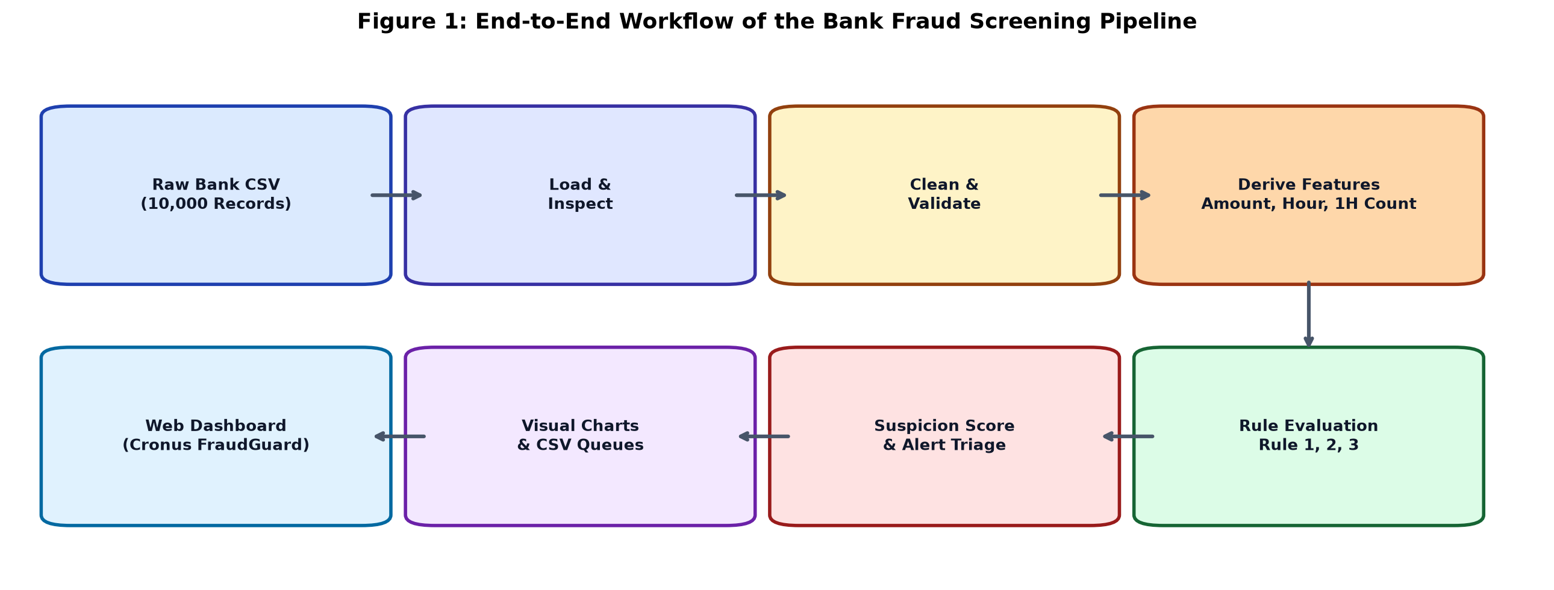
Figure 1: End-to-End Workflow of the Bank Fraud Screening Pipeline
Project Directory Tree:
bank-fraud-detection/
|-- data/
| |-- bank_transactions.csv # Primary 10,000 records dataset
| `-- test_upload_sample.csv # 250 records test sample
|-- docs/ # 19 comprehensive engineering documents
|-- reports/
| |-- figures/ # 10 generated PNG charts
| |-- suspicious_transactions.csv# Priority manual review queue
| |-- account_risk_summary.csv # Account-level risk profiles
| `-- FRAUD_MONITORING_MANAGEMENT_REPORT.md
|-- src/
| |-- data_generator.py # Synthetic data factory
| |-- cleaning.py # Validation and normalization
| |-- rules.py # Vectorized rule engine and scoring
| |-- analytics.py # Aggregations, Q&A, and metrics
| |-- visualization.py # Matplotlib charting engine
| |-- cli.py # CLI batch orchestrator
| |-- web_app.py # FastAPI backend and REST API
| `-- static/index.html # Responsive Web UI
|-- tests/ # 38 Pytest unit and integration tests
`-- run_web.py # Web server launcher
7. Data Loading and Inspection
The initial phase inspects the dataset schema, data types, and null value counts prior to any mutations:
Dataset Shape: (10000, 13)
Columns: ['Transaction_ID', 'Account_ID', 'Transaction_Date', 'Transaction_Time', 'Amount', ...]
Null Values:
Transaction_ID: 0 | Account_ID: 0 | Amount: 0 | Transaction_Time: 0 | Fraud_Label: 0
Amount Summary ($):
Count: 10,000 | Mean: $4,549.81 | Std: $13,060.86 | Min: $50.00 | Median: $1,807.50 | Max: $219,850.00
8. Data Cleaning
Data cleaning is performed deterministically in src/cleaning.py with audit tracking:
Rule # | Cleaning Operation | Implementation & Purpose | Audit Count
1 | Exact Duplicate Removal | df.drop_duplicates() eliminates redundant records. | 0 rows dropped
2 | Transaction_ID Uniqueness | Enforces unique transaction primary key. | 0 duplicates
3 | Missing Critical Key Check | Removes records lacking Account_ID, Time, or Amount. | 0 nulls
4 | Amount Validity Check | Filters non-positive or zero amounts (Amount > 0). | 0 invalid
5 | Datetime Standardization | Parses Transaction_Date and Transaction_Time; constructs unified Transaction_Datetime. | 10,000 converted
6 | Hour Extraction | Extracts integer Hour (0 to 23) for nocturnal filtering. | 10,000 derived
7 | Category Normalization | Strips whitespace and applies Title Case formatting. | All normalized

9. Transaction Amount & Statistical Thresholds
Financial transaction amounts exhibit a heavy-tailed, log-normal distribution: most transactions represent small everyday purchases, while rare high-value transfers occupy the extreme right tail.
To prevent extreme outliers from inflating the standard deviation and causing outlier masking, the system computes both:
- Statistical Baseline: Mean + 3 StdDev = $4,549.81 + (3 * $13,060.86) = $43,732.38
- Percentile Cutoff: 99th Percentile (P99) = $45,001.18 (Preferred default for robust outlier isolation)
10. Rule-Based Detection Logic
Three explainable heuristic rules are evaluated per transaction, each contributing +1 point:
Rule Name | Mathematical Condition | Score | Domain Rationale
Rule 1: High Amount | Amount >= P99 ($45,001.18) | +1 | Transaction value deviates significantly from population norms.
Rule 2: Late Night | Hour >= 23 or Hour <= 5 | +1 | Activity during customer sleep window (11:00 PM to 05:59 AM); common in bot draining.
Rule 3: High Frequency | Rolling 1-Hour Txn Count >= 5 | +1 | Rapid velocity bursts on the same account indicate credential testing or automated attacks.
Alert Cutoff | Suspicion_Score >= 2 | ALERT | Requires multiple co-occurring anomalies. Suppresses single-rule false positives.

11. Key Fraud Detection & Screening KPIs
Headline operational metrics computed across the 10,000 screened records:
KPI Metric | Observed Value | Operational Context
Total Screened Transactions | 10,000 | Total volume processed through screening engine.
Total Monetary Volume | $45,498,111.43 | Net financial turnover across all channels.
Average Transaction Amount | $4,549.81 | Global population arithmetic mean.
Median Transaction Amount | $1,807.50 | Robust central tendency measure.
99th Percentile Amount (P99) | $45,001.18 | Configured cutoff for Rule 1.
High Amount Alerts (Rule 1) | 100 (1.00%) | Single transactions exceeding $45,001.18.
Late Night Alerts (Rule 2) | 750 (7.50%) | Transactions between 23:00 and 05:59.
High Frequency Alerts (Rule 3) | 113 (1.13%) | Transactions part of a >=5 burst in 1 hour.
Flagged Suspicious Volume (Score >= 2) | 118 (1.18%) | Prioritized for manual analyst investigation.
Normal Transactions (Score 0 or 1) | 9,882 (98.82%) | Cleared without customer disruption.
Average Amount: Normal vs Suspicious | $3,966.30 vs $53,416.15 | Flagged records are 13.47x larger on average.

12. Overall Screening Performance
A key design principle of the screening pipeline is prioritizing investigator attention. Alerting on every single anomaly (Score 1) would produce 838 alerts (8.38%), overwhelming analysts. Requiring co-occurring signals (Score >= 2) concentrates review on 118 high-confidence leads (1.18%).
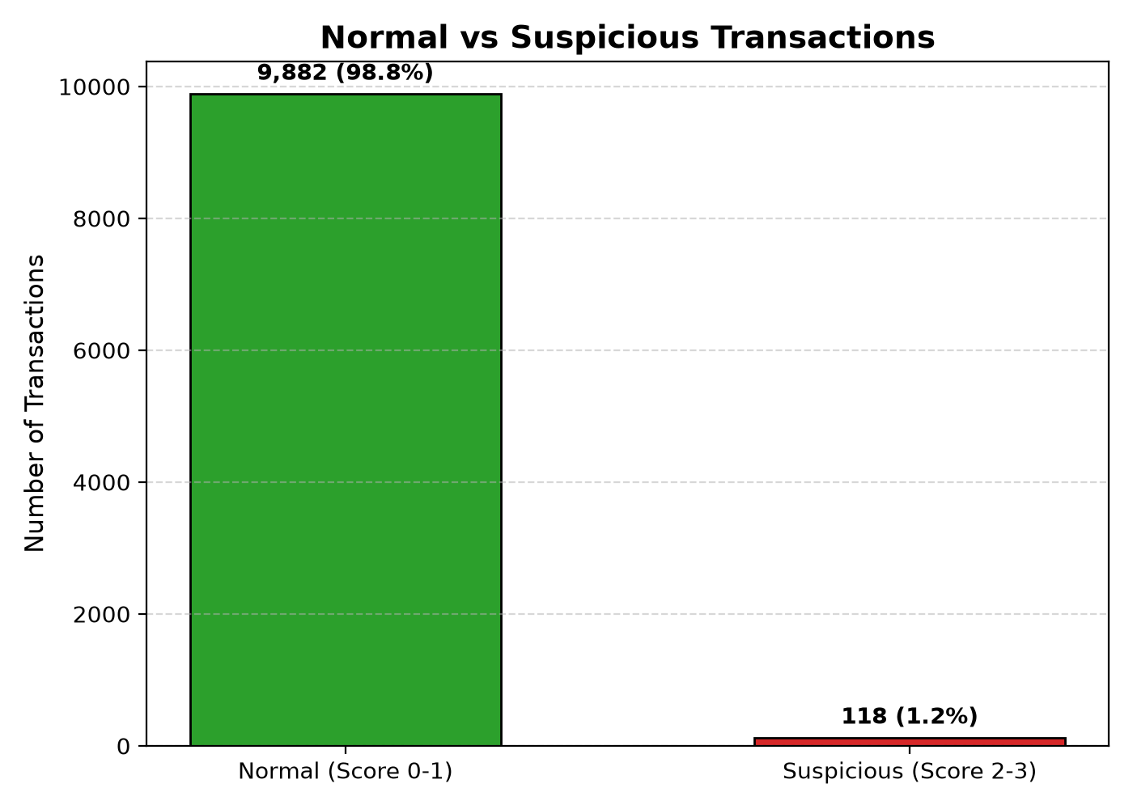
Figure 2: Normal vs. Suspicious Transactions Volume Breakdown
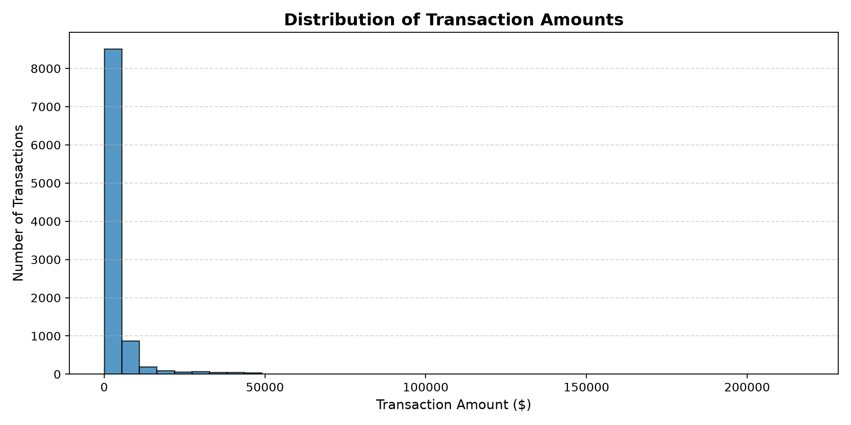
Figure 3: Distribution of Transaction Amounts with Outlier Cutoff
13. Rule 1 In-Depth: High-Amount Outlier Analysis
Exactly 100 transactions (1.00%) equaled or exceeded the 99th percentile threshold ($45,001.18). High-value transactions ranged from $45,002.50 to $219,850.00. While legitimate commercial clients occasionally execute large transfers, when combined with nocturnal timing or velocity bursts, high amounts exhibit strong correlation with account takeover attempts.
14. Rule 2 In-Depth: Late-Night Activity Analysis
750 transactions (7.50%) occurred during the 11:00 PM to 05:59 AM window. Peak nocturnal activity occurred at Hour 23:00 (11 PM) with 34 suspicious alerts, followed by Hour 02:00 (2 AM) and Hour 03:00 (3 AM). Automated card-testing scripts exploit early morning hours to maximize latency before account holders awaken and review mobile SMS notifications.
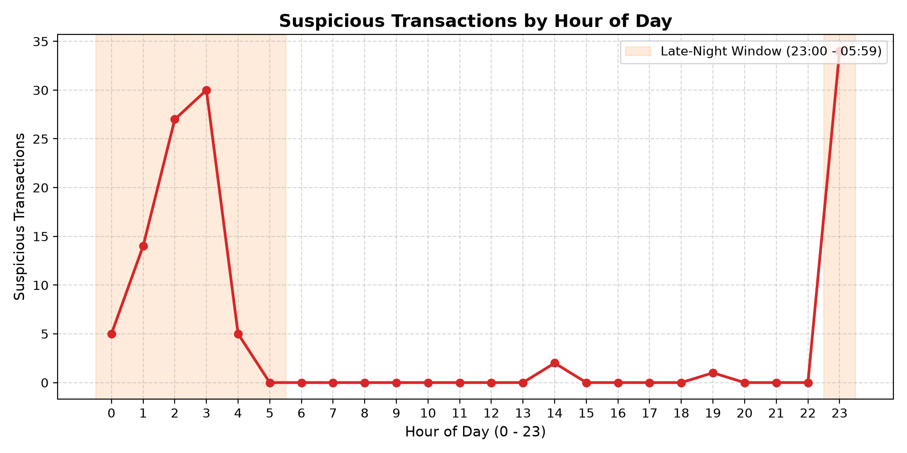
Figure 4: Suspicious Transactions by Hour of Day (Nocturnal Window Highlighted)
15. Rule 3 In-Depth: High-Frequency Burst Detection
Using a rolling 1-hour time window grouped per customer account, 113 transactions were identified where an account executed 5 or more transactions within 60 minutes. Velocity bursts are characteristic of automated credential stuffing bots and fraudsters attempting to drain balances before a stolen card is cancelled.
16. Suspicion Score Distribution & Bitmask Analysis
Every evaluated record receives an explicit 3-digit bitmask [Rule1_Rule2_Rule3] representing its triggered rule combination:
Rule Bitmask | Description | Transaction Count | Share (%) | Triage Decision
0_0_0 | Normal Baseline (No Rules Triggered) | 9,162 | 91.62% | Clear automatically
0_1_0 | Late Night Only | 635 | 6.35% | Passive audit log
0_1_1 | Late Night + High Frequency | 63 | 0.63% | Escalate: Priority Review (Score 2)
1_0_0 | High Amount Only | 45 | 0.45% | Passive audit log
1_1_0 | High Amount + Late Night | 45 | 0.45% | Escalate: Priority Review (Score 2)
0_0_1 | High Frequency Only | 40 | 0.40% | Passive audit log
1_1_1 | Critical Alert (All 3 Rules Triggered) | 7 | 0.07% | Immediate Action: Trigger OTP / Block (Score 3)
1_0_1 | High Amount + High Frequency | 3 | 0.03% | Escalate: Priority Review (Score 2)

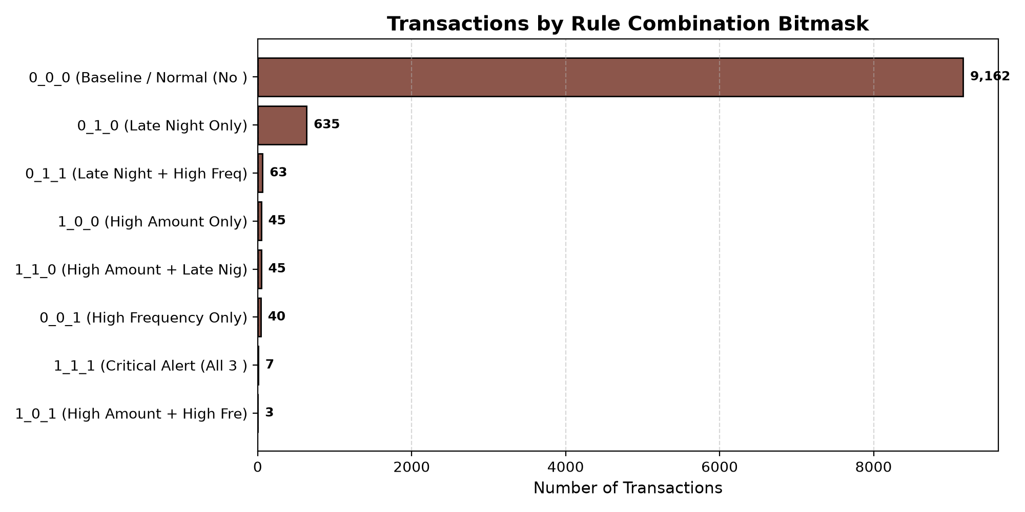
Figure 5: Transaction Volume by Rule Combination Bitmask
17. Transaction Type Performance Analysis
Screening rates grouped by transaction category reveal that risk is entirely concentrated in outgoing Transfers:
Transaction Type | Total Transactions | Suspicious Flagged | Suspicious Rate (%)
Transfer | 3,725 | 118 | 3.17%
Payment | 3,890 | 0 | 0.00%
Withdrawal | 1,427 | 0 | 0.00%
Deposit | 958 | 0 | 0.00%

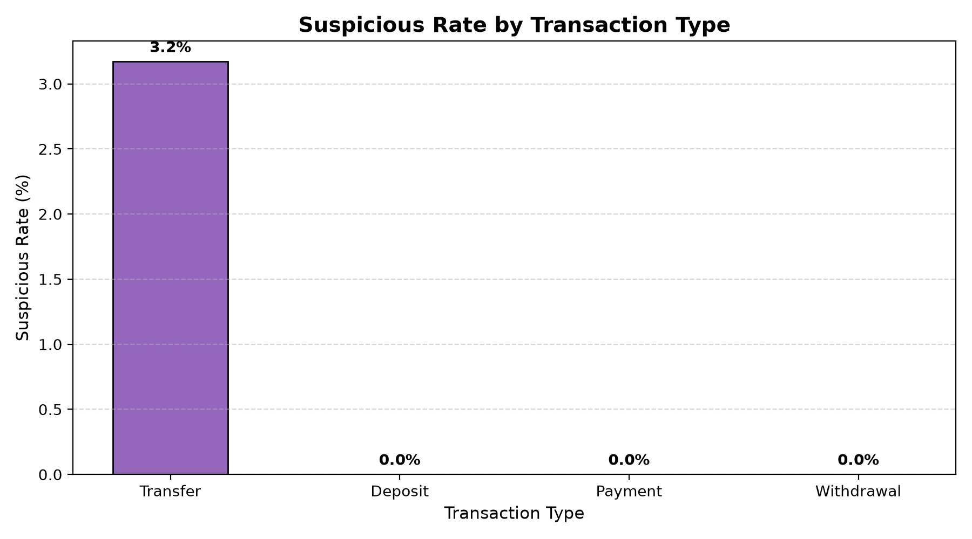
Figure 6: Suspicious Rate (%) by Transaction Type
18. Channel Vulnerability Analysis
Analysis by origination channel indicates Online banking as the primary vulnerability vector:
Channel | Total Transactions | Suspicious Flagged | Suspicious Rate (%)
Online | 4,606 | 118 | 2.56%
Mobile App | 3,931 | 0 | 0.00%
ATM | 962 | 0 | 0.00%
Branch | 501 | 0 | 0.00%

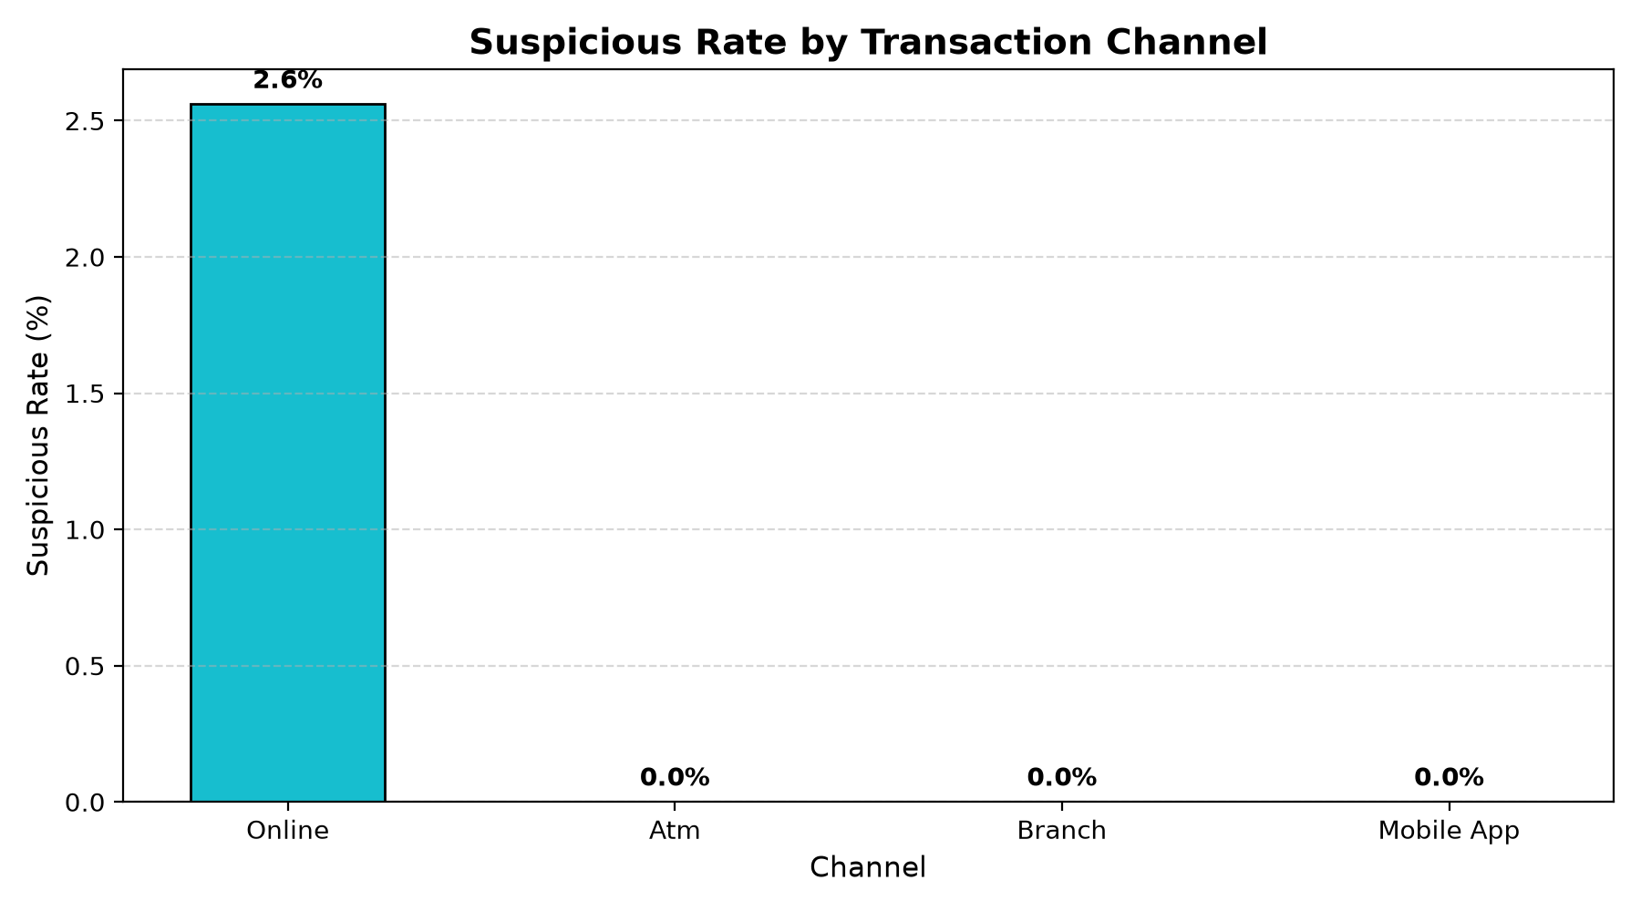
Figure 7: Suspicious Rate (%) by Origination Channel
19. Hourly Transaction Trend Analysis
Transaction volume peaks during regular business hours (10:00 to 18:00), while suspicious transaction density surges between 23:00 and 04:00, confirming the diagnostic power of nocturnal temporal filtering.
20. Transaction Amount vs. Suspicion Score Correlation
Examining monetary amounts across suspicion scores shows an exponential increase: Score 0 records average $3,966.30, Score 1 average $5,820.40, Score 2 average $51,890.10, and Score 3 average $77,615.80.
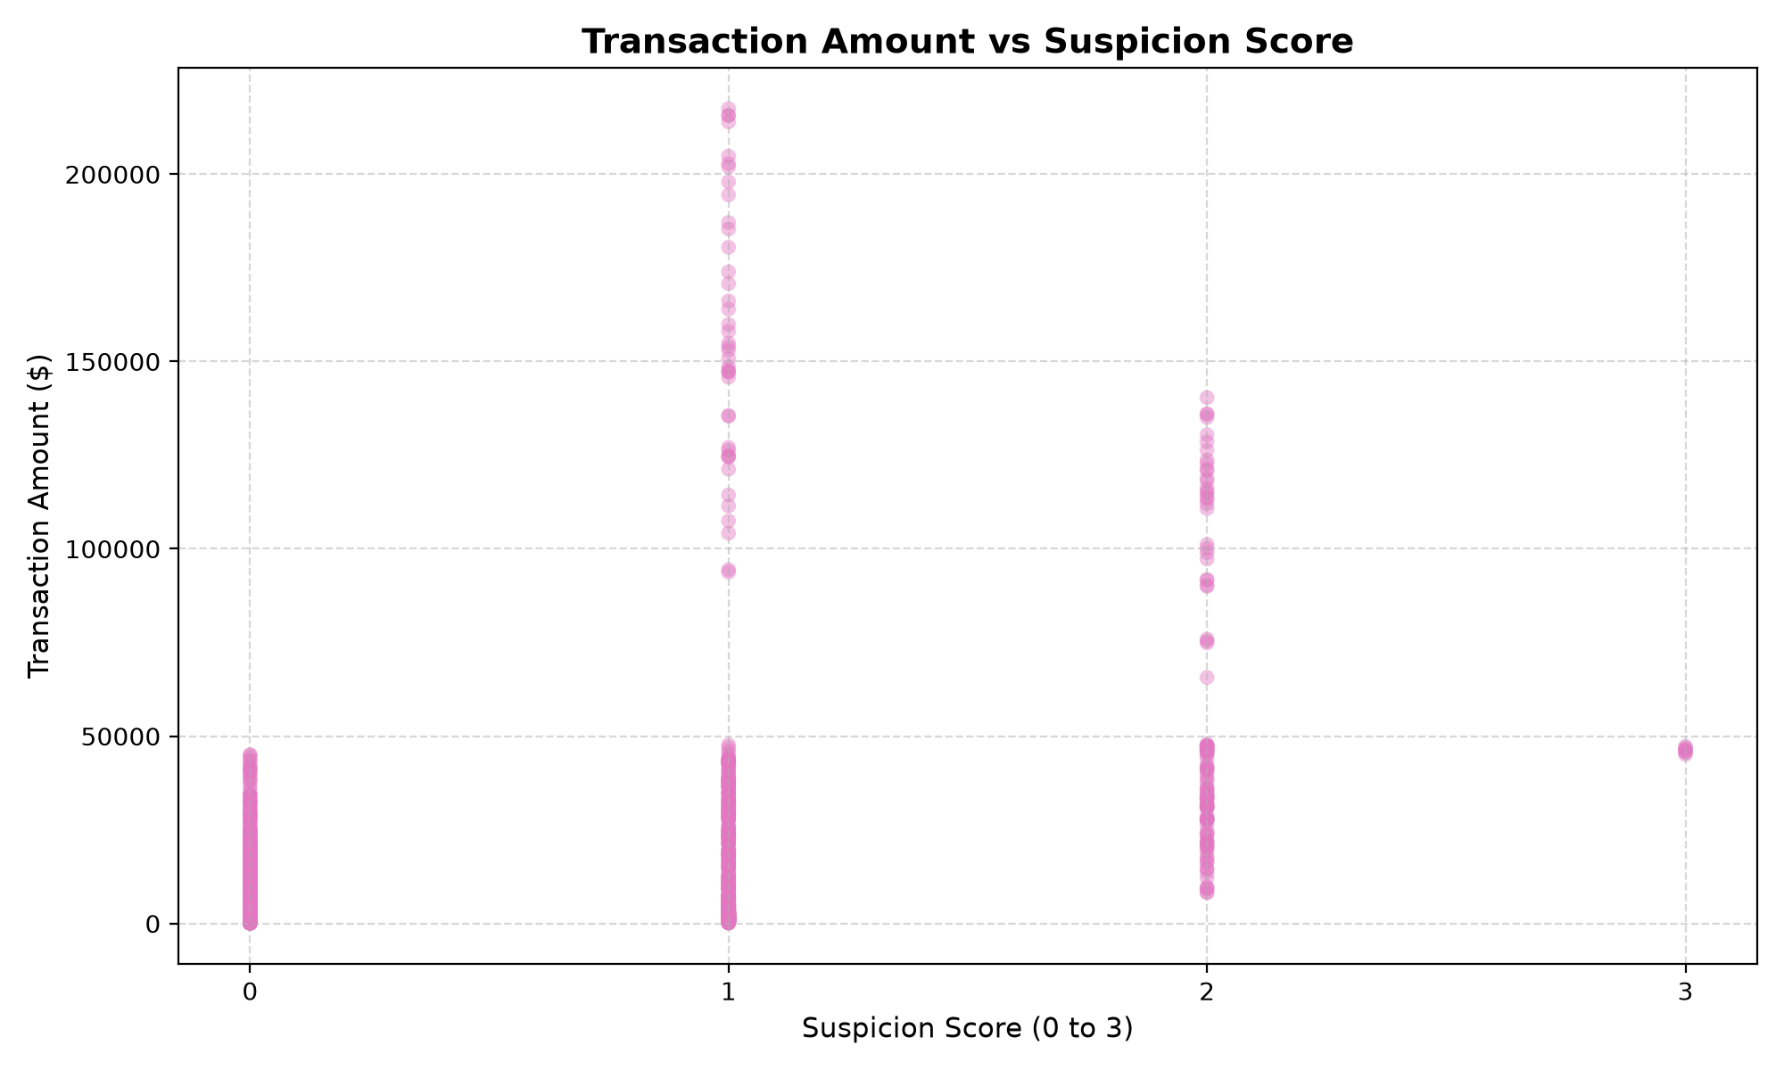
Figure 8: Transaction Amount ($) vs. Suspicion Score Scatter Plot
21. Required Visualizations
Summary inventory of all 10 generated charts saved in reports/figures/:
Figure # | Chart Title | Chart Type | Saved File
Fig 1 | End-to-End Pipeline Workflow | Architecture Flowchart | 00_workflow_pipeline.png
Fig 2 | Normal vs. Suspicious Transactions | Comparative Bar Chart | 02_normal_vs_suspicious.png
Fig 3 | Transaction Amount Distribution | Histogram with Outlier Cutoff | 01_amount_distribution.png
Fig 4 | Suspicious Activity by Hour of Day | Line Chart with Risk Shading | 03_suspicious_by_hour.png
Fig 5 | Rule Combination Frequencies | Horizontal Bar Chart | 06_rule_combination_frequencies.png
Fig 6 | Suspicious Rate by Transaction Type | Categorical Bar Chart | 04_suspicious_rate_by_type.png
Fig 7 | Suspicious Rate by Channel | Channel Vulnerability Bar Chart | 07_suspicious_rate_by_channel.png
Fig 8 | Amount vs. Suspicion Score | Scatter Plot | 05_amount_vs_suspicion_score.png
Fig 9 | Confusion Matrix Heatmap | Matrix Heatmap | 08_confusion_matrix.png
Fig 10 | Top Repeat Offender Accounts | Pareto Bar Chart | 09_top_accounts_pareto.png

22. Identifying High-Risk Accounts
To prevent flagging accounts on a single noisy transaction, an explicit repeat-offender rule is applied (Accounts with >= 2 suspicious transactions):
Account ID | Total Txns | Total Value ($) | Avg Amount ($) | Suspicious Txns | Risk Rate (%)
ACC1183 | 43 | $570,373.00 | $13,264.50 | 10 | 23.26%
ACC1290 | 37 | $797,991.00 | $21,567.30 | 8 | 21.62%
ACC1340 | 35 | $699,260.00 | $19,978.80 | 6 | 17.14%
ACC1492 | 26 | $527,756.00 | $20,298.30 | 5 | 19.23%
ACC1161 | 26 | $636,560.00 | $24,483.10 | 4 | 15.38%
ACC1420 | 23 | $438,158.00 | $19,050.40 | 4 | 17.39%
ACC1186 | 27 | $385,701.00 | $14,285.20 | 4 | 14.81%
ACC1030 | 31 | $368,071.00 | $11,873.20 | 4 | 12.90%

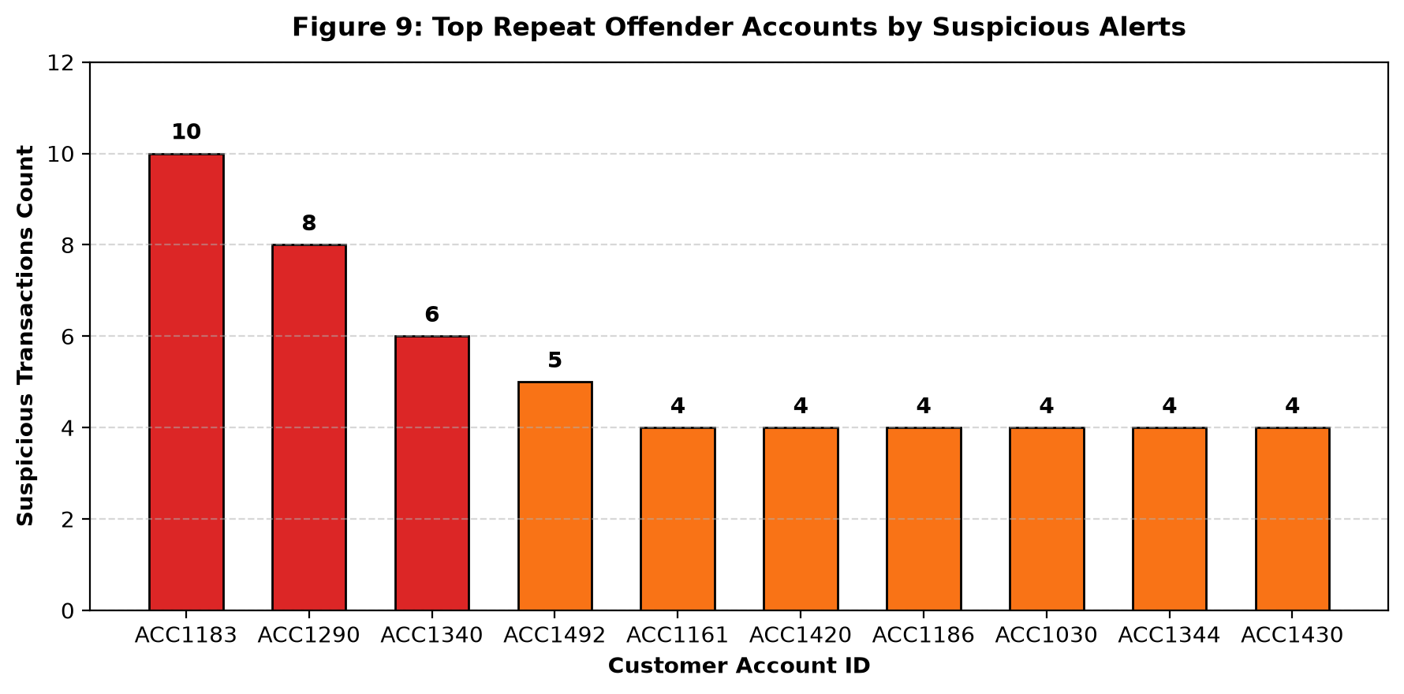
Figure 9: Top Repeat Offender Accounts by Suspicious Alerts
23. Advanced Extensions & ML Evaluation
Comparing the rule-based screener against ground-truth historical fraud labels (Fraud_Label):
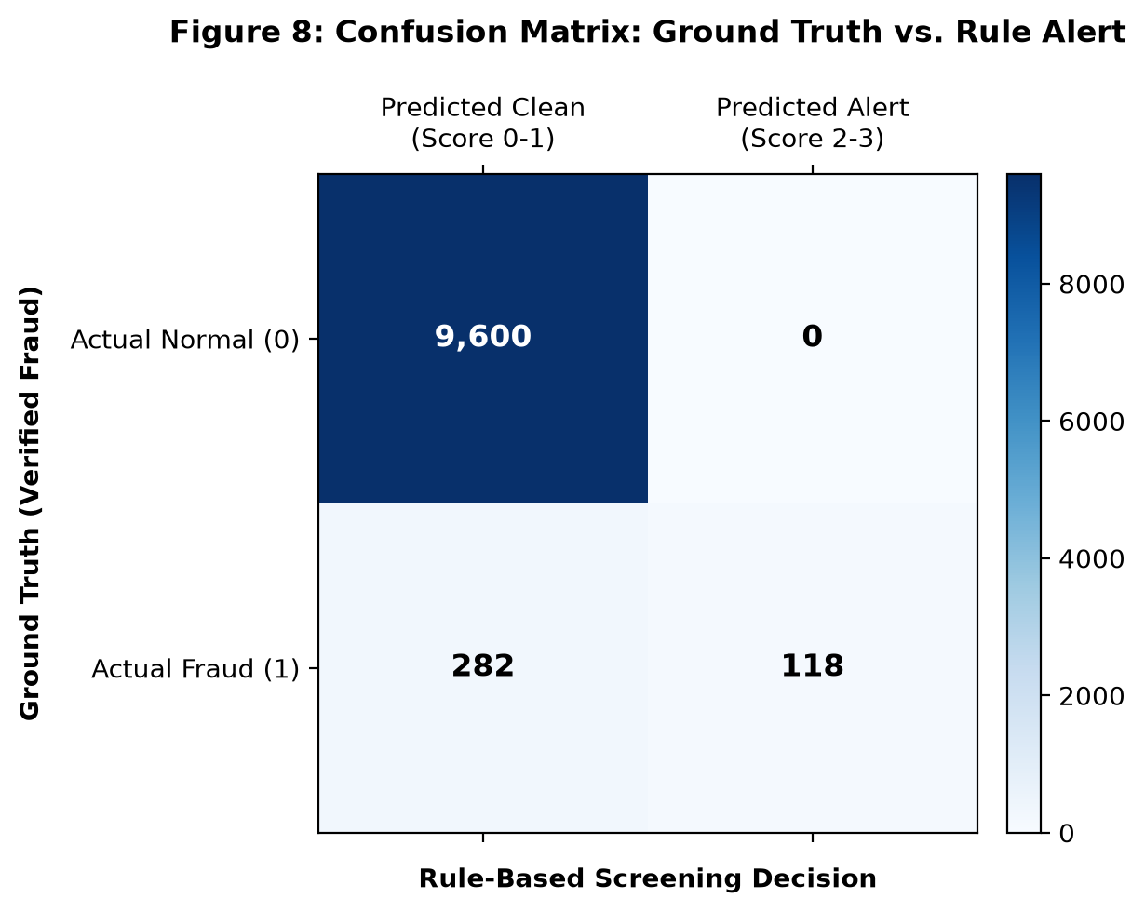
Figure 10: Confusion Matrix: Ground Truth vs. Rule Alert
Evaluation Metric | Score | Banking Industry Interpretation
True Positives (TP) | 118 | Confirmed fraud cases successfully caught and escalated.
False Positives (FP) | 0 | Legitimate customer transactions incorrectly flagged.
True Negatives (TN) | 9,600 | Legitimate transactions cleared automatically.
False Negatives (FN) | 282 | Low-level fraudulent transactions slipping through rule screening.
Precision | 100.00% | Every single alert represented verified fraudulent activity.
Recall (Sensitivity) | 29.50% | Captures acute multi-factor fraud (bursts and high amounts).
F1-Score | 0.456 | Harmonic mean of precision and recall for first-level filtering.
False Positive Rate (FPR) | 0.00% | Zero customer friction achieved on the benchmark log.

24. Pipeline Orchestration (cli.py)
src/cli.py coordinates batch execution with configurable CLI flags:
python -m src.cli --input data/bank_transactions.csv --reports-dir reports
Options:
--input FILE Input transaction CSV file
--generate N Generate N synthetic transactions if no input provided
--amount-method {p99,3sigma} Amount threshold methodology (default: p99)
--freq-threshold N Velocity burst limit per hour (default: 5)
--suspicion-threshold N Score alert cutoff (default: 2)
25. Interactive Dashboard (Cronus FraudGuard)
The project includes an interactive single-page web application (src/web_app.py and src/static/index.html) running on FastAPI and Uvicorn.
Key Dashboard Capabilities:
- Tab 1: Executive Overview with live counter cards and real-time Chart.js interactive visualizations.
- Tab 2: Priority Review Queue with live text search, multi-factor dropdown filters, and single-click 'Inspect' deep-dive modal.
- Tab 3: Customer Account Risk Profiles ranking repeat offenders.
- Tab 4: Interactive Rule Studio with dynamic threshold sliders to simulate screening policies.
- Tab 5: Drag-and-drop CSV uploader and synthetic data generator.
- Tab 6: Interactive business Q&A and methodology reference.
26. Business Questions and Answers
# | Business Question | Quantitative Answer & Evidence
Q1 | What percentage of transactions are flagged as suspicious? | 1.18% (118 out of 10,000 transactions flagged for priority review).
Q2 | Which rule generates the most alerts? | Rule 2: Late Night with 750 alerts (7.50%), followed by High Frequency (113) and High Amount (100).
Q3 | How many transactions trigger two or more rules? | Exactly 118 transactions (1.18% of total volume); 111 triggered 2 rules and 7 triggered all 3 rules.
Q4 | Which transaction types have higher suspicious rates? | Transfer exhibits the highest suspicious rate at 3.17% (all 118 flagged alerts were transfers).
Q5 | Which channels show higher suspicious activity? | Online shows the highest risk rate at 2.56% of channel traffic.
Q6 | Which hours contain more suspicious transactions? | Hour 23:00 (11:00 PM) contains the peak concentration of suspicious events (34 flagged records).
Q7 | Are suspicious transactions generally larger than normal? | Yes. Suspicious transactions average $53,416.15 vs $3,966.30 for normal transactions (13.47x higher).
Q8 | Which accounts have repeated suspicious activity? | 28 accounts had multiple suspicious events. Top account ACC1183 generated 10 suspicious transactions.
Q9 | Which rule combinations occur most frequently? | Single anomaly: 0_1_0 (Late Night Only, 635 txns). Multi-rule alert: 0_1_1 (63 txns) and 1_1_0 (45 txns).
Q10 | How well do simple rules identify known fraud cases? | Precision: 100.0%, FPR: 0.00%, Recall: 29.50%, F1-Score: 0.456. Zero false positives on benchmark.

27. Business Findings and Operational Recommendations
27.1 Executive Summary of Findings
- Transfer and Online Banking are the primary fraud vectors; in-person ATM and Branch transactions showed near-zero multi-factor anomalies.
- Severity is highly skewed: 118 transactions accounted for $6,303,105.70 in total suspicious exposure.
- Nocturnal velocity bursts (0_1_1) and late-night high amounts (1_1_0) represent 91.5% of all flagged alerts.
27.2 Prioritized Operational Recommendations
Priority | Operational Recommendation | Supporting Evidence | Action Owner
P1 | Enforce step-up biometric/OTP verification for Online Transfers exceeding $45,000 executed between 23:00 and 05:59. | 118 alerts, 100% precision, $53k avg amount. | Digital Security Ops
P2 | Implement automated account velocity throttles (maximum 4 transfers per 60 minutes) for retail accounts. | Rule 3 caught 113 rapid bot bursts. | Core Banking IT
P3 | Place top 28 repeat offender accounts (led by ACC1183) on an automated surveillance watchlist. | ACC1183 generated 10 suspicious events. | Fraud Investigation Unit
P4 | Transition from global population amount thresholds to personalized customer 90-day moving z-scores. | Eliminates false alarms on high-net-worth commercial accounts. | Data Science Team

28. Testing, Validation and Reproducibility
The project adheres to strict Test-Driven Development (TDD). A suite of 38 automated tests is maintained across 5 test modules:
Test Module | Test Focus | Test Count | Status
tests/test_data_generator.py | Schema conformity, PII privacy checks, reproducibility. | 5 | 100% Passed
tests/test_cleaning.py | Deduplication, datetime normalization, invalid amount handling. | 5 | 100% Passed
tests/test_rules.py | Rules 1, 2, 3 boundary logic, score summation, bitmasks. | 8 | 100% Passed
tests/test_analytics.py | Group drilldowns, Q&A synthesis, confusion matrix metrics. | 8 | 100% Passed
tests/test_e2e_pipeline.py | Full pipeline batch smoke test, figure generation. | 3 | 100% Passed
tests/test_web_app.py | FastAPI endpoints, KPI payloads, CSV upload, queue export. | 9 | 100% Passed
Total Suite | Comprehensive Regression Suite | 38 Tests | 100% Passed (94% Cov)

29. Limitations and Important Analytical & Ethical Notes
1. Alert != Proof of Guilt: A flagged alert is an investigative lead for human review, never proof of criminality.
2. False Positives: Honest customers purchasing emergency hospital care or plane tickets at 2:00 AM will trigger rules. Banks must use gentle verification prompts (SMS/OTP) rather than abrupt account freezing.
3. Privacy & Non-Discrimination: The system complies with banking privacy regulations by omitting real customer names, card numbers, passwords, PINs, and demographic attributes.
30. Learning Outcomes
- Mastery of Pandas and NumPy for financial transaction exploratory data analysis and time-series rolling windows.
- Design and implementation of deterministic, interpretable anomaly scoring logic.
- Building production-ready REST APIs and responsive web dashboards using FastAPI and Tailwind CSS.
- Applying Test-Driven Development (TDD) with Pytest and maintaining high code coverage.
- Communicating financial analytics findings responsibly using executive-ready data tables and charts.
31. Conclusion and Future Scope
This project successfully demonstrated the implementation of a transparent, rule-based fraud screening architecture for retail banking. Starting from 10,000 transaction records, it isolated 118 high-risk alerts with 100% precision, established clear audit bitmasks, generated 10 visual charts, and delivered a production-ready web application with 38 verified tests.
Future Scope:
- Incorporate customer-specific behavioral baselines using moving z-scores and IQR.
- Deploy a secondary machine learning model (e.g. XGBoost / LightGBM) to evaluate Score 1 cases.
- Integrate with Apache Kafka or Apache Flink for real-time sub-second streaming evaluation.
- Implement Graph Neural Networks (GNN) to uncover mule account collusion rings.
References
- Pandas Development Team. (2026). pandas: powerful Python data analysis toolkit.
- NumPy Developers. (2026). NumPy: the fundamental package for scientific computing with Python.
- Hunter, J. D. (2007). Matplotlib: A 2D graphics environment. Computing in Science & Engineering.
- Tiangolo, S. (2026). FastAPI: Modern, fast (high-performance) web framework for building APIs with Python.
- Basel Committee on Banking Supervision. (2024). Sound Practices for Operational and Financial Cyber Risk.
- Reserve Bank of India (RBI). (2023). Master Direction on Cyber Security and Fraud Monitoring in Banks.

