DNS
DNS (aka domain name service) is a layer 7 protocol that operates with both UDP and TCP for its messages depending on the length of the packet. These communications take place on the 53rd port and are based on a hierarchical system (more on this later).
What does it do? I'm gonna explain it through an example. Let's say that we typed a domain into a browser example.com. Our system sends it to the DNS server that it was configured with and when the request arrives the server takes that domain and matches it with an IP address from its database and then if that server knows where that website is then it forwards the message to that address and we get the website. But if it doesn't know that domain-address pair (which is called a record) then it sends it to a DNS server above it in the hierarchy system that stores more records and DNS servers and this cycle continues until it finds the address of that web server that we are looking for.
There are multiple types of records. These records could be used for websites just like in the example that I talked about or it could be used for security like IPSECKEYs or even informational services like LOCs
(geographical locations) and TXTs or even HTTPS bindings. Here are some that we would configure on a web server:
- A: It associates a domain name with an IPv4 address
- AAAA: It associates a domain name with an IPv6 address
- CNAME: It associates a domain name with another domain name
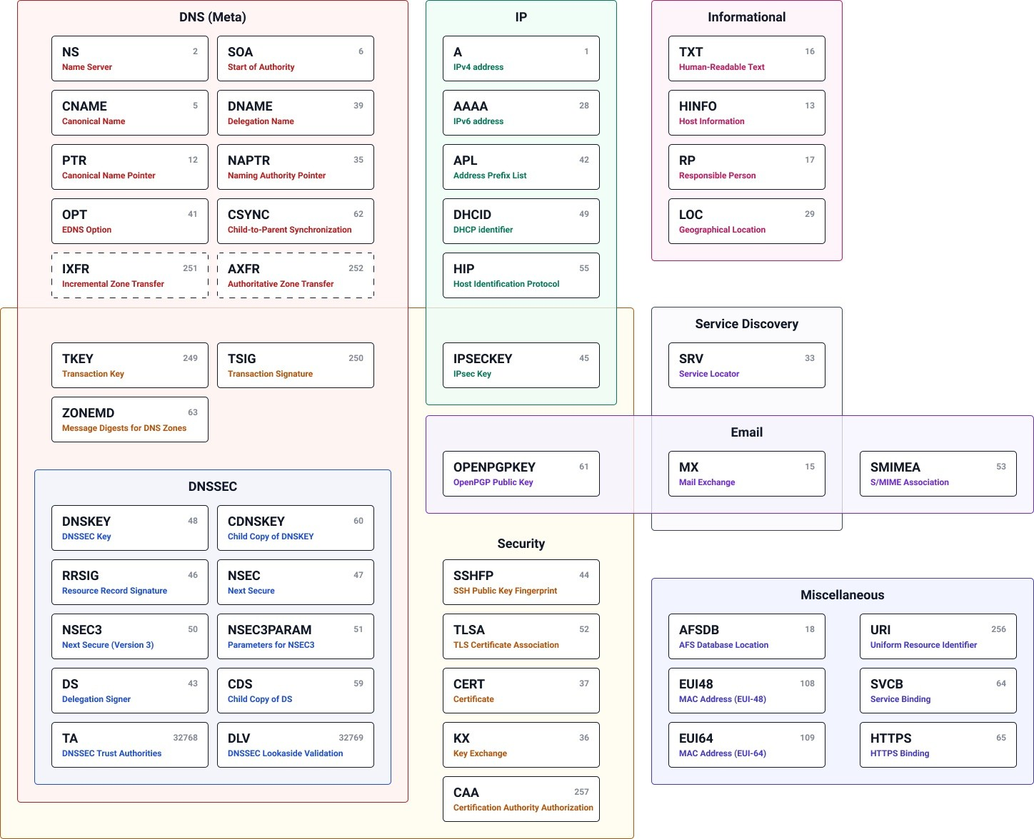
- MX: It directs emails to mail servers DNS record types:

