**EXERCISE- X**

**ITERATIVE CONTROL STRUCTURES**

**WHILE LOOP**

1. **Check whether the given number is Arm strong number or not.**

**Ans:** **num=as.integer(readline(prompt="enter number"))**

**r=0**

**rev=0**

**x=num**

**while(num>0){**

**r=num%%10**

**rev=rev+(r*r*r)**

**num=floor(num/10)**

**}**

**if(rev==x){**

**print(paste(x,"and",rev))**

**print(paste("the number is armstrong"))**

**}else{**

**print(paste("not armstrong"))**

**}**

**Output: enter number101**

**[1] "not armstrong"**

1. **Find sum of natural numbers without formula.**

**Ans:** **num=as.integer(readline(prompt="enter a number"))**

**i=1**

**s=0**

**while(i<=num){**

**s=s+1**

**i=i+1**

**}**

**print(paste("sum=",s))**

**Output:**

**enter a number5**

**[1] "sum= 5"**

1. **Program to print the Fibonacci Series**

**Ans: a1=0**

**a2=1**

**a3=0**

**i=1**

**num=as.integer(readline(prompt="enter the limit"))**

**print(paste("0"))**

**print(paste("1"))**

**while(i<=num-1){**

**a3=a2+a1**

**a1=a2**

**a2=a3**

**print(paste(a3," "))**

**i=i+1**

**}**

**Output:**

**enter the limit0**

**[1] "0"**

**[1] "1"**

**EXERCISE- XI**

**R BAR PLOT**

1. **Let us suppose, we have a vector of maximum temperatures (in degree**

**Celsius) for seven days as follows.**

**Max.temp: 22, 27, 26, 24, 23, 26, 28**

**make a vertical bar plot out of this data.**

**make a horizontal bar plot out of this data with some parameters**

**Ans:**

**temp=c(22,27,26,24,23,26,28)**

**barplot(temp,xlab="day",ylab="tempreture",main="temp per day")**

**Output:**

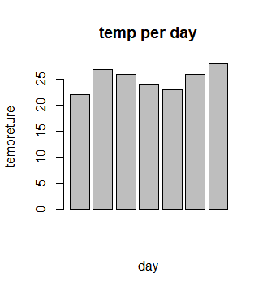

**temp=c(22,27,26,24,23,26,28)**

**barplot(temp,xlab="tempreture",ylab="day",main="temp perday",horiz=TRUE)**

**Output:**

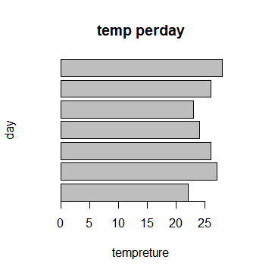

**2.Plotting Categorical Data**

**A vector of age of 10 college students given below**

**age <- c(17,18,18,17,18,19,18,16,18,18).create bar plot with some parameters**

**Ans: age<-c(17,18,18,17,18,19,18,16,18,18)**

**barplot(age,xlab="students",ylab="age",main="Ages of students")**

**Output:**

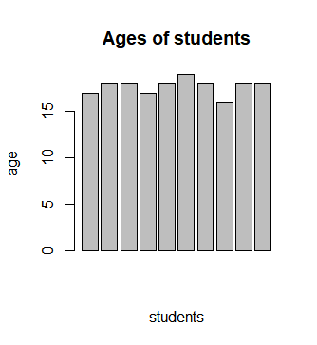

**EXERCISE- XII**

**R PIE CHART**

**3.Let us consider the below data represents the monthly expenditure breakdown of an individual.**

**>expenditure**

**Housing Food Cloths Entertainment Other**

**600 300 150 100 200**

**draw a simple pie chart out of this data**

**Draw Pie chart with additional parameters**

**Ans:**

**x=c(600,300,150,100,200)**

**labels<-c("Housing","food","cloth","Entertainment","other")**

**pie(x,labels,.ain="Expenditure")**

**Output:**

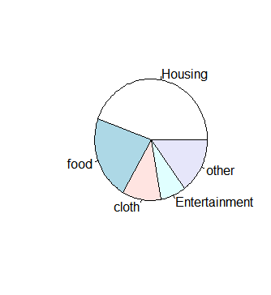

**x=c(600,300,150,100,200)**

**labels<-c("Housing","food","cloth","Entertainment","other")**

**pie(x,labels,.ain="Expenditure",col=rainbow(length(x)))**

**Output:**

