**SKPL**-xxxx

**SOFTWARE REQUIREMENT SPECIFICATION**

**On Time**

For :

RPLGDC Laboratory

Created by:

Akmal Raafid 1301192218

Risyad Faisal Hadi1301194232

Ditya Athallah 1301194095

Nur Ahsar Setiyowen1301180506

Bachelor of Informatics – Faculty of Informatics (School of Computing) Telkom University

Jalan Telekomunikasi Terusan Buah Batu, Bandung Indonesia

|  |  |  |  |
| --- | --- | --- | --- |
| **Informatics Bachelor- Faculty of Informatics** | **Document Number** | | **Halaman** |
| ***SKPL-xxx*** | | **28** |
| **Revisi** |  | *Date :* |



|  |  |  |
| --- | --- | --- |
| *Informatics Bachelor – Telkom University* | *SKPL-xxx* | *Page ii of 28* |
| ***This document and information contained within belongs to Informatics Bachelor-Telkom University and confidential. It is forbidden to reproduce this document without Informatics Bachelor-Telkom University***  ***concern.*** | | |

# Revision List

|  |  |
| --- | --- |
| **Revision** | **Description** |
| **A** | 1. Make table of Definition, Abbreviation, and Acronym 2. Add Cardinality in Class Diagram 3. Add some points in Other Requirements |
| **B** |  |
| **C** |  |
| **D** |  |
| **E** |  |
| **F** |  |
| **G** |  |

|  |  |  |  |  |  |  |  |  |
| --- | --- | --- | --- | --- | --- | --- | --- | --- |
| INDEX | - | A | B | C | D | E | F | G |
| Date |  |  |  |  |  |  |  |  |
| Written by |  |  |  |  |  |  |  |  |
| Examined by |  |  |  |  |  |  |  |  |
| Approved by |  |  |  |  |  |  |  |  |

# Page of Revision List

|  |  |  |  |
| --- | --- | --- | --- |
| **Page** | **Revision** | **Page** | **Revision** |
|  |  |  |  |

# Table of Contents

Revision List 1

Page of Revision List 2

Table of Contents 3

1. Preliminary 4
   1. Purpose of Writing Document 4
   2. Document Coverage 4
   3. Definition, Abbreviation, and Acronym 4
   4. References 5
2. Software Global Description 6
   1. Software Statement of Objective 6
   2. Software Perspective and Function 6
   3. Profil dan Karakteristik Pengguna 6
   4. Operating Environment 7
   5. Software and System Boundaries 7
   6. Assumption and Dependency 7
3. Software Detailed Description 8
   1. Requirement Description 8

Functional Requirement 8

Non-Functional Requirement 9

* 1. Analytical Modelling 10

Usecase Diagram 10

Usecase Scenario #1 10

Usecase Scenario #2 11

Usecase Scenario #3 12

Usecase Scenario #4 13

Usecase Scenario #5 13

Class Diagram 21

1. External Interface Requirement 22
   1. User Interface 22
   2. Hardware Interface 22
   3. Software Interface 23
   4. Communication Interface 23
2. Other Requirements 24
3. **Introduction**

## Purpose of Writing Document

The main purpose of creating this document is to give simplicity for shoes and care.Beside that,this document is also created to do one of the final project of Software Development and Analysis subject.

This SRS document is used as guide for developers and users while the software is being developed.

For developers,this document is a technical reference of the software development that gives explanation about the mobile-android based software that’s going to be built,there’s also general explanation and detailed explanation.As for the user,this SRS document is being used to note the specification requirementss for the software,and user feedback.Beside that,the purpose of the creation of this document is to analyze all of the objects that will be implementated from the software.

## Document Coverage

In the creation of the SRS document, Font that will be used is Times with font size 18pt for chapter title and will use bold effect, 14 pt for sub-chapter and will use bold effect,12pt for every chapter, also 9pt for table and picture names. Spacing that used for line spacing is 1.15.All terms will be typed with italic effects.

## Definition, Abbreviation, and Acronym

|  |  |
| --- | --- |
| **TERM /**  **ABBREVIATION** | **DEFINITION** |
| APPL/SAAD | Software Analysis and Design (SAAD) includes all activities, which help  the transformation of requirement specification into implementation. |
| SKPL/SRS | A Software Requirements Specification (SRS) is a description of a software  system to be developed. |
| ERD | An entity-relationship diagram (ERD) is a data modeling technique that  graphically illustrates an information system’s entities and the  relationships between those entities. |
| GUI | The Graphical User Interface (GUI**)** is a form of user interface that allows users to interact with electronic devices through graphical icons and audio indicator such as primary notation, instead of text-based user interfacest, typed command labels  or text navigation. |
| Use Case | In software and systems engineering, a use case is a list of actions or event steps typically defining the interactions between a role (known in the Unified Modeling  Language (UML) as an actor) and a system to achieve a goal. |
| Class Diagram | Diagram that shows the system’s structure from classes definitiom to  build a system |

|  |  |
| --- | --- |
| Admin | Person that has more access to control the system’s content |
| User | The person who using the application |
| Server | A computer system that serves some services in a computer network |
| Actor | A human entity/machine that interacts with system to do some works |
| System | A system is a group of interacting or interrelated entities that form a unified  whole. |
| Client | A client is a piece of computer hardware or software that accesses a service made  available by a server. |
| Hardware | Tools, machinery, and other durable equipment. |
| Software | The programs and other operating information used by a computer. |

## References

The source that related with this SRS are :

1. Template SKPL Analisis Berorientasi Objek 2022.
2. SKPL Assistant Recruitment Application at Telkom University
3. SKPL Sistem On Time – Telkom University
4. React Native Documentation: [https://reactnative.dev/docs/getting-started.](https://reactnative.dev/docs/getting-started)
5. Google Location API: https://developers.google.com/places/web-service/overview
6. Android Platform Documentation: <https://developer.android.com/docs>

# Software Global Description

## Software Statement of Objective

Being late is almost considered as a habit for college students, the only way to overcome being late is change of habit. It is not easy to change a habit for a short time, but there is some way to help it by making a weekly schedule, setting an alarm or asking a friend to notify the person for a certain event. Those 3 actions can be done within your mobile devices. There are several applications that can do some of those actions. The application contains a calendar and alarm. by marking a date, time, event description, and notification time. by inputting those requirements, the application will notify the user by popping up a notification on the mobile device.

This product is very similar to any reminder applications, but this product is intended to help *civitas academica* so that the product could be connected to the college website to link the schedule to the app. the product will be available in Android and iOS devices only because most of the people in the world use those devices.

## Software Perspective and Function

There’s some product functions from the application:

1. User can do orders via application
2. Student can choose treatment that system alarm
   1. **User Profile and Characteristic**

|  |  |
| --- | --- |
| **User Category** | Task |
| User | 1. Registration 2. Login 3. View Menu 4. Create New event 5. User Customization 6. View Upcomming event |
| Admin | 1. Login 2. Confirm event 3. Add assignment 4. Edit Event Information 5. Edit the event 6. Edit date 7. Edit event description 8. Edit time 9. Delete Customer Data |

|  |  |
| --- | --- |
|  | 1. Delete event 2. Delete customization |

## Operating Environment

These are the minimum specification requirements to run Shoes annd Care application:

* + - Hardware:
      * Android Smartphone
      * Memory 1 GB RAM or more
      * Quad Core 1.2GHz CPU
      * 500MB storage free
      * Internet Celuller / Wifi to connect to the internet
    - Software:
      * Android or more

## Software and System Boundaries

In designing the On Time system there’s some boundaries from

implementation,those are:

1. Not all order has to be done via application,but also via offline (come to store) to do treatment and will be handled by admin
2. This application using english interfaces for nearly for every part of the application.
3. Payment Transaction is manage by courier, not directly into the system

## Assumption and Dependency

1. Users allowed the app to use some of their personal data (schedule) on LMS, Igracias, Google Accounts, and user’s social media for the app usage.
2. Users have stable internet connections.
3. Users have already acquired the school's learning management system accounts.
4. Users have enough power on their mobile devices to send and receive information.
5. This app can also be used with only Google Accounts.

# Software Detailed Description

## Requirement Description

### Functional Requirement

|  |  |  |  |
| --- | --- | --- | --- |
| Number | Requirement Code | Function | Descruption |
| 1. | FR-01 | User | This function is used by  user to make account to access the application. |
| 2. | FR-02 | Login | This function is used by the user to log in to the  application. |
| 3. | FR-03 | Main page | This function is used by the user to view and choose the list treatment  of the application |
| 4. | FR-04 | See Upcoming Event | This function is used by the user to order the  shoes treatment |
| 5. | FR-05 | Customize the web | This function is used by the user to edit the  personal data that user want |
| 6. | FR-06 | Create event | This function is used by the user to view the  user’s order |
| 7. | FR-07 | Link to other app | This function is used by  the user to confirm the order |
| 8. | FR-08 | See Information of the  event | This function is used by the user to add the new order process in offline  store |

### Non-Functional Requirement

|  |  |  |  |
| --- | --- | --- | --- |
| Number | Quality | Requirement Code | Description |
| 1. | Product Requirement | NFR-01 | Reminder that will always remind the users |
| 2. | Organizational Requirement | NFR-02 | A user can set a ringtone on the notification. |
| 3. | External Requirement | NFR-03 | Users will not miss any event. A friendly experience and free Customization |

## Analytical Modelling

***Usecase Diagram***

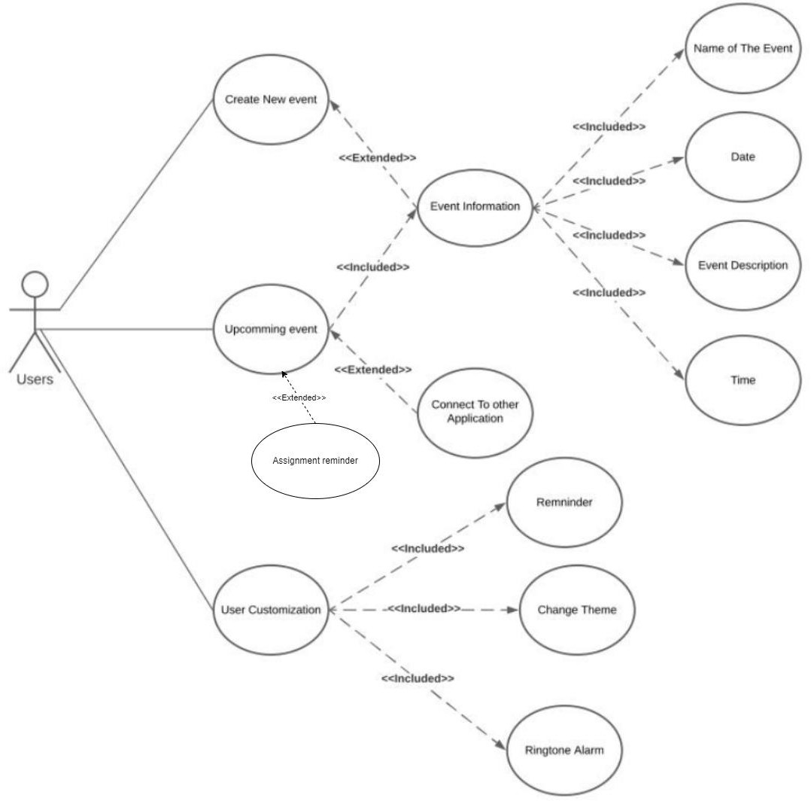Berikut merupakan visualisasi dari *Usecase Diagram* untuk *On Time* yang dibahas dalam SKPL ini :

* + - 1. *Usecase Scenario #1*

|  |  |  |
| --- | --- | --- |
| Use case | Create a account | |
| Description | User can register to create new account | |
| Preconditions | User did not register yet in the system | |
| Postconditions | User registered in the system and have an account | |
| Main Scenario |  | |
|  | Actor | System |
| 1. Open the |  |

|  |  |  |
| --- | --- | --- |
| *Informatics Bachelor – Telkom University* | *SKPL-xxx* | *Page 10 of 28* |
| ***This document and information contained within belongs to Informatics Bachelor-Telkom University and confidential. It is forbidden to reproduce this document without Informatics Bachelor-Telkom University***  ***concern.*** | | |

|  |  |  |
| --- | --- | --- |
|  | registration page |  |
|  | 2. Display the  registration page |
| 3. Fill the biodata form, the click  submit |  |
|  | 4. Doing data  validation |
|  | 5. Display notification  “Registration Success” |
|  | 6. Redirect actor to  login page |

* + - 1. *Usecase Scenario #2*

|  |  |  |
| --- | --- | --- |
| Use case | Login Process | |
| Description | This use case is to explain about the process how actor log  into the system | |
| Preconditions | Actor want to login | |
| Postconditions | Actor has been loggend in | |
| Main Scenario |  | |
|  | Actor | System |
| 1. Open the login page |  |
|  | 2. Display the login  page |
| 3. Actor input the requirement data that needed for  login |  |
|  | 4. System match the data that is entered by the actor from  database. |
| 5. The actor has  logged in to the system |  |

* + - 1. *Usecase Scenario #2*

|  |  |  |
| --- | --- | --- |
| Use case | Create New Event | |
| Description | User can create event | |
| Preconditions | User can see event information | |
| Postconditions | User can get notif information | |
| Main Scenario |  | |
|  | Actor | System |
| 6. Open event |  |

|  |  |  |
| --- | --- | --- |
| *Informatics Bachelor – Telkom University* | *SKPL-xxx* | *Page 11 of 28* |
| ***This document and information contained within belongs to Informatics Bachelor-Telkom University and confidential. It is forbidden to reproduce this document without Informatics Bachelor-Telkom University***  ***concern.*** | | |

|  |  |  |
| --- | --- | --- |
|  |  | 7. Display the menu  event |
| 8. Fill the order menu  form, then click order |  |
|  | 9. Display the  information |
| 10. Actor click “Yes” |  |
|  | 11. Display the  notification “event” |

* + - 1. *Usecase Scenario #3*

|  |  |  |
| --- | --- | --- |
| Use case | Upcomming event | |
| Description | User know assignment | |
| Preconditions | User already login and want to change event | |
| Postconditions | User updated their event | |
| Main Scenario |  | |
|  | Actor | System |
| 1. Open the profile  page |  |
|  | 2. Display the profile  event |
| 3. Actor click edit  button |  |
|  | 4. Display the form of  personal data / biodata |
| 5. Fill the form and  click “Update” | 6. |
|  | 7. Display the notification “Assignment” |

* + - 1. *Usecase Scenario #4*

|  |  |
| --- | --- |
| Use case | User Customization |
| Description | User can view Remnider Change Theme Ringtone Alarm |
| Preconditions | User already know Customization  detail |
| Postconditions | Userr know their Customization in detail |
| Main Scenario |  |

|  |  |  |
| --- | --- | --- |
| *Informatics Bachelor – Telkom University* | *SKPL-xxx* | *Page 12 of 28* |
| ***This document and information contained within belongs to Informatics Bachelor-Telkom University and confidential. It is forbidden to reproduce this document without Informatics Bachelor-Telkom University***  ***concern.*** | | |

|  |  |  |
| --- | --- | --- |
|  | Actor | System |
| 1. Open the order list  page |  |
|  | 2. Display the order  list page |
| 3. Actor clicks  “Detail” in one of order |  |
|  | 4. Display the order  detail page |
|  | |

* + - 1. *Usecase Scenario #5*

|  |  |  |
| --- | --- | --- |
| Use case | View event information | |
| Description | User can view their Name the event, date, event description, time | |
| Preconditions | User want to the information | |
| Postconditions | User know to notif Information | |
| Main Scenario |  | |
|  | Actor | System |
| 1. Open the menu  order page |  |
|  | 2. Display Information |
|  |  |
|  |  |
|  | |

***Class Diagram:***

# External Interface Requirement

## User Interface

In the making of On Time System, user use Interface to interact with the software where the software show the menu and other to user . Software can receive text, click, and option chosen as input from user by using their device.

Output of the software can be seen on user’s device. Interface from On Time

## Hardware Interface

The On Time application will be using the sound interfaces and vibration from the mobile phone. And using the google location API for getting location information when making appointments. And also, the other hardware interfaces of standard mobile phones.

## Software Interface

On Time application using React Native framework with nativebase library for the UI display and will use the same database tools with LMS and iGracias to make it easier to retrieve data.

## Communication Interface

Communication interfaces will only use communication standards for Android and iOS. Nothing special about the communication interfaces. But of course, as in most mobile apps nowadays, users are required to activate mobile data while using the On Time app. Or they could use offline mode with lack of features

# Other Requirements

# 5.1 System Features

There are some features provided for this application. This feature is enabled as a supporting reminder feature of The On Time product as the main feature. Those features include reminders. or other features that will be described as below.

## 5.1.1 Reminder

### Description:

This feature will be shown as a notification in the user’s mobile devices.

### Trigger:

This feature will be triggered at a certain time according to what the users mark on the calendar.

### Input:

The input is date, time, or an event.

### Output:

The output will be a sentence that will inform the users what event that is notified.

### Main Scenario:

To activate this feature, user need to go to user customization and turn on the notification setting. If the notification bar turn into green, it means that this feature has been activated. The users will be notified via their phone.

pre-condition:

* + Users already mark the event.

post-condition:

* + Users will get a notification through their mobile phone.

Steps:

* + The system will check the date that the user marked.

If it's time, then the notification will appear on the user's mobile phone

* + **Exceptional Scenario**

pre-condition:

Users forget to turn on notification on their phone.

Post-Condition:

The feature will not give the user a notification.

Steps:

• Users forget to turn on notification.

• The app will notice that the notification is turn off / disable.

• The feature will not give the user a notification.

## 5.1.2 Ringtone Alarm

### Description:

An alarm that will remind users about an event that has been marked on the app.

### Trigger:

His feature will be triggered at a certain time according to what the users mark on the calendar.

### Input:

Date, time or an event

### Output:

An alarm with a ringtone that the users set.

### Main scenario:

To activate this feature, user need to go to user customization and turn on the alarm setting. If the ringtone bar into green, then this feature is indicating as active. The users will be getting an alarm with a ringtone through the user’s phone.

Pre-condition:

* + User already mark the event.

Post-condition:

* + The ringtone will be ringing on your mobile phone

Steps:

* + Users mark an event on the app.
  + Users choose the song of the ringtone.
  + Ringtone will be sound and ringing on your phone.

## 5.1.3 Connect to Other App

### Description:

Users can connect to the other app; users can mark any event from the other app.

### Trigger:

This feature will be trigger if the users click “connect to other’s app” button.

### Input:

Users username/ID and Password (users account on the other’s app)

### Output:

The app will be connected to the other’s app.

### Main Scenario:

To activate this feature, user need to click the “connect to other’s app” button. User’s need to log in into their account and if the button turns into “connected”. It means that this feature is already activate

pre-condition**:**

* + The app is not connected to the other’s app.

post-Condition:

* + The app connected to the other’s app.

steps:

* + Users click the “Connect to other’s app” button.
  + User login into their account
  + The app will be connected to other’s app.

**Exponential Scenario:**

pre-condition*:*

Users put the wrong account.

post-Condition:

The app will be not connected to the other’s app.

steps:

Users click the “Connect to other’s app” button.

User input the wrong account pass/username.

The app will not be connected to other’s app.

## Theme Changing

### Description:

Users will be able to customize their own theme.

### Trigger:

This feature will be trigger if the users press the “change theme” button.

**Input:**

Choose the desired theme.

**Output:**

The theme will be changed by the users desired.

**Main Scenario:**

To activate this feature, user need to go to user customization and click the theme setting. The users will be given the app default theme. User’s need to choose what theme did they want to use. After clicking on the theme, the theme will automatically change.

pre-condition:

The app use default theme

post-Condition:

The app will use the new theme.

steps:

Users click the “Change theme” button.

Users choose the desired theme.

The app theme will be changed.

**Exponential Scenario:**

pre-condition:

User haven't downloaded the theme.

post-Condition:

the theme will not be change.

steps:

Users click the “Change theme” button.

Users choose the theme that hasn't been downloaded.

The app will not change the theme