Report Lab 01

Compute geodetic coordinates (latitude, longitude and geodetic height) of BRUN, 0001, 0002, 0003 in ETRF at February 2nd, 2019. Compute also the standard deviations of the geodetic coordinates.

Working flow

1. Compute Geocentric Cartesian (GC) coordinates of COMO at 2019/02/02.

They are computed according to the initial position and the velocity given in the webpage of “” and computed using distributed estimates for permanent stations:

$$x\left(t\right)=x\left(t_{0}\right)+x(t-t_{0})$$

So, replacing in the formula the values for the x, y and z coordinates:

COMOx = 4398306.209 + (-0.0145)\*(2019.09041096 - 2010.0);

COMOy = 704149.948 + 0.0181\*(2019.09041096 - 2010.0);

COMOz = 4550154.733 + 0.0113\*(2019.09041096 - 2010.0);

The results are the following:

$$COMO_{GC}=\left[\begin{aligned}4398306.0771890413016080856323242 \\ 704150.1125364383915439248085022 \\ 4550154.8357216436415910720825195\end{aligned}\right]$$

1. Compute BRUN coordinates in ITRF

Having the Como coordinates in ITRF from point 1 knowing the difference between Como and Brunatte in ITRF:

$$Δx_{COMO-BRUN\left(ITRF\right)}=\left[\begin{aligned}-1040.168 \\ -72.970 \\ 1631.398\end{aligned}\right]$$

$$x_{BRUN}=Δx_{COMO-BRUN\left(ITRF\right)}+x_{COMO}$$

$${BRUN}_{GC}=\left[\begin{aligned}4397265.9091890417039394378662109 \\ 704077.14253643841948360204696655 \\ 4551786.2337216436862945556640625\end{aligned}\right]$$

1. Compute Local Cartesian coordinates of 0001 with respect to BRUN

Given a known point and the differe

4. Convert LC of 0001 to pseudo Local Level with respect to BRUN

5. Compute alpha rotation between LC and LL in BRUN

6. Compute LC of 0002 and 0003

7. Compute GC of 0002 and 0003

8. Convert through EPN website ITRF GC coordinates of all the stations to ETRF GC

coordinates at the same epoch

9. Compute ETRF geodetic coordinates of all the stations

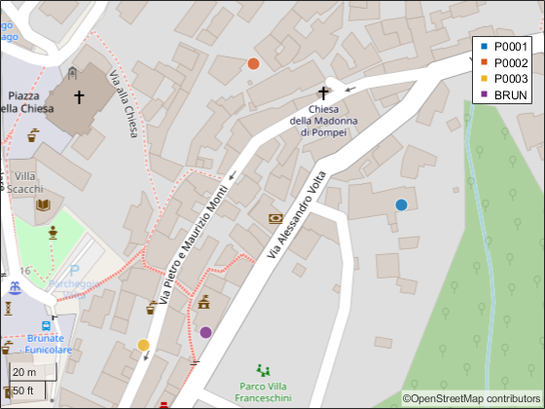

10. Propagate accuracies from LL in BRUN to LC in BRUN

11. Propagate accuracies from LC in BRUN to ETRF geodetic coordinates