A

Minor Project Report

On

**“LAPTOP PRICE PREDICTOR”**

Submitted to

**CHHATTISGARH SWAMI VIVEKANAND TECHNICAL UNIVERSITY**

**BHILAI**

in partial fulfillment of the requirement of for the award of degree

Of

**Bachelors of Technology**

In

**COMPUTER SCIENCE AND ENGINEERING**

**By**

**Divya Pawar, Naman Baveja, Rahul Singhal**

**DEPARTMENT OF COMPUTER SCIENCE AND ENGINEERING**

**SHRI SHANKARACHARYA TECHNICAL CAMPUS,**

**JUNWANI, BHILAI(C.G.)**

**SESSION 2022-2023**

**CERTIFICATE**

This is to certify that the thesis report of the project submitted is an outcome of the project entitled

**“LAPTOP PRICE PREDICTOR”** carried out by **Divya Pawar, Naman Baveja, Rahul Singhal** bearing **Roll no. 301402220038, 301402220083,301402220103 respectively** carried out under my guidance and supervision for the award of Degree in B.Tech in **Computer Science and** **Engineering** of Chhattisgarh Swami Vivekanand Technical university, Bhilai(C.G.),India.

To the best of my knowledge the report.

(1) Embodies the work of the candidates herself/himself.

(2) Fulfills the requirements of the ordinance relating to the B.Tech Degree of the University.And ,

(3) Is up to the desired standard for the purpose of which is submitted.

(Signature of the Class Teacher)

Professor

Computer Science & Engineering Department

**Shri Shankaracharya Technical Campus**

**Junwani, Bhilai(C.G.)**

The project work as mentioned above is hereby being recommended and forwarded for examination and evaluation.

**(Signature of Head of Department with seal)**

**ACKNOWLEDGEMENT**

Working on the project has been a great learning experience for us. There were moments of anxiety when we could not solve a problem for several days & there were moments when we could solve a problem after struggling for several days. But we have enjoyed every moment of the process and are thankful to all people associated with us during this period**.**

We convey our special thanks to our project guide **Mrs. Abha Choubey**, for providing us with all sorts of facilities. His support & guidance helped us to carry out the project. I owe a great debt of gratitude for his constant advice, support, cooperation & encouragement throughout the project.

It will be our pleasure to acknowledge, the utmost cooperation & valuable suggestion from time to time given by **Dr. Siddhartha Choubey (HOD CSE)** also, we would like to thank all those persons who have directly or indirectly helped us by providing computer peripherals and other necessary amenities which helped in the development of this project which would otherwise have not been possible.

**Divya Pawar**

**Rahul Singhal**

**Naman Baveja**

**TABLE OF CONTENTS**

|  |  |  |
| --- | --- | --- |
| **S.No.** | **TITLE NAME** | **Page No.** |
| **1.** | **ABSTRACT** | **1** |
| **2.** | **INTRODUCTION** | **2** |
| **3.** | **OBJECTIVE** | **3** |
| **4.** | **TOOLS AND TECHNOLOGIES** | **4** |
| **5.** | **PROJECT METHODOLOGY** | **5** |
| **6.** | **FUTURE SCOPE** | **8** |
| **7.** | **CONCLUSION** | **9** |

**ABSTRACT**

The Laptop Price Predictor project develops a machine-learning model that predicts the price of laptops based on their specifications. By leveraging historical laptop data and employing data pre-processing techniques, the project trains a predictive model using algorithms such as linear regression or decision trees. The trained model enables users to input laptop specifications and receive estimated prices, aiding consumers in making informed purchasing decisions and helping retailers determine competitive pricing strategies. This project has practical applications in the retail industry, online marketplaces, and for individual consumers seeking to evaluate laptop offerings based on desired specifications.

**INTRODUCTION**

The Laptop Price Predictor project aims to address the challenge faced by consumers in determining the fair market value of laptops based on their specifications. With a wide range of laptop configurations and price ranges available, it can be difficult for buyers to make informed decisions. This project utilizes machine learning techniques to develop a predictive model that can estimate the price of laptops based on features such as processor type, RAM, storage capacity, display size, and brand. By leveraging historical laptop data and training the model using suitable algorithms, the Laptop Price Predictor provides a valuable tool for both consumers and retailers, helping them make informed decisions about laptop purchases and competitive pricing strategies, respectively.

**OBJECTIVE**

1. Develop a predictive model for laptop price estimation.
2. Create a user interface for inputting laptop specifications.
3. Provide users with estimated prices based on their inputs.
4. Utilize historical laptop data to train the model.
5. Employ machine learning algorithms to learn patterns and relationships.
6. Improve the accuracy and reliability of price predictions.
7. Assist consumers in making informed purchasing decisions.
8. Aid retailers in determining competitive pricing strategies.

**TOOLS AND TECHNOLOGIES**

The following tools and technologies can be utilized for this project:

Software requirement: -

* Python
* Git
* Colab notebooks
* IDEs
* matplotlib
* seaborn
* pandas
* numpy
* scikit-learn
* streamlit
* pickle

Hardware requirement: -

* Processor: The processor should have sufficient processing power to handle the complex algorithms involved in emotion detection. A multi-core processor is recommended.
* RAM: The amount of RAM required will depend on the complexity of the algorithms used. A minimum of 8GB RAM is recommended.
* Graphics Processing Unit (GPU): A GPU can be used to accelerate the computation of the machine learning algorithms used in emotion detection. A dedicated GPU with a high number of cores is recommended.

**PROJECT METHODOLOGY**

* Data Collection and Pre-processing: The first step in the project methodology involves collecting a dataset containing information about various laptop models, including their specifications (such as processor type, RAM, storage capacity, display size, and brand) and their corresponding prices. This data can be obtained from various sources, such as online marketplaces or manufacturer websites. Once the dataset is collected, data pre-processing techniques are applied to clean and prepare the data for analysis. This includes handling missing values, normalizing numerical features, and encoding categorical variables.

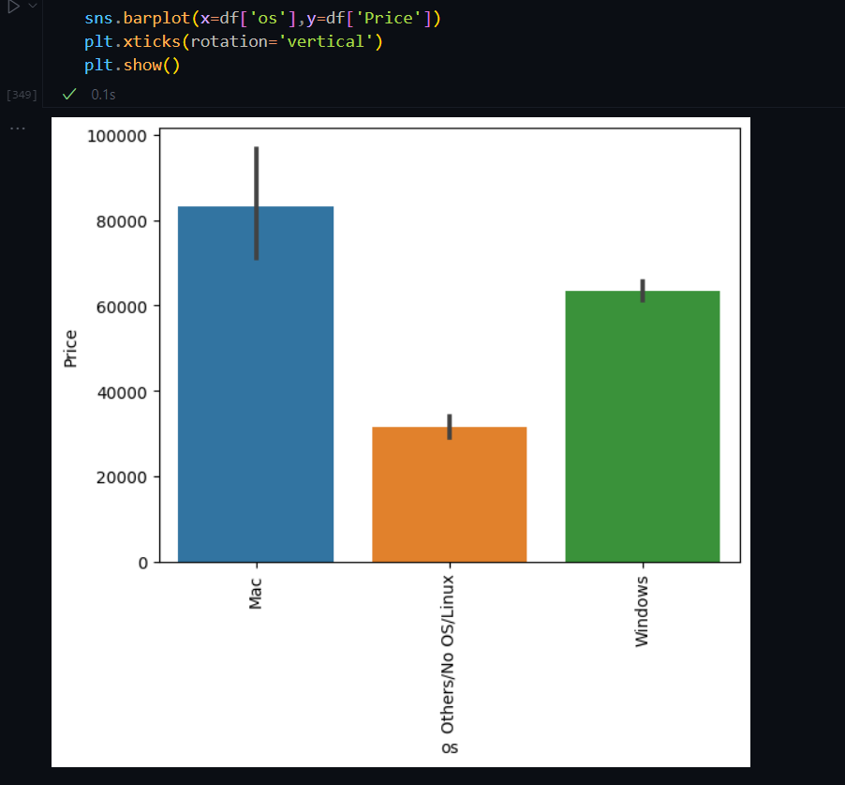

**Figure 1**: Laptop Price Predictor: Data pre-processing

* Model Development and Training: After preprocessing the data, the next phase focuses on model development and training. Different machine learning algorithms, such as linear regression, decision trees, and random forests, are employed to train a predictive model. The dataset is split into training and testing sets to evaluate the model's performance. Various evaluation metrics, such as mean squared error or R-squared, are used to assess the model's accuracy and fine-tune its parameters for optimization. The model is trained iteratively until satisfactory performance is achieved.

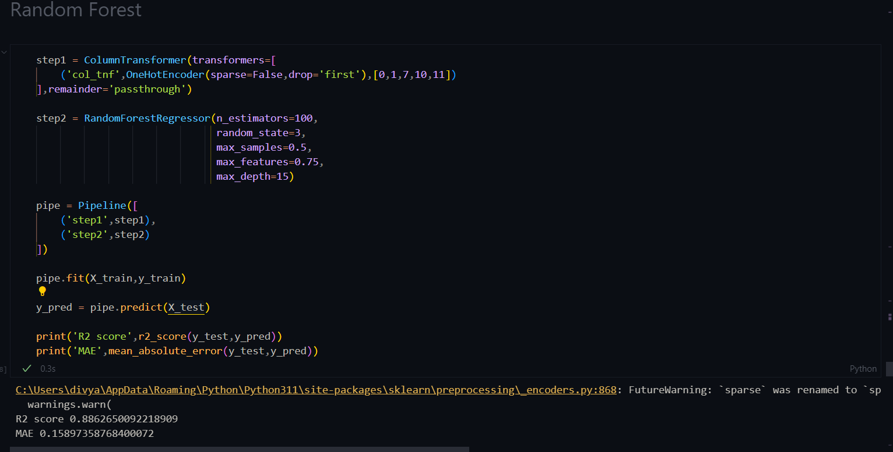

**Figure 2**: Laptop Price Predictor: Model Development and Training

* Prediction and Deployment: Once the model is trained and evaluated, it is ready for prediction and deployment. A user interface is developed where users can input the specifications of a laptop they are interested in, and the trained model generates an estimated price based on those specifications continuous monitoring and updates may be implemented to ensure the model remains accurate over time. The project is concluded by documenting the findings, sharing the code and model, and providing support for users and stakeholders.

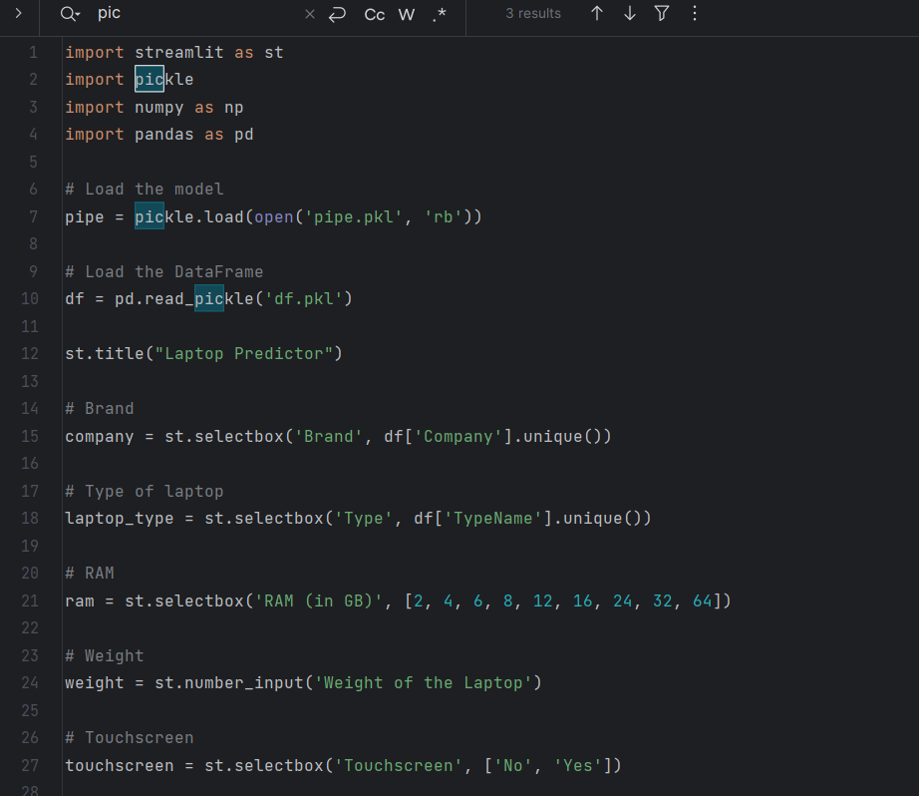

**Figure 3**: Laptop Price Predictor: Model Deployment using streamlit

**5**

**FUTURE SCOPE**

The future scope of the Laptop Price Predictor project includes the following potential advancements:

1. Enhanced Model Accuracy: Continual improvement of the machine learning model can be pursued by incorporating more advanced algorithms, exploring ensemble methods, or leveraging deep learning techniques to further enhance price prediction accuracy.
2. Integration of External Data Sources: Integrating additional data sources, such as user reviews, market trends, or competitor pricing, can provide a more comprehensive view and contribute to more accurate predictions, capturing real-time market dynamics.
3. User Feedback and Rating System: Implementing a user feedback and rating system within the application can allow users to provide feedback on the estimated prices, contributing to a feedback loop for model evaluation and refinement.
4. Mobile Application Development: Expanding the project's scope to develop a mobile application can provide users with convenient access to the Laptop Price Predictor, allowing them to obtain price estimates on the go.
5. Expansion to Other Electronic Devices: Applying the price prediction model to other electronic devices, such as smartphones, tablets, or gaming consoles, can widen the scope of the project and cater to a broader range of consumer needs beyond laptops.

6

**CONCLUSION**

In conclusion, the Laptop Price Predictor project has successfully developed a machine learning model that can estimate the price of laptops based on their specifications. By leveraging historical data and employing various pre-processing techniques, the project has created a valuable tool for both consumers and retailers.

The project has demonstrated the effectiveness of machine learning in addressing the challenge of determining fair market value in the laptop industry. With the potential for future advancements such as model enhancements, integration of external data sources, and expansion into other electronic devices.