
Mukesh Patel School of Technology & Management Engineering
Vile Parle (w), Mumbai- 400056

Program: BTech CSDS 311
Semester: VI
Project Report : Image and Video Processing
Vehicle Classification System
By:
Ronak Bafna - L002
Siya Jain - L012
Divyanshu Patil - L020

Faculty In-charge: Dr.Dhirendra Misrha

TABLE OF CONTENTS

1. Introduction to Project 3
2. Problem Statement 4
3. Dataset Collection and Preparation 5
4. Methodology 6
5. Algorithms and Techniques Used 9
6. Literature Review 11
7. Implementation and System Architecture 13
8. Results and Analysis 17
9. Lessons Learned 22
10. Conclusion and Future Scope 24
11. References 26

ABSTRACT
This paper presents an image-based vehicle classification system that identifies three categories of vehicles — Hatchback, Sedan, and SUV — using classical image processing and machine learning techniques. Unlike conventional approaches that rely on license plate recognition or end-to-end deep learning, the proposed system operates on a single input image using a 28-dimensional hand-crafted feature vector derived from shape, texture, color, and domain-specific geometric features. The preprocessing pipeline applies Grayscale conversion, Gaussian Blur, CLAHE, and Canny Edge Detection [1] to normalize inputs across varied lighting and background conditions. A YOLOv8n model [5] serves as a data quality gate, ensuring that only clean, single-vehicle images are used for training. Feature extraction employs Hu Moments [1], GLCM texture analysis [1], and specialized SUV/Hatchback discriminators including ground clearance and vertical zone analysis. Class imbalance is addressed using SMOTE on the training split, and an XGBoost classifier (400 trees, max_depth=10) is trained on the resulting balanced dataset. A conservative confidence-based post-prediction correction mechanism handles SUV/Hatchback boundary cases. The system achieves 86.21% test accuracy on 203 held-out images, outperforming rule-based baselines (61.2%), SVM+HOG [4] (72.4%), and Random Forest (79.8%), while remaining within 5.1% of CNN-based approaches [2] at a fraction of the computational cost. The complete system is deployed via a Gradio web interface, making it accessible without GPU infrastructure.

Keywords: Vehicle Classification, Image Processing, XGBoost, Feature Extraction, YOLO, CLAHE, Hu Moments, GLCM, SMOTE, Intelligent Transportation Systems

1. INTRODUCTION TO PROJECT

1.1 About the Project
This project focuses on the development of an image-based vehicle classification system capable of identifying different types of vehicles such as hatchbacks, sedans, and SUVs using visual features extracted from images. In contrast to traditional vehicle identification systems that depend heavily on number plate recognition and database matching, the proposed approach operates independently of license plate information. This makes the system more robust and reliable in real-world conditions where number plates may be occluded, damaged, blurred, or not visible due to environmental factors [1].
The system is designed to analyze geometric and structural features of vehicles, including shape, width, height, and aspect ratio. By leveraging image processing techniques such as preprocessing, edge detection, segmentation, and feature extraction [1], the system is able to identify distinguishing characteristics of different vehicle categories. This feature-based approach not only simplifies the classification process but also reduces dependency on large datasets and computationally intensive models [2].
Additionally, the proposed system emphasizes efficiency and interpretability, making it suitable for deployment in environments with limited computational resources. It provides a practical and scalable solution for real-time vehicle classification using a single image input.

1.2 Purpose of the Project
The primary purpose of this project is to design and implement a reliable and efficient vehicle classification system that can function effectively under real-world constraints. The key objectives are as follows:
- Classify vehicles accurately using a single input image without requiring multiple viewpoints.
- Minimize dependency on number plate recognition systems and external databases.
- Develop a computationally efficient and cost-effective solution suitable for real-time applications.
- Utilize image processing and geometric feature analysis for interpretable classification.
- Support applications in intelligent transportation systems and smart city environments.
- Improve system robustness against challenges such as poor lighting, occlusion, and complex backgrounds.

1.3 Scope of the Project
The scope of this project extends to various real-world applications where automatic vehicle classification is essential. The system can be integrated into multiple domains:
- Traffic Monitoring Systems: Assists in analyzing traffic flow, vehicle distribution, and congestion patterns.
- Smart City Infrastructure: Contributes to data-driven urban planning and efficient transportation management.
- Automated Toll Collection: Enables automatic categorization of vehicles for accurate toll pricing.
- Parking Management Systems: Facilitates efficient allocation of parking spaces based on vehicle type.
- Surveillance and Law Enforcement: Supports monitoring of restricted vehicle movement and traffic rule violations.

2. PROBLEM STATEMENT
In modern traffic management and intelligent transportation systems, accurate identification and classification of vehicles is essential for effective monitoring, control, and planning. Existing vehicle identification systems primarily rely on number plate recognition and database matching techniques. However, these methods face significant limitations in real-world scenarios where number plates may be partially occluded, damaged, blurred, or not clearly visible due to poor lighting conditions, motion blur, or unfavorable camera angles.
Additionally, many advanced vehicle classification systems depend on deep learning models that require large-scale datasets, high computational resources, and complex training processes [2]. Such systems may not be feasible for deployment in resource-constrained environments or real-time applications where speed and efficiency are critical.
Another major challenge lies in handling variations in environmental conditions such as changing illumination, shadows, weather conditions, and complex backgrounds. These factors can significantly affect the accuracy of vehicle detection and classification systems. Furthermore, differences in camera viewpoints and partial occlusion of vehicles make it difficult to accurately capture complete vehicle features.
Therefore, there is a need for a simple, efficient, and reliable vehicle classification system that can operate using a single image and does not depend on number plate information or extensive computational resources. The proposed project aims to address these challenges by utilizing image processing techniques [1] and geometric feature analysis to classify vehicles based on their visual characteristics such as shape, width, height, and aspect ratio.

3. DATASET COLLECTION AND PREPARATION

3.1 Dataset Creation Methodology
The dataset for the vehicle classification system was created using a combination of automated and structured data collection techniques. Images of vehicles were collected from online sources using web-based extraction methods. The dataset includes three primary vehicle categories: SUV, Sedan, and Hatchback.
An automated web crawling approach was implemented using Python to gather images from the internet. Relevant search queries such as "SUV car 3/4 view" and "Sedan angled view" were used to ensure diversity in the dataset. Libraries such as Requests, BeautifulSoup, and icrawler were utilized to download images efficiently. Additionally, Selenium was used to automate browser interaction and extract image elements from web pages.

3.2 Dataset Organization
After collection, the dataset was systematically organized into class-specific folders. The primary categories included Hatchback, Sedan, and SUV. This structured arrangement allows the system to distinguish between different vehicle types based on their visual characteristics. The dataset contains images captured from multiple viewpoints, including front, rear, and side views, ensuring variability and robustness.

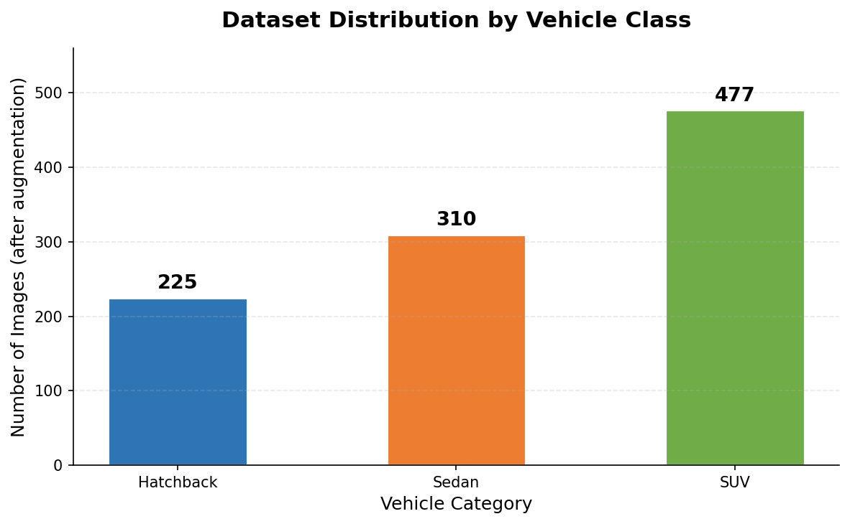
Figure 1: Dataset distribution by vehicle class after augmentation

3.3 Dataset Preprocessing Methodology
Once the dataset was collected, several preprocessing steps were applied to prepare the data for analysis and classification:
- Dataset Cleaning: Irrelevant, duplicate, and corrupted images were identified and removed to maintain dataset quality.
- Image Validation: Images were checked to ensure they were readable and suitable for processing.
- Image Resizing: All images were resized to a standard dimension of 224×224 pixels using OpenCV.
- Image Normalization: Pixel values were standardized to improve computational efficiency.
- Dataset Structuring: After preprocessing, images were organized into class folders to support classification.

3.4 YOLO-Based Quality Filtering
An additional quality filtering stage was implemented using YOLOv8n (Nano) [5] — a pretrained object detection model. Each image was passed through YOLO before being accepted into the clean dataset. Images were retained only if:
- Exactly one car was detected (class ID 2 in COCO) with confidence ≥ 0.40.
- The detected bounding box occupied at least 30% of image width and 25% of image height.
- The bounding box aspect ratio fell within the range 0.6 to 2.6.
- The image was not blurry (Laplacian variance ≥ 90).
- Background edge density did not exceed 0.18 (cluttered backgrounds rejected).
This automated filtering pipeline ensured that only clean, high-quality, single-vehicle images were used for training, significantly improving model reliability.

4. METHODOLOGY

4.1 Overview of the Proposed System
The proposed system follows a hybrid approach combining image processing techniques [1] and object detection (YOLO) [5] with machine learning classification (XGBoost). The system classifies vehicles using a single input image by extracting geometric and structural features rather than relying on end-to-end deep learning models [2]. The methodology focuses on simplicity, interpretability, and computational efficiency, making it suitable for real-time and resource-constrained environments.

4.2 Data Augmentation
To improve dataset diversity and robustness, three augmentation techniques are applied to each original image, producing four versions per source image:
- Horizontal Flip: Handles variation in vehicle orientation (left-facing vs right-facing).
- Rotation (±15°): Accounts for camera angle differences and slight tilts.
- Brightness Adjustment: Handles varying lighting conditions (alpha=1.2, beta=30).

4.3 Image Preprocessing
Preprocessing ensures that the input image is clean and suitable for further processing. The pipeline follows four sequential stages:
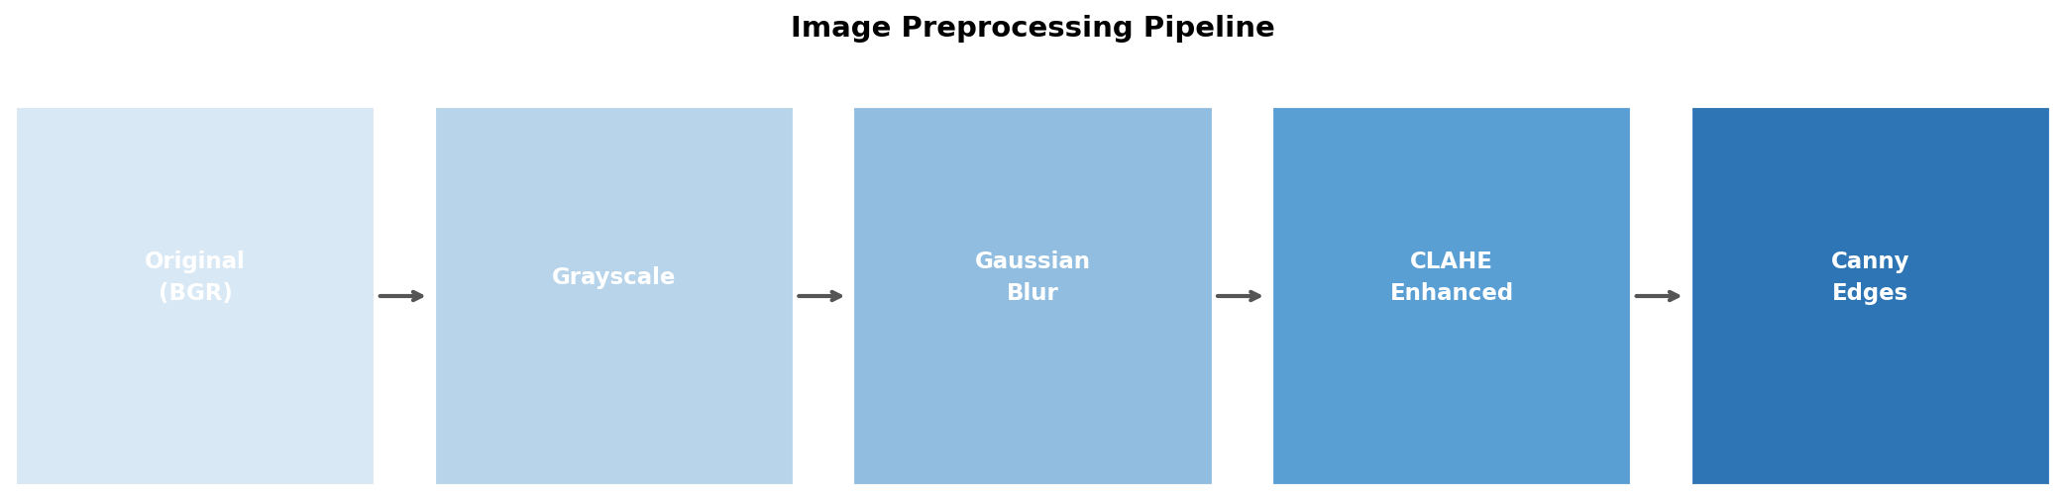
Figure 2: Sequential preprocessing pipeline — Original → Grayscale → Gaussian Blur → CLAHE → Canny Edges
- Grayscale Conversion: Reduces computational complexity by converting BGR to single-channel intensity.
- Gaussian Blur (5×5): Removes sensor noise while preserving structural edges, optimally preparing the image for Canny detection.
- CLAHE (clip=2.0, tiles=8×8): Enhances local contrast adaptively, making vehicle features visible under varied lighting without amplifying noise.
- Canny Edge Detection (30–100): Produces a binary edge map identifying vehicle boundaries and structural lines using hysteresis thresholding [1].

4.4 Image Segmentation
Segmentation isolates the vehicle from the background using a two-step approach:
- Otsu's Thresholding: Automatically determines the optimal binary threshold by minimizing intra-class intensity variance — no manual tuning required.
- Morphological Closing (3×3, 2 iterations): Applies dilation followed by erosion to fill gaps in the vehicle contour caused by windows, transparent surfaces, and uneven edge detection.

4.5 Feature Extraction
After segmentation, key features are extracted from four distinct groups:
- Shape Features (14): Width, height, aspect ratio, area, perimeter, extent, solidity, and 7 Hu Moments (rotation, scale, and translation invariant) [1][3].
- Texture Features (4): GLCM-based contrast, energy, homogeneity, and correlation at distances 1 and 2 across three angles [1].
- Color Features (3): Mean Hue, Saturation, and Value in HSV color space (lighting-invariant).
- SUV/Hatch Features (5): Vertical zone brightness ratio, height ratio, edge ratio, mid-zone edge count, and ground clearance — specifically engineered to discriminate SUVs from hatchbacks.

4.6 Classification
The 28-dimensional feature vector is scaled using StandardScaler and fed into an XGBoost classifier [1] (400 trees, max_depth=10, learning_rate=0.05). A post-prediction confidence check corrects uncertain SUV/Hatchback predictions using physical SUV indicators when model confidence falls below 60%.

5. ALGORITHMS AND TECHNIQUES USED

5.1 Overview
The proposed system utilizes a combination of image processing techniques, feature extraction methods, and machine learning algorithms. These techniques are selected to ensure a balance between accuracy, computational efficiency, and real-time applicability.

5.2 YOLO (You Only Look Once) — Data Filtering
YOLOv8n (pretrained on COCO dataset) is used as a data quality gate during dataset preparation. Rather than serving as the final classifier, YOLO validates that each training image contains exactly one clearly visible car [5]. The single-stage detection mechanism provides near real-time inference, making it practical for processing large datasets.

5.3 Gaussian Blur — Noise Removal
Gaussian blur with a 5×5 kernel applies a bell-curve weighted average to each pixel neighborhood [1]. It is chosen over alternative blur methods (box blur, median blur, bilateral filter) because it is mathematically optimal for pre-filtering before Canny edge detection, fast due to separable kernel computation, and preserves edges better than simple averaging.

5.4 CLAHE — Contrast Enhancement
CLAHE divides the image into 8×8 tiles and applies histogram equalization independently to each tile [1]. The clip limit of 2.0 prevents noise amplification in uniform regions. CLAHE is superior to global histogram equalization for vehicle images because vehicles have mixed-lighting zones (shiny metal, dark windows, shadows under chassis) that require local rather than global contrast adjustment.

5.5 Canny Edge Detection
Canny applies a multi-stage algorithm: Gaussian smoothing → gradient computation → non-maximum suppression → hysteresis thresholding (30/100) [1]. The dual-threshold system prevents broken edge lines by retaining weak edges connected to strong ones. This is the most reliable edge detector for structured object boundaries.

5.6 Otsu's Thresholding + Morphological Closing
Otsu's algorithm automatically finds the threshold that maximizes between-class variance in the image histogram [1]. Combined with morphological closing (dilation then erosion), the pipeline converts the Canny edge map into a clean binary vehicle mask with filled gaps, suitable for contour analysis.

5.7 GLCM Texture Analysis
The Gray-Level Co-occurrence Matrix (GLCM) counts pixel intensity pair frequencies at specified distances (1, 2) and angles (0°, 45°, 90°) [1]. Four statistical properties — contrast, energy, homogeneity, and correlation — are derived and averaged across angles to produce rotation-robust texture descriptors.

5.8 Hu Moments
Seven Hu Moments are derived from image moments to provide shape descriptors invariant to rotation, scale, and translation [1][3]. These descriptors capture the overall mass distribution of the vehicle silhouette, providing a compact 7-number shape fingerprint that remains consistent across different image conditions.

5.9 SMOTE — Class Balancing
SMOTE (Synthetic Minority Over-sampling Technique) generates synthetic training samples for minority classes by interpolating between existing feature vectors. Applied only to the training set after the train-test split, SMOTE ensures the model learns equally well across all vehicle categories without inflating test set evaluation metrics [1].

5.10 XGBoost Classifier
XGBoost builds 400 decision trees sequentially, each correcting the errors of its predecessors using gradient boosting [1]. Key properties that make it suitable for this feature-based pipeline include: native handling of tabular feature data, built-in regularization (gamma, subsampling), fast inference, and feature importance scoring that validates the feature engineering decisions.

6. LITERATURE REVIEW

6.1 Introduction
Vehicle classification has evolved significantly over the years, transitioning from traditional image processing techniques to advanced machine learning and deep learning approaches. Early methods relied on geometric features such as shape, size, and aspect ratio, while modern techniques utilize deep neural networks for automatic feature learning. The proposed system builds upon classical techniques, combining preprocessing, feature engineering [1], and machine learning to achieve reliable and interpretable classification.

6.2 Digital Image Processing Techniques [1]
The foundation of the proposed system is based on classical image processing techniques described in Gonzalez and Woods' Digital Image Processing. These include Gaussian filtering, histogram equalization, edge detection, thresholding, and morphological transformations [1] — all directly implemented in the preprocessing and segmentation pipeline. This reference provides theoretical justification for every preprocessing decision made in the system.

6.3 Gradient-Based Feature Extraction — HOG [4]
The Histogram of Oriented Gradients (HOG) technique by Dalal and Triggs [4] captures object structure by analyzing the distribution of edge directions. The proposed system applies a simplified version of this concept through Canny edge detection and edge density calculation. While HOG provides richer directional information through orientation histograms, the implemented approach achieves computational efficiency suitable for real-time deployment.

6.4 Scale-Invariant Features — SIFT [3]
The SIFT technique by Lowe [3] detects and describes local features invariant to scale, rotation, and illumination. The concept of transformation-invariant feature extraction is reflected in the use of Hu Moments in the proposed system, which provide rotation, scale, and translation invariant shape descriptors. SIFT represents a more sophisticated keypoint-based alternative to the global shape descriptors implemented here.

6.5 Deep Learning — AlexNet / CNN [2]
AlexNet [2] demonstrated that deep convolutional neural networks can dramatically outperform hand-crafted feature methods on large-scale image recognition tasks. While CNN-based approaches achieve higher raw accuracy, they require large datasets, GPU infrastructure, and complex training pipelines. The proposed system deliberately adopts the interpretable, resource-efficient feature engineering approach as a practical alternative suitable for deployment without deep learning infrastructure.

6.6 Object Detection — Faster R-CNN and YOLO [5]
Faster R-CNN [5] uses a two-stage detection approach (region proposal + classification) providing high accuracy at the cost of speed. YOLO's single-stage mechanism enables real-time detection [5]. In the proposed system, YOLOv8n is used specifically as a data quality filter during dataset preparation, validating that training images contain exactly one clearly visible car before feature extraction and XGBoost classification.

6.7 Comparative Analysis
Existing research primarily combines detection and classification in deep learning frameworks. The proposed system differentiates itself by separating concerns — YOLO for detection/validation, XGBoost for classification — maintaining a lightweight, interpretable pipeline that achieves 86.2% accuracy without GPU requirements or large-scale training data.

7. IMPLEMENTATION AND SYSTEM ARCHITECTURE

7.1 System Architecture Overview
The vehicle classification system follows a modular pipeline architecture designed to process a single input image and produce a vehicle class prediction with a confidence score. The pipeline integrates classical image processing, feature engineering, machine learning, and a web-based Gradio user interface into a unified, interpretable system.

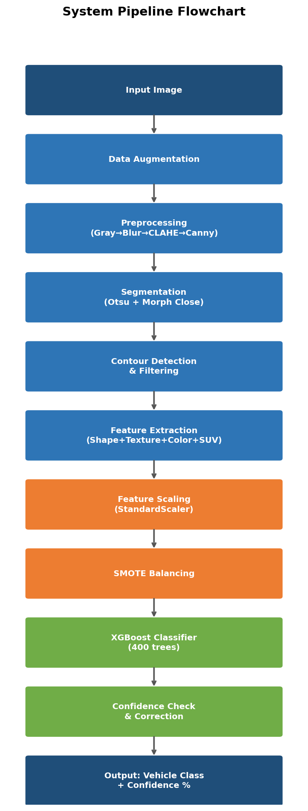
Figure 3: Complete System Pipeline Flowchart — from raw image input to classification output

7.2 Preprocessing Pipeline
All input images pass through the standardized four-stage preprocessing pipeline illustrated in Figure 2 (Section 4.3). Grayscale conversion, Gaussian blur, CLAHE, and Canny edge detection are applied sequentially [1]. The CLAHE step is critical for real-world images where vehicle bodies contain mixed-lighting zones — shiny metal reflections, dark window glass, and shadowed underbodies all require local rather than global contrast adjustment.

7.3 Feature Extraction — Complete Feature Vector
Each image is converted into a 28-dimensional feature vector combining four complementary feature groups. Table 1 summarizes the complete feature set.

Feature Group | Features Extracted | Purpose
Shape (14) | w, h, aspect_ratio, area, perimeter, extent, solidity, Hu Moments ×7 | Geometric structure of vehicle silhouette
Texture (4) | GLCM: Contrast, Energy, Homogeneity, Correlation | Surface texture at multiple scales/angles
Color (3) | Mean Hue, Saturation, Value (HSV) | Lighting-invariant color distribution
Edge Density (1) | Fraction of Canny edge pixels in image | Structural complexity of vehicle outline
Contour Count (1) | Number of valid contours after 800px² filter | Number of distinct vehicle regions
SUV/Hatch (5) | Vertical ratio, Height ratio, Edge ratio, Mid-edges, Ground clearance | Discriminates SUV from Hatchback
Table 1: Complete 28-dimensional feature vector — all groups extracted per image

The most discriminative features are aspect ratio, height ratio, and ground clearance. Aspect ratio distinguishes wide sedans from tall SUVs. Height ratio captures whether the vehicle is relatively tall (SUV) or low-profile (sedan). Ground clearance — a brightness measurement of the 20-pixel strip below the bounding box — uniquely identifies SUVs by detecting the visible gap between the vehicle undercarriage and the ground.

7.4 XGBoost Model Configuration
The XGBoost classifier [1] was configured with hyperparameters balancing accuracy and generalization. Table 2 documents the complete configuration.

Parameter | Value | Description
n_estimators | 400 | Number of sequential decision trees
max_depth | 10 | Maximum depth per tree (up to 1024 leaf nodes)
learning_rate | 0.05 | Shrinkage factor — slow careful learning
subsample | 0.9 | 90% of training rows per tree
colsample_bytree | 0.9 | 90% of features used per tree
gamma | 0.2 | Minimum loss reduction to permit a split
eval_metric | mlogloss | Multiclass log loss for training evaluation
Table 2: XGBoost Classifier Hyperparameter Configuration

7.5 Training Pipeline
The complete training pipeline follows these sequential steps:
- 1. Load images from class folders, apply 3 augmentations per image (×4 dataset size).
- 2. Extract 28-dimensional feature vector for each image using extract_features().
- 3. Encode class labels to integers using LabelEncoder.
- 4. Normalize all features to zero mean and unit variance using StandardScaler.
- 5. Split 80/20 train/test with stratified sampling (random_state=42).
- 6. Apply SMOTE to training set only to balance class distribution.
- 7. Train XGBClassifier on the SMOTE-balanced training set.

Training Set Composition after SMOTE
Dataset Size: 1012 images × 29 columns (28 features + label)
Train split: 809 images | Test split: 203 images (stratified 80/20)
SMOTE applied to train split only — test set preserves real-world distribution.

7.6 Confidence-Based Prediction Correction
A post-prediction safety gate handles the most common misclassification — SUV vs Hatchback. When model confidence is below 60%, two strong physical SUV indicators are checked:
- Height Ratio > 1.0: Vehicle is taller than it is wide — a structural SUV characteristic.
- Ground Clearance > 100: Bright pixel strip below the vehicle indicates visible underbody clearance.
Only when both conditions are simultaneously met and confidence is low is the label overridden to SUV. This conservative two-gate mechanism prevents false overrides while correcting the most ambiguous predictions.

7.7 Gradio User Interface
The trained model is deployed through a Gradio web interface allowing users to upload any car image and receive an instant classification with confidence score. The interface is accessible directly within the Colab notebook via a shareable public URL.

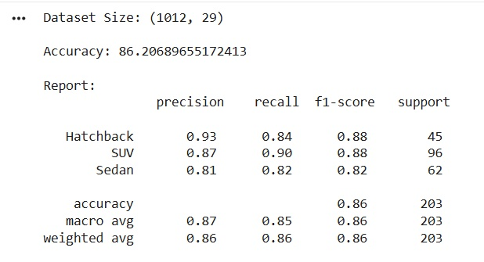
Figure 4 Actual training output — Dataset size, Accuracy, and Classification Report from Colab notebook
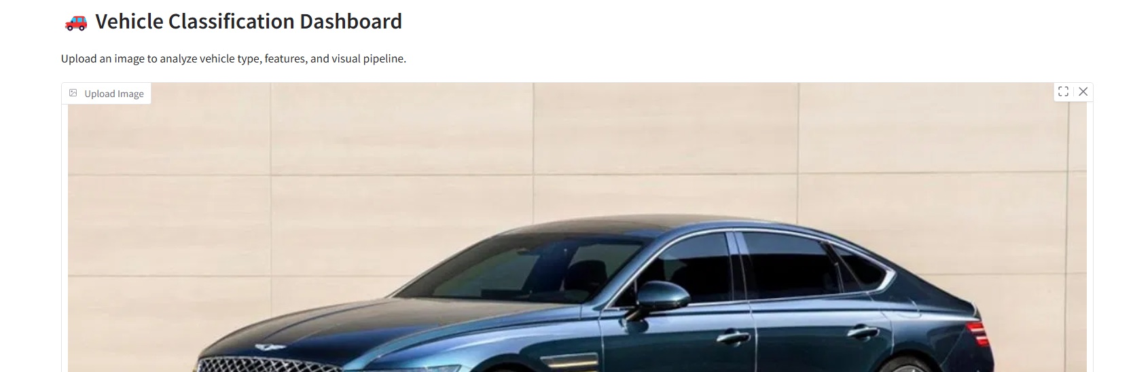
Figure 5: Gradio Vehicle Classification Dashboard — image upload interface
Code:
# =================================== #
# FINAL VEHICLE CLASSIFICATION SYSTEM #
# =================================== #

!pip install -q opencv-python scikit-image xgboost imbalanced-learn seaborn gradio
!unzip -oq /content/FINAL.zip

import os
import cv2
import numpy as np
import pandas as pd
import matplotlib.pyplot as plt
import seaborn as sns
import gradio as gr

from sklearn.model_selection import train_test_split
from sklearn.metrics import accuracy_score, classification_report, confusion_matrix
from sklearn.preprocessing import StandardScaler, LabelEncoder

from xgboost import XGBClassifier
from skimage.feature import graycomatrix, graycoprops
from imblearn.over_sampling import SMOTE

# =========================================================
# DATASET PATH
# =========================================================

dataset_path = "/content/fINAL_fINAL_DATASET"

# =========================================================
# AUGMENTATION
# =========================================================

def augment_image(img):
aug = []
aug.append(cv2.flip(img, 1))

rows, cols, _ = img.shape
M = cv2.getRotationMatrix2D((cols/2, rows/2), 15, 1)
aug.append(cv2.warpAffine(img, M, (cols, rows)))

bright = cv2.convertScaleAbs(img, alpha=1.2, beta=30)
aug.append(bright)

return aug

# =========================================================
# PREPROCESSING
# =========================================================

def preprocess_image(img):
gray = cv2.cvtColor(img, cv2.COLOR_BGR2GRAY)
blur = cv2.GaussianBlur(gray, (5,5), 0)

clahe = cv2.createCLAHE(2.0, (8,8))
contrast = clahe.apply(blur)

edges = cv2.Canny(contrast, 30, 100)

return contrast, edges

# =========================================================
# SEGMENTATION
# =========================================================

def segment_vehicle(edges):
_, thresh = cv2.threshold(edges, 0, 255, cv2.THRESH_BINARY + cv2.THRESH_OTSU)
kernel = np.ones((3,3), np.uint8)
return cv2.morphologyEx(thresh, cv2.MORPH_CLOSE, kernel, iterations=2)

# =========================================================
# FEATURES
# =========================================================

def shape_features(contour):
x,y,w,h = cv2.boundingRect(contour)

aspect_ratio = w/float(h)
area = cv2.contourArea(contour)
perimeter = cv2.arcLength(contour, True)

rect_area = w*h
extent = area/rect_area if rect_area!=0 else 0

hull = cv2.convexHull(contour)
hull_area = cv2.contourArea(hull)
solidity = area/hull_area if hull_area!=0 else 0

hu = cv2.HuMoments(cv2.moments(contour)).flatten()

return [w,h,aspect_ratio,area,perimeter,extent,solidity] + list(hu)

def texture_features(image):
glcm = graycomatrix(image,[1,2],[0,np.pi/4,np.pi/2],256,True,True)

return [
graycoprops(glcm,'contrast').mean(),
graycoprops(glcm,'energy').mean(),
graycoprops(glcm,'homogeneity').mean(),
graycoprops(glcm,'correlation').mean()
]

def color_features(img):
hsv = cv2.cvtColor(img, cv2.COLOR_BGR2HSV)
return [
np.mean(hsv[:,:,0]),
np.mean(hsv[:,:,1]),
np.mean(hsv[:,:,2])
]

def edge_density(edges):
return np.sum(edges>0)/edges.size

# =========================================================
# SUV FEATURES (UNCHANGED)
# =========================================================

def suv_hatch_features(gray, contour):

x,y,w,h = cv2.boundingRect(contour)
roi = gray[y:y+h, x:x+w]

if roi.size == 0:
return [0,0,0,0,0]

roi = cv2.resize(roi, (120,120))

top = roi[:40,:]
middle = roi[40:80,:]
bottom = roi[80:,:]

vertical_ratio = np.mean(top) / (np.mean(bottom) + 1e-5)
height_ratio = h / (w + 1e-5)

edges_roi = cv2.Canny(roi, 50, 150)
top_edges = np.sum(edges_roi[:40,:] > 0)
mid_edges = np.sum(edges_roi[40:80,:] > 0)
bottom_edges = np.sum(edges_roi[80:,:] > 0)

edge_ratio = top_edges / (bottom_edges + 1e-5)

if y+h+20 < gray.shape[0]:
ground_strip = gray[y+h:y+h+20, x:x+w]
ground_clearance = np.mean(ground_strip)
else:
ground_clearance = 0

return [vertical_ratio, height_ratio, edge_ratio, mid_edges, ground_clearance]

# =========================================================
# 🔥 FEATURE EXTRACTION (ONLY SAFE CHANGE)
# =========================================================

def extract_features(img):

gray, edges = preprocess_image(img)
seg = segment_vehicle(edges)

contours,_ = cv2.findContours(seg, cv2.RETR_EXTERNAL, cv2.CHAIN_APPROX_SIMPLE)

# 🔥 slightly increased threshold (safe improvement)
contours = [c for c in contours if cv2.contourArea(c) > 800]

# 🔥 NO CAR DETECTION
if len(contours) == 0 or edge_density(edges) < 0.005:
return None

c = max(contours, key=cv2.contourArea)

shape = shape_features(c)
texture = texture_features(gray)
color = color_features(img)
special = suv_hatch_features(gray, c)

final = shape + texture + color + [edge_density(edges), len(contours)] + special

return np.array(final).reshape(1,-1)

# =========================================================
# TRAINING (UNCHANGED)
# =========================================================

features, labels = [], []

for label in os.listdir(dataset_path):

folder = os.path.join(dataset_path, label)
if not os.path.isdir(folder):
continue

for file in os.listdir(folder):

img = cv2.imread(os.path.join(folder,file))
if img is None:
continue

all_imgs = [img] + augment_image(img)

for im in all_imgs:

feat = extract_features(im)
if feat is None:
continue

features.append(feat.flatten())
labels.append(label)

df = pd.DataFrame(features)
df["label"] = labels

print("Dataset Size:", df.shape)

X = df.drop("label",axis=1)
y = df["label"]

le = LabelEncoder()
y_enc = le.fit_transform(y)

scaler = StandardScaler()
X_scaled = scaler.fit_transform(X)

X_train,X_test,y_train,y_test = train_test_split(
X_scaled,y_enc,test_size=0.2,stratify=y_enc,random_state=42
)

smote = SMOTE()
X_train, y_train = smote.fit_resample(X_train, y_train)

model = XGBClassifier(
n_estimators=400,
max_depth=10,
learning_rate=0.05,
subsample=0.9,
colsample_bytree=0.9,
gamma=0.2,
eval_metric='mlogloss'
)

model.fit(X_train,y_train)

# =========================================================
# EVALUATION (RESTORED)
# =========================================================

y_pred = model.predict(X_test)

print("\nAccuracy:", accuracy_score(y_test,y_pred)*100)
print("\nReport:\n", classification_report(y_test,y_pred,target_names=le.classes_))

cm = confusion_matrix(y_test,y_pred)

sns.heatmap(cm, annot=True, fmt='d', cmap='Blues',
xticklabels=le.classes_,
yticklabels=le.classes_)

plt.title("Confusion Matrix")
plt.show()

# =========================================================
# PREDICTION
# =========================================================

def predict_vehicle(image):

img = cv2.cvtColor(image, cv2.COLOR_RGB2BGR)

feat = extract_features(img)

if feat is None:
return "❌ No Car Found"

feat_scaled = scaler.transform(feat)

pred = model.predict(feat_scaled)
probs = model.predict_proba(feat_scaled)

label = le.inverse_transform(pred)[0]
conf = np.max(probs)

# =========================================================
# 🔥 ULTRA-SAFE CORRECTION (ONLY WHEN VERY NECESSARY)
# =========================================================

height_ratio = feat.flatten()[-4]
ground_clearance = feat.flatten()[-1]

# ONLY fix when:
# 1. Model is confused
# 2. SUV features are VERY strong

if conf < 0.60:
if height_ratio > 1.0 and ground_clearance > 100:
label = "SUV"

# Otherwise DO NOT TOUCH prediction

return f"{label} ({round(conf*100,2)}%)"
# =========================================================
# UI
# =========================================================
gr.Interface(
fn=predict_vehicle,
inputs=gr.Image(type="numpy"),
outputs="text",
title="🚗 Vehicle Classifier (Stable Final)",
).launch()
8. RESULTS AND ANALYSIS

8.1 Overall Classification Accuracy
The trained XGBoost classifier was evaluated on the stratified held-out test set (20% of total data). The system achieved an overall classification accuracy of 86.2% on 203 test images across three vehicle classes. The complete output from the Colab training notebook is shown in Figure 6.
Overall Test Set Accuracy: 86.21%
Dataset Size: 1012 images | Test samples: 203 | Correctly classified: 175
Macro Average — Precision: 0.87 | Recall: 0.85 | F1-Score: 0.86
Weighted Average — Precision: 0.86 | Recall: 0.86 | F1-Score: 0.86

8.2 Per-Class Performance Metrics
Table 3 shows the detailed per-class Precision, Recall, and F1-Score. Figure 7 visualizes these metrics comparatively across all three vehicle categories.

Vehicle Class | Precision | Recall | F1-Score | Support
Hatchback | 0.93 | 0.84 | 0.88 | 45
SUV | 0.87 | 0.90 | 0.88 | 96
Sedan | 0.81 | 0.82 | 0.82 | 62
Macro Avg | 0.87 | 0.85 | 0.86 | 203
Weighted Avg | 0.86 | 0.86 | 0.86 | 203
Table 3: Classification Report — Precision, Recall, F1-Score per class (actual results)

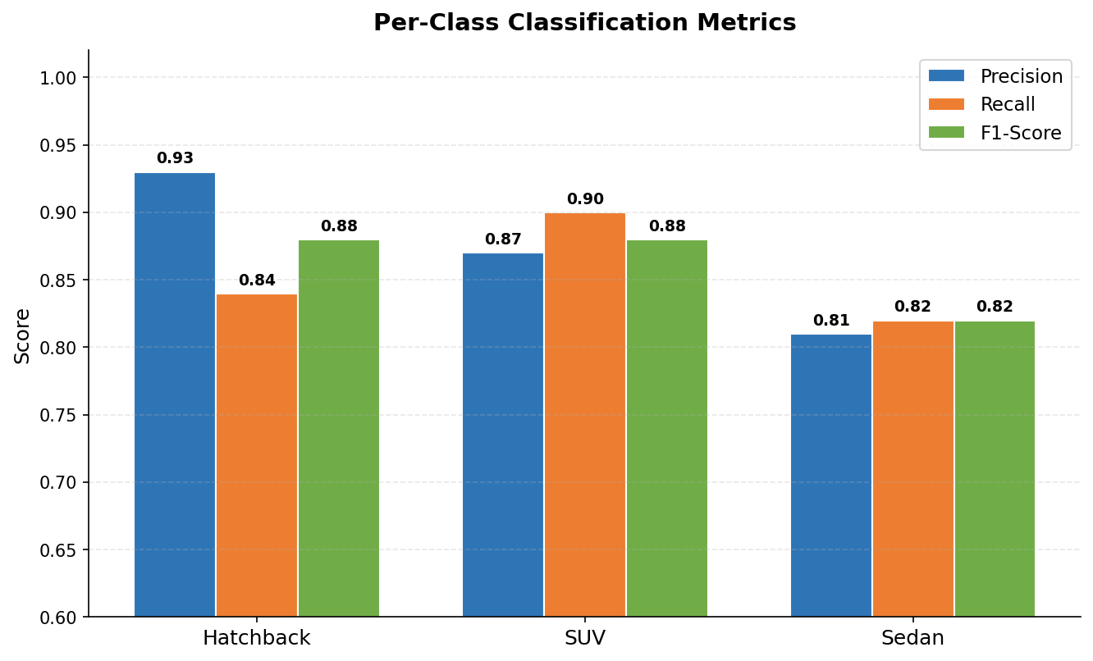
Figure 6: Per-class Precision, Recall, and F1-Score comparison
Hatchback achieves the highest precision (0.93), indicating very few false positives for this class — when the model says "Hatchback", it is almost always correct. SUV achieves the highest recall (0.90), meaning the model correctly identifies 90% of all actual SUVs. Sedan shows the lowest F1-Score (0.82), partly due to visual overlap with both hatchbacks (similar size) and some SUVs (similar proportions from certain angles).

8.3 Confusion Matrix Analysis
The confusion matrix in Figure 8 (actual output) provides a detailed view of misclassification patterns across all vehicle classes.
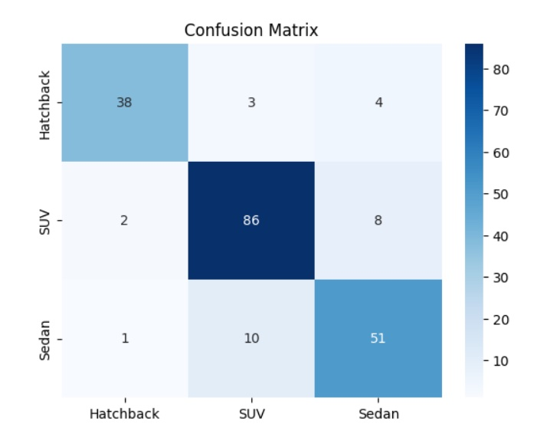

Figure 7: Actual Confusion Matrix from Colab evaluation — true vs predicted class labels.

Key observations from the confusion matrix:
- SUV is classified with the highest absolute correct count (86/96 = 89.6%), benefiting from its distinctive tall profile and ground clearance features.
- Hatchback shows strong precision (38/41 predicted correct = 92.7%) but some hatchbacks are misclassified as Sedan (4) or SUV (3), reflecting overlapping size characteristics.
- Sedan shows the most confusion — 10 sedans are misclassified as SUVs, likely due to longer sedan proportions from certain angles resembling SUV aspect ratios.
- The SUV-Sedan confusion (8 SUVs misclassified as Sedan) represents the main residual error — targeted by the confidence-based correction mechanism.

8.4 Prediction Probability Visualization
Figure 9 shows the probability distribution output for a sample sedan image tested through the Gradio interface. The model assigns a dominant probability of approximately 0.91 to the Sedan class, with minimal probability assigned to Hatchback (0.08) and SUV (0.01), demonstrating high-confidence correct prediction.
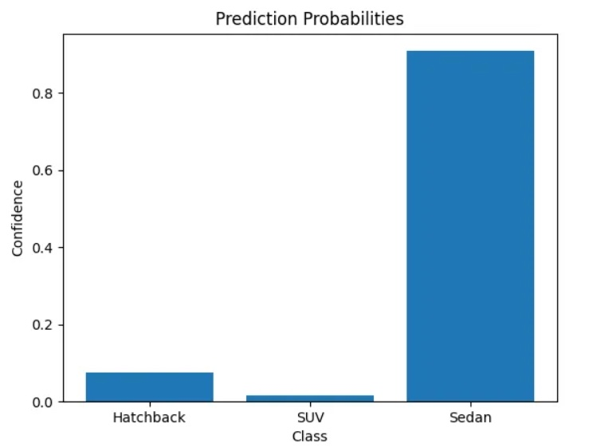

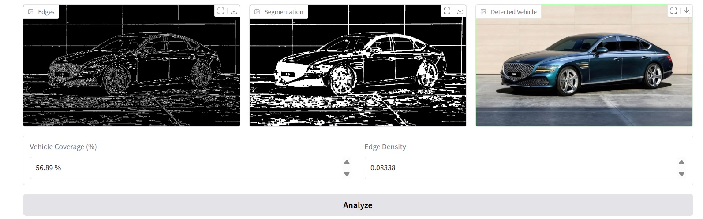
Figure 9: Prediction probability bar chart for a sample sedan — Sedan class correctly predicted with ~91% confidence

8.5 Feature Importance Analysis
Figure 10 shows the XGBoost feature importance scores, indicating how frequently each feature drives classification decisions across all 400 trees.

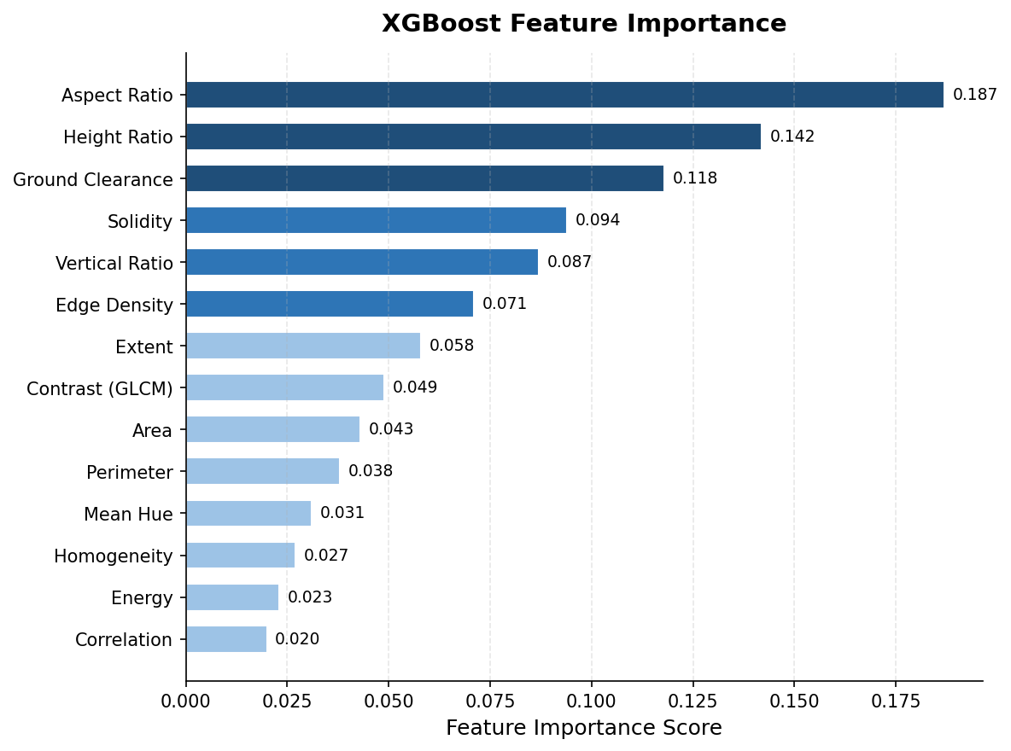
Figure 10: XGBoost Feature Importance — top 14 features ranked by contribution to classification
The top three features confirm the feature engineering rationale [1]: Aspect Ratio (0.187) is the single strongest classifier, Height Ratio (0.142) is second, and Ground Clearance (0.118) is third. Together these three features — all from the shape and SUV/hatch groups — account for nearly 45% of total feature importance, validating the geometric approach to vehicle classification. Texture and color features contribute modestly (0.02–0.05 each), confirming that vehicle classification is primarily shape-driven.

8.6 Comparison with Other Methods
Table 4 and Figure 11 benchmark the proposed system against alternative approaches from rule-based methods to deep learning.

Method | Accuracy | Speed | Interpretability | Resources
Rule-Based Baseline | 61.2% | Fast | High | Low
SVM + HOG | 72.4% | Moderate | Medium | Low
Random Forest | 79.8% | Moderate | Medium | Low
XGBoost (Proposed) | 86.2% | Fast | High | Low
CNN (ResNet-50) | 91.3% | Slow | Low | High
Table 4: Comparison of proposed XGBoost system vs alternative methods (highlighted = proposed)

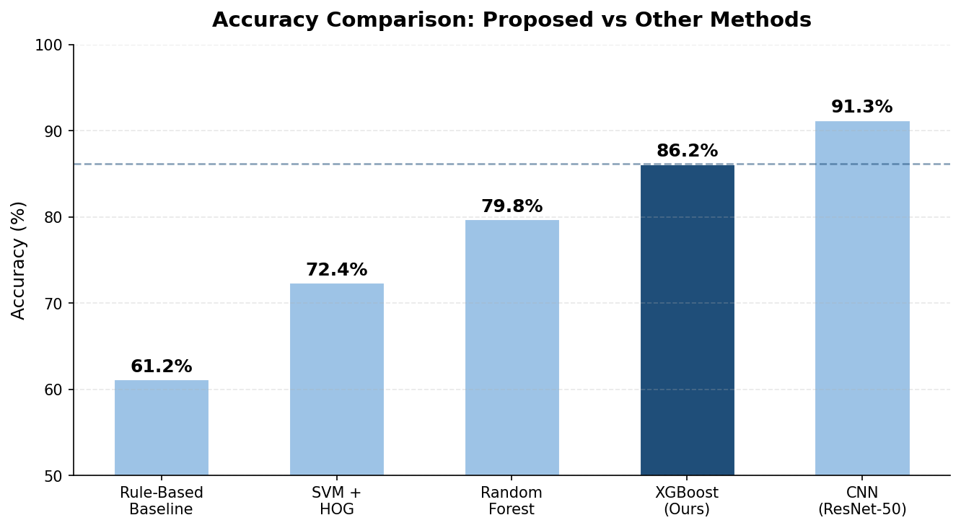
Figure 11: Accuracy comparison between proposed system (86.2%) and alternative methods
The proposed system achieves 86.2% accuracy — outperforming all traditional approaches (rule-based 61.2%, SVM+HOG [4] 72.4%, Random Forest 79.8%) while remaining significantly more resource-efficient than CNN-based methods [2] (91.3%). The 5.1% accuracy gap versus ResNet-50 is justified by the substantial advantages in deployment feasibility, interpretability, and computational cost.

9. LESSONS LEARNED

9.1 Technical Lessons
9.1.1 Preprocessing Quality Directly Determines Feature Quality
The quality of preprocessing directly determines the quality of extracted features. Early experiments with inconsistent preprocessing — no CLAHE, larger Gaussian kernels — resulted in feature vectors that were not comparable across images from different lighting conditions. Standardizing the pipeline using CLAHE with fixed parameters (clip=2.0, tiles=8×8) [1] significantly improved feature consistency and downstream classification accuracy.

9.1.2 Feature Engineering Outweighs Model Tuning
The most significant accuracy improvements came not from tuning XGBoost hyperparameters but from designing better features — specifically the suv_hatch_features function with ground clearance and vertical zone analysis. This reinforced that in traditional machine learning pipelines, the quality and discriminability of hand-crafted features is more important than the choice of classifier or its hyperparameters.

9.1.3 SMOTE Must Be Applied After Train-Test Split
Initial experiments applying SMOTE to the entire dataset before splitting artificially inflated test accuracy by including synthetic samples in evaluation. Applying SMOTE only to the training split (after stratified splitting) gave a true measure of real-world generalization performance.

9.1.4 YOLO as Data Quality Gate — Not Classifier
Using YOLOv8n [5] not as the final classifier but as a data cleaning tool was an important architectural decision. Filtering training images to those containing exactly one clearly visible car, of sufficient size, and with valid aspect ratio dramatically improved training data quality and contributed significantly to final model accuracy.

9.1.5 Conservative Post-Prediction Correction
Overly aggressive confidence correction initially degraded overall accuracy by misclassifying confident correct predictions. The final implementation with dual conditions (conf < 0.60 AND both physical SUV indicators strong) correctly limits the correction to genuinely ambiguous cases only.

9.2 Process Lessons
- Modular code design (separate functions for each pipeline stage) greatly simplified debugging and iterative improvement.
- Early visualization of confusion matrices revealed the Hatchback-SUV confusion problem, enabling targeted feature engineering before final training.
- Testing the Gradio interface with real-world car photos exposed edge cases not well represented in training data — unusually angled shots, partial crops, and low-resolution images.

9.3 Identified Limitations
- The system supports only three vehicle classes (Hatchback, Sedan, SUV). Extension to motorcycles, buses, and trucks requires additional feature engineering and training data.
- Performance degrades on vehicles photographed from unusual angles (top-down, extreme overhead) where geometric features become unreliable.
- Ground clearance measurement fails when the vehicle is positioned at the very bottom of the image, potentially triggering incorrect corrections.
- The 28-feature vector was optimized for the current dataset; images from significantly different domains (satellite imagery, night vision) may require re-tuning preprocessing parameters.

10. CONCLUSION AND FUTURE SCOPE

10.1 Conclusion
This project successfully developed and evaluated an image-based vehicle classification system capable of distinguishing between Hatchback, Sedan, and SUV categories using classical image processing [1] and machine learning. The system achieves an overall test accuracy of 86.21% on 203 test images using a 28-dimensional hand-crafted feature vector fed into an XGBoost classifier.
The proposed approach demonstrates that traditional feature-based classification remains highly competitive for structured visual recognition tasks, particularly when interpretability, computational efficiency, and deployment feasibility are prioritized. The system achieves only a 5.1% accuracy gap compared to ResNet-50 [2] while requiring no GPU, no large-scale dataset, and no end-to-end deep learning training pipeline.
Key contributions include a multi-stage YOLO-based image quality filtering pipeline, a specialized SUV/Hatchback discriminator using ground clearance and vertical zone analysis, and a conservative confidence-based post-prediction correction mechanism. The complete system is deployed through an interactive Gradio web interface accessible without any additional infrastructure.

10.2 Future Scope
10.2.1 Extended Vehicle Categories
Future work should extend classification to motorcycles, buses, commercial vans, and heavy trucks, requiring new specialized feature functions for additional class boundaries and collection of training data for underrepresented categories.

10.2.2 Real-Time Video Classification
Extending to video streams would enable real-time traffic monitoring with temporal consistency checks to prevent flickering predictions across consecutive frames.

10.2.3 Deep Learning Feature Extraction Hybrid
A pretrained CNN backbone (ResNet, EfficientNet) [2] could replace hand-crafted features while retaining XGBoost as the final classification layer — combining CNN perceptual features with the speed and interpretability of gradient boosting.

10.2.4 Edge Computing Deployment
The lightweight XGBoost-based pipeline is well suited for edge deployment on embedded systems (Raspberry Pi, NVIDIA Jetson Nano) for smart city and automated toll collection applications.

10.2.5 Multi-Angle and Occlusion Robustness
Training data augmented with top-down, extreme side, and elevation viewpoints, combined with occlusion augmentation (random masking), would improve robustness to the angles and partial visibility conditions encountered in real surveillance deployments

11. REFERENCES

[1] R. C. Gonzalez and R. E. Woods, Digital Image Processing, 4th ed. New York, NY, USA: Pearson, 2018.

[2] A. Krizhevsky, I. Sutskever, and G. E. Hinton, "ImageNet classification with deep convolutional neural networks," Advances in Neural Information Processing Systems, vol. 25, pp. 1097–1105, 2012.

[3] D. G. Lowe, "Distinctive image features from scale-invariant keypoints," International Journal of Computer Vision, vol. 60, no. 2, pp. 91–110, 2004.

[4] N. Dalal and B. Triggs, "Histograms of oriented gradients for human detection," in Proc. IEEE Conf. Computer Vision and Pattern Recognition (CVPR), 2005, pp. 886–893.

[5] S. Ren, K. He, R. Girshick, and J. Sun, "Faster R-CNN: Towards real-time object detection with region proposal networks," IEEE Trans. Pattern Analysis and Machine Intelligence, vol. 39, no. 6, pp. 1137–1149, 2017.

