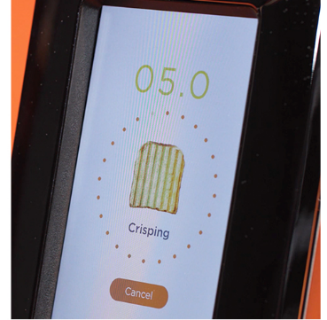
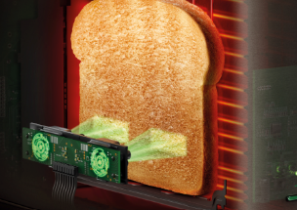
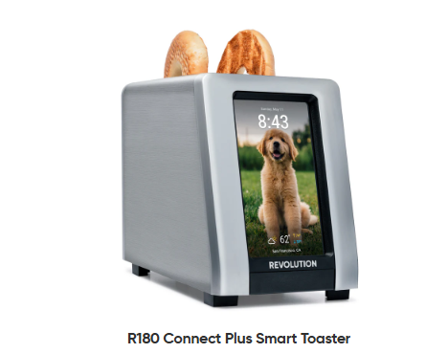
Smart sensors:
- Temperature Sensors.
- Timing Control.
- Optical sensing for browning.
Presets:
- Automatic temperature and time control.
- All depends on the bread type.
Heating Control:
- This toaster has a precise control of the heat radiated.
- It uses a PWM power control system.
Screen:
- User can select bread type, toasting level and the different presets available.
- Time and Weather displayed.
Product to be analyzed: Smart Toaster.
Model: Revolution R180 Connect Plus Toaster Line.
This toaster is known as the world’s first connected toaster.

Divyesh Soobarah
Beng Mechatronics Engineering
SOB 21

Traditional Toasters:
Heat ToastToast Done
The R180 introduces:
Control + Sensing + User interaction

- This toaster will use the info provided by the user (bread type, thickness..) which will act as an input.
- The input will be provided to a microcontroller.
- This will give an adaptive output depending on the input info.
- This toaster also has an unreal Connectivity system where it can connect to the internet.
- This allows remote control interaction where different features may be tweaked.
- The smart sensors inside the toaster constantly send data to the microcontroller which in turns adjust the heating.
- The Screen will then display real time feedback.
IOT Layers:
Sensing Temperature Sensors…
Processing Internal Controller
Communication App
Action Heating Element


Software Used:
The software used is an embedded software(firmware).
A firmware is a Software stored inside the Microcontroller that directly controls
the hardware.
That Software handles the input from the user using the touchscreen.
It will also handle sensor values.
Then it will go through a decision logic system.
This will act like the brain and intelligence of the toaster.
For example, depending of the browning level, the heating element and heating time
will vary.
It will also display various info like toasting time, weather, time and
even pictures using the great screen.
Concerning the communication when the toaster is connected, the toaster receives can receive commands from the app, send status updates and perform updates.
The language used is usually C++ or C like Arduino.
It uses a main loop control that has interrupt routines, sensor handling and communication tasks.

