**Title of Project- Music Player**

**Made by- Divyam Saxena(161B076)**

**Please Read the Instruction Carefully**

The project is used to play the Music of a ”mp3” formats i.e. the audio of the song is played. Moreover the program has basic features like (Play,Pause,UnPause,Stop(fadeout),previous,next,suffle,repeat,playlist,mute,volume).

The program start with a splash screen which gives the detail about the programmer of this software. After 5 second the screen dissapears and the program start.

Now inorder to access the Music Player, you need to login .You can login by typing

UserName:-**Divyam**

Password:- **1228**

Now, after entering username and passwords then select the your Mood which type of song you want to listen and then just click on login. After that a dialog box will appear showing login successfull. Now Music Player window will appear on the screen.

Now select the MP3Player.

It will create the Song Playlist as per your mood.

For playing the song just click on the Play Button.

To pause the song just click on the Pause Button.

To Unpause there is an unpause button given.

Previous button will play the last song you played.

And Next Button will play the next song of your Playlist.

There is One Mute Button which will mute the song.

There is suffle Button which will play random songs of your list.

And Repeat Button which repeat the song.

And One Vol. Button which will Play the song.

Here is preview of Project:-

1:-

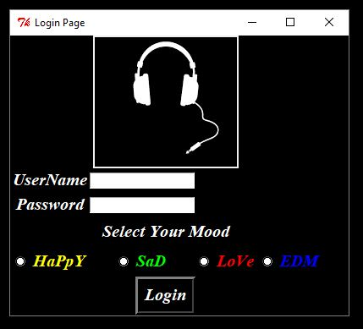

2:-

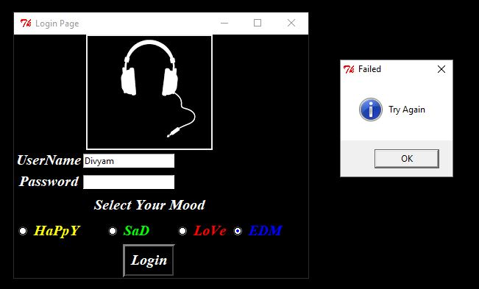

3:-

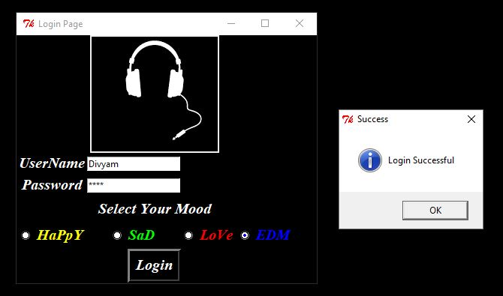

4:-

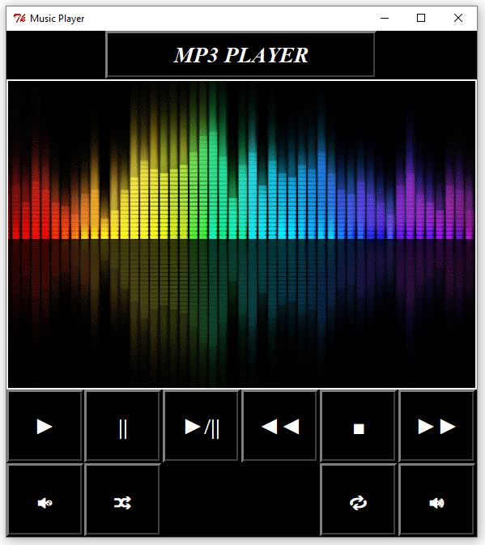

5:-

