Joins
JOIN Keyword is used in SQL queries for joining two or more tables.
SQL> select *from tb1;
RNO | NAME | MARKS
503 | Suma | 40
504 | Raju | 70
505 | Ramu | 45
501 | Abhi | 50
502 | Ravi | 60

SQL>select * from tb2;
RNO | FEE
501 | 15000
502 | 5000
503 | 10000
504 | 25000

Inner Join
The INNER JOIN keyword selects records that have matching values in both tables.
Syntax:select * from tablename1 inner join tablename2 on condition
SQL> select *from tb1 inner join tb2 on tb1.rno=tb2.rno;
Or use the below query also
select *from tb1 join tb2 on tb1.rno=tb2.rno;
RNO | NAME | MARKS | RNO | FEE
503 | Suma | 40 | 503 | 10000
504 | Raju | 70 | 504 | 25000
501 | Abhi | 50 | 501 | 15000
502 | Ravi | 60 | 502 | 5000

Outer Join:
Outer Join is based on both matched and unmatched data.
It is divided into
- Left outer join
The left outer join returns a resultset table with the matched data from the two tables and then the remaining rows of the left table and null from the right table's columns.
Syntax:
SELECT column-name-list FROM
table-name1 LEFT OUTER JOIN table-name2
ON table-name1.column-name = table-name2.column-name;
- Right outer join
The right outer join returns a resultset table with the matched data from the two tables being joined, then the remaining rows of the right table and null for the remaining left table's columns.
Syntax:
SELECT column-name-list FROM
table-name1 RIGHT OUTER JOIN table-name2
ON table-name1.column-name = table-name2.column-name;

Left Outer Join:
SQL> select * from tb1 left outer join tb2 on tb1.rno=tb2.rno;
RNO | NAME | MARKS | RNO | FEE
501 | Abhi | 50 | 501 | 15000
502 | Ravi | 60 | 502 | 5000
503 | Suma | 40 | 503 | 10000
504 | Raju | 70 | 504 | 25000
505 | Ramu | 45 | - | -

Right outer join
SQL>select * from tb1 right outer join tb2 on tb1.rno=tb2.rno;
RNO | NAME | MARKS | RNO | FEE
503 | Suma | 40 | 503 | 10000
504 | Raju | 70 | 504 | 25000
501 | Abhi | 50 | 501 | 15000
502 | Ravi | 60 | 502 | 5000

Natural join
It is based on column having same name and same datatype present in both the tables to be joined.
Syntax:
SELECT * FROM table-name1 NATURAL JOIN table-name2;
SQL>select *from tb1 natural join tb2;
RNO | NAME | MARKS | FEE
503 | Suma | 40 | 10000
504 | Raju | 70 | 25000
501 | Abhi | 50 | 15000
502 | Ravi | 60 | 5000

Cross join
It will return a table which consists of records which combines each row from the first table -with each row of the second table.
Syntax: select * from tablename1,tablename2
SQL>select *from tb1 cross join tb2;
or use the below query
SQL>select * from tb1,tb2;
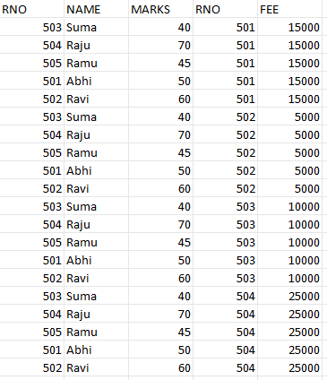
Self Join:
A self join is a join in which a table is joined with itself.
Syntax: SELECT column_name(s)
FROM table1 T1, table1 T2
WHERE condition;
SQL> select t1.rno, t2.name from tb1 t1,tb1 t2 where t1.rno=t2.rno;
RNO | NAME
503 | Suma
504 | Raju
505 | Ramu
501 | Abhi
502 | Ravi

EQUI Join
An Equi Join in SQL is a type of join that combines rows from two or more tables based on a common column or set of columns, using only the equality operator (=) to compare the values in those columns.
Syntax
SELECT column_list
FROM table1, table2....
WHERE table1.column_name =
table2.column_name;
SQL>select * from tb1,tb2 where tb1.rno=tb2.rno;
RNO | NAME | MARKS | RNO | FEE
503 | Suma | 40 | 503 | 10000
504 | Raju | 70 | 504 | 25000
501 | Abhi | 50 | 501 | 15000
502 | Ravi | 60 | 502 | 5000

