Materialized View – SailMV

AIM:
To create and demonstrate a Materialized View (SailMV) with refresh mechanism in Oracle SQL.

SQL Commands and Execution Steps:

Step 1: Create Source Table and Insert Data
CREATE TABLE sailors (
sid NUMBER PRIMARY KEY,
sname VARCHAR2(30),
rating NUMBER,
age NUMBER
);
INSERT INTO sailors VALUES (31, 'John', 8, 25);
INSERT INTO sailors VALUES (45, 'Ravi', 7, 30);
INSERT INTO sailors VALUES (62, 'Priya', 6, 22);
INSERT INTO sailors VALUES (77, 'Amit', 9, 28);
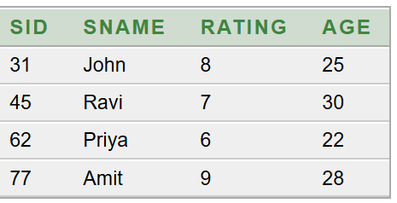

Step 2: Create Materialized View
CREATE MATERIALIZED VIEW SailMV
BUILD IMMEDIATE
REFRESH COMPLETE ON DEMAND
AS
SELECT s.sid, s.sname FROM sailors s;

Step 3: Display Materialized View Data
SELECT * FROM SailMV;
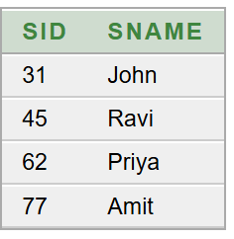

Step 4: Perform DML Operations on MV
INSERT INTO SailMV VALUES (101, 'Farah');
UPDATE SailMV
SET sname = 'Suma'
WHERE sid = 31;
Displaying SailMV before refresh:
Ineserting into base table:
INSERT INTO sailors VALUES (101, 'Farah', 9, 27);
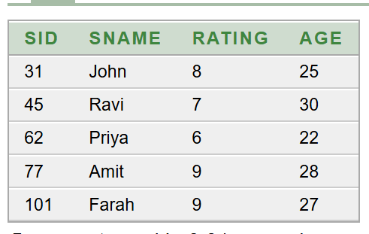

Step 5: Refresh the Materialized View
BEGIN
DBMS_MVIEW.REFRESH('SailMV');
END;
/
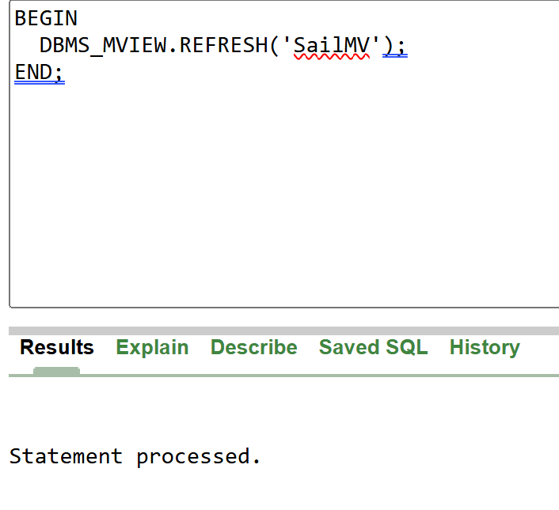
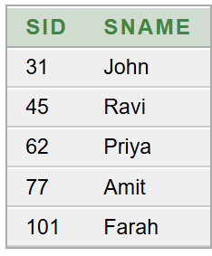

Step 6: Display Final Results after refresh
SELECT * FROM sailors;
SELECT * FROM SailMV;

