**Exp 5 :- Develop a simple application to understand the concept of PAAS using Amazon Elastic Beanstalk and launch it.**

**Aim:-**  
 To learn and deploy web applications in Amazon Elastic Beanstalk platform to learn about platform as a service.

**Procedure:**

**1.** Go to Amazon Console and then login with a valid Amazon account, open the Elastic Beanstalk console page.

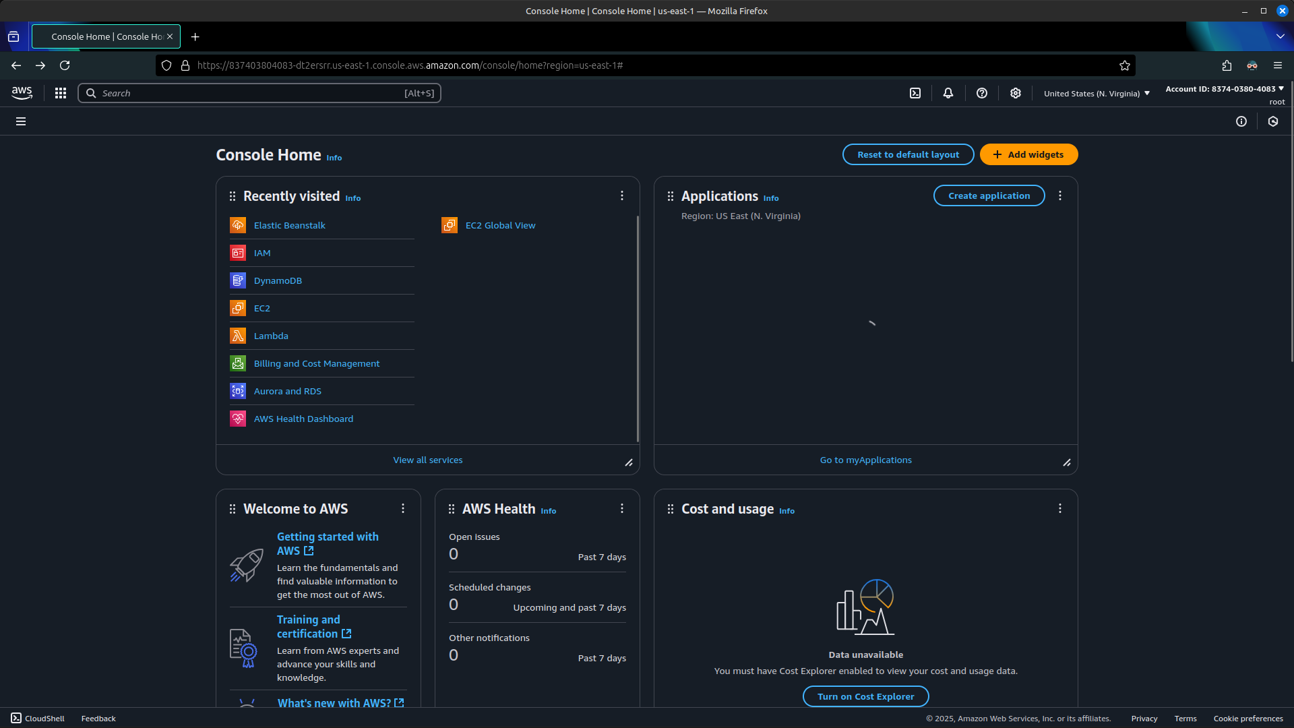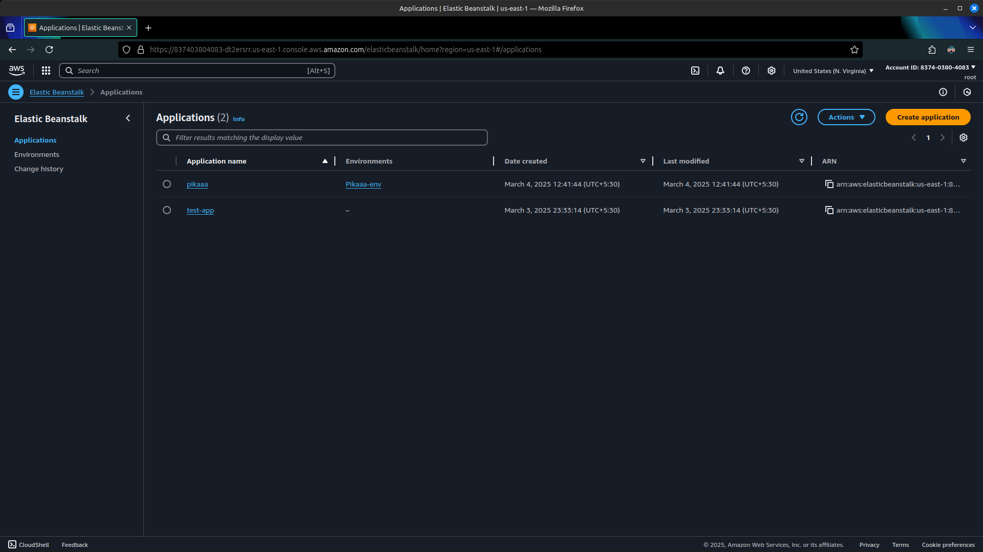

**2.** Select Create application to open the application wizard, choose a suitable name for the project, and then select the required platform needed such as python for django or flask with suitable version, choose sample application for barebone project.

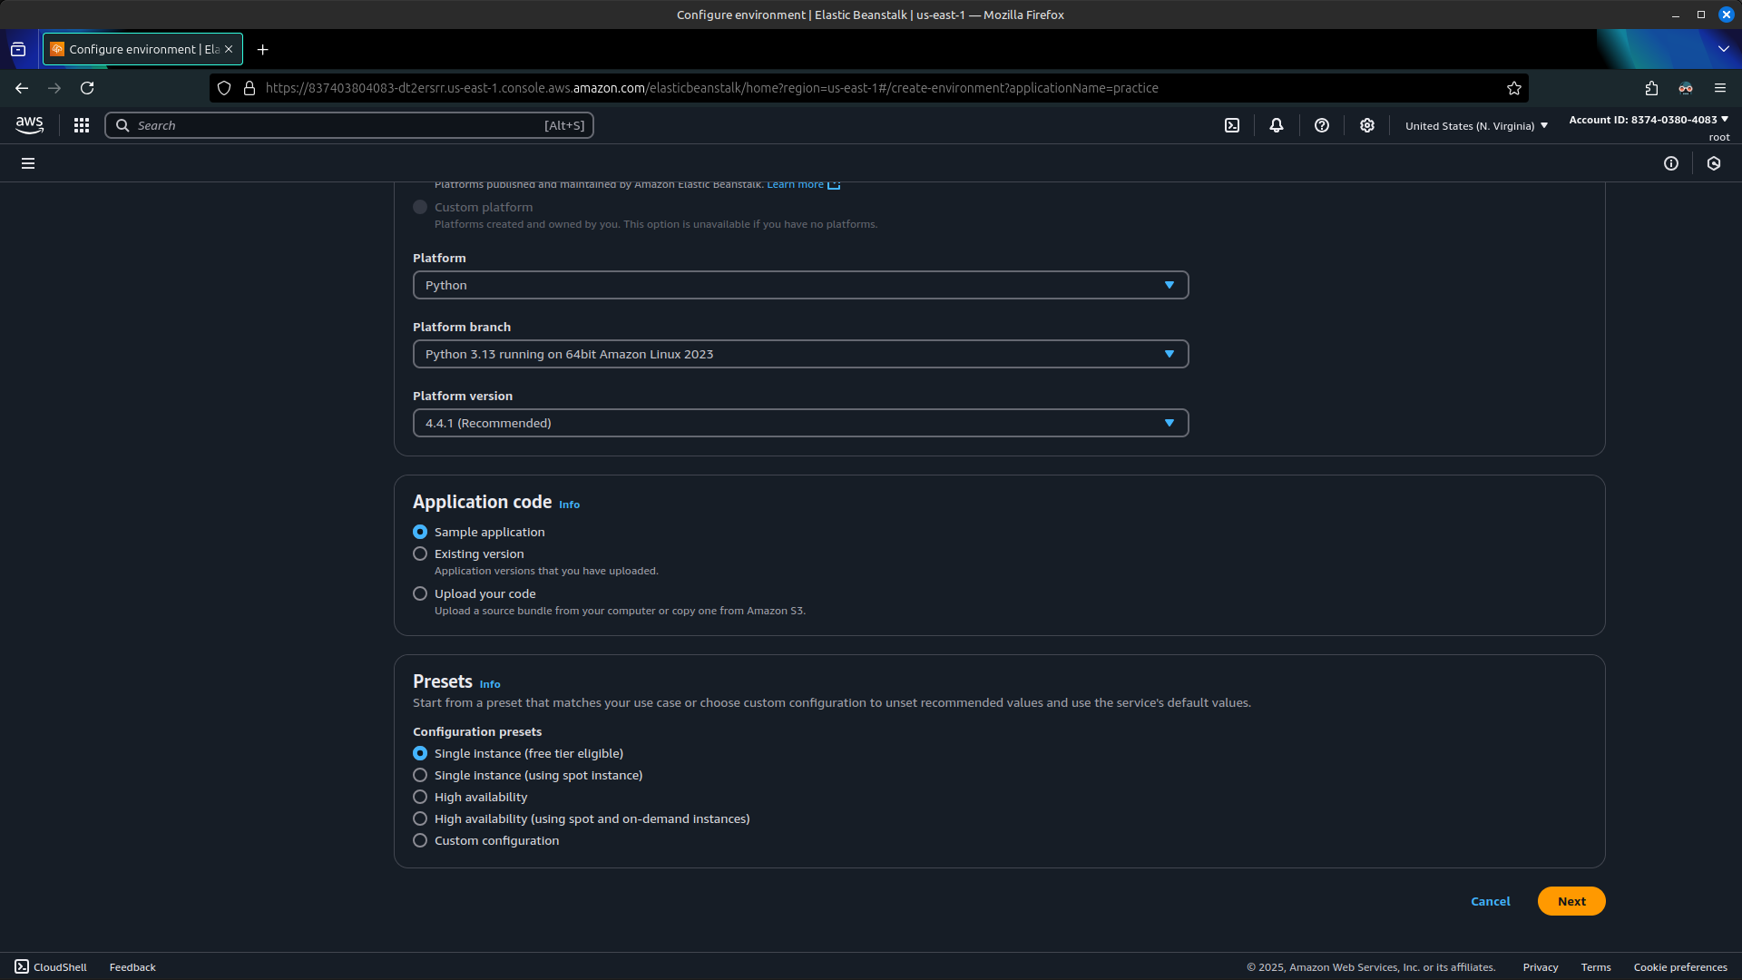

**3.** Go to the next tab, configure the role access and allocate a profile that has administration permission to the platform.

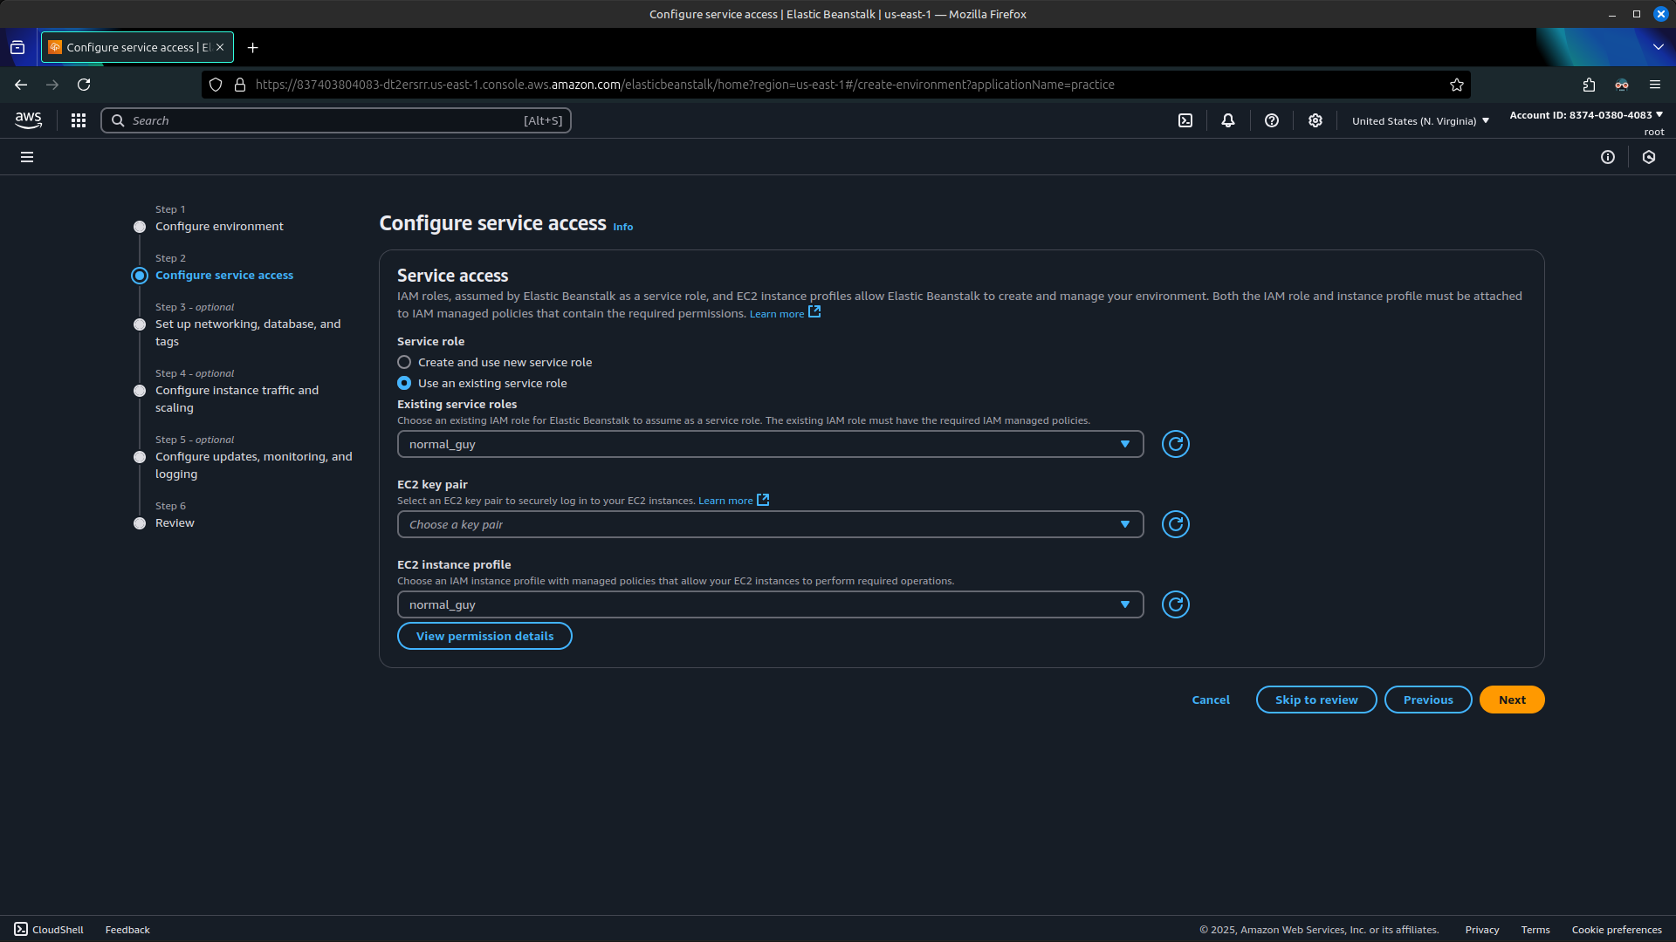

**4.** Select skip to review and confirm the app creation after validating all configured details.

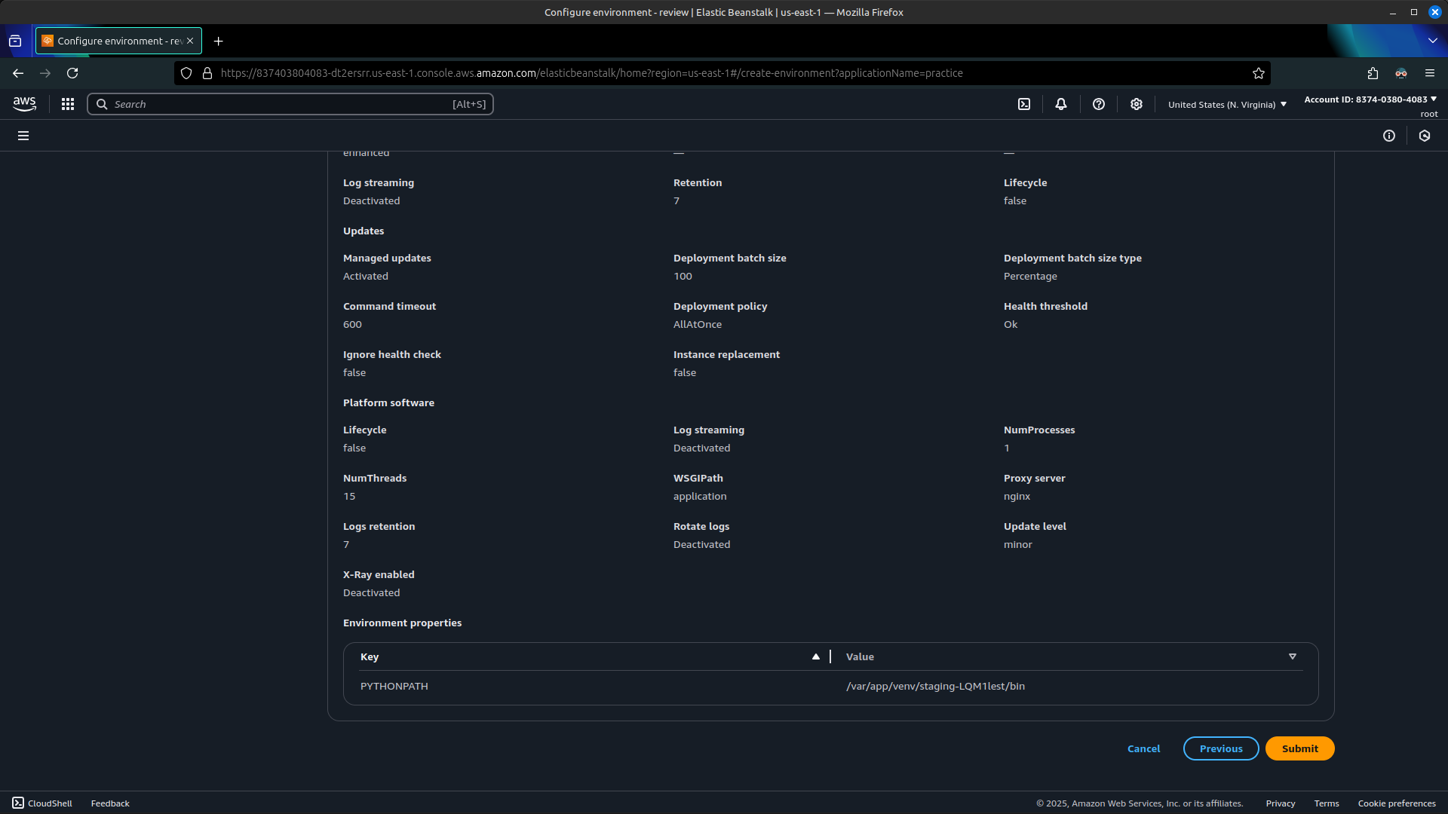

**5.** Wait for the app to be scaffolded and deployed to the EB platform.

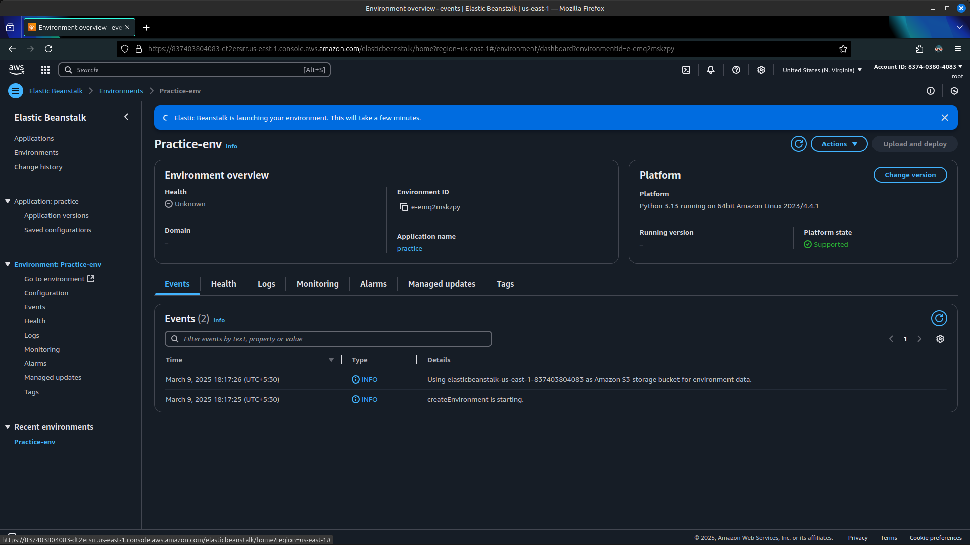

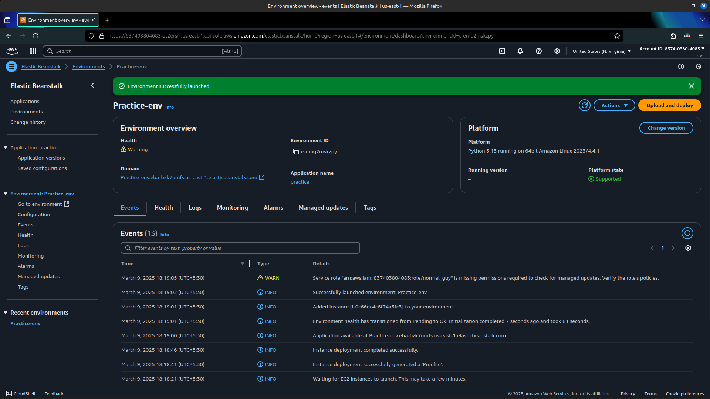  
  
**6.** After the deploy is successfully, acquire the domain address from the environment overview tab.  
  
  
  
  
**7.** Go to the copied domain to view the deployed app, tweak the configurations to update the app on realtime and re-deploy for major code changes.

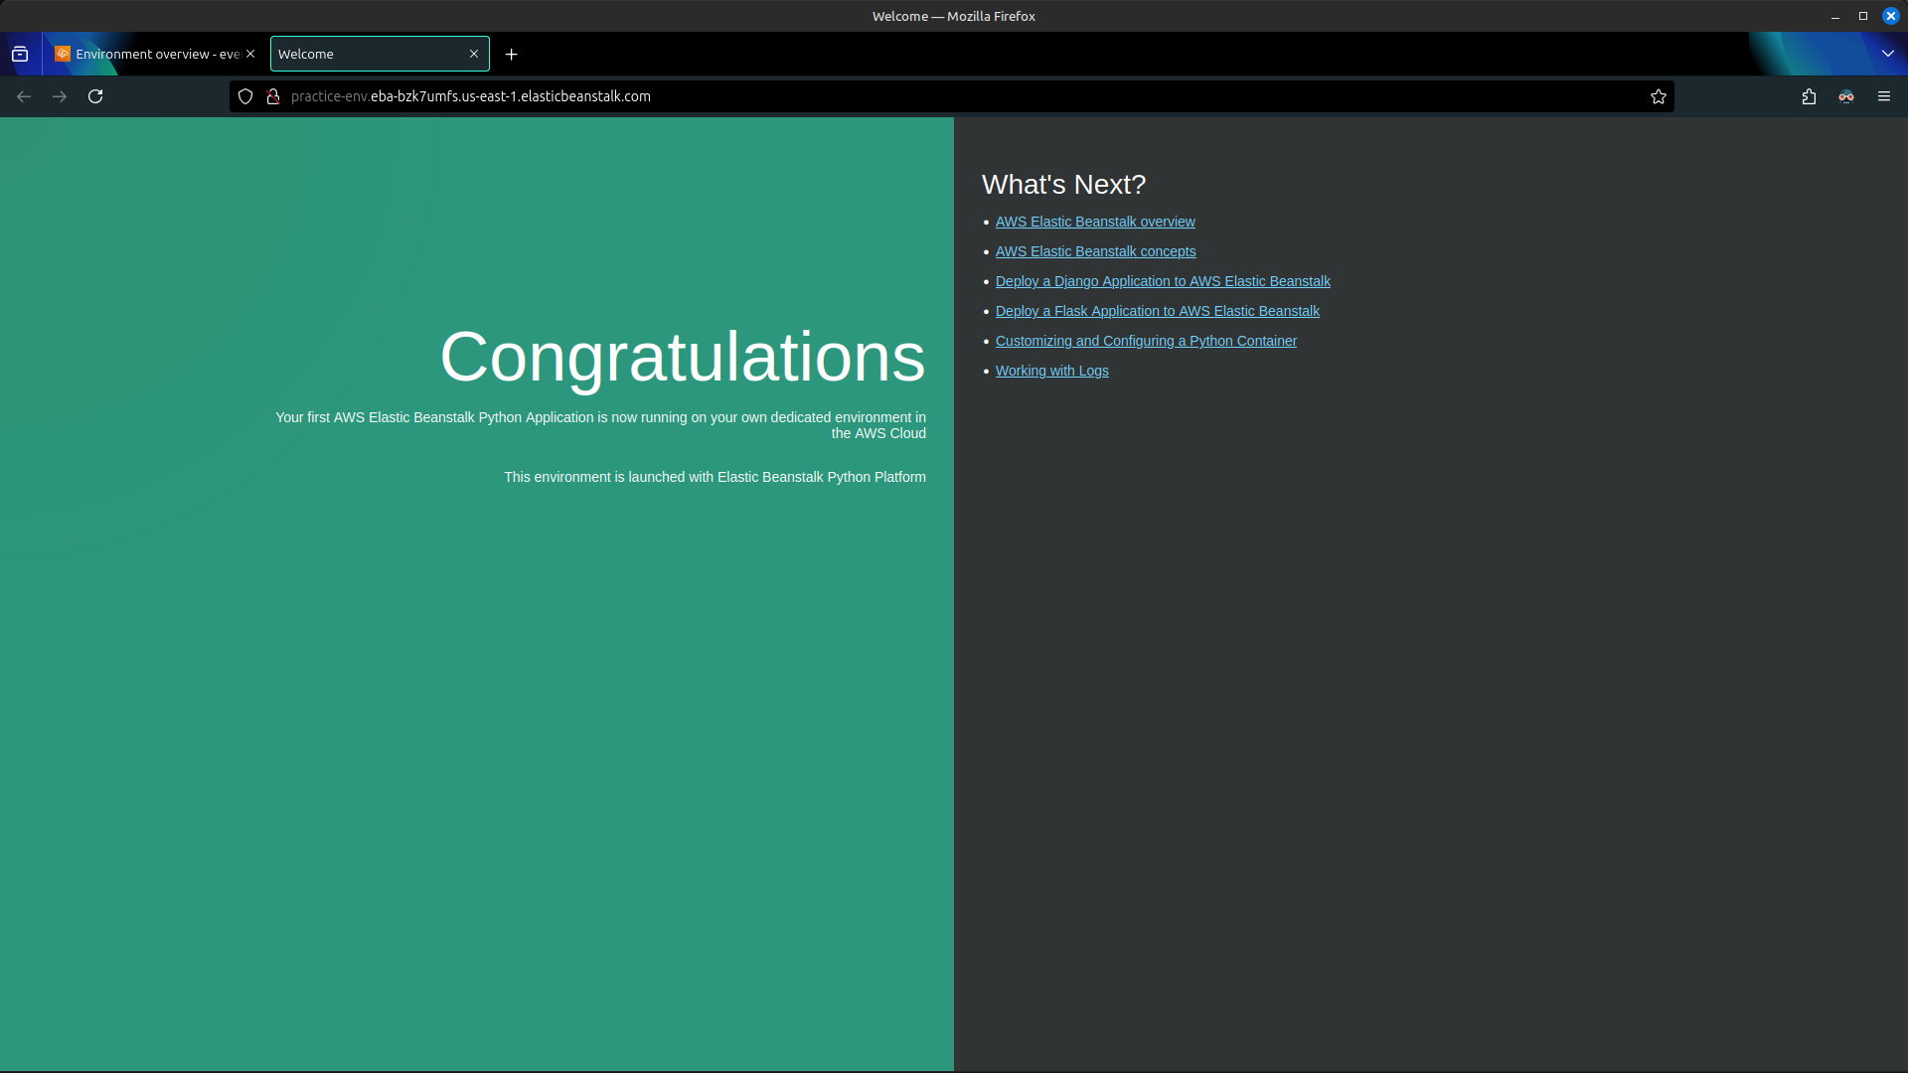  
  
  
  
  
  
  
  
  
  
  
  
  
  
  
  
  
  
  
  
  
  
  
  
  
 **Result:**

Thus the concept of PaaS is leart and a simple web application is deployed on the Amazon Elastic Beanstalk.