**Bidding System**

1. GET [/api/auctions?status=RUNNING](http://localhost:8080/api/auctions?status=RUNNING)

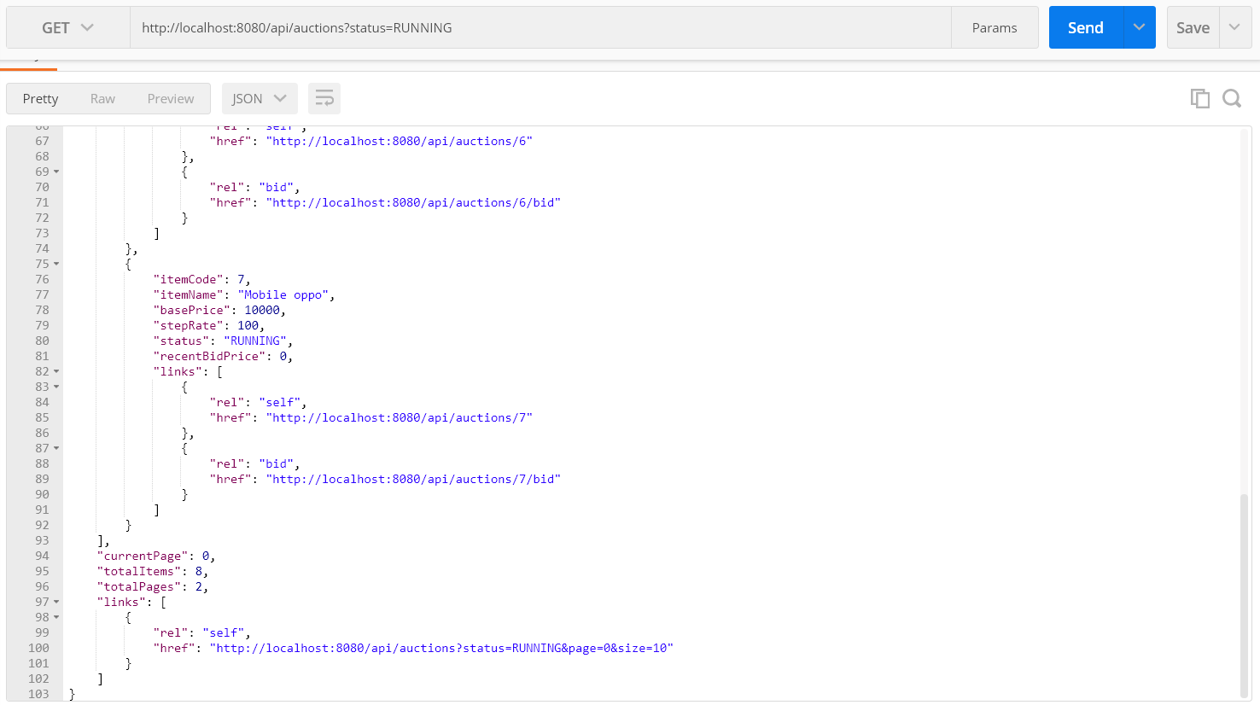

1. GET [/api/auctions/5](http://localhost:8080/api/auctions/5)

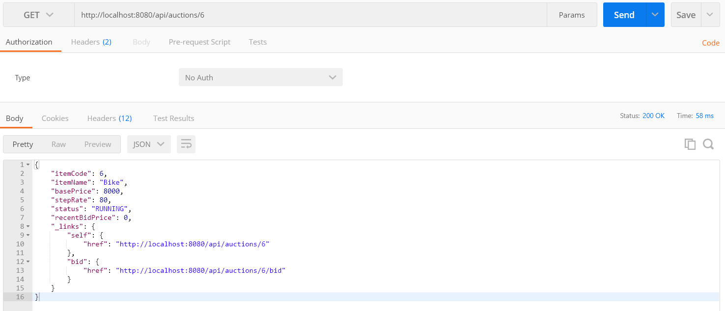

1. `POST http://localhost:8080/api/auth/signup`

Payload Info

`Content-Type: application/json`

`{

"username": "DivakarK",

"password": "cars24-bidding-system",

"email": "c@c.com"

}`

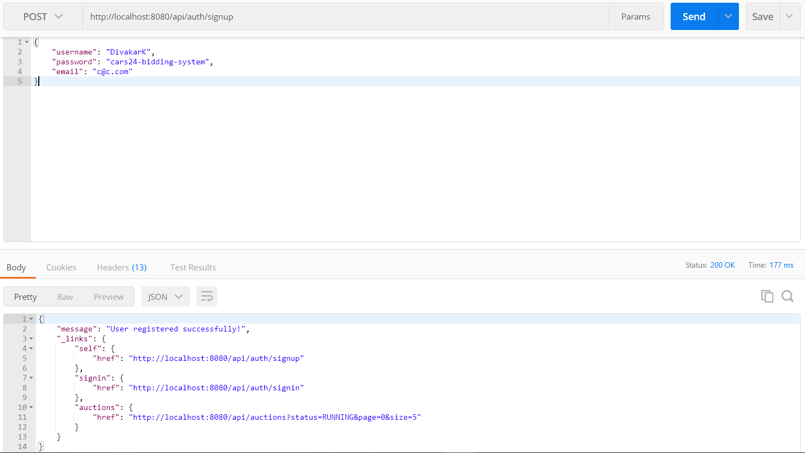

1. Signin

`POST http://localhost:8080/api/auth/signin`

Payload Info

`Content-Type: application/json`

`{

"username": "DivakarK",

"password": "cars24-bidding-system"

}`

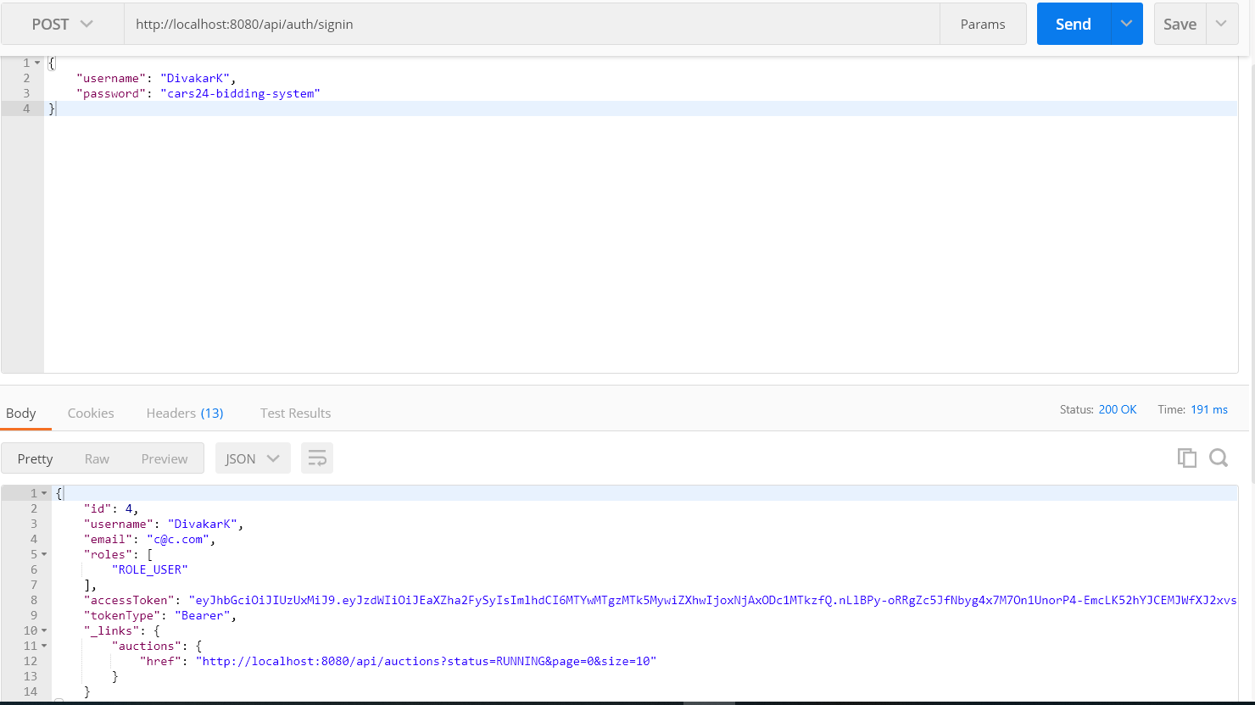

1. Use `Autherization` key for bidding as below.

`POST http://localhost:8080/api/auctions/6/bid`

Payload Info

`Content-Type: application/json`

`Authorization: Bearer <authrization_key_obtained_on_successfull_login>`

`{

"bidAmount": 10000

}`

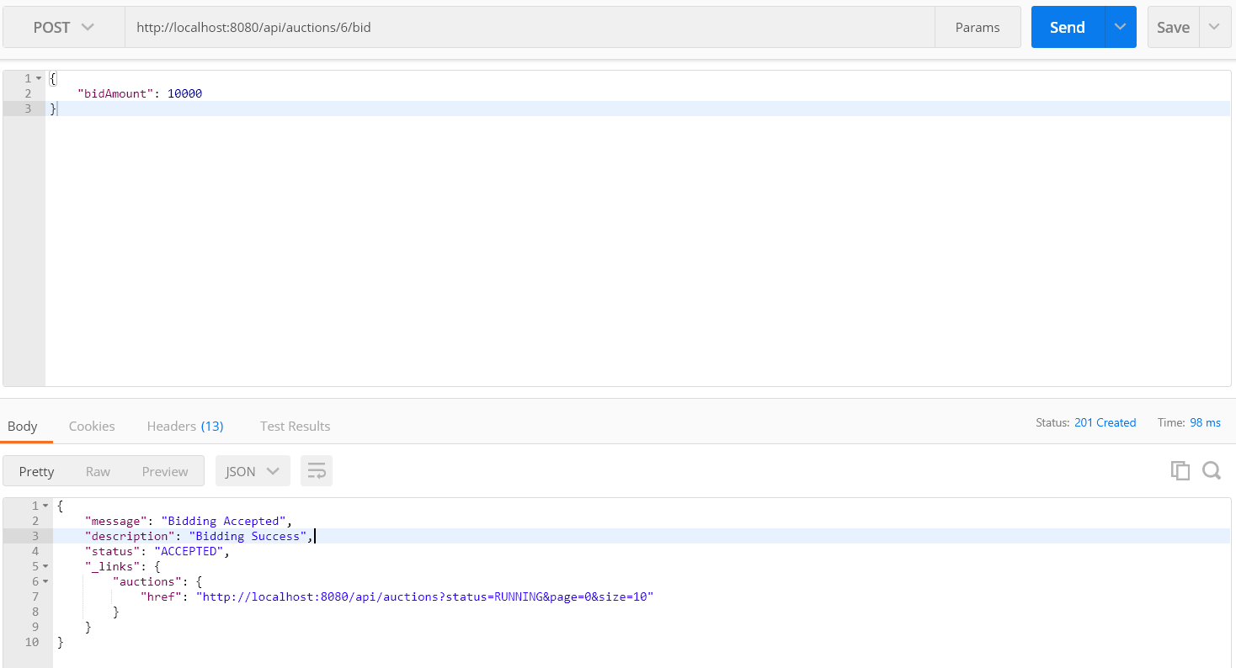

1. Bidding Rejected Example – Status 406

`POST http://localhost:8080/api/auctions/2/bid`

Payload Info

`Content-Type: application/json`

`Authorization: Bearer <authrization_key_obtained_on_successfull_login>`

`{

"bidAmount": 10000

}`

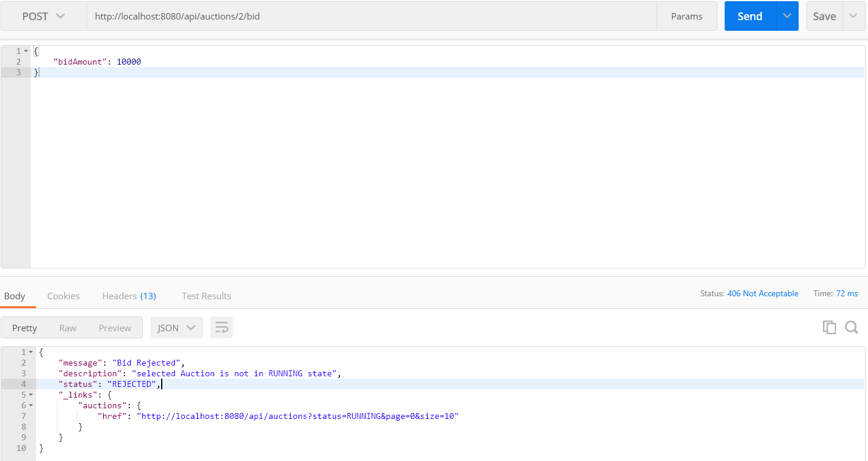

1. Bidding Rejected Example – Status 406 - User will get proper message why its rejected. (another example)

`POST http://localhost:8080/api/auctions/6/bid`

Payload Info

`Content-Type: application/json`

`Authorization: Bearer <authrization_key_obtained_on_successfull_login>`

`{

"bidAmount": 10000

}`

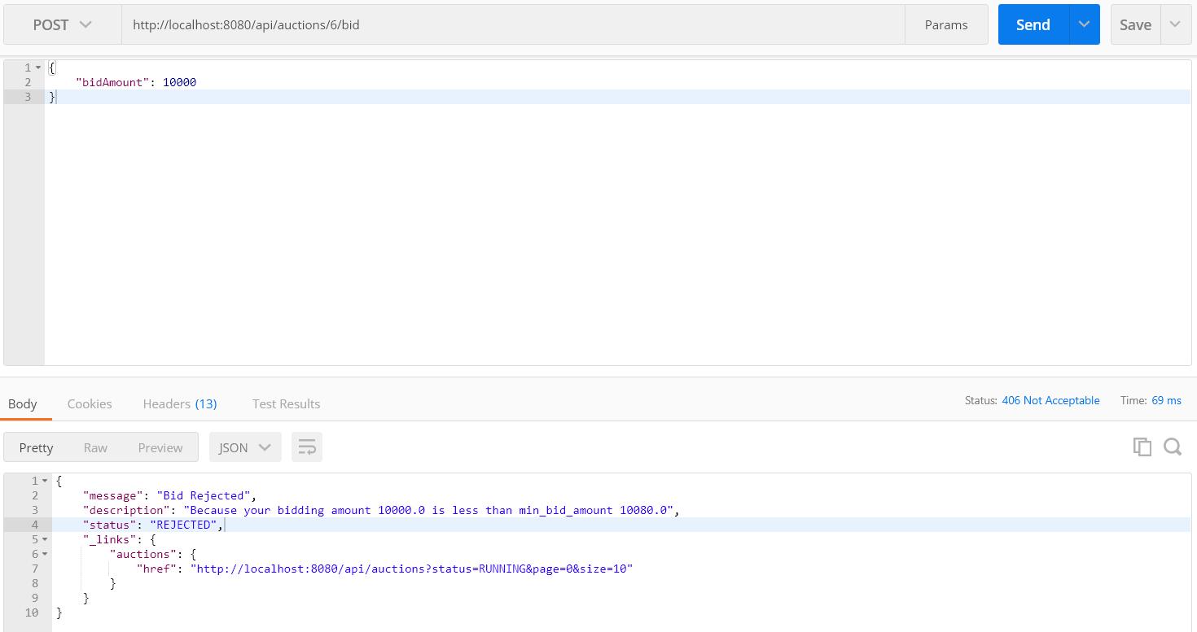

1. Bidding Rejected – Status 404 – Auction not found (another example)

`POST http://localhost:8080/api/auctions/6/bid`

Payload Info

`Content-Type: application/json`

`Authorization: Bearer <authrization_key_obtained_on_successfull_login>`

`{

"bidAmount": 10000

}`

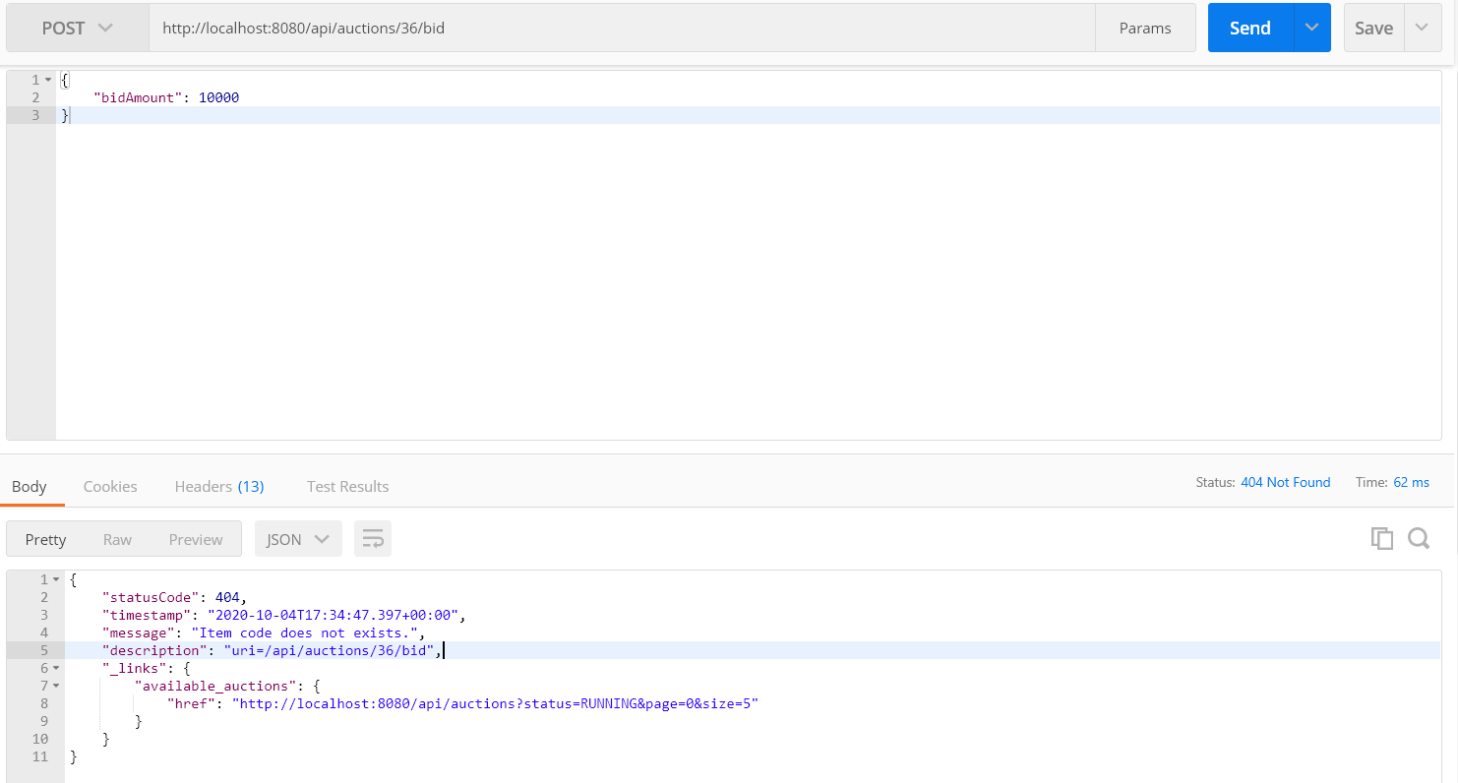

**Bonus**

1. User with `admin` role can Add & Update Auctions

If you signup with the following payload you will be Admin

Signup

`POST /api/auth/signup`

Payload Info

`Content-Type: application/json`

`{

"username": "DivakarKummara",

"password": "cars24-bidding-system",

"email": "c@y.com",

"role": ["admin"]

}`

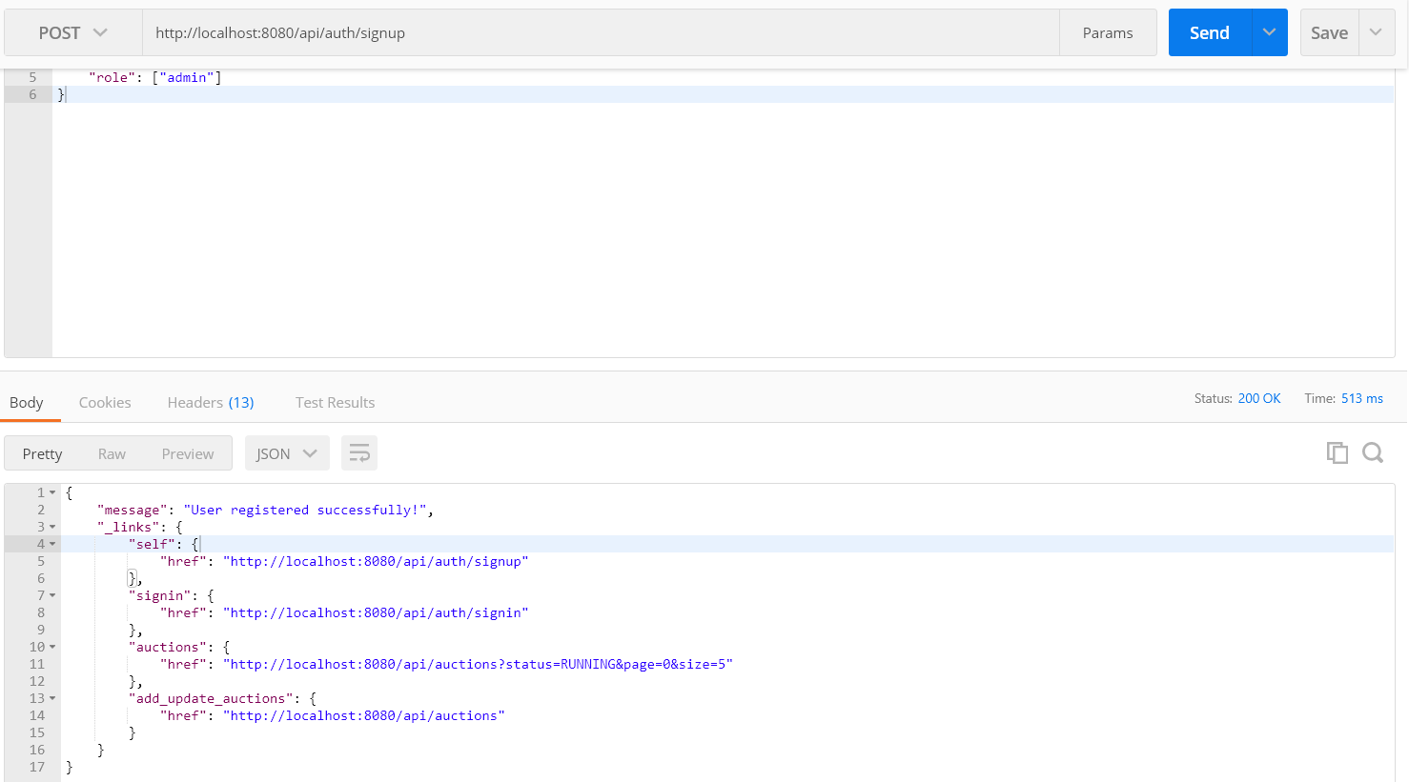

Since the user’s role is Admin, he has the right to add/Update Auctions. **Same is shown in _links**

1. Create Auction

`POST /api/auctions`

`Content-Type: application/json`

`Authorization: Bearer <authrization_key_obtained_on_admin_successfull_login>`

`{

"itemName": "Boat",

"basePrice": 40000,

"stepRate": 10,

"status": "YET_TO_START"

}`

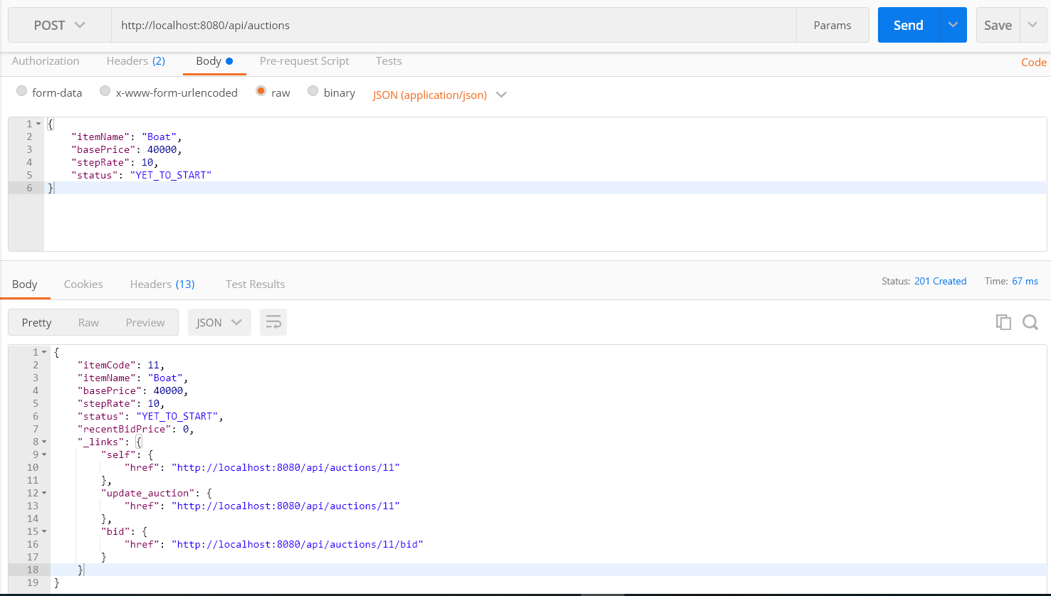

1. Update Auction

`PUT /api/auctions/{itemCode}`

`Content-Type: application/json`

`Authorization: Bearer <authrization_key_obtained_on_admin_successfull_login>`

`{

"status": "RUNNING"

}`

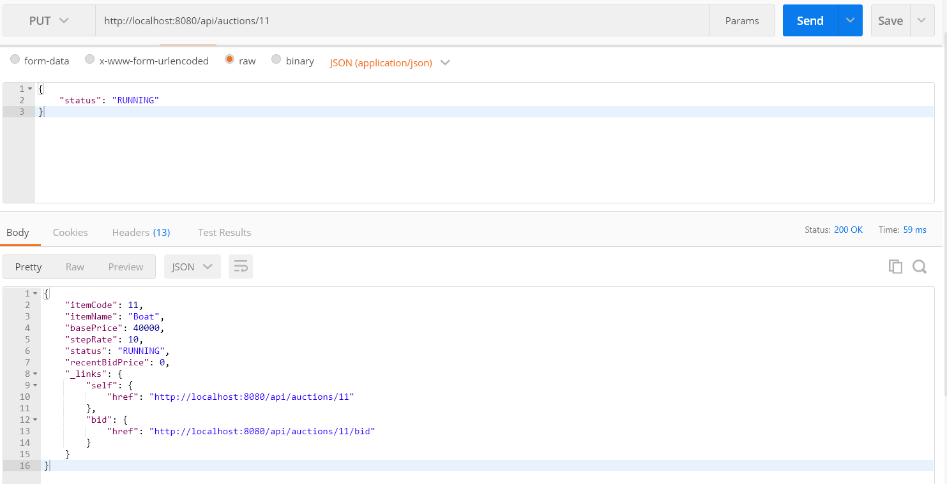

Bidding-system> mvn clean install

