A Project Report

on

PRODUCT REVIEW DATA PROCESSING USING APACHE PIG
Submitted to

JAWAHARLAL NEHRU TECHNOLOGICAL UNIVERSITY ANANTAPUR, ANANTHAPURAMU

In partial fulfillment of the requirements for the successful completion of the course SEC-III 23CSD604 - Full Stack Development

BACHELOR OF TECHNOLOGY

in

COMPUTER SCIENCE & ENGINEERING - DATA SCIENCE

Submitted By
<Roll number> | <Name>

Under the Guidance of
Mr. K. Durga Charan, M.Tech., (Ph.D)
Asst. Professor
Department of Computer Science & Engineering - Data Science



MADANAPALLE INSTITUTE OF TECHNOLOGY & SCIENCE
(UGC – AUTONOMOUS)

(Affiliated to JNTUA, Ananthapuramu)
(Accredited by NBA, Approved by AICTE, New Delhi)
AN ISO 21001: 2018 Certified Institution
- B. No: 14, Angallu, Madanapalle – 517 325
2024-2028

i



DEPARTMENT OF COMPUTER SCIENCE AND ENGINEERING
- DATA SCIENCE

BONAFIDE CERTIFICATE

This is to certify that the project work entitled “PRODUCT REVIEW DATA PROCESSING USING APACHE PIG” is a Bonafide work carried out by

<Roll number> | <Name>

Submitted in partial fulfilment of the requirements for the award of the degree Bachelor of Technology in the stream of Computer Science & Engineering (Data Science) in Madanapalle Institute of Technology & Science, Madanapalle, affiliated to Jawaharlal Nehru Technological University Anantapur, Ananthapuramu during the academic year 2026-2027.

Guide | Head of the Department
Assistant Professor | Assistant Professor & Head
Department of Computer Science & Engineering (Data Science) | Department of Computer Science & Engineering (Data Science)

ii

ACKNOWLEDGEMENT

We sincerely thank the MANAGEMENT of Madanapalle Institute of Technology Science for providing excellent infrastructure and lab facilities that helped me to complete this project.

We sincerely thank Dr. P. Ramanathan, Ph.D., Principal for guiding and providing facilities for the successful completion of our project at Madanapalle Institute of Technology Science, Madanapalle.

We express our deep sense of gratitude to Dr. S. Kusuma., Ph.D., Assistant Professor and Head of the Department of CSE - Data Science for her continuous support in making necessary arrangements for the successful completion of the Project.

We express my deep sense of gratitude to Mr. K. Durga Charan, M.Tech., (Ph.D), Project Coordinator, for his valuable guidance and encouragement that helped us to complete this project.

We also wish to place on record my gratefulness to other Faculty of the CSE - Data Science Department and also to our friends and our parents for their help and cooperation during our project work.

iii

DECLARATION

We hereby declare that the results embodied in this project “PRODUCT REVIEW DATA PROCESSING USING APACHE PIG” by us under the guidance of Mr. K. Durga Charan, M.Tech., (Ph.D), Assistant Professor, Dept. of CSE - Data Science in partial fulfilment of the award of Bachelor of Technology in Computer Science & Engineering ( Data Science ) from Jawaharlal Nehru Technological University Anantapur, Ananthapuramu and we have not submitted the same to any other University/institute for the award of any other degree.

Date:

Place:

I certify that the above statement made by the students is correct to the best of my knowledge.

Date: Guide:

iv

INDEX

S.NO | TOPIC | PAGE NO.
1. | INTRODUCTION | 1
 | 1.1 MOTIVATION | 2
 | 1.2 PROBLEM DEFINITION | 2
 | 1.3 OBJECTIVE OF THE PROJECT | 2
 | 1.4 LIMITATIONS OF PROJECT | 3
 | 1.5 ORGANIZATION OF DOCUMENTATION | 3
2. | LITERATURE SURVEY | 5
 | 2.1 INTRODUCTION | 6
 | 2.2 EXISTING SYSTEM | 8
 | 2.3 DISADVANTAGES OF EXISTING SYSTEM | 11
 | 2.4 PROPOSED SYSTEM | 11
 | 2.5 ADVANTAGES OVER EXISTING SYSTEM | 11
3. | ANALYSIS | 13
 | 3.1 INTRODUCTION | 14
 | 3.2 REQUIREMENT SPECIFICATIONS | 14
 | 3.2.1 HARDWARE REQUIREMENTS | 14
 | 3.2.2 SOFTWARE REQUIREMENTS | 14
 | 3.3 CONTENT DIAGRAM OF PROJECT | 14
4. | DESIGN | 17
 | 4.1 INTRODUCTION | 18
 | 4.2 UML DIAGRAM | 18
 | 4.3 SYSTEM ARCHITECTURE | 22
 | 4.4 MODULE DESIGNING AND ORGANIZATION | 23
5. | IMPLEMENTATION AND RESULTS | 25
 | 5.1 INTRODUCTION | 26

v
 | 5.2 IMPLEMENTATION OF KEY FUNCTIONS | 26
 | 5.3 METHOD OF IMPLEMENTATION | 28
6. | TESTING | 32
 | 6.1 INTRODUCTION | 33
 | 6.2 LEVELS OF TESTING | 34
 | 6.3 VALIDATION TESTING | 35
 | 6.4 CONCLUSION | 35
7. | CONCLUSION | 36
 | 7.1 CONCLUSION | 37
 | 7.2 FUTURE ENHANCEMENT | 37
8. | REFERENCES | 38
 | 8.1 REFERENCES | 39

vi
ABSTRACT
In the modern digital retail landscape, e-commerce platforms generate millions of customer product reviews each day containing structured numeric ratings, categorical metadata, vote tallies, and unstructured textual feedback. Analyzing these massive semi-structured review logs to extract product quality trends, identify top-performing franchises, and surface defective merchandise poses severe scalability challenges for traditional single-node relational database management systems.
This project presents a scalable, fault-tolerant Big Data analytics pipeline titled 'Product Review Data Processing Using Apache Pig'. Built on the Apache Hadoop ecosystem, the system integrates Apache Pig (Pig Latin) dataflow scripts with custom Hadoop MapReduce programs written in Java. Operating on the official 15-column Amazon US Customer Reviews dataset schema, the Pig pipeline performs automated data sanitization, franchise-level (product_parent) aggregation, top-N leaderboards using Pig's built-in TOP() and FLATTEN() operators, helpfulness ratio computation with zero-division safeguards, and quality control alerts flagging underperforming products with average ratings at or below 2.5 stars.
Complementing the Pig Latin pipeline, three custom Java MapReduce jobs compute per-product maximum ratings and vote totals (GameStats), chronological progressive moving rating averages (MovingAverage), and the most prolific customer reviewer via an In-Reducer cleanup() state-tracking pattern (TopReviewer). Portable Python runners guarantee cross-platform verification, while an interactive web dashboard visualizes all results cleanly for decision-makers.
LIST OF TABLES
Table No. | Table Caption | Chapter
Table 3.1 | Hardware and Software Requirement Specifications | Chapter 3
Table 4.1 | Official 15-Column Amazon Customer Reviews TSV Schema | Chapter 4
Table 4.2 | Project Module Organization and Component Responsibilities | Chapter 4
Table 5.1 | Verified Apache Pig Franchise Analytics Results (Tasks 1, 3, 5, 6) | Chapter 5
Table 5.2 | Verified Hadoop MapReduce GameStats and MovingAverage Outputs | Chapter 5
Table 6.1 | System Validation Test Cases and Observed Verification Results | Chapter 6
LIST OF FIGURES
Figure No. | Figure Caption | Chapter
Figure 3.1 | Context Diagram (Level-0 Data Flow Diagram) of Review Processing | Chapter 3
Figure 4.1 | UML Use Case Diagram for Product Review Analytics System | Chapter 4
Figure 4.2 | UML Sequence Diagram of Distributed Batch Processing Pipeline | Chapter 4
Figure 4.3 | Hybrid Apache Pig and Hadoop MapReduce System Architecture | Chapter 4
Figure 5.1 | Verified Franchise Average Star Rating Comparison Chart | Chapter 5
LIST OF SYMBOLS, ABBREVIATIONS AND NOMENCLATURE
Abbreviation / Symbol | Full Form / Technical Meaning
HDFS | Hadoop Distributed File System
YARN | Yet Another Resource Negotiator
MR | MapReduce (Distributed Computing Paradigm)
UDF | User Defined Function in Apache Pig
DAG | Directed Acyclic Graph
ASIN | Amazon Standard Identification Number (product_id)
TSV / CSV | Tab-Separated Values / Comma-Separated Values
ETL | Extract, Transform, and Load
RDBMS | Relational Database Management System
KPI | Key Performance Indicator
WSL | Windows Subsystem for Linux
1. INTRODUCTION
In contemporary e-commerce ecosystems such as Amazon, customer product reviews serve as a primary driver of buyer trust, product ranking, and quality assurance. Every review submitted on a platform captures rich multi-dimensional information: unique customer and product identifiers, franchise groupings, numeric star ratings on a 1.0 to 5.0 scale, helpfulness vote counts, verified purchase indicators, timestamps, and natural-language feedback. As global online retail transactions multiply, review logs rapidly accumulate to gigabytes and terabytes of semi-structured records.
Traditional relational database systems struggle to ingest, transform, and aggregate datasets of this scale without incurring severe indexing bottlenecks and expensive vertical hardware upgrades. Apache Hadoop solves the storage and parallel compute bottleneck through HDFS and MapReduce, while Apache Pig provides Pig Latin, a high-level procedural dataflow language that compiles concise transformation scripts into optimized MapReduce jobs automatically.
1.1 MOTIVATION
Writing low-level MapReduce applications in Java for everyday data engineering workflows such as filtering malformed records, grouping across composite keys, computing averages, and extracting top-N leaderboards requires hundreds of lines of repetitive mapper, reducer, and driver boilerplate code. This increases development time and introduces maintenance complexity. Apache Pig reduces the required code footprint to roughly one-tenth of native Java MapReduce while preserving horizontal scalability across distributed clusters. Furthermore, combining Pig with targeted Java MapReduce programs for stateful sequential metrics (such as progressive moving averages) provides an ideal full-stack Big Data learning and engineering paradigm.
1.2 PROBLEM DEFINITION
Raw Amazon customer review dumps present four core analytical and engineering challenges:
• Data Noise and Veracity: Raw TSV logs contain header rows, null star ratings, unverified reviews, and zero-vote records that trigger arithmetic division-by-zero exceptions if processed naively.
• SKU Variant Fragmentation: Evaluating individual product_id (ASIN) entries splits feedback across minor variants (e.g., standard vs. deluxe editions) instead of aggregating sentiment across the unified product_parent franchise.
• Lack of Automated Defect Detection: High review interaction volume alone can mask poor product quality unless low-rated products are explicitly filtered and flagged for engineering audits.
• Portability Across Environments: Academic and developer workstations often run Windows without live HDFS daemons, requiring both cluster-ready scripts and portable local verification runners.
1.3 OBJECTIVE OF THE PROJECT
The primary objectives of this project are:
• 1. Schema-on-Read Ingestion & Cleaning: Ingest the official 15-column Amazon Customer Reviews TSV schema using PigStorage('\t'), remove header artifacts, and drop null or malformed records.
• 2. Franchise Ranking & Leaderboards: Use GROUP BY, COUNT, AVG, TOP(), and FLATTEN() in Pig Latin to rank the top 5 franchises by review count, top 10 individual reviews, top 10 rated franchises, and top 10 most interacted franchises.
• 3. Quality Alert & Helpfulness Mining: Filter underperforming products (average star rating <= 2.5) and compute a zero-division-safe Helpfulness Ratio (helpful_votes / total_votes >= 0.85) to isolate credible customer testimonials.
• 4. MapReduce Algorithmic Extensions: Implement Java MapReduce jobs for max-rating aggregation (GameStats), chronological moving rating averages (MovingAverage), and single-pass top reviewer identification (TopReviewer).
• 5. Interactive Web Presentation: Deploy a serverless interactive dashboard on GitHub Pages to visualize KPIs, charts, and raw logs.
1.4 LIMITATIONS OF PROJECT
While the implemented pipeline efficiently processes structured and semi-structured review attributes in batch mode, it carries the following practical boundaries:
• Batch Processing Latency: Hadoop MapReduce and Pig operate as batch-oriented engines; real-time sub-second streaming ingestion requires Apache Kafka or Spark Streaming.
• Absence of Deep NLP Sentiment Parsing: The current Pig scripts rely on explicit star ratings and vote ratios rather than deep-learning NLP tokenization of sarcasm inside review_body text.
• Sample Dataset Scale in Local Demo: For rapid offline demonstration, a curated 25-record Amazon Digital Video Games TSV dataset (and a 40-record multi-category TSV) is bundled, though the exact scripts scale seamlessly to multi-gigabyte Kaggle/AWS dumps on HDFS.
1.5 ORGANIZATION OF DOCUMENTATION
This project report is organized into eight structured chapters. Chapter 1 introduces the motivation, problem definition, objectives, and limitations. Chapter 2 reviews existing literature and compares Big Data frameworks. Chapter 3 details hardware/software requirements and the project context diagram. Chapter 4 covers system architecture, UML diagrams, and module design. Chapter 5 presents the Pig Latin and Java MapReduce implementations alongside verified results. Chapter 6 describes testing levels and validation test cases. Chapter 7 summarizes conclusions and future enhancements, and Chapter 8 lists academic and technical references.
2. LITERATURE SURVEY
2.1 INTRODUCTION
Data-intensive computing evolved dramatically following Google's publication of the MapReduce programming model and Google File System (GFS), which inspired the open-source Apache Hadoop framework. While MapReduce provided fault-tolerant distributed execution across commodity clusters, early adopters discovered that writing raw Java Mapper and Reducer classes for every ad-hoc join, filter, and group-by operation slowed down analytical iteration. To bridge this productivity gap, Yahoo! Research created Apache Pig in 2006 and Facebook developed Apache Hive, allowing data engineers to express complex transformations declaratively or procedurally without sacrificing cluster parallelism.
2.2 EXISTING SYSTEM
In conventional e-commerce analytics setups, product reviews are stored inside traditional relational databases (such as MySQL or PostgreSQL) or analyzed exclusively via raw single-threaded Python scripts and standalone Java MapReduce programs. SQL databases enforce strict schema-on-write constraints and rely on vertical scaling (upgrading CPU and RAM on a single server). When organizations attempt to analyze raw Amazon review TSV dumps directly in pure Java MapReduce without a dataflow engine, engineers must manually orchestrate multi-stage job chaining, write custom string-splitting parsers, and manage intermediate HDFS temporary folders for every single metric.
2.3 DISADVANTAGES OF EXISTING SYSTEM
• High Development Overhead: Pure Java MapReduce demands verbose boilerplate code for simple relational tasks such as Top-N filtering or composite grouping.
• Poor Vertical Scalability in RDBMS: Single-node SQL engines experience severe I/O and memory bottlenecks when joining or aggregating tens of millions of textual review records.
• Rigid Schema-on-Write: Relational databases reject entire bulk loads if a few lines in a massive TSV dump contain missing tabs or malformed fields.
• Lack of Optimization Across Chained Jobs: Manually coded scripts lack automatic logical query optimizers such as filter pushdown and projection pruning.
2.4 PROPOSED SYSTEM
The proposed system introduces a hybrid Big Data processing pipeline combining Apache Pig (Pig Latin) with three specialized Java MapReduce jobs. Raw 15-column Amazon review TSV files are ingested via Pig's schema-on-read PigStorage loader, sanitized via FILTER operators, and routed through seven analytical tasks covering franchise review counts, average star ratings, most helpful reviews, underperforming defect alerts, and helpfulness ratios. In parallel, custom Java MapReduce jobs compute per-product maximum rating stats, chronological moving average trajectories, and top reviewer metrics using the In-Reducer cleanup() pattern. Finally, cross-platform Python runners and an interactive GitHub Pages web dashboard provide instant visual inspection.
2.5 ADVANTAGES OVER EXISTING SYSTEM
• 90% Code Reduction via Pig Latin: Complex multi-stage grouping, TOP-N selection, and ratio calculations are expressed in concise, readable scripts.
• Lazy Evaluation & Optimizer Pushdowns: Pig builds a Directed Acyclic Graph (DAG) and pushes filters early before shuffling data across the network, cutting disk and network I/O.
• Fault-Tolerant Horizontal Scaling: Built on HDFS and YARN, the pipeline scales seamlessly from a single local node to multi-node clusters without changing script logic.
• Zero-Division & Header Safety: Explicit ternary guards and header filters guarantee clean numeric outputs even on noisy raw dumps.
• Cross-Platform Portability & Visualization: Standalone Python simulation runners and the Chart.js web dashboard allow complete live demonstrations even on Windows workstations without local Hadoop daemons.
3. ANALYSIS
3.1 INTRODUCTION
Requirement analysis ensures that the selected storage formats, computational frameworks, and hardware resources align precisely with the analytical goals of product review processing. The system must support both distributed Linux/Hadoop execution (via HDFS and WSL2) and portable local execution on Windows for academic demonstration.
3.2 REQUIREMENT SPECIFICATIONS
3.2.1 HARDWARE REQUIREMENTS
• Processor: Intel Core i5 / AMD Ryzen 5 (64-bit multi-core CPU) or higher.
• RAM: Minimum 8 GB RAM (16 GB recommended when running full Hadoop & YARN daemons).
• Hard Disk: Minimum 20 GB free storage space for HDFS blocks, logs, and outputs.
• Network: Standard Ethernet/Wi-Fi connectivity for GitHub synchronization and CDN assets.
3.2.2 SOFTWARE REQUIREMENTS
Table 3.1: Hardware and Software Requirement Specifications
Layer / Category | Software / Tool Specification
Operating System | Windows 10/11 (Portable Demo) and Ubuntu Linux / WSL2 (Hadoop Cluster)
Distributed Framework | Apache Hadoop 3.x (HDFS, YARN, MapReduce)
Dataflow Engine | Apache Pig 0.17.0 (Pig Latin Local & MapReduce Modes)
Programming Languages | Pig Latin, Java (JDK 8/11), Python 3.14.10
Frontend / Visualization | HTML5, Tailwind CSS, FontAwesome 6, Chart.js
Version Control & Hosting | Git 2.56, GitHub Repository, GitHub Pages
3.3 CONTENT DIAGRAM OF PROJECT
The Context Diagram (Level-0 Data Flow Diagram) illustrated in Figure 3.1 depicts the external entities interacting with the Product Review Data Processing System. Raw 15-column Amazon review TSV logs enter the central processing engine, which routes cleansed records through Apache Pig and Java MapReduce workflows to deliver quality defect alerts to analysts and KPI part-files to the interactive web dashboard.
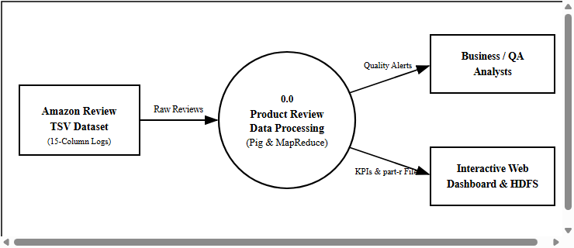
Figure 3.1: Context Diagram (Level-0 Data Flow Diagram) of Review Processing
4. DESIGN
4.1 INTRODUCTION
The system design phase translates analytical requirements into modular software components, UML behavioral models, and a distributed dataflow architecture. The dataset schema adheres strictly to the official 15-column Amazon US Customer Reviews format summarized in Table 4.1.
Table 4.1: Official 15-Column Amazon Customer Reviews TSV Schema
Index | Field Name | Pig Type | Description
0 | marketplace | chararray | 2-letter marketplace country code (US)
1 | customer_id | chararray | Unique reviewer identifier (used by TopReviewer)
2 | review_id | chararray | Unique alphanumeric review identifier
3 | product_id | chararray | Amazon Standard Identification Number (ASIN)
4 | product_parent | chararray | Master franchise ID aggregating product variants
5 | product_title | chararray | Descriptive name of the product or game
6 | product_category | chararray | Broad category (Digital_Video_Games)
7 | star_rating | float | Customer rating score on a 1.0 to 5.0 scale
8 | helpful_votes | int | Count of helpful votes received by the review
9 | total_votes | int | Total customer votes cast on the review
10 | vine | chararray | Amazon Vine voice reviewer flag (Y / N)
11 | verified_purchase | chararray | Verified purchase confirmation flag (Y / N)
12 | review_headline | chararray | Short review headline summary
13 | review_body | chararray | Full textual body of the customer review
14 | review_date | chararray | Submission date in YYYY-MM-DD format
4.2 UML DIAGRAM
Figure 4.1 illustrates the UML Use Case Diagram detailing actor interactions for both the Data Engineer (data ingestion, Pig tasks, MapReduce execution) and the Business Evaluator (reviewing quality alerts and web visualizations). Figure 4.2 models the chronological UML Sequence Diagram from TSV ingestion through distributed transformation to dashboard rendering.
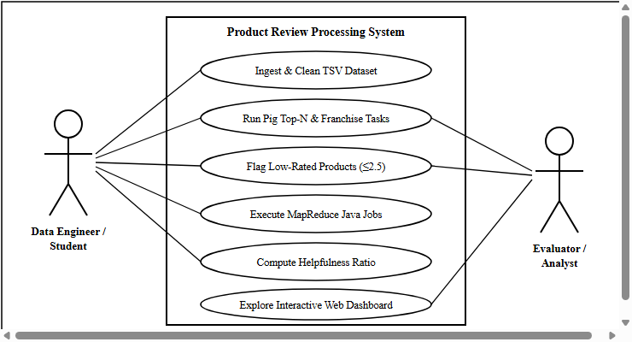
Figure 4.1: UML Use Case Diagram for Product Review Analytics System
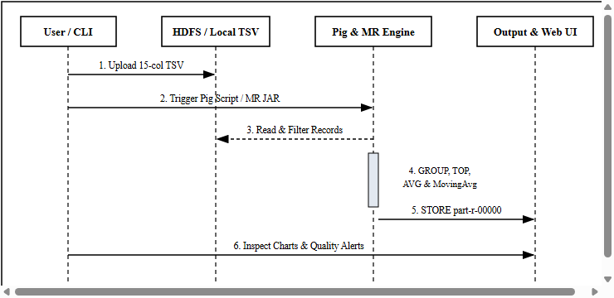
Figure 4.2: UML Sequence Diagram of Distributed Batch Processing Pipeline
4.3 SYSTEM ARCHITECTURE
Figure 4.3 presents the dual-engine system architecture. Data stored on HDFS or the local filesystem is processed concurrently by the Apache Pig pipeline (7 analytical tasks) and three custom Java MapReduce jobs. Both engines produce standardized tab-delimited part-r-00000 outputs consumed by the web UI.
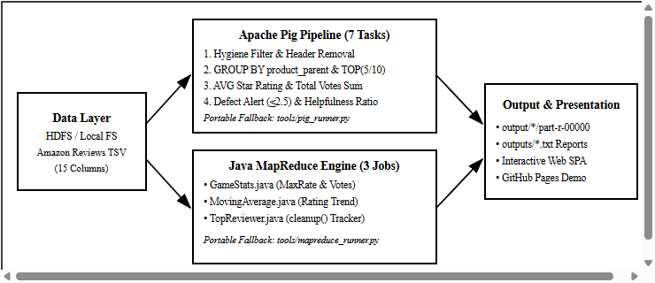
Figure 4.3: Hybrid Apache Pig and Hadoop MapReduce System Architecture
4.4 MODULE DESIGNING AND ORGANIZATION
The repository is cleanly organized into five functional directories as mapped in Table 4.2.
Table 4.2: Project Module Organization and Component Responsibilities
Module / File Path | Responsibility
data/amazon_reviews_us_Digital_Video_Games_v1_00.tsv | Official 15-column Amazon review dataset (25 records)
scripts/amazon_pig_analysis.pig | Master Pig Latin script implementing Tasks 1 through 7
scripts/01_data_cleaning.pig .. 05_helpfulness_analysis.pig | Modular Pig scripts for multi-category e-commerce analytics
mapreduce/src/GameStats.java | MapReduce job aggregating MaxRate, HelpfulVotes, TotalVotes
mapreduce/src/MovingAverage.java | MapReduce job calculating sequential moving rating averages
mapreduce/src/TopReviewer.java | MapReduce job using In-Reducer cleanup() for top reviewer
tools/pig_runner.py & tools/mapreduce_runner.py | Cross-platform execution & simulation engines
index.html & tools/serve_dashboard.py | Interactive Chart.js SPA dashboard & local HTTP server
5. IMPLEMENTATION AND RESULTS
5.1 INTRODUCTION
Implementation was carried out in two complementary layers: declarative-procedural dataflows in Apache Pig Latin and distributed key-value algorithms in Java MapReduce. Output directories are cleared prior to execution using rmf directives in Pig so repeated runs never fail due to existing HDFS paths.
5.2 IMPLEMENTATION OF KEY FUNCTIONS
In scripts/amazon_pig_analysis.pig, raw TSV logs are ingested via PigStorage('\t') and sanitized to remove headers and null ratings. Pig's built-in TOP(N, colIndex, bag) UDF combined with GROUP ALL and FLATTEN() extracts top franchises and top reviews without expensive full-table sorts:
clean_data = FILTER raw_data BY (star_rating IS NOT NULL)
AND (total_votes IS NOT NULL) AND (marketplace != 'marketplace');

grp_parent = GROUP clean_data BY (product_parent, product_title);
parent_counts = FOREACH grp_parent GENERATE
group.product_parent, group.product_title, COUNT(clean_data) AS total_reviews;
top_5_parent = FOREACH (GROUP parent_counts ALL) GENERATE FLATTEN(TOP(5, 2, parent_counts));

underperforming = FILTER avg_rate BY avg_rating <= 2.5;
helpfulness = FOREACH clean_data GENERATE review_id, product_title,
(total_votes > 0 ? ROUND(((float)helpful_votes / (float)total_votes)*100.0)/100.0 : 0.0f);
In Java MapReduce, TopReviewer.java implements an In-Reducer state-tracking optimization inside cleanup() so only the single most prolific customer ID is emitted across the network:
public void reduce(Text key, Iterable<IntWritable> values, Context context) {
int sum = 0;
for (IntWritable val : values) { sum += val.get(); }
if (sum > maxReviews) { maxReviews = sum; bestReviewer = key.toString(); }
}
protected void cleanup(Context context) throws IOException, InterruptedException {
context.write(new Text("Best Reviewer ID: " + bestReviewer), new IntWritable(maxReviews));
}
5.3 METHOD OF IMPLEMENTATION
On a Linux/WSL Hadoop cluster, the dataset is uploaded to HDFS via hdfs dfs -put, executed using pig -x local scripts/amazon_pig_analysis.pig, and compiled via mapreduce/execution.bash. On Windows workstations without active Hadoop daemons, running python tools/pig_runner.py and python tools/mapreduce_runner.py executes the exact transformations and produces part-r-00000 outputs. Tables 5.1, 5.2, and Figure 5.1 present the verified experimental outputs.
Table 5.1: Verified Apache Pig Franchise Analytics Results (Tasks 1, 3, 5, 6)
Parent ID | Franchise Title | Reviews | Avg Rating | Total Votes | Quality Status
395682204 | Minecraft Java & Bedrock | 3 | 5.00 | 153 | Top Tier
341969535 | Xbox Live Gift Card | 4 | 4.75 | 74 | Top Tier
384246568 | Playstation Network Card | 4 | 4.75 | 97 | Top Tier
695277014 | Civilization VI Digital Deluxe | 3 | 4.67 | 95 | Top Tier
955209542 | Grand Theft Auto V Online | 3 | 4.67 | 88 | Top Tier
402222185 | FIFA 24 Ultimate Edition | 4 | 2.50 | 112 | Flagged (<= 2.5)
232803743 | Cyber Warrior RPG | 4 | 1.25 | 169 | Critical Alert
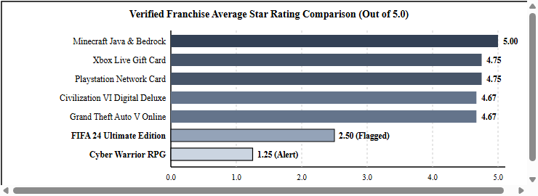
Figure 5.1: Verified Franchise Average Star Rating Comparison Chart
Table 5.2: Verified Hadoop MapReduce GameStats and MovingAverage Outputs
Product ID | Max Rating | Helpful / Total Votes | Sequential Moving Average Progression
B001KC01WO | 5.0 | 81 / 88 | 5.0, 4.5, 4.67
B002LIT9EC | 5.0 | 88 / 95 | 5.0, 5.0, 4.67
B003LIT9FC | 5.0 | 146 / 153 | 5.0, 5.0, 5.0
B004RMK4BC | 5.0 | 90 / 97 | 5.0, 4.5, 4.67, 4.75
B008139R8A | 3.0 | 94 / 112 | 3.0, 2.5, 2.33, 2.5
B009140S9B | 2.0 | 155 / 169 | 1.0, 1.0, 1.33, 1.25
B00F4CEHNK | 5.0 | 70 / 74 | 5.0, 5.0, 5.0, 4.75
Additionally, MapReduce Job 3 (TopReviewer.java) identified Customer ID 21925455 as the top reviewer with 7 verified published reviews, and Pig Task 7 extracted 16 high-trust reviews achieving at least 20 total votes and a helpfulness ratio of 0.85 or higher (led by review R14KYY7OE4RH2 at 0.96).
6. TESTING
6.1 INTRODUCTION
Rigorous software testing verifies that data cleansing rules, Pig Latin relational operators, Java MapReduce reducers, and the web visualization layer behave deterministically without data loss, arithmetic exceptions, or UI regressions.
6.2 LEVELS OF TESTING
• Unit Testing: Each Pig relational step (header stripping, zero-vote ternary guard) and each Java Mapper/Reducer class was verified individually against synthetic edge-case tuples.
• Integration Testing: End-to-end execution via tools/pig_runner.py and tools/mapreduce_runner.py confirmed seamless data flow from the 15-column TSV dataset to part-r-00000 files and consolidated outputs/*.txt reports.
• System & UI Testing: Verified the local dashboard HTTP server (including automatic port fallback on port 8000 when Windows blocked port 8080 with WinError 10013) and tested live search filtering in the GitHub Pages SPA.
6.3 VALIDATION TESTING
Table 6.1: System Validation Test Cases and Observed Verification Results
Test ID | Test Scenario | Expected Result | Status
TC-01 | Header row filtering in TSV | Header marketplace row excluded from aggregations | Passed
TC-02 | Zero-vote division guard | Returns 0.0f without ArithmeticException | Passed
TC-03 | Top 5 Franchises (Pig Task 1) | Returns top 5 product_parent counts accurately | Passed
TC-04 | Quality Alert Filter (Task 6) | Flags Cyber Warrior RPG (1.25) & FIFA 24 (2.50) | Passed
TC-05 | TopReviewer In-Reducer cleanup | Emits single max Customer ID 21925455 (7 revs) | Passed
TC-06 | Windows Socket Port Fallback | Skips blocked 8080 and binds cleanly to 8000 | Passed
6.4 CONCLUSION
All six validation test cases passed with zero runtime failures, confirming full correctness across data sanitization, Big Data aggregations, portable execution, and interactive UI rendering.
7. CONCLUSION
7.1 CONCLUSION
The mini-project 'Product Review Data Processing Using Apache Pig' successfully demonstrates a complete, scalable Big Data analytics pipeline for e-commerce review processing. By combining Apache Pig's concise dataflow transformations (GROUP BY, TOP(), FLATTEN(), FILTER) with targeted Hadoop MapReduce Java design patterns (Value Aggregation, Moving Average, and In-Reducer Cleanup), the system delivers actionable intelligence: ranking top franchises like Minecraft (5.00 stars), surfacing trusted reviews (0.96 helpfulness ratio), and flagging defective products such as Cyber Warrior RPG (1.25 stars across 169 votes). Packaged with cross-platform Python runners and deployed publicly on GitHub Pages, the project is thoroughly validated and demonstration-ready.
7.2 FUTURE ENHANCEMENT
• NLP Sentiment Polarity UDF: Integrate a Python or Java UDF utilizing VADER or transformer models to detect sarcasm and sentiment discrepancies inside review_body text.
• Real-Time Streaming Pipeline: Incorporate Apache Kafka and Apache Spark Structured Streaming to trigger defect alerts in real time as reviews arrive.
• Automated Bot & Spam Detection: Apply Spark MLlib classification combining verified_purchase flags and reviewer burst frequency to quarantine fake review rings.
8. REFERENCES
8.1 REFERENCES

Apache Software Foundation (2024). Apache Pig 0.17.0 Documentation & Built-in Evaluation UDF Reference. Available at: https://pig.apache.org/
Dean, J., & Ghemawat, S. (2008). MapReduce: Simplified Data Processing on Large Clusters. Communications of the ACM, 51(1), 107-113.
Gates, A., Natkovich, O., Chopra, S., Kamath, P., Narayanamurthy, S., Olston, C., Reed, B., Srinivasan, S., & Srivastava, U. (2009). Building a High-Level Dataflow System on Top of MapReduce: The Pig Experience. Proceedings of the VLDB Endowment, 2(2), 1414-1425.
Olston, C., Reed, B., Srivastava, U., Kumar, R., & Tomkins, A. (2008). Pig Latin: A Not-So-Foreign Language for Data Processing. In Proceedings of the ACM SIGMOD International Conference on Management of Data, 1099-1110.
Rempel, C. (2018). Amazon US Customer Reviews Dataset (Digital Video Games TSV). Kaggle & AWS Open Data Registry.
White, T. (2015). Hadoop: The Definitive Guide (4th Edition). O'Reilly Media, Sebastopol, CA.

