Login into the console and choose EC2 from the services under the compute list,
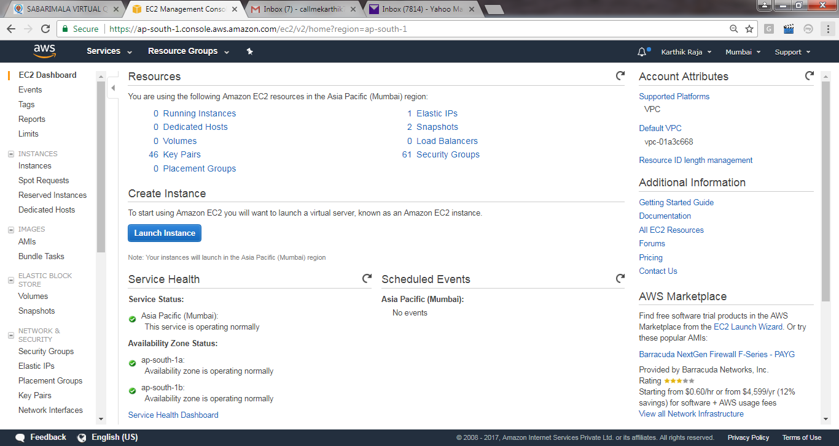
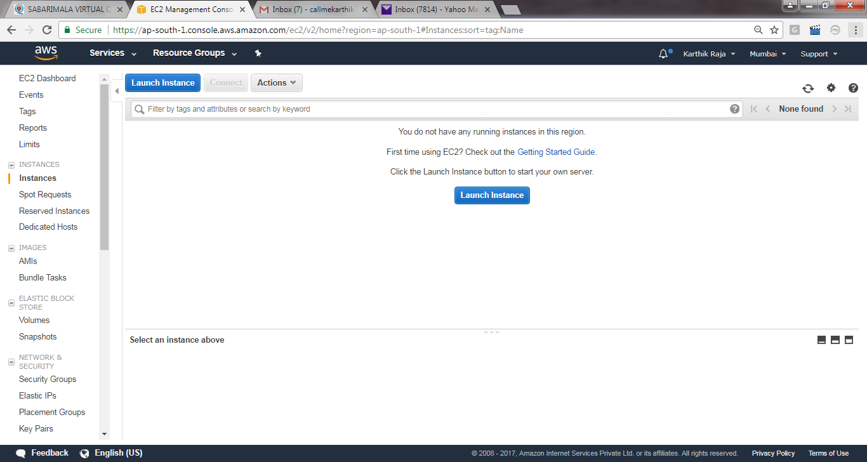
Choose an Amazon Machine Image (AMI)

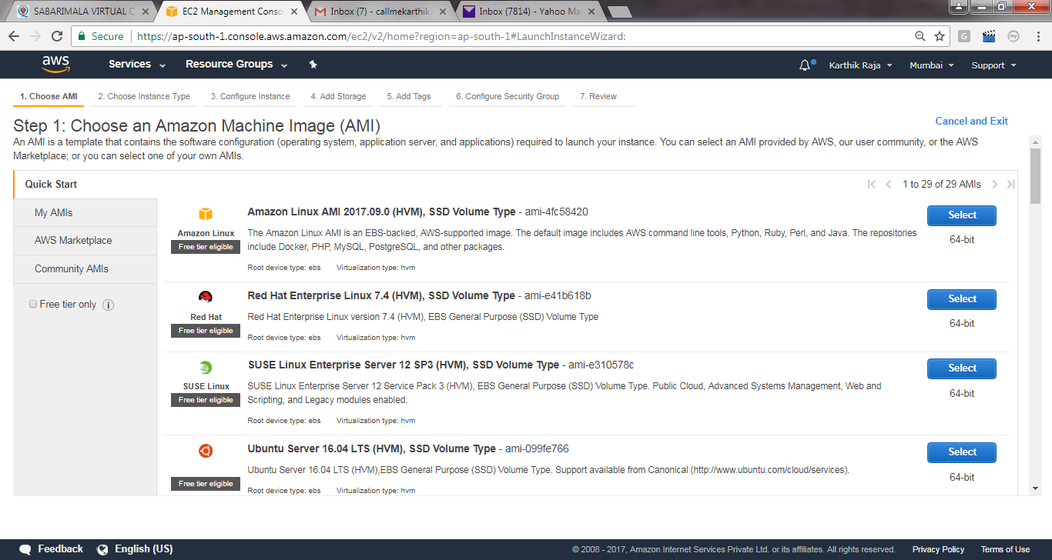

Choose Instance Type
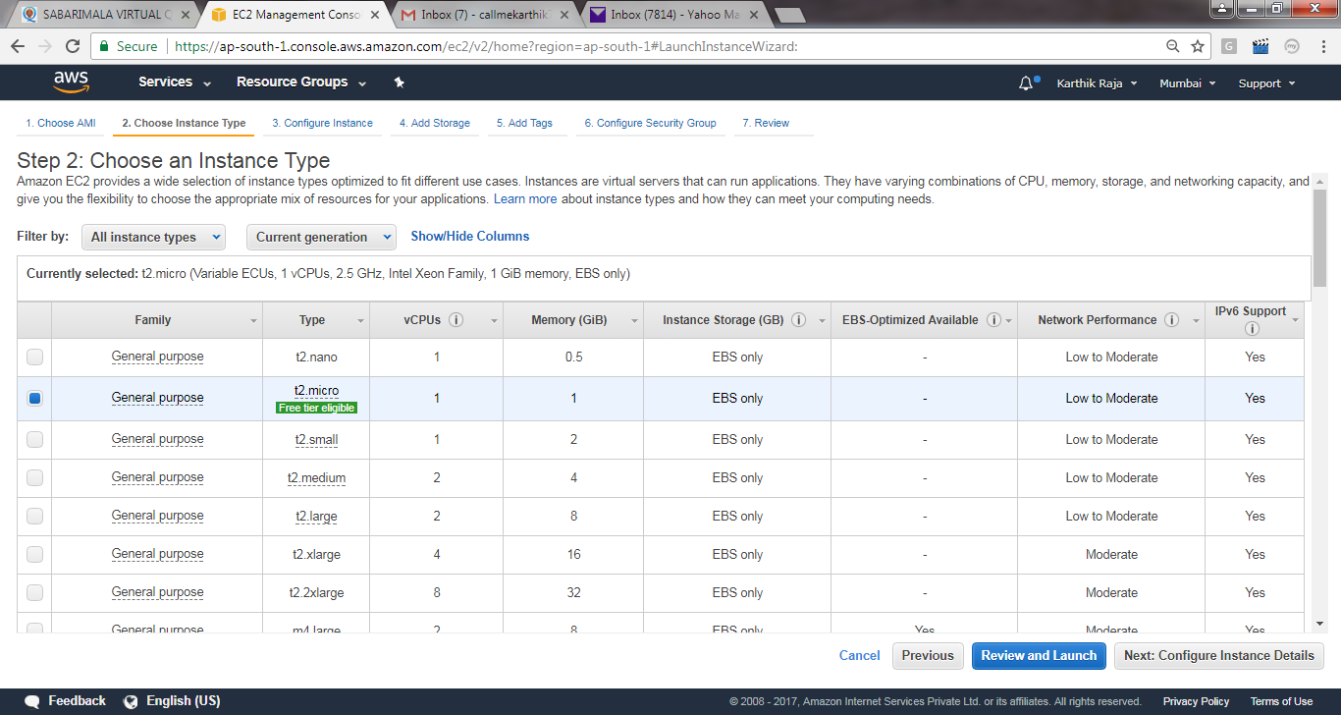
Configure Instance
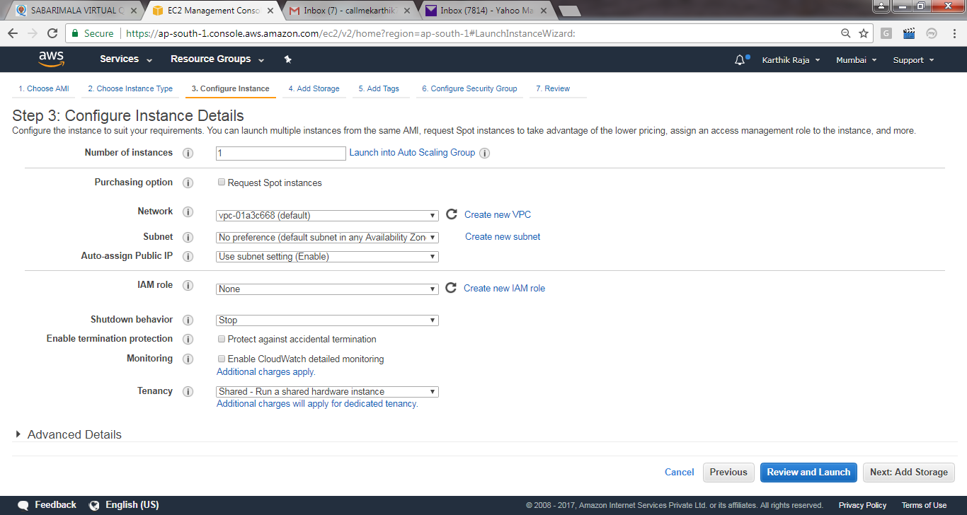
Add Storage
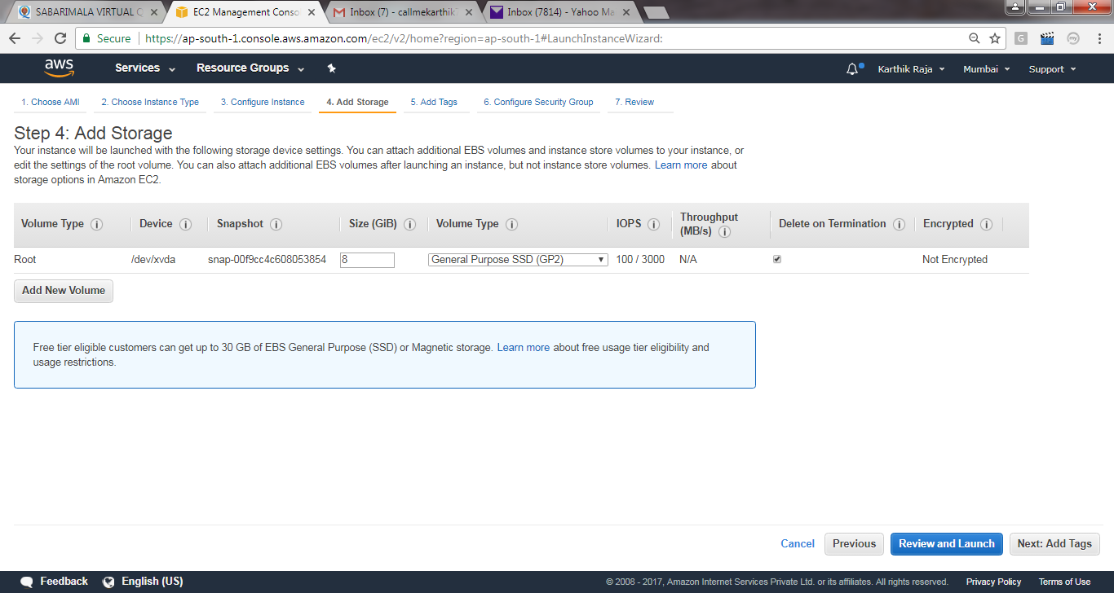
Add tags: Name the EC2 to be created.
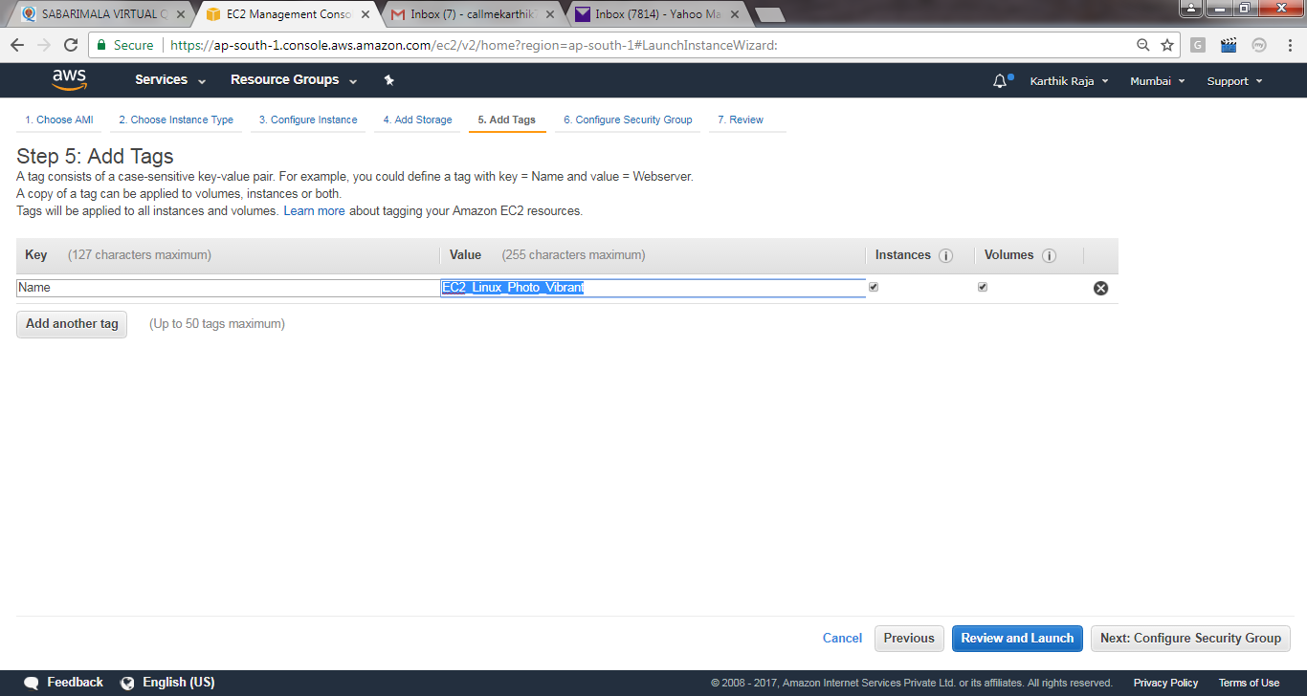
Configure Security Group: Keep as default, just add HTTP/HTTPs for application webservices.
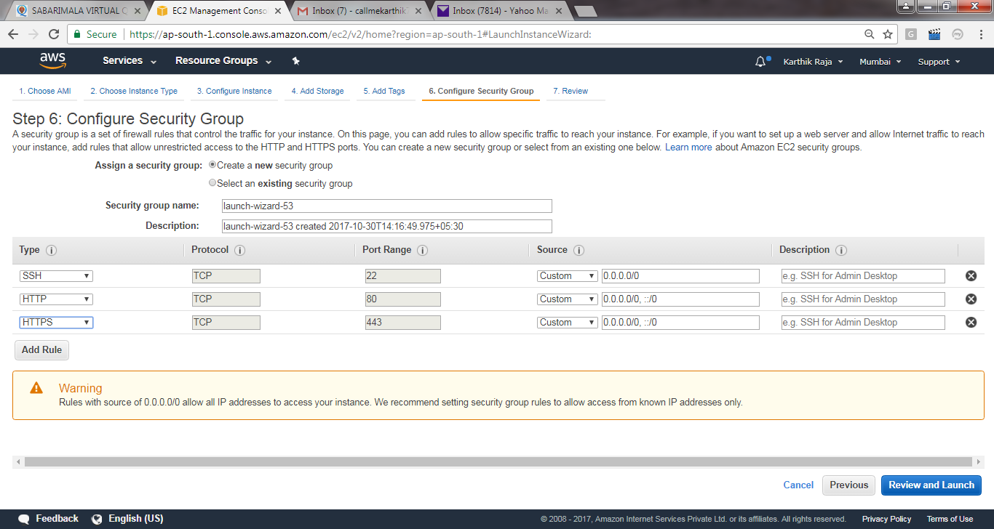
Review it and lauch.
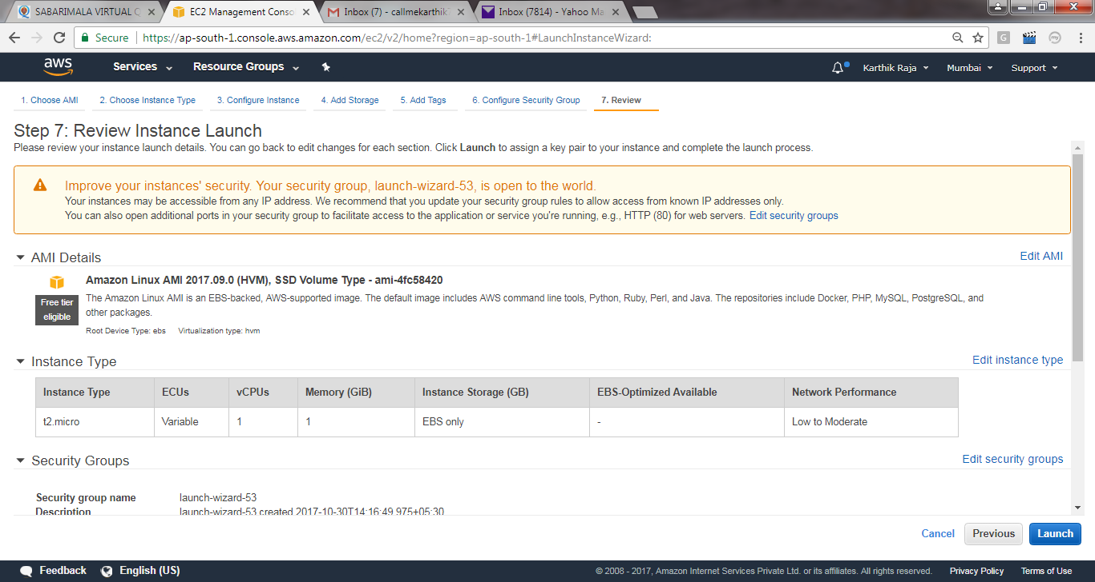
Download the key pair by keeping the same name for the keys as the EC2 name.
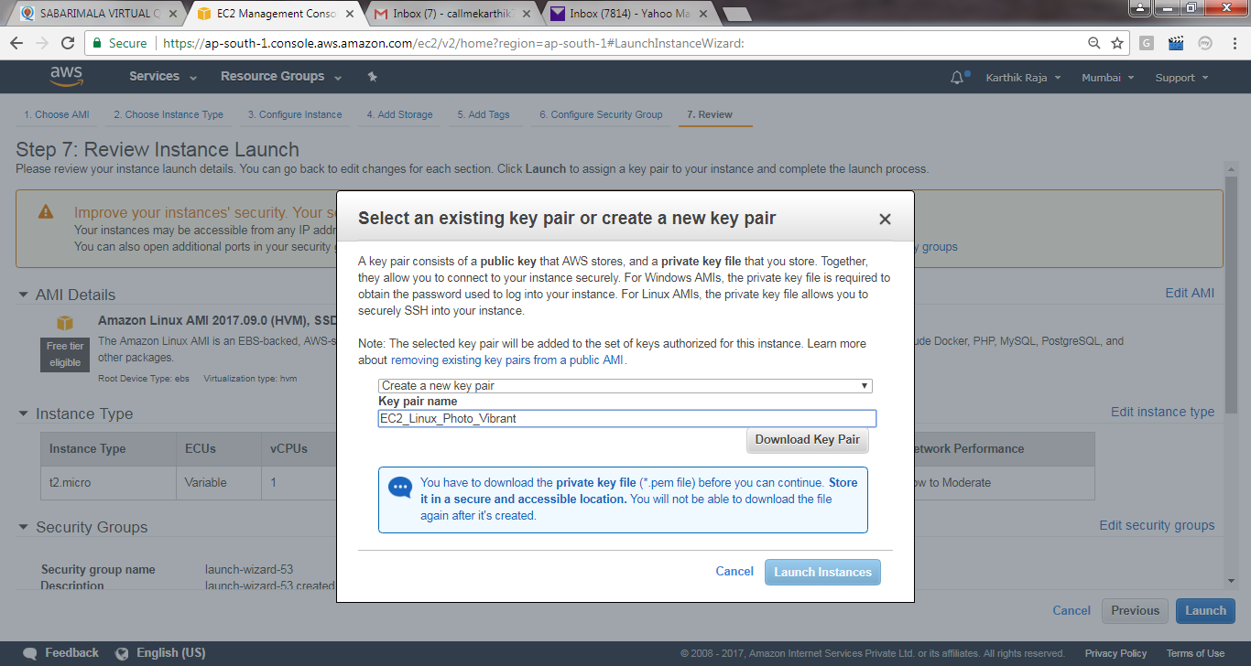
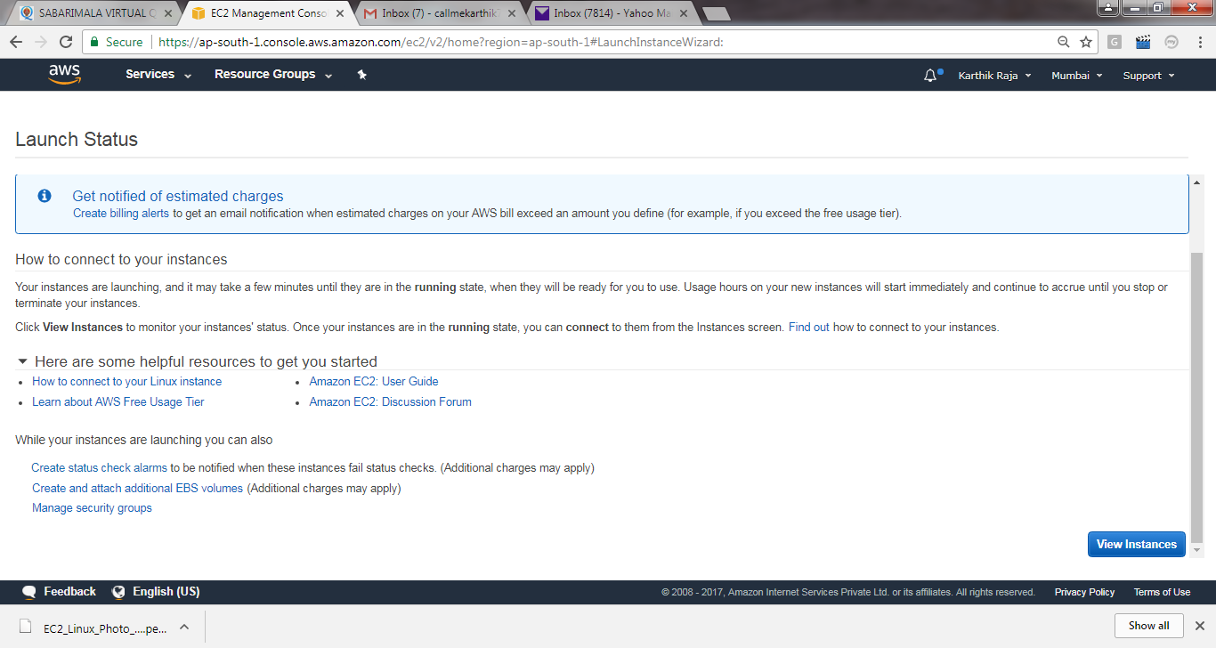
Allow sometime for the instances to launch completely, then pick the IP address, User [ec-user].
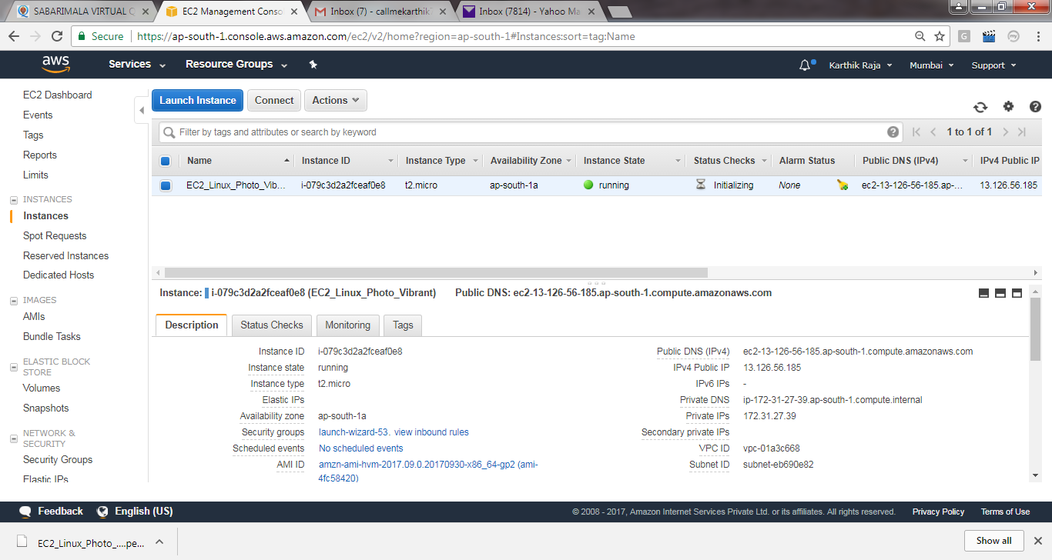

Use the tool – Puttygen to convert the pem file -> .ppk file. Load it and download it as private key.
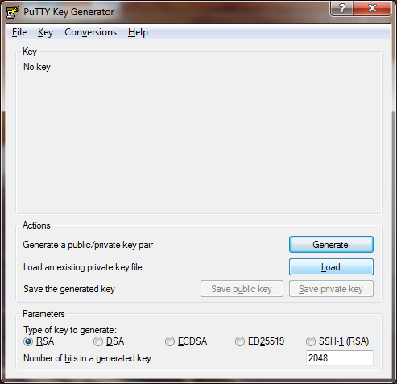

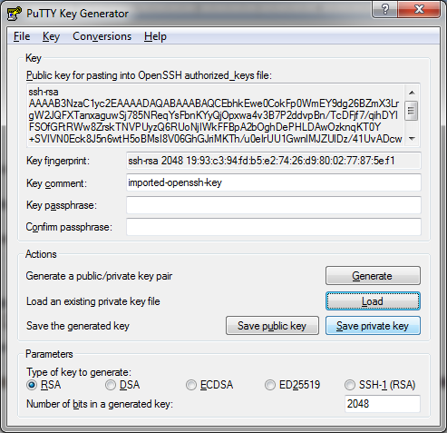

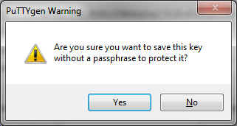
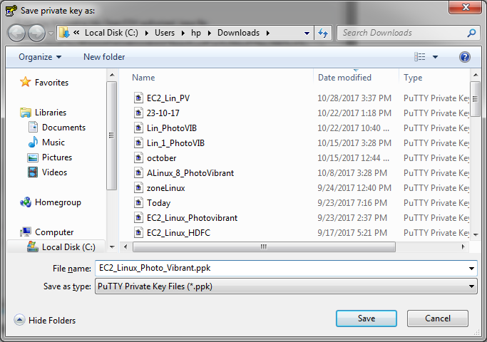
Login into the puuty using the ip address, user and the ppk file. Load the .ppk file as below screen shot under ssl -> auth.
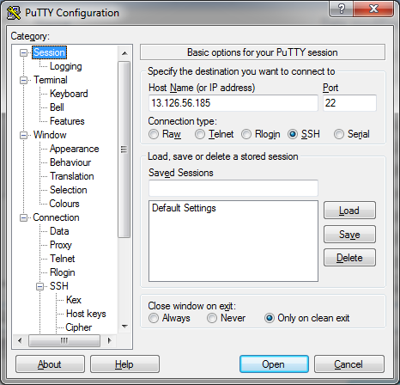
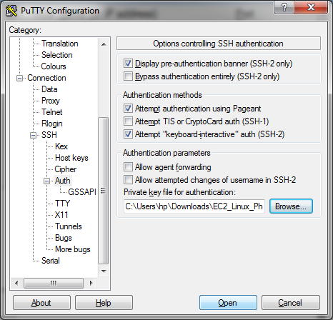
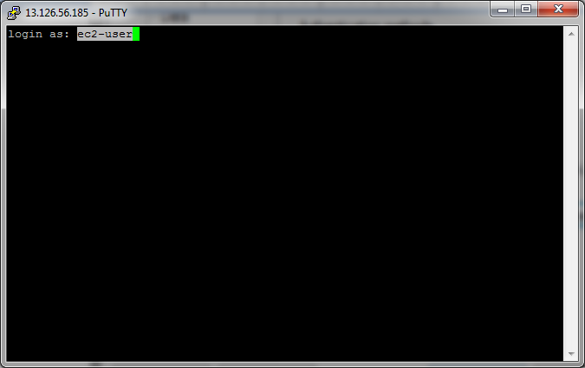
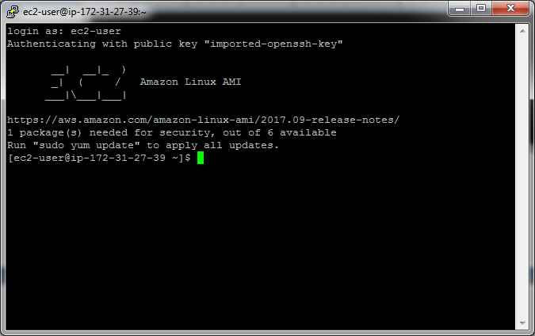

Switch user to root, by using below command.
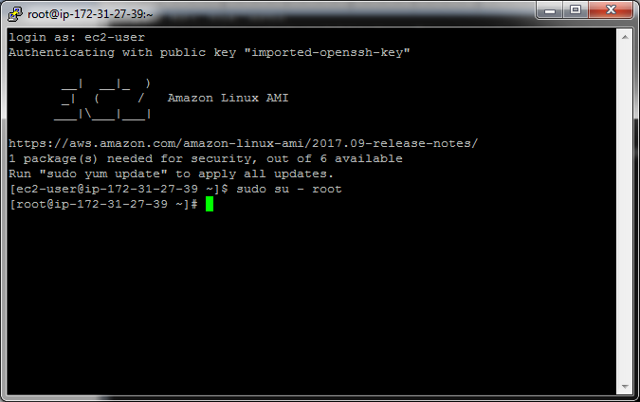
Install apache using the below command.
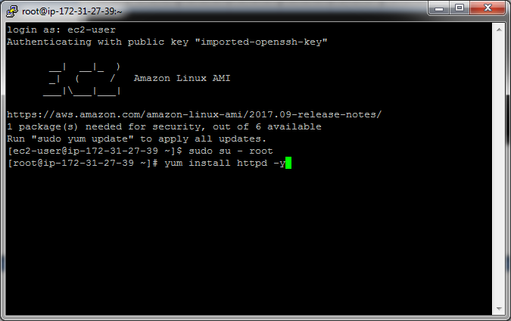
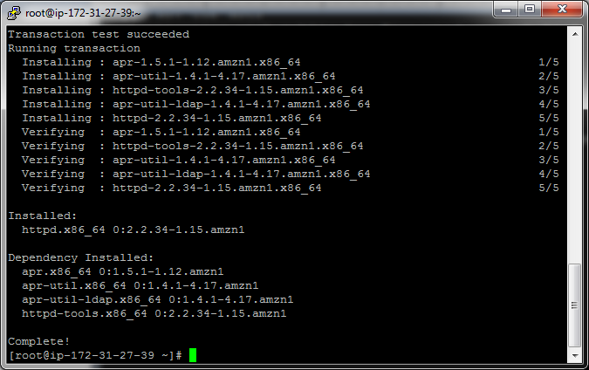
Start the apache using the below command and test the same using the DNS url of the EC2 in the browser.
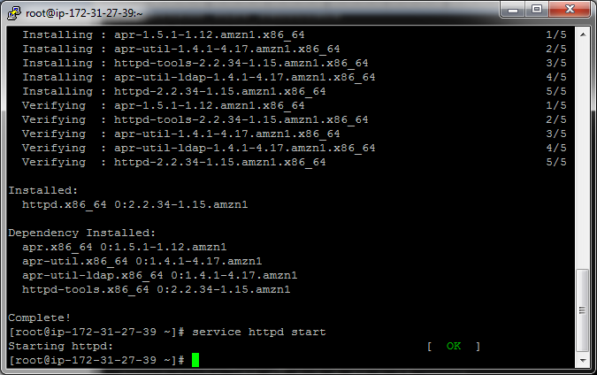
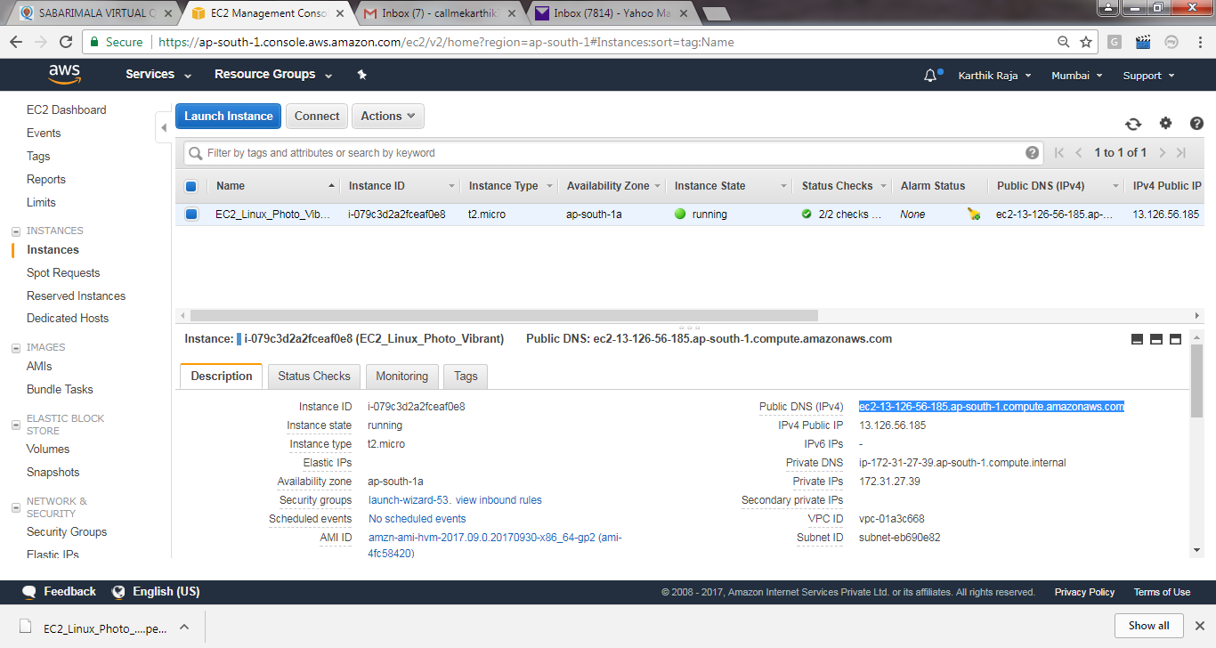
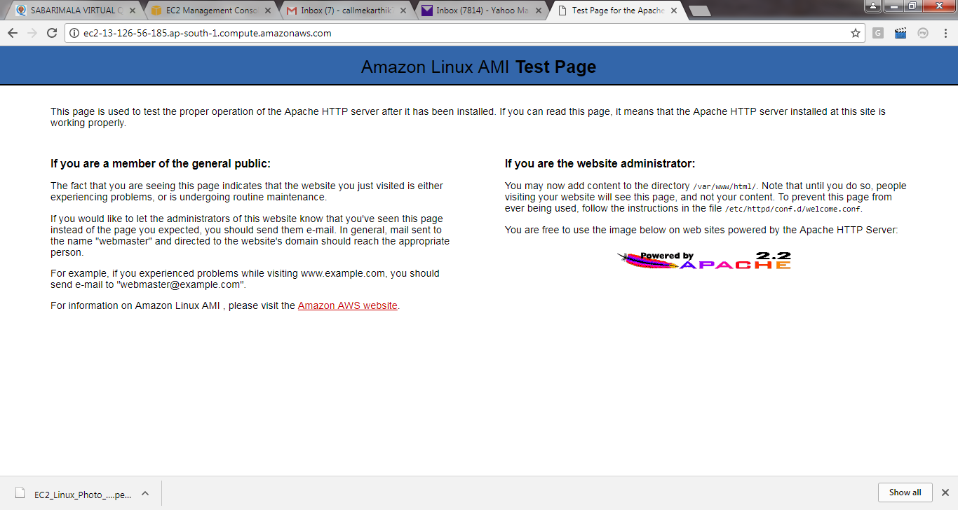
Use WINSCP tool to transfer the application files to the server, before that download the file as per the screen shot.
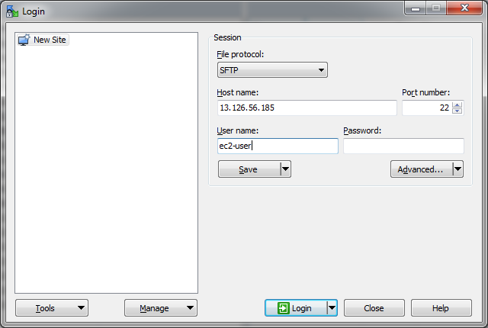
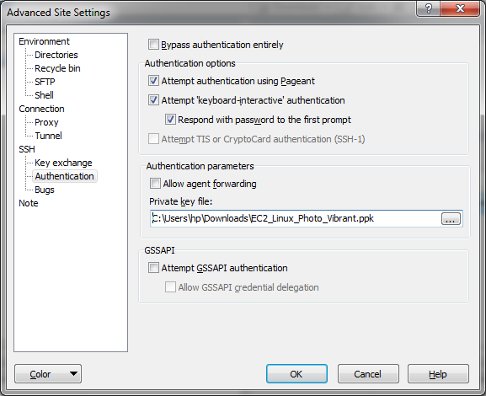
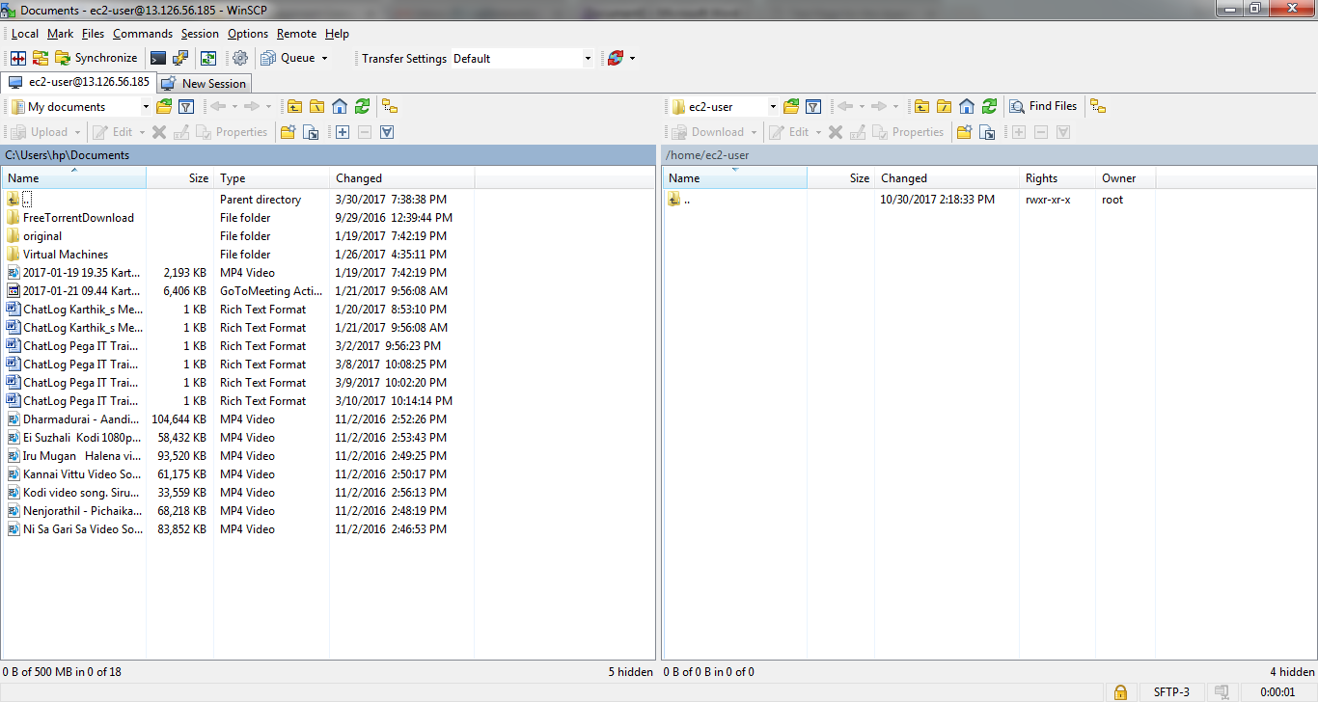
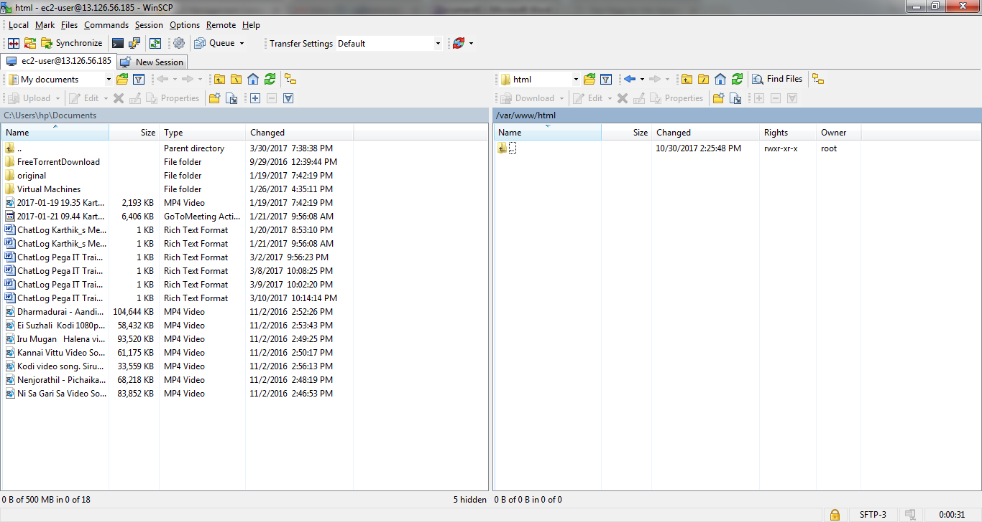
Give full permission to the folder before placing the application files.
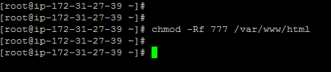
Since we don’t have developer to provide the application file, download it from google under free web template downloads,
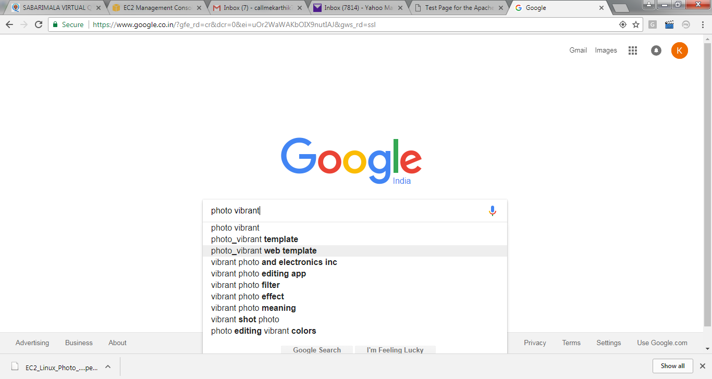
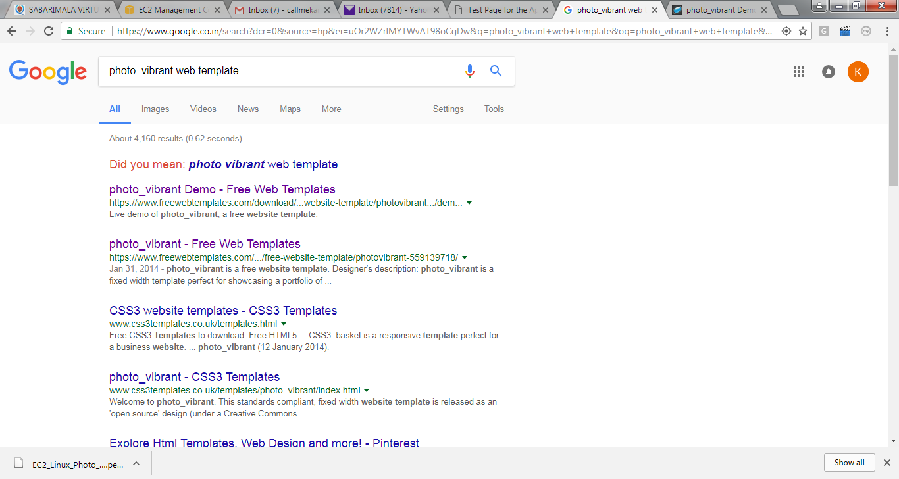
Download the Zip file from TOP CORNER of the Photo vibrant page
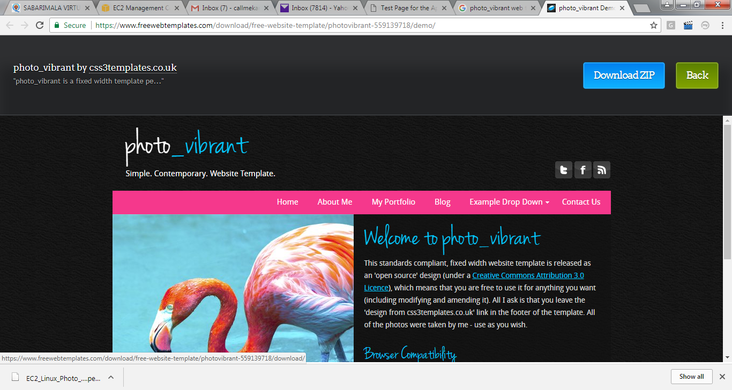
Extract the downloaded zip file & covert it into folder and keep it in the desktop.
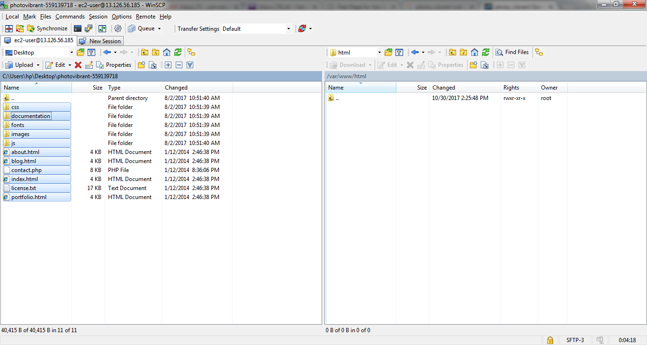

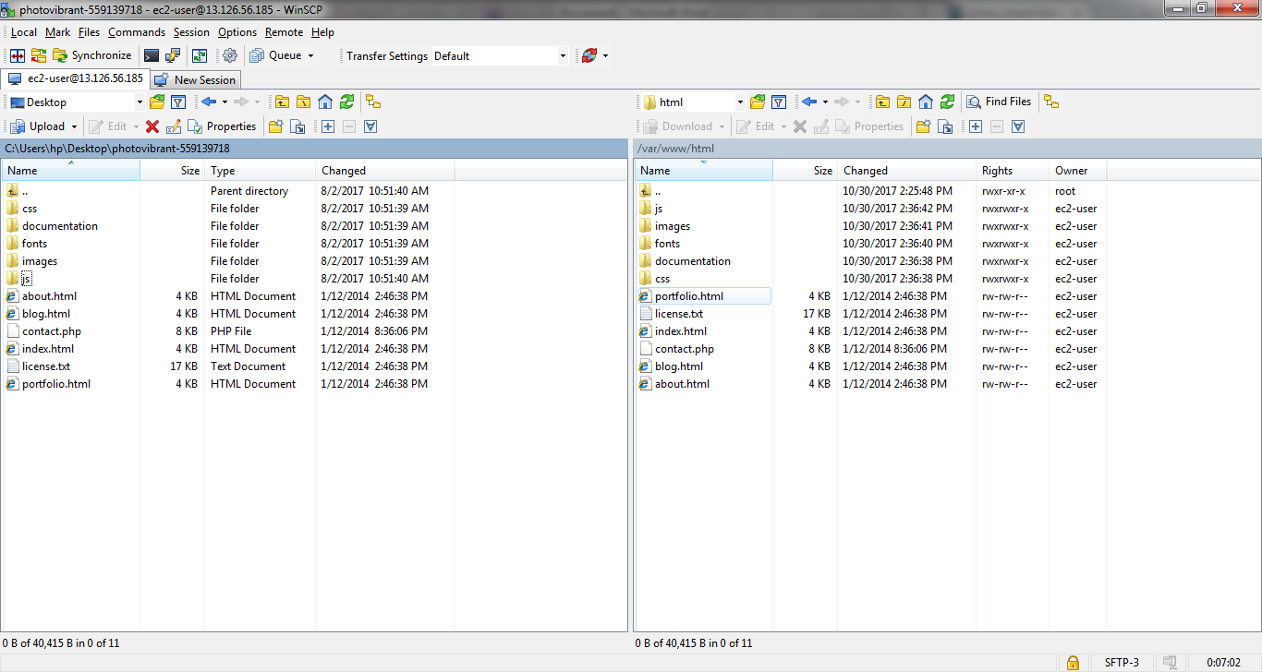
Then give full permissions for the files in the folder /var/www/html as below.
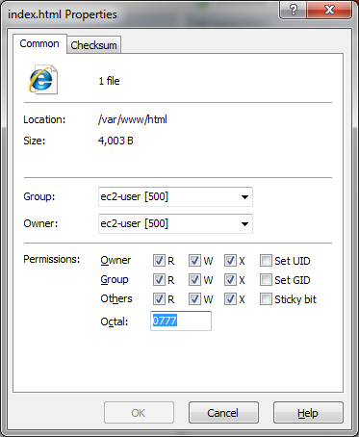
Then hit the same URL of the EC2 instance, from the browser,
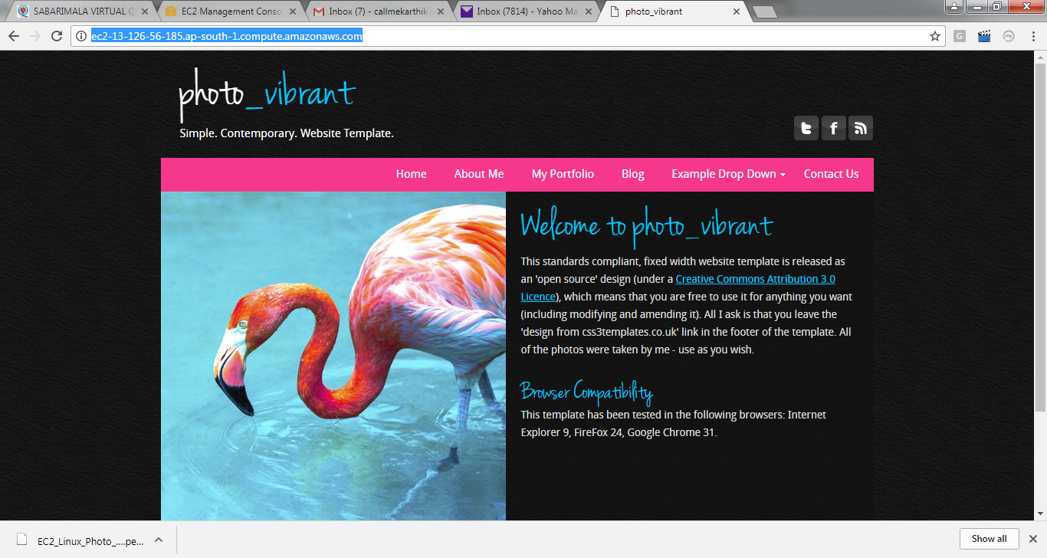
The page will be loaded and viewed.
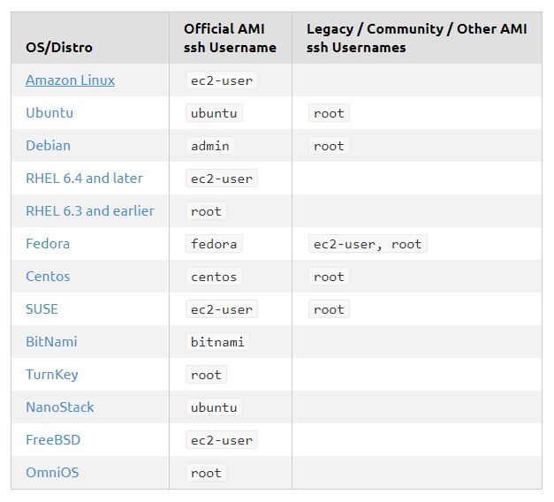

- https://www.youtube.com/watch?v=ljvgwmJCUjw - Linux Server GUI
- https://www.youtube.com/watch?v=oqUNkF8WoU4
- In this tutorial you will learn how to setup desktop and vnc in ec2 under ubuntu

- Steps:
- Connect ssh to ec2 instance.
- Become the super user after executing the command
- sudo –su – Logged in as Root user

- Type the following commands to install vncserver:

- sudo apt-get install ubuntu-desktop
- sudo apt-get install vnc4server
- sudo apt-get install gnome-panel

- Type the command vncserver once.
- 5. Remember the password you use for accessing the vncserver. Kill vncserver by typing the command
- Vncserver -kill :1
- Goto vi .vnc/xstartup and modify the file
- #!/bin/sh
- unset SESSION_MANAGER
- # exec /etc/X11/xinit/xinitrc
Add - > gnome-session –session=gnome-classic & gnome-panel
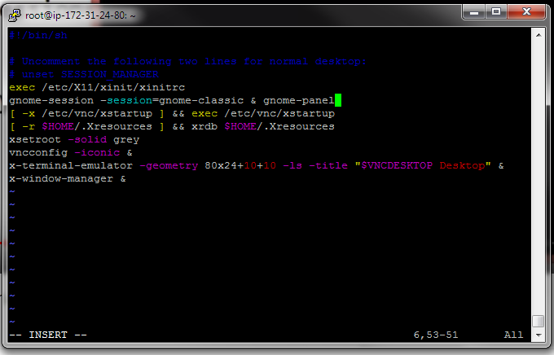
- Press ESC, followed by :wq to save and exit the file
- Type vncserver again to start vncserver.
- Download and install tightvnc to connect remote desktop from the following link
- http://www.tightvnc.com/download.php
- Now run tightvnc viewer
- Add the port no 5901 in your ec2 security group (Inbound Rule)
- Write your public ip in remote host text box and port no.
- publicIp::port
- Your desktop in ec2 instance is ready and execute the command vncserver after every restart.

