

A Plagiarism Detector in Learning Management System for UTHM

NAMA  Name | : | DIVAKHAR A/L RAJAH
NO. MATRIK  Matric No. | : | AI230082
TARIKH  Date | : | 30/11/2025
SUPERVISOR | : | Dr. Nur Ziadah Binti Harun

CHAPTER TWO

LITERATURE REVIEW

2.1 Introduction
The chapter provides a comparison of Learning Management Systems (LMS) that are significant to this research in terms of technology, features, and shortfalls. An LMS is simply a means of providing educational materials, assigning and submitting homework, and communicating between students and lecturers. The way they approach automation, data safe-handling, plagiarism detection, and learning analytics varies widely among different systems. The main LMS used by UTHM is Author [1], which supports academic activities at UTHM but has limited features for managing the submission of assignments.
The analysis of the comparison with other systems identifies where gaps exist to build an integrated plagiarism detection solution tailored specifically for the LMS of UTHM. From this comparison, the identified information will be used to create a more secure, efficient, and supportive LMS for academic success.

2.2 Manual or Traditional Study Assessment
Manual or Traditional Study Assessments consist of lecturers taking print-offs out of the mail, going through them individually, writing in their own comments for each student's papers, and keeping track of students' grades in a hard-copy format. This process causes lecturers to physically handle and store large numbers of printed papers, which is time-consuming and tedious. Lecturers have difficulty identifying similarities and evidence of plagiarism or copying, because they have to rely solely on their memories and their observations; this adds inconsistency and lowers the level of trust in the assessment process. Identifying student success and failure and providing timely feedback becomes difficult when there are no electronic systems to assist lecturers. Electronic assessment systems would address these constraints by reducing the amount of time needed to assess and grade various forms of student assessments; eliminate the possibility of misplaced assessment materials; provide more ways for lecturers to communicate feedback to their students; and reduce the amount of effort required to create, manage, and maintain assessment material for each individual student[2].

2.3 Learning Management System
Learning Management System is a computer-based system to manage, facilitate, monitor, and evaluate training activities [3]. It provides an online learning environment that gathers all of the content associated with the teaching and learning process into one location for use by all stakeholders (lecturers, students) involved in the process. Lecturers may upload their training materials to the LMS, assign assignments, administer assessments, publish training information or updates, and monitor how engaged students are with their assigned materials. Students can access any of their assigned training materials at any time, submit completed assignments, communicate with their lecturer about any questions that they may have about the content, and track their academic progress through the LMS.
There are many advantages of using a learning management system in today's education system [4]. The most noteworthy is the flexibility that it provides for students because they can learn at their own pace and access the materials from anywhere in the world. This flexibility allows for students to participate in learning activities in a way that accommodates their individual learning styles and schedules. Additionally, LMS systems can be used to automate administrative tasks, such as grading, tracking attendance, and distributing course content. LMS also facilitates the communication between lecturers and students by including automated messaging functions, forums, and notifications. Furthermore, LMS systems maintain digital records of submissions, grades, and feedback, promoting transparency and reducing the risk of misplaced documents. Overall, an LMS improves teaching effectiveness, strengthens student engagement, and provides a scalable and sustainable approach to digital learning.

2.4 Plagiarism
Plagiarism is seen as the act of using someone else’s ideas, methods, or other written works without having received prior approval from the original author, and with the intention to have the work credited to you. There are many reasons why people commit this offense and many different factors that lead someone to commit this act. It can also be an intentional act or an unintentional act [5]. Academic institutions view plagiarism as a serious violation of academic integrity [6] since it diminishes a student's credibility for their academic work, and also detracts from a student's actual learning or knowledge. To ensure fairness and uphold the integrity of the academic process, many universities have implemented policies and support tools [7] to help monitor the originality of all assignments, reports, and research projects.
Universiti Tun Hussein Onn Malaysia (UTHM) allows a maximum limit of 30% similarity index or plagiarism index [8]. All submitted academic work must not exceed this threshold when excluding direct quotes, references, and standard templates. The 30% limit provides a guideline for students to write their own content while allowing for some level of similarity that will occur naturally in all academic writing. Limiting similarity scores to less than the percentage limit will help ensure that what is submitted reflects the student’s own understanding of the material and is not just copied from a source or improperly reused. The UTHM policy promotes ethical writing practices, provides guidelines for academic honesty, and ensures students are assessed fairly based on their actual learning.

2.5 Method or Technology to Detect Plagiarism
The plagiarism detection process is structured and equitable according to this workflow. In the first step, a lecturer sets up the assignment in the Learning Management System (LMS). After that, the LMS will prepare the assignment for worry scanning automatically. Next, all students' assignments will be submitted to the LMS and time-stamped, but not compared yet; all assignments will be queued until after the submission deadline. After the due date has passed, the LMS uses an automated process to compare every submission to each other. This prevents students who submitted their assignments early from having an edge over their classmates and ensures everyone receives equal treatment regarding plagiarism checking.
2.5.1 Cosine Similarity
Cosine similarity [9] is a method for identifying the degree to which two text documents match. A cosine similarity algorithm quantifies the degree of similarity between a document and another document or group of documents by using numerical vector representations of the text and then calculating the cosine of the angle between the two vectors. A high cosine similarity score indicates that the two documents share a great deal of commonality in terms of important words, meaning their vectors are pointing toward the same direction. A significant advantage of cosine similarity is it only measures the relationship between the words in two different documents. For example, if the lengths of the two documents differ significantly, the cosine similarity algorithm will still produce an accurate comparison
2.5.2 Term Frequency–Inverse Document Frequency
The statistical product term frequency-inverse document frequency (TF-IDF) is a means of determining the important words in text documents. TF-IDF does this by establishing the frequency of occurrence of the word in the text document (TF), and then, the number of occurrences of words considered generic or common amongst all submissions is reduced (IDF). Using TF-IDF [10] when comparing student submissions assists in isolating and identifying unique or significant words, making it easier to find instances of potential and probable plagiarism. By isolating the highest contributing keywords to the originality of the submissions, TF-IDF contributes to increasing the likelihood that students' submissions will be accurately evaluated.
Example:
Table 2.1: TF-IDF
Word | TF in Doc1 | TF in Doc2 | IDF | TF-IDF (Doc1) | TF-IDF (Doc2)
"algorithm" | 3 | 3 | 2 | 6 | 6
"student" | 1 | 5 | 3 | 3 | 15
If both have similar TF-IDF vectors, then the documents are similar.
2.5.3 N-gram sequence matching
N-gram sequence matching [11] is another means of determining similarity. N-grams are the continuous sub-sequences or called the chunks of text of n terms that are each analysed for similarities. For instance, a 3-word n-gram may include "in this study". In comparing all student submissions for similarities, the software will locate identical sequences across all student submissions. The more identical 3-word n-gram sequences two students submit, the greater the similarity score assigned by the software. The power of N-gram matching to identify the similarities between submissions increases significantly when the N-grams are utilised when noting similarities between assigned submissions because N-gram matching provides a comparative analysis of sentence structure and order of phrases as opposed to just the comparison of single term occurrences.

2.6 Study of Existing Related Systems
UTHM's LMS has proven to be an efficient platform for teaching and learning, allowing users to upload their content, submit assignments, take quizzes, and communicate with their lecturer. However, the AUTHOR LMS currently does not come equipped with a built-in plagiarism detection tool, therefore, lecturers use a third-party service such as Turnitin [12] to check the originality of their students' work. The use of an external service for checking the originality of student works can be inconsistent and time-consuming.
Similar to the AUTHOR LMS, other currently utilized LMS's such as Google Classroom and Edmodo also do not have built-in anti-plagiarism tools. Google Classroom has an extremely high level of accessibility, ease of use, and provides easy access to all of the different tools available through Google Workspace [13]. However, Google Classroom relies on third-party companies for their plagiarism detection tools and typically those companies charge high subscription fees. Edmodo, on the other hand, provides an excellent way to encourage interaction and collaboration, but does not offer an automated plagiarism detection system. Therefore, lecturers are required to manually check student work for originality which may or may not be reliable.
2.6.1 AUTHOR UTHM
UTHM's official Learning Management System (LMS), AUTHOR, offers the necessary functionality which is uploading educational content, submitting assessments, providing an evaluation system, grading students to create a structured digital learning space. Unfortunately, AUTHOR does not have integrated tools for detecting plagiarism; therefore, lecturers must use external systems like Turnitin or other online tools. With the proposed solution, similarity scanning, text comparison algorithms, and automated reports would be added to the submission workflow so that an instantaneous analysis is available for the lecturer at the time of submission. The systemic inclusion of the similarity check as part of the standard assessment process and leveraging AUTHOR's existing submission framework allows for a more consistent evaluation of student work while improving academic integrity. The proposed system provides an efficient, scalable means to reinforce the fairness and reliability of the evaluation of student work.

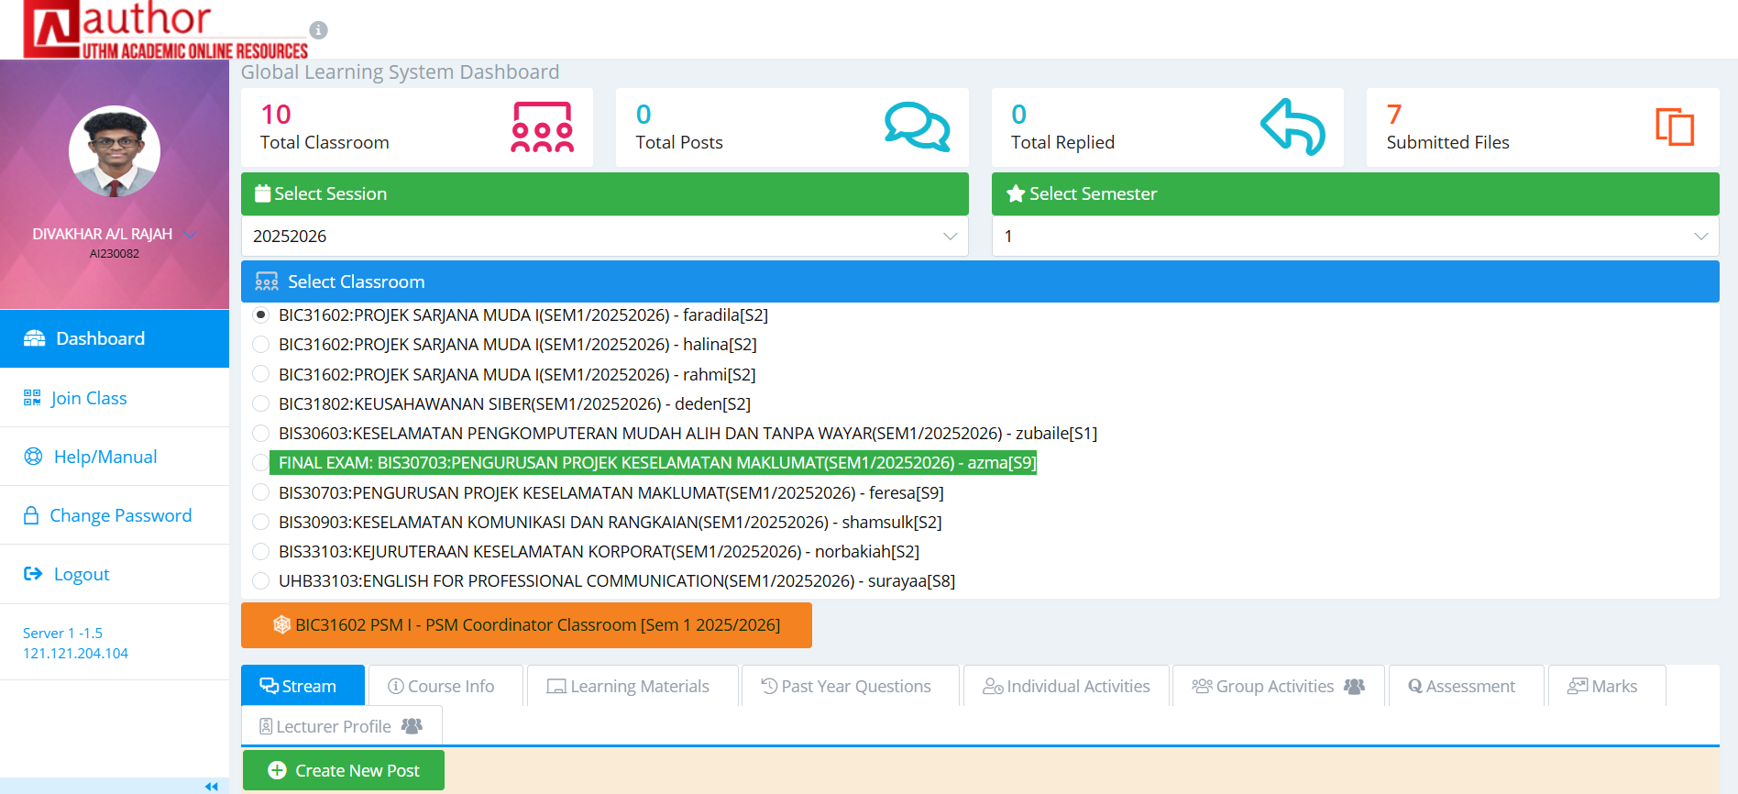
Figure 2.1 : AUTHOR Dashboard

2.6.2 Google Classroom
Google Classroom[14] is a great online educational management system for how it makes distributing assignments, communicating with students or staff, grading students, and organizing classes. However, Google’s current plagiarism detection features are limited to paid options that require additional tools. The proposed system will have similarities to the existing Google Classroom in that it will have some or all of the same features to allow for assignment submissions and lecturer reviews. But the proposed system will have the added benefit of automatic similarity checking, detailed originality reports with highlighted matched text, and a breakdown of the similarities produced from checked documents. The proposed system will allow for a central location to save student submissions, which will allow for comparisons between students and across groups of students. This capability will provide an advantage with respect to internal plagiarism detection capabilities; therefore, the proposed system will expand on Google Classroom’s strengths by providing a more comprehensive, scalable, and tailored approach to plagiarism detection based on UTHM’s needs.

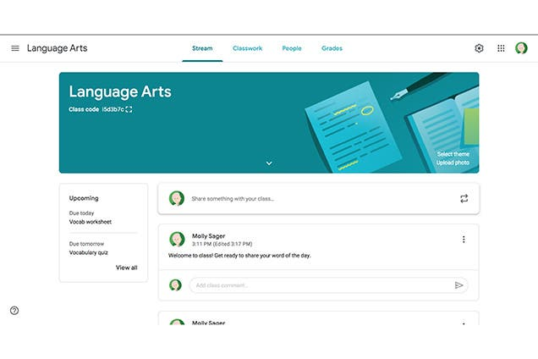
Figure 2.2: Google Classroom Dashboard
2.6.3 Edmodo
The educational platform Edmodo [15] provides communication, engagement, resource-sharing, and other benefits to educators and learners through a social-media-style website, yet the application of Edmodo for higher learning is limited because Edmodo does not contain integrated tools for determining instances of plagiarism. However, Edmodo can still serve as a source of inspiration for the development of the new plagiarism detection system’s user-friendly dashboards, reports, and notifications. In conclusion, Edmodo is a very effective means of managing a classroom environment and facilitating communication between lecturers and students; however, it cannot provide universities with the necessary institutional-level analysis of originality of submitted work in support of academic integrity, as will be provided in the proposed system through centralised management of the submission of work.

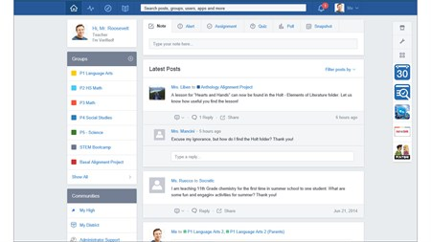
Figure 2.3: Edmodo Dashboard
2.7 Comparison with Existing System
This chapter compares the proposed system to three well-known Learning Management Systems. The LMS's compared are AUTHOR, Google Classroom, and Edmodo. Although these systems provide features which promote online learning, each has a level of depth, configurability, and applicability to the customization of an institution. This comparison demonstrates the advantages and disadvantages of each existing LMS; therefore, the research of this chapter provides an evaluation, based on specific criteria for each LMS, including user authentication, document processing, communication tools, assessment capabilities, analytics, and security of the system. Additionally, the research illustrates how the proposed system integrates and improves many key elements to address the operational requirements and objectives of an academic environment.
Table 2.2: Comparison Table
Features / System | AUTHOR | Google Classroom | Edmodo | Proposed System
Login | ✓ | ✓ | ✓ | ✓
User Role Management | ✓ | ✓ | ✓ | ✓
Upload / Submit Documents | ✓ | ✓ | ✓ | ✓
Communication / Announcements | ✓ | ✓ | ✓ | ✓
Assessment / Tracking Progress | ✓ | ✓ | ✓ | ✓
Report & Analytics | ✓ | Limited | Limited | ✓
File Sharing | ✓ | ✓ | ✓ | ✓
Feedback System | ✓ | ✓ | ✓ | ✓
Data Backup | X | ✓ | ✓ | ✓
Security / Access Control | ✓ | ✓ | ✓ | ✓
Built-in Plagiarism Detector | X | X | X | ✓
In conclusion, the comparison shows that while AUTHOR, Google Classroom and Edmodo provide useful resources for learning purposes, there are many differences between the three platforms regarding security and academic integrity features. For example, on one hand, AUTHOR has an Education-provided, secure, university-managed environment. From another perspective, Google Classroom also provides strong data protection through Google's cloud storage. In contrast, Edmodo provides more communication and engagement capabilities than it does security compliance capabilities. For instance, Edmodo provides only basic security controls and does not provide any type of similarity analysis for submissions uploaded by students. However, all three LMSs do not provide built-in plagiarism tool. Contrarily, with the proposed system, it improves security and enhances the way that student submissions will be processed through the integration of an automated plagiarism detection module into the student upload process. Every assignment that is uploaded will now be scanned, analysed, and securely stored, significantly decreasing the likelihood of academic fraud. As a result, the proposed system creates a medium to ensure consistency and reliability in the area of academic integrity.
2.8 Chapter Summary
This chapter thoroughly reviewed related literature concerning assessment techniques; the role of Learning Management Systems (LMS) in education; the issue of plagiarism; and existing online tools for plagiarism detection, as a reference for creating the Plagiarism Detector in Learning Management System. A comparison of currently available platforms (AUTHOR, Google Classroom and Edmodo) revealed that these three platforms support the teaching and learning processes, but none provide necessary integrated or automated ways to detect similarities and plagiarism at the level of universities. Therefore, these findings supported the proposal of a complete integrated solution. Finally, this chapter discussed how the proposed system uses algorithms such as TF-IDF, cosine similarity and n-gram analysis to achieve automated scanning for similarities, comprehensive originality reports, comparisons between two or more bodies of work, organizational/comparative repositories, and analytical data on writers. In conclusion, this chapter showed how current systems are not sufficient to enable the enforcement of academic integrity in relation to plagiarism and illustrated how the proposed system provides a comprehensive, institution-oriented approach to supporting UTHM’s academic integrity objectives.

References
[1] Pusat Teknologi Maklumat, “AUTHOR UTHM,” UTHM Publisher. [Online]. Available: author.uthm.edu.my
[2] I. Maslov, S. Nikou, and P. Hansen, “Exploring user experience of learning management system,” International Journal of Information and Learning Technology, vol. 38, no. 4, 2021, doi: 10.1108/IJILT-03-2021-0046.
[3] D. Turnbull, R. Chugh, and J. Luck, “An Overview of the Common Elements of Learning Management System Policies in Higher Education Institutions,” TechTrends, pp. 855–867, 2022, doi: 10.1007/s11528-022-00752-7.
[4] M. Furqon, P. Sinaga, L. Liliasari, and L. S. Riza, “The Impact of Learning Management System (LMS) Usage on Students,” TEM Journal, vol. 12, no. 2, pp. 1082–1089, 2023, doi: 10.18421/TEM122-54.
[5] Maimunah et al., “Cutting the prevalence of plagiarism in the digital era: Student teachers’ perceptions on plagiarism in Indonesian Higher Education,” Problems of Education in the 21st Century, vol. 76, no. 5, pp. 663–677, 2018, doi: 10.33225/pec/18.76.663.
[6] C. Bouaine, F. Benabbou, and I. Sadgali, “Word Embedding for High Performance Cross-Language Plagiarism Detection Techniques,” International Journal of Interactive Mobile Technologies, vol. 17, no. 10, pp. 69–91, 2023, doi: 10.3991/ijim.v17i10.38891.
[7] V. Cebrián-Robles, F. J. Ruíz-Rey, M. Raposo-Rivas, and M. Cebrián-de-la-Serna, “Impact of Digital Contexts in the Training of University Education Students,” Educ Sci (Basel), vol. 13, no. 9, 2023, doi: 10.3390/educsci13090923.
[8] M. O. Eze and S. A. Kamboh, “Plagiarism Index Estimation Algorithm: A Quantitative Approach,” Int J Comput Appl, vol. 111, no. 17, pp. 36–46, 2015, doi: 10.5120/ijais15-451307.
[9] R. Fauzi, M. Iqbal, and T. Haryanti, “Design and Implementation of a Final Project Plagiarism Detection System Using Cosine Similarity Method,” IJAIT (International Journal of Applied Information Technology), vol. 05, no. 02, p. 1, 2022, doi: 10.25124/ijait.v5i02.4146.
[10] S. Qaiser and R. Ali, “Text Mining: Use of TF-IDF to Examine the Relevance of Words to Documents,” Int J Comput Appl, vol. 181, no. 1, pp. 25–29, 2018, doi: 10.5120/ijca2018917395.
[11] M. Davoodifard, “Automatic Detection of Plagiarism in Writing,” Studies in Applied Linguistics and TESOL, vol. 21, no. 2, pp. 54–60, 2022, doi: 10.52214/salt.v21i2.9058.
[12] L. Graham-Matheson and S. Starr, “Is it cheating or learning the craft of writing? Using Turnitin to help students avoid plagiarism,” Research in Learning Technology, vol. 21, no. 1063519, pp. 1–13, 2013, doi: 10.3402/rlt.v21i0.17218.
[13] U. Akcil, H. Uzunboylu, and E. Kinik, “Integration of technology to learning-teaching processes and google workspace tools: A literature review,” Sustainability (Switzerland), vol. 13, no. 9, 2021, doi: 10.3390/su13095018.
[14] Google, “Google Classroom,” Google for Education. [Online]. Available: classroom.google.com
[15] N. Borg, “Edmodo,” Edmodo, Inc. [Online]. Available: edmodo.com

