ARGO
AUTOMATED RETRIEVAL & GATE OPERATIONS
Automate. Notify. Verify.
Gate-1 · Zone-1 · Plaksha University | Group 6 — Team Helios | ILGC-II
TECHNICAL OVERVIEW & SYSTEM DOCUMENTATION

1. Executive Summary
Gate-1 at Plaksha University handles parcels for close to 800 students entirely by hand: a paper register, an unsorted heap of boxes, and a guard checking identities by eye. In Q1 2026, 1,175 parcels passed through the gate, and 332 of them — 28% — were still sitting uncollected at the end of the quarter, with no record of who had been notified, or when.
ARGO (Automated Retrieval & Gate Operations) replaces that process end-to-end, running on the tablet already sitting at the gate. A guard photographs a parcel label; Gemini 2.5 Flash reads it and the system assigns a shelf slot automatically. The recipient is emailed the moment their parcel is stored, and again on a 48-hour reminder cycle for anything still uncollected. At pickup, a one-time PIN identifies the parcel and a live face match against the recipient's enrolled photo confirms the right person is at the counter; the guard gives final sign-off, and the exchange is logged against their ID and a timestamp.
Everything described below is a working, demoed prototype — Flutter on the tablet, Firebase across authentication, data and compute, and an on-device model that generates each face embedding locally on the tablet rather than sending photos to a third-party vision API.

2. The Problem at Gate-1
Every parcel is logged once on arrival. Retrieval means sifting through an unsorted heap; verification is a guard glancing at a student ID; and no channel tells a student their parcel has even arrived.
How might we eliminate parcel misplacement and uncollected backlogs at Gate-1 for ~800 students, with a system guards can operate with minimal training — achieving zero misplacements and 90% collection within 48 hours, at minimalrecurring cost?
- Manual, duplicate logging — no searchable record between arrival and pickup
- No notification channel — students learn about parcels by chance or a trip to the gate
- Unstructured storage and visual-only ID checks — slow retrieval, error-prone verification, and zero audit trail

3. Research & Validation
Before any design work, the team ran structured interviews with both Gate-1 security guards, two rounds of student surveys (n = 36 to 107), and direct process observation through April 2026. The figures below anchor every downstream design decision.
Metric | Finding | Source
Parcels handled, Q1 2026 | 1,175 | Gate-1 operations interview data
Uncollected at end of Q1 | 332 (28%) | Gate-1 operations interview data
Students who'd lost or misplaced a parcel | 43% | Survey, n=107, Mar 2026
Rated retrieval difficulty ≥ 3 of 5 | 67.7% | Survey, n=99, Apr 2026
Want a digital notification system | 84.1% | Survey, n=63, Apr 2026
Prefer face-scan over QR at pickup | 85.3% (vs. 14.7%) | Survey, n=95, Apr 2026

Stakeholders
Primary | Secondary
Students (~800 on campus) — depend on timely, secure parcel delivery | Courier personnel — deliver multiple parcels daily, rely on efficient handling
Gate-1 security guards — receive, log, store and hand over every parcel | Campus administration — accountable for operational efficiency and loss

“During peak delivery hours, parcels get stacked together and it becomes difficult to quickly find a specific student's package.” — Gate-1 security guard

4. Existing Solutions & Gap Analysis
Four approaches were evaluated against Gate-1's actual constraints. None closed every gap on its own — minimal cost, OCR logging a non-technical guard can run in one photo, identity verification without dedicated hardware, automatic shelf assignment, and a per-guard audit trail.
Approach | What it solves | Why it doesn't fit Gate-1
RFID platforms  (e.g. EZTrackIt) | Full chain-of-custody, notifications, analytics | Per-unit hardware and licensing cost; needs IT procurement — not viable at low budget
QR-based pickup  (GoKhana model) | Proxy prevention, proven at Plaksha campus scale | Solves delivery only — no parcel logging, shelf assignment, or identity verification
Prior campus build  (AutoParcel, Dec 2023) | Proved OCR logging + notifications work on this campus | Phone numbers aren't accessible through official campus systems
Paper register (current) | Zero cost, zero setup | No verification, no logging, no shelf management, no accountability

5. Solution Design
ARGO is built around three commitments, reflected directly in the tagline: Automate, Notify, Verify.
Automate. every parcel is logged, assigned a shelf slot, and tracked — from the moment it arrives, so nobody searches a heap at pickup time.
Notify. the recipient is emailed — on arrival, and again every 48 hours until the parcel is collected.
Verify. every handover is confirmed by a live face match — and closed out with the guard's ID and a timestamp — no step in the chain of custody goes undocumented.

The first design (v1.0) leaned on QR codes and WhatsApp, mirroring GoKhana's model. Guard interviews and student surveys pushed it in a different direction: 85.3% of students preferred face verification over a scannable code, and the campus could only reliably reach students by email — phone numbers aren't accessible through official systems. v2.0, the version built, replaced QR with face verification and WhatsApp with email, and added the 48-hour reminder loop.

6. System Architecture
ARGO runs as a Flutter tablet application in front of a fully serverless Firebase backend, with two AI services doing the heavy lifting: Gemini 2.5 Flash for label OCR, and a locally-executed ONNX model for face matching.
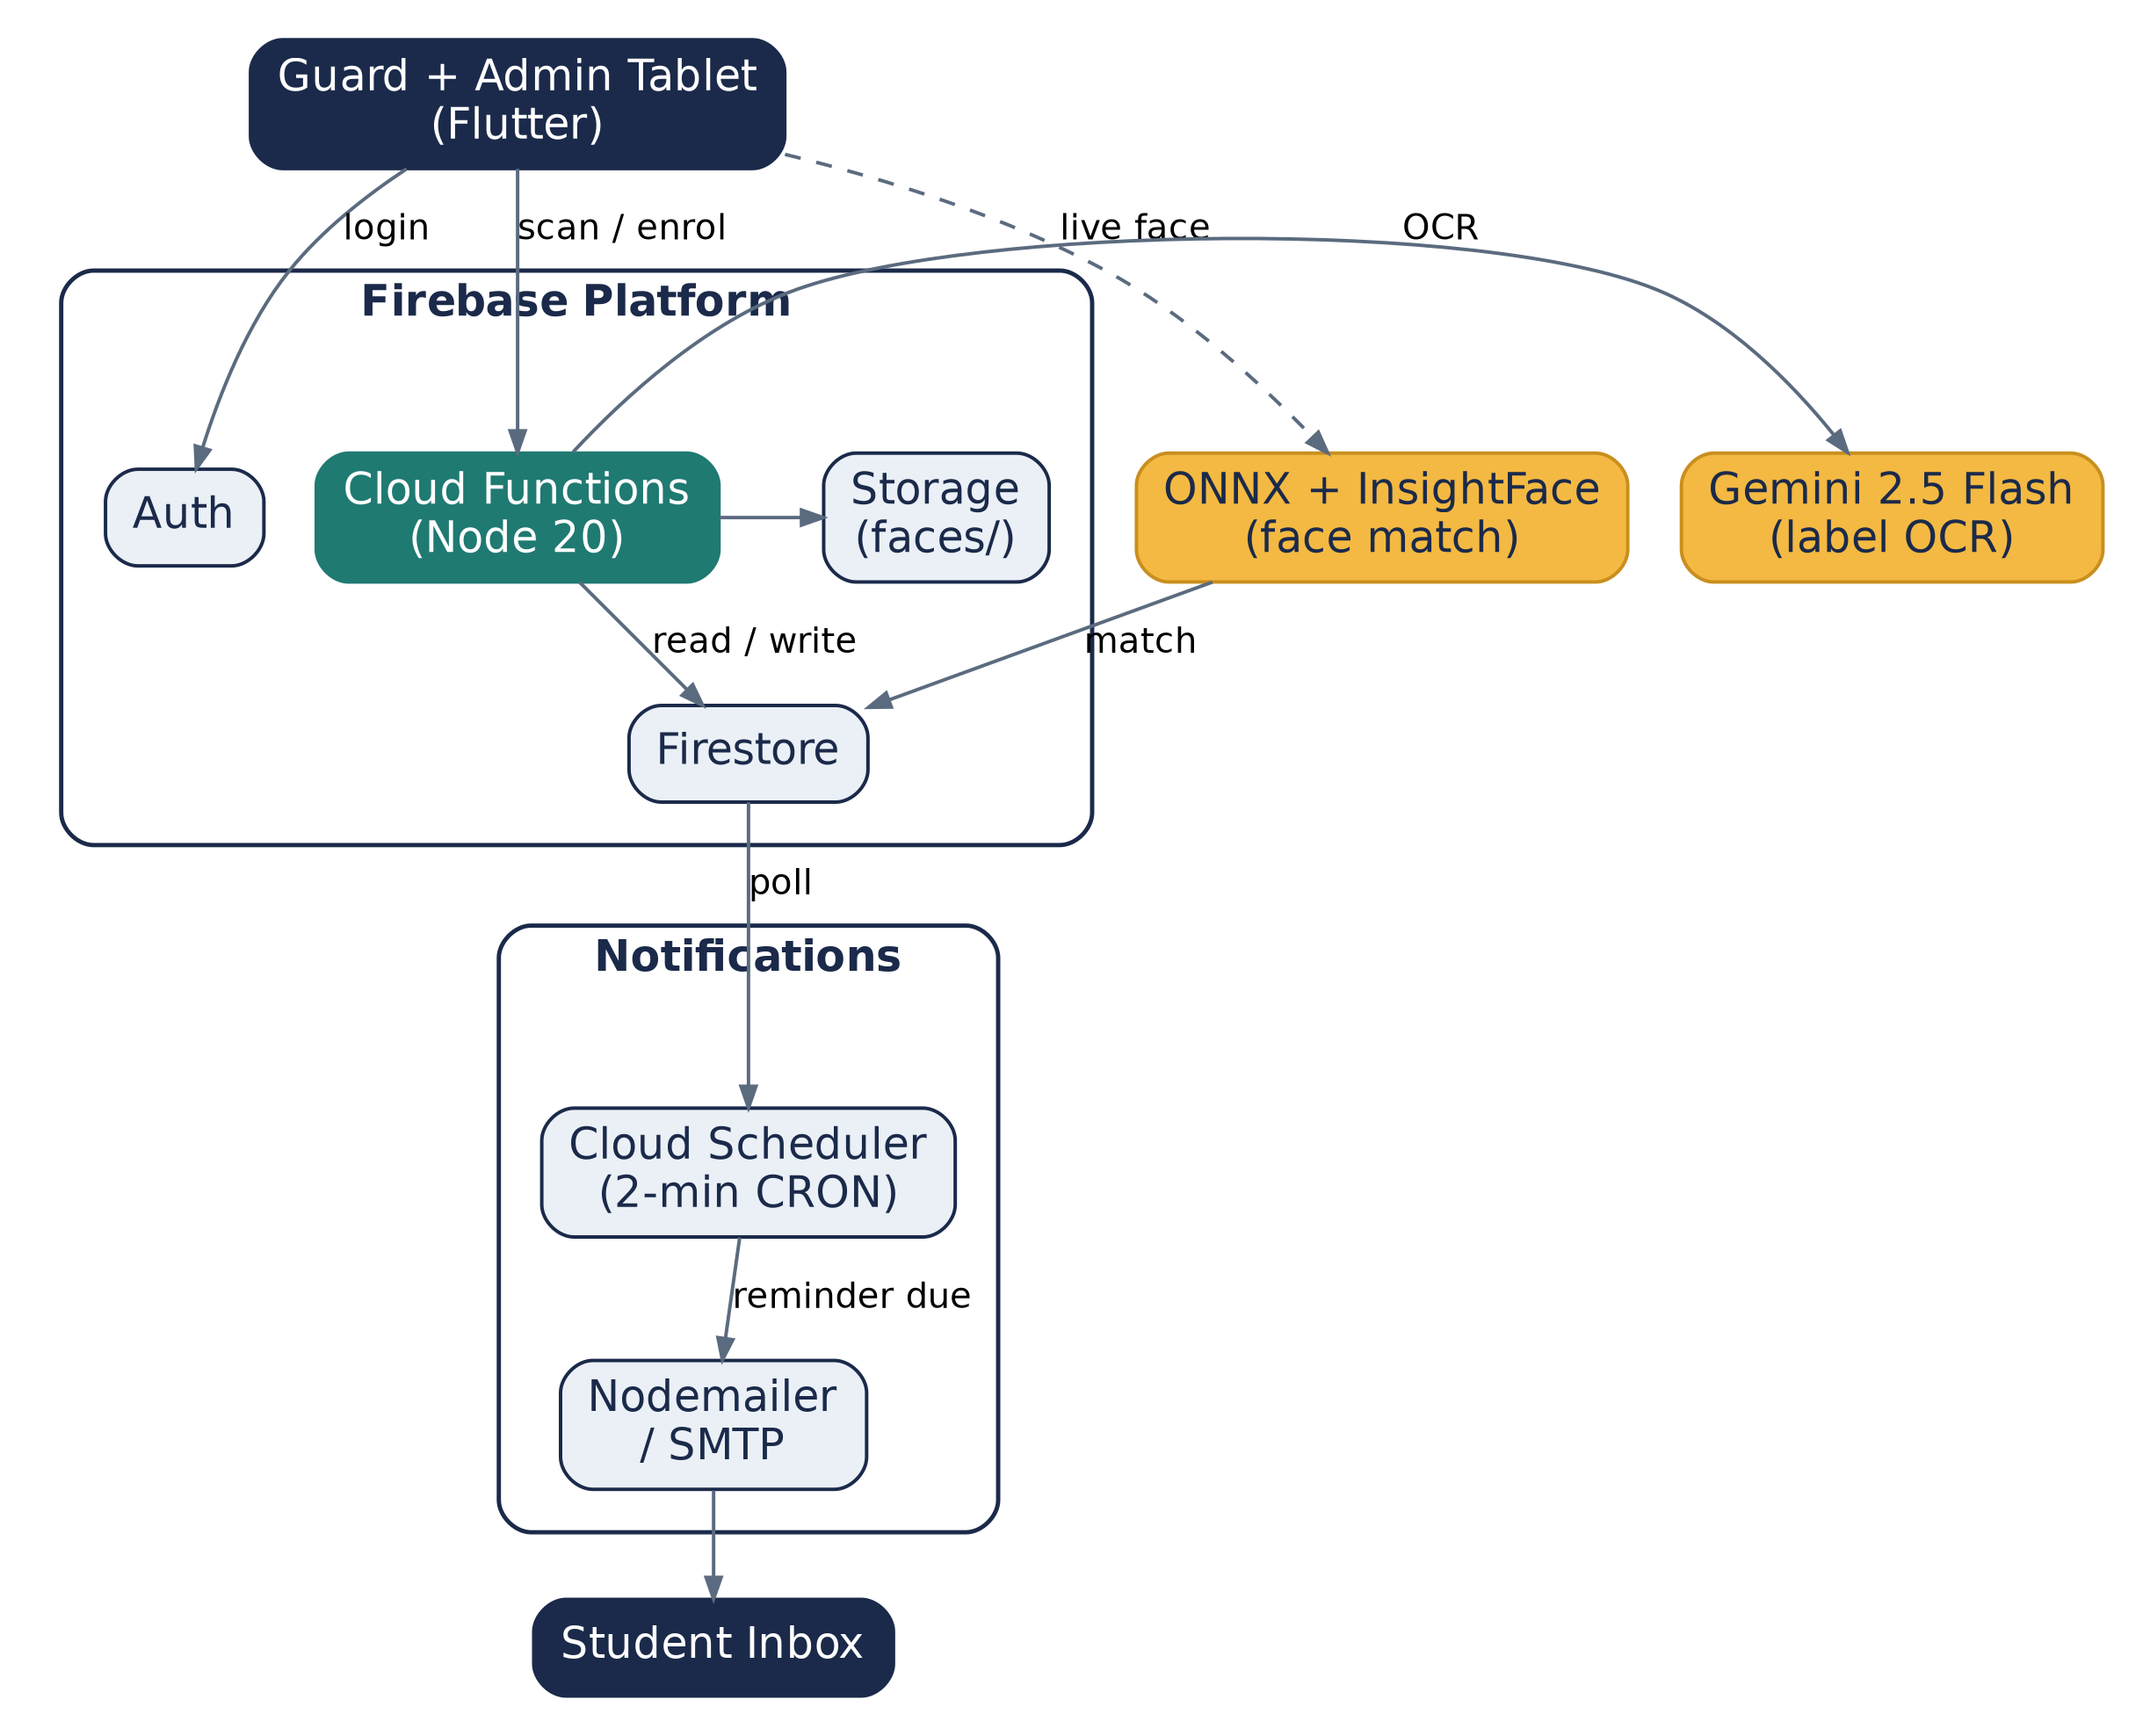
Figure 1. ARGO system architecture — client, Firebase platform, AI/ML layer, and the notification loop.

Data Model — Cloud Firestore Collections
Collection | Holds
students | Profiles, contact info, and each student's face embedding
parcels | Status (stored / collected), tracking number, assigned rack, timestamps
racks | Physical shelf capacity and live occupancy counts, kept in sync by a Firestore trigger
guards | Directory of active / inactive security personnel
emails | Outbound notification queue, dispatched via SMTP
pinAttempts | Rate-limiting and device lockouts for PIN-entry brute-force protection

7. Core Workflows

7.1 Parcel Intake & Label Scanning
The guard photographs the shipping label; the app base64-encodes the image and calls the scanLabel Cloud Function, which sends it to Gemini 2.5 Flash. Gemini returns structured JSON — courier, recipient name, and tracking number — which pre-fills the arrival form for the guard to confirm.

7.2 Automated Rack Assignment
The assignRack function evaluates live occupancy across every shelf and assigns the parcel to the first one holding fewer than five stored parcels. A Firestore trigger, syncRackOccupancy, keeps each rack's live count in sync automatically as parcels are stored or collected — no manual shelf bookkeeping.

7.3 Facial Recognition Handover
At pickup, a one-time PIN sent at storage time identifies the parcel. The tablet camera locates a face using Google ML Kit; the cropped frame is run through a local InsightFace model to generate a 128-dimensional embedding, compared against the recipient's enrolled embedding by cosine similarity. A match — plus the guard's final sign-off — releases the parcel; the exchange is logged with the guard's ID and a timestamp.

7.4 Automated Notifications & Reminders
A Cloud Scheduler job (checkAndSendReminders) polls every two minutes, comparing each stored parcel's arrival timestamp against the current time. Anything that crosses the 48-hour threshold is queued into the emails collection and dispatched via Nodemailer over SMTP, carrying the collection PIN and gate instructions.

8. Security, Reliability & Accountability
- Rate-limited PIN entry — repeated failed attempts lock the device (pinAttempts collection), guarding against brute-force guesses
- OCR with manual override — every scanned label can be corrected by the guard before submission; extraction never silently commits an unverified field
- Threshold-based face matching — a live embedding is compared to the enrolled photo by cosine similarity; below threshold, the parcel is not released
- Guard sign-off and audit trail — every handover carries a guard ID and a timestamp, closing the accountability gap that let 332 parcels go untracked in Q1
- No single point of failure — OCR, rack assignment, and identity verification each keep a human checkpoint alongside the automation

9. Impact, Targets & Roadmap

Targets
- Zero misplacement — every parcel gets a unique identifier and a fixed shelf slot at arrival
- Promoted collection within 48 hours, driven by instant notification plus the automated reminder loop
- Minimal recurring cost — runs on the tablet and infrastructure already at Gate-1; on-device face matching carries no per-call API cost, and label OCR stays costs around ₹2500 per annum.

Roadmap
- Return-parcel handling — the same chain-of-custody logic, run in reverse
- Pickup-risk prediction from historical collection-time data, to trigger earlier, targeted reminders
- Campus-wide rollout to other entry points and hostel stores — same codebase, configuration changes only

