***Buat Database dengan Nama sma***

***Dengan nama table Guru***

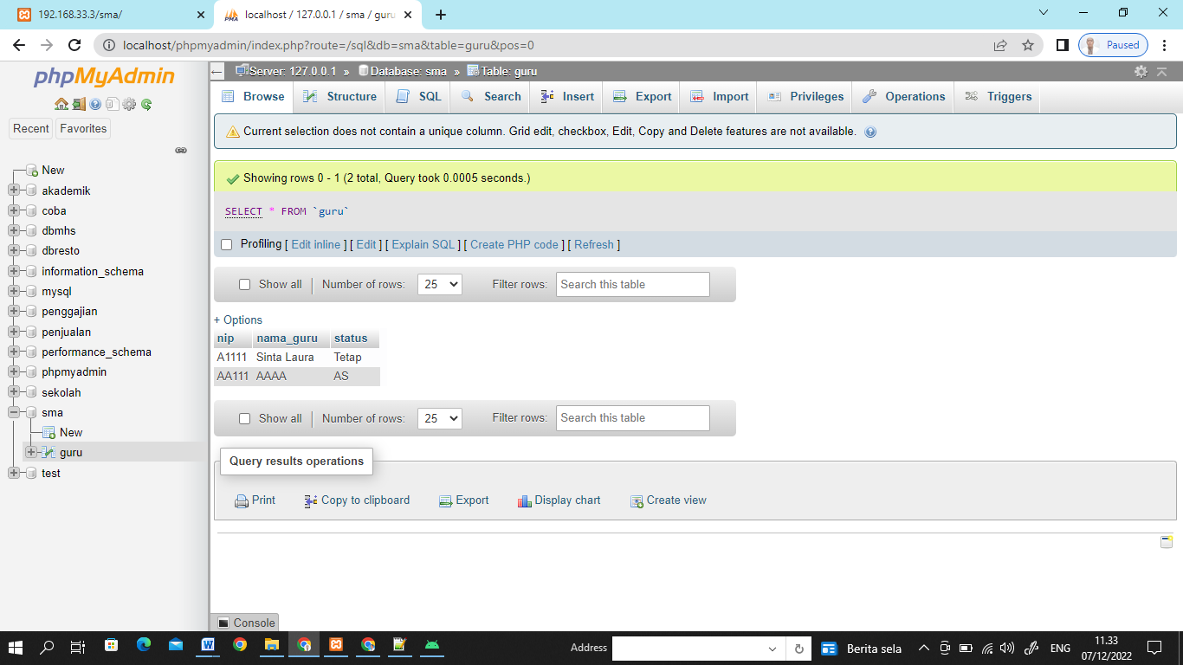

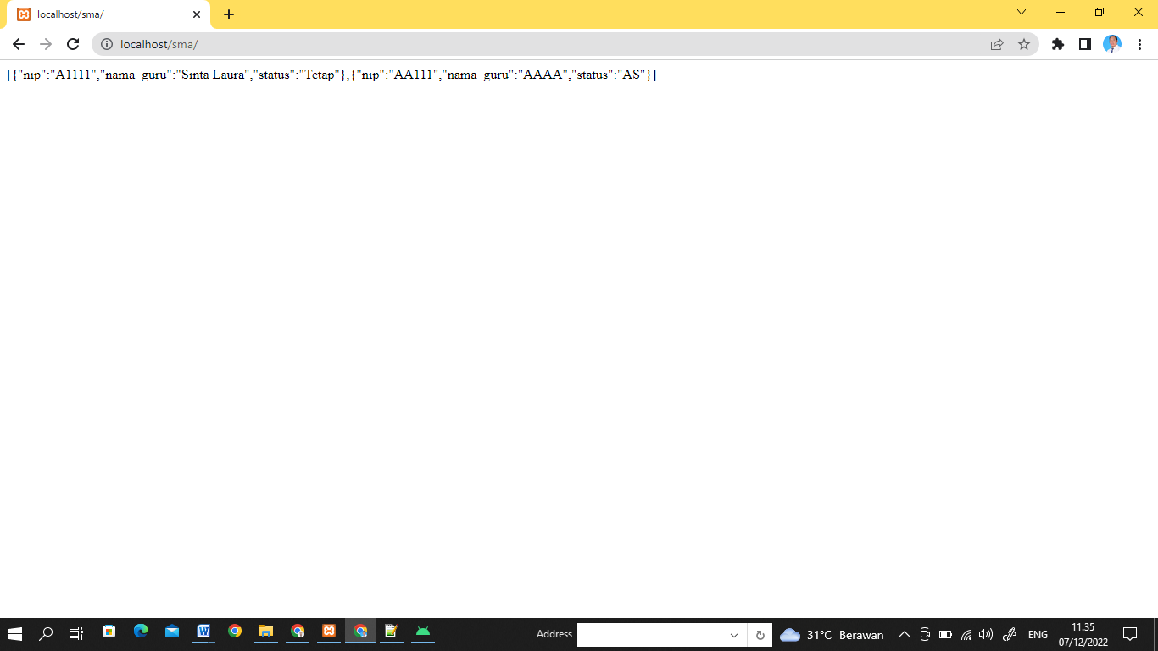

Pada folder htdocs/sma buat program php sbb:

***INDEX.PHP***

<?php

try{

$konn=new PDO("mysql:host=localhost;dbname=sma","root","");

}catch(PDOException $err)

{

echo "Koneksi gagal".$err;

}

if($_SERVER['REQUEST_METHOD']==='GET'){

$msql = "select * from guru order by nip";

$stm=$konn->prepare($msql);

$stm->execute();

$data=$stm->fetchAll(PDO::FETCH_ASSOC);

echo json_encode($data);

}else if($_SERVER['REQUEST_METHOD']==='POST'){

//Mendapatkan Nilai Variable

$nip = $_POST['nip'];

$nama = $_POST['nama_guru'];

$status = $_POST['status'];

$msql = "INSERT INTO guru (nip,nama_guru,status) VALUES (?,?,?)";

$stm=$konn->prepare($msql);

$data=$stm->execute([$nip,$nama,$status]);

echo json_encode($data);

if ($data)

{

echo "Sukses";

}

}

?>

***Build.gradel: app***

***dependencies {*** implementation 'androidx.appcompat:appcompat:1.5.1'  
 implementation 'com.google.android.material:material:1.6.1'  
 implementation 'androidx.constraintlayout:constraintlayout:2.1.4'  
 implementation 'de.hdodenhof:circleimageview:3.1.0'

**implementation 'androidx.recyclerview:recyclerview:1.2.0-alpha01'**

**implementation 'com.squareup.retrofit2:retrofit:2.9.0'  
 implementation 'com.squareup.retrofit2:converter-gson:2.9.0'**

testImplementation 'junit:junit:4.13.2'  
 androidTestImplementation 'androidx.test.ext:junit:1.1.3'  
 androidTestImplementation 'androidx.test.espresso:espresso-core:3.4.0'  
**}**

***buat Package dengan nama***

***ADAPTOR***

***1. Buat Class didalam package dengan Nama AdaptorGuru***

***API***

***2. Buat Class didalam package dengan Nama KoneksiAPI***

***CLASS***

***3. Buat Class didalam package dengan Nama EntryDataGuru***

***4.Buat Class didalam package dengan Nama RestAPIGuru***

***MODUL***

***5.Buat Class didalam package dengan Nama ModulGuru***

***INTERFACE***

***6.Buat Interfaces didalam package dengan Nama InterfaceGURU***

1. ***Class AdaptorGuru***

package com.example.projectseninsiang.ADAPTOR;  
  
import android.content.Context;  
import android.view.LayoutInflater;  
import android.view.View;  
import android.view.ViewGroup;  
import android.widget.TextView;  
  
import androidx.annotation.NonNull;  
import androidx.recyclerview.widget.RecyclerView;  
  
import com.example.projectseninsiang.MODUL.ModulGuru;  
import com.example.projectseninsiang.R;  
  
import java.util.ArrayList;  
  
public class AdaptorGuru extends RecyclerView.Adapter<AdaptorGuru.myViewHolder> {  
  
 ArrayList<ModulGuru> guruArrayList;  
  
 public AdaptorGuru(ArrayList<ModulGuru> guruArrayList) {  
 this.guruArrayList = guruArrayList;  
 }  
  
 @NonNull  
 @Override  
 public myViewHolder onCreateViewHolder(@NonNull ViewGroup parent, int viewType) {  
 Context context=parent.getContext();  
 LayoutInflater inflater=LayoutInflater.*from*(context);  
 View view=inflater.inflate(R.layout.*format_data_guru*,parent,false);  
 return new AdaptorGuru.myViewHolder(view);  
 }  
  
 @Override  
 public void onBindViewHolder(@NonNull myViewHolder holder, int position) {  
 holder.cnip.setText(guruArrayList.get(position).getNip());  
 holder.cnama.setText(guruArrayList.get(position).getNama_guru());  
 holder.cstatus.setText(guruArrayList.get(position).getStatus());  
 }  
  
 @Override  
 public int getItemCount() {  
 return guruArrayList.size();  
 }  
  
 public class myViewHolder extends RecyclerView.ViewHolder {  
 TextView cnip,cnama,cstatus;  
 public myViewHolder(@NonNull View itemView) {  
 super(itemView);  
 cnip=itemView.findViewById(R.id.*nipguru*);  
 cnama=itemView.findViewById(R.id.*namaguru*);  
 cstatus=itemView.findViewById(R.id.*statusguru*);  
 }  
 }  
}

1. ***Class KoneksiAPI***

package com.example.projectseninsiang.API;  
  
import retrofit2.Retrofit;  
import retrofit2.converter.gson.GsonConverterFactory;  
  
public class KoneksiAPI {  
 public static final String *url_base*="http://192.168.1.7/";  
 private static Retrofit *retrofit*;  
  
 public static Retrofit Koneksi()  
 {  
 if(*retrofit*==null)  
 {  
 *retrofit*=new Retrofit.Builder()  
 .baseUrl(*url_base*)  
 .addConverterFactory(GsonConverterFactory.*create*())  
 .build();  
 }  
 return *retrofit*;  
 }  
}

1. ***Class EntryDataGuru***

package com.example.projectseninsiang.CLASS;  
  
import androidx.appcompat.app.AppCompatActivity;  
  
import android.os.Bundle;  
import android.view.View;  
import android.widget.Button;  
import android.widget.EditText;  
import android.widget.Toast;  
  
import com.example.projectseninsiang.API.KoneksiAPI;  
import com.example.projectseninsiang.INTERFACE.InterfaceGuru;  
import com.example.projectseninsiang.MODUL.ModulGuru;  
import com.example.projectseninsiang.R;  
  
import java.util.ArrayList;  
  
import retrofit2.Call;  
import retrofit2.Callback;  
import retrofit2.Response;  
  
public class EntryDataGuru extends AppCompatActivity implements View.OnClickListener{  
 EditText ednip,ednama,edstatus;  
 Button tblsave,tblview;  
 ArrayList<ModulGuru> guruArrayList=new ArrayList<>();  
 InterfaceGuru interfaceGuru;  
  
 @Override  
 protected void onCreate(Bundle savedInstanceState) {  
 super.onCreate(savedInstanceState);  
 setContentView(R.layout.*activity_entry_data_guru*);  
  
 ednip=findViewById(R.id.*editnip*);  
 ednama=findViewById(R.id.*editnama*);  
 edstatus=findViewById(R.id.*editstatus*);  
 tblsave=findViewById(R.id.*tombolsave*);  
 tblview=findViewById(R.id.*tombolback*);  
  
 tblsave.setOnClickListener(this);  
 tblview.setOnClickListener(this);  
  
 }  
  
 @Override  
 public void onClick(View view) {  
 if (view.getId()==R.id.*tombolsave*)  
 {  
 *//save  
 //interfaceGuru= KoneksiAPI.Koneksi().create(InterfaceGuru.class);* String xnip=ednip.getText().toString();  
 String xnama=ednama.getText().toString();  
 String xstatus=edstatus.getText().toString();  
  
 interfaceGuru= KoneksiAPI.*Koneksi*().create(InterfaceGuru.class);  
 Call<ModulGuru> saveguru=interfaceGuru.simpanGuru(xnip,xnama,xstatus);  
 saveguru.enqueue(new Callback<ModulGuru>() {  
 @Override  
 public void onResponse(Call<ModulGuru> call, Response<ModulGuru> response) {  
 Toast.*makeText*(EntryDataGuru.this, ""+response.body().getNip(), Toast.*LENGTH_SHORT*).show();  
 }  
  
 @Override  
 public void onFailure(Call<ModulGuru> call, Throwable t) {  
 Toast.*makeText*(EntryDataGuru.this, "Gagal"+t.getMessage(), Toast.*LENGTH_SHORT*).show();  
 }  
 });  
 }else  
 {  
 *//back* }  
 }  
}

1. ***RestAPIGuru***

package com.example.projectseninsiang.CLASS;  
  
import androidx.appcompat.app.AppCompatActivity;  
import androidx.recyclerview.widget.LinearLayoutManager;  
import androidx.recyclerview.widget.RecyclerView;  
  
import android.content.Intent;  
import android.os.Bundle;  
import android.view.View;  
import android.widget.Toast;  
  
import com.example.projectseninsiang.ADAPTOR.AdaptorGuru;  
import com.example.projectseninsiang.API.KoneksiAPI;  
import com.example.projectseninsiang.INTERFACE.InterfaceGuru;  
import com.example.projectseninsiang.MODUL.ModulGuru;  
import com.example.projectseninsiang.R;  
import com.google.android.material.floatingactionbutton.FloatingActionButton;  
  
import java.util.ArrayList;  
import java.util.List;  
  
import retrofit2.Call;  
import retrofit2.Callback;  
import retrofit2.Response;  
  
public class RestAPIGuru extends AppCompatActivity {  
 RecyclerView recyclerView;  
 ArrayList<ModulGuru> guruArrayList=new ArrayList<>();  
 InterfaceGuru interfaceGuru;  
 KoneksiAPI koneksiAPI;  
 FloatingActionButton tmblinput;  
  
 @Override  
 protected void onCreate(Bundle savedInstanceState) {  
 super.onCreate(savedInstanceState);  
 setContentView(R.layout.*activity_rest_apiguru*);  
 recyclerView=findViewById(R.id.*recyclerviewGuru*);  
 interfaceGuru=KoneksiAPI.*Koneksi*().create(InterfaceGuru.class);  
 recyclerView.setLayoutManager(new LinearLayoutManager(this));  
 tmblinput=findViewById(R.id.*tombolinput*);  
 tmblinput.setOnClickListener(new View.OnClickListener() {  
 @Override  
 public void onClick(View view) {  
 startActivity(new Intent(RestAPIGuru.this,EntryDataGuru.class));  
 }  
 });  
 }  
  
 @Override  
 protected void onResume() {  
 Call<List<ModulGuru>> gurumuncul=interfaceGuru.tampilkanGuru();  
 gurumuncul.enqueue(new Callback<List<ModulGuru>>() {  
 @Override  
 public void onResponse(Call<List<ModulGuru>> call, Response<List<ModulGuru>> response) {  
 ArrayList<ModulGuru> guruArrayList= (ArrayList<ModulGuru>) response.body();  
 AdaptorGuru adaptorGuru=new AdaptorGuru(guruArrayList);  
 recyclerView.setAdapter(adaptorGuru);  
 }  
  
 @Override  
 public void onFailure(Call<List<ModulGuru>> call, Throwable t) {  
 Toast.*makeText*(RestAPIGuru.this, "Guru"+t.getMessage(), Toast.*LENGTH_SHORT*).show();  
 }  
 });  
 super.onResume();  
 }  
}

1. ***ModulGuru***

package com.example.projectseninsiang.MODUL;  
public class ModulGuru {  
 String nip,nama_guru,status;  
  
 public ModulGuru(String nip, String nama_guru, String status) {  
 this.nip = nip;  
 this.nama_guru = nama_guru;  
 this.status = status;  
 }  
  
 public String getNip() {  
 return nip;  
 }  
  
 public void setNip(String nip) {  
 this.nip = nip;  
 }  
  
 public String getNama_guru() {  
 return nama_guru;  
 }  
  
 public void setNama_guru(String nama_guru) {  
 this.nama_guru = nama_guru;  
 }  
  
 public String getStatus() {  
 return status;  
 }  
 public void setStatus(String status) {  
 this.status = status;  
 }  
}

1. ***InterfaceGURU***

* ***Buatlah Interface dengan nama interface guru***

package com.example.projectseninsiang.INTERFACE;  
  
import com.example.projectseninsiang.MODUL.ModulGuru;  
  
import java.util.List;  
  
import retrofit2.Call;  
import retrofit2.http.DELETE;  
import retrofit2.http.Field;  
import retrofit2.http.FormUrlEncoded;  
import retrofit2.http.GET;  
import retrofit2.http.POST;  
import retrofit2.http.Query;  
  
public interface InterfaceGuru {  
 @GET("sma/")  
 Call<List<ModulGuru>> tampilkanGuru();  
  
 @FormUrlEncoded  
 @POST("sma/")  
 Call<ModulGuru> simpanGuru (@Field("nip") String nip,  
 @Field("nama_guru") String nama_guru,  
 @Field("status") String status  
 );

}

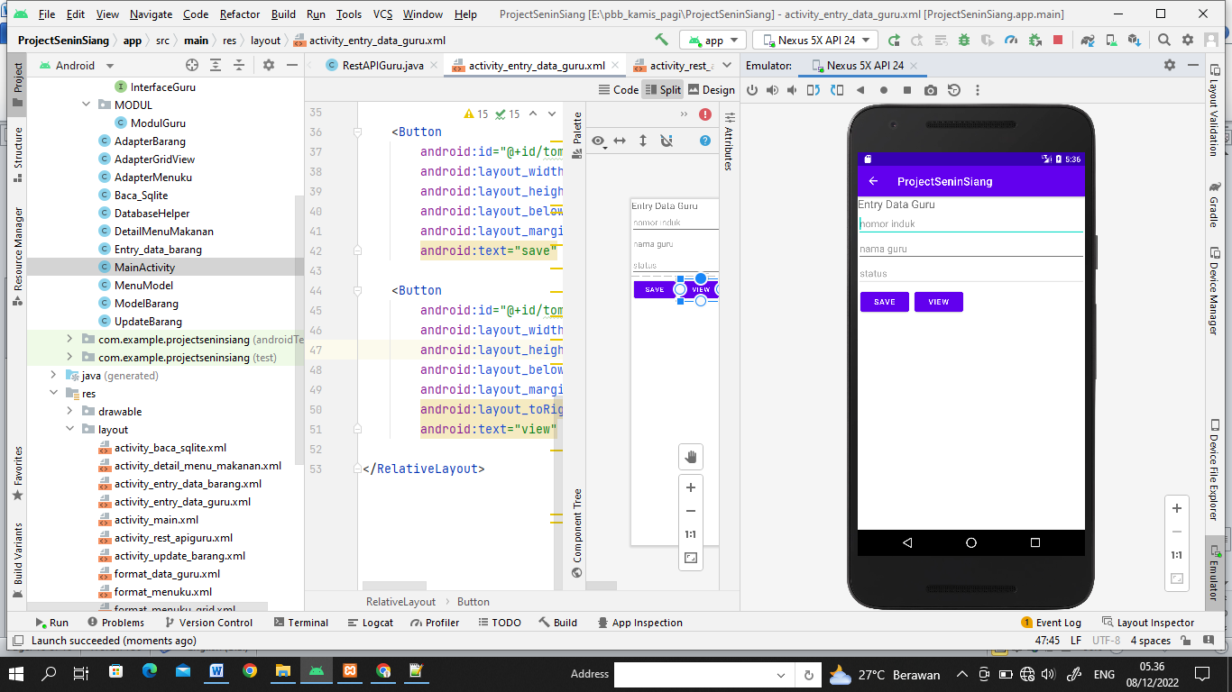

1. ***Entry_data_guru.xml***

*<?*xml version="1.0" encoding="utf-8"*?>*<RelativeLayout xmlns:android="http://schemas.android.com/apk/res/android"  
 xmlns:app="http://schemas.android.com/apk/res-auto"  
 xmlns:tools="http://schemas.android.com/tools"  
 android:layout_width="match_parent"  
 android:layout_height="match_parent"  
 tools:context=".CLASS.EntryDataGuru">  
  
 <TextView  
 android:id="@+id/judul"  
 android:text="Entry Data Guru"  
 android:textSize="20dp"  
 android:layout_width="match_parent"  
 android:layout_height="wrap_content"/>  
  
 <EditText  
 android:id="@+id/editnip"  
 android:layout_width="match_parent"  
 android:hint="nomor induk"  
 android:layout_below="@+id/judul"  
 android:layout_height="wrap_content"/>  
 <EditText  
 android:id="@+id/editnama"  
 android:layout_width="match_parent"  
 android:hint="nama guru"  
 android:layout_below="@+id/editnip"  
 android:layout_height="wrap_content"/>  
 <EditText  
 android:id="@+id/editstatus"  
 android:layout_width="match_parent"  
 android:hint="status"  
 android:layout_below="@+id/editnama"  
 android:layout_height="wrap_content"/>  
  
  
 <Button  
 android:id="@+id/tombolsave"  
 android:layout_width="wrap_content"  
 android:layout_height="wrap_content"  
 android:layout_below="@+id/editstatus"  
 android:layout_margin="5dp"  
 android:text="save" />  
  
 <Button  
 android:id="@+id/tombolback"  
 android:layout_width="wrap_content"  
 android:layout_height="wrap_content"  
 android:layout_below="@+id/editstatus"  
 android:layout_margin="5dp"  
 android:layout_toRightOf="@+id/tombolsave"  
 android:text="view" />  
  
</RelativeLayout>

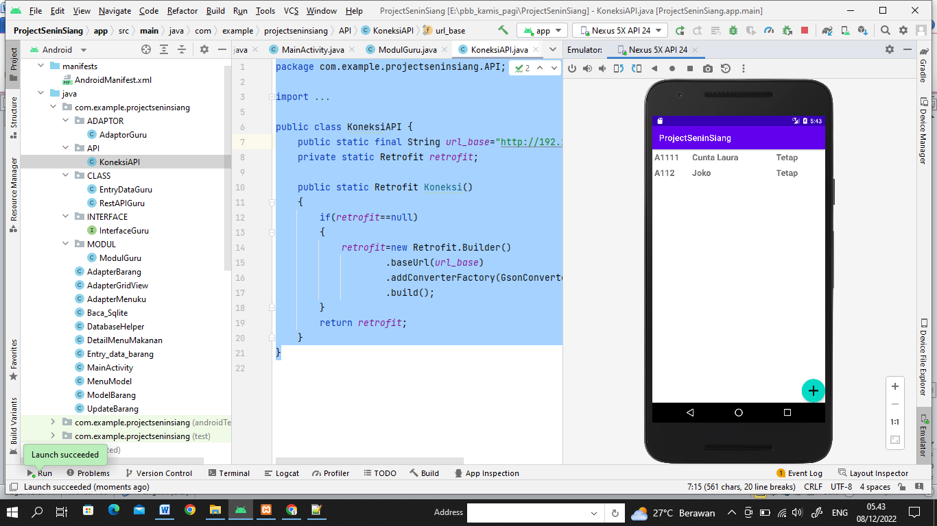

1. ***Format_Data_Guru.xml***

*<?*xml version="1.0" encoding="utf-8"*?>*<RelativeLayout xmlns:android="http://schemas.android.com/apk/res/android"  
 android:layout_width="match_parent"  
 android:padding="5dp"  
 android:layout_height="wrap_content">  
 <TextView  
 android:id="@+id/nipguru"  
 android:layout_width="90dp"  
 android:hint="nip"  
 android:textSize="20dp"  
 android:textStyle="bold"  
 android:layout_height="wrap_content"/>  
 <TextView  
 android:id="@+id/namaguru"  
 android:hint="nama guru"  
 android:textSize="20dp"  
 android:textStyle="bold"  
 android:layout_toRightOf="@+id/nipguru"  
 android:layout_width="200dp"  
 android:layout_height="wrap_content"/>  
 <TextView  
 android:id="@+id/statusguru"  
 android:layout_width="100dp"  
 android:textSize="20dp"  
 android:textStyle="bold"  
 android:hint="status"  
 android:layout_toRightOf="@+id/namaguru"  
 android:layout_height="wrap_content"/>  
  
</RelativeLayout>

**9.acticity_rest_apiguru.xml**

*<?*xml version="1.0" encoding="utf-8"*?>*<RelativeLayout xmlns:android="http://schemas.android.com/apk/res/android"  
 xmlns:app="http://schemas.android.com/apk/res-auto"  
 xmlns:tools="http://schemas.android.com/tools"  
 android:layout_width="match_parent"  
 android:layout_height="match_parent"  
 tools:context=".CLASS.RestAPIGuru">  
 <androidx.recyclerview.widget.RecyclerView  
 android:id="@+id/recyclerviewGuru"  
 android:layout_width="match_parent"  
 android:layout_height="match_parent"/>  
 <com.google.android.material.floatingactionbutton.FloatingActionButton  
 android:id="@+id/tombolinput"  
 android:src="@drawable/ic_baseline_add_24"  
 app:maxImageSize="40dp"  
 android:clickable="true"  
 android:layout_alignParentBottom="true"  
 android:layout_alignParentRight="true"  
 android:layout_width="wrap_content"  
 android:layout_height="wrap_content"/>  
</RelativeLayout>