МИНИСТЕРСТВО НАУКИ И ВЫСШЕГО ОБРАЗОВАНИЯ  
РОССИЙСКОЙ ФЕДЕРАЦИИ

федеральное государственное автономное   
образовательное учреждение высшего образования  
«Самарский национальный исследовательский университет   
имени академика С.П. Королева»

(Самарский университет)

Институт информатики, математики и электроники

Факультет информатики  
Кафедра суперкомпьютеров и общей информатики

**Отчет по лабораторной работе №1**

Дисциплина: «Развертывание и жизненный цикл программного обеспечения»

Тема: **«RAID»**

Выполнила: Богданова Ю.Н.

Группа: 6133-010402D

Самара 2021

**ЗАДАНИЕ**

Create a simple RAID1 on a Linux virtual machine based on the additionally created virtual disks. Test the RAID by creating a file and removing one of the drives.

**ХОД РАБОТЫ**

Firstly, let’s see what disks we have in created system. There is hard disk sda with OS installed on it with root, boot, SWAP and home partitions. And we have 2 more hard disks: sdb and sdc that we will combine in RAID1.

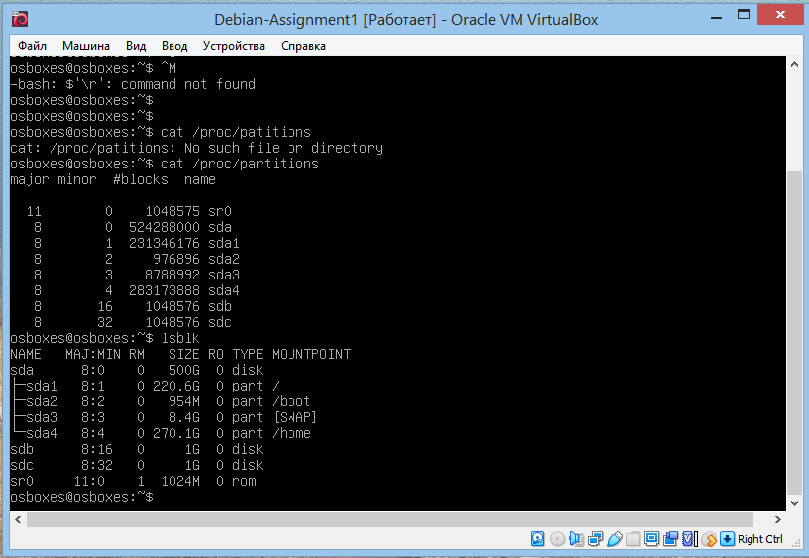

To combine sdb and sdc in RAID1 we need to create partitions and file system for them. We use fdisk and following commands for it.

n – add new partition, p – create primary partition, choose default 1;

p – print partition table (i.e. show configuration of new partition);

w – write changes and exit.

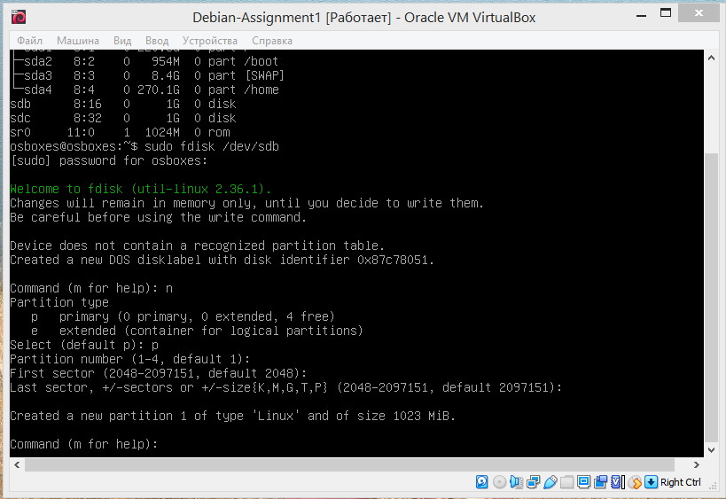

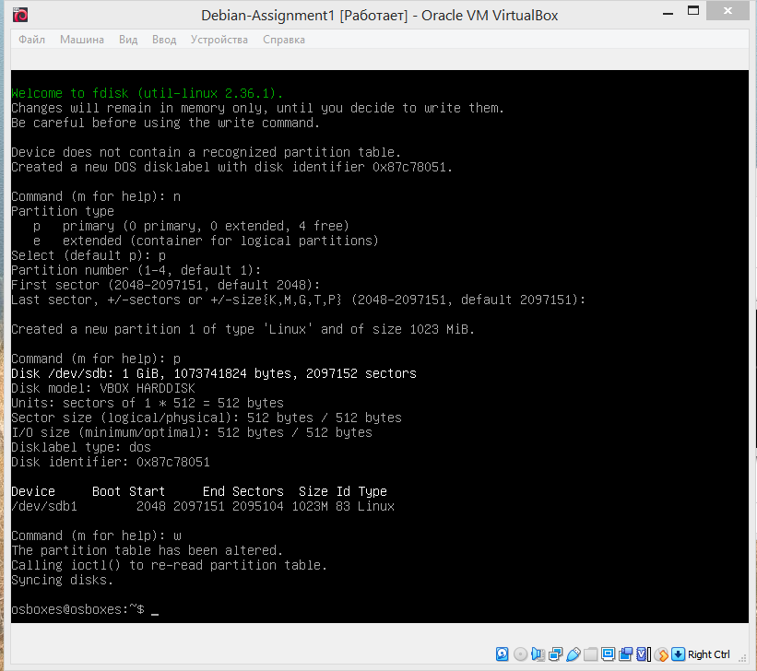Then we need to do the same with other disk and check changes we made with lsblk.

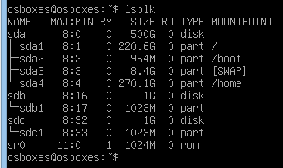

Now we can install mdadm and use it to create a RAID array on /dev/md0 based on the created partitions. We can see that sdb and sdc are in RAID1 now.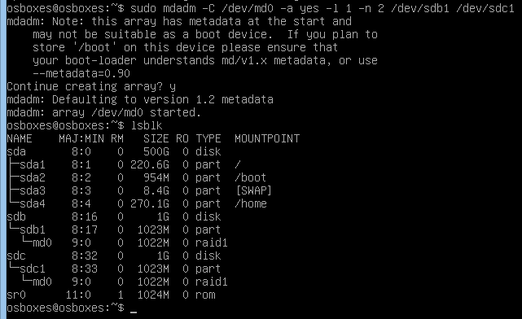

Then we create file system for our RAID1 array and mount it.

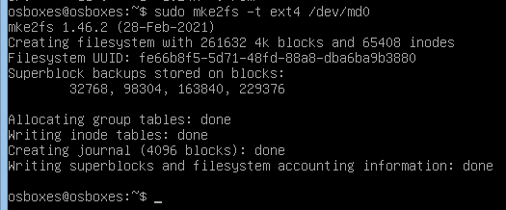

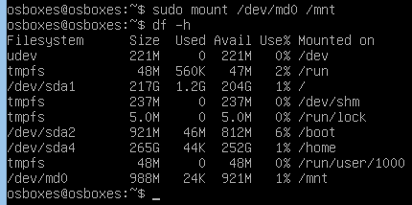

Next, we need to save created partitions so that they are mounted when the system boots.

Firstly, we get UUID of our RAID1.



Write that UUID and other information as follows in /etc/fstab/ file. This file stores descriptions for all units that should be mounted when the system boots.

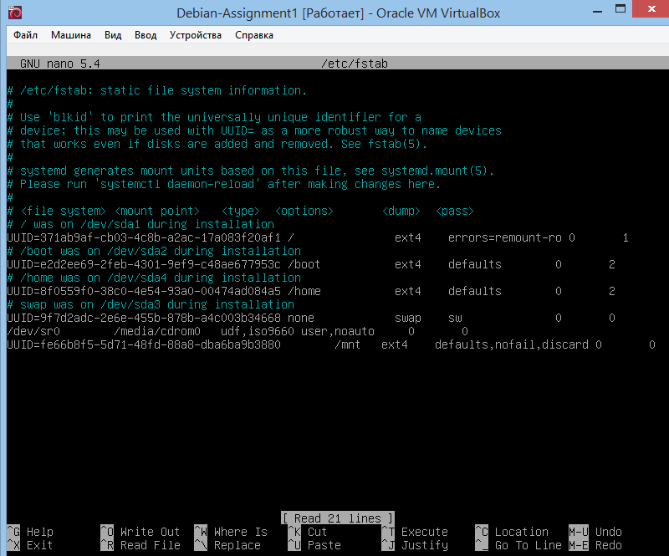

Checking created configuration, no errors.



Let’s test file creation. We go to /mnt and create test-file. We add some text to file to make some weight to it.

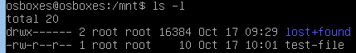

Let's simulate an accident: shutdown virtual machine and remove first disk in settings.

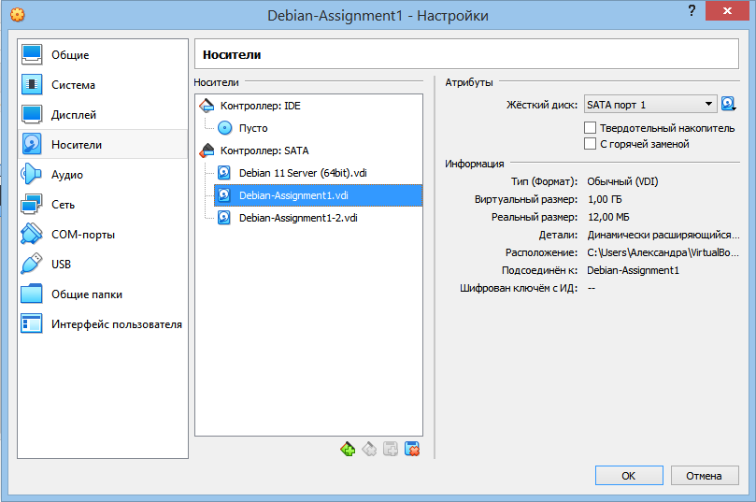

Then run virtual machine.

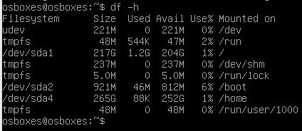

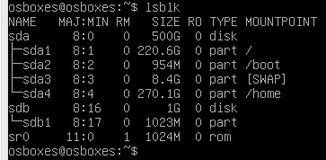

Oops, RAID1 and md0 are absent. Let’s change the approach.

We return first disk to its place, run virtual machine, sdb and sdc are in RAID1 with file system named md127, the file we created is still in /mnt.

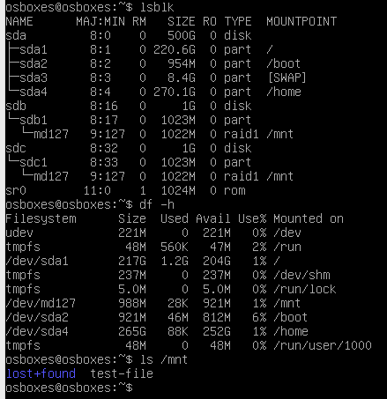

Let’s recreate an accident. Firstly, fail one of the disks.

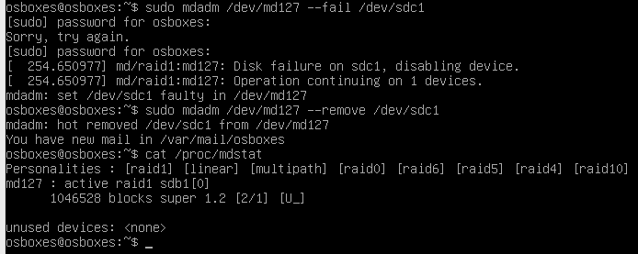

Secondly, we delete the file system from the detached disk.



Then, we shutdown virtual machine and go to settings. We delete second disk, create new disk with number 3.

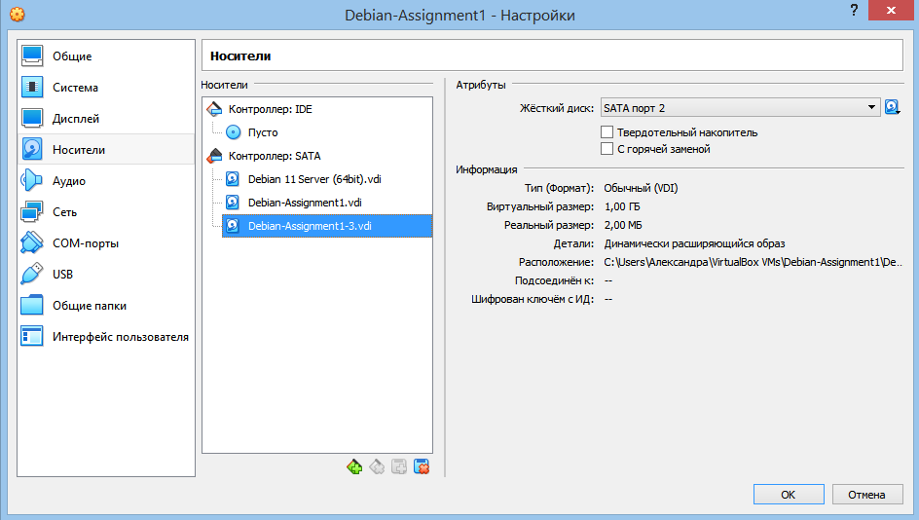

We run the machine and see, that there is only sdb left in RAID1 and we can also see our new disk named sdc.

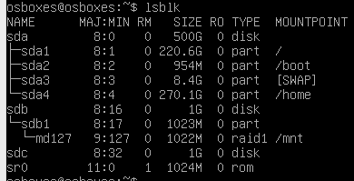

To get new sdc to RAID1 we need to make new partition in it as we did before. Then, we need to add it to RAID as backup disk. With cat /proc/mdstat command we can check its current state, we see 2/2 disk are active.

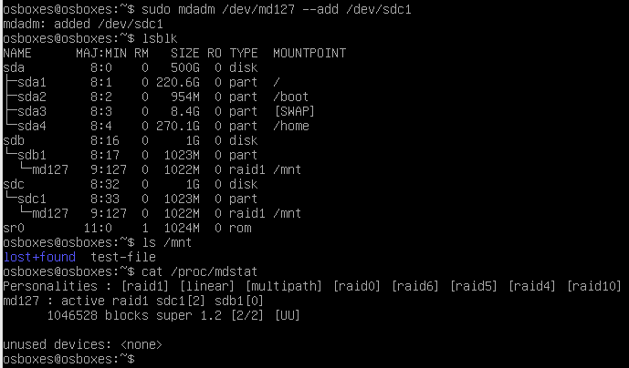

**ЗАКЛЮЧЕНИЕ**

In this work we studied the basic utilities of the Debian system for working with the file system, partitioning and creating RAID arrays. A simple RAID1 was created from two virtual disks. It was tested by imitating a failure of one disk and recovery by creating a backup disk.