МИНИСТЕРСТВО НАУКИ И ВЫСШЕГО ОБРАЗОВАНИЯ  
РОССИЙСКОЙ ФЕДЕРАЦИИ

федеральное государственное автономное   
образовательное учреждение высшего образования  
«Самарский национальный исследовательский университет   
имени академика С.П. Королева»

(Самарский университет)

Институт информатики, математики и электроники

Факультет информатики  
Кафедра суперкомпьютеров и общей информатики

**Отчет по лабораторной работе №1**

Дисциплина: «Развертывание и жизненный цикл программного обеспечения»

Тема: **«VM and RAID»**

Выполнил: Фролов Н. М.

Группа: 6412-100503D

Самара 2022

# TASK

Steps:

1. Create virtual machine with debian/ubuntu/centos or download preinstalled image (https://www.osboxes.org/).
2. Add simple raid1 to virtual machine: *nix os system on 1-st hdd, 2d and 3d hdds are in raid1. 1 (with star). Only two hdds. Os system on raid1, based on this two hdd.
3. How to test raid1. Create file on raid1 file system. Turn off vm and remove one of the hhds from vm. Turn on vm. File should be accessible.
4. Add new hdd and sync it to raid1.
5. Add section with assignment1 description into docx and send by e-mail for checking.

# PROCEDURE

Install an Ubuntu Server 20.04 virtual machine using Virtual Box and add two additional hard drives (Disk_1 and Disk_2) to the virtual machine:

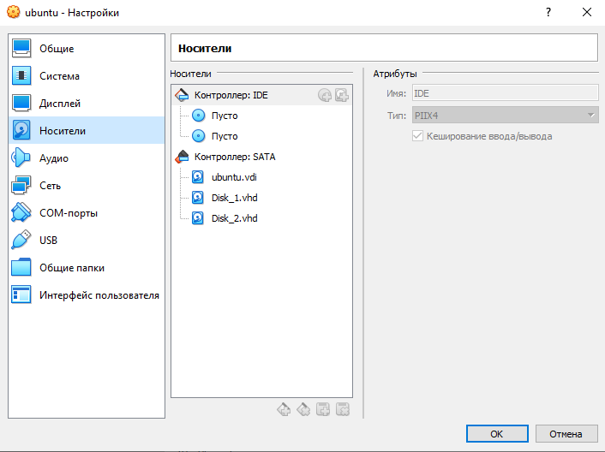

Connect to the virtual machine using SSH as shown below:

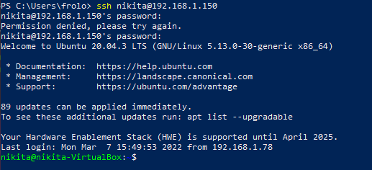

View a list of all virtual machine disks using the lsblk command:

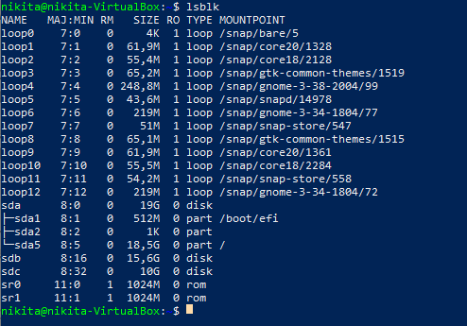

Create RAID1 based on sdb and sdc. In order to do that, create two primary partitions sdb1 and sdc1 respectively with the fdisk utility program:

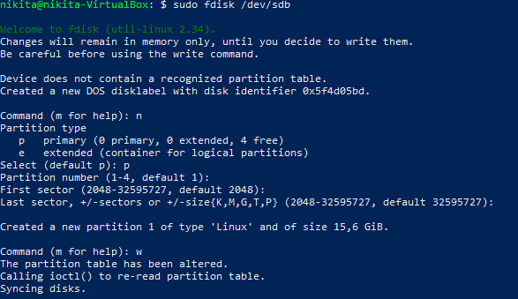

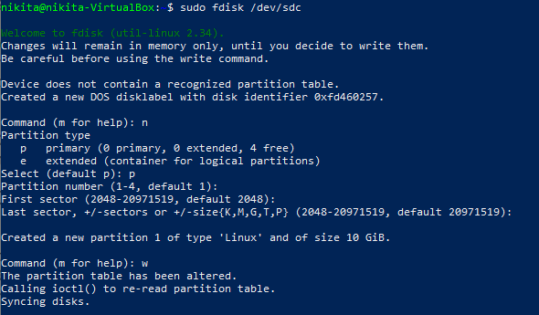

Let's check the result:

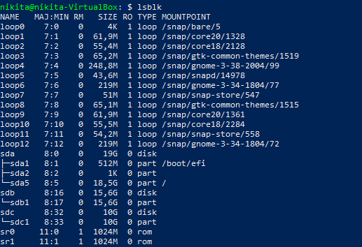

The two partitions created successfully.

Let's create a RAID1 array in /dev/md0 based on the created partitions: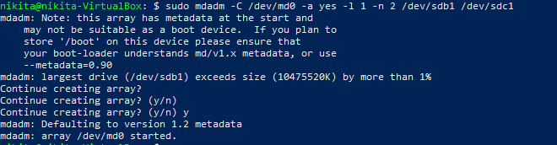

Create a file system based on RAID1:

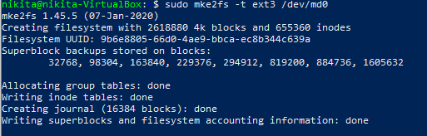

Mount the file system:



Check for success result:

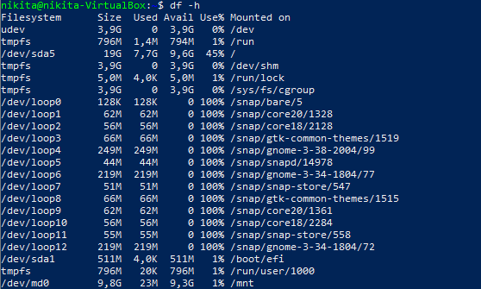

Next, save the created partitions so that they are mounted automatically every time the system boots. To do this, get the UUID for the RAID1 array:



After that, edit the /etc/fstab file containing boot information and paste the UUID there:



Display the edited file:

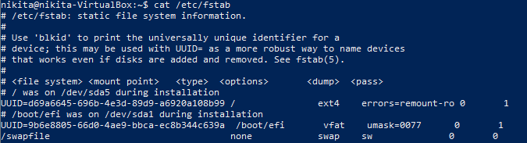

For the RAID1 test, let's add a test file to the /mnt directory, as shown in the figure below:

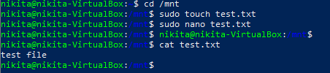

Checking if the file exists :

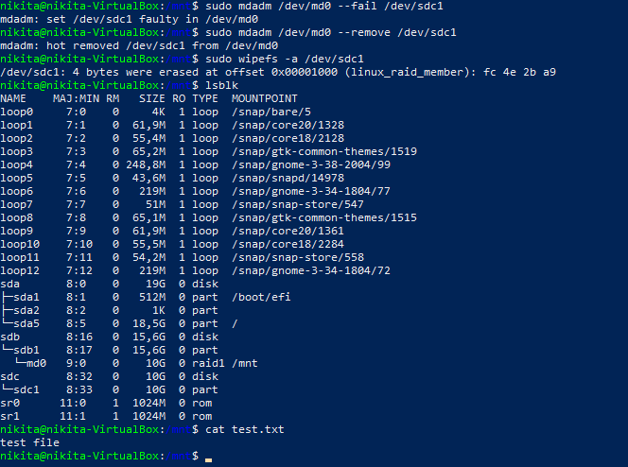

The file remained unchanged. After that, turn off the VM and remove one of the disks:

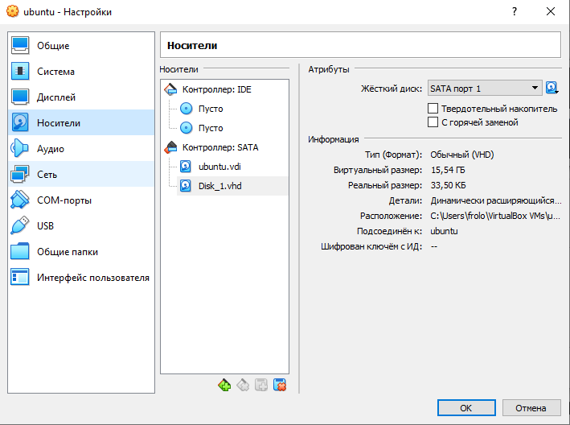

Power on the VM again and map its disks to check if the sdc is completely removed but the file is still untouched:

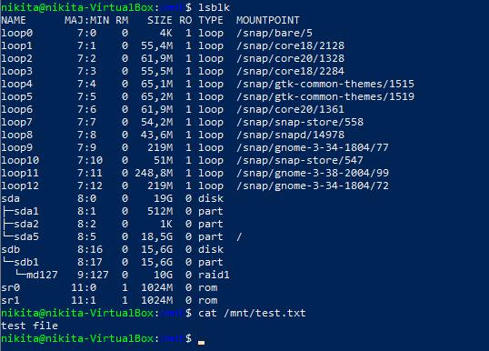

Turn the VM off and add a new HDD (ubuntuDisk3) to it:

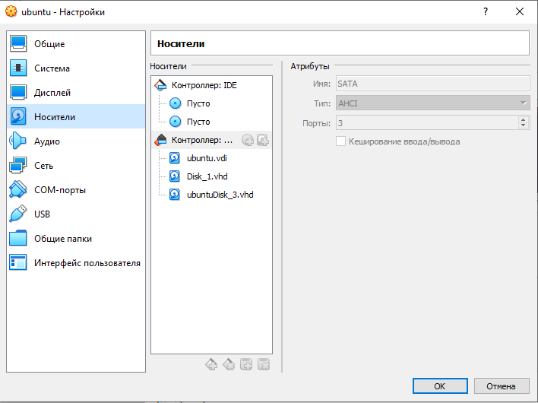

Turn the VM back on and display its disks with command lsblk:

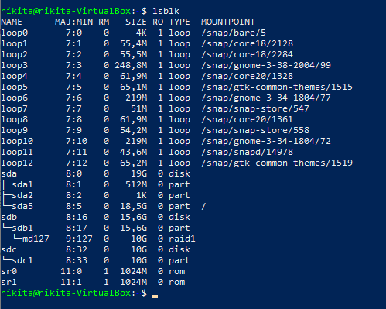

A new hard drive has been detected but not added to the RAID. Let's add it with the following command and check for successful operation.

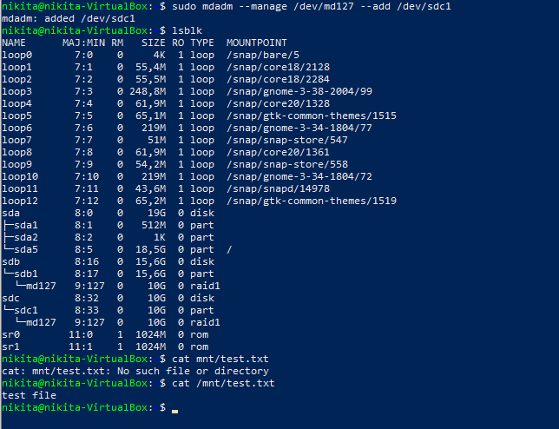

The test file still left unaffected.

# CONCLUSION

At the end of the laboratory work, the main utilities of the Ubuntu system for working with the file system, partitioning and creating RAID arrays were studied. All necessary steps have been successfully completed.