SmartExpense—Expense Tracker Management System

UML Use Case Diagram
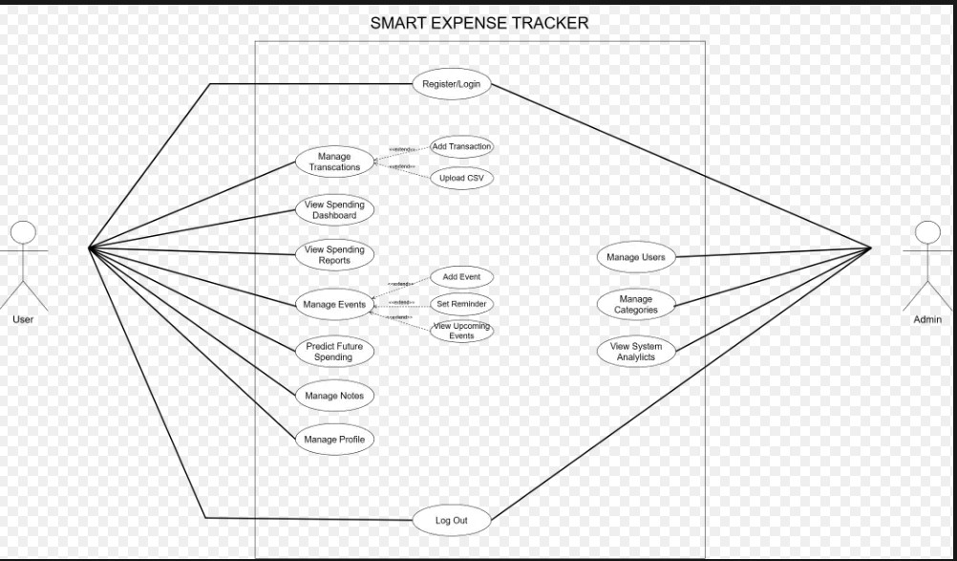
Figure 1: UML Use Case Diagram
Figures: User · Admin
User: Register/Login, Transactions (Add/CSV), Dashboard, Events, Predict Spending, Notes, Profile, Logout | Admin: Manage Users, Categories, Analytics

Data Flow Diagram — Level 0 (Context Diagram)
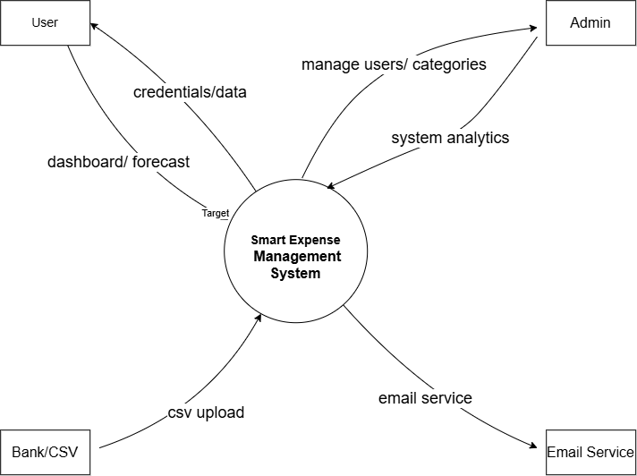
Figure 2: Level 0 DFD — Context Diagram
Spendsight as a single system. Shows all external entities and high-level data flows.
External entities: User · Bank/CSV · Email Service · Admin

Data Flow Diagram — Level 1 (Detailed Process View)
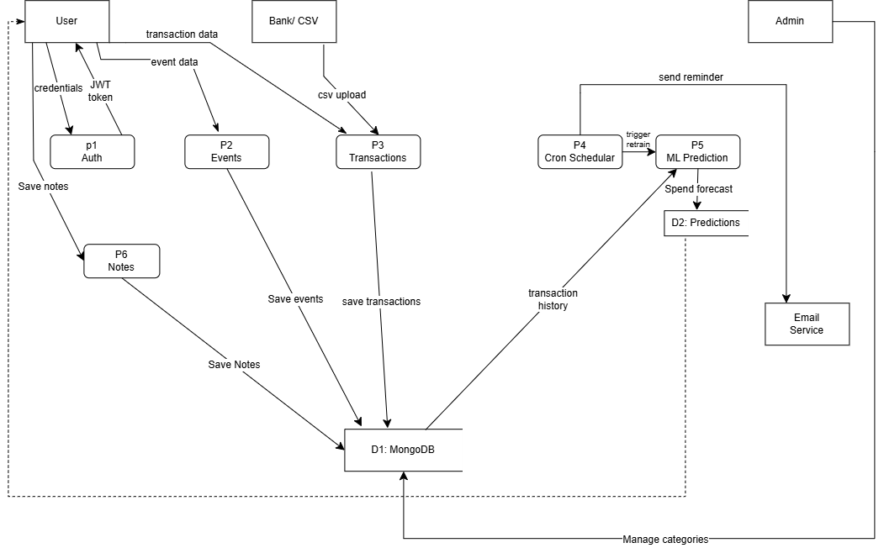
Figure 3: Level 1 DFD — Detailed Process View
Processes: P1 Auth · P2 Events · P3 Transactions · P4 Cron Scheduler · P5 ML Prediction · P6 Notes
Data Stores: D1 MongoDB · D2 Predictions

