SmartExpense—Expense Tracker Management System

UML Use Case Diagram
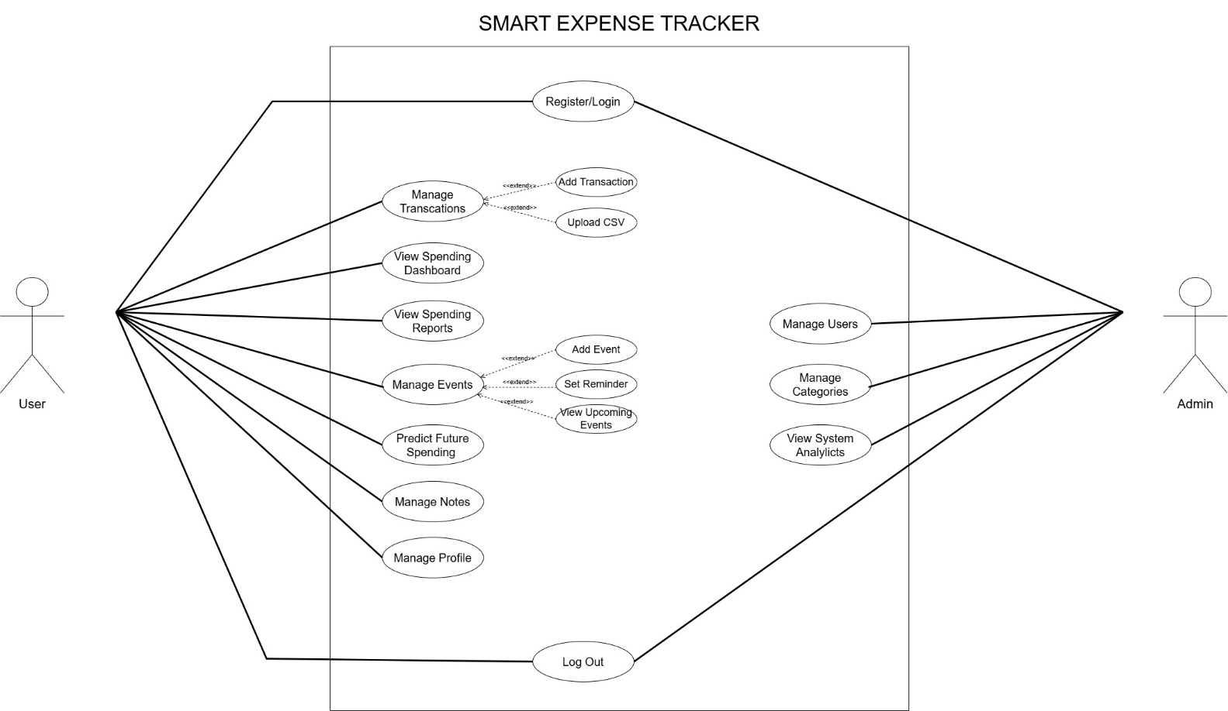
Figure 1: UML Use Case Diagram
Figures: User · Admin
User: Register/Login, Transactions (Add/CSV), Dashboard, Events, Predict Spending, Notes, Profile, Logout | Admin: Manage Users, Categories, Analytics

Data Flow Diagram — Level 0 (Context Diagram)
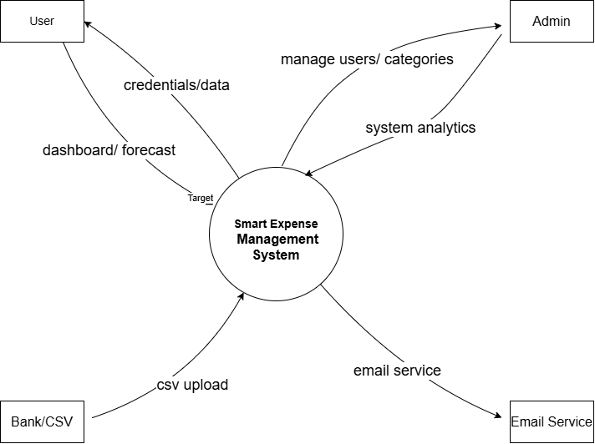
Figure 2: Level 0 DFD — Context Diagram
Spendsight as a single system. Shows all external entities and high-level data flows.
External entities: User · Bank/CSV · Email Service · Admin

Data Flow Diagram — Level 1 (Detailed Process View)
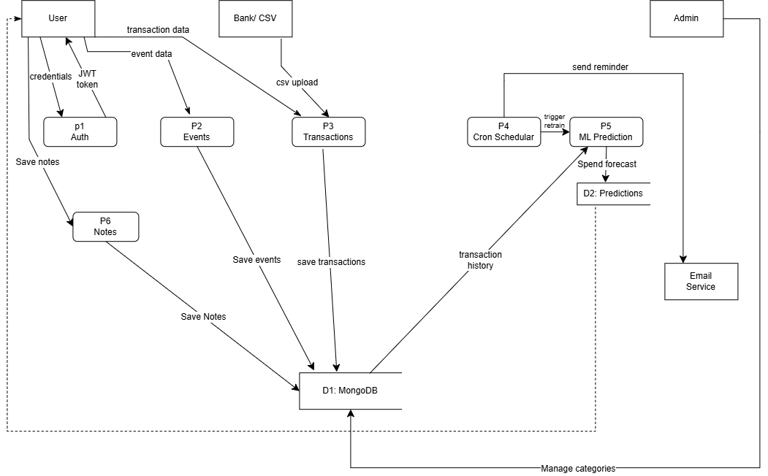
Figure 3: Level 1 DFD — Detailed Process View
Processes: P1 Auth · P2 Events · P3 Transactions · P4 Cron Scheduler · P5 ML Prediction · P6 Notes
Data Stores: D1 MongoDB · D2 Predictions

Data Flow Diagram — Level 2 (P3:Transactions)
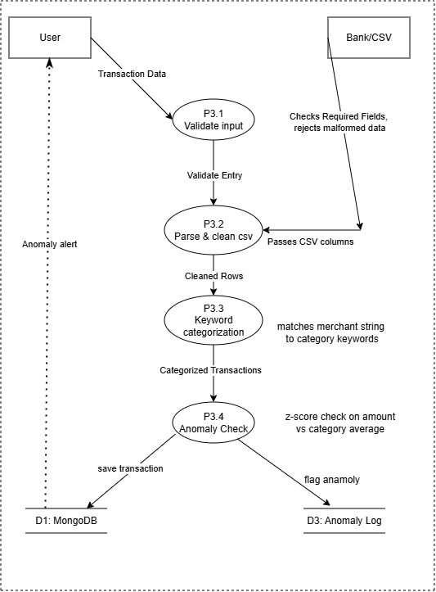
Figure 4: Level 2 DFD — P3 Transactions expanded into 4 sub processes
P3.1 Validate input, P3.2 Parse & Cleans CSV, P3.3 Keyword Categorize, P3.4 Anomaly check
Balancing: inputs(transaction data, CSV upload) and outputs(save transaction, anomaly alert)

Data Flow Diagram — Level 2 (P5:ML prediction)

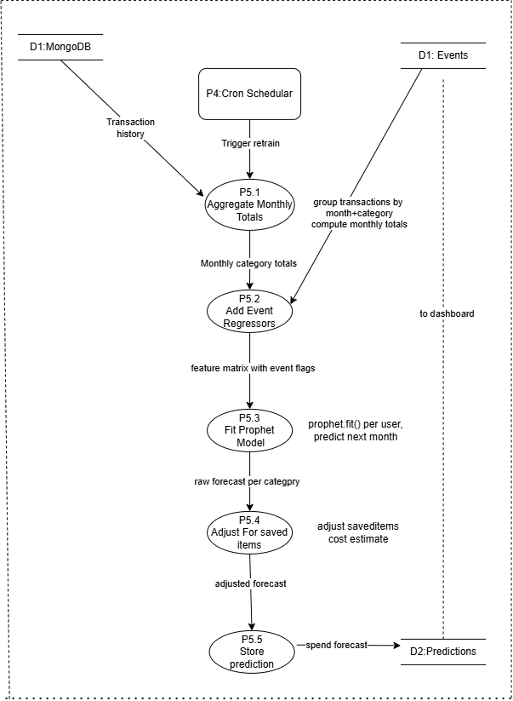
Figure 5: Level 2 DFD — P5 Prediction expanded into 5 sub processes
P5.1 Aggregate , P5.2 event regressors, P5.3 prophet fit, P5.4 saved items check, P5.5 store
Balancing: inputs(transaction history, trigger retrain, event data) and outputs(spend forecast)

