Reviewer: 1

Comments to the Author
The manuscript received gives a modified UC that considers the flexibility potential produced by data centers. The DVFS control scheme is extended to address the detailed demand consumption from data centers. The mentioned topic is timely and relevant, my questions are listed below,

- It is recommended to provide an overall description of the proposed research framework before the discussion of the proposed method.

Response:
Thank you for this wonderful suggestion.
As the review has advised that, a research framework concerning DVFS-controlled Data Center Clusters (DCCs) flexible capabilities is added in the revised manuscript, which is also illustrated as below.

- The contributions to this work should be highlighted and given clearly explanations in the introduction section.

Response:
Thank you for this valuable recommendation.

The main contribution of this work is a reformulated model that describes workload-balancing processes among multiple DCCs, with adjustable power consumption rescheduling via the DVFS technique. Through this, the potential flexibility provided by DCCs can be released to support intra-day scheduling processes. Furthermore, a McCormick envelope method is applied to linearize the constructed control processes for workload allocation among multiple DVFS-controlled DCCs, and then a reshaped SOS-1-type constraint is extended.

To further highlight the significance of this work, the contributions have been rewritten in this round, which are listed below. Thank you for reminding us.
- A set of physical security constraints is developed to characterize the multi-DCC workload process and the refined power consumption adjustment of individual DCCs governed by the DVFS mechanism. These proposed DCC-related constraints are subsequently linearized using the McCormick envelope technique to ensure computational tractability in large-scale scheduling formulations. It is worth emphasizing that the reformulated physical constraints can also be extended to power system planning problems, where the flexibility contribution of DCCs is explicitly considered.
- A refined DCC-constrained unit commitment (UC) model is formulated to capture the flexibility potential of DVFS-controlled DCCs accurately. Through this model, the available flexibility contributions from both DCCs and battery energy storage systems (BESSs) can be effectively quantified and coordinated within system operations.
- The effectiveness of the proposed DCC-related constraints embedded within the UC framework is validated using a modified IEEE 30-bus test system. In this case study, the reallocated power distributions across multiple DCCs and the detailed power consumption profiles of individual DCCs managed through the DVFS mechanism are quantitatively evaluated. Furthermore, the computational performance, including memory usage and overall solving efficiency, is compared and analyzed before and after incorporating the flexibility potential offered by multi-DCCs.

- It seems that the DVFS-controlled behind data center clusters is a novel point in this work. It is recommended to provide more description and discussions about the control logic in the DVFS-controlled data center clusters.

Response:
Thank you for this worthful suggestion.
To help reader clearly understand the logic route of this work, both flexibility potential assessment of DVFS-controlled DCCs and its application under scheduling processes is explained before deriving relevant control constraints representing DVFS-controlled DCCs. In addition, an overall research framework is provided in the revised manuscript.
Dynamic Voltage and Frequency Scaling (DVFS) is a key technique for enhancing energy efficiency and computational flexibility in DCC workload management. By dynamically adjusting the processor’s operating voltage and frequency according to real-time workload demands, DVFS enables an effective trade-off between performance and power consumption (see figure 1). Since chip power consumption is approximately proportional to the square of the voltage and linearly proportional to the frequency, DVFS can significantly reduce both energy use and heat generation during low-load periods, while restoring high-frequency operation under heavy workloads. This dynamic adjustment allows DCCs to maintain computing reliability and performance while achieving suitable workload tasks and low time-instant requirement.
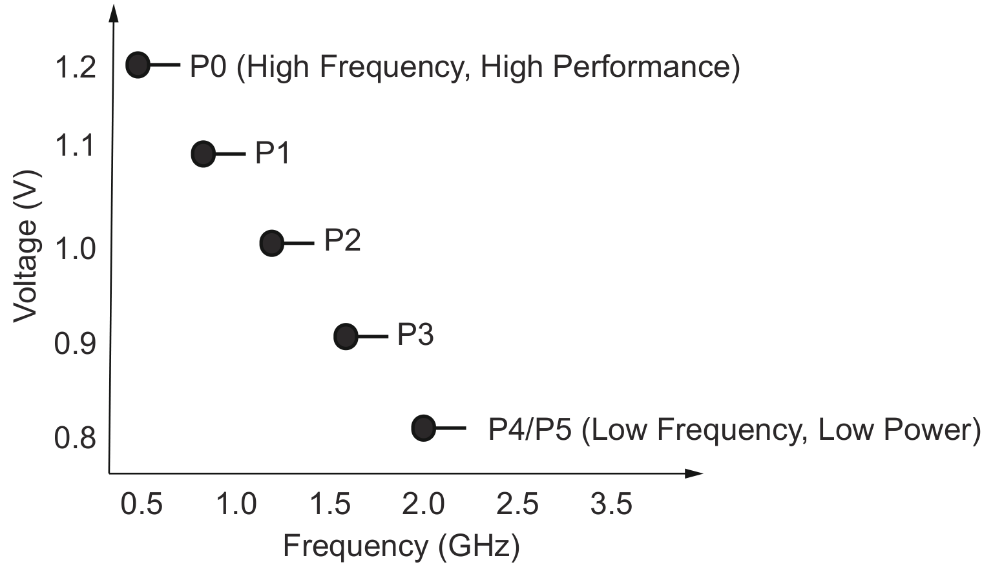
Figure.1 DCC workload power consumption along with voltage and dynamic frequency changing.

- Figure.8 and figure.11 compares the voltage and power consumption of DCCs under different redistribution intervals. Nevertheless, it is still unclear how the voltage and power consumption of DCCs are affected by the redistribution intervals. It is suggested to provide more detailed explanations in the main text.

Response:
Thank you for your suggestion.
To better illustrate the difference before and after considering the flexibility potential provided by DCC across the entire scheduling process, the following figure shows the reallocated power consumption for individual DCC device. In Figure 2, the workload demand curve, represented by the light-red area, corresponds to the high- or medium-workload DCC types. In contrast, the remaining curves, marked by the light-green area, represent light-workload states. In comparison with subfigure 2(a) that describes the initial workload distribution hosted by individual DCC devices, the light-workload DCC in sub-figures 2(b)-2(e) would increase their load consumption. At the same time, the heavy workload of DCC would decrease its demand for contracts. This prehension shows the workload reallocation among multiple DCC devices, also known as workload-balancing processes. Nevertheless, such load-balancing processes cannot occur at any time. For each workload type, the reallocated workload-balancing processes are also affected by the delay rate, which limits load balancing to the current time instant or to adjacent upstream and downstream time instants.
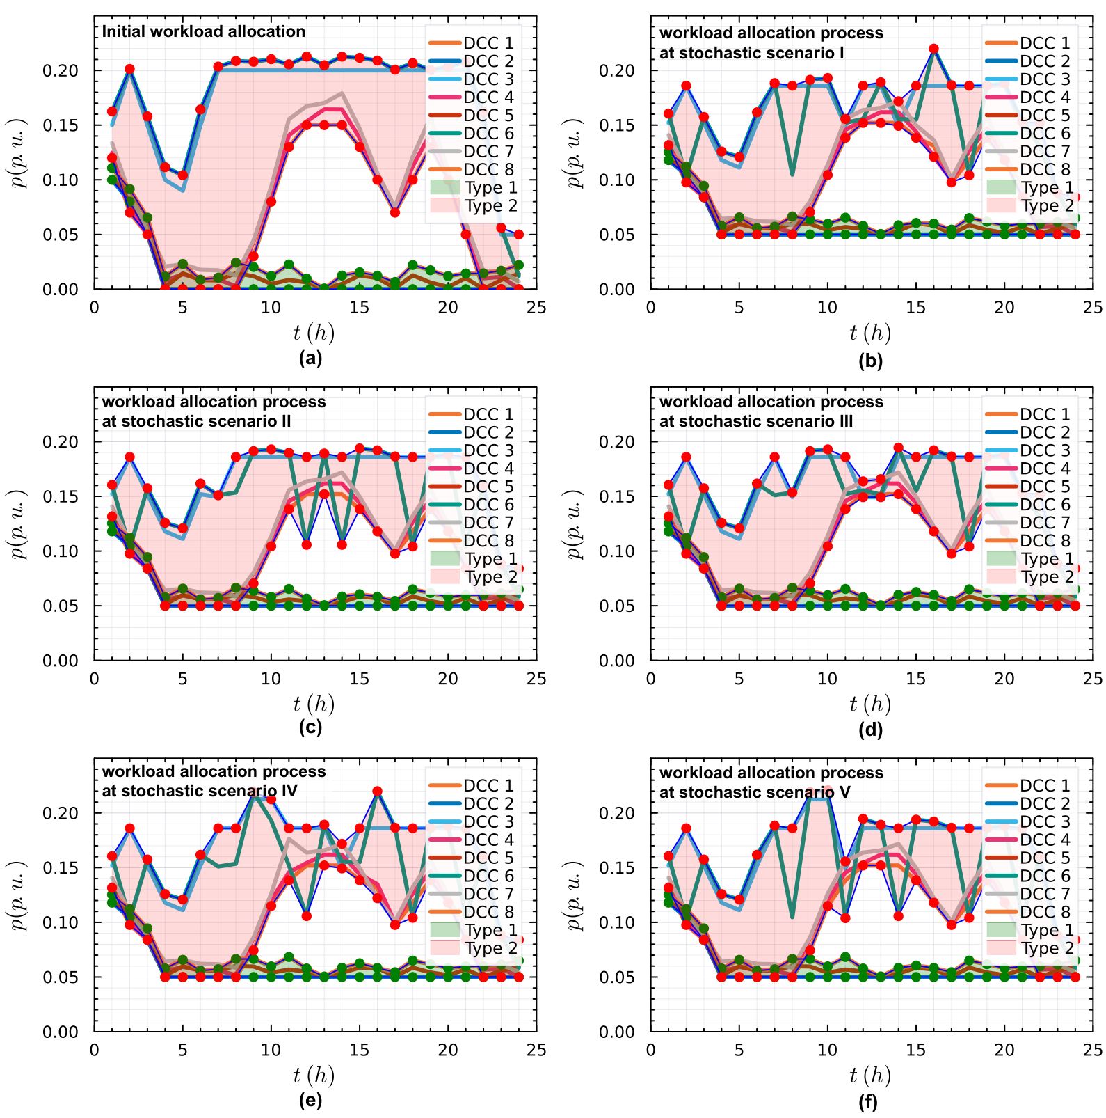
Figure.2 workload power consumption of individual DCC device through the proposed model: (a) initial pre-defined workload consumption for each DCC, and (b)-(f) reallocated workload power consumption for each DCC device.

Reviewer: 2

Comments to the Author
This paper discusses the application of data center clusters through DVFS-based control in the operation process of power systems. The extended UC model considering DVFS-controlled DCCs is compared with existing literature, and the results seem promising. However, there are several issues that need improvement:

- Supplementing the running time is suggested to further verify the feasibility of the proposed method in near real-time scheduling.

Response:
Thank you for your valuable suggestions.

According to the proposed methodology, the runtime of the refined UC that accounts for the potential flexibility across multiple DCCs is about 200s-300s. For the problems and performance requirements of approximate real-time scheduling, we usually meet the requirement that the (real-time) scheduling solution time does not exceed 15 minutes, which is feasible for system tests of this scale. Nevertheless, for the unit commitment (UC) problem in large-scale power systems, due to the NP-hard nature of UC itself, there remains a significant gap when considering the active cooperation of many data centers in responding to scheduling instructions. Although this problem is not solely due to the complexity of the data center's modeling process, this paper still provides an in-depth discussion of the issues mentioned earlier. In addition, the runtime and memory resource usage of the proposed methods relative to baseline models is added to the modified manuscript.

- The McCormick envelops technique is applied to linearize the bilinear terms when modeling the DVFS-controlled DCCs. It is suggested to add the runtime and GPU memory consumption of the proposed method in comparison with benchmark.

Response:
Thank you for your wonderful recommendation.

According to the proposed methodology, the runtime of the refined UC studies considering the potential flexibility from multi-DCCs is 193.62MiB, while the one using the benchmark is 26.067MiB. Note that the constraint reformulation and sequential calculation processes for DVFS-controlled DCC-constrained UC studies (the proposed) are implemented using a commercial solver (e.g., Gurobi) or open-source solvers (e.g., Ipopt, Cbs, and Hips). Therefore, the thread allocation for such MIP optimization is likely to be on the CPU rather than the GPU. By further comparing memory consumption between the proposed model and the benchmark, we found that the proposed method runs in 282.547s, while the benchmark runs in 0.831s. Therefore, adopting the constraint reconstruction strategy proposed in this paper has a limited impact on overall solution time and CPU memory usage. From this point, the proposed model can be used to refine the description of DCC contribution in terms of active response and provision of regulatory reserve capacity.
Also, both the calculation time and memory resources of the proposed methods relative to baseline models are added to the modified manuscript.

- In the section. II, please provide a high-level description about SOS-1 constraints before deriving the operations constraints of DVFS-controlled DCCs. Availability, a simplified illustrative example (possibly with a two-variable case or graphical explanation) would significantly improve accessibility for readers.

Response:
Thank you for your valuable suggestion.
As you have suggested, we have provided an easy-to-understood case to explain the detailed constraint reformation processes from the original physical constraints to the linearized SOS1 type.
For individual DVFS-controlled DCC device, its workload power consumption can be derived as $p=fv^{2}$. Since both DCC frequency and voltage are continuous variables, and the adjusted bound for f can be assumed as (0.5, 1.5), and the bound for v remains as (0.8, 1.25), then, an equivalent constraint representing DCC workload consumption can be rewritten as below,
$$\begin{aligned}p={\left(\frac{f+v^{2}}{2}\right)}^{2}-{\left(\frac{f-v^{2}}{2}\right)}^{2}\#\left(1\right)\end{aligned}$$
For the sake of note simplification, let k1, k2, respectively, denote the value of $\frac{f+v^{2}}{2}$ and $\frac{f-v^{2}}{2},$ then, the equation (1) can be directly simplified as $p={\left(k_{1}\right)}^{2}-{\left(k_{2}\right)}^{2}$. The advantage of this conversation through (1) is that x and y themselves are non-convex and nonlinear, which cannot be identified through shed-on-off solvers. However, both k1 and k2 in (1) keep convex quadratic term. Through this transformation, the original non-convex optimization problem can be converted into a convex constrained problem.
In the next step, we just need to perform differential linearization on k1 and k2 and incorporate their differential form into the above constraints. That is,
$$\begin{aligned}\left\{\begin{matrix}k_{1}= \sum_{n=1}^{N}{k_{1}^{\left(n\right)}ω_{1}^{\left(n\right)}},∀n∈\left\{1,2,3,…,N\right\} \\ k_{2}= \sum_{n=1}^{N}{k_{2}^{\left(n\right)}ω_{2}^{\left(n\right)}},∀n∈\left\{1,2,3,…,N\right\}\end{matrix}\right.\#\left(2\right)\end{aligned}$$
where $k_{1}^{\left(n\right)}$, $k_{2}^{\left(n\right)}$ denote the discrete differential values of $k_{1}$ and $k_{2}$, respectively. Here, the value of k1 determined by selecting the current actual discrete value $k_{1}^{\left(n\right)}$ at the n-th block, with all other discrete terms remain inactive, analogously, the value of k2 is determined in the same manner. From this viewpoint, additional indicator variables $ω_{1}^{\left(n\right)},ω_{2}^{\left(n\right)}$ can thus be introduced to characterize whether to adopt the current value. On this basis, to restrict the uniqueness of k1 and k2 within their discretized differential value intervals, it is obviously necessary to add the SOS-1 constraint (3),
$$\begin{aligned}\left\{\begin{matrix} \sum_{n=1}^{N}{ω_{1}^{\left(n\right)}}=1,∀n∈\left\{1,2,3,…,N\right\} \\ \sum_{n=1}^{N}{ω_{2}^{\left(n\right)}=1},∀n∈\left\{1,2,3,…,N\right\}\end{matrix}\right.\#\left(3\right)\end{aligned}$$
By integrating the operations mentioned before, the product terms among the aforementioned variables can be decomposed into a combination of convex-type constraints through ingenious constraint transformation and SOS-1 reformulation. The following figure.3 illustrates the correspondence between the solution derived using SOS-1 and the original constraints. It can be observed that the adopted constraint reformulation process is capable of accurately depicting the structure of the original constraints.

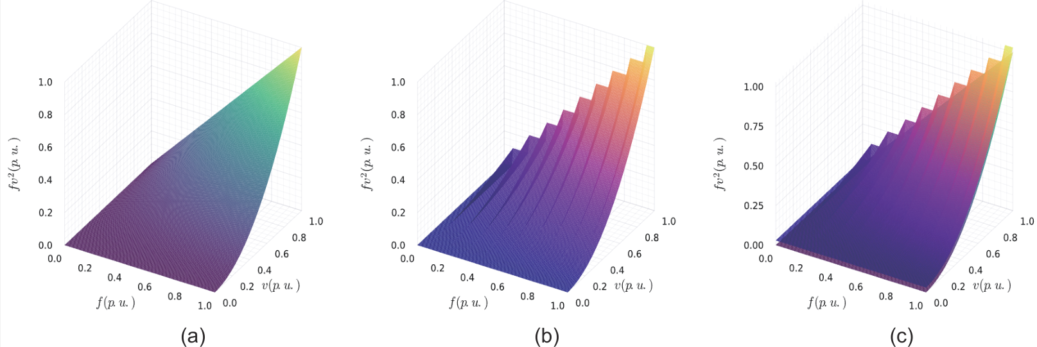
Figure.3 The nonlinear constraint $fv^{2}$ consisting of a product of two continuous variables corresponds to the decision variables $f$ and $v$, as well as the linearization reformulation process: (a) the original constraints structure, (b) the SOS1-type discretized reformulated constraint, and (c) the difference between original constraints and reformulated constraints.

- It is suggested to add a detailed description of the workload balancing and DVFS control strategy, the difference between these two physical processes is also suggested to be explained.

Response:
Thank you for reminding us.
In the revised manuscript, we provide a high-level academic framework describing the overall workload reallocation among multi DCCs and adjustable demand consumption hosted on individual DCC device.

In the revised manuscript, we introduce a structured high-level framework that systematically describes the coordinated workload reallocation among multiple DCCs, as well as the adjustable demand allocation deployed on individual computational devices within each DCC. The framework captures the interaction between global dispatch decisions and local resource management, highlighting how distributed workloads can be dynamically migrated, consolidated, or throttled in response to demand fluctuations, energy constraints, and operational flexibility. By incorporating workload shifting, demand elasticity, and fine-grained control of device-level consumption through DVFS, the proposed structure provides a unified representation of cross-center coordination and intra-center scheduling, enabling more efficient, robust, and energy-aware DCC operation.

- Some abbreviations (such as "UC" and "BESS") do not provide complete definitions when they first appear in the context (although they are implicitly defined in the abstract). It is suggested to add a complete description of the abbreviations in the nomenclature section.

Response:
Thank you for your kindness.

we have corrected them in the revised manuscript. In addition, similar grammar issues and spelling problems have been also double-checked in the revised version.

- The manuscript contains several grammatical and typographical errors (e.g., “shut-up/shut-down” should be “start-up/shut-down”). A thorough proofreading or professional English editing service is recommended.

Response:
Thank you for your suggestion. we have double-checked potential grammatical issues in this manuscript and corrected them in this round. Thank you again.

Reviewer: 3

Comments to the Author
This manuscript extends a DCC-constrained UC model to analyze the flexible capabilities of large-scale DCCs through DVFS control scheme. The topic is interesting and timely, and the structure of the entire manuscript is well organized, but the settings of case studies need to be improved, and my concerns are listed below.

- It is recommended to clearly distinguish between the effects of load balancing processes across multi DCCs and the detailed DVFS control scheme hosted within individual DCC in this paper, and a more high-level explanation describing these two processes would be better for enhancing readability.

Response:
Thank you very much for your valuable suggestion.

The major difference between workload reallocation and balancing process and workload adjustable power consumption regulation process through DVFS lies in the distinct power control objects and control manners. The former processes occur among multiple DCC devices, and this process is an inter-DCC level workload reallocation behavior. During this process, the system reallocates computational workload among geographically distributed DCCs to maintain power balance and optimize system-wide consumption, in addition, suitable time latency requirement should be additionally reconsidered over the workload reallocation processes.
In contract, the latter workload consumption processes occur for individual DCC device, and this process is an intra-DCC level workload power consumption regulation stage. Each DCC further refines its power usage through DVFS-based adjustment on individual computing devices, enabling fine-grained, rapid, and controllable demand response. During this process, suitable frequency parameter and voltage parameters are essential when applying DVFS techniques.

This clarification is now included in the revised Introduction and Method sections. By separating the roles of global workload reallocation and local DVFS-based consumption tuning, the logical structure of the proposed model becomes clearer and easier to understand.

- The contribution should be highlighted, and the significance of this work differs from existing relevant studies be added in the introduction section.

Response:
Thank you very much for your constructive suggestion.

According to the advice suggested by the reviewer, we have carefully revised the Introduction and clearly emphasized the significance and innovative aspects of our work. In the revised manuscript, we provide a structured description of modeling about workload-balancing process across multiple DCCs, along with adjustable power-consumption rescheduling enabled by the DVFS technique. In addition, we explicitly explain how this mechanism releases the potential flexibility of DCCs to support intra-day scheduling.

The signification of this work can be summarized as below,
- A set of physical security constraints is developed to represent multi-DCC workload transitions and refined power-consumption adjustments for individual DCCs governed by the DVFS mechanism. These constraints are further linearized using the McCormick envelope technique to ensure computational tractability. It is worth noting that the reformulated constraints can be directly applied to power system planning scenarios that explicitly consider DCC flexibility.
- A refined DCC-constrained unit commitment (UC) model is formulated to capture the flexibility potential of DVFS-controlled DCCs accurately. With this formulation, the scheduling contributions from both DCCs and BESSs can be jointly quantified and coordinated in system operations.
- The effectiveness of the proposed constraints embedded in the UC framework is validated on a modified IEEE 30-bus system. The case study evaluates reallocating power across multiple DCCs and detailed consumption profiles of individual DCCs under DVFS operation. Furthermore, both computational performances, including memory usage and solution efficiency, is compared before and after the integration of DCC flexibility.

- The coordinate axis labels and unit descriptions in Fig. 8 and Fig. 9, can be further clarified and standardized to ensure accuracy and ease of interpretation.

Response:
Thank you for your kindness.

We have corrected them in the revised manuscript. Both fig. 8 and fig. 9 have also been redrawn to meet publication standards and requirements.

- The support benefits from DCCs are reflected through power balance and frequency control, the authors are encouraged to elaborate on the role and significance of DCCs in frequency dynamic response. This would better emphasize their practical importance.

Response:
Thank you the reviewer’s insightful suggestion.

we have expanded the discussion in the introduction section of the revised manuscript to present a clearer explanation of how DCCs contribute to frequency stability and dynamic response. As modern DCCs are capable of fast power modulation through workload shifting and DVFS-based consumption adjustment, they provide rapid and fine-grained controllable demand flexibility. The benefit of DCC participating into frequency support lies in, 1) DCCs can increase or decrease computational power usage depending on system frequency deviation, 2) DVFS-enabled power adjustments allow DCCs to serve as virtual fast-response controllable resources, helping to mitigate renewable fluctuations, and 3) These features make DCCs valuable contributors to real-time frequency dispatch, enhancing short-term stability and reducing reliance on conventional generators. These revisions strengthen the practical significance of the proposed model and clarify the role of DCCs in supporting frequency-related ancillary services.

Besides, the discussion of DCC on how to provide frequency support is also extended in the conclusion section of the revised manuscript.

