**ELEC 374 – Digital Systems Engineering**

**Phase 3 Report**

**Group 18**

**Divaydeep Singh 20143859**

**Lucas Austin 20061953**

**Code**

Ctrl_unit.v

main1.v

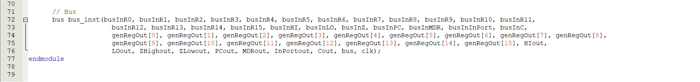

pc_reg.v

memSubsys.v

datapath_tb.v

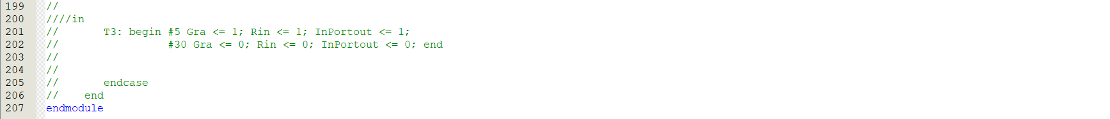

**Functional Simulations**

Instructions 0-15

Instructions 16-31

Instructions 32-end

**State of memory**

Memory before run

Memory after run

Memory before run (Hex)

Memory after run (Hex)

