

**Homework Assignment 1 (20 Points)**

**CSE 100, Fall B 2013**

**CIDSE, Arizona State University**

**Please see submission instructions given in the last page**

**------------------------------------------------------------------------------------------------------------------------------------------**

**Introduction:** This assignment helps you to reinforce the topics discussed in the class including a) Problem solving process

1. Using cin and cout objects
2. Develop a program that involves data input, variables, and arithmetic operations.

**Part I**

**1. [5 Points] Names and Places:** The goal in this exercise is to develop a program that will print out a list of student names together with other information for each. The tab character (an escape sequence) is helpful in getting the list to line up nicely. A program with only two names is in the file Names.cpp.

// *************************************************************** // Names.cpp

//

// Prints a list of student names with their hometowns

// and intended major

// ***************************************************************

#include<iostream> using namespace std;

int main()

{

// ------------------------

// main prints the list

// ------------------------

cout<<endl;

cout<<"\tName\t\tHometown"<<endl; cout<<"\t====\t\t========"<<endl; cout<<"\tSally\t\tRoanoke"<<endl;

cout<<"\tAlexander\tWashington"<<endl;

cout<<endl;

}

1. Save Names.cpp your directory. Compile and run it to see how it works.
2. Modify the program so that your name and hometown and the name and hometown of at least two classmates are printed. Save, compile and run the program. Make sure the columns line up.
3. Modify the program to add a third column with the intended major of each person (assume Sally's major is Computer Science and Alexander's major is Math). Be sure to add a label at the top of the third column and be sure everything is lined up (use tab characters!).

Submit the modified program (See submission instructions given in the last page).

Part II

**2. [15 Points] Ideal Weight Program:**

Write a program to compute the ideal weight for both males and females. According to one study, the ideal weight for a female is 100 pounds plus 5 pounds for each inch in height over 5 feet. For example, the ideal weight for a female who is 5'3" would be 100 + 3*5 = 115 pounds. For a male the ideal weight is 106 pounds plus 6 pounds for each inch in height over 5 feet. For example, the ideal weight for a male who is 5'3" would be 106 + 3*6 = 124 pounds. *Your program should ask the user to enter his/her height in feet and inches (both as integers—so a person 5'3" would enter the 5 and the 3). It should then compute and print both the ideal weight for a female and the ideal weight for a male. The general outline of your main function would be as follows:*

 Declare your variables (think about what variables you need—you need to input two pieces of information (what?), then you need some variables for your calculations (see the following steps)

Get the input (height in feet and inches) from the



Compute the total number of inches of height (convert feet and inches to total inches, ***note: 1 foot equal 12 inches and hence 5 feet equal 60 inches***)

 Compute the ideal weight for a female and the ideal weight for a male ( please see the assignment for sample calculation )

Display the answers



You can assume that people use this software are at least 5 feet tall

Plan your program, then type it in, compile and run it. Be sure it gives correct answers. When a user runs your program, he/she should see the following output

Program output should be something similar to the one shown below(notice that feet and inches are given in the same line separated by space):

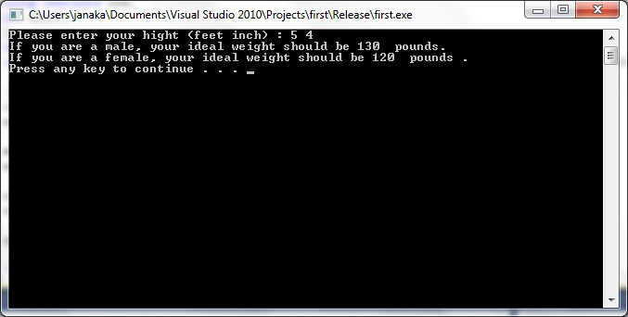

**Submit your homework by following the instructions below:**

*********************************************************************************

* Submit your **Assignment1.cpp** file on-line to the homework 1 basket of dropbox.

* **Assignment1.cpp** should have the following, in order:

o In comments, the answers to written exercises for part one o The working C++ code requested in Part #2.

**Important Note:** You may resubmit as many times as you like until the deadline, but we will only mark your last submission.

**NO LATE ASSIGNMENTS WILL BE ACCEPTED**