EEE 120: Digital Design Fundamentals
Summer 2014

Sample & Practice Problems - Week 1

Please (a) review the sample problems, (b) complete the partially completed Practice Problems and (c) complete the remaining Practice Problems. This will prepare you for the Quiz 1 (Week 1).

- Which circuit belongs to which column in the following truth table?
A | B | w | x | y | z
0 | 0 | 1 | 1 | 0 | 1
0 | 1 | 0 | 0 | 0 | 0
1 | 0 | 0 | 0 | 1 | 1
1 | 1 | 1 | 1 | 0 | 1

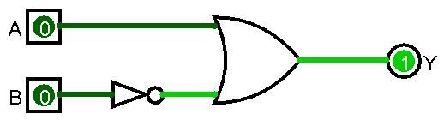
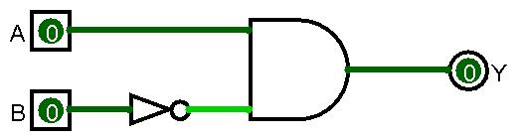

z

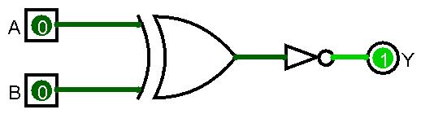
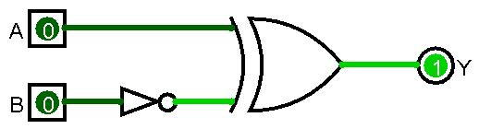

- Is the following circuit doing anything useful? Which signal appears at the output?
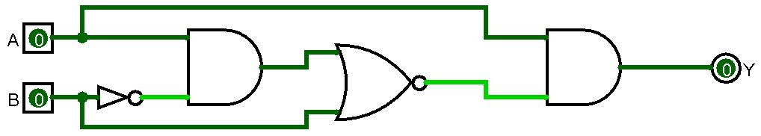

- Why are the following circuits showing an error at the output?
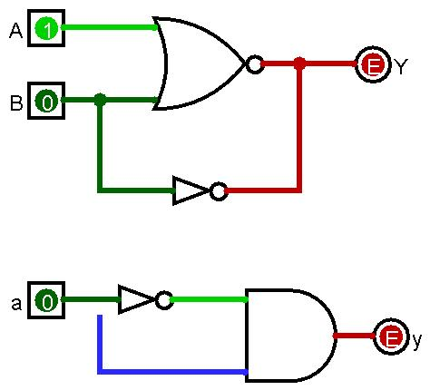
- Write down the truth table for the following digital logic circuits:
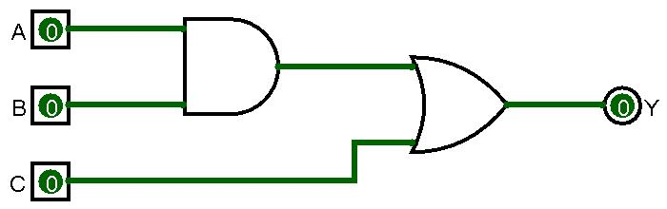
T
A | B | C | T | Y
0 | 0 | 0 | 0 | 0
0 | 0 | 1 | 0 | 1
0 | 1 | 0
0 | 1 | 1
1 | 0 | 0
1 | 0 | 1
1 | 1 | 0
1 | 1 | 1 | 1 | 1

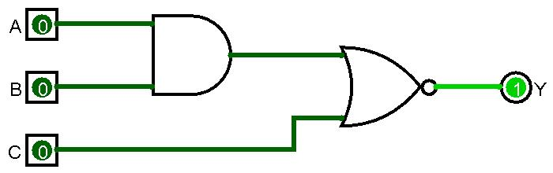
T
A | B | C | T | Y
0 | 0 | 0 | 0 | 1
0 | 0 | 1 | 0 | 0
0 | 1 | 0
0 | 1 | 1
1 | 0 | 0
1 | 0 | 1
1 | 1 | 0
1 | 1 | 1 | 1 | 0

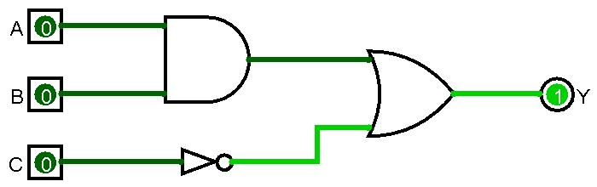
T
A | B | C | T | Y
0 | 0 | 0 | 0 | 1
0 | 0 | 1 | 0 | 0
0 | 1 | 0
0 | 1 | 1
1 | 0 | 0
1 | 0 | 1
1 | 1 | 0
1 | 1 | 1 | 1 | 0

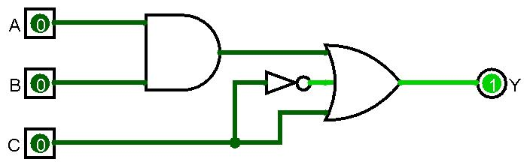
A | B | C | T | Y
0 | 0 | 0 | 0 | 1
0 | 0 | 1
0 | 1 | 0
0 | 1 | 1
1 | 0 | 0
1 | 0 | 1
1 | 1 | 0
1 | 1 | 1

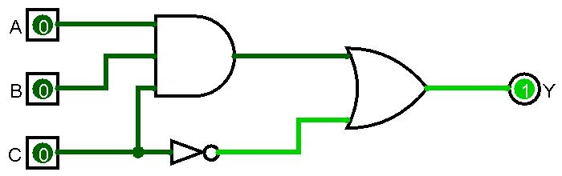
A | B | C | T | Y
0 | 0 | 0 | 0 | 1
0 | 0 | 1
0 | 1 | 0
0 | 1 | 1
1 | 0 | 0
1 | 0 | 1
1 | 1 | 0
1 | 1 | 1

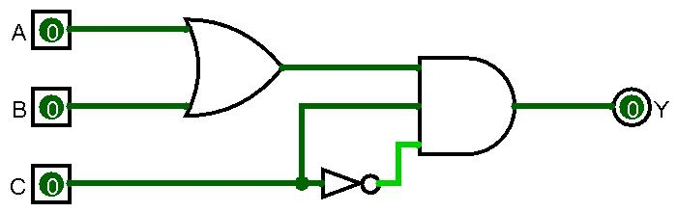
A | B | C | T | Y
0 | 0 | 0 | 0 | 0
0 | 0 | 1
0 | 1 | 0
0 | 1 | 1
1 | 0 | 0
1 | 0 | 1
1 | 1 | 0
1 | 1 | 1

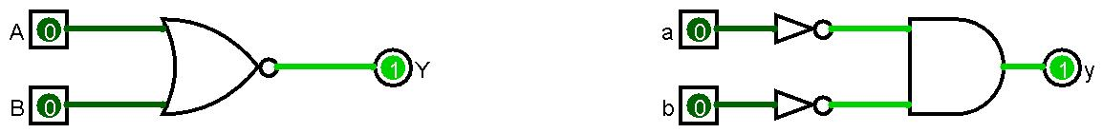
- Verify using a truth table if the two logic circuits perform the same function:
s

t

Aa | Bb | Y | s | t | y
0 | 0 | 1 | 1 | 1 | 1
0 | 1 | 0
1 | 0 | 0
1 | 1 | 0

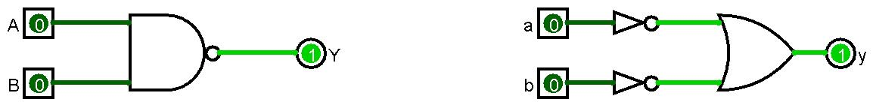

Aa | Bb | Y |  |  | y
0 | 0 | 1 |  |  | 1
0 | 1 | 1
1 | 0 | 1
1 | 1 | 0

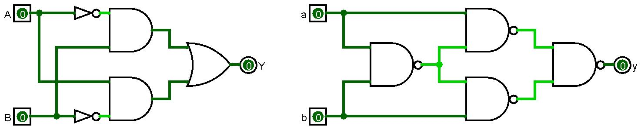

Aa | Bb |  |  |  |  | Y |  |  |  |  | y
0 | 0
0 | 1
1 | 0
1 | 1

- Complete the truth tables and draw the symbol for the following digital logic gates:
  - 2-input XNOR
A | B | a
0 | 0 | 1
0 | 1 | 0
1 | 0 | 0
1 | 1 | 1

A | B | C | b
0 | 0 | 0 | 0
0 | 0 | 1
0 | 1 | 0
0 | 1 | 1 | 1
1 | 0 | 0
1 | 0 | 1
1 | 1 | 0 | 1
1 | 1 | 1
  - 3-input OR

  - 4-input NAND
A | B | C | D | c | d | e
0 | 0 | 0 | 0
0 | 0 | 0 | 1
0 | 0 | 1 | 0
0 | 0 | 1 | 1
0 | 1 | 0 | 0
0 | 1 | 0 | 1 |  | 0
0 | 1 | 1 | 0
0 | 1 | 1 | 1
1 | 0 | 0 | 0 |  | 1
1 | 0 | 0 | 1
1 | 0 | 1 | 0
1 | 0 | 1 | 1 |  | 1
1 | 1 | 0 | 0
1 | 1 | 0 | 1
1 | 1 | 1 | 0
1 | 1 | 1 | 1

  - 4-input XOR

  - 4-input AND

- Construct the truth table for a 3-input “majority gate”. This circuit will output logic true whenever more than half of its inputs are true. Use Logisim to generate a circuit based on your truth table.
A | B | C | Y
0 | 0 | 0 | 0
0 | 0 | 1
0 | 1 | 0
0 | 1 | 1 | 1
1 | 0 | 0 | 0
1 | 0 | 1
1 | 1 | 0 | 1
1 | 1 | 1

- Construct the truth table for a 3-input gate that outputs a true value whenever an odd number of inputs is true. Does this truth table look familiar?
A | B | C | Y
0 | 0 | 0 | 0
0 | 0 | 1 | 1
0 | 1 | 0
0 | 1 | 1 | 0
1 | 0 | 0 | 1
1 | 0 | 1
1 | 1 | 0
1 | 1 | 1 | 1

- Construct the truth table for a 3-input gate that outputs a true value whenever at least one input is true.
A | B | C | Y
0 | 0 | 0 | 0
0 | 0 | 1 | 1
0 | 1 | 0
0 | 1 | 1 | 1
1 | 0 | 0 | 1
1 | 0 | 1
1 | 1 | 0
1 | 1 | 1 | 1

- You are supposed to design a circuit that indicates which months of the year have 31 days. You receive the value of the month in form of a combination four input signals as shown in the following truth table. How would you complete the output column?
Month | A | B | C | D | 31 days
January | 0 | 0 | 0 | 0 | 1
February | 0 | 0 | 0 | 1 | 0
March | 0 | 0 | 1 | 0
April | 0 | 0 | 1 | 1
May | 0 | 1 | 0 | 0
June | 0 | 1 | 0 | 1
July | 0 | 1 | 1 | 0
August | 0 | 1 | 1 | 1 | 1
September | 1 | 0 | 0 | 0
October | 1 | 0 | 0 | 1
November | 1 | 0 | 1 | 0
December | 1 | 0 | 1 | 1
not used | 1 | 1 | 0 | 0 | X
not used | 1 | 1 | 0 | 1 | X
not used | 1 | 1 | 1 | 0 | X
not used | 1 | 1 | 1 | 1 | X

- Circle the gates which are behaving wrong.
1

0

0

1

0

0

0

