EEE 120: Digital Design Fundamentals
Summer 2014

Sample & Practice Problems - Week 1

Please (a) review the sample problems, (b) complete the partially completed Practice Problems and (c) complete the remaining Practice Problems. This will prepare you for the Quiz 1 (Week 1).

- Which circuit belongs to which column in the following truth table?
A | B | w | x | y | z
0 | 0 | 1 | 1 | 0 | 1
0 | 1 | 0 | 0 | 0 | 0
1 | 0 | 0 | 0 | 1 | 1
1 | 1 | 1 | 1 | 0 | 1

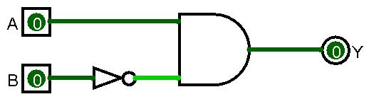
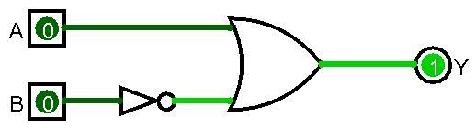
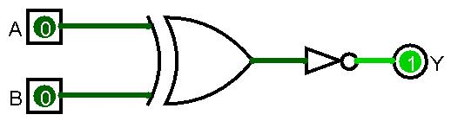

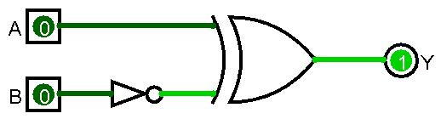

- Is the following circuit doing anything useful? Which signal appears at the output?
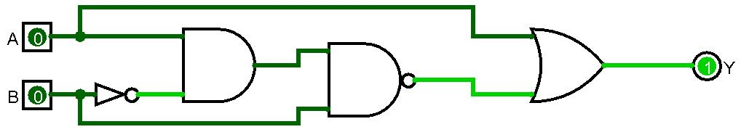

- Why are the following circuits showing an error at the output?
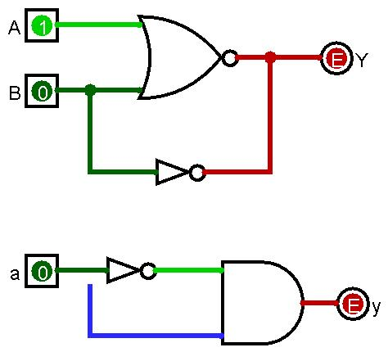

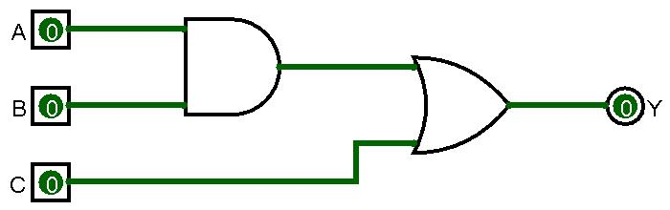
- Write down the truth table for the following digital logic circuits:
A | B | C |  | Y
0 | 0 | 0
0 | 0 | 1
0 | 1 | 0
0 | 1 | 1
1 | 0 | 0
1 | 0 | 1
1 | 1 | 0
1 | 1 | 1

- Construct a truth table for a 3-input XOR and draw the corresponding gate symbol:
A | B | C | Y
0 | 0 | 0
0 | 0 | 1
0 | 1 | 0
0 | 1 | 1
1 | 0 | 0
1 | 0 | 1
1 | 1 | 0
1 | 1 | 1

- Construct the truth table for a 3-input gate that outputs a true value whenever an even number of inputs is true.
A | B | C | Y
0 | 0 | 0
0 | 0 | 1
0 | 1 | 0
0 | 1 | 1
1 | 0 | 0
1 | 0 | 1
1 | 1 | 0
1 | 1 | 1

- Circle the gates which are behaving wrong.
1

0

0

1

0

1

1

