EEE 120
Simulation Lab 0 Answer Sheet
Simulator Tutorial: Using Logisim
Name:_Jason Pototsky _________
Date:__05/23/2014____________
Task A: Creating a Subcircuit
Include a picture of your Logisim circuit SUB_TRY.circ here:

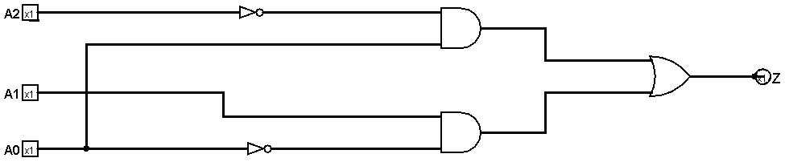

Include a picture of your Logisim circuit subdemo.circ here:

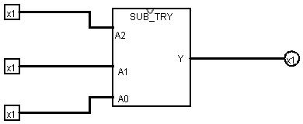

Create a truth table for the output function Z in Table 1. Test your subcircuit and place a mark (after successful testing) in the checkmark column.
Table 1
Input  (Logic Values) |  |  | Output  (Logic Values) | Debug checkmark
A2 | A1 | A0 | Z | Debug checkmark
0 | 0 | 0 | 0 | Check
0 | 1 | 0 | 1 | Check
1 | 0 | 0 | 0 | Check
1 | 1 | 0 | 1 | Check
0 | 0 | 1 | 1 | Check
0 | 1 | 1 | 1 | Check
1 | 0 | 1 | 0 | Check
1 | 1 | 1 | 0 | Check

Task B: 4-Bit Keyboard
Include a picture of your Logisim circuit implementation of the 4-Bit Keyboard circuit that you created under the name of kbddemo.circ here:

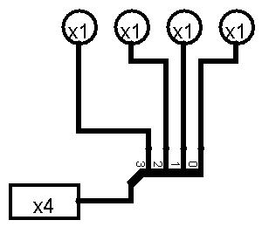

Task C: Hex Display
Include a picture of your Logisim circuit implementation of the Hexadecimal Display circuit that you created under the name of dispdemo.circ here:
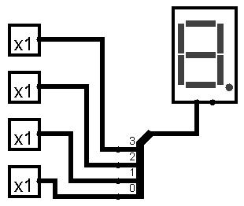

Simulation Lab 0: Lab Report Grade Sheet

Name: | Jason Pototsky

Instructor Assessment
Grading Criteria | Max Points | Points Lost
Template
Neatness, Clarity, and Concision | 2
Description of Assigned Tasks, Work Performed & Outcomes Met
Task A: Creating a Subcircuit | 6
Task B: 4-Bit Keyboard | 6
Task C: Hex Display | 6
Self-Assessment Worksheet (The content of the self-assessment worksheet will not be graded. Full credit is given for including the completed worksheet.) | (2 extra points)
 | Points Lost
Lab Score | Late Lab
 | Lab Score

Self-Assessment Worksheet

Put an ‘X’s’ in the table below indicating how strongly you agree or disagree that the outcomes of the assigned tasks were achieved. Use ‘5’ to indicate that you ‘strongly agree’, ‘3’ to indicate that you are 'neutral', and ‘1’ to indicate that you ‘strongly disagree’. Use ‘NA’, ‘Not Applicable’, when the tasks you performed did not elicit this outcome. Credit may be given for including this worksheet with your lab report; however, your responses will not be graded. They are for your instructor’s information only.
Table 1: Self-Assessment of Outcomes for Simulator Tutorial: Using Logisim.
After completing the assigned tasks and report, I am able to: | 5 | 4 | 3 | 2 | 1 | NA
Use parts in the Logisim Library; place those in the schematic window and connect those using wires. | X
Apply names to signals and devices. | X
Create, and modify the appearance of a subcircuit. | X
Use the self-created subcircuit in Logisim library. | X
Create bus lines and breakouts. | X
Use the multi-bit keyboard and hex display and connect to the outputs or inputs respecting the correct bit order. | X

Write below any suggestions you have for improving this laboratory exercise so that the stated learning outcomes are achieved.
Honestly, I do not believe anything needs to be changed. Except perhaps one exercise to bring all three circuits together, but I think the utilization of the Task A’s part B does that enough. Thank you.

