EEE 120
Simulation Lab 2 Answer Sheet
4-Bit Full Adder, Multiplexer, Decoder & Buffer
Name:_Jason Pototsky __ _______
Date:___6/15/2014____________
Task 2-1: Design a Full Adder
Write down the canonical SOP expressions for the C_{out} and SUM function of a full adder. Be sure to check the lab manual for more detailed information.
C_{out} = BC_{In} + AC_{In} + AB
Sum = A’ B’ C_{In} + A’B C_{In}’ + AB’C_{In}’ + ABC_{In}
Include a picture of your Logisim circuit that implements your canonical SUM and _{Co}ut functions here:
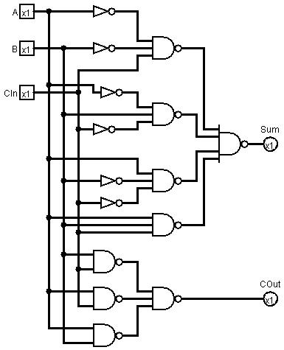
Follow the testing procedures outlined in the laboratory manual on your circuit and record your results in Error: Reference source not found. Place a mark in the checkmark column of Table 3 to indicate the values you checked.
Table 1 |  |  |  |  | Debug Checkmark
A | B | C_{in} | C_{out} | SUM | Debug Checkmark
0 | 0 | 0 | 0 | 0 | X
0 | 0 | 1 | 0 | 1 | X
0 | 1 | 0 | 0 | 1 | X
0 | 1 | 1 | 1 | 0 | X
1 | 0 | 0 | 0 | 1 | X
1 | 0 | 1 | 1 | 0 | X
1 | 1 | 0 | 1 | 0 | X
1 | 1 | 1 | 1 | 1 | X

Task 2-2: Build, Debug and Test a 1-Bit Full Adder
Include a picture of your Logisim 1-bit minimal form full-adder circuit here:
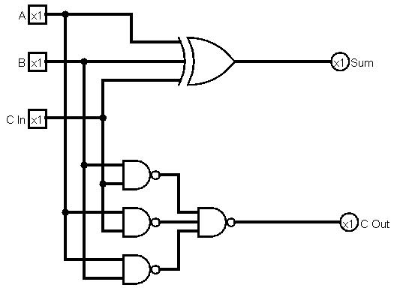
Test your minimal form full-adder circuit and record your results in Table 1. Place a mark in the checkmark column of Table 3 to indicate the values you checked.
Table 1 |  |  |  |  | Debug Checkmark
A | B | C_{in} | C_{out} | SUM | Debug Checkmark
0 | 0 | 0 | 0 | 0 | X
0 | 0 | 1 | 0 | 1 | X
0 | 1 | 0 | 0 | 1 | X
0 | 1 | 1 | 1 | 0 | X
1 | 0 | 0 | 0 | 1 | X
1 | 0 | 1 | 1 | 0 | X
1 | 1 | 0 | 1 | 0 | X
1 | 1 | 1 | 1 | 1 | X

Include a picture of your Logisim 1-bit full adder subcircuit symbol here:
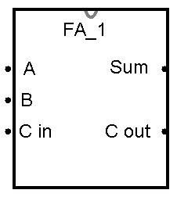

Task 2-3: Design, Build and Test a 4-Bit Full Adder

Include a picture of your Logisim 4-bit full-adder circuit here:
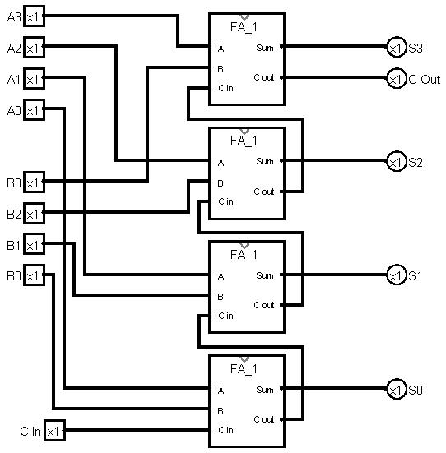

Include a picture of your Logisim 4-bit full-adder testing set up. Connect a multi-bit input pin to the inputs A and B as well as a hex digit display to SUM.
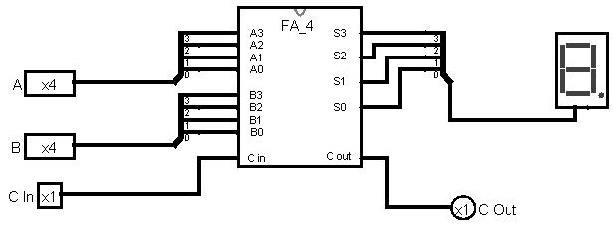
Develop a test plan and record your results in Table 2 (Note: Do NOT test all input combinations. Table 2 may not need to be entirely filled in). It is left to you to decide what constitutes a sufficient test set. Give justification as to why completing your tests make it likely that the 4-bit full-adder circuit is operating correctly:
In reality the most important tests involve one of the inputs being 1111 and the other simple being 0001 as well as testing input 0,1,2,3 individually to ensure the math is being performed correctly. As such the only tests that truly need to be done is when there is a carry out scenario. 1000+1000, 0100+0100, 0010+0010, 0001+0001 need to be tested and with C in applied.

Test your circuit and place a mark in the checkmark column of Table 2 next to values you used to verify your circuit.
Table 2 |  |  |  |  | Debug Checkmark
A  (4-bit binary) | B  (4-bit binary) | C_{in} | C_{out} | SUM  (hex) | Debug Checkmark
1000 | 1000 | 0 | 1 | 0 | X
0100 | 0100 | 0 | 0 | 8 | X
0010 | 0010 | 0 | 0 | 4 | X
0001 | 0001 | 0 | 0 | 2 | X
1000 | 1000 | 1 | 1 | 1 | X
0100 | 0100 | 1 | 0 | 9 | X
0010 | 0010 | 1 | 0 | 5 | X
0001 | 0001 | 1 | 0 | 3 | X

Include a picture of your Logisim 4-bit full-adder subcircuit symbol here:
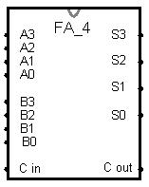

Task 2-4: Design, Build and Test a MUX
Include a picture of your Logisim 1-bit 2-to-1 MUX circuit here:
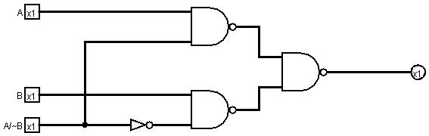
Test your 1-bit 2-to-1 MUX circuit and record your results in Table 3. Place a mark in the checkmark column of Table 3 to indicate the values you checked.
Table 3 |  |  |  | Debug checkmark
A/~B | A | B | Y | Debug checkmark
0 | 0 | 0 | 0 | X
0 | 0 | 1 | 1 | X
0 | 1 | 0 | 0 | X
0 | 1 | 1 | 1 | X
1 | 0 | 0 | 0 | X
1 | 0 | 1 | 0 | X
1 | 1 | 0 | 1 | X
1 | 1 | 1 | 1 | X

Include a picture of your Logisim 1-bit 2-to-1 MUX subcircuit symbol here:
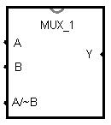
Task 2-5: Build a 2-Input 4-Bit Multiplexer
Include a picture of your Logisim 4-bit MUX circuit here:
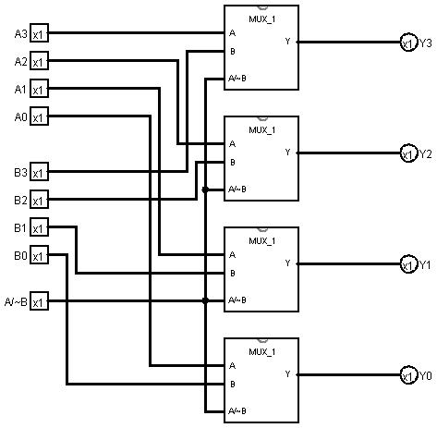
Test your MUX and record your results in Table 4. It is left to you to decide what test combination to use. Note all of Table 5 may not need to be filled in. Include a picture of your Logisim 4-bit MUX circuit testing set up (You may test it with the Multi-Bit Input Pin and Hex Digit Display).

Table 4
A  (4-bit binary) | B  (4-bit binary) | A/~B | Y  (hex) | Debug checkmark
1111 | 0000 | 0 | 0 | X
0000 | 1111 | 0 | F | X
1111 | 0000 | 1 | F | X
0000 | 1111 | 1 | 0 | X
1110 | 0000 | 0 | 0 | X
1110 | 0000 | 1 | E | X

Include a picture of your Logisim 4-bit MUX subcircuit symbol here:
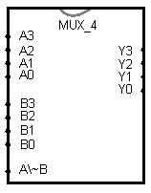
Task 2-6: Build and Test a 1-to-2 Decoder
Include a picture of your Logisim 1-bit, 1-to-2 decoder circuit here:
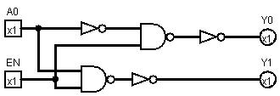

Test your 1-bit, 1-to-2 decoder circuit and record the results in Error: Reference source not found. Place a mark in the checkmark column of Table 3 to indicate the values you checked.
Table 6 |  |  |  | Debug checkmark
EN | A0 | Y0 | Y1 | Debug checkmark
0 | 0 | 0 | 0 | X
0 | 1 | 0 | 0 | X
1 | 0 | 1 | 0 | X
1 | 1 | 0 | 1 | X

Include a picture of your Logisim 1-bit, 1-to-2 decoder subcircuit symbol here:
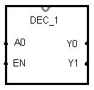
Task 2-7: Build and Test a 2-to-4 Decoder
Include a picture of your Logisim 2-to-4 decoder circuit here:
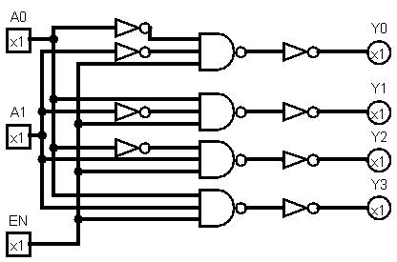

Test your 2-to-4 decoder circuit and record your results in Table 3. Place a mark in the checkmark column of Table 3 to indicate the values you checked.

Table 7 |  |  |  |  |  |  | Debug checkmark
EN | A1 | A0 | Y0 | Y1 | Y2 | Y3 | Debug checkmark
0 | 0 | 0 | 0 | 0 | 0 | 0 | X
0 | 0 | 1 | 0 | 0 | 0 | 0 | X
0 | 1 | 0 | 0 | 0 | 0 | 0 | X
0 | 1 | 1 | 0 | 0 | 0 | 0 | X
1 | 0 | 0 | 1 | 0 | 0 | 0 | X
1 | 0 | 1 | 0 | 1 | 0 | 0 | X
1 | 1 | 0 | 0 | 0 | 1 | 0 | X
1 | 1 | 1 | 0 | 0 | 0 | 1 | X

Include a picture of your Logisim 2-to-4 decoder subcircuit symbol here:
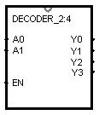
Task 2-8: Design, Build & Test a 4-to-16 Decoder Using 2-to-4 Decoders
Include a picture of your Logisim 4-to-16 decoder circuit, constructed from copies of the subcircuit developed in Task 2-7, here:
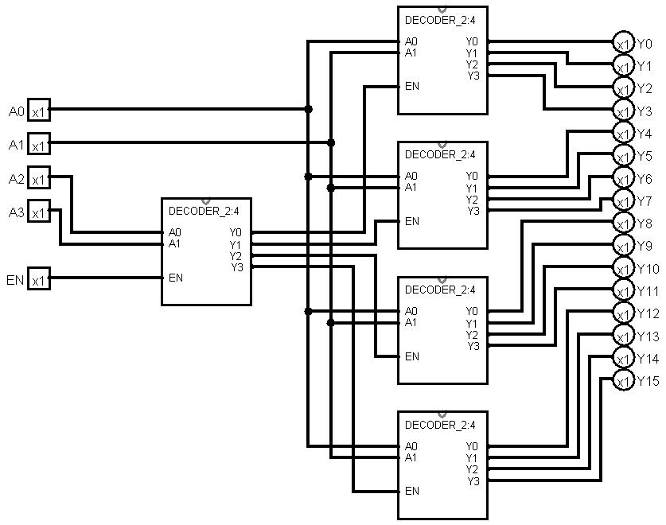
Test your circuit, with EN set to 1, and record your results in Table . Place a mark in the checkmark column of Table next to values that you tested.
Table 8 |  |  |  |  |  |  |  |  |  |  |  |  |  |  |  |  |  |  |  | Debug checkmark
A3 | A2 | A1 | A0 | Y0 | Y1 | Y2 | Y3 | Y4 | Y5 | Y6 | Y7 | Y8 | Y9 | Y10 | Y11 | Y12 | Y13 | Y14 | Y15
0 | 0 | 0 | 0 | 1 |  |  |  |  |  |  |  |  |  |  |  |  |  |  |  | X
0 | 1 | 0 | 0 |  |  |  |  | 1 |  |  |  |  |  |  |  |  |  |  |  | X
1 | 0 | 0 | 0 |  |  |  |  |  |  |  |  | 1 |  |  |  |  |  |  |  | X
1 | 1 | 0 | 0 |  |  |  |  |  |  |  |  |  |  |  |  | 1 |  |  |  | X
1 | 0 | 1 | 1 |  |  |  |  |  |  |  |  |  |  |  | 1 |  |  |  |  | X

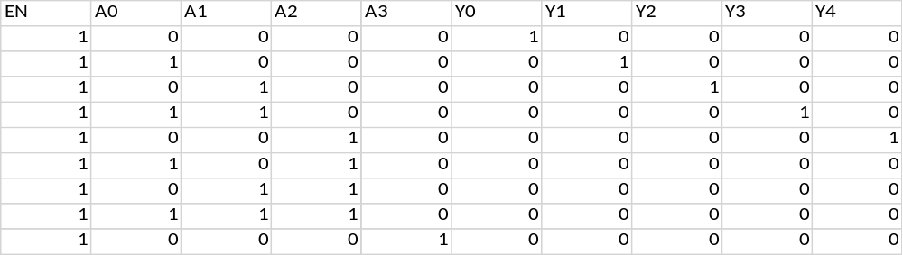

Include a picture of your Logisim 4-to-16 decoder subcircuit symbol here:
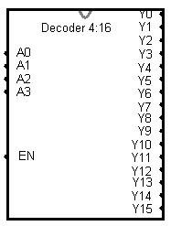

Task 2-9: Build a 4-Bit Buffer
Include a picture of your Logisim 4-bit buffer circuit here:
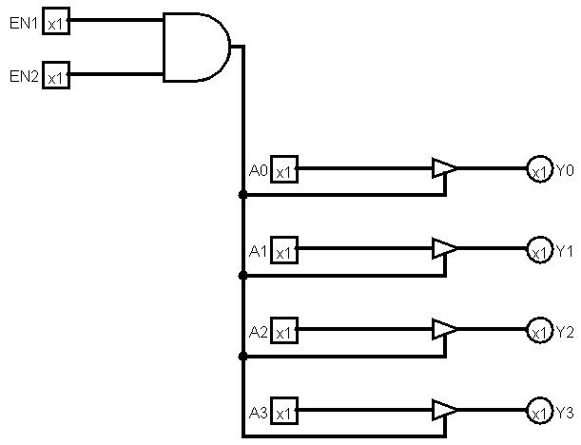

Test your circuit and record your results in Table . Place a mark in the checkmark column of Error: Reference source not found next to values you used to verify your circuit. Describe your testing procedures and results for the 4-bit buffer here:
I decided that the best test for this was to ensure that data did not pass through the buffer when either EN was in a low state and that low values were passed from the buffers as well as low values. Since each buffer has only two states to push to the data a test of 0000 with EN1,2 enabled and 1111 was sufficient and tests to ensure that there was nothing pushed to the outputs when either EN1 or 2 was Low.

Table 9
A  (4-bit binary) | EN1 | EN2 | Y  (4-bit binary) | Checkmark
1111 | 1 | 1 | 1111 | X
0000 | 1 | 1 | 0000 | X
1111 | 0 | 0 | Nothing | X
1111 | 0 | 1 | Nothing | X
1111 | 1 | 0 | Nothing | X

Include a picture of your Logisim 4-bit buffer subcircuit symbol here:
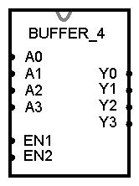
Task 2-10: Backup Your Files
Did you backup your files to a NEW directory?
Yes I did and I backed it up to Google Drive as well.

Simulation Lab 2: Lab Report Grade Sheet

Name: | Jason Pototsky

Instructor Assessment
Grading Criteria | Max Points | Points Lost
Template
Neatness, Clarity, and Concision | 1
Description of Assigned Tasks, Work Performed & Outcomes Met
Task 2-1: Design a Full Adder | 3
Task 2-2: Build, Debug and Test a 1-Bit Full Adder | 2
Task 2-3: Design, Build and Test a 4-Bit Full Adder | 3
Task 2-4: Design, Build and Test a MUX | 3
Task 2-5: Build a 2-Input 4-Bit Multiplexer | 2
Task 2-6: Build and Test a 1-to-2 Decoder | 2
Task 2-7: Build and Test a 2-to-4 Decoder | 3
Task 2-8: Design, Build & Test a 4-to-16 Decoder Using 2-to-4 Decoders | 3
Task 2-9: Build a 4-Bit Buffer | 3
Self-Assessment Worksheet (The content of the self-assessment worksheet will not be graded. Full credit is given for including the completed worksheet.) | (2 extra points)
 | Points Lost
Lab Score | Late Lab
 | Lab Score

Self-Assessment Worksheet

Put “X’s” in the table below indicating how strongly you agree or disagree that the outcomes of the assigned tasks were achieved. Use ‘5’ to indicate that you ‘strongly agree’, ‘3’ to indicate that you are 'neutral', and ‘1’ to indicate that you ‘strongly disagree’. Use ‘NA’, ‘Not Applicable’, when the tasks you performed did not elicit this outcome. Credit will be given for including this worksheet with your lab report; however, your responses will not be graded. They are for your instructor’s information only.
Table __: Self-Assessment of Outcomes for Simulation Lab 2: 4-Bit Full Adder, Multiplexer & Decoder.
After completing the assigned tasks and report, I am able to: | 5 | 4 | 3 | 2 | 1 | NA
A POS or SOP form of a full adder. |  | X
A 4-bit full adder. | X
A 2-to-1 multiplexer. |  | X
A 4-bit, 2-to-1 multiplexer. |  | X
A 1-to-2 decoder. |  | X
A 2-to-4 decoder. |  | X
A 4-to-16 decoder. |  | X
A 4-bit buffer. |  | X

Write below any suggestions you have for improving this laboratory exercise so that the stated learning outcomes are achieved.

