EEE 120
Simulation Lab 3 Answer Sheet
Arithmetic and Logic Unit
Name:__Jason Pototsky ________
Date:__6/20/2014_____________
Task 3-1: Build the NOT/NEG Circuit
Include a picture of your Logisim NOT/NEG circuit here:
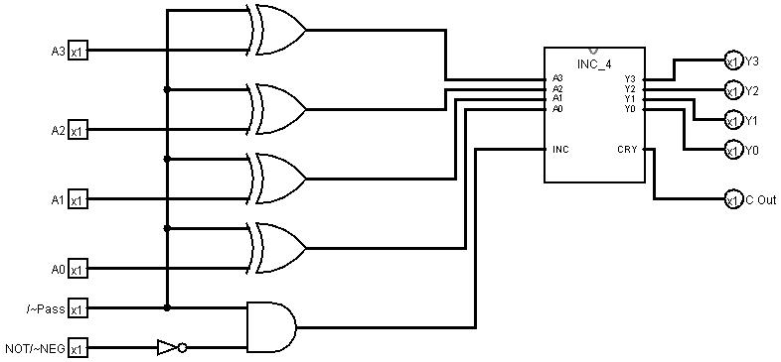
Table 1 lists the functionality of the NOT/NEG circuit based on the input control values. Perform the testing procedures outlined in the laboratory manual on your circuit and record your results in Error: Reference source not found. Place a mark in the checkmark column of Error: Reference source not found next to values you used to verify your circuit. Explain your test plan here: I decided to test the functionality of the circuit by utilizing 1111 and 0000 input while the /~Pass function and NOT/~NEG alternates in their functionality. This will ensure that I get a representative scope of the arithmetic functions.

Table 1
/~Pass | NOT/~NEG | Function
0 | 0 | Pass-through
0 | 1 | Pass-through
1 | 0 | Two’s complement
1 | 1 | One’s complement

Table 2 *
 |  |  |  |  |  |  |  |  |  |  | Debug
/~Pass | NOT/~NEG | A3 | A2 | A1 | A0 | Y3 | Y2 | Y1 | Y0 | Cout | Checkmark
0 | 0 | 1 | 1 | 1 | 1 | 1 | 1 | 1 | 1 | 0
0 | 0 | 0 | 0 | 0 | 0 | 0 | 0 | 0 | 0 | 0
0 | 1 | 1 | 1 | 1 | 1 | 1 | 1 | 1 | 1 | 0
0 | 1 | 0 | 0 | 0 | 0 | 0 | 0 | 0 | 0 | 0
1 | 0 | 1 | 1 | 1 | 1 | 0 | 0 | 0 | 1 | 0
1 | 0 | 0 | 0 | 0 | 0 | 0 | 0 | 0 | 0 | 1
1 | 1 | 1 | 1 | 1 | 1 | 0 | 0 | 0 | 0 | 0
1 | 1 | 0 | 0 | 0 | 0 | 1 | 1 | 1 | 1 | 0

*You may add lines to this table if you see that it is necessary.
Include a picture of your Logisim NOT/NEG subcircuit symbol here:
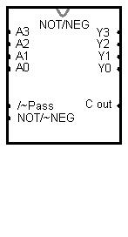
Task 3-2: Build and Test the AND/ADD Circuit
Copy the tabular information from Table 2 in the lab manual into Table 2 (see Table 1 as an example).
Include a picture of your Logisim circuit, which implements the logic show in Figure 5 of the laboratory manual, here:
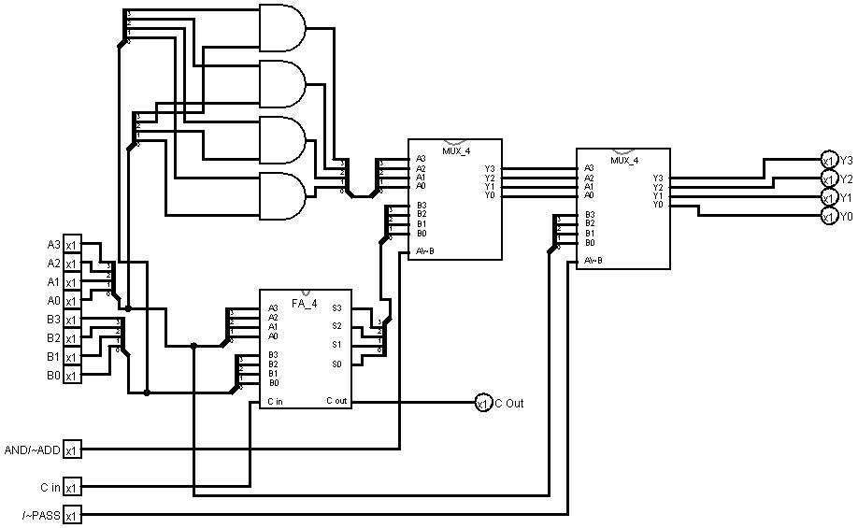
Test your circuit and record your results in Table 3. Place a mark in the checkmark column of Error: Reference source not found next to values you used to verify your circuit. Explain and justify your test procedure here:___I utilized the way that the table seemed to break it down into functions, by splitting it into the Pass, Add, and Add functions I could plan my tests that way. During the ADD I want to test the Carry out by using 1111 and 1111 for A and B. Additionally I will test 0001 and 0001 for A and B to ensure it is correctly applying the add. For the AND I will test 1111 and 1111 for as well as 1001 0001 to ensure that only the and circuits are outputting.

Table 2*
/~Pass | AND/~ADD | Function
0 | 0 | Pass through
0 | 1 | Pass through
1 | 0 | ADD
1 | 1 | AND
*Be sure to list functionality in column 3 of Table 2.
Table 3
Function = Pass-Through ( /~Pass = 0 ) |  |  |  |  |  |  |  |  |  |  |  |  | Debug
A3 | A2 | A1 | A0 | B3 | B2 | B1 | B0 | Y3 | Y2 | Y1 | Y0 | Cout | Checkmark
1 | 1 | 1 | 1 | 1 | 1 | 1 | 1 | 1 | 1 | 1 | 1 | 0 | X
0 | 0 | 0 | 0 | 1 | 1 | 1 | 1 | 0 | 0 | 0 | 0 | 0 | X
1 | 1 | 1 | 1 | 0 | 0 | 0 | 0 | 1 | 1 | 1 | 1 | 0 | X
Function = ADD (/~Pass = 1 / AND/~ADD= 0)
A3 | A2 | A1 | A0 | B3 | B2 | B1 | B0 | Y3 | Y2 | Y1 | Y0 | Cout
1 | 1 | 1 | 1 | 1 | 1 | 1 | 1 | 1 | 1 | 1 | 0 | 1 | X
1 | 1 | 1 | 1 | 0 | 0 | 0 | 0 | 1 | 1 | 1 | 1 | 0 | X
0 | 0 | 0 | 1 | 0 | 0 | 0 | 1 | 0 | 0 | 1 | 0 | 0 | x
Function = AND (/~Pass = 1 / AND/ADD = 1)
A3 | A2 | A1 | A0 | B3 | B2 | B1 | B0 | Y3 | Y2 | Y1 | Y0 | Cout
1 | 1 | 1 | 1 | 1 | 1 | 1 | 1 | 1 | 1 | 1 | 1 | 0 | X
0 | 0 | 0 | 0 | 0 | 0 | 0 | 0 | 0 | 0 | 0 | 0 | 0 | X
1 | 0 | 0 | 1 | 0 | 0 | 0 | 1 | 0 | 0 | 0 | 1 | 0 | X

Include a picture of your Logisim subcircuit symbol for Task 3-2 here:
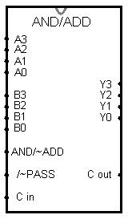
Task 3-3: Build and Test the ALU Circuit
Include a picture of your Logisim ALU circuit, shown in Figure 7 of the laboratory manual, here:
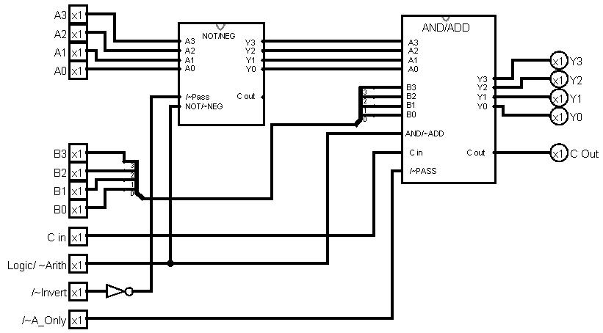
Record the function performed for different combinations of inputs in Table 4. Test your ALU circuit and record the results of your testing in Table 5. Place a mark in the checkmark column of Error: Reference source not found next to values you used to verify your circuit. Describe and justify your testing procedure here: Once I have broken the ALU down into functions the testing can begin, the functions will require a round of A=1111 B=1111, A=0000 B=0000, and A=0011 B=0011 in order to test each function. This should allow the truest test to ensure that all arithmetic and logic is performed. I know what the answer should be for each function and if they match up then all testing is concluded.

Table 4
/~A_Only | Logic/~Arith | /~Invert | Function
0 | 0 | 0 | Two’s Complement
0 | 0 | 1 | A_Only (Pass-Through)
0 | 1 | 0 | One’s Complement / Not
0 | 1 | 1 | A_Only (Pass-Through)
1 | 0 | 0 | Subtraction/ Two Complement addition
1 | 0 | 1 | Arithmetic Sum, A+B
1 | 1 | 0 | A’+B AND/ Ones Complement AND
1 | 1 | 1 | AND

Table 5
Function = Two’s Complement (/~A_Only = 0 Logic/~Arith = 0 /~Invert= 0 ) |  |  |  |  |  |  |  |  |  |  |  |  | Debug
A3 | A2 | A1 | A0 | B3 | B2 | B1 | B0 | Y3 | Y2 | Y1 | Y0 | Cout | Checkmark
1 | 1 | 1 | 1 | 1 | 1 | 1 | 1 | 0 | 0 | 0 | 1 | 0 | X
0 | 0 | 0 | 0 | 0 | 0 | 0 | 0 | 0 | 0 | 0 | 0 | 0 | X
0 | 0 | 1 | 1 | 0 | 0 | 1 | 1 | 1 | 1 | 0 | 1 | 0 | X
Function = A_Only (Pass-Through) (/~A_Only = 0 Logic/~Arith = 0 /~Invert= 1 )
A3 | A2 | A1 | A0 | B3 | B2 | B1 | B0 | Y3 | Y2 | Y1 | Y0 | Cout
1 | 1 | 1 | 1 | 1 | 1 | 1 | 1 | 1 | 1 | 1 | 1
0 | 0 | 0 | 0 | 0 | 0 | 0 | 0 | 0 | 0 | 0 | 0
0 | 0 | 1 | 1 | 0 | 0 | 1 | 1 | 0 | 0 | 1 | 1
Function = One’s Complement/NOT (/~A_Only = 0 Logic/~Arith = 1 /~Invert= 0 )
A3 | A2 | A1 | A0 | B3 | B2 | B1 | B0 | Y3 | Y2 | Y1 | Y0 | Cout
1 | 1 | 1 | 1 | 1 | 1 | 1 | 1 | 0 | 0 | 0 | 0
0 | 0 | 0 | 0 | 0 | 0 | 0 | 0 | 1 | 1 | 1 | 1
0 | 0 | 1 | 1 | 0 | 0 | 1 | 1 | 1 | 1 | 0 | 0
Function = A_Only (Pass-through) (/~A_Only = 0 Logic/~Arith = 1 /~Invert= 1 )
A3 | A2 | A1 | A0 | B3 | B2 | B1 | B0 | Y3 | Y2 | Y1 | Y0 | Cout
1 | 1 | 1 | 1 | 1 | 1 | 1 | 1 | 1 | 1 | 1 | 1
0 | 0 | 0 | 0 | 0 | 0 | 0 | 0 | 0 | 0 | 0 | 0
0 | 0 | 1 | 1 | 0 | 0 | 1 | 1 | 0 | 0 | 1 | 1
Function = Subtraction/ Two Complement addition(/~A_Only = 1 Logic/~Arith = 0 /~Invert= 0 )
A3 | A2 | A1 | A0 | B3 | B2 | B1 | B0 | Y3 | Y2 | Y1 | Y0 | Cout
1 | 1 | 1 | 1 | 1 | 1 | 1 | 1 | 0 | 0 | 0 | 0 | 1
0 | 0 | 0 | 0 | 0 | 0 | 0 | 0 | 0 | 0 | 0 | 0 | 0
0 | 0 | 1 | 1 | 0 | 0 | 1 | 1 | 0 | 0 | 0 | 0 | 1
Function = Arithmetic Sum, A+B (/~A_Only = 1 Logic/~Arith = 0 /~Invert= 1 )
A3 | A2 | A1 | A0 | B3 | B2 | B1 | B0 | Y3 | Y2 | Y1 | Y0 | Cout
1 | 1 | 1 | 1 | 1 | 1 | 1 | 1 | 1 | 1 | 1 | 0 | 1
0 | 0 | 0 | 0 | 0 | 0 | 0 | 0 | 0 | 0 | 0 | 0 | 0
0 | 0 | 1 | 1 | 0 | 0 | 1 | 1 | 0 | 1 | 1 | 0 | 0
Function = A’B AND/ Ones Complement AND (/~A_Only = 1 Logic/~Arith = 1 /~Invert= 0 )
A3 | A2 | A1 | A0 | B3 | B2 | B1 | B0 | Y3 | Y2 | Y1 | Y0 | Cout
0 | 0 | 0 | 0 | 1 | 1 | 1 | 1 | 1 | 1 | 1 | 1 | 1
0 | 0 | 0 | 0 | 0 | 0 | 0 | 0 | 0 | 0 | 0 | 0 | 0
0 | 0 | 1 | 1 | 0 | 0 | 1 | 1 | 0 | 0 | 0 | 0 | 0
Function = AND AB (/~A_Only = 1 Logic/~Arith = 1 /~Invert= 1 )
A3 | A2 | A1 | A0 | B3 | B2 | B1 | B0 | Y3 | Y2 | Y1 | Y0 | Cout
1 | 1 | 1 | 1 | 1 | 1 | 1 | 1 | 1 | 1 | 1 | 1 | 1
0 | 0 | 0 | 0 | 0 | 0 | 0 | 0 | 0 | 0 | 0 | 0 | 0
0 | 0 | 1 | 1 | 0 | 0 | 1 | 1 | 0 | 0 | 1 | 1 | 0

Include a picture of your Logisim ALU subcircuit symbol here:
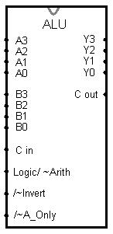
Task 3-4: Backup Your Files
Did you backup your files to a NEW directory?
Yes I did and then backed up that directory to google drive.

Simulation Lab 3: Lab Report Grade Sheet

Name: | Jason Pototsky

Instructor Assessment: Task Oriented
Grading Criteria | Max Points | Points Lost
Template
Neatness, Clarity, and Concision | 3
Description of Assigned Tasks, Work Performed & Outcomes Met
Task 3-1: Build the NOT/NEG Circuit | 12
Task 3-2: Build and Test the Logic/ADD Circuit | 15
Task 3-3: Build and Test the ALU Circuit | 20
Self-Assessment Worksheet (The content of the self-assessment worksheet will not be graded. Full credit is given for including the completed worksheet.) | (2 extra points)
 | Points Lost
Lab Score | Late Lab
 | Lab Score

Self-Assessment Worksheet

Put “X’s” in the table below indicating how strongly you agree or disagree that the outcomes of the assigned tasks were achieved. Use ‘5’ to indicate that you ‘strongly agree’, ‘3’ to indicate that you are 'neutral', and ‘1’ to indicate that you ‘strongly disagree’. Use ‘NA’, ‘Not Applicable’, when the tasks you performed did not elicit this outcome. Credit will be given for including this worksheet with your lab report; however, your responses will not be graded. They are for your instructor’s information only.
Table __: Self-Assessment of Outcomes for Simulation Lab 3: Arithmetic and Logic Unit.
After completing the assigned tasks and report, I am able to: | 5 | 4 | 3 | 2 | 1 | NA
Build, test, debug, and imbed in a subcircuit, an elementary arithmetic and logic unit (ALU). |  | X
Describe the arithmetic and logical operations of which the ALU is capable. |  |  | X
Describe the input control line values that correspond to each arithmetic and logical operation of the ALU. |  | X
Write a top-down description of a complex logic circuit. |  | X

Write below any suggestions you have for improving this laboratory exercise so that the stated learning outcomes are achieved.

