EEE 120
Simulation Lab 4 Answer Sheet
The Microprocessor
Name: Jason Pototsky
Date: 7/2/2014
Task 4-1: Build the Brainless Central Processing Unit
Include a picture of your Logisim Brainless Central Processing Unit circuit here:
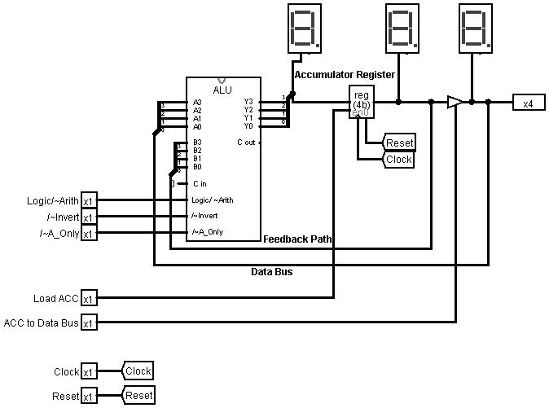
Task 4-2: Test and Control the Brainless Central Processing Unit
Perform the testing procedures outlined in the laboratory manual and fill in the blanks below. (Note that these questions appear in the text of the laboratory manual.)
- Record the first number placed on the data bus here: 6 or 0110
- What do the following three switches need to be set to in order to perform the pass-through operation? /~A_Only = 0 /~Invert= 1 Logic/~Arith= x
- Enter the second number you entered into the data bus here: 4 or 0100
- What do the following three switches need to be set to in order to perform the ADD operation? /~A_Only = 1 /~Invert= 1 Logic/~Arith= 0
- Write down the number that appears in the accumulator here: A or 10 or 1010
Describe other numerical additions and other operations you checked in order to verify your brainless CPU here I performed a couple other addition and subtraction functions to ensure that everything was properly working, including a couple logic functions. Everything appeared to be functioning as it was designed.
After you are convinced your circuit is working properly, remove the 4-bit binary keyboard and set the ACC to Data Bus pin to 1. Did the output of the accumulator appear on the data bus? Yes it appeared on the output Hex display.
How does the output of the ALU change? Once the ALU is reset without an input coming in from the data bus the impedance error shows up on the inputs of the A on the ALU, blue wires.
If the 4-bit binary keyboard was not removed and the ACC to Data Bus switch is set to 1, what would you expect to see displayed in the hex digit display attached to the data bus? I would expect that there would be a data error display showing – in the hex display. This is caused by a conflict in data between the input on the data bus and the output of the controlled buffer.
Add the 4-bit binary keyboard back into your circuit and observe the hex digit display on the data bus for various keyboard values. Is the value on the hex digit display what you expected? I expected them to begin displaying again after I input the keyboard back on and they did. Explain_This input is to simulate data traveling from one area of the microprocessor to another, ie. From the RAM to the ALU.
Why do you think the register at the output of the ALU is called the ‘accumulator’? Well it appears to be able to accumulate data that can be passed, it can store a single operand of data in order to process and feed it back. So it allows for an accumulation of data in order to process and end up with an “answer”.

Task 4-3: Build the Addressing Logic
Include a picture of your Logisim addressing logic circuit here:
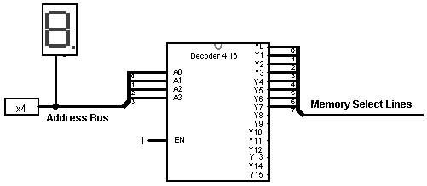
Test your circuit and record the results in Table 1. Include a picture of your Logisim addressing logic circuit testing set up.
Table 1
A  (4-bit binary) | Y0 | Y1 | Y2 | Y3 | Y4 | Y5 | Y6 | Y7
0000 | 1 | 0 | 0 | 0 | 0 | 0 | 0 | 0
0001 | 0 | 1 | 0 | 0 | 0 | 0 | 0 | 0
0010 | 0 | 0 | 1 | 0 | 0 | 0 | 0 | 0
0011 | 0 | 0 | 0 | 1 | 0 | 0 | 0 | 0
0100 | 0 | 0 | 0 | 0 | 1 | 0 | 0 | 0
0101 | 0 | 0 | 0 | 0 | 0 | 1 | 0 | 0
0110 | 0 | 0 | 0 | 0 | 0 | 0 | 1 | 0
0111 | 0 | 0 | 0 | 0 | 0 | 0 | 0 | 1

Task 4-4: Build a 4-Bit ROM Memory Cell
Include a picture of your Logisim 4-bit ROM circuit here:
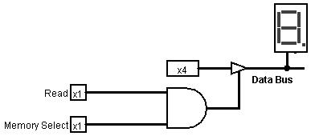
Test your circuit and record the results in Table 2. Include a picture of your Logisim 4-bit ROM circuit testing set up.
Table 2
A  (4-bit binary) | Read | Memory Select | Y  (Data Bus)
1111 | 0 |  | -/Nothing
1111 | 0 | 1 | -/Nothing
1111 | 1 | 0 | -/Nothing
1111 | 1 | 1 | F/15
0000 | 1 | 1 | 0
1010 | 1 | 1 | A/10

Task 4-5: Build 4-Bit Output Port
Include a picture of your Logisim 4-bit output port circuit here:
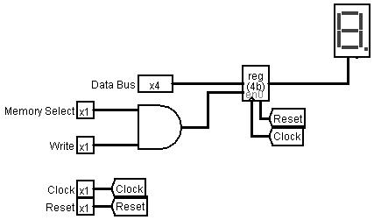
Test your circuit and record the results in Table .
Table 3
Data Bus (4-bit binary) | Write | Memory Select | Q
1111 | 0 | 0 | 0
1111 | 1 | 0 | 0
1111 | 0 | 1 | 0
1111 | 1 | 1 | F
0000 | 1 | 1 | 0
0101 | 1 | 1 | 5
1010 | 1 | 1 | A
1001 | 1 | 1 | 9

Task 4-6: Build the 4-Bit RAM Cell
Include a picture of your Logisim 4-bit RAM circuit here:
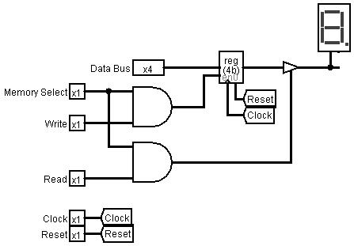
Test your circuit and record the results in Table . Include a picture of your Logisim 4-bit RAM circuit testing set up.
Table 4
Data Bus  (4-bit binary) | Write | Memory Select | Read | Q {between register and buffer} | Data Bus {after buffer}
1111 | 0 | 0 | 0 | 0 | 0
1111 | 0 | 1 | 0 | 0 | 0
1111 | 1 | 1 | 0 | F | 0
1111 | 1 | 1 | 1 | F | F
1010 | 1 | 1 | 1 | A | A
0001 | 1 | 1 | 1 | 1 | 1

Task 4-7: Build the Brainless Microprocessor
Include a picture of your Logisim brainless microprocessor circuit here:
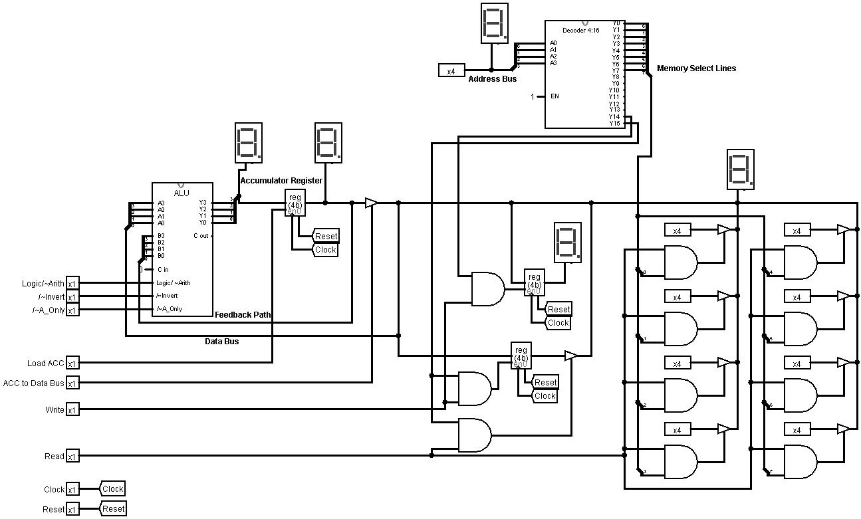
Task 4-8: Testing and Controlling the Brainless Microprocessor
Follow steps 1 through 3 outlined in the laboratory manual to test your brainless microprocessor circuit. List in Table the control lines you needed to control to store the accumulator (ACC) to RAM. (If the control line value has no impact, place a dash ‘-‘ in the value column).
Table 5
Control line | Value
4-bit binary keyboard  (Address Bus) | 1111
Write | 1
Read | 0
ACC to Data Bus | 1
Load ACC | 0
/~A_Only | -
/~Invert | -
Logic/~Arith | -

Describe any other tests that you performed. NOTE: the laboratory manual gives you a minimum set of items to test: I performed a test to ensure that I could conduct and ADD of two numbers as well as subtracting a number. I also decided to test to ensure that I could store the result in RAM and also to output. I also tested the functions of the ALU while the load ACC was at 0 to ensure that those inputs were in fact inconsequential to the outcome of the storage. I would like to add that this was extremely fun, and the fact that I found this fun has made me truly appreciate how much of a nerd I am.
Error: Reference source not found is an example, for the ADD command, of how to fill out tables to record the values of the control lines during every clock cycle.
Table 6
Instruction [ Add operand to Accumulator (ACC) ]
Control Line | Value
4-bit Binary Keyboard (Address Bus) | Address of operand
Write | 0
Read | 1
ACC to Data Bus | 0
Load ACC | 1
/~A_Only | 1
/~Invert | 1
Logic/~Arith | 0

For all of the instructions you performed (i.e. Subtract, Load ACC, etc.) record the values of the control lines during every clock cycle in Error: Reference source not found, Error: Reference source not found and Error: Reference source not found.

Table 7
Instruction [ Subtract operand from ACC ]
Control Line | Value
4-bit Binary Keyboard (Address Bus) | 0010 I stored an 8 in the memory at the third location
Write | 0
Read | 1
ACC to Data Bus | 0
Load ACC | 1
/~A_Only | 1
/~Invert | 0
Logic/~Arith | 0

Table 8
Instruction [ Load ACC with operand ]
Control Line | Value
4-bit Binary Keyboard (Address Bus) | Location of Operand
Write | 0
Read | 1
ACC to Data Bus | 0
Load ACC | 1
/~A_Only | 0
/~Invert | 1
Logic/~Arith | -
Instruction [AND operand with ACC]
Control Line | Value
4-bit Binary Keyboard (Address Bus) | Location of Operand
Write | 0
Read | 1
ACC to Data Bus | 0
Load ACC | 1
/~A_Only | 1
/~Invert | 1
Logic/~Arith | 1
Instruction [ Store ACC to RAM ]
Control Line | Value
4-bit Binary Keyboard (Address Bus) | 1111
Write | 1
Read | 0
ACC to Data Bus | 1
Load ACC | 0
/~A_Only | -
/~Invert | -
Logic/~Arith | -

Table 9
Instruction [ Not (operand) to ACC ]
(1’s complement)
Control Line | Value
4-bit Binary Keyboard (Address Bus) | Location of Operand
Write | 0
Read | 1
ACC to Data Bus | 0
Load ACC | 1
/~A_Only | 1
/~Invert | 0
Logic/~Arith | 0
Instruction [ Negate(operand) to ACC ]
(2’s complement)
Control Line | Value
4-bit Binary Keyboard (Address Bus) | Location of Operand
Write | 0
Read | 1
ACC to Data Bus | 0
Load ACC | 1
/~A_Only | 0
/~Invert | 0
Logic/~Arith | 1

Task 4-9: Build the Memory-Address-Generation Circuit
Include a picture of your Logisim memory address generation circuit here:
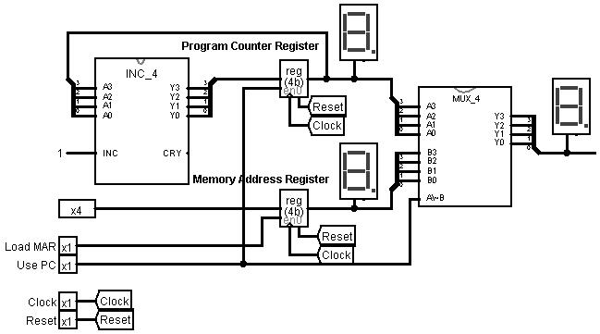

Task 4-10: Build the Controller Circuit
Include a picture of your Logisim controller circuit here:
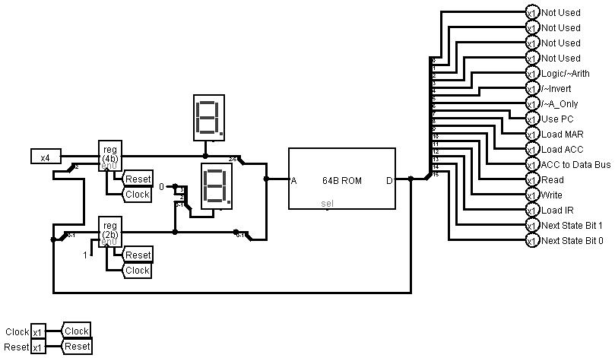

Task 4-11: Build the Complete Microprocessor Circuit
Include a picture of your Logisim complete microprocessor circuit, with controller, here:
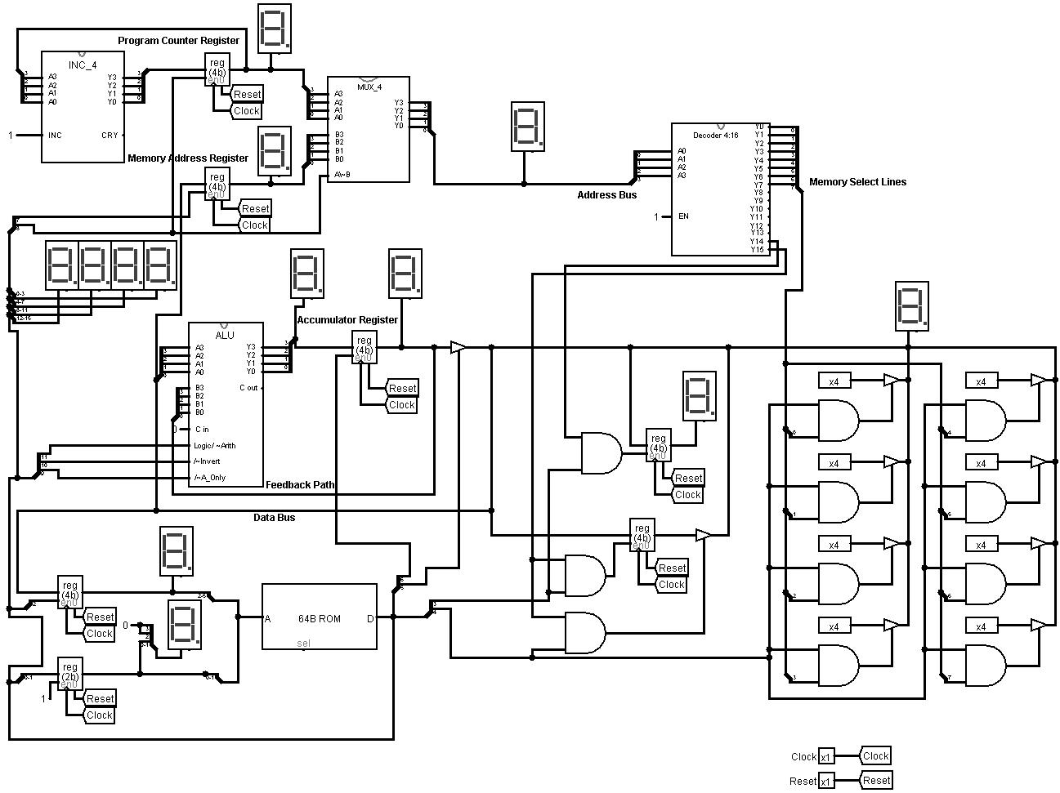
Task 4-12: Write and Execute a Simple Program for Your Microprocessor
Write the program given in your laboratory manual into the appropriate memory locations. Observe the operation of each step of your program (i.e. observe the values of the control lines and record whether data is being moved properly according to those control line settings). Did you get an 8 stored into the accumulator with you initial test? Yes I did.
If not, what error(s) did you find during your debugging process?_My debugging actually had to occur before getting to this point. I was not getting a display on my instructions going to the memory address register which led me to believe that there was an issue there. It turned out that I had an error that was not allowing anything to pass that point, it was because I had some wires incorrectly applied. After solving this the microprocessor worked as it was designed.

Task 4-13: Add the ‘AND’, ‘Zero’, ‘Subtract’, and ‘Store ACC’ Instructions
Use Table and Table to enter your values into the microinstruction definition table for each of the four instructions asked for in the laboratory manual. Be sure to label the name of each and every instruction.
Table 10
 | Instruction | AND |  |  |  | Zero
 | Opcode | 3 |  |  |  | 4
 | Pres. State | 00 | 01 | 02 | 03 | 00 | 01 | 02 | 03
Description | Pin number
Next State Bits | 1-0 | 1 | 0 | 0 | 0 | 1 | 0 | 0 | 0
Load IR | 2 | 1 | 0 | 0 | 0 | 1 | 0 | 0 | 0
Write | 3 | 0 | 0 | 0 | 0 | 0 | 0 | 0 | 0
Read | 4 | 1 | 1 | 0 | 0 | 1 | 0 | 0 | 0
ACC to Data Bus | 5 | 0 | 0 | 0 | 0 | 0 | 0 | 0 | 0
Load ACC | 6 | 0 | 1 | 0 | 0 | 0 | 0 | 0 | 0
Load MAR | 7 | 0 | 0 | 0 | 0 | 0 | 0 | 0 | 0
Use PC | 8 | 1 | 1 | 0 | 0 | 1 | 0 | 0 | 0
/~A_only | 9 | 0 | 1 | 0 | 0 | 0 | 0 | 0 | 0
/~Invert | 10 | 0 | 1 | 0 | 0 | 0 | 0 | 0 | 0
Logic/~Arith | 11 | 0 | 1 | 0 | 0 | 0 | 0 | 0 | 0
X | 12 | X | X | 0 | 0 | X | X | 0 | 0
X | 13 | X | X | 0 | 0 | X | X | 0 | 0
X | 14 | X | X | 0 | 0 | X | X | 0 | 0
X | 15 | X | X | 0 | 0 | X | X | 0 | 0
 | HEX equiv | 0115 | 0F50 | 0000 | 0000 | 0115 | 0026 | 0000 | 0000

Table 11
 | Instruction | Subtract |  |  |  | Store ACC
 | Opcode | 5 |  |  |  | 6
 | Pres. State | 00 | 01 | 02 | 03 | 00 | 01 | 02 | 03
Description | Pin number
Next State Bits | 1-0 | 1 | 0 | 0 | 0 | 1 | 1 | 0 | 0
Load IR | 2 | 1 | 0 | 0 | 0 | 1 | 1 | 0 | 0
Write | 3 | 0 | 0 | 0 | 0 | 0 | 1 | 1 | 0
Read | 4 | 1 | 1 | 0 | 0 | 1 | 0 | 0 | 0
ACC to Data Bus | 5 | 0 | 0 | 0 | 0 | 0 | 1 | 1 | 0
Load ACC | 6 | 0 | 1 | 0 | 0 | 0 | 0 | 0 | 0
Load MAR | 7 | 0 | 0 | 0 | 0 | 0 | 1 | 0 | 0
Use PC | 8 | 1 | 1 | 0 | 0 | 1 | 0 | 0 | 0
/~A_only | 9 | 0 | 1 | 0 | 0 | 0 | X | X | 0
/~Invert | 10 | 0 | 0 | 0 | 0 | 0 | X | X | 0
Logic/~Arith | 11 | 0 | 0 | 0 | 0 | 0 | X | X | 0
X | 12 | X | X | X | X | X | X | X | 0
X | 13 | X | X | X | X | X | X | X | 0
X | 14 | X | X | X | X | X | X | X | 0
X | 15 | X | X | X | X | X | X | X | 0
 | HEX equiv | 0115 | 0350 | 0000 | 0000 | 0115 | 0192 | 0028 | 0000

Test your instructions by writing and executing programs. Record at least four programs and the output of each program in tables like that of Table .
Table 12
Program #0 ( Example: ADD = 3+5)
Address | Value | Operation (In English)
0 | 0 | The 'Load ACC' Opcode
1 | 3 | The number '3' to be loaded into the Accumulator
2 | 1 | The 'Add to ACC' Opcode
3 | 5 | The number '5' to be added to the Accumulator
4 | 2 | The 'Stop' Opcode
What was the final output of your program? ___8__
Was the program successful? YES_
If not what error(s) did you find in your circuit?

Program #1 (Load 3 into ACC and then Zero)
Address | Value | Operation (In English)
0 | 0 | The 'Load ACC' Opcode
1 | 3 | The number ‘3’ to be loaded into the Accumulator
2 | 4 | The ‘Zero’ Opcode
3 | 3 | The number ‘3’ to be loaded into the Accumulator
4 | 5 | The ‘Subtract Opcode
5 | 6 | The result of the subtract Stored in memory
6 | 2 | The ‘Stop’ Opcode
What was the final output of your program? A was the final output
Was the program successful? Yes or No
If not what error(s) did you find in your circuit? I had to troubleshoot in order to solve it. Mainly because of the way I programmed it, not because of the circuit.

Task 4-14: Invent Your Own Instruction (Extra Credit)
Fill in the following two tables for your invented instruction.
 | Instruction | Load RAM into ACC
 | Opcode | 7
 | Pres. State | 00 | 01 | 02 | 03 | 00 | 01 | 02 | 03
Description | Pin number
Next State Bits | 1-0 | 1 | 0 | 0 | 0
Load IR | 2 | 1 | 1 | 0 | 0
Write | 3 | 0 | 0 | 0 | 0
Read | 4 | 1 | 1 | 0 | 0
ACC to Data Bus | 5 | 0 | 0 | 0 | 0
Load ACC | 6 | 0 | 0 | 0 | 0
Load MAR | 7 | 0 | 1 | 0 | 0
Use PC | 8 | 1 | 0 | 0 | 0
/~A_only | 9 | 0 | 0 | 0 | 0
/~Invert | 10 | 0 | 1 | 0 | 0
Logic/~Arith | 11 | 0 | X | 0 | 0
X | 12 | X | X | 0 | 0
X | 13 | X | X | 0 | 0
X | 14 | X | X | 0 | 0
X | 15 | X | X | 0 | 0
 | HEX equiv | 0115 | 0494 | 0000 | 0000

Program # ( Add two numbers together, store result to memory and read )
Address | Value | Operation (In English)
0 | 0 | Load value into ACC
1 | 3 | Value ‘3’ to enter into ACC
2 | 1 | Add to ACC
3 | 5 | Value ‘5’ to add
4 | 6 | Store ACC to Memory
5 | F/15 | Memory Register Value
6 | 7 | Memory to ACC
7 | 2 | Stop
What was the final output of your program? 8
Was the program successful? Yes or No_
If not what error(s) did you find in your circuit? It was not initially successful because I did not program the values correctly. It took a considerable amount of “tweaking” in order to get this to execute correctly.

Simulation Lab 4: Lab Report Grade Sheet

Name: | Jason Pototsky

Instructor Assessment: Task Oriented
Grading Criteria | Max Points | Points Lost
Template
Neatness, Clarity, and Concision | 2
Description of Assigned Tasks, Work Performed & Outcomes Met
Task 4-1: Build the Brainless Central Processing Unit | 5
Task 4-2: Test and Control the Brainless Central Processing Unit | 12
Task 4-3: Build the Addressing Logic | 3
Task 4-4: Build a 4-Bit ROM Memory Cell | 3
Task 4-5: Build 4-Bit Output Port | 3
Task 4-6: Build the 4-Bit RAM Cell | 3
Task 4-7: Build the Brainless Microprocessor | 10
Task 4-8: Testing and Controlling the Brainless Microprocessor | 14
Task 4-9: Build the Memory-Address-Generation Circuit | 5
Task 4-10: Build the Controller Circuit | 5
Task 4-11: Build the Complete Microprocessor Circuit | 10
Task 4-12: Write and Execute a Simple Program for your Microprocessor | 5
Task 4-13: Add the ‘AND’, ‘Zero’, ‘Subtract’, and ‘Store ACC’ Instructions | 20
Task 4-14: Invent Your Own Instruction | (5 extra points)
Self-Assessment Worksheet (The content of the self-assessment worksheet will not be graded. Full credit is given for including the completed worksheet.) | (2 extra points)
 | Points Lost
Lab Score | Late Lab
 | Lab Score

Self-Assessment Worksheet

Put ‘X’s’ in the table below indicating how strongly you agree or disagree that the outcomes of the assigned tasks were achieved. Use ‘5’ to indicate that you ‘strongly agree’, ‘3’ to indicate that you are 'neutral', and ‘1’ to indicate that you ‘strongly disagree’. Use ‘NA’, ‘Not Applicable’, when the tasks you performed did not elicit this outcome. Credit will be given for including this worksheet with your lab report; however, your responses will not be graded. They are for your instructor’s information only.
Table __: Self-Assessment of Outcomes for Simulation Lab 4: The Brainless Microprocessor
After completing the assigned tasks and report, I am able to: | 5 | 4 | 3 | 2 | 1 | NA
Build, debug and control a simulation of a central processing unit (CPU) |  | X
Build, debug and control a simulation of a ROM, RAM and an output port. |  | X
Build and debug a simulation of a microprocessor that is absent a controller. |  | X
Act as the controller for an elementary microprocessor. |  | X
Design a PROM-based controller for an elementary microprocessor. |  | X
Create an instruction set for an elementary microprocessor. |  | X
Use the language of your instruction set to create a program and enter it into memory. |  | X
Execute a program on your simulated microprocessor. |  | X

Write below any suggestions you have for improving this laboratory exercise so that the stated learning outcomes are achieved.

