No to forget!

Fix the percent of Class if I can

To store educator password in JSon

FB authenitification

Emails

Antiforgery tokens

Responsive!

Tests

Upload to Azure

Presentation training

OOP Principles

UTC Time?

Antibot – reCaptcha

Filters for courses

Select lock after validation?! How to fix

TODO:

Tables filter by year and major (dynamical with ajax or just with jsquerry)

Table pagination

Right sidebar with current events and ?messages

Home page for all?

To add to the educator and student sidebar all current courses

The All courses table stays different

Assignments

Adding antiforgery token?

Back button – in AddLecturecise /Edit course, etc.

Registration and Profile – adequate + Fb + email verification and Logout – Last seen

Admin - Filtering on the users and button functionality

Filtering the courses

Possibly sorting the courses and pagination

Error View

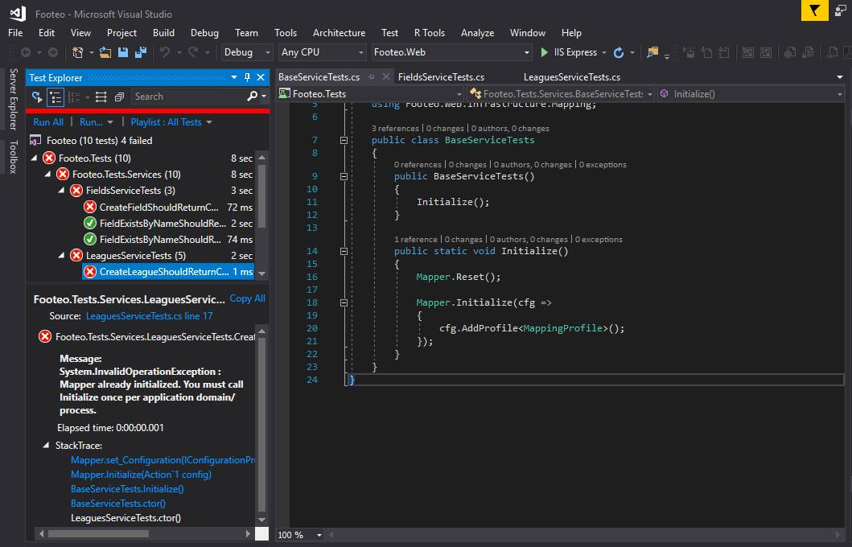

Най-лесните решения, които открих са: Mapper.Reset() и поставяне на [Collection(collectionName)] над всеки клас, в който пишеш тестове. Важното е, че collectionName-а трябва да е един и същ за всички класове. Трябва да се използват двете заедно.