Design and Validation of a Scalable Retail ETL and MLOps Pipeline
Hyrum Prince
National University
DDS8530: Big Data Integration
Dr. Sebhat Gezehey
October 13, 2026

Design and Validation of a Scalable Retail ETL and MLOps Pipeline
This study implemented and evaluated a reproducible extract–transform–load (ETL) and machine-learning operations (MLOps) workflow for historical retail forecasting. The objective was to determine whether fixed-configuration gradient boosting could predict one-week-ahead recorded merchandise units more accurately than a previous-week baseline. The implementation connected Python preprocessing, partitioned Dask transformations, PostgreSQL persistence, MLflow experiment tracking, Flask serving, Apache Airflow orchestration, and Prometheus/Grafana monitoring. A GitHub Actions pathway to Amazon Web Services (AWS) was also configured, but no AWS-hosted prediction service was verified.

Study Design and Data Sources
The primary source was Chen’s (2015) UCI Online Retail dataset, consisting of 541,909 transactions from December 2010 through December 2011. Structured transaction fields and free-text descriptions were processed alongside PostgreSQL data accessed through SQLAlchemy and historical public holidays retrieved through the Nager.Date (n.d.) API. The model was limited to United Kingdom (UK) merchandise because UK transactions comprised 91.71% of curated records; UK holiday indicators were not applied to sales from other countries.
The design emphasized evidence retention rather than asserting unmeasured cloud scalability. As Kreuzberger et al. (2023) describe, operational ML requires coordinated data, model, deployment, and monitoring practices. Here, each processing stage produced validation evidence, and independently executed workflows were compared before any deployment claim was made.

Extract, Transform, and Load
The raw source archive was preserved with a SHA-256 fingerprint, and the Excel-to-CSV conversion was reconciled against all 541,909 records. Cleaning was performed in batches of 100,000. Cancellations, nonpositive quantities, and nonpositive unit prices were excluded from gross-positive-sales modeling; overlapping exclusion categories were not double-counted. Stock-code review distinguished merchandise from postage, banking adjustments, vouchers, and ambiguous manual entries. Potentially legitimate duplicate invoice lines were retained rather than arbitrarily removed.
Dask aggregated validated merchandise sales by product and Monday-starting week using four partitions. The first and last incomplete weeks were excluded. A transaction-level geographic filter then generated a UK-specific product-week series. SQLAlchemy loaded global weekly results transactionally into PostgreSQL, with primary-key uniqueness and a separate Airflow-produced table. The two SQL tables were compared by full outer join: all 96,063 product-week records and corresponding units matched, with zero discrepancies. The single observed 0.32-second Dask run was not treated as comparative throughput evidence.
Table 1
Source reconciliation and ETL outcomes
Control | Verified quantity
Original transaction rows | 541,909
Positive paid-sale candidates | 530,104
Curated merchandise rows | 527,758
UK merchandise transactions | 484,004
Global complete-week product rows | 96,063
Airflow-versus-original SQL differences | 0
Note. Values are from saved source, curation, Dask, and SQL audit outputs. Categories are reconciled at the record level.

Model Preparation and Evaluation
The modeling panel comprised 52 complete weeks. Product eligibility was decided using only the first 40 weeks: 1,608 products had at least 20 observed sales weeks in that development period. After the first recorded transaction, 15,910 unobserved product-weeks were filled with zero recorded sales, without assuming stock availability. Predictors included lagged quantities (one, two, and four weeks), a lagged four-week moving average, cyclical calendar terms, and national UK holiday flags. Standardization was fitted on training data only. The resulting panel contained 56,579 development and 19,296 final-test observations.
An eight-week validation window within the development data compared a previous-week naive forecast with a Poisson-loss histogram gradient boosting regressor. After fixing hyperparameters, the model was refitted on the 40-week development partition and evaluated once on the final 12-week holdout. This was a sequential one-week-ahead evaluation: preceding actual weekly sales were assumed available before each next prediction. Chronological separation and run-level fingerprints limit leakage and reproducibility risks identified by Sculley et al. (2015).
Table 2
Recorded model errors by evaluation phase
Measure | Validation baseline | Validation model | Test baseline | Test model
MAE (units) | 33.183 | 28.443 | 39.838 | 35.038
RMSE (units) | 111.449 | 86.211 | 123.250 | 106.444
WAPE (%) | 86.457 | 74.109 | 77.424 | 68.096
Note. Lower is better. The final-test model reduced MAE by 12.05%; WAPE remained 68.096%, indicating substantial remaining error.

Orchestration, Experiment Tracking, and Delivery
Airflow executed nine dependent tasks, including Dask transformation, PostgreSQL reconciliation, UK feature engineering, MLflow training, and model verification. All tasks succeeded, and the Airflow SQL table reproduced all 96,063 original product-weeks. MLflow retained model parameters, evaluation metrics, and run identifiers; the saved local model reproduced 25 sampled holdout predictions with maximum absolute difference of 1.42 × 10⁻¹⁴. These results establish local workflow reproducibility, not high-volume reliability.
GitHub Actions configuration adds source checks, a locked-model rebuild, API tests, and a Docker image build. A separate manual, approval-gated workflow specifies ECR publication and App Runner deployment. Neither cloud publication nor rollout was executed, so an AWS endpoint and deployment-efficiency gain cannot be claimed. This distinction reflects the MLOps lifecycle and technical-debt risks described by Kreuzberger et al. (2023) and Sculley et al. (2015).
Figure 1
Nine dependency-controlled Airflow tasks and verified outcomes
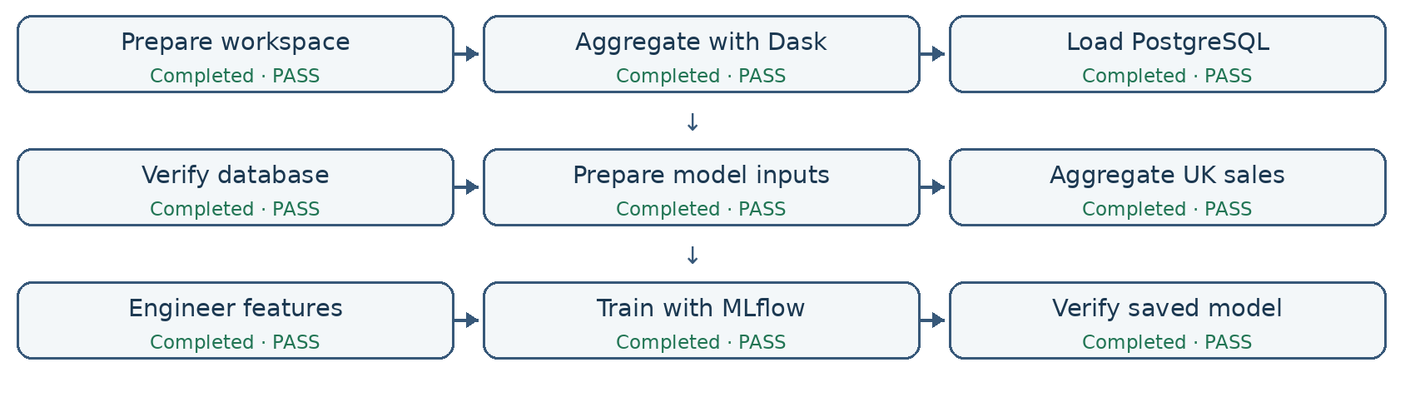
Note. Redrawn from the nine-task successful local Airflow graph; original capture retained in the repository.

Monitoring, Limitations, and Conclusion
The Flask service passed six in-process tests and a separate live HTTP prediction test. Prometheus scraped the API, and Grafana visualized request outcomes and latency. Controlled replay generated 75 valid and 15 invalid requests; the captured dashboard showed 76 cumulative successes, 16 rejections, and P95 latency of 24.1 ms. This local observation is not a sustained throughput benchmark or cloud-level guarantee. Correctness, latency, and cost tradeoffs are discussed by Akidau et al. (2015).
Figure 2
Grafana monitoring during a controlled prediction replay
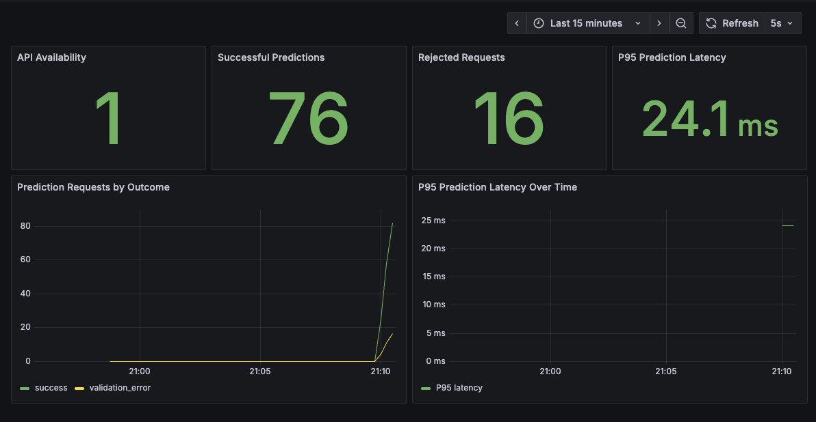
Note. Actual local Grafana capture, October 13, 2026; cumulative counters include earlier API checks. No live AWS deployment is represented.
The workflow demonstrates repeatable ETL and local MLOps integration, but not operational forecasting readiness. Limitations include historical data, unknown stockouts, zero-filled weeks, no nationally flagged holidays in the holdout, high forecasting error, precomputed API features, and untested AWS rollout and drift monitoring.

References
Akidau, T., Bradshaw, R., Chambers, C., Chernyak, S., Fernández-Moctezuma, R. J., Lax, R., McVeety, S., Mills, D., Perry, F., Schmidt, E., & Whittle, S. (2015). The dataflow model: A practical approach to balancing correctness, latency, and cost in massive-scale, unbounded, out-of-order data processing. Proceedings of the VLDB Endowment, 8(12), 1792–1803. https://doi.org/10.14778/2824032.2824076
Chen, D. (2015). Online retail [Data set]. UCI Machine Learning Repository. https://doi.org/10.24432/C5BW33
Kreuzberger, D., Kühl, N., & Hirschl, S. (2023). Machine learning operations (MLOps): Overview, definition, and architecture. IEEE Access, 11, 31866–31879. https://doi.org/10.1109/ACCESS.2023.3262138
Nager.Date. (n.d.). Public holidays API. https://date.nager.at/Api
Sculley, D., Holt, G., Golovin, D., Davydov, E., Phillips, T., Ebner, D., Chaudhary, V., Young, M., Crespo, J.-F., & Dennison, D. (2015). Hidden technical debt in machine learning systems. In Advances in Neural Information Processing Systems (Vol. 28, pp. 2503–2511). https://papers.nips.cc/paper/5656-hidden-technical-debt-in-machine-learning-systems

