Mission Space Lab Phase 4 report outline

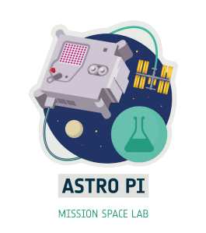

Team name: Centauri
Chosen theme: Life in Space/Life on Earth
Organisation name: Diverbot
Country: Spain

Layout information:
- Your report must fit on no more than 4 pages of A4. Reports that exceed this length won’t be accepted.
- Each section should have a title, as shown in this outline.
- Please use the font ‘Verdana’ with the titles in font 14 and the main text in size 11.
- All images and graphics should have a concise caption underneath the image.
- Once your report is finished, save it as a PDF for submission.
- Please avoid writing any personal data, such as student names or social media accounts in this report.

1. Introduction
In this section you should introduce your investigation. Explain what your team aimed to investigate, why this is interesting and what you expected to find.
This section is limited to 200 words.
2. Method
In this section you should explain what your team decided to measure, how you collected the data you needed and how you decided to analyse your data. You should explain any advantages or disadvantages of the methods that you chose.
Some things to think about are:

- What sensors did you use, and why?
- What type of data was collected? Images, text files etc.
- Was any of the data processed on Earth?
- If you used machine learning, did you use the Coral dongle to do this during your data collection, or during analysis when you had received your data?
- (Optional) If you are submitting a link to a GitHub repository with your report, briefly explain the additional programs/code you have written to help analyse your experiment data.
This section is limited to 200 words.
3. Experiment results
In this section you should present your results. We encourage teams to use pictures, charts and figures where they are helpful to explain your findings. This section is limited to 300 words.
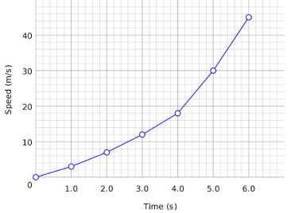
Figure 1 (example): Speed versus time

4. Learnings
This is a new section this year. Please tell us about your experience working as a team on Mission Space Lab. This shouldn’t just be limited to skills such as coding, using the hardware and analysis techniques (although we would love to hear about this too!). For example:
- How did you plan and organise your work as a team?
- What challenges did you experience and how did you overcome them?
- What did you learn?
- What would you do differently next time?
This section is limited to 200 words.

5. Conclusion
Don’t leave writing this section until the last minute — it is the most important! This is the final section that judges will read and should bring everything from your previous sections together. It is an opportunity for the team to share their reflections on their experience, their experiment design and results, and conclude on their findings. Did you find out what you were expecting? If not, why not? If your experiment did not produce any valid results, explain what you think went wrong and what you would do differently next time. This is still a valid finding.
This section is limited to 200 words.

1-INTRODUCTION

El cambio climatico que esta afectando actualmente a la Tierra es debido principalmente a los gases de efecto hinvernadero. Mas alla de gases emitidos de forma artificial como el CO2, es bien sabido que el vapor de agua es un gran contribuidor al efecto hinvernadero. Las mayores concentraciones de vapor de agua se encuentran en las nubes. Tambien es sabido que nubes altas afectan en mayor grado que nubes mas bajas.
El objetivo de nuestro experimento es averiguar la altura de las nubes y llegar a saber si se encuentran en zonas mas altas o mas bajas de la troposfera.
Para obtener los datos se uso la nueva camara de Astro Pi y luego se procesaron los datos en tierra.

Learnings

Creemos que una de las cosas que todos hemos aprendido por igual ha sido el poder de trabajar en equipo en trabajos de tal profesionalidad. Nadie de los tres nunca habia participado en competiciones que requisieran tanta profesionalidad y coordinacion a la hora de escribir el codigo.
Tambien es destacable uno de nuestros grandes fallos, la falta de coordinacion del tiempo. No nos coordinamos bien el tiempo con tablas de tiempo especificas, sumado que ademas nos inscribimos en otros concursos realizados por la ESA, hizo que tubieramos muy poco tiempo para el analisis de los datos.
Deberiamos por lo tanto coordinar mejor el tiempo con ayuda de plataformas como Trello para futuros proyectos.

The climate change that is currently affecting the Earth is mainly due to greenhouse gases. Beyond artificially emitted gases such as CO2, it is well known that water vapor is a major contributor to the greenhouse effect. The highest concentrations of water vapor are found in clouds. It is also known that high clouds affect it to a greater degree than lower clouds.
The objective of our experiment is to find out the height of the clouds and to know if they are in higher or lower areas of the troposphere.
To obtain the data, the new Astro Pi camera was used and then the data was processed on the ground.
learnings
We believe that one of the things that we have all learned alike has been the power of working as a team on jobs of such professionalism. None of the three had ever participated in competitions that required so much professionalism and coordination when writing the code.
One of our great failures is also noteworthy, the lack of coordination of time. We did not coordinate time well with specific time tables, added to the fact that we also signed up for other contests held by the ESA, meant that we had very little time to analyze the data.
We should therefore better coordinate time with the help of platforms like Trello for future projects.

