The purpose of this document is to explain in detail the situation that has occurred over recent months regarding the Discord server **Diversity** (300k+).  
Server ID: 799038547399016450

**Contents**

Server Information 1

Loss Of Ownership Account 1

Requesting Ownership 4

Ownership Transferred To Server Staff Member 6

New Owner’s Abuse Of Power 9

Message Links 9

Contacting Discord Staff About Community Guidelines 12

Server Member Submits A Ticket To Discord Support 14

New Owners Try To Find Personal Information To Doxx Me 15

Creating A New Server, Server Gets Deleted Without Explanation 17

## Server Information

Server Name: Diversity

Server ID: 799038547399016450

## Loss Of Ownership Account

The ownership for Diversity was held by a second account that was **used purely to hold ownership**, it was **never** used for any other purpose. This was done as it seemed like a more secure way to ensure that the ownership stayed safe as the server was so large and continued to grow.

However, the account that held ownership was banned by Discord. **Discord did not send an email explaining the reason for the ban** and so a ticket was created trying to figure out what had happened. The ownership account was never used for any other purpose and so it was unclear why it had ever been banned by Discord.

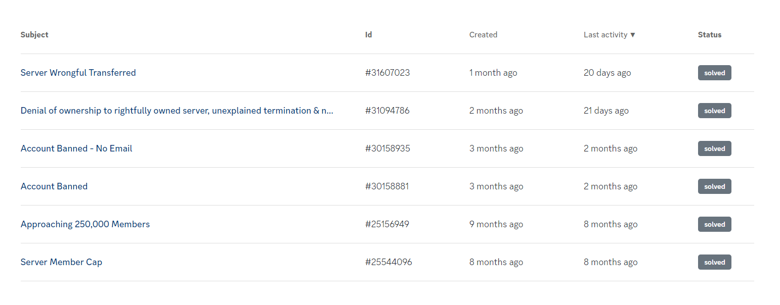

Figure - Tickets created on the ownership account

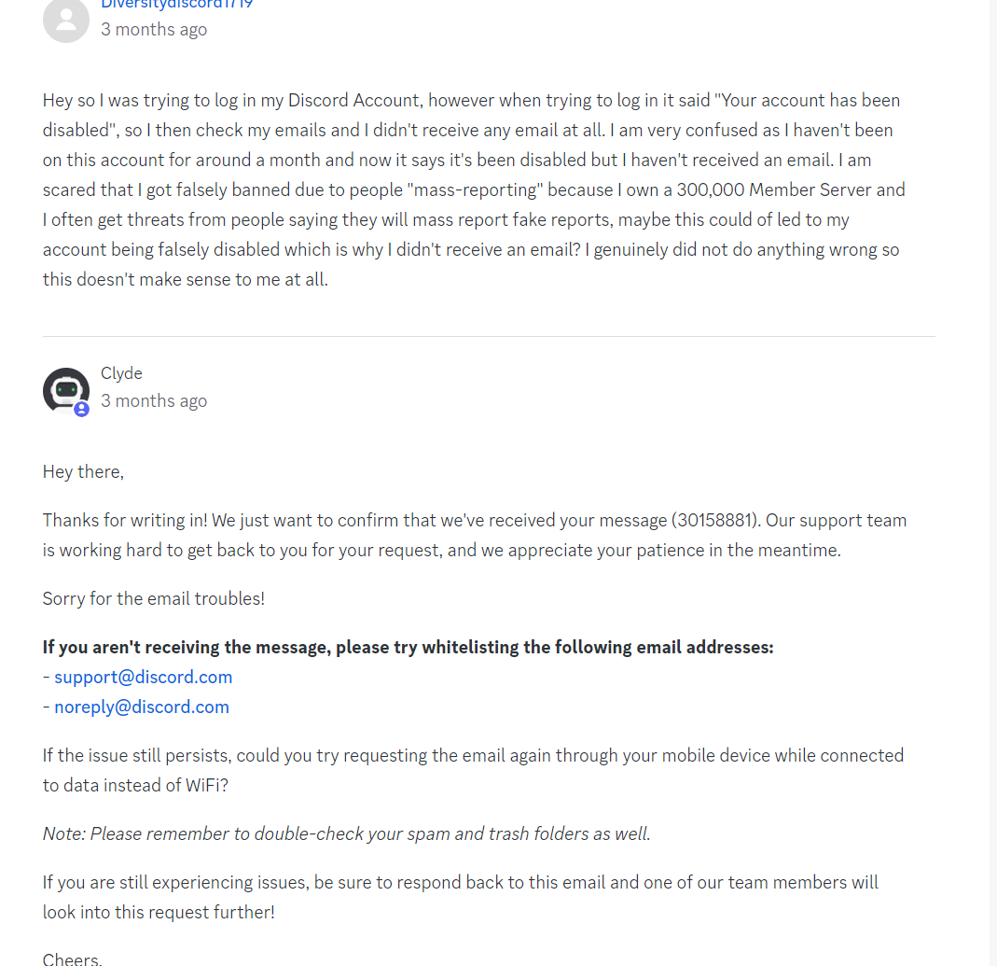

Figure - Initial ticket created when the ownership account was banned

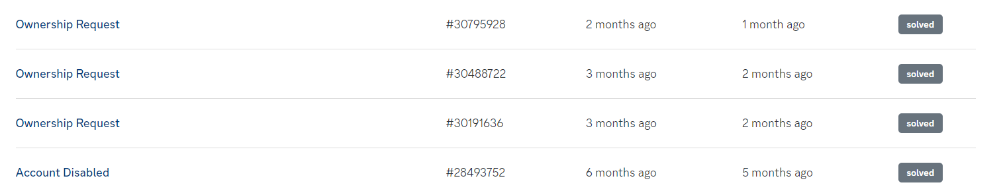

## Requesting Ownership

With no success regarding this, after the 30 day period I submitted another ticket on my main account and requested for Discord to transfer ownership of Diversity over to my main account which had full admin perms in the server and held the highest role. I tried to request ownership 3 separate times but every time I was denied and told each time that **the server did not meet the requirements for an ownership transfer**. This request was denied by Discord staff members Fred, and twice by **Calypso** who all stated that **the server did not meet the requirements for an ownership transfer**, even though it met all of the criteria at the time.

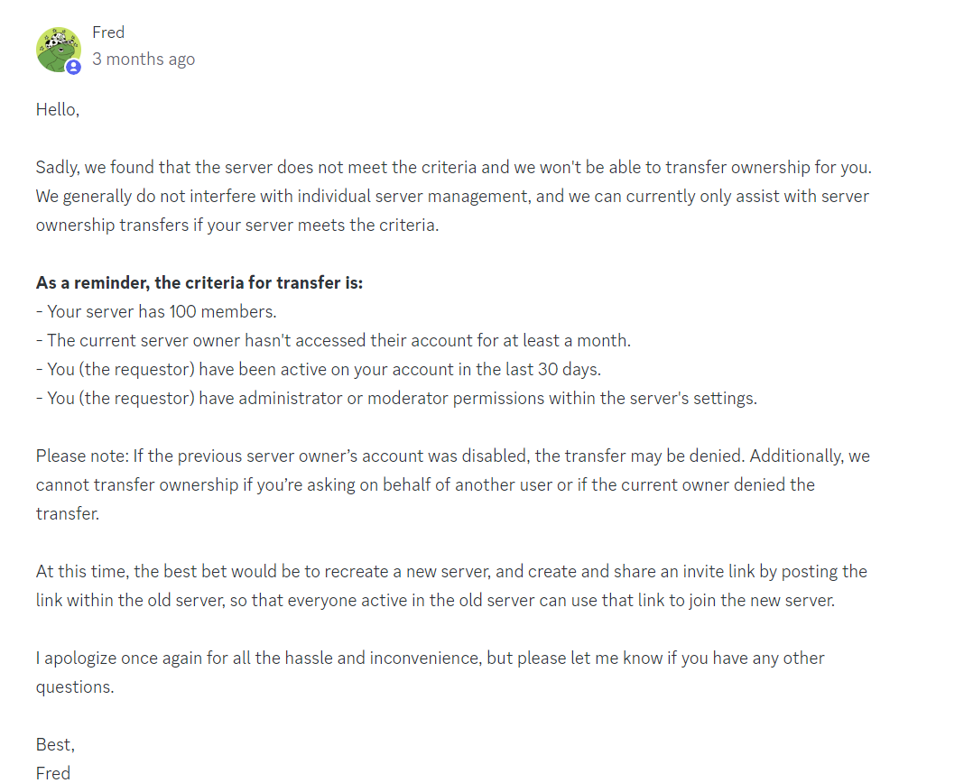

Figure - Fred denied the ownership transfer as the server did not meet the criteria

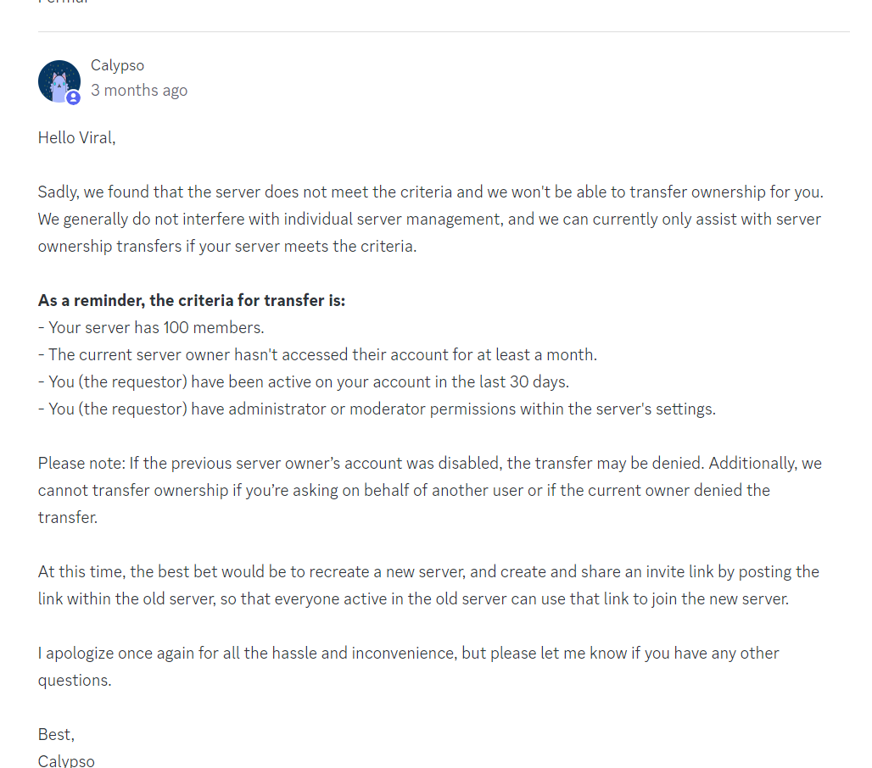

Figure – Calypso denied the ownership transfer as the server did not meet the criteria

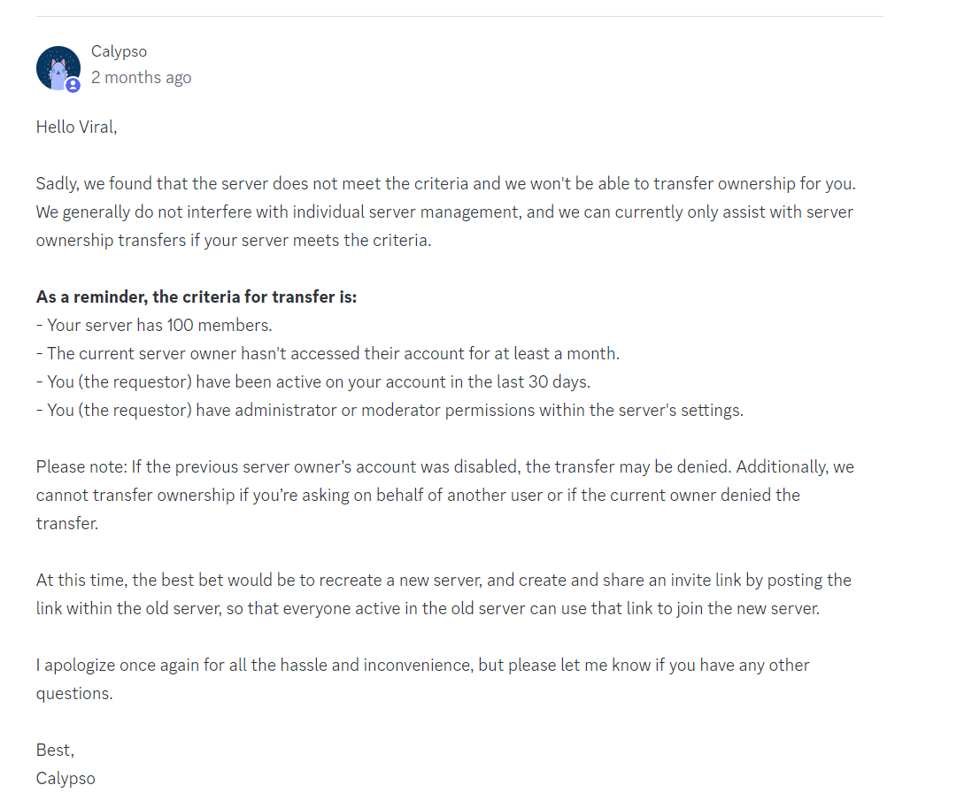

Figure - Calypso once again denying the ownership transfer as the server did not meet the criteria

## Ownership Transferred To Server Staff Member

Despite this I later found out that a few days later the server ownership was then transferred over to someone who had staff in Diversity by the another Discord staff member, despite multiple staff telling me that the server did not meet the requirements for ownership transfer just days earlier.

A screenshot showing that Discord staff had transferred ownership of Diversity to someone else, despite the fact that the server did not meet the criteria for ownership transfer

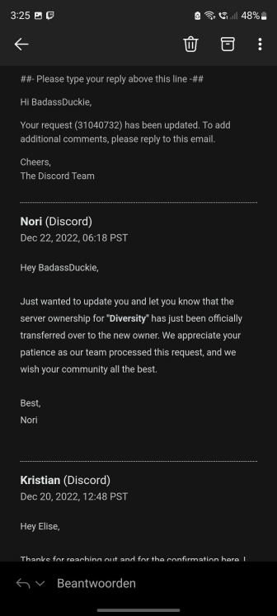

I tried again to contact Discord support after this as I felt that something just didn’t add up. How could a Discord staff member tell me twice that Diversity did not meet the criteria for ownership transfer and yet another staff member could go ahead and transfer ownership of the server to someone else? If my server did not meet the requirements when I asked, why did it suddenly meet the criteria when someone else did?

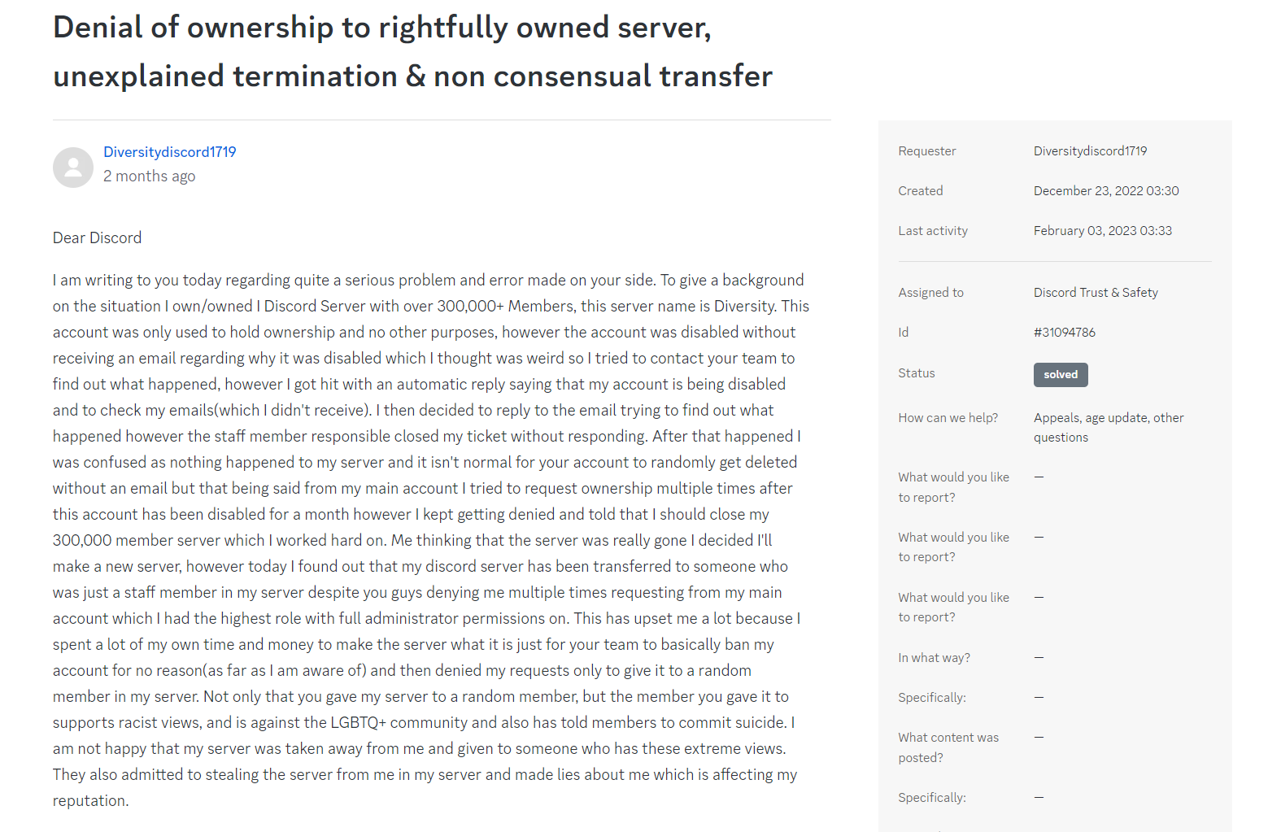

Figure - Another ticket submitted when the ownership was transferred to someone else

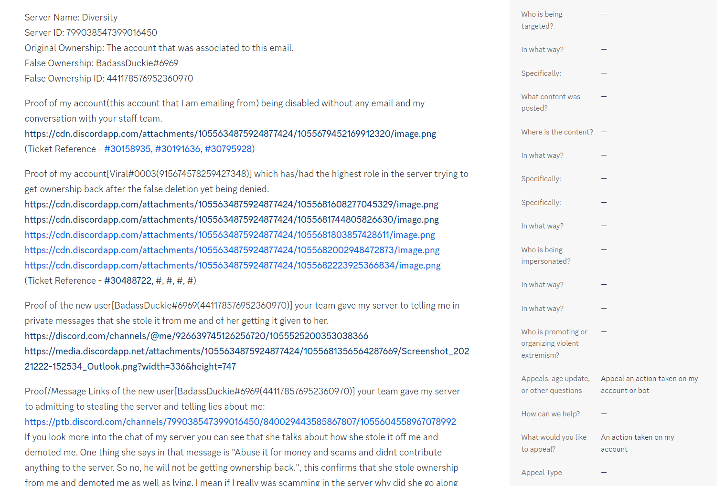

## New Owner’s Abuse Of Power

When the ownership was transferred to the Diversity staff member, she immediately **banned me and the other owner** along with **over 90% of the staff team** who must have been viewed as a threat due to their loyalty to me. I tried multiple times to contact Discord regarding this, but I have not received anything more than automated replies and bans to my account for antispam when I have tried to bump the tickets due to the urgency of the situation. The situation quickly became volatile as since taking control of the server the new owners had began to repeatedly **break Discord’s community guidelines**, filling Diversity with racism, anti lgbt views and allowing a toxic environment that is filled with hate and bullying to run rampant. It destroyed everything that I worked so hard to build and goes against everything that I wanted Diversity to stand for. I have included some message links below that show the kind of hatred that is now widespread and flourishes amongst **staff and owners in Diversity**.

## Message Links

<https://discord.com/channels/799038547399016450/840029457921867816/1065046612440793139> <<< moderator saying the server needs a new rule, all furries should be bullied into suicide

<https://discord.com/channels/799038547399016450/840029457921867816/1064921703173591190> <<< someone telling someone else to commit suicide and duckie (owner) messaging right after not even acknowledging it

<https://discord.com/channels/799038547399016450/840029457921867816/1064562157523574844> <<< moderator telling someone to write something in their suicide note

<https://discord.com/channels/799038547399016450/840029457921867816/1064562157523574844> <<< moderator saying suicide should be the first option

<https://discord.com/channels/799038547399016450/840029457921867816/1064925649363538062> <<< staff saying duckie (owner) seriously doesn't care when another user wanted to report bullying in server to her

<https://discord.com/channels/799038547399016450/840029457921867816/1064747261667594250> <<< roela (owner) banning someone and saying they're too fat for this world

<https://discord.com/channels/799038547399016450/840029457921867816/1064926723738697839> <<< staff saying complaining about bullies is a bannable offence when someone was getting bullied in the server

<https://discord.com/channels/799038547399016450/840029457921867816/1064963765818368082> <<< staff telling people to send nudes in dms

<https://discord.com/channels/799038547399016450/840029457921867816/1065363858702749773> <<< helper saying do you ever wish (another user) gets bullied into suicide

<https://discord.com/channels/799038547399016450/840029457921867816/1065906072818303077> <<< admin saying shut up black n word

<https://discord.com/channels/799038547399016450/840029457921867816/1065978311399972986> <<< admin saying stfu and stop being bitchy no one asked if you give a fuck

<https://discord.com/channels/799038547399016450/840029457921867816/1065982686625267782> <<< chat being toxic in general

<https://discord.com/channels/799038547399016450/840029457921867816/1066501401770983485> <<< duckie (owner) saying why are you still talking virgin

<https://discord.com/channels/799038547399016450/840029457921867816/1066513307638435861> <<< duckie (owner) calling someone a snowflake when they complained about being called a n word and a slave

<https://discord.com/channels/799038547399016450/840029457921867816/1066501669791223889> <<< duckie (owner) saying to a member “that you are a virgin is noticable, pretending to look cool while youre a sad asf person who cant pull any bitches”

<https://discord.com/channels/799038547399016450/840029457921867816/1065410688081731664> <<< moderator saying legalise non-consensual sex

<https://discord.com/channels/799038547399016450/840029457921867816/1065410299483664454> <<<helper saying they’ll stab a furries throat

<https://discord.com/channels/799038547399016450/840029457921867816/1066528151989129227> <<<moderator harassing a user asking about their genitals

<https://discord.com/channels/799038547399016450/840029457921867816/1066200748813197372> moderator calling lgbt a mental illness

<https://discord.com/channels/799038547399016450/840029457921867816/1066528078341361744> <<<staff telling someone to stop trying to sound different with their identity

<https://discord.com/channels/799038547399016450/840029457921867816/1066527982899974154> <<< moderator saying theres only one gender,.. MALE. Women Are Inferior, and therefore not counted

<https://discord.com/channels/799038547399016450/840029457921867816/1078440596093546576> <<<furries are the cancer of society

<https://discord.com/channels/799038547399016450/840029457921867816/1078816278858440775> <<< moderator saying Oh classic so original you pedophile badger fucking raccoon ass sniffing dumpster diving child molesting crack addict

<https://discord.com/channels/799038547399016450/840029457921867816/1078145071062462494> <<< admin saying there are rules not to be nice to (member)

<https://discord.com/channels/799038547399016450/840029457921867816/1078145592913576017> <<< admin saying that they were harassing

<https://discord.com/channels/799038547399016450/840029457921867816/1076672453801168926> <<< admin telling someone to seek suicide

<https://discord.com/channels/799038547399016450/840029457921867816/1078790950542905374> <<< moderator telling someone kys

<https://discord.com/channels/799038547399016450/840029457921867816/1078659006039589004> <<< helper saying I don’t like you, get lost

<https://discord.com/channels/799038547399016450/840029457921867816/1078072102105665596> <<< moderator saying and you still haven’t kys to a member

<https://discord.com/channels/799038547399016450/840029457921867816/1078706734811590726> <<< moderator saying it’s in the rules you fucking dumbass n word to a user

<https://discord.com/channels/799038547399016450/840029457921867816/1078833640320024636> <<< high level member telling chat they like their girls 12 n word

<https://discord.com/channels/799038547399016450/840029457921867816/1078701106084991068> <<< server member called Adolf Hitler saying ong n word should end himself

<https://discord.com/channels/799038547399016450/840029457921867816/1078765022081196102> <<< someone typed Arabic (I think) in chat and helper said fy saying n word ion wanna get bombed (edited)

<https://discord.com/channels/799038547399016450/840029457921867816/1078765156554776607> <<< chat gets Islamophobic after last message, someone asks what’s up with the racism and a helper replies allah akhbar

<https://discord.com/channels/799038547399016450/840029457921867816/1078765323068649542> <<< same helper then sends a gif of a plane crashing

<https://discord.com/channels/799038547399016450/840029457921867816/1078765594465292468> <<< very high level member sends a pic that has actual corpses in it and says it’s lgbt people getting bullied in Diversity

<https://discord.com/channels/799038547399016450/840029457921867816/1078397844031017120> <<< helper saying people don’t think and that’s why they’re trans

<https://discord.com/channels/799038547399016450/840029457921867816/1078246465719255060> <<< helper sent a gif that says me explaining why you should kill yourself

<https://discord.com/channels/799038547399016450/840029457921867816/1078182895555981332> <<< helper saying we should ban furries

<https://discord.com/channels/799038547399016450/840029457921867816/1078006218100068412> <<< helper saying nah stfu ching chong to a user

<https://discord.com/channels/799038547399016450/840029457921867816/1077960350030372965> <<< helper encouraging a fight

<https://discord.com/channels/799038547399016450/840029457921867816/1077822938889334835> <<< helper telling someone to shut up and that they look like a turd with Down’s syndrome

<https://discord.com/channels/799038547399016450/840029457921867816/1077337144202375289> <<< moderator replying to another mod who reposted his deleted message saying that he loves racism, replies saying fuck you n word kys

<https://discord.com/channels/799038547399016450/840029457921867816/1078321680633581578> <<< moderator saying there’s only 2 genders

<https://discord.com/channels/799038547399016450/840029457921867816/1078875086980923432> <<< high level member with an owners custom role saying how about you kys like the world will be better yk. Furries will be gone. The lgbtq community will die and etc to another member

<https://discord.com/channels/799038547399016450/840029457921867816/1078510542311915652> <<< high level member saying women aren’t good at anything enough producing babies and milk

<https://discord.com/channels/799038547399016450/840029457921867816/1079052799402311821> <<< roela (owner) telling a user su kys

<https://discord.com/channels/799038547399016450/840029457921867816/1079055765488283730> <<< roela (owner) saying she doesn’t give a fuck about slurs other than n word

<https://discord.com/channels/799038547399016450/840029457921867816/1079055506137681950> <<< roela (owner) replying to another member that they can say the slur retard bc they are one

<https://discord.com/channels/799038547399016450/840029457921867816/1073338526575370282> <<< admin saying you don't respect trans women cause you are transphobic. I don't respect trans women cause they are women.

<https://discord.com/channels/799038547399016450/840029457921867816/1077089890161926234> <<< admin calling someone a massive retard

## Contacting Discord Staff About Community Guidelines

Concerned about what was happening to my server and frustrated that I was receiving no help from Discord I was able to contact a staff member directly through a mutual server. I expressed my concerns to her and she was quick to agree that the server was full of racism and hate. **Clearly in violation of Discord’s community guidelines.**

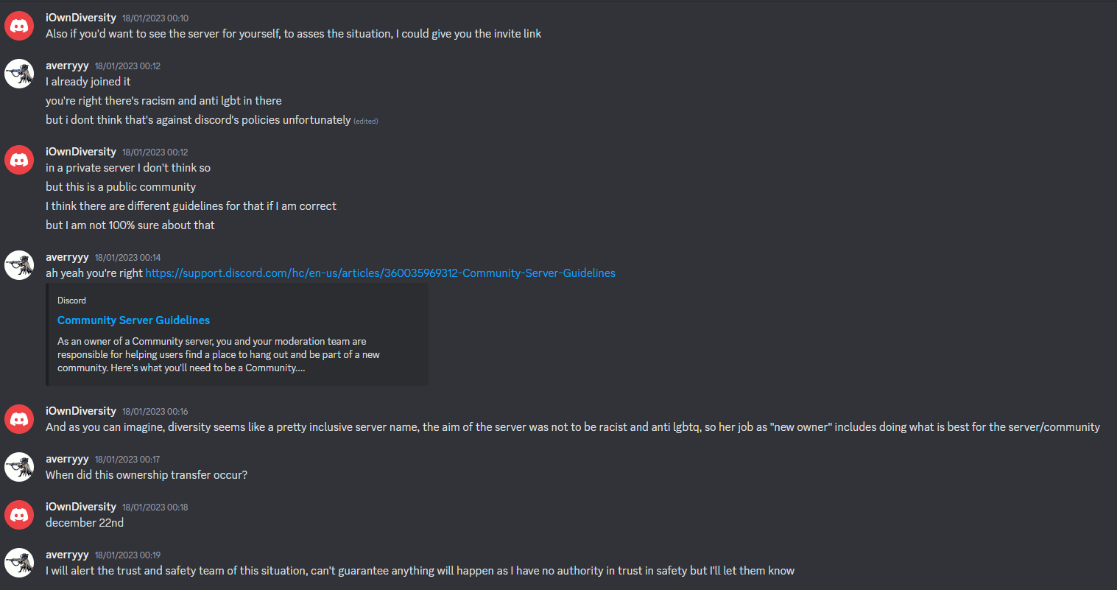

Figure - Staff member Avery acknowledging that Diversity was breaking the Discord community guidelines under the new owners

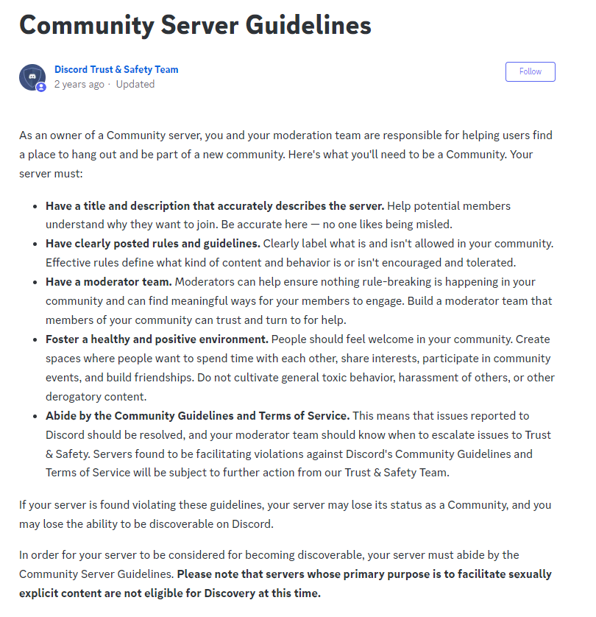

<https://support.discord.com/hc/en-us/articles/360035969312-Community-Server-Guidelines>

## Server Member Submits A Ticket To Discord Support

Following this I was told by a member of the server that she had sent a ticket to Discord as she was concerned about the environment that was now thriving within the server. Within her ticket she included an explanation of her concerns and multiple message links that each illustrated the way that the new owners and staff were acting in their new positions. This was met by yet another automated reply from Discord, and they told her to raise the concerns to the server staff, and marked the ticket as being solved. But as the issue was to do with the owners and the staff she did not feel as though she was able to speak up as she had witnessed other members get muted and permanently banned for much less and so instead opted to reply to Discord to reopen the ticket as she felt ignored and unsatisfied with their reply and reiterated the issue. She has not received a single response or acknowledgement of this in over a month and the problem still remains to this day.

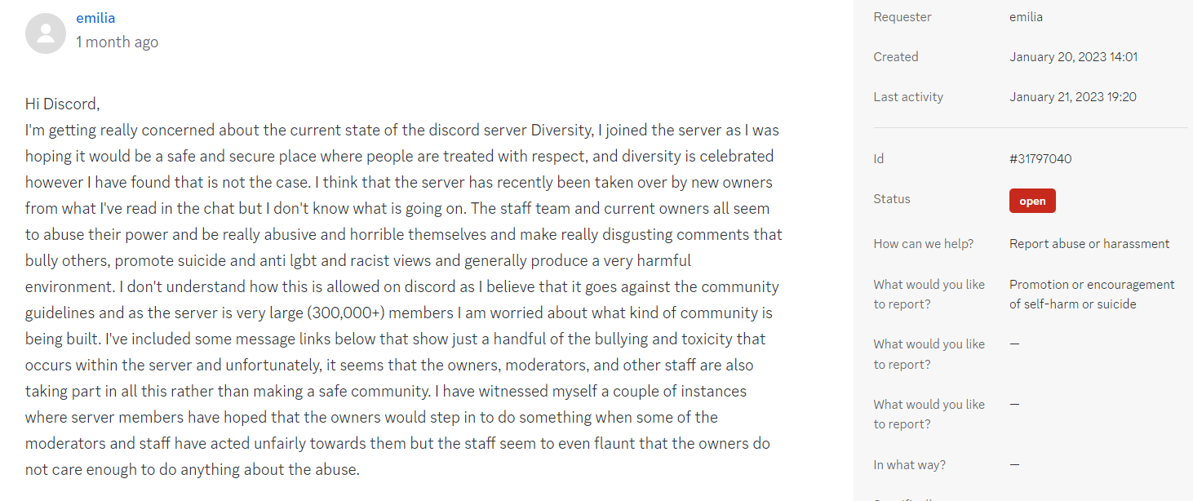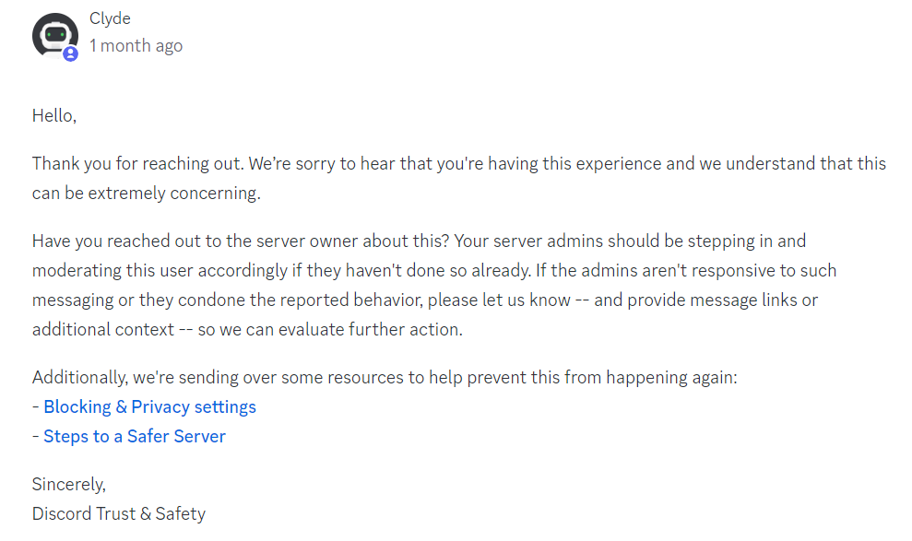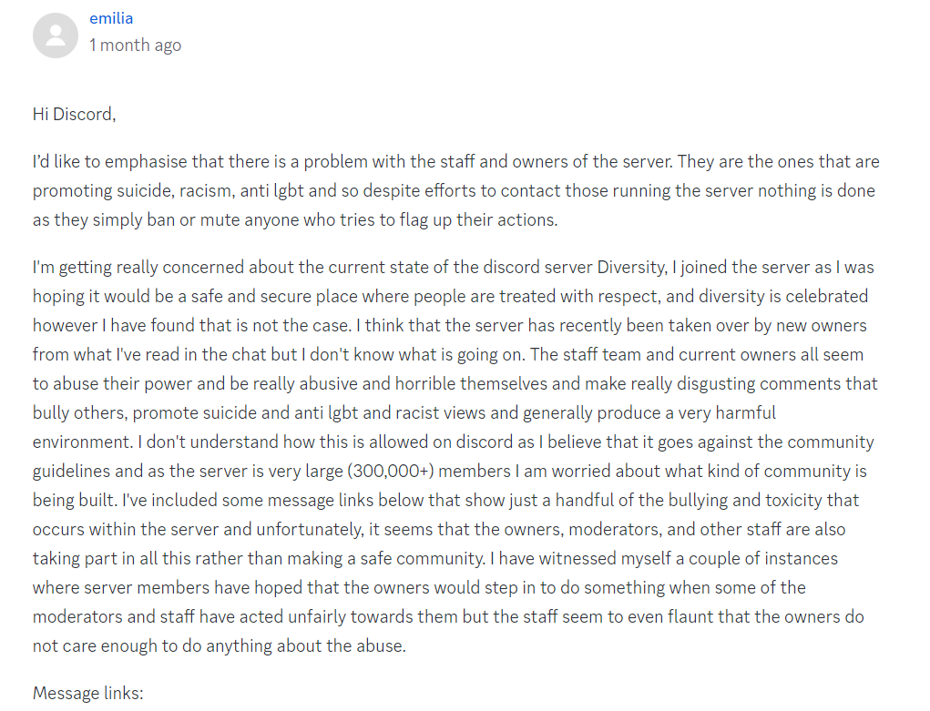

## New Owners Try To Find Personal Information To Doxx Me

I found out that the new owners were also trying to doxx me, by asking other large community owners that I had befriended if they knew any personal and private information about me, such as my identity. Of course, hearing this frightened me as it seemed that they were not satisfied with stealing my server and banning me from it, but they also had a personal vendetta against me. I went to Discord support regarding this, as I was now worried for my safety on the platform but once again my plea for help was met with no support as the staff member stated that there was nothing that could be done as they could not check messages that had been deleted despite me providing additional screenshots as well as message links and the ticket was once again marked as solved, but the threat to my safety remained.

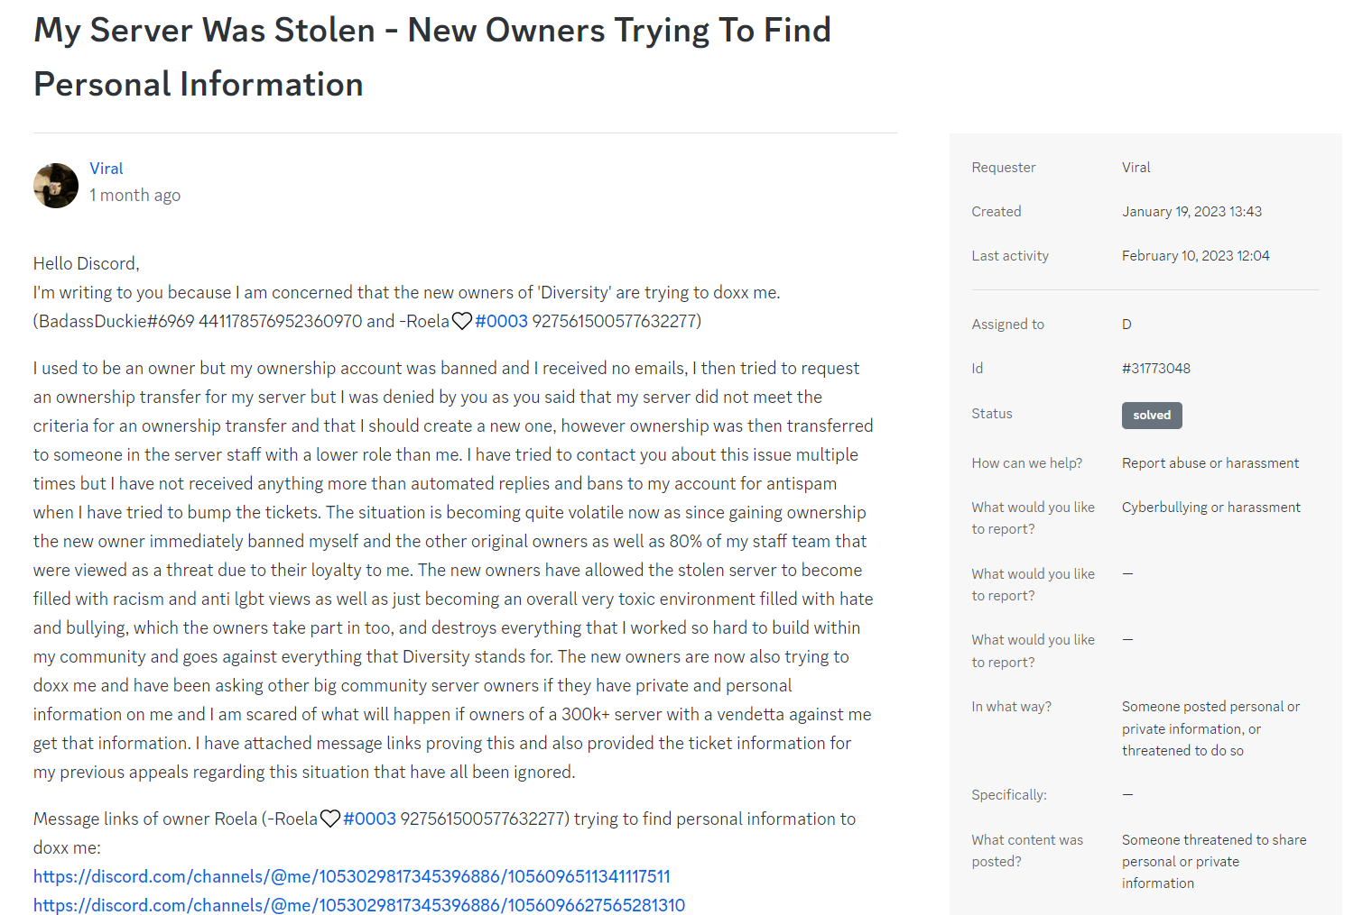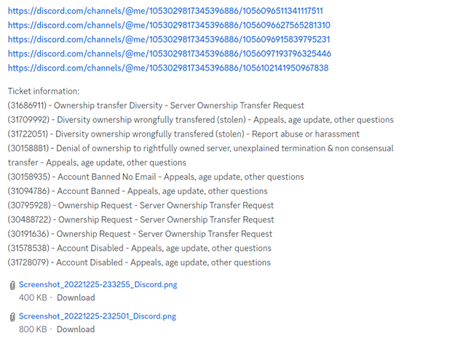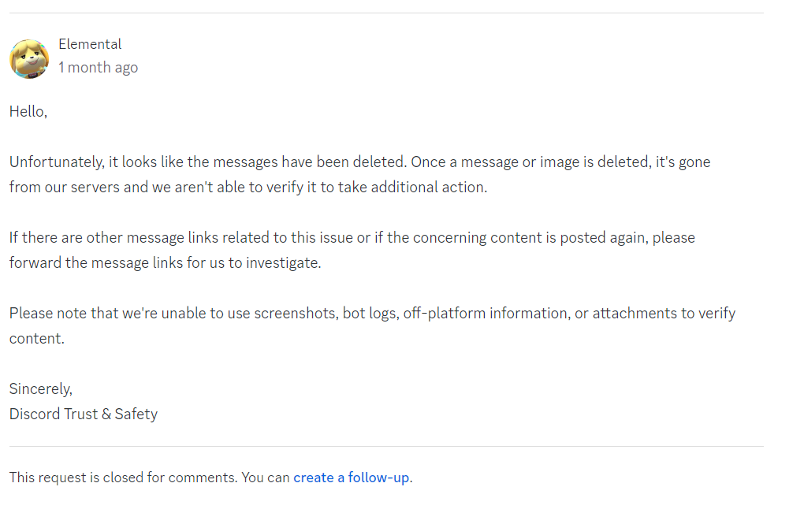

Figure - Discord staff telling me that they could not help in response to my ticket about the new Diversity owners trying to doxx me

## Creating A New Server, Server Gets Deleted Without Explanation

When my ownership request was first denied, I was advised by the Discord staff to create a new server as the server did not meet the requirements for ownership transfer and so it was effectively lost in their eyes. I held out hope for a while but after receiving only automated replies from Discord and my tickets being marked as solved when issues clearly remained and them effectively telling me that they would not help I chose to cut my losses and move on by following the advice that I received, and so I decided to make a new server.



Determined not to let past mistakes reoccur, I kept my staff team small and only full of those that I trusted completely. Seeing how the stolen server was now effectively cyberbullying central thanks to the new owners and staff who promoted some truly horrific views I introduced strict moderation in my new server to ensure that it would never turn into a place full of such hatred. However, on February 23rd my new server had been deleted without any explanation whatsoever and Discord had transferred the vanity that I was using to the stolen server and my account that had owner role was also banned.

I do not understand why this is happening and it honestly feels as though I am being targeted over and over again. It seems as though I have been failed again and again by Discord despite trying to be as detailed and as helpful as possible in all of the tickets that I have submitted. Whenever I try to get real support from Discord nothing is ever done yet those who have repeatedly threatened and bullied me seem to have the full support of Discord to continue to act as tyrants on the platform, break Discord community guidelines and to spread hate.