**Parameters Optimization Using Swarm Intelligence**

Submitted in partial fulfilment of the requirements for the award of the degree of

**Bachelor of Technology**

**in**

**Information Technology**

Under the guidance of

**Prof. Arvinder Kaur**

&

**Mr. Amrit Pal Singh**

Submitted by

Guneet Singh Dhillon

(02816401514)

7th Semester



**University School of Information and Communication Technology**

**GGS Indraprastha University, Delhi-78**

**Parameters Optimization Using Swarm Intelligence**

Submitted in partial fulfilment of the requirements for the award of the degree of

**Bachelor of Technology**

**in**

**Information Technology**

Under the guidance of

**Prof. Arvinder Kaur**

&

**Mr. Amrit Pal Singh**

Submitted by

Divesh Bisht

(04616401514)

7th Semester



**University School of Information and Communication Technology**

**GGS Indraprastha University, Delhi-78**

**PROBLEM STATEMENT**

Deep learning has been successfully applied in several fields such as machine translation, manufacturing, and pattern recognition. However, successful application of deep learning depends upon appropriately setting its parameters to achieve high-quality results. The number of hidden layers and the number of neurons in each layer of a deep machine learning network are two key parameters, which have main influence on the performance of the algorithm.

Manual parameter setting and grid search approaches somewhat ease the users’ tasks in setting these important parameters. Nonetheless, these two techniques can be very time-consuming.

In this project, we show that the Particle swarm optimization (PSO) technique holds great potential to optimize parameter settings and thus saves valuable computational resources during the tuning process of deep learning models.

**TOOLS USED**

The following tools will be used during this project:

* HARDWARE TOOLS : Desktop PC, capable of running Python and related software packages.
* SOFTWARE TOOLS : The following software packages will be used during the project
  + Python 2.7 or greater
  + TensorFlow, Keras, Theano frameworks
  + Jupyter-Notebook
  + Weka 3 – Data Mining Tool

**GANTT CHART**

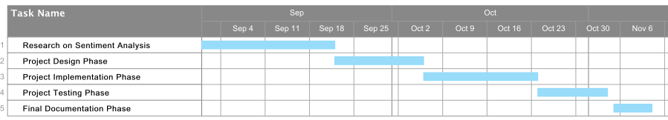

Phase 1: (1st Feb to 21st Feb)

Research on Deep Learning

Phase 2: (22nd February to 5th March)

Project Design Phase

Phase 3: (6th March to 23rd March)

Project Implementation Phase

Phase 4: (24th March to 4th April)

Project Testing Phase

Phase 5: (5th April to 15th April)

Final Documentation Phase