Assignment -05 _HPC_LAB_U23AI060

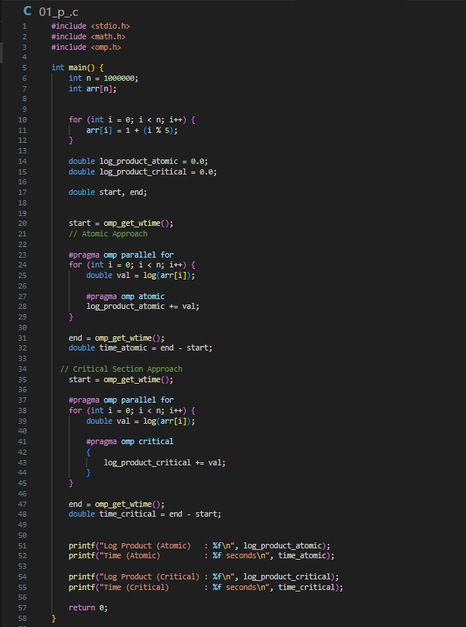
Program_01: Program_02:
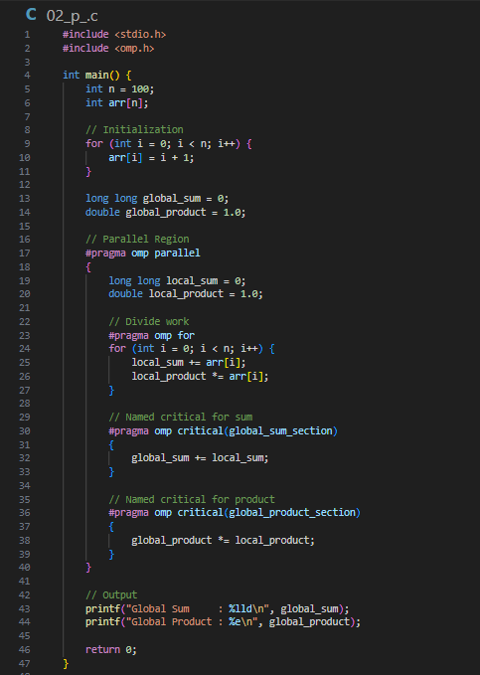

output: Output:
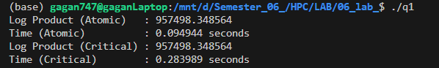

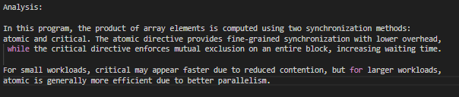
Analysis: Analysis:
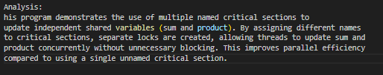

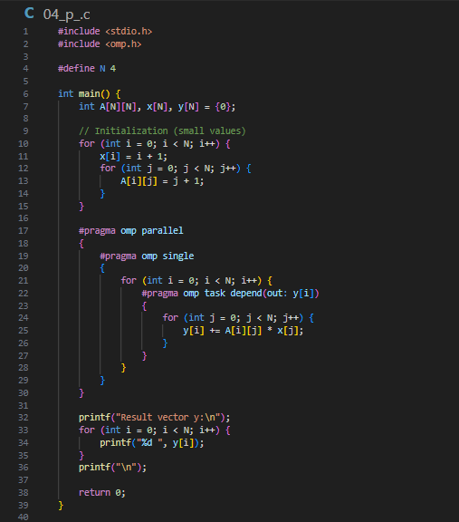
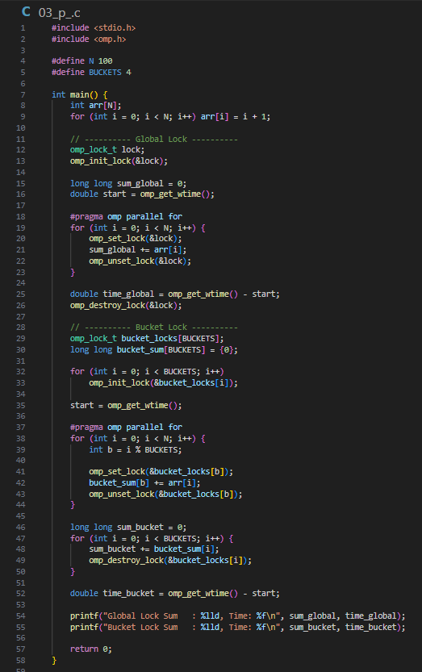
Program_03: Program_04:

Output : Output

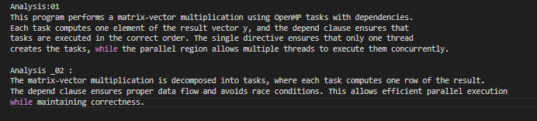
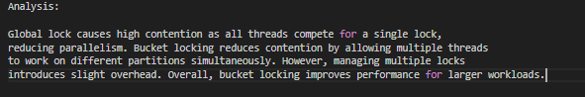
Analysis: Analysis:

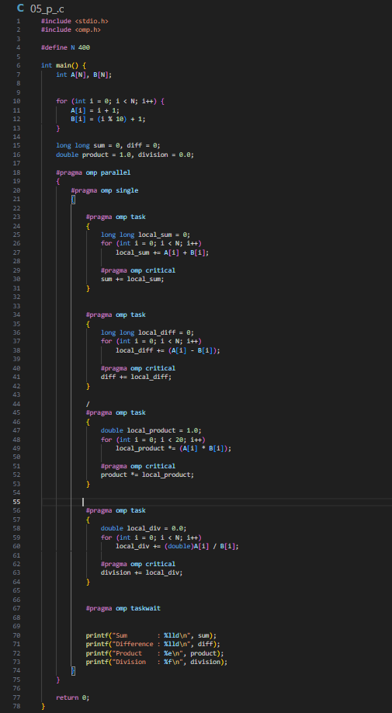
Program_05:
Output:
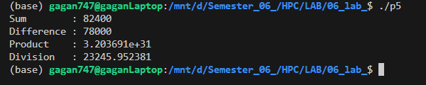

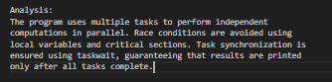
Analysis:


