1.Write a â€œpersonâ€ class to hold all the details.

class Person {

constructor(firstName, lastName, age, email) {

this.firstName = firstName;

this.lastName = lastName;

this.age = age;

this.email = email;

}

getFullName() {

return `${this.firstName} ${this.lastName}`;

}

getAge() {

return this.age;

}

getEmail() {

return this.email;

}

// You can add more methods here for additional functionality

}

const person1 = new Person("Dina", "Dinesh", 24, "Dina@example.com");

console.log(person1.getFullName());

console.log(person1.getAge());

console.log(person1.getEmail());

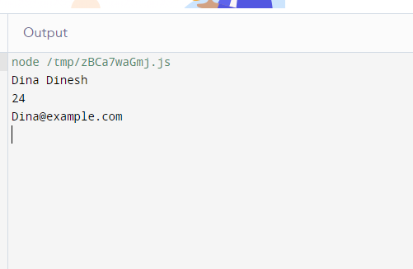

-------------------------------------------------------------------------------------------------------------

2.write a class to calculate the uber price.

class UberPriceCalculator {

constructor(baseFare, costPerMile, costPerMinute, surgeMultiplier) {

this.baseFare = baseFare;

this.costPerMile = costPerMile;

this.costPerMinute = costPerMinute;

this.surgeMultiplier = surgeMultiplier || 1; // Default to no surge pricing

}

calculatePrice(distanceInMiles, timeInMinutes) {

const fareBeforeSurge = this.baseFare +

(this.costPerMile \* distanceInMiles) +

(this.costPerMinute \* timeInMinutes);

const finalFare = fareBeforeSurge \* this.surgeMultiplier;

return finalFare;

}

}

// Example usage:

const calculator = new UberPriceCalculator(2.5, 1.5, 0.3); // Base fare, cost per mile, cost per minute

const distance = 5; // miles

const time = 15; // minutes

const price = calculator.calculatePrice(distance, time);

console.log(`The estimated Uber price is $${price.toFixed(2)}`);

