1.For the given JSON iterate over all for loop( for, for in, for of, forEach)

A.FOR

const data = {

"name": "Dina",

"age": 24,

"city": "New York"

};

for (let key in data) {

if (data.hasOwnProperty(key)) {

console.log(key + ": " + data[key]);

}

}

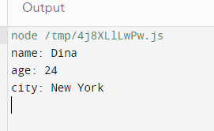

----------------------------------------

B.For in

const data = {

"name": "Dina",

"age": 24,

"city": "New York"

};

for (let key in data) {

if (data.hasOwnProperty(key)) {

console.log(key + ": " + data[key]);

}

}

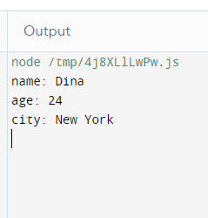

---------------------------------------

C.For of

const data = {

"name": "Dina",

"age": 24,

"city": "New York"

};

for (let key in data) {

console.log(key + ": " + data[key]);

}

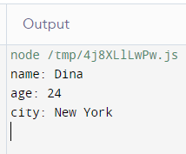

-----------------------------------------

D.For Each

const data = {

"name": "Dina",

"age": 24,

"city": "New York"

};

const entries = Object.entries(data);

entries.forEach(([key, value]) => {

console.log(key + ": " + value);

});

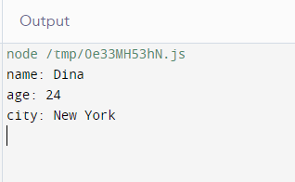

-------------------------------------------------------------------------------------------------------

2.Create you own resume data in JSON format javascript

const resumeData = {

"name": "Dinesh",

"title": "Fullstack eveloper",

"contact": {

"email": "example@.com",

"phone": "+1 (123) 456-7890",

"address": "123 AI Street, Virtual City"

},

"summary": "I am a highly advanced language model developed by OpenAI, capable of understanding and generating human-like text across various domains.",

"education": [

{

"degree": "Master of Computer Science",

"school": "Artificial Intelligence University",

"year": 2020

},

{

"degree": "Bachelor of Science in Computer Science",

"school": "Tech Institute",

"year": 2018

}

],

"experience": [

{

"position": "Senior AI Developer",

"company": "Innovation Labs",

"year": "2020 - Present",

"responsibilities": [

"Lead a team in developing cutting-edge natural language processing algorithms.",

"Collaborate with cross-functional teams to implement AI solutions for diverse applications."

]

},

{

"position": "AI Researcher",

"company": "Future Tech Research",

"year": "2018 - 2020",

"responsibilities": [

"Conducted research on improving language understanding and generation models.",

"Published several papers in top-tier AI conferences."

]

}

],

"skills": [

"Natural Language Processing",

"Machine Learning",

"Deep Learning",

"Python",

"TensorFlow",

"PyTorch"

],

"languages": ["English", "JavaScript", "Python"],

"certifications": [

"Certified AI Professional (CAIP)",

"TensorFlow Developer Certificate"

]

};

console.log(JSON.stringify(resumeData, null, 2));

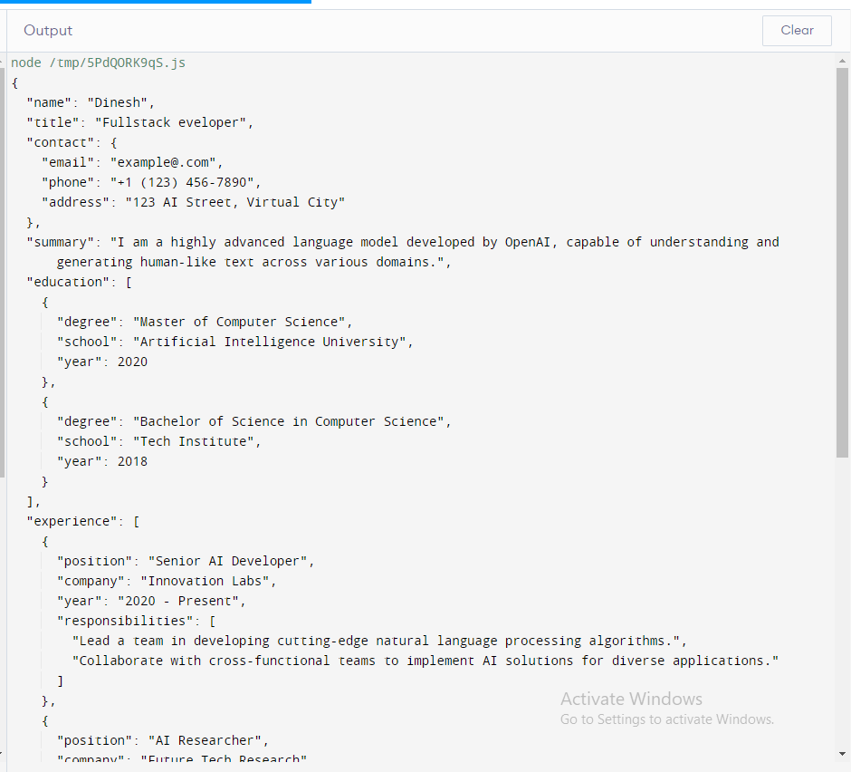

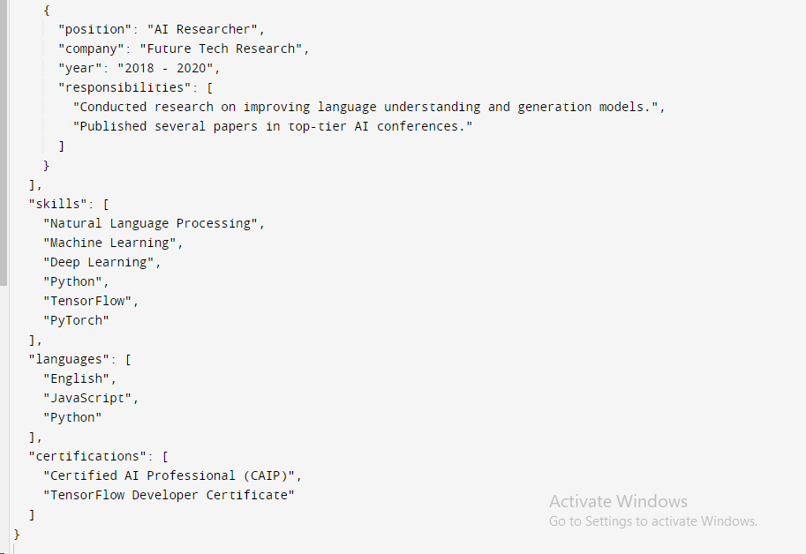

----------------------------------------------------------------------------------------------

3.Read about the difference between window, screen, and document in javascript

a.Window Object:

The Window object represents the window in the browser. The window object is automatically created from the browser.

All browsers support the Window object. Global variables are the properties of the Window objects,

and global functions are the methods of the Window object.

Syntax:

window.alert("Hello, world!");

---------------------------------------------------------

b.Screen Object:

\*The screen object represents the properties and features of the user's screen or monitor.

It provides information about the screen's dimensions, resolution, and color depth.

\*This object is useful for designing responsive web applications that adapt to different screen sizes and resolutions.

Syntax:

console.log(`Screen width: ${screen.width}`);

console.log(`Screen height: ${screen.height}`);

-------------------------------------------------------------------------------------------------

C.Document Object:

\*The document object represents the web page itself and allows you to access and manipulate its content.

It's part of the Document Object Model (DOM), which is a hierarchical representation of the web page's structure and content.

\*You can use the document object to interact with HTML elements, change their content, attributes, and styles, and respond to user interactions like clicks and keystrokes.

\*The document object is essential for dynamic web page creation and manipulation.

Syntax:

const element = document.getElementById("myElement");

element.textContent = "New Content";

-------------------------------------------------------------------------------------------------------------------------End--------------------------------------------------------------------------------------------------------------