**Portfolio Project**

**Deliverable – 5**

**Group 5-3**

**Topic: Tech Layoffs happened in the companies from Public and Private Sectors and their impact on workforce.**

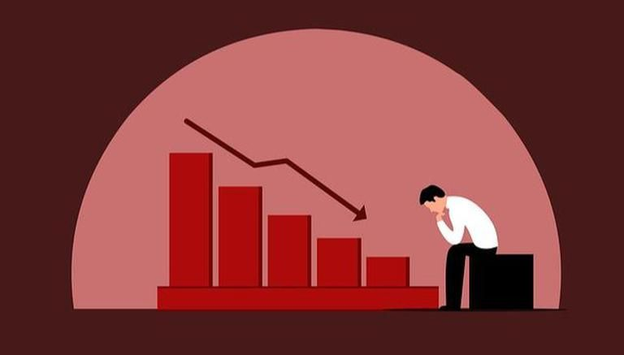

**Introduction:**

**Interest in Dataset:** Many technology companies like Lyft, Meta, Amazon, and others have experienced major layoffs in 2022. According to announcements made by tech companies across the world, thousands of employees will be laid off from the start of 2023. This is a serious real-time problem faced by many employees currently and as we are focusing on real-time data, we wanted to work on a dataset that is trending so we are analyzing this latest problem of layoffs done by different companies on different dates. The dataset we used is named as "tech_layoffs " and is hosted on Kaggle which is a platform for data science and machine learning enthusiasts to find and share datasets, kernels and platforms.

**Dataset Summary:**

Here is the link to get the dataset:

<https://www.kaggle.com/datasets/salimwid/technology-company-layoffs-20222023-data>

The dataset contains information about the company name, headquarter location, industry, number of layoffs, impacted workforce percentage, sources, date, status of the company. I have done the necessary cleaning of the data by watching videos from bblearn and I have added an extra column named Unique ID to understand and analyze the dataset in a more meaningful way and cleaned the dataset according to our requirements by removing the blank and missing data from the data set. After all these modifications, the dataset has 9 variables and 238 observations.

**Data Dictionary:**

|  |  |
| --- | --- |
| **Variable** | **Description** |
| Unique ID | Represents each individual company id in the dataset. |
| Company | It gives the names of the company in which layoffs are done. |
| total_layoff | It represents the number of layoffs happened in each company |
| impacted_workforce_percentage | Represents the percentage of workforce impacted in a company. |
| reported_date | It gives the date on which the layoffs are done. |
| Industry | Represents the company belonging to each industry. |
| headquarter_location | Gives the headquarter locations of the companies. |
| sources | Gives the source details from which the layoffs information is taken. |
| status of the company | Represents whether the company belongs to private or public sector. |

To analyze the data set variables, we needed categorical variables and quantitative variables so that we can summarize the variables accordingly and plot the graphs using best practices. One unexpected problem raised for us is the dataset had only two quantitative variables and we didn’t have enough proper categorical variables which can be visualized using excel best practices. Most of the categorical variables are in a way that we can visualize them using a bigger visualization tool such as Tableau. So, we continued with the data we had and analyzed using the Excel tools and graphs.

We wanted to analyze a few managerial questions like

* What is the highest and lowest percentage of layoffs happened in the given time.
* Is the private sector or public sector has the high number of layoffs in the given dataset.
* Which companies has the highest impacted workforce percentage in public and private sectors.

**Analysis of Managerial questions:**

After analyzing the dataset in excel using descriptive analysis, bar charts, and other plots, we got to understand a lot more information about the dataset such as how layoffs are impacting the workforce, how they differ in each sector of the company, and in the given reported dates. From the analysis, we have observed that the high percentage of layoffs that occurred in different companies is 35.6% in quarter 4 of the year 2022 and we can see that the lowest percentage of layoffs that occurred in the companies is 2.1 % in quarter 1 of 2022. To understand this data, I have considered a line chart (Figure 1) to visualize the information. From our analysis, we can also observe from the below bar chart (Figure 2) that 71.55% i.e., the highest percent of layoffs have happened in the private sector and the public sector had only 28.45% of layoffs of the given total layoffs which is less when compared to the private sector. We can also see this data analysis through the below visuals. One interesting piece of information we can see here in the data set is that quarter 2 and quarter 3 of the year 2022 had the same percentage of layoffs occurring in different technology companies and the percentage of layoffs was 23.4%.

**2 Visuals from Excel Analysis:**

Figure 1: Line Chart representing the percentage of layoffs in the given time

Figure 2: Bar Chart representing the percentage of layoffs happened in public and private sectors

**2 Visuals from Tableau Analysis:**

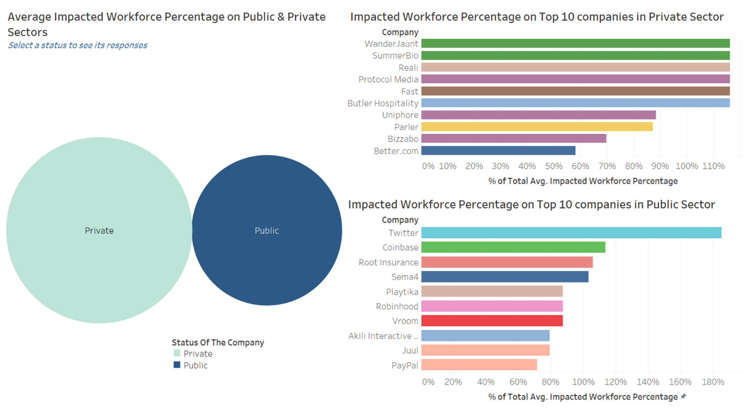

Figure 3: Tableau Visualization – Dashboard for average impacted workforce percentage on Top 10 companies in both sectors

From the above visual (Figure 3), we have analyzed the average impacted workforce on companies involving both public and private sectors. We can see that the average impacted workforce percentage is more in private sector with 110.86%. We can see the top 10 companies in both sectors whose workforce is affected. The top 10 companies in private sector which are affected by these layoffs are WanderJaunt, SummerBio, Reali, Protocol Media, Fast, Butler Hospitality, Uniphore, Parler, Bizzabo, and Better.com. The companies having highest average impacted workforce in this sector are 6 companies namely WanderJaunt, SummerBio, Reali, Protocol Media, Fast, Butler Hospitality with 116.14%. The top 10 companies which are affected by average workforce percentage in public sector are Twitter, Coinbase, Root Insurance, Sema4, Playtika, Robinhood, Vroom, Akili Interactive Labs, Juul, and PayPal among which the company which is highly affected in terms of average impacted workforce in this sector is Twitter with 185.2%.

We also analyzed the average impacted workforce percentage in both public and private sectors for bottom 10 companies too. We can see this analysis in the below visual (Figure 4). The bottom 10 companies in private sector are Clarify Health, Argo AI, Abra, Headspace Health, Foxtrot, Armis Security, Thirty Madison, Amperity, Addepar and C2FO. Among these, the three companies whose average impacted workforce is high are Clarify Health, Argo AI and Abra with 131.58%. Whereas the bottom 10 companies in public sector are Cisco, BlackLine, Amazon, Nutanix, WalkMe, Outbrain, Coursera, Amdocs, and Freshworks in which three companies are having high average impacted workforce percentage with 147.1% and they are Cisco, BlackLine, and Amazon.

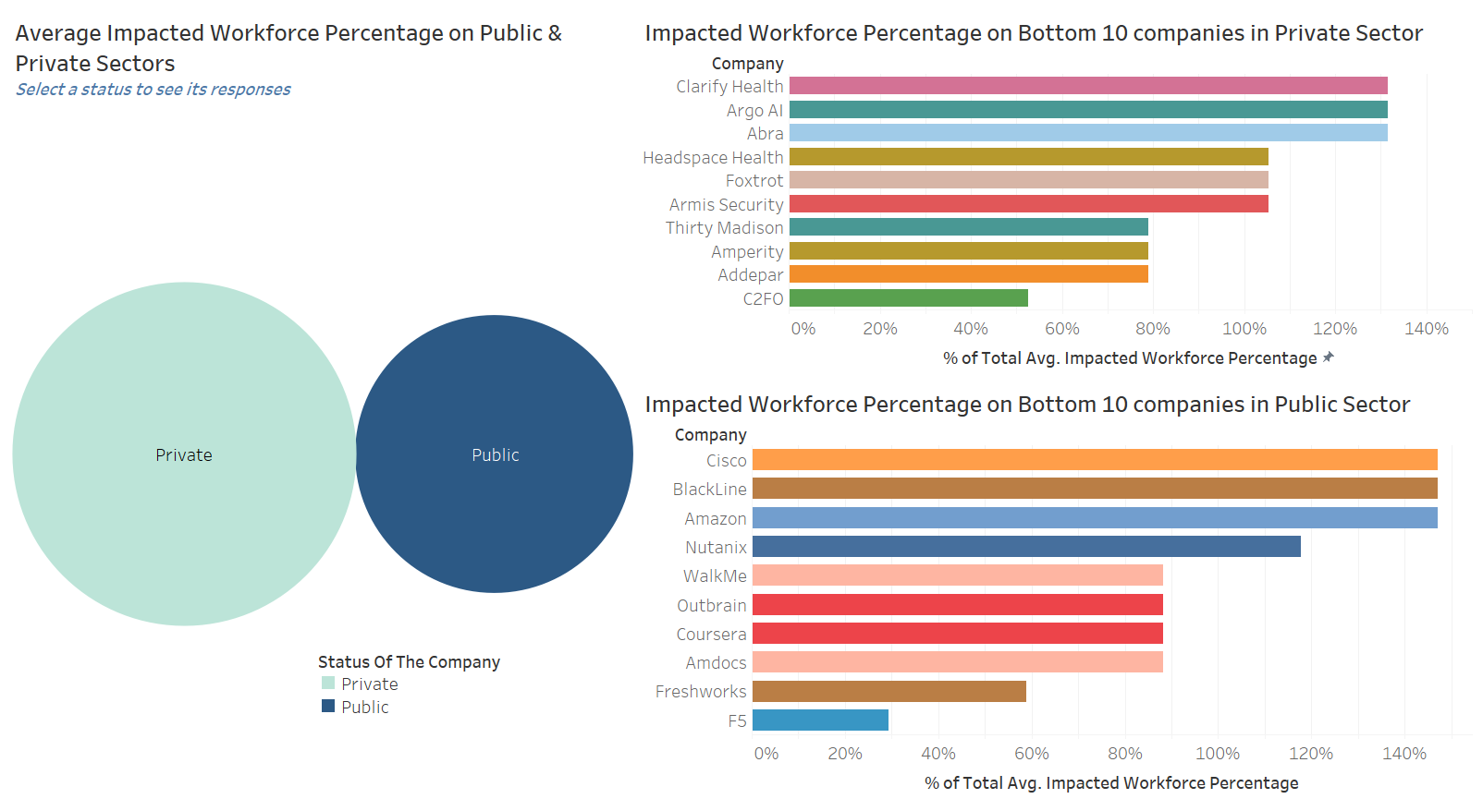

Figure 4: Tableau Visualization - Dashboard for average impacted workforce percentage on Bottom 10 companies in both sectors

**Conclusion:**

Through our analysis of the " Technology Company Layoffs (2022-2023) " dataset, we were able to answer the managerial questions we initially posted. We have understood how layoffs are done in different companies has affected their workforce and corresponding industry. We discovered that the highest percentage of layoffs occurred in quarter 4 2022 at 35.6%, while the lowest percentage occurred in quarter 1 2022 at 2.1%. We also found that the private sector experienced a higher percentage of layoffs (71.55%) compared to the public sector (28.45%).

In terms of the average impacted workforce percentage, the private sector had a higher overall average at 110.86%. Our analysis identified the top 10 companies in both private and public sectors that experienced the highest workforce impact due to layoffs. The bottom 10 companies in both sectors were also analyzed to understand their average impacted workforce percentages.

This analysis provides valuable insights into the ongoing layoffs in the technology sector and their impact on the workforce. By understanding the trends and identifying the companies and sectors that are most affected by these layoffs, we can identify the overall effects on the industry and companies where layoffs are done and be able to develop potential strategies to lessen the impact on employees.