Practical File

Submitted by: Divija

102018056

2020-2024

COmputational Statistics

***LAB-BASIC STATISTICS***

import numpy as np

import pandas as pd

from bisect import bisect_right as upper_bound

import statistics

import math

#random.randit is used to generate random numbers in a particular range

data = np.random.randint(0, 100, size=(5, 3))

#pd.dataframe prints data in tabular form ,thus easy to access

df = pd.DataFrame(data, columns=['random_1', 'random_2', 'random_3'])

print(df)

#iloc helps to extract rows and col to make x array

x=df.iloc[:,:].values

#.shape gives the dimensions of the dataframe

print(x.shape)

n=x.shape[0]

m=x.shape[1]

#for harmonic mean

sumh=0

for i in range(n):

sumh=sumh+1/x[i][0]

hm=(n)/sumh

print('harmonic mean by formula is :', round(hm, 2))

print('harmonic mean by inbuilt function is :' ,round(statistics.harmonic_mean(df.random_1), 2))

#for geometric mean

product=1

for i in range(n):

product=product * x[i][0]

gm = (float)(math.pow(product, (1 / n)))

print('geometeric mean by formula is :', round(gm, 2))

print('geometeric mean by inbuilt function is :' ,round(statistics.geometric_mean(df.random_1), 2))

#for mean of data

sum =0

for i in range(n):

for j in range(m):

sum=sum+x[i][j]

me=sum/(n*m)

print('mean by formula is :', round(me, 2))

print('mean by inbuilt function is :' ,round(np.mean(x), 2))

#for median of data

#first we have to sort the data

a=np.array(x)

def sortRowWise(a):

# One by one sort individual rows.

for i in range(len(a)):

a[i].sort()

return 0

MAX = 100;

# Function to find median in the matrix

def median_using_binary(a, n, m):

mi = a[0][0]

mx = 0

for i in range(n):

#finding min

if a[i][0] < mi:

mi = a[i][0]

#finding max

if a[i][m-1] > mx :

mx = a[i][m-1]

#stores the value of median if matrix is put in array format

desired = (n * m + 1) // 2

while (mi < mx):

mid = mi + (mx - mi) // 2

#place stores the number of elements less than mid in the matrix

place = [0];

# Find count of elements smaller than mid

for i in range(n):

j = upper_bound(a[i], mid)

place[0] = place[0] + j

if place[0] < desired:

mi = mid + 1

else:

mx = mid

return mi

#calling of functions

sortRowWise(a)

mi=median_using_binary(a, n, m)

print ("Median by formula is", mi)

print('median by inbuilt function is :' ,round(np.median(x), 2))

var=0

for i in range(n):

for j in range(m):

var=var+(x[i][j]-sum/(n*m))**2

#for variance

print('variance by inbuilt function is',round(np.var(x),2))

def variance(a, n, m, me):

sum1 = 0;

for i in range(n):

for j in range(m):

# subtracting mean from elements

a[i][j] -= me;

# squaring each terms

a[i][j] *= a[i][j];

# taking sum

for i in range(n):

for j in range(m):

sum1 += a[i][j];

return sum1/(n*m)

variance(x,n,m,me)

print('variance by formula is', round(var/(n*m),2))

def covariance_data():

data=exercise.iloc[1: , 0:5].values

csum=[]

sum=0

for i in range(data.shape[1]):

for j in range(data.shape[0]):

sum+=data[j][i]

csum.append(sum)

sum=0

cmean=[]

for i in csum:

mean=0

mean=i/data.shape[0]

cmean.append(mean)

cov_mat=np.empty((data.shape[0],data.shape[1]))

cov=0

for i in range (data.shape[1]):

for j in range (data.shape[1]):

for k in range (data.shape[0]):

cov+=(data[k][i]-cmean[i])*(data[k][j]-cmean[j])

cov=cov/(data.shape[0]-1)

cov_mat[i][j]=cov

print(cov_mat)

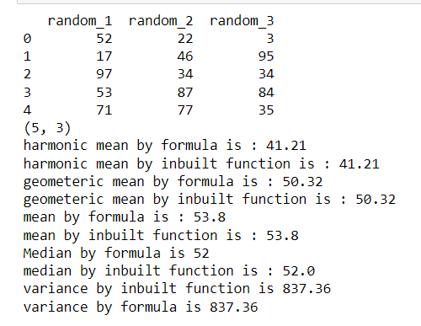

***LAB-GRAPH PLOTTING***

import pandas as pd

import matplotlib.pyplot as plt

import numpy as np

df = pd.read_csv(r'C:\Users\hp\Desktop\Iris.csv')

print(df.head(5))

def simpleline():

#straight line graph

plt.title('Linear graph')

x = np.linspace(0, 10, 50)

y=np.linspace(0, 5, 50)

plt.plot(x,"o",y,"r")

plt.xlabel('x-axis')

plt.ylabel('Y-axis')

plt.show()

def trigno():

x= np.linspace(0,10,50)

y= np.linspace(0,5,50)

sin_x = np.sin(x)

cos_y =np.cos(y)

z=sin_x + cos_y

w=sin_x**2

plt.title('Trignometry')

plt.plot(z,label ='z=sin_x+cos_y',color ='green',linestyle ='-')

plt.plot(sin_x, label='sinwave', color ='red', linestyle = '--')

plt.plot(cos_y, label='coswave', color ='blue', linestyle = '-')

plt.plot(w, label='sin_x**2', color ='yellow', linestyle = '-')

plt.legend()

plt.show()

def subplots():

names = ['group_1', 'group_2', 'group_3']

values = [10, 50, 200]

plt.figure(figsize=(10, 3))

#bar-graph

# 1x3 grid for 1st plot

plt.subplot(131)

plt.bar(names, values)

#scatter plot

plt.subplot(132)

plt.scatter(names, values,c=['red'])

#normal plot

plt.subplot(133)

plt.plot(names, values,"g",)

plt.suptitle('Categorical Plotting')

plt.show()

def symbols():

#plot using diff symbols

#arrange takes values start,stop and step

t = np.arange(0, 5, 0.2)

plt.plot(t, t, 'g--', label='linear' )

plt.plot(t, t**2, 'rs',label='square')

plt.plot(t, t**3, 'b^',label='cube')

plt.legend()

plt.show()

def random_data():

data1 = np.random.randn(2, 10)

print(data1)

print(data1.shape)

plt.plot(data1)

plt.show()

def pie_chart():

species = ['SETOSA', 'VERSICOlOR', 'VIRGINIA']

data = [50,50,50]

# Creating plot

fig = plt.figure(figsize =(10, 7))

plt.pie(data, labels = species)

plt.title('Different species of Irirs')

# show plot

plt.show()

def scatterplot_fileread():

print('Enter any two attributes of the data(SepalWidthCm,SepalLengthCm ,PetalLengthCm,PetalWidthCm )')

atr1=input()

atr2=input()

colors = {'Iris-setosa':'r', 'Iris-virginica':'g', 'Iris-versicolor':'y'}

if atr1 == 'SepalWidthCm' and atr2 == 'SepalLengthCm' :

plt.xlabel('SepalWidthCm')

plt.ylabel('SepalLengthCm')

plt.scatter(df.SepalWidthCm, df.SepalLengthCm, c=df['Species'].apply(lambda col_vector: colors[col_vector]), s = 100)

elif atr1 == 'SepalWidthCm' and atr2 == 'PetalLengthCm' :

plt.xlabel('SepalWidthCm')

plt.ylabel('PetalLengthCm')

plt.scatter(df.SepalWidthCm, df.PetalLengthCm, c=df['Species'].apply(lambda col_vector: colors[col_vector]), s = 100)

elif atr1 =='PetalWidthCm' and atr2 == 'PetalLengthCm' :

plt.xlabel('PetalWidthCm')

plt.ylabel('PetalLengthCm')

plt.scatter(df.PetalWidthCm, df.PetalLengthCm, c=df['Species'].apply(lambda col_vector: colors[col_vector]), s = 100)

elif atr1 == 'PetalWidthCm' and atr2 =='SepalLengthCm' :

plt.xlabel('PetalWidthCm')

plt.ylabel('SepalLengthCm')

plt.scatter(df.PetalWidthCm, df.SepalLengthCm, c=df['Species'].apply(lambda col_vector: colors[col_vector]), s = 100)

print("\n------------------------------------------------\n")

print('1 Simpleline')

print('2 Trigno_functions')

print('3 Subplots')

print('4 Random_data_plot')

print('5 pie chart')

print('6 scatterplot_fileread')

print("\n------------------------------------------------\n")

x=int(input("Enter your choice: "))

if x==1:

simpleline()

elif x==2:

trigno()

elif x==3:

subplots()

elif x==4:

random_data()

elif x==5:

pie_chart()

elif x==6:

scatterplot_fileread()

else:

print("Please enter valid choice")

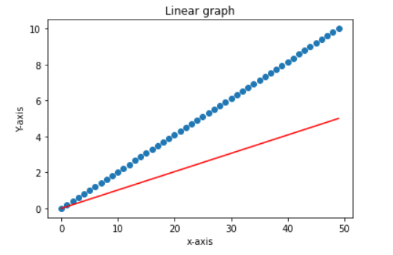

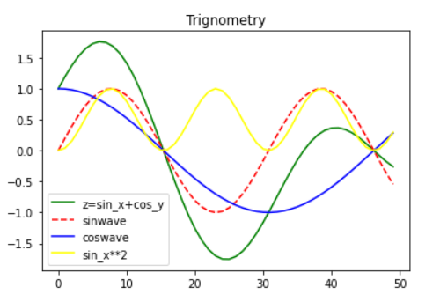

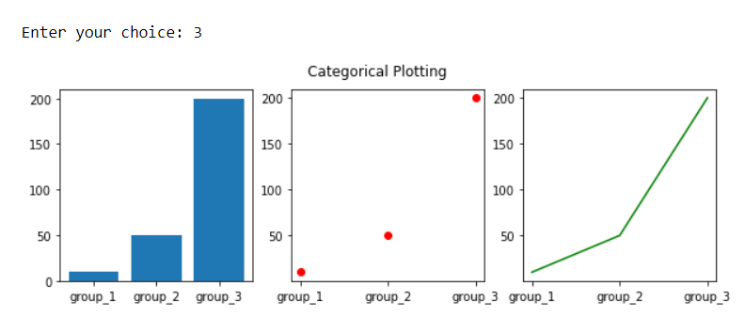

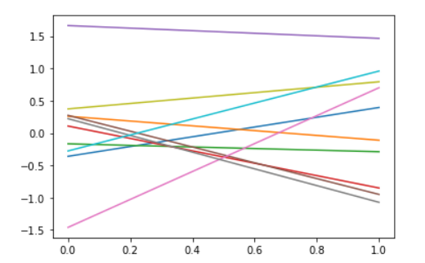

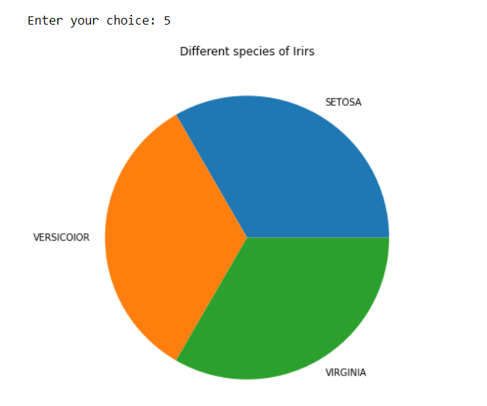

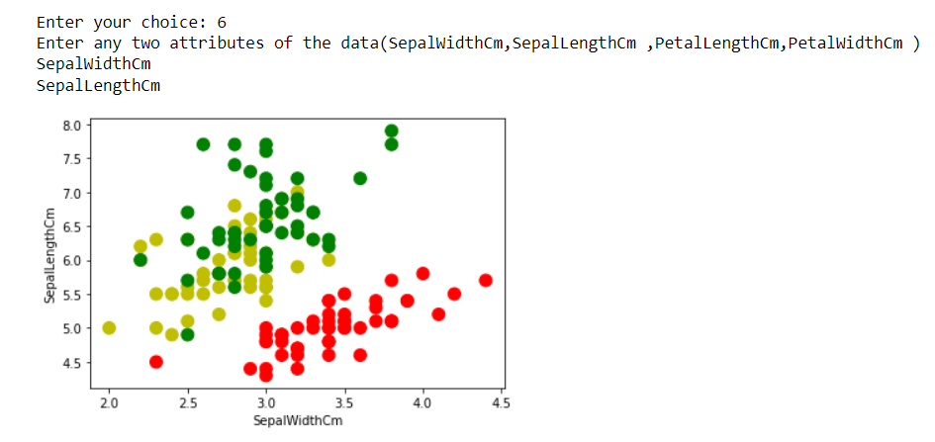

***LAB- LINEAR REGRESSION***

import numpy as np

import pandas as pd

import matplotlib.pyplot as plt

data = pd.read_csv("headbrain.csv")

#head size is independent

#brain weight is dependent

#values() returns a list of all the values available in given data

x = data['Head Size(cm^3)'].values

y = data['Brain Weight(grams)'].values

print(data.head())

#237 input values

# total no.of input values

l = len(x)

sum_x =0

sum_y =0

# calculating the mean of x and y

for i in range(l):

    sum_x += x[i]

mean_x = sum_x/l

for i in range(l):

    sum_y += y[i]

mean_y = sum_y/l

# using the formula to calculate m & c

numer = 0

denom = 0

for i in range(l):

    numer += (x[i] - mean_x) * (y[i] - mean_y)

    denom += (x[i] - mean_x) ** 2

m = numer / denom

c = mean_y - (m * mean_x)

print('The value of m =' ,m)

print('The value of c =' ,c)

#m is b1 and c is b0

# y=b0 +b1*x

y_reg=[]

y_reg= c+(m*x)

plt.figure(figsize =(10,8))

plt.scatter(x,y, color ="green" ,label ="plot of head size v/s brain weight")

plt.plot(x,y_reg ,color ="red" , label ="regression line")

plt.xlabel("Head Size")

plt.ylabel("Brain Weight")

plt.legend()

plt.title("Plot of linear Regression")

plt.show()

from sklearn.linear_model import LinearRegression

Reg_model = LinearRegression()

x=np.array(x)

y=np.array(y)

#array will get reshaped in such a way that the resulting array has only 1 column

#no reshaping,error while fitting it in the model.

x=x.reshape(-1,1)

y=y.reshape(-1,1)

#takes array as an input

Reg_model.fit(x,y)

Reg_model.coef_

Reg_model.intercept_

# calculating R-squared value for measuring goodness of our model.

ss_t = 0 #total sum of squares

ss_r = 0 #total sum of square of residuals

for i in range(len(x)):

    y_pred = c + m * x[i]

    ss_t += (y[i] - mean_y) ** 2

    ss_r += (y[i] - y_pred) ** 2

r2 = 1 - (ss_r/ss_t)

print(r2)



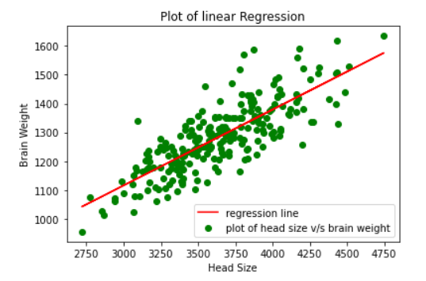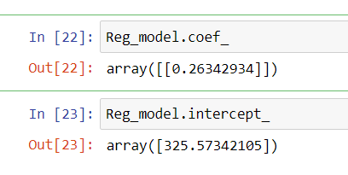

***LAB MULTICOLLINEARITY AND VIF***

import pandas as pd

import math

data=pd.read_csv(r'C:\Users\hp\Desktop\cs_data.csv')

data.head()

df=data.iloc[:,0:4]

print(df)

# data = data.drop(columns="sales")

# print(data)

#using karl pearson method to calculate VIF

def calculate(x1,x2):

    n = len(x1)

    sum_x1 = 0

    sum_sq_x1 = 0

    sum_x2 = 0

    sum_sq_x2 = 0

    sum_x1_x2=0

    for i in range(n):

        sum_x1 += x1[i]

        sum_sq_x1 +=(x1[i]*x1[i])

        sum_x2 += x2[i]

        sum_sq_x2 +=(x2[i]*x2[i])

        sum_x1_x2 +=x1[i]*x2[i]

    r=0

    num =0

    den= 0

    num = (n*sum_x1_x2) - (sum_x1*sum_x2)

    den = math.sqrt((n*sum_sq_x1)-(sum_x1**2))*math.sqrt((n*sum_sq_x2)-(sum_x2**2))

    r=num/den

    r_sq = r*r

    print('r_sq=', r_sq)

    vif=1/(1-r_sq)

    print('vif =' ,vif)

    for i in range(df.shape[1]):

        for j in range(i+1,df.shape[1]):

            calculate(df.iloc[:,i],df.iloc[:,j])

from statsmodels.stats.outliers_influence import variance_inflation_factor

from statsmodels.tools.tools import add_constant

vif = pd.DataFrame()

vif["features"] = df.columns

vif["VIF Factor"] = [variance_inflation_factor(df.values, i)

                     for i in range(df.shape[1])]

print(vif)

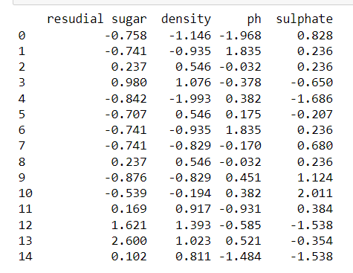

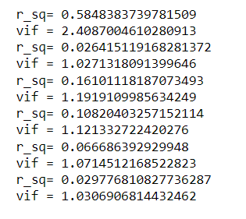

***LAB MULTIPLE LINEAR REGRESSION***

import pandas as pd

import math

import numpy as np

from statistics import stdev

data=pd.read_csv('./bodyfat.csv')

data.head()

df=data.iloc[:,:]

print(df.head())

df_normalized = df.copy()

for i in df_normalized.columns:

    df_normalized[i] = (df_normalized[i] - df_normalized[i].mean()) / df_normalized[i].std()

df=df_normalized

df1=df_normalized.iloc[:,1:6]

X = df1.to_numpy()

print(len(X))

ALL_ONE=[1]*len(X)

X1=np.insert(X,0,ALL_ONE,axis=1)

print(X1)

y=df_normalized.iloc[:,0]

Y=y.to_numpy()

X1_T = X1.T

print(X1_T.shape[0])

X1_mul = np.matmul(X1_T,X1)

print(X1_mul.shape[0])

print(X1_mul.shape[1])

X_inv = np.linalg.inv(X1_mul)

print(X_inv.shape[0])

print(X_inv.shape[1])

X_final = np.matmul(X_inv, X1_T)

b=np.matmul(X_final,Y)

Y_pred = []

for i in range(len(Y)):

    Y_pred=b[0] + b[1]*df_normalized.iloc[:,1][i]+b[2]*df_normalized.iloc[:,2][i]+b[3]*df_normalized.iloc[:,3][i]+b[4]*df_normalized.iloc[:,4][i]+b[5]*df_normalized.iloc[:,5]

print(Y_pred)

e=0

for i in range(len(Y)):

    e+=(Y[i]-Y_pred[i])**2

print(e/len(Y))

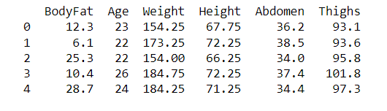

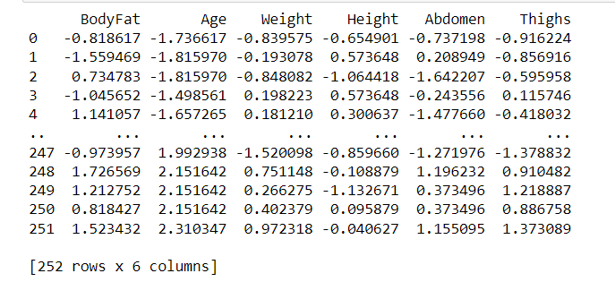

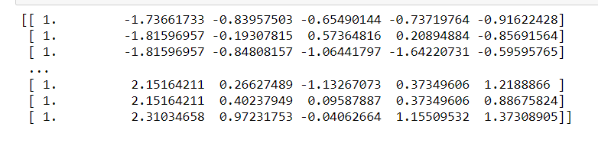

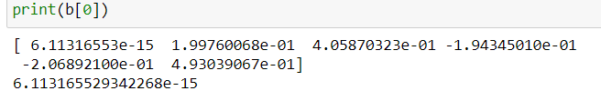

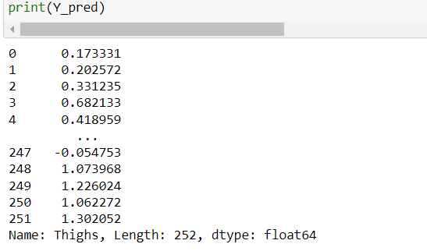

Error:

