OOPS CODES PRACTICAL FILE

Submitted To: DR. RINKLE RANI

Submitted By:

*Divija* CSBS-3

102018056

*INDEX*

|  |  |  |
| --- | --- | --- |
| SR NO. | DESCRIPTION | PAGE NUMBER |
| 1 | ASSIGNMENT NUMBER -1 | 2-10 |
| 2 | ASSIGNMENT NUMBER -2 | 11-22 |
| 3 | ASSIGNMENT NUMBER -3 | 23-33 |
| 4 | ASSIGNMENT NUMBER -4 | 34-43 |
| 5 | ASSIGNMENT NUMBER -5(a) | 44-52 |
| 6 | ASSIGNMENT NUMBER -5 | 53-60 |
| 7 | ASSIGNMENT NUMBER -6 | 61-75 |
| 8 | ASSIGNMENT NUMBER -7 | 76-86 |
| 9 | ASSIGNMENT NUMBER -8 | 87-94 |
| 10 | ASSIGNMENT NUMBER -9 | 95-103 |

LAB ASSIGNMENT 1

**Question:1**

#include <iostream>

using namespace std;

int main()

{

cout << "Hello, World!\n";

return 0;

}

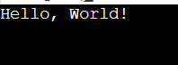

**Question:2**

#include<iostream>

using namespace std;

int main()

{

int n;

float d;

char c;

cout<<"Enter a number, decimal &character: ";

cin>>n>>d>>c;

}



**Question:3**

#include<iostream>

using namespace std;

int main()

{

int a,b;

cout<<"Enter 2 numbers: ";

cin>>a>>b;

float c=float (a)/b;

cout<<"Sum: "<<(a+b)<<endl;

cout<<"Difference: "<<(a-b)<<endl;

cout<<"Product: "<<(a*b)<<endl;

cout<<"Quotient: "<<c<<endl;

cout<<"Mod: "<<(a%b);

return 0;

}

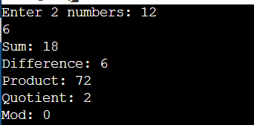

**Question:4**

#include<iostream>

using namespace std;

int main()

{

int n,c=0;

cout<<"Enter a number: ";

cin>>n;

cout<<"The prime numbers are :";

for(int i=2;i<=n;i++)

{

int count=0;

for(int j=2;j<=(i/2);j++)

{

if(i%j==0)

count++;

}

if(count==0)

{

cout<<i;

cout<<", ";

c++;

}

}

cout<<"\b\b ,i.e., "<<c<<".";

return 0;

}

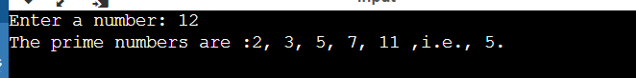

**Question:5**

#include<iostream>

using namespace std;

int main()

{

float temp;

cout<<"Enter temperature in Celsius: ";

cin>>temp;

float f=(9*temp/5)+32;

cout<<"Temperature in degree Fahrenheit:"<<f;

return 0;

}



**Question:6**

#include<iostream>

#include<iomanip>

using namespace std;

int main()

{

cout<<"1.)Hello\nWorld\n";

cout<<"2.)Hello"<<endl<<"World"<<endl;

cout<<"3.)Hello\tWorld\n";

cout<<“4.)Hello” << setw(10) <<"World"<<endl;

return 0;

}

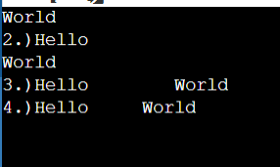

**Question:7**

#include<iostream>

using namespace std;

int main()

{

int a;

cout<<"Enter a number: ";

cin>>a;

cout<<(a+=1)<<endl;

cout<<(a-=1)<<endl;

cout<<(a*=2)<<endl;

cout<<(a/=2)<<endl;

return 0;

}

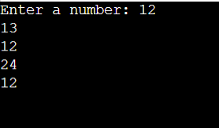

**Question:8**

#include<iostream>

using namespace std;

int main()

{

int a,b,temp;

cout<<"Enter value of first number = ";

cin>>a;

cout<<"Enter value of second number = ";

cin>>b;

temp=a^b;

b=temp^b;

a=a^temp;

cout<<"Swapped values of a and b are :" <<a<<" , "<<b<<endl;

return 0;

}

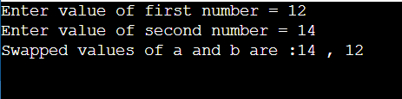

**Question:9**

#include<iostream>

using namespace std;

int main()

{

int days,fine=0;

cout<<"Enter the number of days after due: ";

cin>>days;

if(days<=5)

fine=0.50;

else

{

if(days<=10)

fine=1;

else

{

if(days<=30)

fine=5;

else

cout<<"\nYour Library Membership has been cancelled due to late return."<<endl;

}

}

if(days<=0)

cout<<"\nPlease enter a valid value.";

else

{

if(days<=30)

cout<<"\nPlease pay a fine of Rs. "<<fine<<" due to "<<days<<" days late return."<<endl;

}

return 0;

}

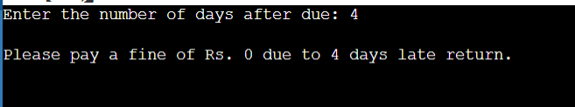

**Question:10**

# include <iostream>

using namespace std;

int main() {

char op;

float num1, num2;

cout << "Enter operator: (+, -, *, /,%): ";

cin >> op;

cout << "Enter two operands: ";

cin >> num1 >> num2;

switch(op) {

case '+':

cout << num1 << " + " << num2 << " = " << num1 +

num2<<endl;

break;

case '-':

cout << num1 << " - " << num2 << " = " << num1 -

num2<<endl;

break;

case '*':

cout << num1 << " * " << num2 << " = " << num1 *

num2<<endl;

break;

case '/':

cout << num1 << " / " << num2 << " = " << num1 /

num2<<endl;

break;

case '%':

cout << num1 << " % " << num2 << " = " << num1 /

num2<<endl;

break;

default:

// If the operator is other than +, -, * or /, error message isshown

cout << "Entered operator is not correct";

break;

}

return 0;

}

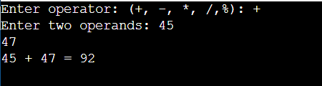

LAB ASSIGNMENT 2

1. WAP to check whether the given number is even or odd (By using if-else and conditional operator).

#include <iostream>

using namespace std;

int main()

{

int n;

cin>>n;

(n%2==0)?cout<<"even":cout<<"odd";

if(n%2==0)

{

cout<<endl<<"even";

}

else

{

cout<<endl<<"odd";

}

return 0;

}

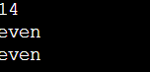

WAP to print the following series:

10,9,8,.......1

2,4,6,8,......20

10,13.5,17,20.5

#include <iostream>

using namespace std;

int main()

{

for(int i=10;i>=1;i--)

{

cout<<i<<" ";

}

cout<<endl;

for(int i = 2 ; i<=20 ;i++)

{

cout<<i<<" ";

i++;

}

cout<<endl;

for(float i = 10;i <= 20.5 ;i++)

{

cout<<i<<" ";

i=i+2.5;

}

cout<<endl;

return 0;

}

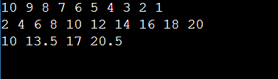

3. WAP to factorial of a given no • Using for loop • Using while loop

#include <iostream>

using namespace std;

int main()

{

int n;

cin>>n;

int res = 1, i;

for (i = 2; i <= n; i++)

{

res *= i;

}

cout<<res;

cout<<endl;

int j=2;

int ress=1;

while(j<=n)

{

ress *= j;

j++;

}

cout<<ress;

return 0;

}

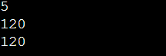

4. WAP to Print the Fibonacci series up to n numbers. • Using for loop • Using while loop

#include <iostream>

using namespace std;

int main()

{

int n, t1 = 0, t2 = 1, nextTerm = 0;

cin >> n;

cout << "Fibonacci Series: ";

for (int i = 1; i <= n; ++i) {

if(i == 1)

{

cout << t1 << ", ";

continue;

}

if(i == 2)

{

cout << t2 << ", ";

continue;

}

nextTerm = t1 + t2;

t1 = t2;

t2 = nextTerm;

cout << nextTerm << ", ";

}

}



5. WAP to find out largest element of an array.

#include <iostream>

using namespace std;

int main()

{

int arr[5]={5,7,3,19,2};

int max=0;

for(int i=0;i<5;i++)

{

if(arr[i]>arr[max])

{

max=i;

}

}

cout<<arr[max];

return 0;

}



. 6. WAP to sort element of an array in ascending order.

#include <iostream>

using namespace std;

int main()

{

int arr[5]={5,7,3,19,2};

int temp;

for(int i=0;i<5;i++)

{

for(int j=i+1;j<5;j++)

{

if(arr[i]>arr[j])

{

temp =arr[i];

arr[i]=arr[j];

arr[j]=temp;

}

}

}

for(int i=0;i<5;i++)

{

cout<<arr[i]<<" ";

}

return 0;

}

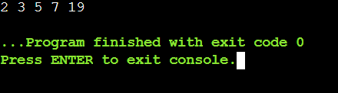

7. WAP to print the sum of each rows of a 2-D matrix.

#include <iostream>

using namespace std;

int main()

{

int n,m;

cin>>n>>m;

int arr[n][m];

for(int i=0;i<n;i++)

{

for(int j=0;j<m;j++)

{

cin>>arr[i][j];

}

}

for(int i=0;i<n;i++)

{

int sum=0;

for(int j=0;j<m;j++)

{

sum +=arr[i][j];

}

cout<<sum<<endl;

}

return 0;

}

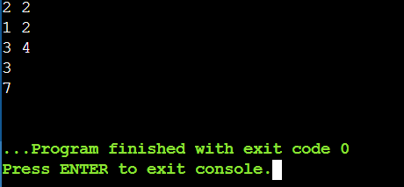

8. WAP to print transpose of a matrix

#include <iostream>

using namespace std;

int main()

{

int n,m;

cin>>n>>m;

int arr[n][m];

for(int i=0;i<n;i++)

{

for(int j=0;j<m;j++)

{

cin>>arr[i][j];

}

}

cout<<"Original Matrix:"<<endl;

for(int i=0;i<n;i++)

{

for(int j=0;j<m;j++)

{

cout<<arr[i][j]<<" ";

}

cout<<endl;

}

cout<<"transpose of the matrix:"<<endl;

for(int j=0;j<m;j++)

{

for(int i=0;i<n;i++)

{

cout<<arr[i][j]<<" ";

}

cout<<endl;

}

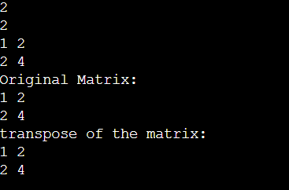

9. WAP to convert the string from uppercase to lowercase.

#include<iostream>

#include<string.h>

using namespace std;

void swap(int *xp, int *yp)

{

int temp = *xp;

*xp = *yp;

*yp = temp;

}

int main(){

char str[30];

cout<<"Enter string: ";

gets(str);

for( int i=0;i<=strlen(str);i++){

if(str[i]>=65 && str[i]<=90){

str[i]=str[i]+32;

}

}

puts(str);

}



10. WAP program to copy the strings without using strcpy function

#include <iostream>

#include<string>

using namespace std;

int main()

{

char str[] = "Hello", str1[100], i;

cout<<str<<endl;

for (i = 0; str[i] != '\0'; ++i)

{

str1[i] = str[i];

}

str1[i] = '\0';

cout<<str1;

return 0;

}

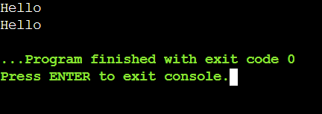

LAB ASSIGNMENT 3

**Question:1**

#include<iostream>

using namespace std;

int multiply(int a,int b)

{

int res=a*b;

return res;

}

int main()

{

int a,b;

cin>>a>>b;

cout<<multiply(a,b);

}

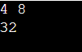

**Question:2**

#include<iostream>

using namespace std;

int power(int a,int b)

{

int res=1;

for(int i=1;i<=b;i++)

{

res*=a;

}

return res;

}

int main()

{

int a,b;

cin>>a>>b;

cout<<power(a,b);

}



**Question:3**

#include<iostream>

using namespace std;

void swap_c(int a,int b)

{

int temp;

temp=a;

a=b;

b=temp;

cout<<a<<" "<<b<<endl;

}

void swap_r(int &a,int &b)

{

int temp;

temp=a;

a=b;

b=temp;

cout<<a<<" "<<b;

}

int main()

{

int a,b;

cin>>a>>b;

cout<<"Swap by call by value:"<<endl;

swap_c(a,b);

cout<<"Swap by call by refrence:"<<endl;

swap_r(a,b);

}

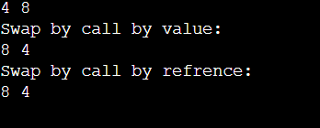

**Question:4**

#include<iostream>

using namespace std;

void add(int *ptr,int n)

{

int sum=0;

for(int i=0;i<n;i++)

{

//*ptr refers to the value at address

sum = sum + *ptr;

ptr++;

}

cout<<"Sum of all the numbers is:"<<sum;

}

int main()

{

int n;

cin>>n;

int arr[n];

for(int i =0;i<n;i++)

{

cin>>arr[i];

}

cout<<"Base Address :"<<&arr[0]<<endl;

for(int i=0;i<n;i++)

{

cout<<"address of element_"<<i+1<<" is: "<<&arr[i]<<endl;

}

int *ptr;

// array is equal to base address

//array = &array[0] //

ptr = arr;

add(ptr,n);

}

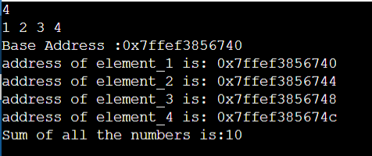

**Question:5**

#include<iostream>

#include <bits/stdc++.h>

using namespace std;

struct data{

int age;

int num;

int av_run;

};

bool compareTwoStudents(data a, data b)

{

// If total marks are not same then

// returns true for higher total

if (a.av_run != b.av_run)

return a.av_run < b.av_run;

}

int main()

{

data arr[20];

for(int i=0;i<3;i++)

{

cout<<"enter age of player "<<i+1<<endl;

cin>>arr[i].age;

cout<<"enter the number of matches played by player "<<i+1<<endl;

cin>>arr[i].num;

cout<<"enter the average runs scored:"<<endl;

cin>>arr[i].av_run;

}

for(int i=0;i<3;i++)

{

sort(arr, arr + 3, compareTwoStudents);

}

cout<<"Age"<<" "<<"matches"<<" "<<"average score";

cout<<endl;

for(int i=0;i<3;i++)

{

cout<<arr[i].age<<"\t"<<arr[i].num<<"\t "<<arr[i].av_run;

cout<<endl;

}

}

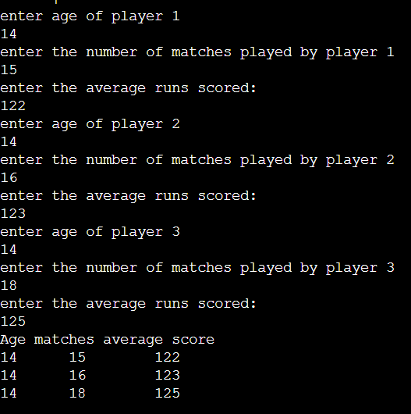

**Question:6**

#include<iostream>

using namespace std;

struct complex

{

int real, img;

};

int main()

{

complex num1,num2,res;

cout<<"enter the value of a and b a+bi :";

cin>>num1.real>>num1.img;

cout<<"enter the value of c and d c+di :";

cin>>num2.real>>num2.img;

char op;

cout<<"enter the operator:";

cin>>op;

if(op =='+')

{

res.real = num1.real+ num2.real;

res.img =num1.img+num2.img;

cout<<res.real<<"+"<<res.img<<"i";

}

else if(op == '-')

{

res.real = num1.real- num2.real;

res.img =num1.img-num2.img;

if(res.img>0)

cout<<res.real<<"+"<<res.img<<"i";

else

cout<<res.real<<res.img<<"i";

}

}

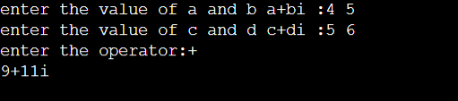

**Question:7**

#include<iostream>

#include<string>

using namespace std;

struct student{

char name[30];

int roll;

float perc;

} c[10];

int main()

{

struct student std;

struct student *ptr;

ptr= &std;

cout<<("Enter details of student: ");

cout<<("\nName :"); cin>>(ptr->name);

cout<<("Roll No :"); cin>>(ptr->roll);

cout<<("Percentage: "); cin>>(ptr->perc);

cout<<("\nEntered details: ");

cout<<"\nName: "<<ptr->name <<"\nRollNo: "<<ptr->roll<< "\nPercentage:"<<ptr->perc;

return 0;

}

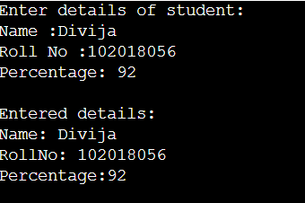

**Question:8**

#include <iostream>

using namespace std;

struct date{

int day,month,year;

};

int main()

{

date date1;

cout<<"Enter the date:";

cin>>date1.day>>date1.month>>date1.year;

if(date1.day>31 || date1.month>12 )

{

cout<<"invalid";

}

if(date1.month%2==0 ||date1.month !=8)

{

if(date1.day>30)

{

cout<<"invalid";

}

}

if (date1.year % 4 != 0)

if (date1.year % 100 != 0)

if (date1.year % 400 != 0)

if(date1.month ==2)

if(date1.day>28)

//not a leap year

cout<<"invlaid";

}

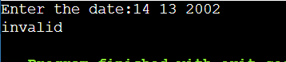

LAB ASSIGNMENT 4

**Question:1**

#include<iostream>

using namespace std;

class Student{

int age,standard;

string first_name;

string last_name;

public:

void get_data(int age1,int standard1,string first_name1,string last_name1){

age=age1;

standard=standard1;

first_name=first_name1;

last_name=last_name1;

}

void set_data()

{

cout<<"AGE:"<<age<<endl<<"STANDARD:"<<standard<<endl<<"NAME:"<<first_name<<" "<<last_name;

}

};

int main()

{

int age,standard;

string first_name,last_name;

cin >> age >> standard >> first_name >> last_name ;

Student st;

st.get_data(age,standard,first_name,last_name);

st.set_data();

}

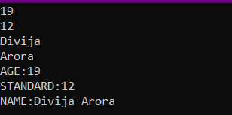

**Question:2**

#include<iostream>

using namespace std;

class bank{

public:

string name,type;

int num,bal;

void set_ini_vals()

{

cout<<"Name of the depositor:";

cin>>name;

cout<<"Account Number:";

cin>>num;

cout<<"Account type:";

cin>>type;

cout<<"Balance";

cin>>bal;

display_det();

}

void display_det()

{

cout<<name<<"\n"<<num<<"\n"<<type<<"\n"<<bal<<"\n";

}

void dep_amount(int amount)

{

bal=bal+amount;

cout<<bal;

}

void withdraw_amount(int amount)

{

if(amount <= bal)

{

bal=bal-amount;

}

else

{

cout<<"balance is less than the required amount.";

}

cout<<bal;

}

};

int main()

{

bank p1;

p1.set_ini_vals();

p1.dep_amount(200);

p1.withdraw_amount(300);

}

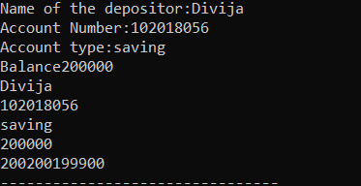

**Question:3**

#include<bits/stdc++.h>

using namespace std;

class Complex{

float a,b;

public:

void setComplex(float v1,float v2){

a=v1;

b=v2;

displayComplex();

}

void displayComplex(){

cout<<a<<"+"<<b<<"i"<<endl;

}

void sum(Complex const &c2)

{

a = a + c2.a;

b = b + c2.b;

}

};

int main(){

float rl[2],im[2];

for(int i =0;i<2;i++)

{

cout<<"enter the real part of"<<i+1<<"complex number"<<endl;

cin>>rl[i];

cout<<"enter the imaginary part of"<<i+1<<"complex number"<<endl;

cin>>im[i];

}

Complex c1,c2;

c1.setComplex(rl[0],im[0]);

c2.setComplex(rl[1],im[1]);

c1.sum(c2);

c1.displayComplex();

return 0;

}

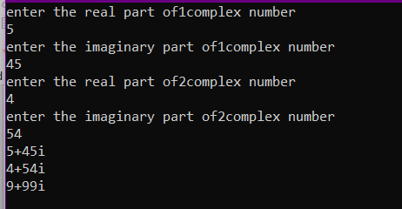

**Question:4**

#include<iostream>

using namespace std;

class rectangle{

public:

float length, width;

void setLenght(float l)

{

length = l;

}

void setWidth(float w)

{

width = w;

}

float perimeter()

{

cout<<"PERI: ";

return 2*length*width ;

}

float area()

{

cout<<"AREA: ";

return length*width;

}

void show()

{

cout<<"length:"<<length<<endl;

cout<<"width:"<<width<<endl;

}

int sameArea(rectangle r2)

{

if(area() == r2.area())

return 1;

else

return 0;

}

};

int main()

{

rectangle r1,r2;

r1.setLenght(5);

r1.setWidth(2.5);

r2.setLenght(5);

r2.setWidth(18.9);

r1.show();

r2.show();

cout<<r1.area();

cout<<r1.perimeter();

cout<<endl;

cout<<r2.area();

cout<<r2.perimeter();

cout<<r1.sameArea(r2);

}

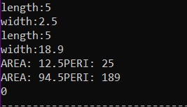

**Question:5**

#include<iostream>

using namespace std;

class Distance{

public:

int feet;

float inches;

void set(int f, float i)

{

feet =f;

inches = i;

disp();

}

void disp()

{

cout<<"Feet:"<<feet<<endl;

cout<<"Inches:"<<inches<<endl;

}

Distance add(Distance d2)

{

Distance t;

t.inches=inches + d2.inches;

t.feet =0;

if(t.inches>=12.0)

{

t.inches-=12.0;

t.feet++;

}

t.feet +=feet + d2.feet;

return t;

}

};

int main()

{

Distance d1,d2,d3;

d1.set(20,8.5);

d2.set(15,4.5);

d3=d1.add(d2);

d3.disp();

}

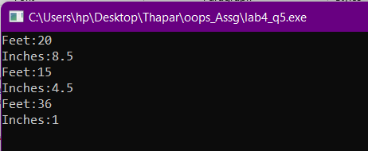

LAB ASSIGNMENT 5(a)

**Question:1**

#include<iostream>

#include<vector>

using namespace std;

class base

{

int n;

vector <int> v;

public:

void get()

{

cout<<"how many numbers?";

cin>>n;

cout<<"Enter the numbers:"<<endl;

int a;

for(int i =0;i<n;i++)

{

cin>>a;

v.push_back(a);

}

}

friend float mean(base ob);

};

float mean(base ob)

{

int sum=0;

for(int i =0; i<ob.n;i++)

{

sum+= ob.v[i];

}

return sum/ob.n;

}

int main()

{

base obj;

obj.get();

cout<<"\nMean value is :: "<<mean(obj)<<"\n";

return 0;

}

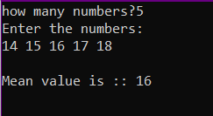

**Question:2**

#include<iostream>

using namespace std;

class myclass

{

int a;

int b;

public:

void get()

{

cout<<"enter the first value:";

cin>>a;

cout<<"enter the second value:";

cin>>b;

}

friend int find(myclass ob);

};

int find(myclass ob)

{

return ob.a >= ob.b?ob.a:ob.b;

}

int main()

{

myclass ob1;

ob1.get();

cout<<find(ob1);

}

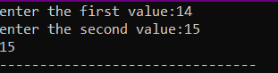

**Question:3**

#include<iostream>

#include<string>

using namespace std;

class student{

string name;

int roll_no,standard;

char section;

public:

void get()

{

cout<<"enter the name:";

getline(cin,name);

cout<<"enter the roll no:";

cin>>roll_no;

cout<<"enter the class:";

cin>>standard;

cout<<"enter the section:";

cin>>section;

}

friend void display(student obj);

};

void display(student obj)

{

cout<<obj.name<<" "<<obj.roll_no<<" "<<obj.standard<<obj.section;

}

int main()

{

student ob;

ob.get();

display(ob);

}

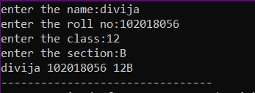

**Question:4**

#include<iostream>

using namespace std;

class num{

int a;

int b;

public:

void get()

{

cin>>a>>b;

}

friend void swapping(num ob);

};

void swapping(num ob)

{

int temp = ob.a;

ob.a= ob.b;

ob.b= temp;

cout<<ob.a<<" "<<ob.b;

}

int main()

{

num obj;

obj.get();

swapping(obj);

}

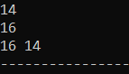

**Question:5**

#include<iostream>

using namespace std;

class Distance{

int meter;

public:

Distance(): meter(0){} //constructor,initializong meter value to 0

friend int addFive(Distance);

};

int addFive(Distance obj)

{

obj.meter +=5;

return obj.meter;

}

int main()

{

Distance ob;

cout<<addFive(ob);

}



**Question :6**

#include<iostream>

using namespace std;

class B;

class A{

int a;

public:

A(): a(5){}

friend int gre(A,B);

};

class B{

int b;

public:

B() : b(6){}

friend int gre(A,B);

};

int gre(A ob1,B ob2)

{

return ob1.a>ob2.b?ob1.a:ob2.b;

}

int main()

{

A ob1;

B ob2;

cout<<gre(ob1, ob2);

}

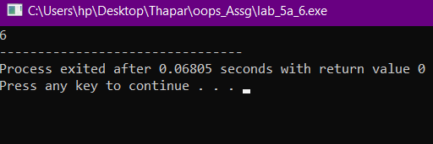

**Question:7**

#include<iostream>

using namespace std;

class B;

class A{

public:

int a;

int b;

void get(){

cin>>a>>b;

}

//any member of B can access data of A

friend class B;

};

class B{

public:

int add(A x)

{

cout<<x.a<<" "<<x.b<<endl;

return x.a+x.b;

}

};

int main()

{

A ob;

ob.get();

B ob1;

cout<<ob1.add(ob);

}

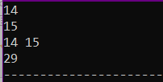

LAB ASSIGNMENT 5

**Question:1**

#include<iostream>

using namespace std;

class student

{

char name [20];

int roll_no;

int marks[6];

public:

void getdata ();

void tot_marks ();

} ;

void student ::getdata()

{

cin>>name;

cin>>roll_no;

for(int i =0 ;i<6;i++)

{

cin>>marks[i];

}

tot_marks();

}

void student::tot_marks()

{

int sum =0;

for(int i =0;i<6;i++)

{

sum+=marks[i];

}

cout<<"total marks :"<<sum;

}

int main()

{

student s1;

s1.getdata();

}

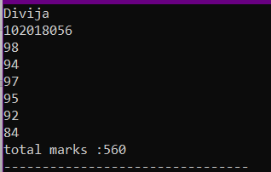

**Question:2**

#include<iostream>

#include<string>

using namespace std;

class student{

char name[20];

int roll_no,age,cl;

public:

void getdata();

void displaydata();

};

void student::getdata()

{

cin>>name;

cin>>roll_no>>age>>cl;

}

void student::displaydata()

{

cout<<name<<" "<<roll_no<<" "<<cl<<" "<<age;

cout<<endl;

}

int main()

{

int n;

cout<<"enter the number of students";

cin>>n;

student s1[n];

for(int i =0;i<n;i++)

{

s1[i].getdata();

}

for(int i =0;i<n;i++)

{

s1[i].displaydata();

}

} 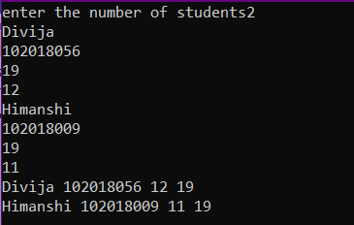

**Question:3**

#include<iostream>

#include<string>

using namespace std;

class emp

{

char name[10];

// string name;

int age;

public:

void getData();

void putData();

};

void emp :: getData()

{

cout << "Enter Name: ";

// getline(cin,name);

cin >> name;

cout << "Enter Age: ";

cin >> age;

}

void emp :: putData()

{ cout << "\tName: " << name << "\tAge: " << age << endl; }

int main()

{

int n;

cin>>n;

emp manager[n];

for (int i = 0; i < n; i++)

{

cout << "\nEnter details of manager " << i + 1 << endl;

manager[i].getData();

}

for (int i = 0; i < n; i++)

{

cout << "\nManager " << i + 1;

manager[i].putData();

}

return 0;

}

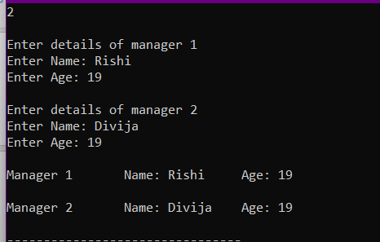

**Question:4**

#include<iostream>

using namespace std;

//static are defined in class, requires global defination

//static data member- smae value is used throughout the function

class myclass{

static int a;

int b;

public:

static int c;

void set(int i , int j)

{

a++;

b=i;

c=j;

}

void get()

{

cout<<"static a:"<<a<<"non-static b:"<<b<<"static c:"<<c<<endl;

}

};

int myclass ::a =10;

int myclass ::c;

int main()

{

cout<<"Public static c:"<<myclass::c<<endl;

myclass m1,m2;

m1.set(1,2);

m2.set(3,4);

m1.get();

m2.get();

}

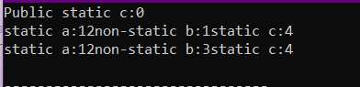

**Question:5**

#include<iostream>

using namespace std;

class myclass{

int code;

static int count;

public:

myclass()

{

code = ++count;

}

void showcode()

{

cout<<"\n\tObject number is :"<<code;

}

//static member function can only access static data members and funcs

static void showcount()

{

cout<<"\n\tCount Objects :"<<count;

}

};

int myclass::count;

int main()

{

myclass obj1,obj2;

//use scope resolution to call static member func

obj1.showcount();

obj1.showcode();

obj2.showcount();

obj2.showcode();

}

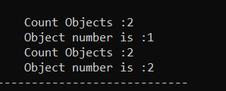

LAB ASSIGNMENT 6

**Question:1**

#include <iostream>

using namespace std;

class matrix

{

private:

int** m;

public:

void getdata();

void show();

matrix mul(matrix m1);

matrix()

{

m = new int*[3];

for (int i = 0; i < 3; i++)

{

m[i] = new int[3];

}

}

};

void matrix::getdata()

{

cout << "Enter the matrix: \n";

for (int i = 0 ; i < 3 ; i++)

{

for (int j = 0 ; j < 3 ; j++)

{

cin >> m[i][j];

}

}

}

void matrix::show()

{

cout << "The matrix is: \n";

for (int i = 0; i < 3; i++)

{

for (int j = 0; j < 3; j++)

{

cout << m[i][j] << " ";

}

cout << "\n";

}

}

matrix matrix::mul(matrix m1)

{

matrix m2;

for (int i = 0; i < 3; i++)

{

for (int j = 0; j < 3; j++)

{

m2.m [i][j] = 0;

for (int k = 0 ; k < 3 ; k++)

{

m2.m[i][j] += m[i][k] * m1.m[k][j];

}

}

}

return m2;

}

int main()

{

matrix m1,m2,m3;

m1.getdata();

m1.show();

m2.getdata();

m2.show();

m3 = m1.mul(m2);

m3.show();

}

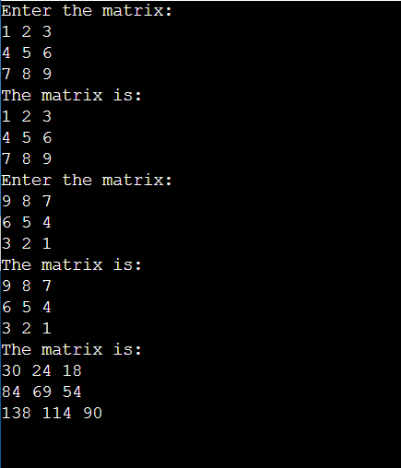

**Question :2**

#include <iostream>

using namespace std;

class matrix

{

private:

int** m;

public:

void getdata();

void show();

friend matrix operator *(matrix m1, matrix m2);

matrix()

{

m = new int*[3];

for (int i = 0; i < 3; i++)

{

m[i] = new int[3];

}

}

};

void matrix::getdata()

{

cout << "Enter the matrix: \n";

for (int i = 0 ; i < 3 ; i++)

{

for (int j = 0 ; j < 3 ; j++)

{

cin >> m[i][j];

}

}

}

void matrix::show()

{

cout << "The matrix is: \n";

for (int i = 0; i < 3; i++)

{

for (int j = 0; j < 3; j++)

{

cout << m[i][j] << " ";

}

cout << "\n";

}

}

matrix operator *(matrix m1, matrix m2)

{

matrix m3;

for (int i = 0; i < 3; i++)

{

for (int j = 0; j < 3; j++)

{

m3.m [i][j] = 0;

for (int k = 0 ; k < 3 ; k++)

{

m3.m[i][j] += m1.m[i][k] * m2.m[k][j];

}

}

}

return m3;

}

int main()

{

matrix m1,m2,m3;

m1.getdata();

m1.show();

m2.getdata();

m2.show();

m3 = m1 * m2;

m3.show();

}

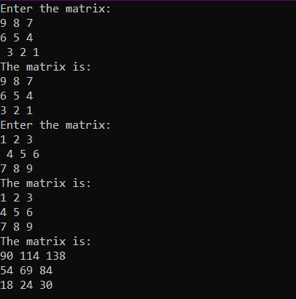

**Question :3**

#include<iostream>

#include<cstdlib>

using namespace std;

float area(float r)

{

return(3.14 * r * r);

}

float area(float b,float h)

{

return(0.5 * b * h);

float area(int l,int b)

{

return (l * b);

}

int main()

{

float b,h,r,l;

int ch;

do

{

cout<<"\n 1. Area of Circle";

cout<<"\n 2. Area of Triangle";

cout<<"\n 3. Area of Rectangle";

cout<<"\n 4. Exit";

cout<<"\n\n Enter Your Choice : ";

cin>>ch;

switch(ch)

{

case 1:

{

cout<<"\n Enter the Radius of Circle : ";

cin>>r;

cout<<"\n Area of Circle : "<<area(r);

break;

}

case 2:

{

cout<<"\n Enter the Base & Height of Triangle : ";

cin>>b>>h;

cout<<"\n Area of Triangle : "<<area(b,h);

break;

}

case 3:

{

cout<<"\n Enter the Length & Bredth of Rectangle : ";

cin>>l>>b;

cout<<"\n Area of Rectangle : "<<area(l,b);

break;

}

case 4:

exit(0);

default:

cout<<"\n Invalid Choice... ";

}

}while(ch!=4);

return 0;

}

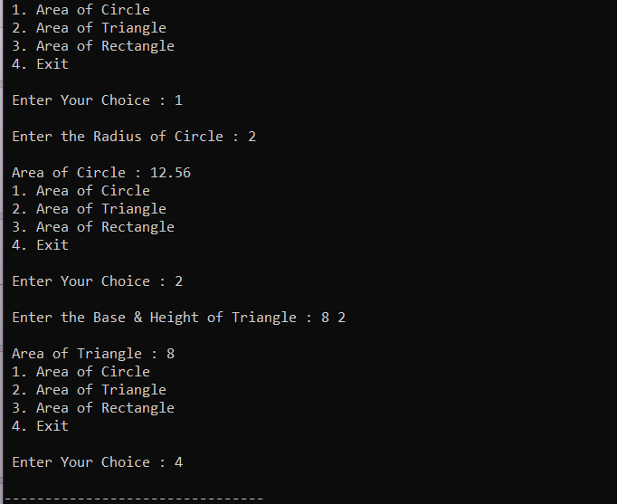

**Question :4**

#include <iostream>

using namespace std;

class complex

{

private:

float real;

float imag;

public:

complex(float a, float b);

void disp();

friend complex sum(complex c, complex d);

};

complex::complex(float a, float b)

{

real = a;

imag = b;

}

void complex::disp()

{

cout << real << " + i(" << imag << ")";

}

complex sum(complex a, complex b)

{

float x, y;

x = a.real + b.real;

y = a.imag + b.imag;

complex d(x,y);

return d;

}

int main()

{

float a, b;

cout << "Enter the first complex number: "

<< "\nReal part: ";

cin >> a;

cout << "Imaginary part: ";

cin >> b;

complex c1(a,b);

cout << "\nEnter the second complex number: "

<< "\nReal part: ";

cin >> a;

cout << "Imaginary part: ";

cin >> b;

complex c2(a,b);

complex c3 = sum(c1,c2);

cout << "\nThe first complex number is: ";

c1.disp();

cout << "\nThe second complex number is: ";

c2.disp();

cout << "\nThe sum of the complex numbers is: ";

c3.disp();

}

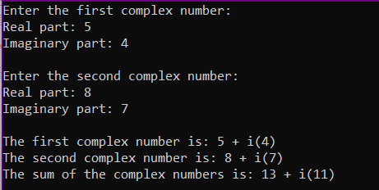

**Question :5**

#include<iostream>

#include<string.h>

using namespace std;

class String

{

private:

char str[100];

public:

void getdata();

void putdata();

friend bool operator ==(String s1, String s2);

friend String operator +(String s1, String s2);

};

void String::getdata()

{

cout << "\n\nEnter the string: ";

gets(str);

}

void String::putdata()

{

cout << "The string is: ";

puts(str);

}

bool operator == (String s1, String s2)

{

return (!strcmp(s1.str,s2.str));

}

String operator +(String s1, String s2)

{

String s;

int a,b;

for (int i = 0 ; i < strlen(s1.str) ; i++)

{

s.str[i] = s1.str[i];

a = i;

}

for (int i = 0 ; i < strlen(s2.str) ; i++)

{

s.str[a + i + 1] = s2.str[i];

b = i;

}

a = a + b + 2;

s.str[a] = '\0';

return s;

}

int main()

{

String s1,s2,s3,s4;

s1.getdata();

s1.putdata();

s3.getdata();

s3.putdata();

s4 = s1 + s3;

cout << "The strings are equal: " << (s1 == s2)

<< "\nConcatenation: \n";

s4.putdata();

}

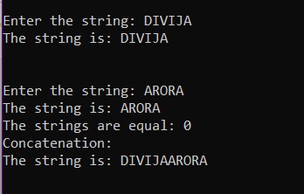

**Question :6**

#include<iostream>

using namespace std;

class integer

{

private:

int a;

public:

void getdata();

void putdata();

friend void operator ++ (integer &i);

};

void integer::getdata()

{

cout << "Enter the integer: ";

cin >> a;

}

void integer::putdata()

{

cout << "The integer is: " << a;

}

void operator ++ (integer &i)

{

i.a++;

i.a++;

}

int main()

{

integer x;

x.getdata();

operator++(x);

x.putdata();

}

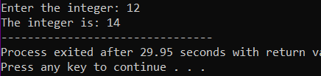

LAB ASSIGNMENT 7

**Question :1**

#include<iostream>

#include<string>

using namespace std;

class Publication

{

public:

string title;

float price;

get_data()

{

cout<<"enter the title:";

//cin.ignore();

getline(cin>>ws,title);

cout<<"enter the price:";

cin>>price;

}

};

class book : public Publication

{

public:

int page_count;

get_data_b()

{

get_data();

cout<<"enter the page count:";

cin>>page_count;

}

put_data_b()

{

cout<<"THE TITLE OF THE BOOK IS: "<<title<<endl<<"THE PRICE OF THE GIVEN BOOK IS: "<<price<<endl;

cout<<"IT HAS "<<page_count<<" PAGES."<<endl;

}

};

class tape: public Publication

{

public:

float play_time;

get_data_t()

{

get_data();

cout<<"enter the play_time";

cin>>play_time;

}

put_data_t()

{

cout<<"THE TITLE OF THE TAPE IS: "<<title<<endl<<"THE PRICE OF THE GIVEN TAPE IS: "<<price<<endl;

cout<<"IT HAS A PLAY TIME OF "<<play_time<<" MINUTES.";

}

};

int main()

{

book b1;

tape t1;

b1.get_data_b();

b1.put_data_b();

t1.get_data_t();

t1.put_data_t();

} 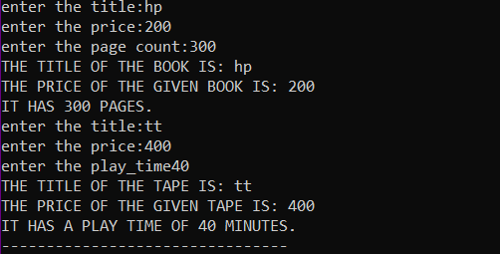

**Question :2**

#include<bits/stdc++.h>

#include<string>

using namespace std;

class student{

public:

string name;

int roll_no;

get_data()

{

cout<<"enter your name:";

getline(cin>>ws ,name);

cout<<"enter your roll number:";

cin>>roll_no;

cin.ignore();

}

};

class exam : public student{

public:

int marks[5];

get_marks()

{

get_data();

cout<<"enter the marks scored in various subjects"<<endl;

for(int i =0;i<5;i++)

{

cout<<"Scores in subject "<<i+1<<endl;

cin>>marks[i];

}

}

};

class result : public exam{

int av;

int to;

public:

get_result()

{

to =0;

av=0;

for(int i =0;i<5;i++)

{

to+=marks[i];

}

av=to/5;

display();

}

display()

{

cout<<"The average marks of "<< name <<" is "<<av;

}

};

int main()

{

result s1;

s1.get_marks();

s1.get_result();

result s2;

s2.get_marks();

s2.get_result();

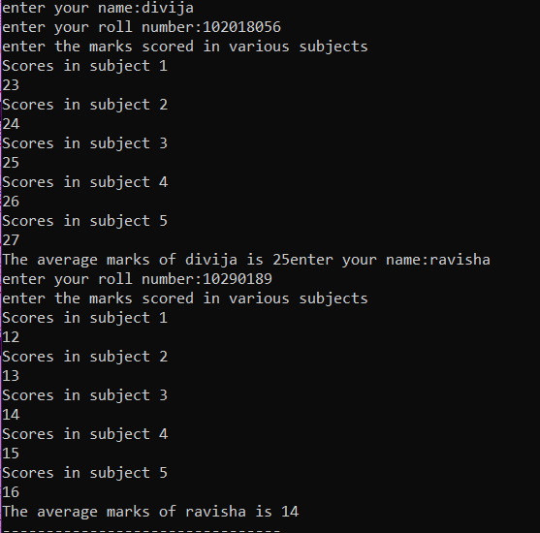

**Question :3**

#include<iostream>

using namespace std;

class Shape

{

public:

double height,base;

void get_data()

{

cout<<"\nEnter height and base to compute area :";

cin>>height>>base;

}

//declaration of virtual function display_area()

virtual void display_area()

{

}

};

class Triangle : public Shape

{

public:

//redefining function display_area()

void display_area()

{

cout<<height;

cout<<"\nArea of Triangle = "<<(height*base)/2;

}

};

class Rectangle : public Shape

{

public:

void display_area()

{

cout<<"\nArea of Rectangle = "<<height*base;

}

};

int main()

{

Rectangle r;

r.get_data();

r.display_area();

Triangle t;

t.get_data();

t.display_area();

}

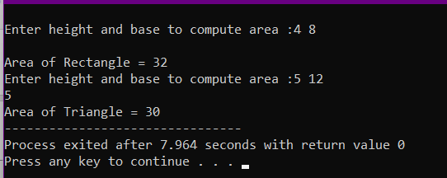

**Question :4**

#include<iostream>

using namespace std;

class Shape

{

public:

double height,base;

//constructor to assign initial values to height and base

Shape()

{

height=0;

base=0;

}

//declaration of virtual function display_area()

virtual void display_area() = 0;

};

//class triangle inheriting class Shape

class Triangle : public Shape

{

public:

Triangle(int h , int b)

{

height=h;

base=b;

}

//redefining function display_area()

void display_area()

{

cout<<height;

cout<<"\nArea of Triangle = "<<(height*base)/2;

}

};

//class Rectangle inheriting class Shape

class Rectangle : public Shape

{

public:

Rectangle(int h , int b)

{

height=h;

base=b;

}

//redefining function display_area()

void display_area()

{

cout<<"\nArea of Rectangle = "<<height*base;

}

};

int main()

{

Rectangle r(4,5);

r.display_area();

Triangle t(3,4);

t.display_area();

}

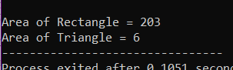

LAB ASSIGNMENT 8

**Question :1**

#include<iostream>

#include<fstream>

using namespace std;

int main()

{

fstream datafile;

datafile.open("NOTES.TXT", ios::out);

for(int i =0;i<=100;i++)

{

datafile <<i<<endl;

}

}

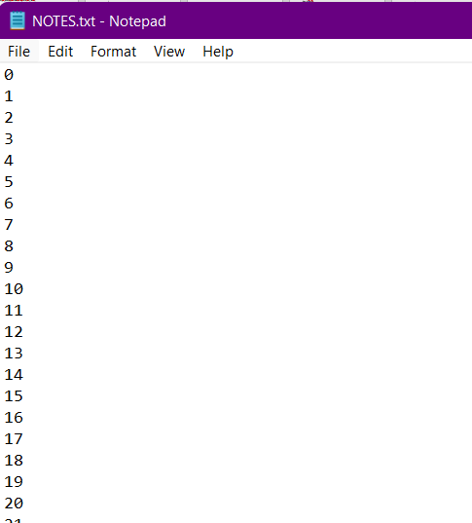

**Question :2**

#include<iostream>

#include<fstream>

using namespace std;

int count_alphabets()

{

fstream datafile;

char ch;

datafile.open("OUT.txt", ios::in);

if (!datafile)

{

cout<<"Error opening file"<<endl;

}

else

{

cout<<"File opened successfully"<<endl;

}

datafile.get(ch);

int c=0;

while (!datafile.eof())

{

cout << ch ;

datafile.get(ch);

c++;

}

cout<<"\nCount of alphabets = "<<c;

datafile.close();

return 0;

}

int main()

{

count_alphabets();

}

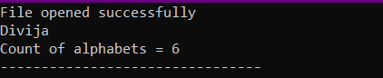

**Question :3**

#include <iostream>

#include <fstream>

using namespace std;

int main()

{

ifstream ini_file ("sample69.txt");

ofstream out_file ("copy.txt");

char ch;

while(!ini_file.eof())

{

ini_file.get(ch);

out_file << ch;

}

ini_file.close();

out_file.close();

return 0;

}

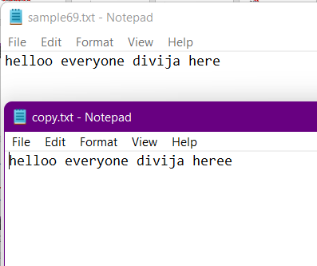

**Question :4**

#include<iostream>

#include <fstream>

using namespace std;

int main( )

{

struct employee

{

char name[ 20 ];

int age;

float basic;

float gross;

};

employee e; int c;

while(1)

{

cout<<"Enter choice:"<<endl;

cin>>c;

switch(c){

case 1:

{

char ch = 'Y';

ofstream outfile;

outfile.open( "EMPLOYEE.txt", ios::out | ios::binary );

while( ch == 'Y' )

{

cout << endl << "Enter a record: ";

cin >> e.name >> e.age >> e.basic >> e.gross; outfile.write( ( char * )&e, sizeof( e ) ); cout << endl << "Add Another Y/N: ";

cin >> ch;

}

outfile.close( );

break;

}

case 2:

{

ifstream infile;

infile.open( "EMPLOYEE.txt", ios::in | ios::binary );

while( infile.read( ( char * )&e, sizeof( e ) ) )

{

cout << endl << e.name << "\t" << e.age << "\t" << e.basic << "\t"

<< e.gross;

}

break;

}

}

}

}

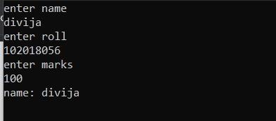

**Question :5**

#include<iostream>

#include<fstream>

#include<string.h>

using namespace std;

int main()

{

char string[80];

cout<<"Enter a string: ";

cin>>string;

int len = strlen(string);

cout<<endl;

cout<<"Length of string: "<<len;

fstream datafile;

datafile.open("TEXT.txt",ios::in | ios::out);

for(int i=0; i<len;i++)

{

datafile.put(string[i]);

}

datafile.seekg(0);

char ch;

cout<<endl;

cout<<"String read from file: ";

while(datafile)

{

datafile.get(ch);

cout<<ch;

}

return 0;

}

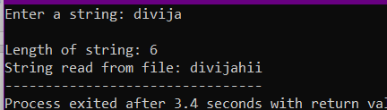

LAB ASSIGNMENT 9

**Question :1**

#include<iostream>

using namespace std;

int main()

{

int y;

cout<<"Enter any value:";

cin>>y;

try{

if(y==0)

throw 5;

else

throw "you are right";

cout<<y<<endl;

}

catch (int i){

cout<<"caught i =" <<i<<endl;

}

catch (const char*e){

cout<<e<<endl;

}



**Question :2**

#include<iostream>

#include<string.h>

using namespace std;

class conditions

{ public:

char vehicle;

int salary,age;

string city_name;

conditions()

{

age=0;

vehicle=0;

salary=0;

}

void getdata(){

cout<<"What is your age: ";

cin>>age;

if(age<18 || age>55) { throw 1; }

cout<<"What is your Salary Permonth: ";

cin>>salary;

if(salary<50000 || salary>100000){ throw 2;}

cout<<"Do u have four wheeler(yes/no): ";

cin>>vehicle;

if(vehicle=='n'){ throw 3; }

cout<<"What is the name of your city:";

cin>>city_name;

if(city_name=="pune" || city_name=="mumbai" || city_name=="bangalore" || city_name=="chennai")

{}

else {throw 4;}

}

};

int main()

{

conditions u;

try

{

u.getdata();

}

catch(int i)

{

switch(i)

{

case 1:

cout<<"Please enter age between(18-55)"<<endl;break;

case 2:

cout<<"Please enter salary between(50000-100000)"<<endl;break;

case 3:

cout<<"User Donot have four vehicle"<<endl;break;

case 4:

cout<<"Invalid city_name"<<endl;break;

}

}

return 0;

}

}

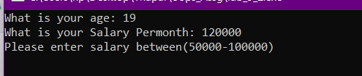

**Question :3**

#include<iostream>

#include<string>

using namespace std;

int main()

{

float x, y, result;

char Operator;

cout<<"Arithmetic Operations"<<endl;

try

{

cout<"Enter First Number: "<<endl;

cin>>x;

if(x==0)

throw 0;

cout<<"Enter Operator: ";

cin>>Operator;

if(Operator != '+' && Operator != '-' && Operator != '*' && Operator != '/')

throw Operator;

cout<<"Enter Second Number : "<<endl;

cin>>y;

switch(Operator)

{

case '+':

result = x + y;

break;

case '-':

result = x - y;

break;

case '*':

result = x * y;

break;

case '/':

result = x / y;

break;

}

if(y == 0) //finding if the denominator is 0

throw 0;

cout<<"\n result: "<<x<<" "<<Operator<<" "<<y<<" = "<<result;

}

catch(const char c)

{

cout<<c<<" is not a Valid Operator";

}

catch(const int n)

{

cout<<"Please enter a valid number.";

}

return 0;

}

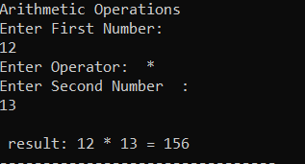

**Question :4**

#include <iostream>

using namespace std;

void rethrow()

{

try

{

throw "hello";

}

catch (const char*)

{

cout <<"Caught exception inside rethrow function"<<endl;

throw; //rethrow char* out of function

}

}

int main()

{

cout<< "started"<<endl;

try

{

rethrow();

}

catch(const char*)

{

cout <<"Caught exception inside Main\n";

}

cout << "end";

}

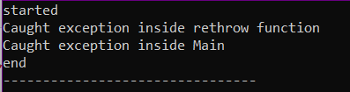

**Question :6**

#include<iostream>

#include<string>

using namespace std;

int main()

{

string user_name,password;

cout<<"username:";

getline(cin,user_name);

cout<<"\nPassword";

getline(cin,password);

try{

if(password.length() < 6)

throw 0;

int count =0 ;

for(int i = 0 ;i <password.length();i++)

{

if(isdigit(password[i]))

{

count ++;

}

}

if(count == 0)

{

throw 0 ;

}

else{

cout<<"password is correct";

}

}

catch(int a)

{

cout<<"invalid password format!";

}

}

