UCT-402

DATABASE MANAGEMENT SYSTEMS

Submitted To: Dr Rinkle Rani,

Ms Shruti Arora



BY: Divija 102018056 CSBS-3

Assignment: 1

Question 1:

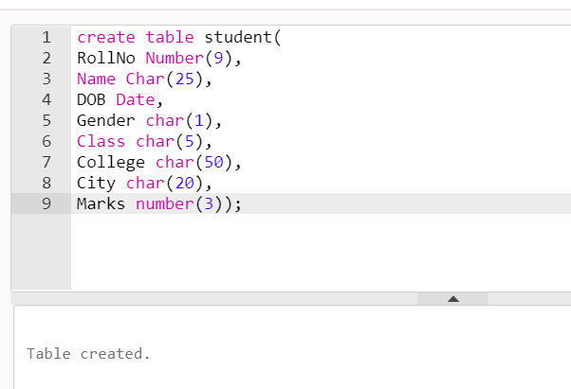

Question 2:

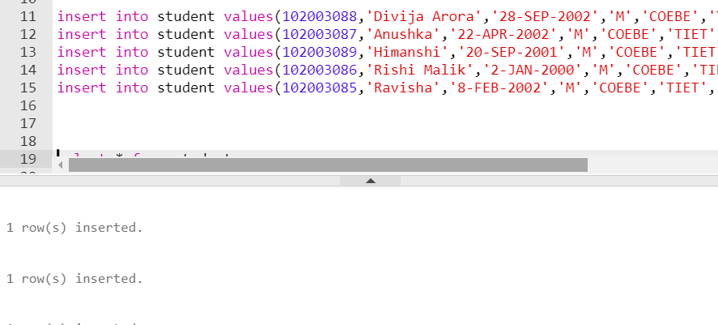

Question 3:

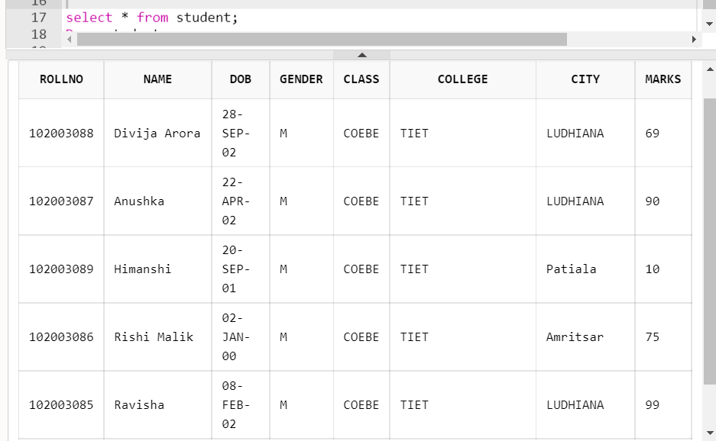

Question 4:

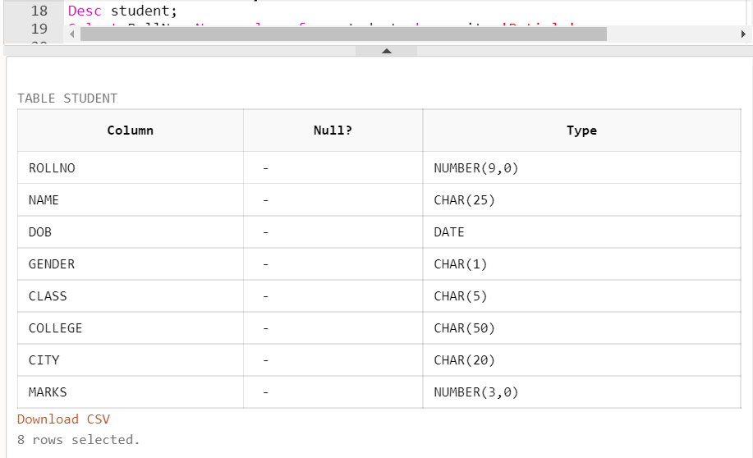

Question 5:

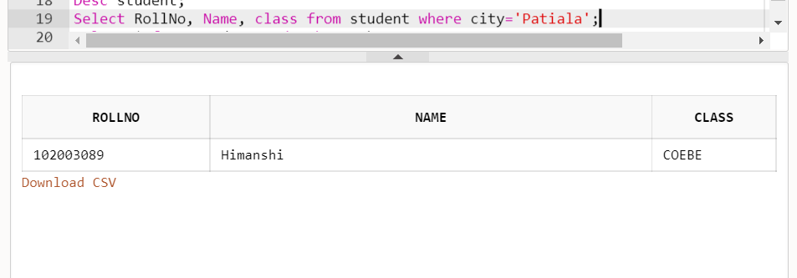

Question 6:

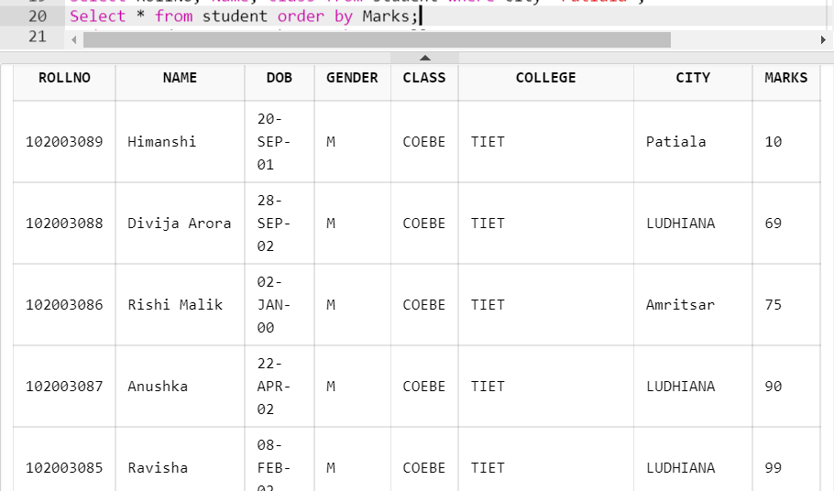

Question 7:

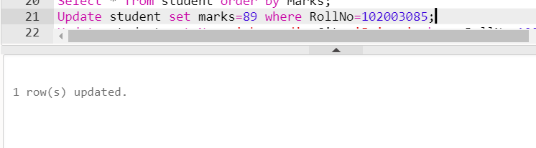

Question 8:

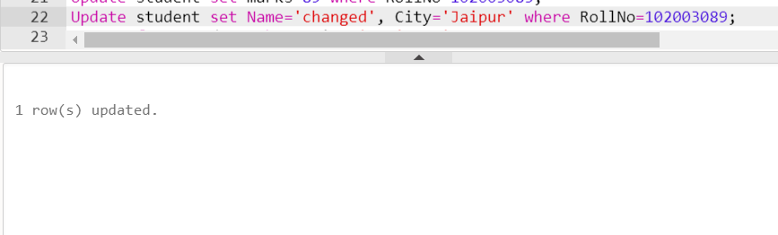

Question 9:

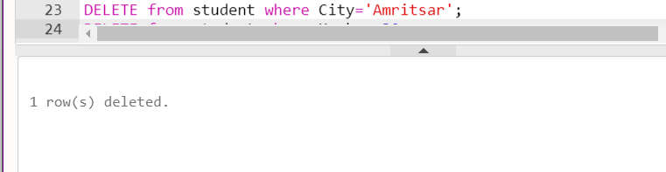

Question 10:

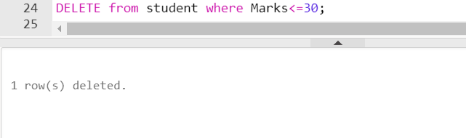

Assignment: 2

Question 1:

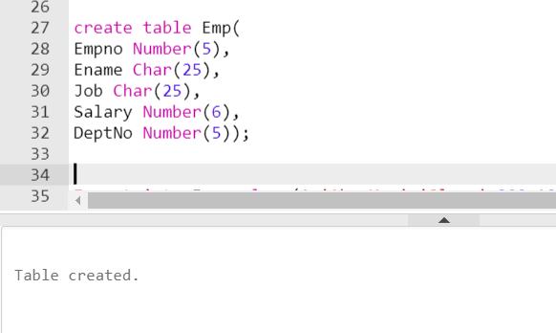

Question 2:

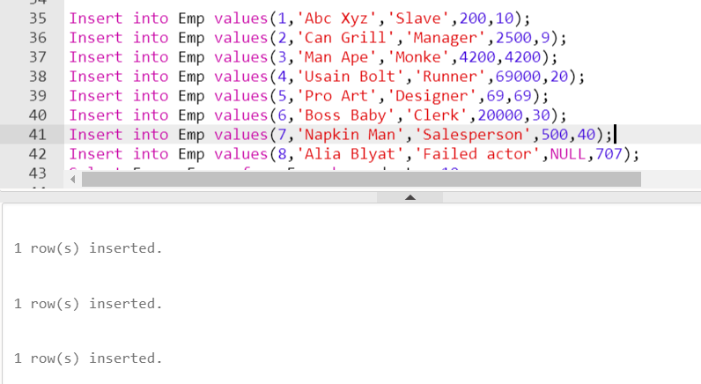

Question 3:

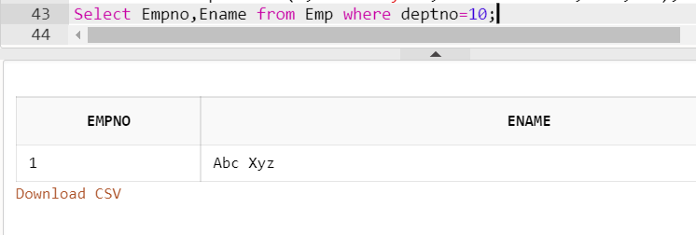

Question 4:

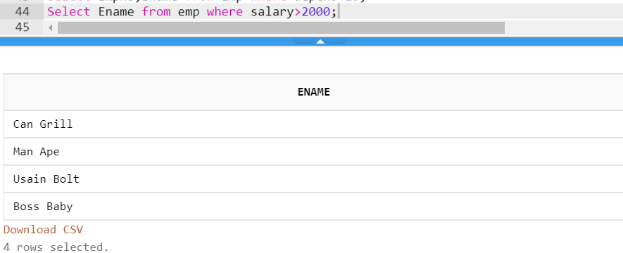

Question 5:

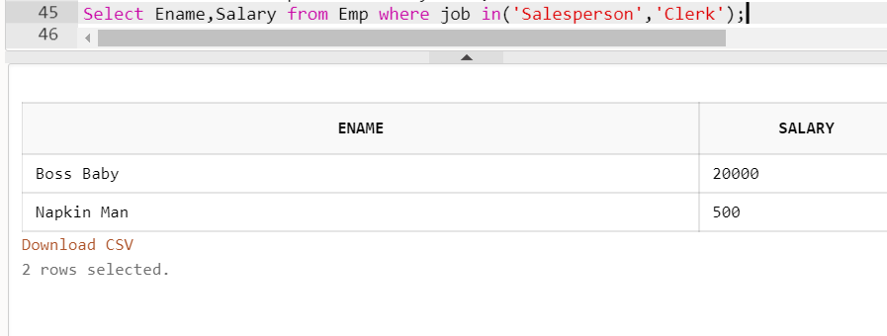

Question 6:

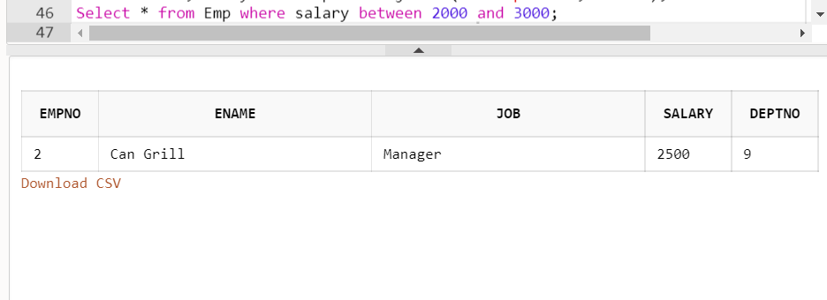

Question 7:

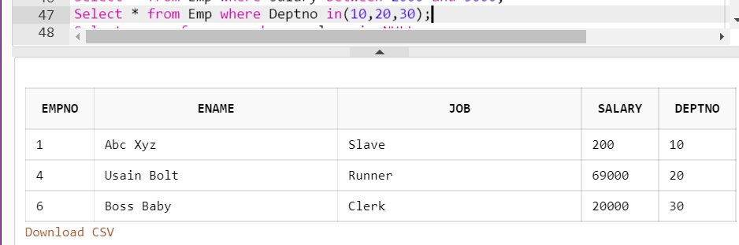

Question 8 :

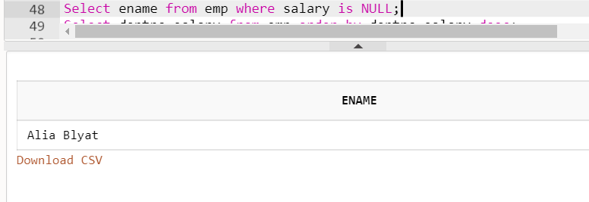

Question 9:

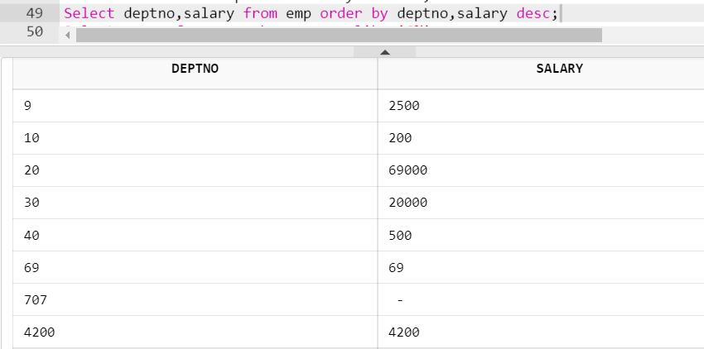

Question 10 :

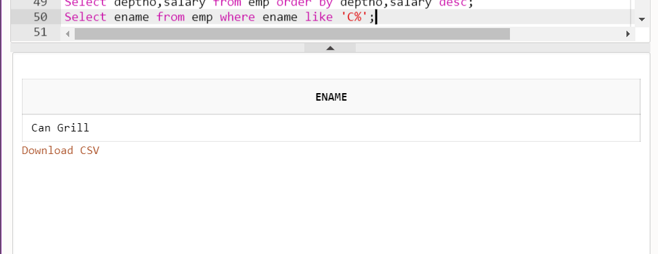

Question 11 and 12:

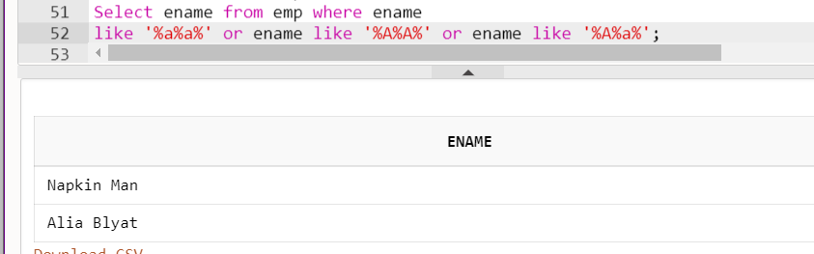

Question 13:

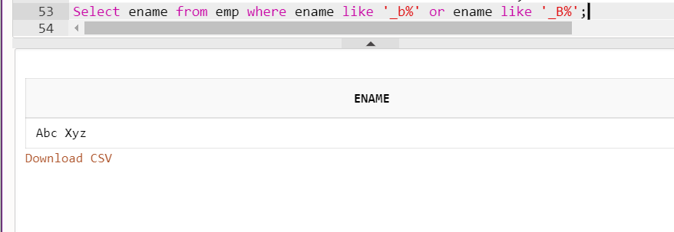

Question 14:

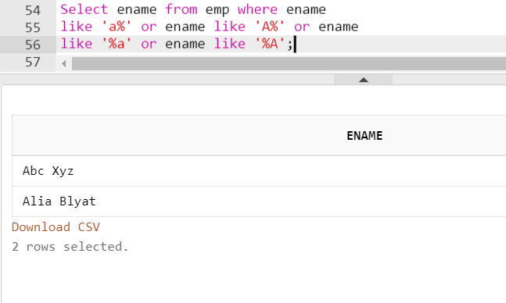

Assignment: 3

Question 1:

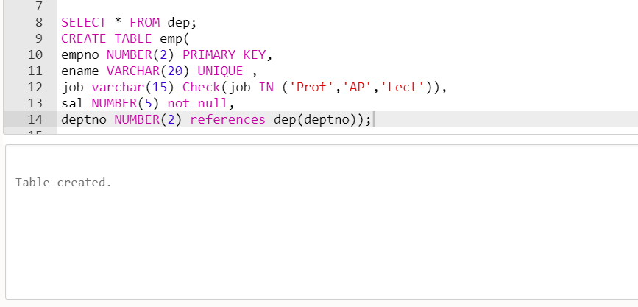

Question 2:

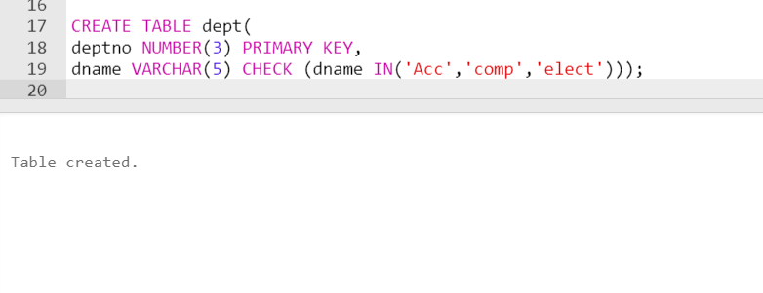

Question 3:

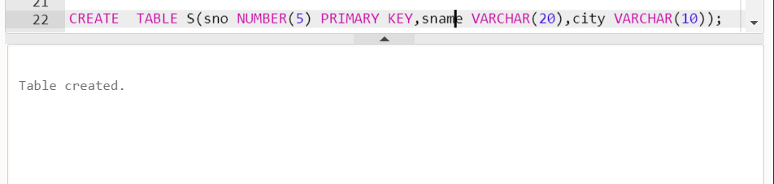

Question 4:

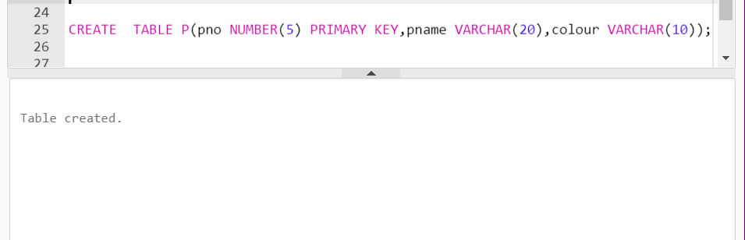

Question 5:

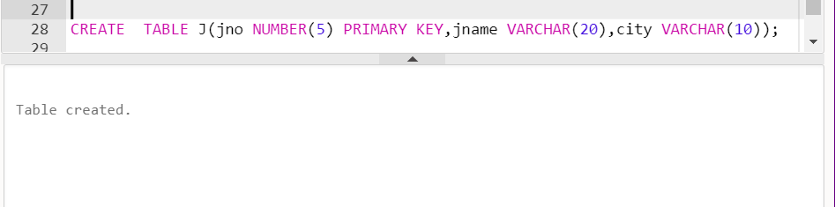

Question 6:

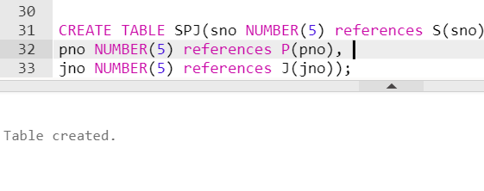

Question 7 : records inserted in assignment 6

Assignment: 4

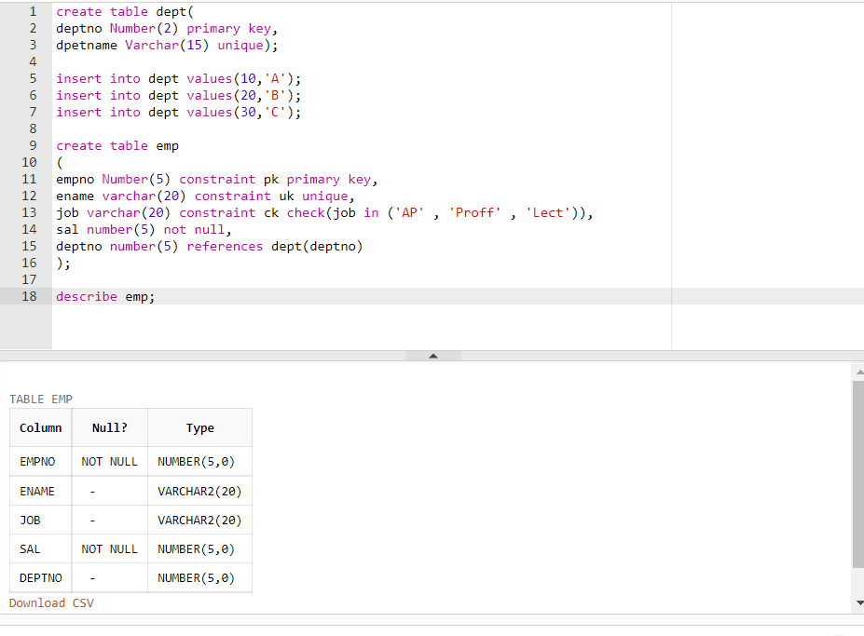Question 1:

Question 2:

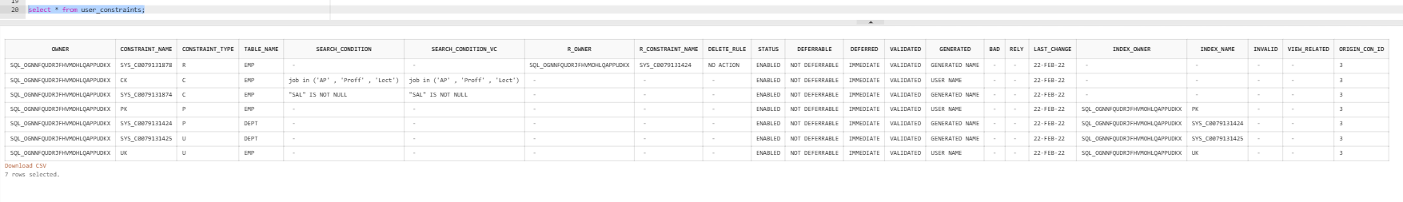

Question 3:

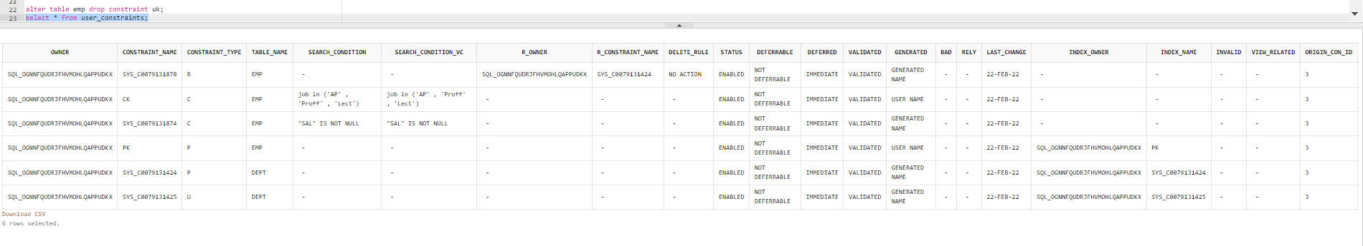

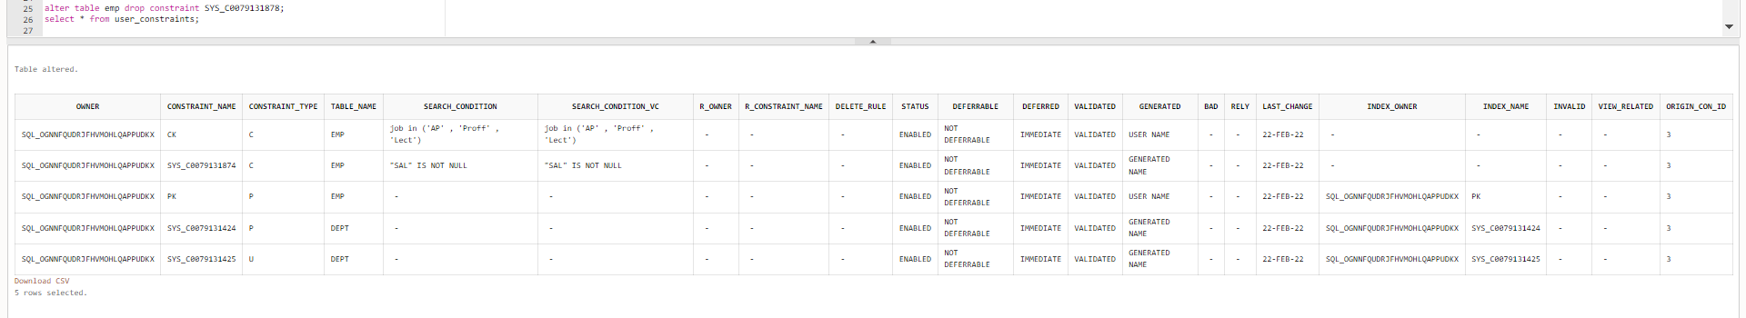Question 4:

Question 5:

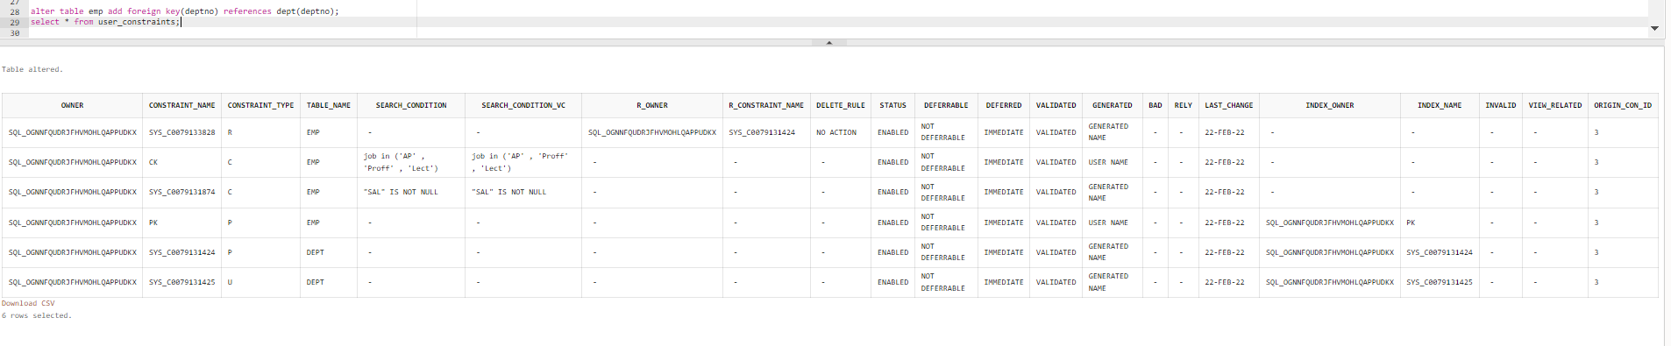

Question 6:

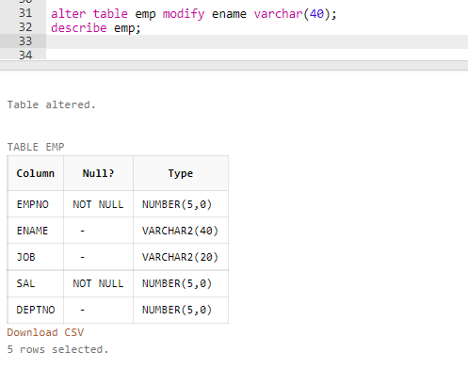

Question 7:

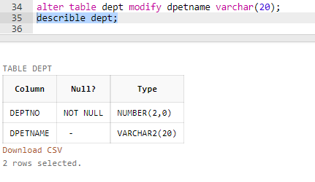

Question 8:

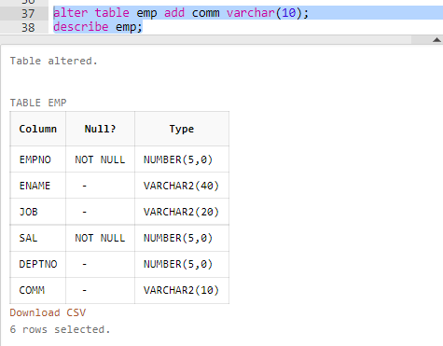

Question 9:

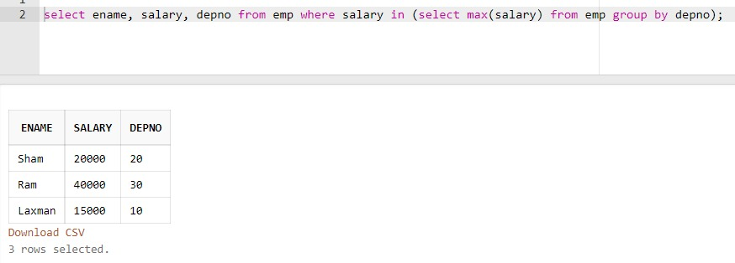

Question 10:

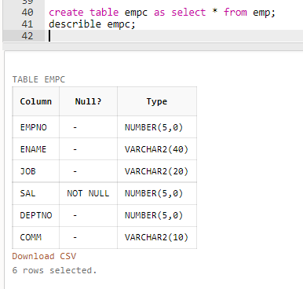

Question 11:

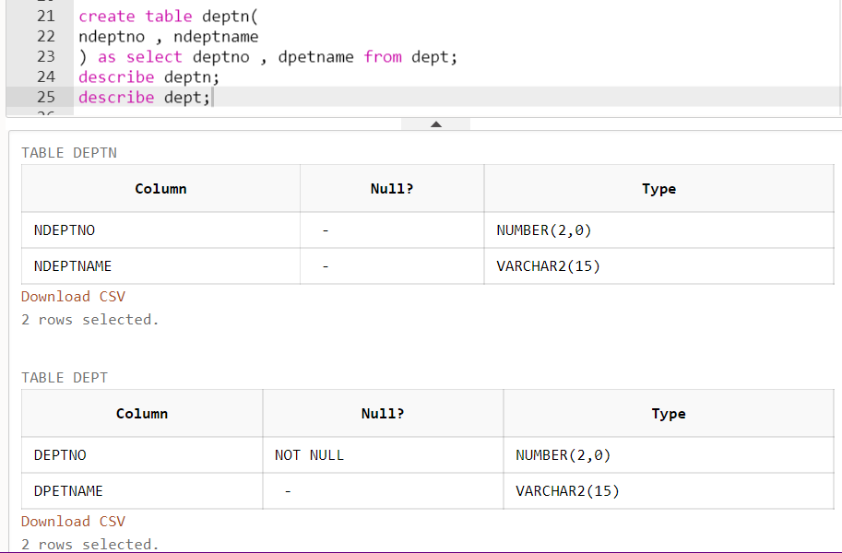

Question 12:

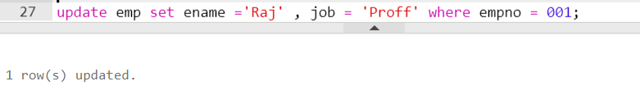

Question 13:

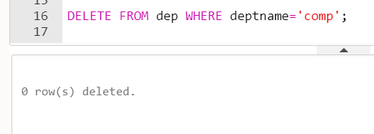



Question 14:

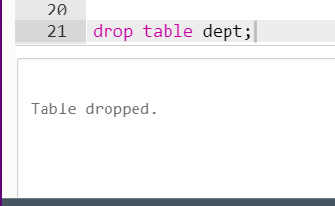

Question 15:

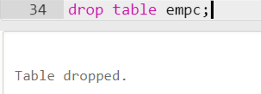

Assignment :5

Question 1:

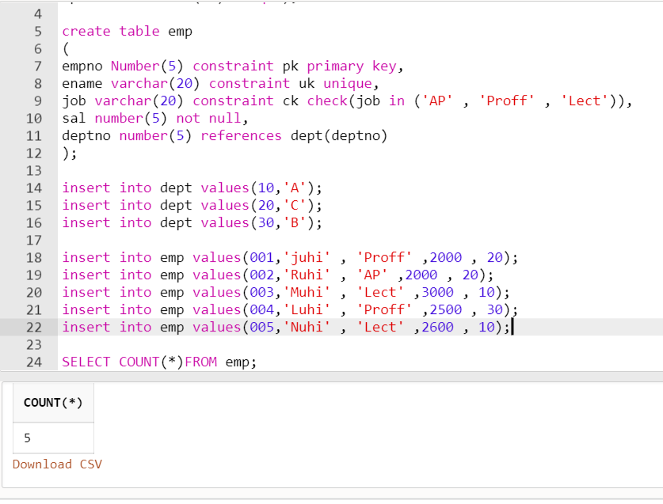

Question 2:

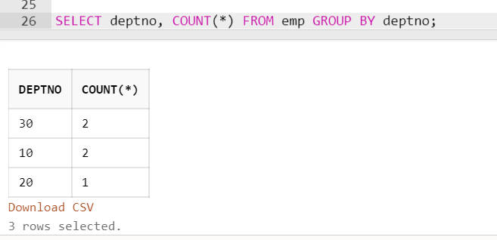

Question 3:

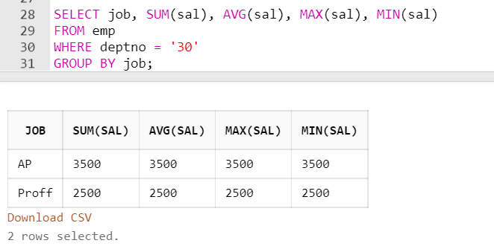

Question 4:

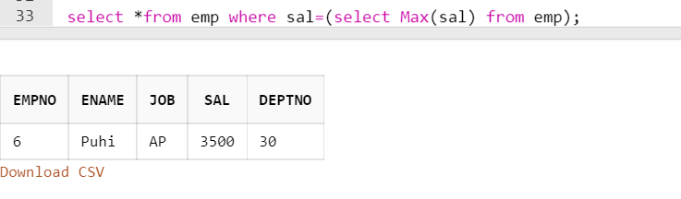

Question 5:

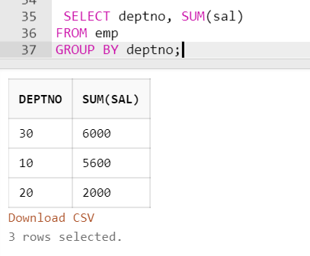

Question 6:

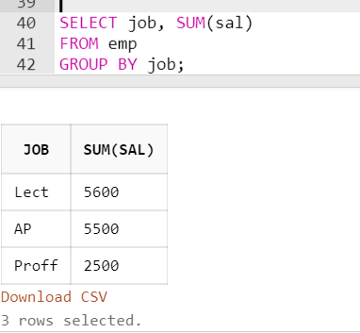

Question 7:

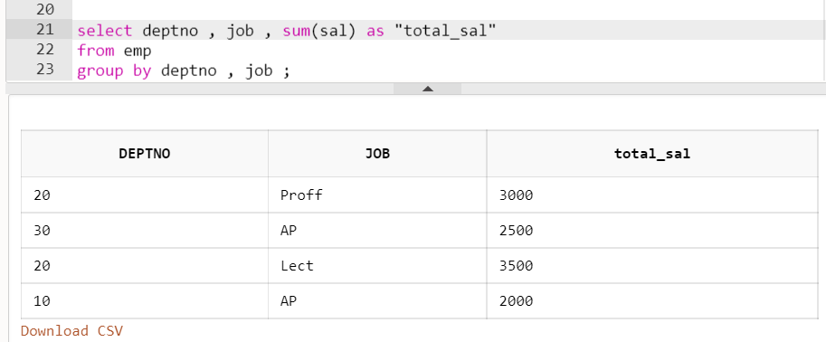

Question 8:

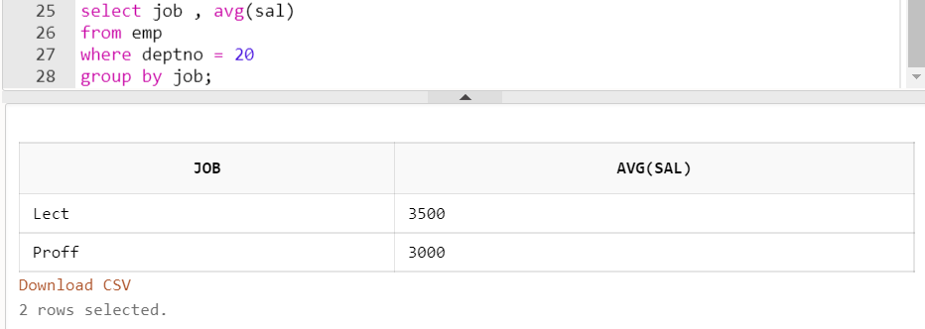

Question 9:

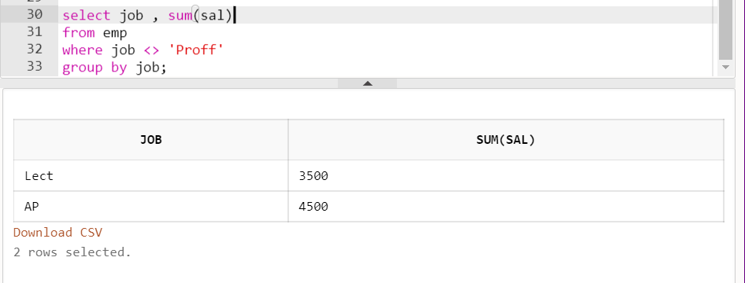

Question 10:

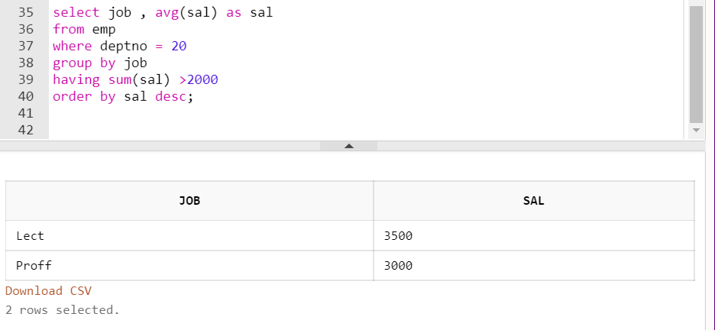

Question 11:

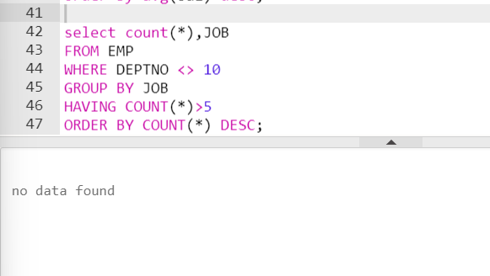

Question 12 : NA

Question 13:

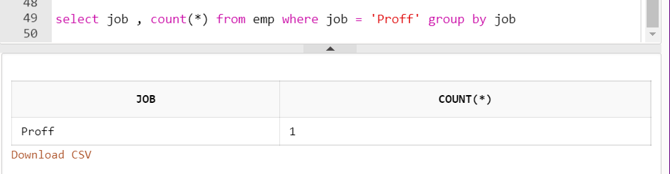

Question 14:



Question 15 :

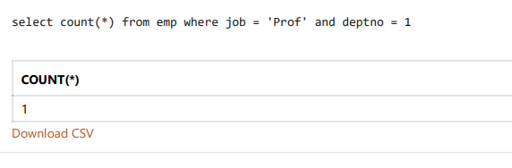

Question 16:

Question 17:

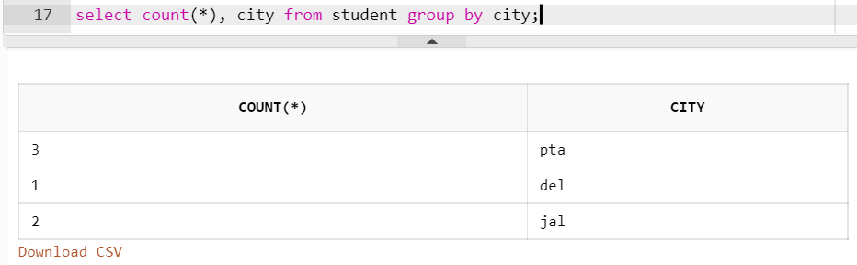

Question 18:

Question 19:

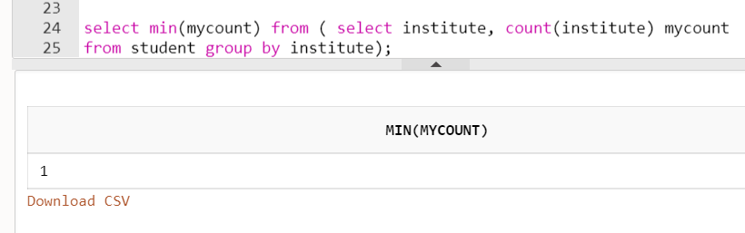

Question 20:

Question 21:

Question 22:

Assignment: 6

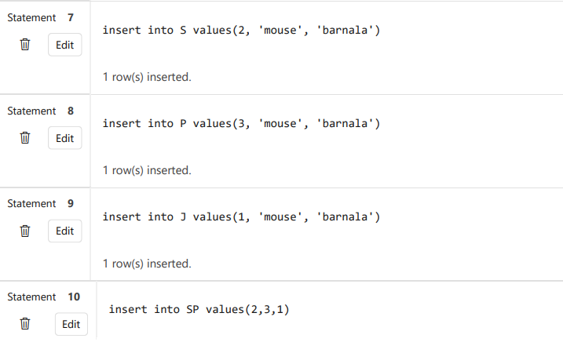

Question 1:

Question 2:

Question 3:

Question 4:

Question 5,6,7,8,9:

Question 10:

Question 11:



Question 12:

Question 13:

Question 14:

Question 15:

Question 16:

Question 17:

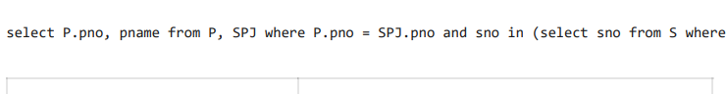

Question 18:

Assignment: 7

Question 1:

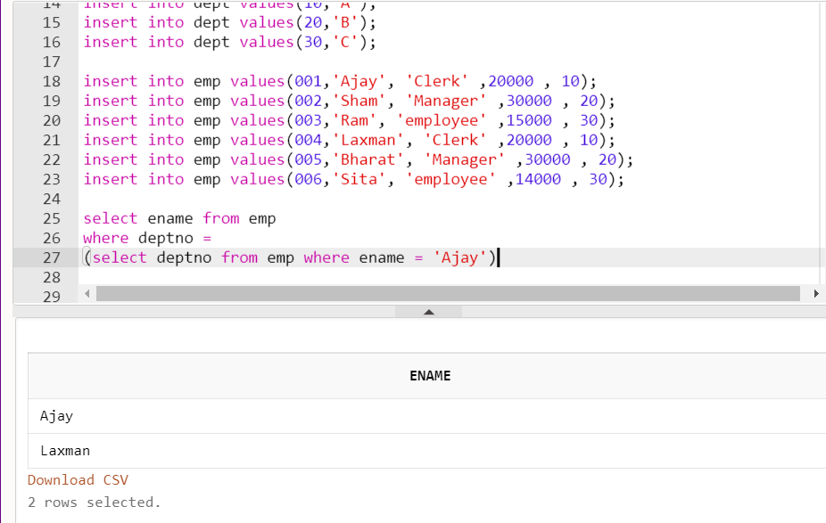

Question 2

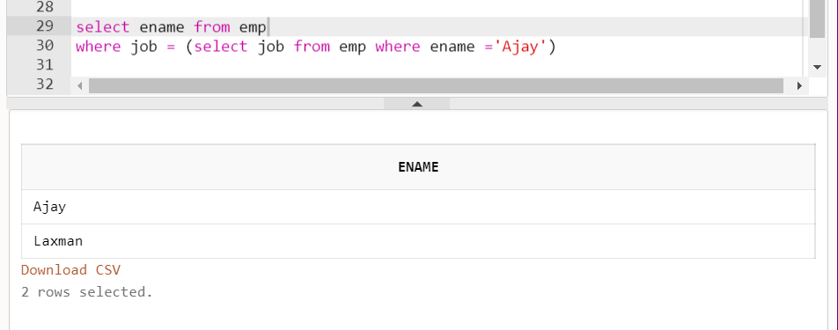

Question 3:

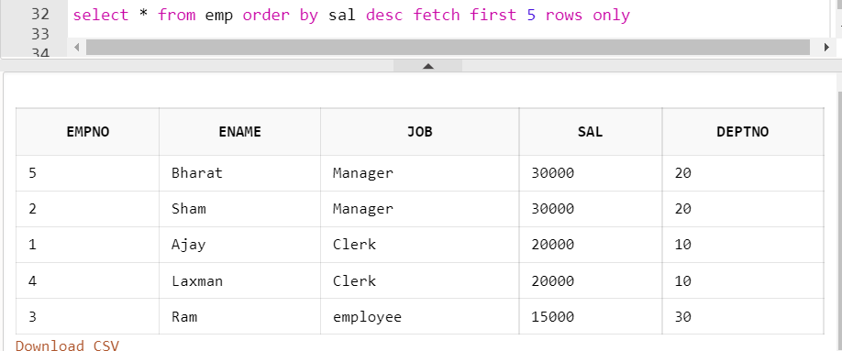

Question 4:

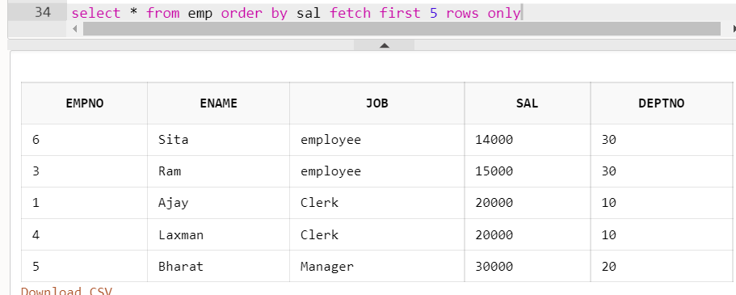

Question 5:

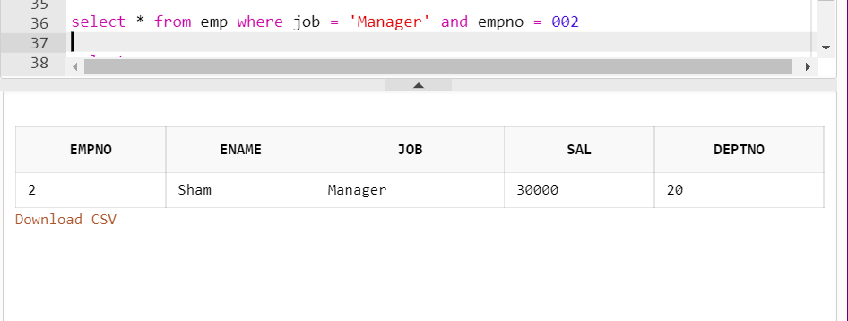

Question 6 :

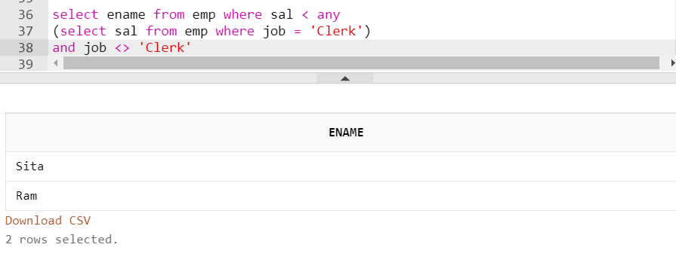

Question 7:

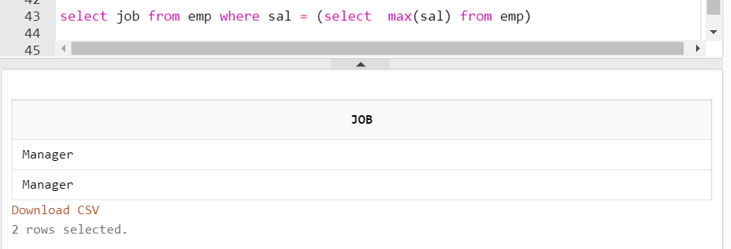

Question 8:



Question 9:



Question 10: Repeat

Question 11:



Question 12: 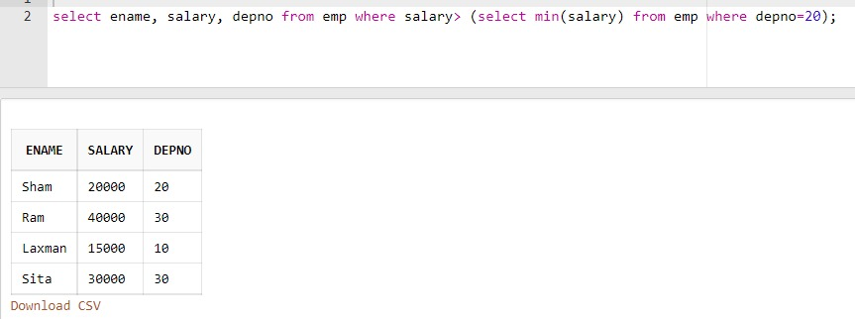

Question 13:

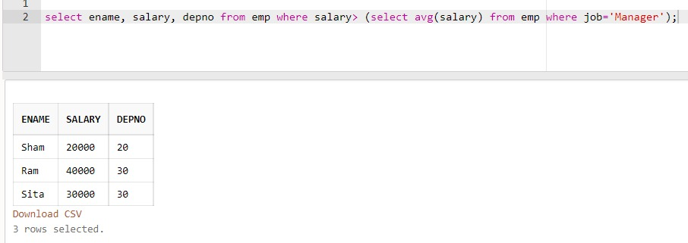

Question 14:

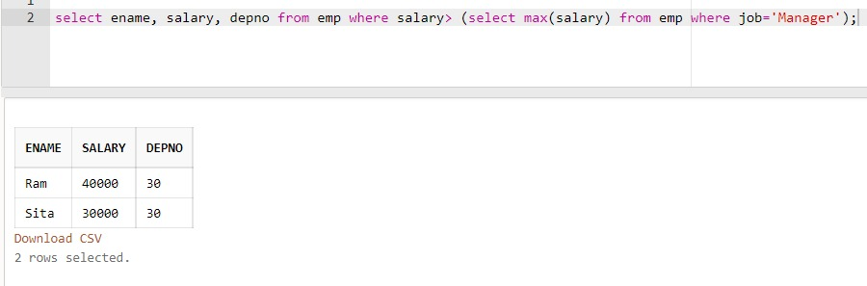

Question 15:



Assignment: 8

Question 1:

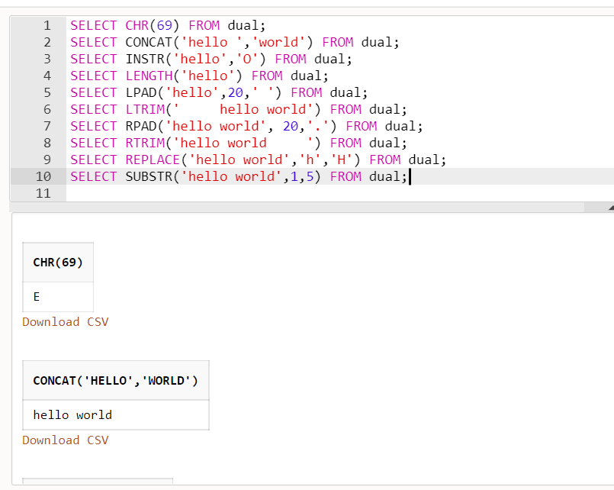

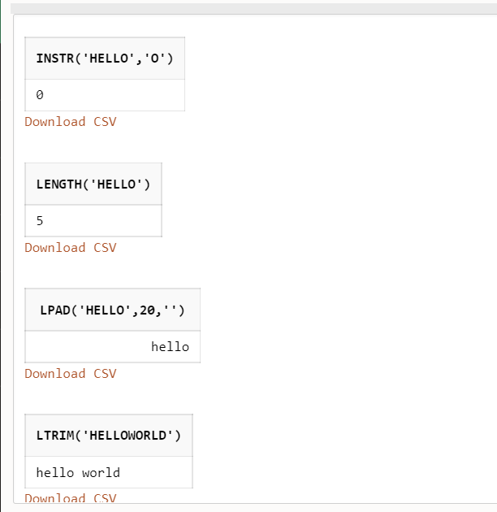

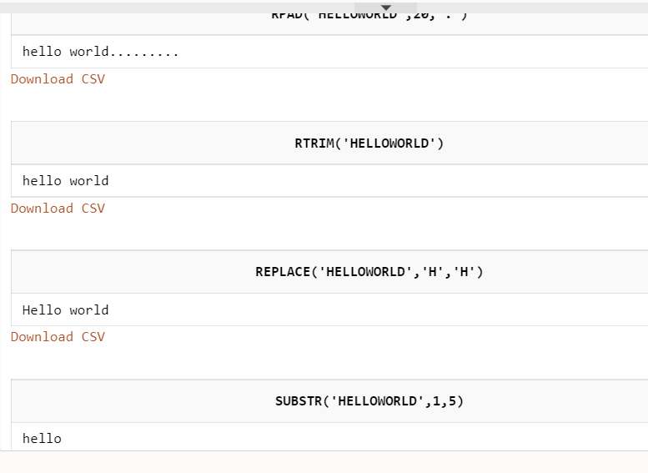

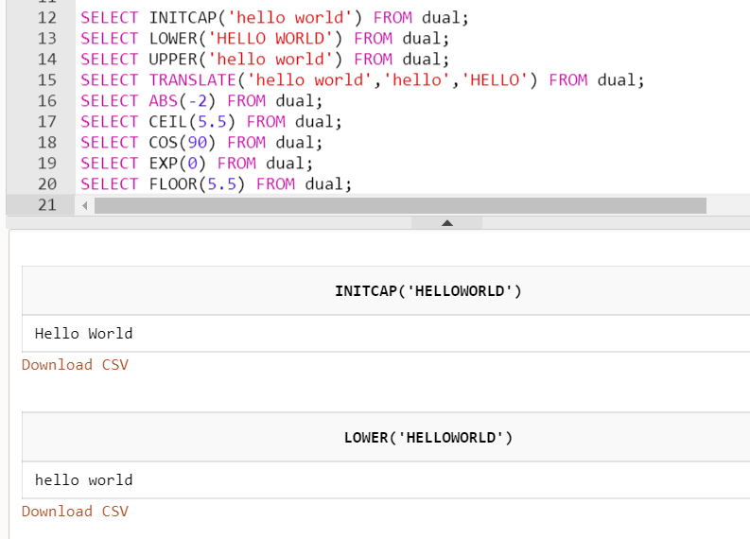

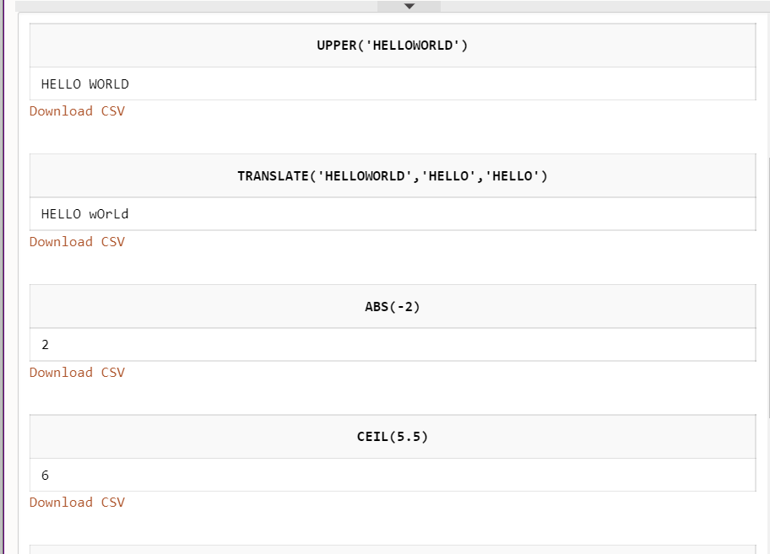

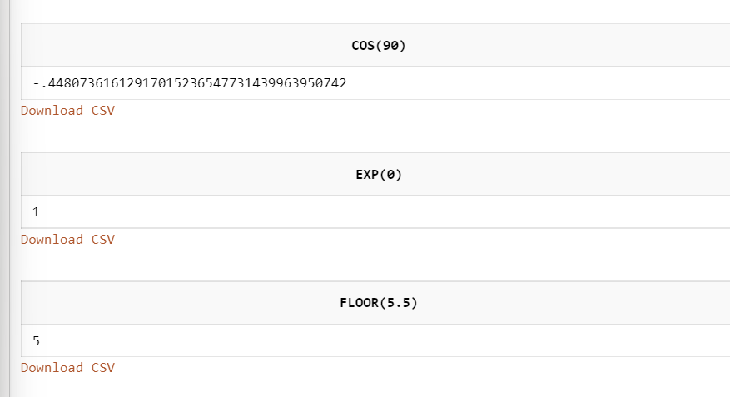

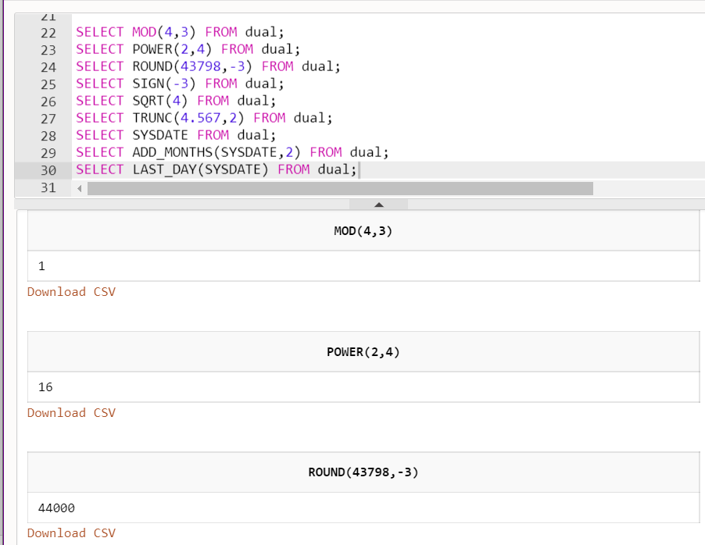

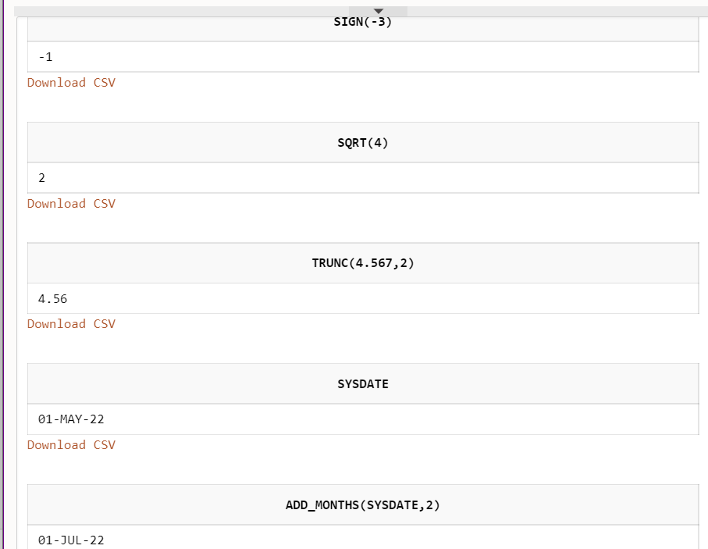

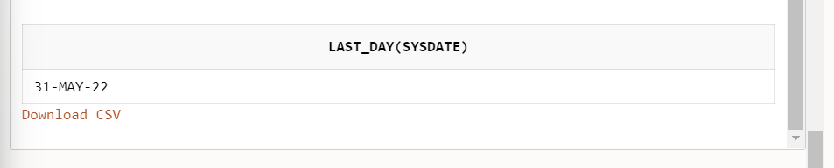

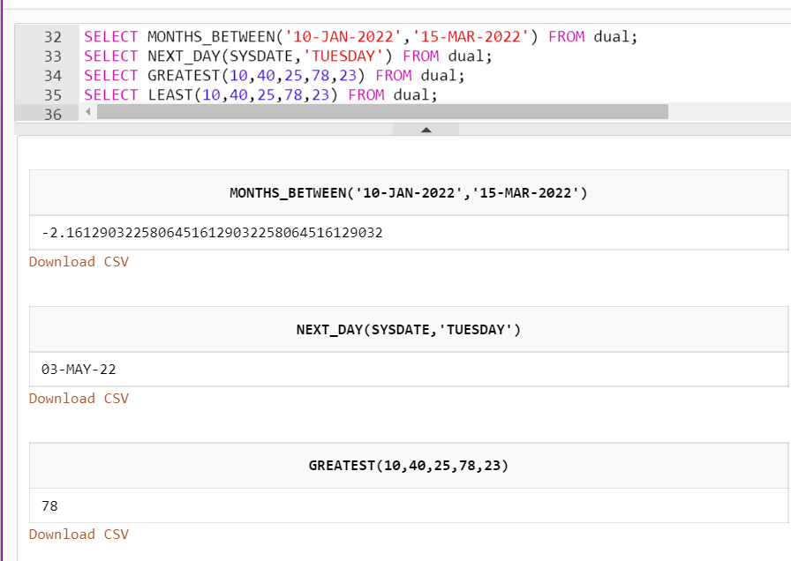

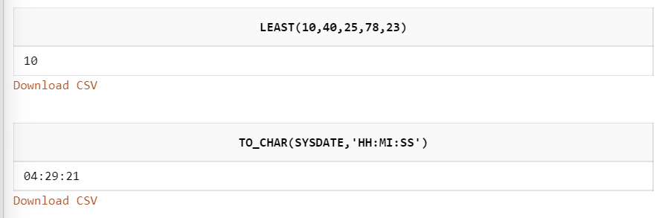

Question 3:

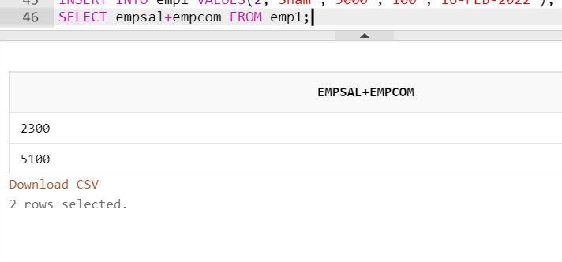

Question 4:

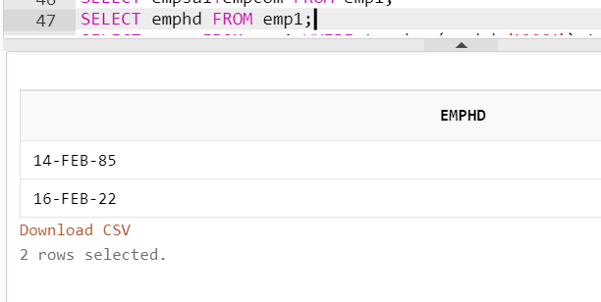

Question 5:

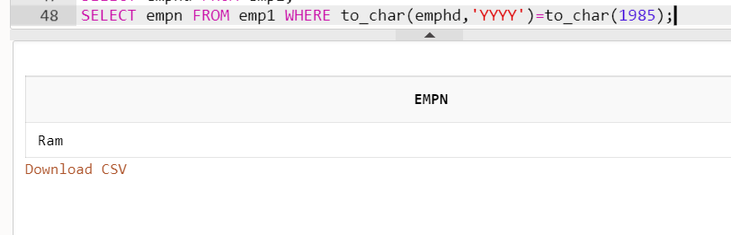

Question 6:

