**INTRODUCTION TO DESIGN THINKNG**

What is design thinking?

Design thinking originally came about as a way of teaching engineers how to approach problems creatively, like designers do. One of the first people to write about design thinking was John E. Arnold, professor of mechanical engineering at Stanford University. In 1959, he wrote “Creative Engineering,” the text that established the four areas of design thinking. From there, design thinking began to evolve as a “way of thinking” in the fields of science and design engineering—as can be seen in Herbert A. Simon’s book “The Sciences of the Artificial” and in Robert McKim’s “Experiences in Visual Thinking”.

With the rise of human-centered design in the 80s and the formation of design consultancy IDEO in the 90s, design thinking became increasingly popular. By the start of the 21st century, design thinking was making its way into the world of business. In 2005, Stanford University’s d.school began teaching design thinking as an approach to technical and social innovation.

Indeed, many of the methods and techniques used in design thinking have been borrowed from the designer’s toolkit.

So what exactly is design thinking?

Design thinking is both an ideology and a process that seeks to solve complex problems in a user-centric way. It focuses on achieving practical results and solutions that are:

Technically feasible: They can be developed into functional products or processes;

Economically viable: The business can afford to implement them;

Desirable for the user: They meet a real human need.

The ideology behind design thinking states that, in order to come up with innovative solutions, one must adopt a designer’s mindset and approach the problem from the user’s perspective. At the same time, design thinking is all about getting hands-on; the aim is to turn your ideas into tangible, testable products or processes as quickly as possible.

The design thinking process outlines a series of steps that bring this ideology to life—starting with building empathy for the user, right through to coming up with ideas and turning them into prototypes.

At this point, you’re probably thinking that this sounds suspiciously like UX. So what makes design thinking so special?

Design thinking helps us tackle “wicked” problems

The uniqueness of design thinking lies in the kinds of problems it addresses. When it comes to the problems to be solved with design thinking, we’re not just talking about ordinary, common problems that have tried-and-tested solutions. We’re talking about highly complex, “wicked” problems: the kind that refuse to be solved using standard methods and approaches.

Not only are these problems difficult to define, but any attempt to solve them is likely to give way to even more problems. Wicked problems are everywhere, ranging from global issues such as climate change and poverty, to challenges that affect almost all businesses such as change management, achieving sustainable growth, or maintaining your competitive edge.

Design thinking is an actionable approach which can be used to tackle the world’s wickedest of problems. It fosters user-centricity, creativity, innovation, and out-of-the-box thinking.

With that in mind, let’s explore the principles and pillars of design thinking in more detail.

What are the principles of design thinking?

There are certain principles that are pivotal to design thinking. These are reflected in the design thinking methodology, which we’ll explore in detail a little later on. We’ve outlined five of design thinking’s most important principles below.

1. User-centricity and empathy

Design thinking is all about finding solutions that respond to human needs and user feedback. People, not technology, are the drivers of innovation, so an essential part of the process involves stepping into the user’s shoes and building genuine empathy for your target audience.

2. Collaboration

The aim of design thinking is to pool a diverse variety of perspectives and ideas; this is what leads to innovation! Design thinking encourages collaboration between heterogeneous, multidisciplinary teams which may not typically work together.

3. Ideation

Design thinking is a solution-based framework, so the focus is on coming up with as many ideas and potential solutions as possible. Ideation is both a core design thinking principle and a step in the design thinking process. The ideation step is a designated judgment-free zone where participants are encouraged to focus on the quantity of ideas, rather than the quality.

4. Experimentation and iteration

It’s not just about coming up with ideas; it’s about turning them into prototypes, testing them, and making changes based on user feedback. Design thinking is an iterative approach, so be prepared to repeat certain steps in the process as you uncover flaws and shortcomings in the early versions of your proposed solution.

5. A bias towards action

Design thinking is an extremely hands-on approach to problem-solving favoring action over discussion. Instead of hypothesizing about what your users want, design thinking encourages you to get out there and engage with them face-to-face. Rather than talking about potential solutions, you’ll turn them into tangible prototypes and test them in real-world contexts.

The design thinking methodology in action

So far, we’ve covered quite a bit of theory. We know what design thinking is and the key principles that shape it. Now let’s consider what the design thinking methodology looks like in action, starting with the five key steps in the design thinking process.

The design thinking framework: five key steps

The design thinking framework can be divided into three distinct phases: immersion, ideation, and implementation. This framework can be further broken down into five actionable steps which make up the design thinking process:

Empathize

Define

Ideate

Prototype

Test

Although these steps appear to be sequential, it’s important to point out that design thinking doesn’t follow a strictly linear process. At each stage in the process, you’re likely to make new discoveries that require you to go back and repeat

**IMPORTANCE OF DESIGN THINKING FOR BUSINESS**

**Successful businesses are making billions by recognizing the value of integrating “design thinking” into their process.**

Great design is simple, beautiful, and easy to use. It creates a sense of purpose and place. It responds to user needs, and it just works. Aside from these characteristics, how can we know whether a design is “good”? Moreover, how can a business know whether the investment of time and money into a design was worth it?

The proof is in the numbers. Businesses have slowly come around to recognize that design can be used as a differentiator to respond to changing trends and consumer behaviors. Time and time again, Fortune 500 names such as Apple, Microsoft, Disney, and IBM have demonstrated the intrinsic value of “design thinking” as a competitive advantage that impacts the bottom line and drives business growth.

They’ve come to recognize that design innovation happens at the intersection of desirability for customers, viability at the business level, and feasibility for technology. Design thinking—a product design approach that has been slowly evolving since the 1950’s—integrates all three.

business thinking vs design thinking

Design thinking, often brushed aside by business owners in previous decades, has now become a considerable driving force in the business world through mentions in the Harvard Business Review and Forbes.

Made into a buzzword and popularized by Tim Brown (CEO of IDEO, a global design firm), design thinking is “a human-centred approach to innovation that draws from the designer’s toolkit to integrate the needs of people, the possibilities of technology, and the requirements for business success.”

Today, this growing trend is changing fundamental business practices. It’s shifting the way the C-suite is thinking and how design and product teams operate. Some have even bought into the value of user experience and, by extension, investing in improving customer experience.

That is pretty incredible, since just ten years ago most firms didn’t even know what user experience meant.

What Exactly Is Design Thinking?

Design thinking is an approach to creative problem solving that is widely recognized as a valuable course to human-centered product innovation. It has been called a methodology, a culture, and a philosophy. Design thinking, fundamentally, recognizes that design should achieve purpose and business goals, not just beauty.

Design thinking was born out of big corporations’ lack of ability to be creative and create new products and services that serve the unmet needs of their customers. At its core, the methodology arises from and revolves around the customer. The design thinking process considers people’s ethnographic background, behavior, thinking, motivations, habits, and needs. Think of a person in their everyday life and all of their interactions with a variety of products and services throughout their day.

**What is the define stage and why is it necessary?**

As the second step in the Design Thinking process, the define stage is dedicated to defining the problem: what user problem will you be trying to solve? In other words, what is your design challenge?

The define stage is preceded by the [**empathize phase**](https://careerfoundry.com/en/blog/ux-design/what-is-empathy-in-design-thinking/), where you’ll have learned as much about your users as possible, conducting interviews and using a variety of immersion and observation techniques. Once you have a good idea of who your users are and, most importantly, their wants, needs, and pain-points, you’re ready to turn this empathy into an actionable problem statement.

The relationship between the empathize and define stages can best be described in terms of analysis and synthesis. In the empathize phase, we use analysis to break down everything we observe and discover about our users into smaller, more manageable components—dividing their actions and behaviour into “what”, “why” and “how” categories, for example. In the define stage, we piece these components back together, synthesising our findings to create a detailed overall picture.

Why is the define stage so important?

The define stage ensures you fully understand the goal of your design project. It helps you to articulate your design problem, and provides a clear-cut objective to work towards. A meaningful, actionable problem statement will steer you in the right direction, helping you to kick-start the ideation process (see [**Stage Three of the Design Thinking process**](https://careerfoundry.com/en/blog/ux-design/what-is-ideation-in-design-thinking/)) and work your way towards a solution.

Without a well-defined problem statement, it’s hard to know what you’re aiming for. Your work will lack focus, and the final design will suffer. Not only that: in the absence of a clear problem statement, it’s extremely difficult to explain to stakeholders and team members exactly what you are trying to achieve.

With this in mind, let’s take a closer look at problem statements and how you can go about defining them.

2. What is a problem statement?

A problem statement [**identifies the gap between the current state (i.e. the problem) and the desired state (i.e. the goal) of a process or product**](https://en.wikipedia.org/wiki/Problem_statement). Within the design context, you can think of the user problem as an unmet need. By designing a solution that meets this need, you can satisfy the user and ensure a pleasant user experience.

A problem statement, or point of view (POV) statement, frames this problem (or need) in a way that is actionable for designers. It provides a clear description of the issue that the designer seeks to address, keeping the focus on the user at all times.

Problem or POV statements can take various formats, but the end goal is always the same: to guide the design team towards a feasible solution. Let’s take a look at some of the ways you might frame your design problem:

* **From the user’s perspective:** “I am a young working professional trying to eat healthily, but I’m struggling because I work long hours and don’t always have time to go grocery shopping and prepare my meals. This makes me feel frustrated and bad about myself.”
* **From a user research perspective:** “Busy working professionals need an easy, time-efficient way to eat healthily because they often work long hours and don’t have time to shop and meal prep.”
* **Based on the four Ws—who, what, where, and why:** “Our young working professional struggles to eat healthily during the week because she is working long hours. Our solution should deliver a quick and easy way for her to procure ingredients and prepare healthy meals that she can take to work.”

As you can see, each of these statements addresses the same issue—just in a slightly different way. As long as you focus on the user, what they need and why, it’s up to you how you choose to present and frame your design problem.

We’ll look at how to form your problem statement a little later on. Before we do, let’s consider some problem statement “do”s and “don’t”s.

What makes a good problem statement?

A good problem statement is human-centered and user-focused. Based on the insights you gathered in the empathize phase, it focuses on the users and their needs—not on product specifications or business outcomes. Here are some pointers that will help you create a meaningful problem statement:

* **Focus on the user:** The user and their needs should be front and center of your problem statement. Avoid statements that start with “we need to…” or “the product should”, instead concentrating on the user’s perspective: “Young working professionals need…”, as in the examples above.
* **Keep it broad:** A good problem statement leaves room for innovation and creative freedom. It’s important to keep it broad enough to invite a range of different ideas; avoid any references to specific solutions or technical requirements, for example.
* **Make it manageable:** At the same time, your problem statement should guide you and provide direction. If it’s too broad in terms of the user’s needs and goals, you’ll struggle to hone in on a suitable solution. So, don’t try to address too many user needs in one problem statement; prioritize and frame your problem accordingly.

Bearing these things in mind, let’s explore some useful methods for creating a meaningful problem statement.

3. How to write a meaningful problem statement

Writing a meaningful problem statement can be extremely challenging. How do you condense all the complexities of the user’s conscious and unconscious desires into one simple, actionable statement? Fortunately, there are some tried-and-tested methods that will help you do just that.

Space saturation and group

One of the first steps in defining a problem statement is to organize your findings from the empathize phase. [**Space saturation and group is a popular method used by design thinkers**](https://careerfoundry.com/en/blog/ux-design/design-thinking-workshop/) to collect and visually present all observations made in the empathize phase in one space. As the name suggests, you will literally “saturate” a wall or whiteboard with Post-It notes and images, resulting in a collage of artifacts from your user research.

As the [**Stanford d.school**](https://dschool-old.stanford.edu/groups/k12/wiki/65da6/Space_Saturation_and_Group.html) explains: “You space saturate to help you unpack thoughts and experiences into tangible and visual pieces of information that you surround yourself with to inform and inspire the design team. You group these findings to explore what themes and patterns emerge, and strive to move toward identifying meaningful needs of people and insights that will inform your design solutions.”

This method should involve anyone who took part in the empathize stage of the design project, and should take no longer than 20-30 minutes.

The four Ws

Asking the right questions will help you put your finger on the right problem statement. With all your findings from the empathize phase in one place, ask yourself the four Ws: **Who**, **what**, **where**, and **why?**

* **Who is experiencing the problem?** In other words, who is your target user; who will be the focus of your problem statement?
* **What is the problem?** Based on the observations you made during the empathize phase, what are the problems and pain-points that frequently came up? What task is the user trying to accomplish, and what’s standing in their way?
* **Where does the problem present itself?** In what space (physical or digital), situation or context is the user when they face this problem? Are there any other people involved?
* **Why does it matter?** Why is it important that this problem be solved? What value would a solution bring to the user, and to the business?

Approaching your observations with these four questions in mind will help you to identify patterns within your user research. In identifying the most prevalent issues, you’ll be one step closer to formulating a meaningful problem statement.

The five whys

Another question-based strategy, the **five whys technique** can help you delve deeper into the problem and drill down to the root cause. Once you’ve identified the root cause, you have something that you can act upon; somewhere specific to focus your problem-solving efforts.

Let’s take our previous example of the young working professional who wants to eat healthily, but finds it difficult to do so. Here’s how you might use the five whys to break the problem down and get to the root cause:

1. **Why is she not eating healthily?** **→** She orders takeaway everyday.
2. **Why does she order takeaway everyday?** **→** Her fridge and cupboards are empty.
3. **Why are the fridge and cupboards empty?** **→** She hasn’t been grocery shopping in over a week.
4. **Why hasn’t she been grocery shopping?** **→** She doesn’t have time to go to the supermarket.
5. **Why doesn’t she have time?** **→** She works long hours and is exhausted.

The root cause here is a lack of time, so your solution might focus on efficiency and convenience. Your final problem statement might look something like this: “Young working professionals need a quick, convenient solution to eating healthily.”

4. What comes after the define phase?

By the end of the define phase, you’ll have turned your findings from the empathize stage into a meaningful, actionable problem statement. With your problem statement to hand, you’ll be ready to move on to the [**ideation phase**](https://careerfoundry.com/en/blog/ux-design/what-is-ideation-in-design-thinking/), where you’ll turn your problem statement into “how might we” questions and generate as many potential solutions as possible.

As you move through the Design Thinking process, you’ll constantly refer back to your problem statement to make sure you’re moving in the right direction. A well-thought-out problem statement will keep you on track, help you communicate your objectives to key stakeholders, and ultimately lead you to that all-important user solution.

**Best practices for the Define stage of Design Thinking**

**Reading time: about 6 min**

Design Thinking is often used by UX and UI designers who are trying to create a positive customer experience. As a creative and iterative process, Design Thinking centers around a deep understanding of the target audience, consumer, and users who are being designed for.

There are [5 stages to Design Thinking](https://lucidspark.com/blog/five-stages-of-design-thinking), but each stage builds on the step that came before it. Which makes the second stage—Define—especially exciting because it follows the first stage of Empathize, so you can begin building on your data and start seeing the results of your foundational work.

We’ll walk you through this second step so you can confidently continue on your Design Thinking journey.

**What is the Define stage of Design Thinking?**

Imagine your team meets together to solve the biggest marketing issue. However, someone has neglected to define what the biggest issue is, so your marketing team arrives with solutions to email marketing processes, social media marketing concepting problems, and ways to fix the quality of coffee in the break room.

The Define stage of Design Thinking first identifies the problem designers are trying to solve. This keeps everyone oriented to the same solution. This stage also helps to define the problem in the most beneficial way: it should be broad but not too obscure and narrow but not too limiting. It’s best if you can distill your problem into a single statement.

**4 fundamental questions for the Define stage**

Examining the problem from multiple angles is the best way to understand the core issue at play. But that’s also a daunting task that can feel too obscure to be helpful. Luckily, there are guideposts to help you get started. By answering a few fundamental questions, you can formulate a better definition of your problem.

1. **Who’s having the problem?** This is your core user. Start by defining your target user, their desires and motivations, and how they interact with your product. Without knowing who you’re trying to help, you’ll be unable to actually deliver value to their life.
2. **What problem is your user actually having?**If you’re designing a car buying platform, you may think the problem you’re trying to solve is how to offer a greater array of car buying options. But your core user may not actually be suffering from options, but rather from indecision. Examine the pain points you identified during the [Empathize stage](https://lucidspark.com/blog/best-practices-for-design-thinking-empathy) and determine what the user *really* needs. Then you can also brainstorm different ways to solve this problem.
3. **Where is the issue?**This is important to UX designers because the issue may only be in one specific area (i.e. the mobile app or the desktop version or within one portion of the product). This is a great step because it allows you to hone in your focus on one specific space. Or, if the problem presents in multiple spaces, you’ll better understand the contexts in which it must be remedied.
4. **Why?**This question is perhaps the most profound of all four fundamental questions. It asks what it would mean to your user if the problem were solved. What value would be gained to the user? On a larger scale, how would solving the user’s problem impact the entire business?

**Best practices for the Define stage**

Just as there are questions to help you complete the Define stage, there are also several best practices you should follow as you embrace this step of Design Thinking.

**Use a Point of View (POV) statement**

This single statement is the summation of your work. It defines who your user is, what their needs are, and any surprising elements or insights you’ve gathered from your research. This point of statement can follow a formula: (user) needs to (verb) because (surprising element or insight)

So, in our car scenario above, the point of view statement could look like this: “Brian, the Indecisive Car Buyer, needs to be shown the perfect car for him because lacks the confidence to make a large purchase.” Keep your POV statement centered on the user.

**Ask “how might we?”**

Once you have your POV statement, you can determine opportunities for solving the user’s problem within design. Examine your POV statement and brainstorm topics that stem from the problem. Then turn those subtopics and issues into a question by adding “How might we…” before them. For instance, using the above POV statement, a few “How might we” questions could be:

* How might we determine the car Brian actually wants?
* How might we boost Brian’s confidence?
* How might we best present financing options?

Your “How might we” statements should allow you to come up with many possible solutions, including solutions that seem outlandish or not feasible. The point here is to generate a pool of solutions so that you can pick solutions that seem especially valid and prioritize them.

**Use the 5 Whys**

The [5 Whys technique](https://www.lucidchart.com/blog/5-whys-analysis) was developed by Toyota as part of its problem-solving training to get to the root cause of a problem. It involves asking an initial question and then asking “why” for each subsequent answer. So, with our Brian example, it could look like this:

1. Why does Brian lack confidence about buying a new car? Because he’s overwhelmed by the options.
2. Why do the options seem overwhelming to him? Because he doesn’t think he knows enough about cars to make a good decision.
3. Why does he think he doesn’t know enough about cars? Because when he goes car shopping, he doesn’t know what questions to ask.
4. Why doesn’t he know what questions to ask? Because he doesn’t know what’s most important to him in a car.
5. Why doesn’t he know what’s most important to him in a car? Because he’s never been forced to think about it.

So, the root issue of Brian’s lack of confidence for purchasing a new car could be that he doesn’t know what he actually wants. One solution could be a quiz in your product that helps Brian determine his top priorities in a car.

**Why/how laddering**

This technique is used to discover a variety of user needs and actions that can be taken to meet those needs. The ladder begins by asking a fundamental question, then asking why several times until a more abstract statement emerges with core feelings from the user. Then start with to work back down that abstract statement by asking “how” about each statement. You should end up with a hierarchy of your user’s needs that can help you better formulate a variety of solutions.

**Collect and unpack user stories**

By unpacking user stories in a user story map, you can better determine which tasks and activities hold the most discomfort for your user, and then formulate solutions to that discomfort.

If you know, for instance, that Brian hates logging into websites, you can consider alternative solutions to creating a password and username. Visualizing a user story map will help you see where opportunities lie.

**Try analysis and synthesis**

Once you have your problem statement, you can then break it down into parts. Then look at each part and determine solutions for that segment of the problem.

There you have it—all the tools and best practices for you to identify what problem you’ll actually be solving and why it will be of value.

[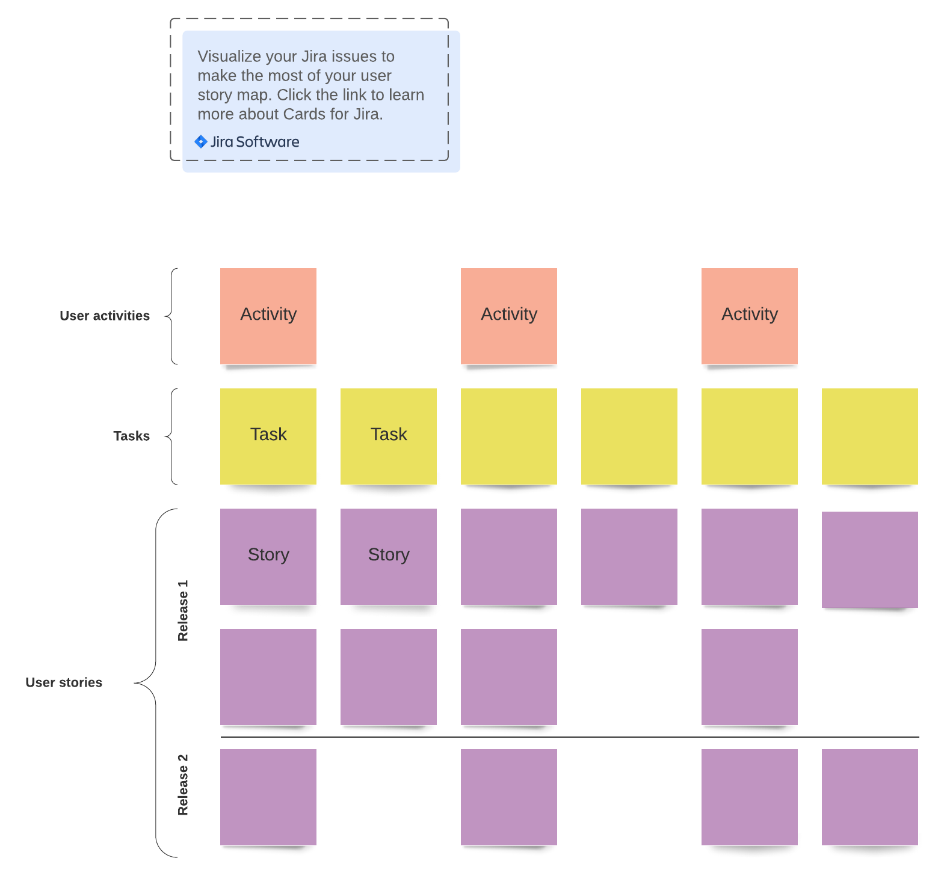](https://lucid.app/lucidspark/editNewOrRegister/885d9c94-7ec7-448e-8541-6937d9f78665?anonId=0.f7da376817f881fa772&sessionDate=2022-03-14T11:10:50.227Z&sessionId=0.08d204b417f881fa773)User story map example (Click on image to modify online)