**OPERATING SYSTEMS**

**COURSE CODE: UCT401**

**SUBMITTED BY: DIVIJA**

**102018056**

**CSBS3**

**INDEX**

|  |  |
| --- | --- |
| SERIAL NUMBER | TITLE |
| 1 | Even odd |
| 2 | Prime number |
| 3 | Factorial |
| 4 | Fibonacci |
| 5 | Sum of series |

**Question 1: EVEN ODD:**

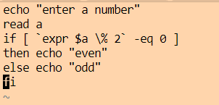

OUTPUT:

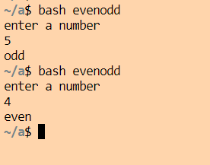

**Question 2: PRIME NUMBER**:

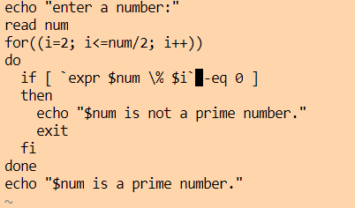

OUTPUT:

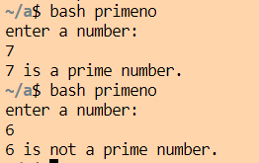

**Question 3: FACTORIAL:**

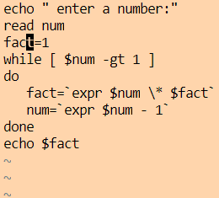

OUTPUT:

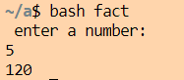

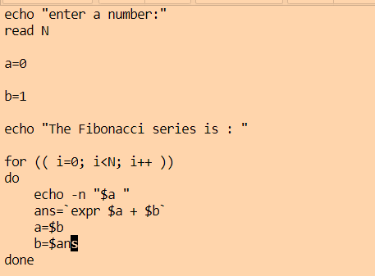**Question 4: FIBONACCI SERIES:**

OUTPUT:

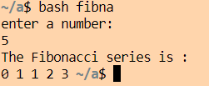

**Question 5 : SUM OF SERIES:**

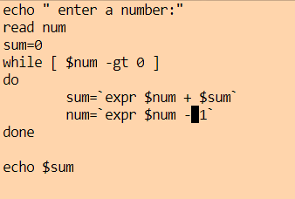

OUTPUT:

