UMA019

OPERATIONS RESEARCH

Submitted To: Dr.Navdeep Kailey



BY: Divija 102018056 CSBS-3

|  |  |  |
| --- | --- | --- |
| Sr no | Topic | Page no |
| 1 | Lab Experiment -1 (Graphical Method) | 3 |
| 2 | Lab Experiment- 2 (Basic feasible solutions) | 9 |
| 3 | Lab Experiment- 3 (The simplex method) | 12 |
| 4 | Lab Experiment- 4 (The Big-M method) | 17 |
| 5 | Lab Experiment- 5 (The Two phase method) | 23 |
| 6 | Lab Experiment- 6 (The dual simplex method) | 26 |
| 7 | Lab Experiment- 7 (Least cost method) | 32 |

INDEX

**ASSIGNMENT 1:**

Question 1:

clc

clear all

format short

%Phase I: To input Parameter

A=[2 4;3 5];

B=[8; 15];

c = [3 2];

%Phage II: To Plot the lines on the graph

x1= 0:max (B)

x21= (B(1)-A(1,1).*x1)./A(1,2)

x22= (B(2)-A(2,1).*x1)./A(2,2)

x21=max(0,x21)

x22=max(0,x22)

plot (x1, x21, 'r' ,x1,x22,'b' )

title('xl vs x2')

xlabel ('value of x11');

ylabel ('value of x21');

legend('2x1+4x2=8', '3x1+5x2=15');

grid on

%Phase 3

cx1 = find(x1==0)

c1 = find(x21==0)

line1 = [x1(:,[c1 cx1]); x21(:,[c1 cx1]);]';

c2 = find(x22==0)

line2 = [x1(:,[c2 cx1]); x22(:,[c2 cx1]);]';

corpt = unique([line1;line2],'rows')

%phase 4

pt = [0;0]

for i=1:size(A,1)

A1 = A(i,:)

B1 = B(i,:)

for j=i+1:size(A,1)

A2 = A(j,:);

B2 = B(j,:);

A4 = [A1;A2];

B4 = [B1;B2];

X = A4\B4;

pt = [pt X]

end

end

ptt = pt'

%phase 5

allpt = [ptt;corpt];

points = unique(allpt,"rows")

%phase 6

%find the feasible region

PT = constraint(points)

P = unique(PT,"rows")

%phase 7 : find value of objective func

%max z = x1+5x2

for i=1:size(P,1)

fn(i,:)= (sum(P(i,:).*c))

end

values = [P fn]

%phase 8 : to find optimal sol

[Optval Optposition] = max(fn)

Optval = values(Optposition,:)

OPTIMAL_BFS = array2table(Optval);

OPTIMAL_BFS.Properties.VariableNames(1:size(Optval,2))={'x1', 'x2', 'z' }

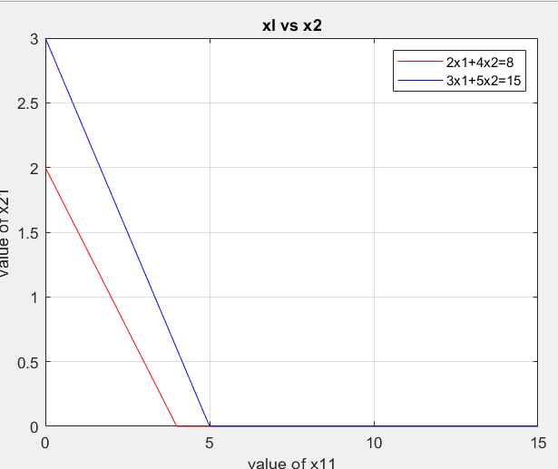

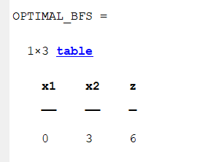

Question 2:

clc

clear all

format short

%Phase I: To input Parameter

A=[2 4;3 5];

B=[8; 15];

c = [3 2];

%Phage II: To Plot the lines on the graph

x1= 0:max (B)

x21= (B(1)-A(1,1).*x1)./A(1,2)

x22= (B(2)-A(2,1).*x1)./A(2,2)

x21=max(0,x21)

x22=max(0,x22)

plot (x1, x21, 'r' ,x1,x22,'b' )

title('xl vs x2')

xlabel ('value of x11');

ylabel ('value of x21');

legend('2x1+4x2=8', '3x1+5x2=15');

grid on

%Phase 3

cx1 = find(x1==0)

c1 = find(x21==0)

line1 = [x1(:,[c1 cx1]); x21(:,[c1 cx1]);]';

c2 = find(x22==0)

line2 = [x1(:,[c2 cx1]); x22(:,[c2 cx1]);]';

corpt = unique([line1;line2],'rows')

%phase 4

pt = [0;0]

for i=1:size(A,1)

A1 = A(i,:)

B1 = B(i,:)

for j=i+1:size(A,1)

A2 = A(j,:);

B2 = B(j,:);

A4 = [A1;A2];

B4 = [B1;B2];

X = A4\B4;

pt = [pt X]

end

end

ptt = pt'

%phase 5

allpt = [ptt;corpt];

points = unique(allpt,"rows")

%phase 6

%find the feasible region

PT = constraint1(points)

P = unique(PT,"rows")

%phase 7 : find value of objective func

%max z = x1+5x2

for i=1:size(P,1)

fn(i,:)= (sum(P(i,:).*c))format rat

c = [3,2];

a = [2 4;3 5];

b = [8; 15];

p=max(b);

x1 = 0:1:max(b)

x12 = (b(1)

-a(1,1).*x1)./a(1,2)

x22 = (b(2)

-a(2,1).*x1)./a(2,2)

x12 = max(0,x12)

x22 = max(0,x22)

%%x32 = max(0,x32)

plot( x1,x12,'r',x1,x22,'b')

cx1=find(x1==0)

c1=find(x12==0)

line1 = [x1(:,[c1 cx1]); x12(:,[c1 cx1])]'

c2=find(x22==0);

line2= [x1(:,[c2 cx1]); x22(:,[c2 cx1])]'

corpt = unique([line1;line2],'rows')

pt =[0;0];

for i=1:size(a,1)

a1 = a(i,:);

b1 = b(i,:);

for j =i+1:size(a,1)

a2 = a(j,:);

b2 = b(j,:);

a4 = [a1;a2];

b4 = [b1;b2];

x = a4

\b4;

pt = [pt x];

end

end

pt = [pt x]

ptt = pt'

allpt=[ptt;corpt]

points=unique(allpt,'rows')

PT = constraint(points)

p=unique(PT,'rows')

for i=1:size(PT,1)

fx(i,:)=sum(PT(i,:).*c)

end

P a g e | 4

vert_fns=[PT fx];

[fxval,indfx] = max(fx)

optval=vert_fns(indfx,:)

optimalbfs=array2table(optval)

optimalbfs.Properties.VariableNames(1:3) = {'x1', 'x2','z'}

end

values = [P fn]

%phase 8 : to find optimal sol

[Optval Optposition] = max(fn)

Optval = values(Optposition,:)

OPTIMAL_BFS = array2table(Optval);

OPTIMAL_BFS.Properties.VariableNames(1:size(Optval,2))={'x1', 'x2', 'z' }

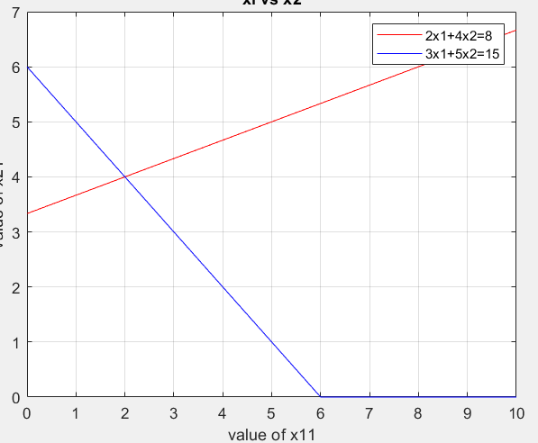

Question 4:

clc

clear all

format short

%Phase I: To input Parameter

A=[2 4;3 5];

B=[8; 15];

c = [3 2];

%Phage II: To Plot the lines on the graph

x1= 0:max (B)

x21= (B(1)-A(1,1).*x1)./A(1,2)

x22= (B(2)-A(2,1).*x1)./A(2,2)

x21=max(0,x21)

x22=max(0,x22)

plot (x1, x21, 'r' ,x1,x22,'b' )

title('xl vs x2')

xlabel ('value of x11');

ylabel ('value of x21');

legend('2x1+4x2=8', '3x1+5x2=15');

grid on

%Phase 3

cx1 = find(x1==0)

c1 = find(x21==0)

line1 = [x1(:,[c1 cx1]); x21(:,[c1 cx1]);]';

c2 = find(x22==0)

line2 = [x1(:,[c2 cx1]); x22(:,[c2 cx1]);]';

corpt = unique([line1;line2],'rows')

%phase 4

pt = [0;0]

for i=1:size(A,1)

A1 = A(i,:)

B1 = B(i,:)

for j=i+1:size(A,1)

A2 = A(j,:);

B2 = B(j,:);

A4 = [A1;A2];

B4 = [B1;B2];

X = A4\B4;

pt = [pt X]

end

end

ptt = pt'

%phase 5

allpt = [ptt;corpt];

points = unique(allpt,"rows")

%phase 6

%find the feasible region

PT = constraint1(points)

P = unique(PT,"rows")

%phase 7 : find value of objective func

%max z = x1+5x2

for i=1:size(P,1)

fn(i,:)= (sum(P(i,:).*c))format rat

c = [3,2];

a = [2 4;3 5];

b = [8; 15];

p=max(b);

x1 = 0:1:max(b)

x12 = (b(1)

-a(1,1).*x1)./a(1,2)

x22 = (b(2)

-a(2,1).*x1)./a(2,2)

x12 = max(0,x12)

x22 = max(0,x22)

%%x32 = max(0,x32)

plot( x1,x12,'r',x1,x22,'b')

cx1=find(x1==0)

c1=find(x12==0)

line1 = [x1(:,[c1 cx1]); x12(:,[c1 cx1])]'

c2=find(x22==0);

line2= [x1(:,[c2 cx1]); x22(:,[c2 cx1])]'

corpt = unique([line1;line2],'rows')

pt =[0;0];

for i=1:size(a,1)

a1 = a(i,:);

b1 = b(i,:);

for j =i+1:size(a,1)

a2 = a(j,:);

b2 = b(j,:);

a4 = [a1;a2];

b4 = [b1;b2];

x = a4

\b4;

pt = [pt x];

end

end

pt = [pt x]

ptt = pt'

allpt=[ptt;corpt]

points=unique(allpt,'rows')

PT = constraint(points)

p=unique(PT,'rows')

for i=1:size(PT,1)

fx(i,:)=sum(PT(i,:).*c)

end

P a g e | 4

vert_fns=[PT fx];

[fxval,indfx] = max(fx)

optval=vert_fns(indfx,:)

optimalbfs=array2table(optval)

optimalbfs.Properties.VariableNames(1:3) = {'x1', 'x2','z'}

end

values = [P fn]

%phase 8 : to find optimal sol

[Optval Optposition] = max(fn)

Optval = values(Optposition,:)

OPTIMAL_BFS = array2table(Optval);

OPTIMAL_BFS.Properties.VariableNames(1:size(Optval,2))={'x1', 'x2', 'z' }



**ASSIGNMENT 2:**

**Question 1:**

clc

clear all

format short

c=[1,2]

a = [-1 1; 1 1]

b = [1; 2]

s = eye (size(a,1))

I = [0,0]

index= find(I==1)

s(index,index)= -s(index,index)

mat=[a s b]

obj=array2table(c);

obj.Properties.VariableNames(1:size(c,2))={'x_1','x_2'}

cons=array2table(mat);

cons.Properties.VariableNames(1:size(mat,2))={'x_1','x_2','s1','s2','b'}

n=size(a,2)

m=size(a,1)

if(n<m)

disp("invalid")

else

ans = nchoosek(n,m)

pairs= nchoosek(1:n,m)

sol = []

for i = 1:ans

y = zeros(n,1)

X = a(:,pairs(i,:))\b

if all(X>=0 & X ~= inf)

Y(pairs(i,:))= X

sol = [sol, y]

end

end

end

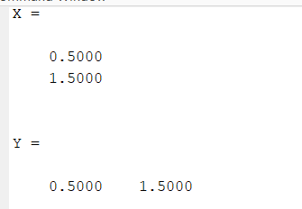

**Question 2:**

clc

clear all

format short

c = [1,3,7]

a = [1 1 0; 0 -1 1]

b = [1;0]

n=size(a,2)

m=size(a,1)

if(n<m)

disp("invalid")

else

ans = nchoosek(n,m)

pairs= nchoosek(1:n,m)

sol = []

for i = 1:ans

y = zeros(n,1)

X = a(:,pairs(i,:))\b

if all(X>=0 & X ~= inf)

Y(pairs(i,:))= X

sol = [sol, y]

end

end

end

**Question 3:**

clc

clear all

format short

% phase1: Input Parameter

A=[1 0 0 1 0 0 0; 0 1 0 0 1 0 0; -1 1 0 0 0 1 0; -1 0 2 0 0 0 1];

B=[4;4;6;4];

C=[-1 2 -1 0 0 0 0];

% phase2: Set of all Basic solutions

m=size(A,1);

n=size(A,2);

if (n>m)

nCm=nchoosek(n,m);

pair=nchoosek(1:n,m);

sol=[];

for i=1:nCm

y=zeros(n,1);

temp=pair(i,:);

P=A(:,temp);

x=inv(P)*B;

if (x>=0 & x~=inf & x~=-inf)

y(temp)=x;

sol=[sol, y]

end

end

else

error('nCm does not exist')

end

% phase3: Basic feasible solution

Z=C*sol

[Zmax , Zindex]=max(Z);

bfs1=sol(:,Zindex);

optimal_value=[bfs1' Zmax]

optimal_bfs=array2table(optimal_value);

optimal_bfs.Properties.VariableNames(1:size(optimal_bfs,2))={'x1', 'x_2' , 'x_3','s_1' , 's_2', 's_3', 's_4', 'Z' }

fprintf('Optimal solution:');

disp(Zmax);

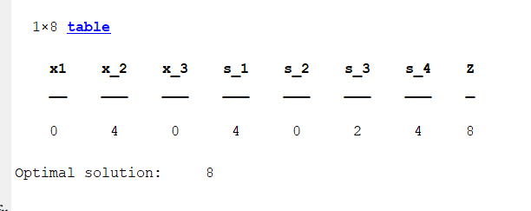

**Question 4:**

clc

clear all

format short

c = [1,3,7]

a = [1 1 0; 0 -1 1]

b = [1;0]

n=size(a,2)

m=size(a,1)

if(n<m)

disp("invalid")

else

ans = nchoosek(n,m)

pairs= nchoosek(1:n,m)

sol = []

for i = 1:ans

y = zeros(n,1)

X = a(:,pairs(i,:))\b

if all(X>=0 & X ~= inf)

Y(pairs(i,:))= X

sol = [sol, y]

end

end

end

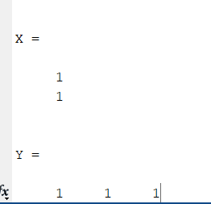

**ASSIGNMENT 3:**

**Question 1:**

%% Max. z = x1 + 2x2,

%%subject to ? x1 + x2 ? 1, x1 + x2 ? 2,

%%x1, x2 ? 0.

clc

clear all

format short

noofvariables=2;

c = [1 2]

a = [-1 1; 1 1]

b = [1;2]

s= eye(size(a,1));

A = [a s b]

cost = zeros(1,size(A,2));

cost(1:noofvariables)=c;

bv = noofvariables+1:size(A,2)-1;

zjcj = cost(bv)*A -cost;

zcj = [zjcj; A];

simptable = array2table(zcj)

simptable.Properties.VariableNames(1:size(zcj,2))= {'x_1','x_2','s1','s2','b'}

run = true;

while(run)

zc=zjcj(1:end-1);

if any(zc<0);

fprintf('bfs is not optimal')

[Enter_val,pvt_col]=min(zc)

if all(A(:,pvt_col)<=0)

error('lpp is unbounded')

else

sol = A(:,end)

col= A(:,pvt_col)

for i=1:size(A,1)

if(col(i)>0)

ratio(i)=sol(i)/col(i)

else

ratio(i) = inf

end

end

[leaving_variable,pvt_row]=min(ratio)

end

pvt_key = A(pvt_row, pvt_col)

bv(pvt_row) = pvt_col

A(pvt_row,:)=A(pvt_row,:)/pvt_key

for i=1:size(A,1)

if i~= pvt_row

A(i,:)= A(i,:)- A(i,pvt_col).*A(pvt_row,:)

end

end

zjcj = zjcj - zjcj(pvt_col).* A(pvt_row,:)

zcj1=[zjcj;A]

table = array2table(zcj1)

table.Properties.VariableNames(1:size(zcj1,2))= {'x_1','x_2','s1','s2','b'}

BFS=zeros(1,size(A,2));

BFS(bv)=A(:,end);

BFS(end)=sum(BFS.*cost);

CurrentBFS=array2table(BFS);

CurrentBFS.Properties.VariableNames(1:size(CurrentBFS,2))={'x1','x2','s1','s2','Sol'}

else

run = false;

fprintf("the current bfs is optimal")

end

end

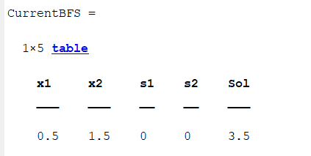

**Question 2:**

%%M ax. z = 4x1 + 6x2 + 3x3 + x4,

%%subject to

%%x1 + 4x2 + 8x3 + 6x4 ? 11, 4x1 + x2 + 2x3 + x4 ? 7,

%%2x1 + 3x2 + x3 + 2x4 ? 2, x1, x2, x3 ? 0.

clc

clear all

format short

noofvariables=4;

c = [4 6 3 1]

a = [1 4 8 6; 4 1 2 1; 2 3 1 2]

b = [11; 7; 2]

s= eye(size(a,1));

A = [a s b]

cost = zeros(1,size(A,2));

cost(1:noofvariables)=c;

bv = noofvariables+1:size(A,2)-1;

zjcj = cost(bv)*A -cost;

zcj = [zjcj; A];

simptable = array2table(zcj)

simptable.Properties.VariableNames(1:size(zcj,2))= {'x_1','x_2','x_3','x_4','s1','s2','s3','b'}

run = true;

while(run)

zc=zjcj(1:end-1);

if any(zc<0);

fprintf('bfs is not optimal')

[Enter_val,pvt_col]=min(zc)

if all(A(:,pvt_col)<=0)

error('lpp is unbounded')

else

sol = A(:,end)

col= A(:,pvt_col)

for i=1:size(A,1)

if(col(i)>0)

ratio(i)=sol(i)/col(i)

else

ratio(i) = inf

end

end

[leaving_variable,pvt_row]=min(ratio)

end

pvt_key = A(pvt_row, pvt_col)

bv(pvt_row) = pvt_col

A(pvt_row,:)=A(pvt_row,:)/pvt_key

for i=1:size(A,1)

if i~= pvt_row

A(i,:)= A(i,:)- A(i,pvt_col).*A(pvt_row,:)

end

end

zjcj = zjcj - zjcj(pvt_col).* A(pvt_row,:)

zcj1=[zjcj;A]

table = array2table(zcj1)

table.Properties.VariableNames(1:size(zcj1,2))= {'x_1','x_2','x_3','x_4','s1','s2','s3','b'}

BFS=zeros(1,size(A,2));

BFS(bv)=A(:,end);

BFS(end)=sum(BFS.*cost);

CurrentBFS=array2table(BFS);

CurrentBFS.Properties.VariableNames(1:size(CurrentBFS,2))={'x_1','x_2','x_3','x_4','s1','s2','s3','b'}

else

run = false;

fprintf("the current bfs is optimal")

end

end

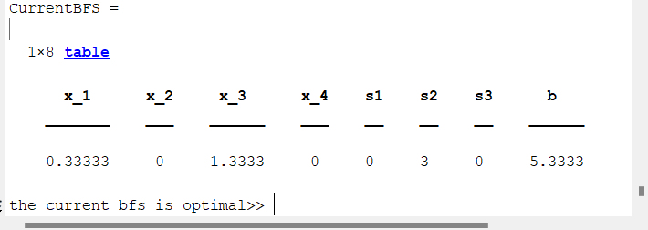

**Question 3:**

clc

clear all

format short

noofvariables=7;

c = [0 0 0 3/4 -20 1/2 -6]

a = [1 0 0 1/4 -8 -1 9; 0 1 0 1/2 -12 -1/6 3; 0 0 1 0 0 1 0]

b = [0; 0; 1]

%%s= eye(size(a,1));

A = [a b]

cost = zeros(1,size(A,2));

cost(1:noofvariables)=c;

%%bv = noofvariables+1:size(A,2)-1;

bv = 1:3

zjcj = cost(bv)*A -cost;

zcj = [zjcj; A];

simptable = array2table(zcj)

simptable.Properties.VariableNames(1:size(zcj,2))= {'x_1','x_2','x_3','x_4','x_5','x_6','x_7','b'}

run = true;

while(run)

zc=zjcj(1:end-1);

if any(zc<0);

fprintf('bfs is not optimal')

[Enter_val,pvt_col]=min(zc)

if all(A(:,pvt_col)<=0)

error('lpp is unbounded')

else

sol = A(:,end)

col= A(:,pvt_col)

for i=1:size(A,1)

if(col(i)>0)

ratio(i)=sol(i)/col(i)

else

ratio(i) = inf

end

end

[leaving_variable,pvt_row]=min(ratio)

end

pvt_key = A(pvt_row, pvt_col)

bv(pvt_row) = pvt_col

A(pvt_row,:)=A(pvt_row,:)/pvt_key

for i=1:size(A,1)

if i~= pvt_row

A(i,:)= A(i,:)- A(i,pvt_col).*A(pvt_row,:)

end

end

zjcj = zjcj - zjcj(pvt_col).* A(pvt_row,:)

zcj1=[zjcj;A]

table = array2table(zcj1)

table.Properties.VariableNames(1:size(zcj1,2))= {'x_1','x_2','x_3','x_4','x_5','x_6','x_7','b'}

BFS=zeros(1,size(A,2));

BFS(bv)=A(:,end);

BFS(end)=sum(BFS.*cost);

CurrentBFS=array2table(BFS);

CurrentBFS.Properties.VariableNames(1:size(CurrentBFS,2))={'x_1','x_2','x_3','x_4','x_5','x_6','x_7','Sol'}

else

run = false;

fprintf("the current bfs is optimal")

end

end

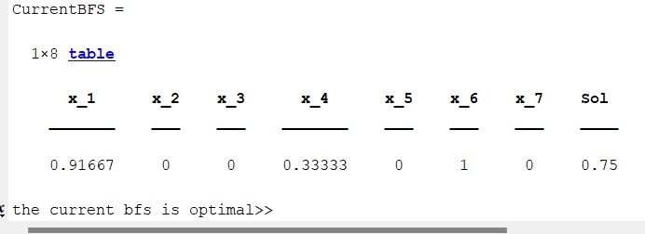

**ASSIGNMENT 4:**

**QUESTION 1:**

%code for big M

clc

clear

format short

x_1 = 10000

cost=[-3 -5 0 0 -x_1 -x_1 0]

b=[3;

2]

a= [1 3 -1 0 1 0 ;

1 1 0 -1 0 1 ]

A=[a b]

noofvar=2;

%bv are index of starting basic variables

%starting basic variable n + 1 se start hokr size -1 wale honge

bv=noofvar+3:1:size(A,2)-1

%cost(bv) gives cost of basic variables

zjcj=cost(bv)*A-cost;

zcj = [zjcj; A]

simptable = array2table(zcj)

simptable.Properties.VariableNames(1:size(zcj,2))= {'x_1','x_2','s1','s2','A1','A2','b'}

run= true

while run

zc=zjcj(1:end-1)

if any(zc<0);

fprintf('bfs is not optimal')

%to find minimum with its position(most negative entering variable)

[Enter_val,pvt_col]=min(zc)

fprintf('the most neagtive element in Zrow is %d corresponding to column %d',Enter_val,pvt_col)

if all(A(:,pvt_col)<=0)

error('lpp is unbounded')

else

%to find leaving variable

sol = A(:,end)

col= A(:,pvt_col)

%now we will find the minimum ratio between pivot col and sol col

for i=1:size(A,1)

if(col(i)>0)

ratio(i)=sol(i)/col(i)

else

%inf stands for infinity (MAX)

ratio(i) = inf

end

end

[leaving_variable,pvt_row]=min(ratio)

end

%to display new basic variables in next iteration

bv(pvt_row) = pvt_col;

disp(bv)

% to indentify pivot element

pvt_key = A(pvt_row, pvt_col)

%updating table for next iteration

%updating pivot row first

A(pvt_row,:)=A(pvt_row,:)./pvt_key

% for updation of other rows

for i=1:size(A,1)

% ab isme pivot row nhi leni

if i~= pvt_row

A(i,:)= A(i,:)- A(i,pvt_col).*A(pvt_row,:)

end

end

%now updating the z row

zjcj = zjcj - zjcj(pvt_col).* A(pvt_row,:)

zcj1=[zjcj;A]

% to print the table

table = array2table(zcj1)

table.Properties.VariableNames(1:size(zcj1,2))= {'x_1','x_2','s1','s2','A1','A2','b'}

BFS = zeros(1,size(A,2));

BFS(bv) = A(:,end)

% to find objective func wala sol

BFS(end) = sum(BFS.*cost)

curr_Bfs = array2table(BFS);

curr_Bfs.Properties.VariableNames(1:size(curr_Bfs,2)) = {'x_1','x_2','s1','s2','A1','A2','b'}

else

run = false;

end

end

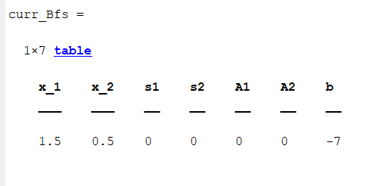

**QUESTION 2:**

%code for big M

clc

clear

format short

x_1 = 10000

cost=[-12 -10 0 0 0 -x_1 -x_1 -x_1 0]

b=[10;

30;

8]

a= [5 1 -1 0 0 1 0 0;

6 5 0 -1 0 0 1 0;

1 4 0 0 -1 0 0 1 ]

A=[a b]

noofvar=5;

%bv are index of starting basic variables

%starting basic variable n + 1 se start hokr size -1 wale honge

bv=noofvar+1:1:size(A,2)-1

%cost(bv) gives cost of basic variables

zjcj=cost(bv)*A-cost;

zcj = [zjcj; A]

simptable = array2table(zcj)

simptable.Properties.VariableNames(1:size(zcj,2))= {'x_1','x_2','s1','s2','s3','A1','A2','A3','b'}

run= true

while run

zc=zjcj(1:end-1)

if any(zc<0);

fprintf('bfs is not optimal')

%to find minimum with its position(most negative entering variable)

[Enter_val,pvt_col]=min(zc)

fprintf('the most neagtive element in Zrow is %d corresponding to column %d',Enter_val,pvt_col)

if all(A(:,pvt_col)<=0)

error('lpp is unbounded')

else

%to find leaving variable

sol = A(:,end)

col= A(:,pvt_col)

%now we will find the minimum ratio between pivot col and sol col

for i=1:size(A,1)

if(col(i)>0)

ratio(i)=sol(i)/col(i)

else

%inf stands for infinity (MAX)

ratio(i) = inf

end

end

[leaving_variable,pvt_row]=min(ratio)

end

%to display new basic variables in next iteration

bv(pvt_row) = pvt_col;

disp(bv)

% to indentify pivot element

pvt_key = A(pvt_row, pvt_col)

%updating table for next iteration

%updating pivot row first

A(pvt_row,:)=A(pvt_row,:)./pvt_key

% for updation of other rows

for i=1:size(A,1)

% ab isme pivot row nhi leni

if i~= pvt_row

A(i,:)= A(i,:)- A(i,pvt_col).*A(pvt_row,:)

end

end

%now updating the z row

zjcj = zjcj - zjcj(pvt_col).* A(pvt_row,:)

zcj1=[zjcj;A]

% to print the table

table = array2table(zcj1)

table.Properties.VariableNames(1:size(zcj1,2))={'x_1','x_2','s1','s2','s3','A1','A2','A3','b'}

BFS = zeros(1,size(A,2));

BFS(bv) = A(:,end)

% to find objective func wala sol

BFS(end) = sum(BFS.*cost)

curr_Bfs = array2table(BFS);

curr_Bfs.Properties.VariableNames(1:size(curr_Bfs,2)) = {'x_1','x_2','s1','s2','s3','A1','A2','A3','b'}

else

run = false;

end

end

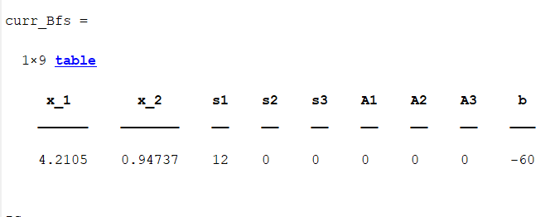

**Question 3:**

%code for big M

clc

clear

format short

x_1 = 10000

cost=[3 2 0 0 -x_1 0]

b=[2;

3;

1]

a= [1 1 1 0 0;

1 3 0 1 0;

1 -1 0 0 1]

A=[a b]

noofvar=2;

%bv are index of starting basic variables

%starting basic variable n + 1 se start hokr size -1 wale honge

bv=noofvar+1:1:size(A,2)-1

%cost(bv) gives cost of basic variables

zjcj=cost(bv)*A-cost;

zcj = [zjcj; A]

simptable = array2table(zcj)

simptable.Properties.VariableNames(1:size(zcj,2))= {'x_1','x_2','s1','s2','A3','b'}

run= true

while run

zc=zjcj(1:end-1)

if any(zc<0);

fprintf('bfs is not optimal')

%to find minimum with its position(most negative entering variable)

[Enter_val,pvt_col]=min(zc)

fprintf('the most neagtive element in Zrow is %d corresponding to column %d',Enter_val,pvt_col)

if all(A(:,pvt_col)<=0)

error('lpp is unbounded')

else

%to find leaving variable

sol = A(:,end)

col= A(:,pvt_col)

%now we will find the minimum ratio between pivot col and sol col

for i=1:size(A,1)

if(col(i)>0)

ratio(i)=sol(i)/col(i)

else

%inf stands for infinity (MAX)

ratio(i) = inf

end

end

[leaving_variable,pvt_row]=min(ratio)

end

%to display new basic variables in next iteration

bv(pvt_row) = pvt_col;

disp(bv)

% to indentify pivot element

pvt_key = A(pvt_row, pvt_col)

%updating table for next iteration

%updating pivot row first

A(pvt_row,:)=A(pvt_row,:)./pvt_key

% for updation of other rows

for i=1:size(A,1)

% ab isme pivot row nhi leni

if i~= pvt_row

A(i,:)= A(i,:)- A(i,pvt_col).*A(pvt_row,:)

end

end

%now updating the z row

zjcj = zjcj - zjcj(pvt_col).* A(pvt_row,:)

zcj1=[zjcj;A]

% to print the table

table = array2table(zcj1)

table.Properties.VariableNames(1:size(zcj1,2))= {'x_1','x_2','s1','s2','A3','b'}

BFS = zeros(1,size(A,2));

BFS(bv) = A(:,end)

% to find objective func wala sol

BFS(end) = sum(BFS.*cost)

curr_Bfs = array2table(BFS);

curr_Bfs.Properties.VariableNames(1:size(curr_Bfs,2)) = {'x_1','x_2','s1','s2','A3','b'}

else

run = false;

end

end

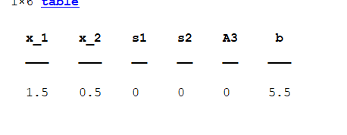

**ASSIGNMENT 5:**

QUESTION 1:

clc

clear all

format short

Variables= {'x1','x2','s1','s2','a1','a2','sol'};

OVariables={'x1','x2','s1','s2','sol'};

Origc=[-3 -5 0 0 -1 -1 0]

A=[1 3 -1 0 1 0 3;

1 1 0 -1 0 1 2]

bv=[5 6]

%%phase-1

Cost= [0 0 0 0 -1 -1 0]

startbv=find(Cost<0);

%calling of function to find optimal table for arbitary z function

[BFS,A]=simp(A,bv,Cost,Variables);

%%phase-2

%dropping the artifical variable in phase 2

A(:,startbv)=[];

Origc(startbv)=[];

%calling of function for optimal sol for original functiom

[optbfs,optA]=simp(A,BFS,Origc,OVariables);

final_bfs=zeros(1,size(A,2));

final_bfs(optbfs)=optA(:,end)

final_bfs(end)=sum(final_bfs.*Origc)

optimalbfs=array2table(final_bfs)

optimalbfs.Properties.VariableNames(1:size(optimalbfs,2))=OVariables

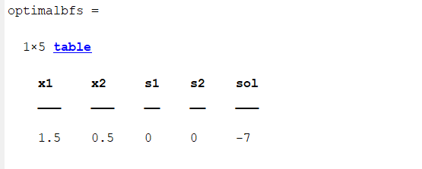

QUESTION 2:

clc

clear all

max = 0;

Variables = {'x1', 'x2', 's1', 's2', 's3', 'A1', 'A2', 'A3', 'sol'}

OVariables = {'x1', 'x2', 's1', 's2', 's3', 'sol'}

info = [5 1 -1 0 0 1 0 0 10;

6 5 0 -1 0 0 1 0 30;

1 4 0 0 -1 0 0 1 8]

origC = [-12 -10 0 0 0 -1 -1 -1 0]

bv4 = [6 7 8]

A = info

cost = [0 0 0 0 0 -1 -1 -1 0]

zjcj = (cost(bv4)*A) - cost

[bv2,A] = simp(A,bv4,cost,Variables)

if bv2==0

fprintf('\n UNBOUNDED SOLUTION ')

else

%PHASE2

A(:,bv4) = []

origC(:,bv4)=[]

[ opt_bfs,optA] = simp(A,bv2,origC,OVariables)

if (opt_bfs == 0)

fprintf('\n UNBOUNDED SOLUTION ')

else

bfss = zeros(1,size(A,2))

bfss(opt_bfs) = A(:,end)

%bfss(end) = sum(bfss.*origC)

if max==1

bfss(end) = sum(bfss.*origC)

else

bfss(end) = -sum(bfss.*origC)

end

currentbfs = array2table(bfss)

currentbfs.Properties.VariableNames(1:size(currentbfs,2)) = OVariables

end

end

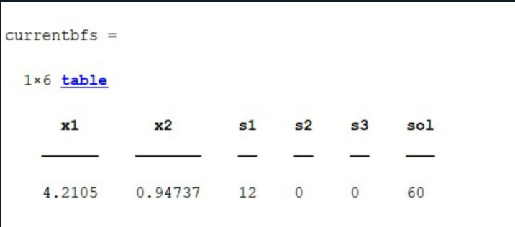

QUESTION :3

clc

clear all

format short

Variables= {'x1','x2','s1','s2','a1','sol'};

OVariables={'x1','x2','s1','s2','sol'};

Origc=[3 2 0 0 -1 0]

A=[1 1 1 0 0 2;1 3 0 1 0 3; 1 -1 0 0 1 1]

bv=[3 4 5]

%%phase-1

Cost= [0 0 0 0 -1 0]

startbv=find(Cost<0);

%calling of function to find optimal table for arbitary z function

[BFS,A]=simp(A,bv,Cost,Variables);

%%phase-2

%dropping the artifical variable in phase 2

A(:,startbv)=[];

Origc(startbv)=[];

%calling of function for optimal sol for original functiom

[optbfs,optA]=simp(A,BFS,Origc,OVariables);

final_bfs=zeros(1,size(A,2));

final_bfs(optbfs)=optA(:,end)

final_bfs(end)=sum(final_bfs.*Origc)

optimalbfs=array2table(final_bfs)

optimalbfs.Properties.VariableNames(1:size(optimalbfs,2))=OVariables

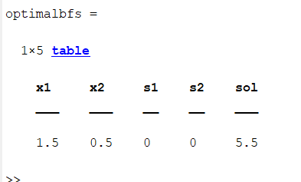

**ASSIGNMENT 6:**

QUESTION 1:

clc

clear all

format short

%Phase I: To input Parameter

A=[2 4;3 5];

B=[8; 15];

c = [3 2];

%Phage II: To Plot the lines on the graph

x1= 0:max (B)

x21= (B(1)-A(1,1).*x1)./A(1,2)

x22= (B(2)-A(2,1).*x1)./A(2,2)

x21=max(0,x21)

x22=max(0,x22)

plot (x1, x21, 'r' ,x1,x22,'b' )

title('xl vs x2')

xlabel ('value of x11');

ylabel ('value of x21');

legend('2x1+4x2=8', '3x1+5x2=15');

grid on

%Phase 3

cx1 = find(x1==0)

c1 = find(x21==0)

line1 = [x1(:,[c1 cx1]); x21(:,[c1 cx1]);]';

c2 = find(x22==0)

line2 = [x1(:,[c2 cx1]); x22(:,[c2 cx1]);]';

corpt = unique([line1;line2],'rows')

%phase 4

pt = [0;0]

for i=1:size(A,1)

A1 = A(i,:)

B1 = B(i,:)

for j=i+1:size(A,1)

A2 = A(j,:);

B2 = B(j,:);

A4 = [A1;A2];

B4 = [B1;B2];

X = A4\B4;

pt = [pt X]

end

end

ptt = pt'

%phase 5

allpt = [ptt;corpt];

points = unique(allpt,"rows")

%phase 6

%find the feasible region

PT = constraint1(points)

P = unique(PT,"rows")

%phase 7 : find value of objective func

%max z = x1+5x2

for i=1:size(P,1)

fn(i,:)= (sum(P(i,:).*c))format rat

c = [3,2];

a = [2 4;3 5];

b = [8; 15];

p=max(b);

x1 = 0:1:max(b)

x12 = (b(1)

-a(1,1).*x1)./a(1,2)

x22 = (b(2)

-a(2,1).*x1)./a(2,2)

x12 = max(0,x12)

x22 = max(0,x22)

%%x32 = max(0,x32)

plot( x1,x12,'r',x1,x22,'b')

cx1=find(x1==0)

c1=find(x12==0)

line1 = [x1(:,[c1 cx1]); x12(:,[c1 cx1])]'

c2=find(x22==0);

line2= [x1(:,[c2 cx1]); x22(:,[c2 cx1])]'

corpt = unique([line1;line2],'rows')

pt =[0;0];

for i=1:size(a,1)

a1 = a(i,:);

b1 = b(i,:);

for j =i+1:size(a,1)

a2 = a(j,:);

b2 = b(j,:);

a4 = [a1;a2];

b4 = [b1;b2];

x = a4

\b4;

pt = [pt x];

end

end

pt = [pt x]

ptt = pt'

allpt=[ptt;corpt]

points=unique(allpt,'rows')clear all

clc

format short

c = [3 5 0 0 0]

A = [-1 -3 1 0 -3;

-1 -1 0 1 -2;]

bv = [3,4]

cost = zeros(1, size(A,2))

cost(1:5) = c

zjcj = cost(bv)*A - cost

zcj = [zjcj;A]

soln = A(:,end)

run = true

while(run == true)

if(any(soln<0))

negIND = find(soln<0)

[leaving_var, pivot_row] = min(soln(negIND))

ratio = []

for i = 1:size(A,2)-1

if A(pivot_row,i) <0

ratio(i) = abs(zjcj(i)/A(pivot_row,i))

else

ratio(i) = inf;

end

end

[entering_var, pivot_col] = min(ratio)

pvt_key = A(pivot_row, pivot_col)

bv(pivot_row) = pivot_col;

A(pivot_row,:) = A(pivot_row,:)/pvt_key;

for i = 1 : size(A,1)

if i ~= pivot_row

A(i,:) = A(i,:) - (A(i,pivot_col).*A(pivot_row,:));

end

end

zjcj = zjcj - (zjcj(pivot_col).*A(pivot_row,:))

zc = zjcj(1:end-1)

soln = A(:,end)

else

run = false

fprintf("Current BFS is Optimal")

zcj = [zjcj;A]

optimum_simplex_table = array2table(zcj)

P a g e | 27

optimum_simplex_table.Properties.VariableNames(1:size(zcj,2)) = {'x1', 'x2', 's1', 's2', 'soln'}

optimal_solution = zjcj(end)

solns = [bv' A(:,end)]

end

end

PT = constraint(points)

p=unique(PT,'rows')

for i=1:size(PT,1)

fx(i,:)=sum(PT(i,:).*c)

end

P a g e | 4

vert_fns=[PT fx];

[fxval,indfx] = max(fx)

optval=vert_fns(indfx,:)

optimalbfs=array2table(optval)

optimalbfs.Properties.VariableNames(1:3) = {'x1', 'x2','z'}

end

values = [P fn]

%phase 8 : to find optimal sol

[Optval Optposition] = max(fn)

Optval = values(Optposition,:)

OPTIMAL_BFS = array2table(Optval);

OPTIMAL_BFS.Properties.VariableNames(1:size(Optval,2))={'x1', 'x2', 'z' }

Question 2:

clear all

clc

format short

%taking input

%the z function sholud be max always

c = [12 10 0 0 0 0]

%the info matrix with identity matrix and sol col included

A = [-5 -1 1 0 0 -10;

-6 -5 0 1 0 -30;

-1 -4 0 0 1 -8]

%index of starting basic variables

noofvar = 2

%bv = [3,4,5]

bv = noofvar+1:1:size(A,2)-1

cost = zeros(1, size(A,2));

cost(1:6) = c

zjcj = cost(bv)*A - cost

zcj = [zjcj;A]

%taking end wala col of A matrix

soln = A(:,end)

run = true

while(run == true)

%because feasibilty disturb hoti toh sol col dekhenge

%most negative choose krna

if(any(soln<0))

%finding the index of all the negative values in sol col

negIND = find(soln<0)

%finding leaving variable

[leaving_var, pivot_row] = min(soln(negIND))

ratio = []

for i = 1:size(A,2)-1

%z row mei se negative enteries ki ratio leni hai

if A(pivot_row,i) <0

ratio(i) = abs(zjcj(i)/A(pivot_row,i))

else

ratio(i) = inf;

end

end

%row ki jgha col lena yaha

[entering_var, pivot_col] = min(ratio)

%updation of pivot key

pvt_key = A(pivot_row, pivot_col)

%updating basic variable

bv(pivot_row) = pivot_col;

%updation of pivot row

A(pivot_row,:) = A(pivot_row,:)/pvt_key;

%updation of other rows

for i = 1 : size(A,1)

% ab isme pivot row nhi leni

if i ~= pivot_row

A(i,:) = A(i,:) - (A(i,pivot_col).*A(pivot_row,:));

end

end

%updation of z row

zjcj = zjcj - (zjcj(pivot_col).*A(pivot_row,:))

zc = zjcj(1:end-1)

soln = A(:,end)

else

run = false

fprintf("Current BFS is Optimal")

zcj = [zjcj;A]

dual_simpl_table = array2table(zcj);

dual_simpl_table.Properties.VariableNames(1:size(zcj,2)) = {'x1', 'x2', 's1', 's2', 's3', 'soln'}

optimal_solution = zjcj(end)

end

end

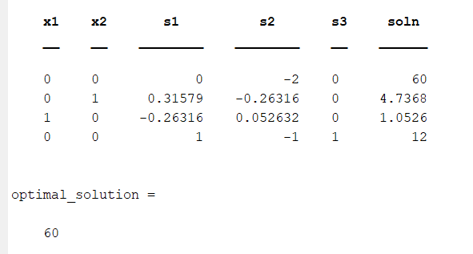

QUESTION 3:

clc

clear all

format short

Variables={'x1','x2','s1','s2','sol'};

Cost=[-3 2 0 0 0];

info=[-1 -1 ;-1 -2 ];

s = eye(size(info,1))

b=[-1; -3];

A = [info s b]

BV = [];

for j=1:size(s,2)

for i=1:size(A,2)

if A(:,i)==s(:,j)

BV = [BV i];

end

end

end

fprintf('Basic Variables (BV)=')

disp(Variables(BV));

ZjCj = Cost(BV)*A-Cost;

ZCj = [ZjCj;A];

Simptable = array2table(ZCj);

Simptable.Properties.VariableNames(1:size(ZCj,2))=Variables

RUN = true;

while RUN

sol = A(:,end);

if any(sol<0)

fprintf("Current BFS is not feasible \n");

%Finding the leaving variable

[LV, pivot_row] = min(sol);

fprintf("Leaving row =%d\n",pivot_row);

%finding entering variable

Row = A(pivot_row,1:end-1);

ZJ = ZjCj(:,1:end-1);

for i=1:size(Row,2)

if Row(i)<0

ratio(i)= abs(ZJ(i)./Row(i));

else

ratio(i)=inf;

end

end

[minVal, pvt_col]=min(ratio);

fprintf("Entering Variable = %d\n",pvt_col);

%Updation

BV(pivot_row)=pvt_col;

fprintf('Basic Variables (BV) =')

disp(Variables(BV));

pvt_key = A(pivot_row,pvt_col);

A(pivot_row,:)=A(pivot_row,:)./pvt_key;

for i=1:size(A,1)

if i~=pivot_row

A(i,:)=A(i,:)-A(i,pvt_col).*A(pivot_row,:);

end

end

ZjCj = Cost(BV)*A-Cost

else

RUN = false

fprintf("Current BFS is feasible");

ZCj = [ZjCj;A];

SimpTable= array2table(ZCj);

SimpTable.Properties.VariableNames(1:size(ZCj,2)) =Variables

end

end

solution=ZCj(1,end);

fprintf('\noptimal solution reached');

fprintf('\n\n optimal solution is %d',-1*solution)

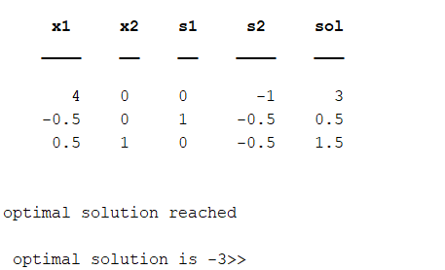

**ASSIGNMENT 7**

QUESTION 1:

%every balanced problem has feasible sol

%basic m+n-1

format short

clear all

clc

%obtain the intital bfs

cost = [2 10 4 5 ;

6 12 8 11 ;

3 9 5 7];

%supply

A = [ 12 25 20];

%demad

B = [ 25 10 15 5];

%check if balanced or not

if sum(A) == sum(B)

fprintf('given transportation problem is balanced\n');

else

fprintf('given transportation problem is not balanced\n');

if sum(A) < sum(B)

%ek row add krenge

cost(end + 1,:) = zeros(1,size(cost,2));

A(end+1) = sum(B) - sum(A);

elseif sum (B) < sum(A)

%column add krenge

cost(:,end + 1) = zeros(size(cost,1),1);

B(end+1) = sum(A) - sum(B);

end

end

Icost = cost;

%initial allocation

X = zeros(size(cost));

%finding no of rows and cols

[m , n] = size(cost);

Bfs = m+n-1;

%finding the cell with min cost

for i = 1: size(cost , 1)

for j = 1:size(cost,2)

hh = min(cost(:));

[rowind , colind] = find(hh==cost);

%to give allocations

x11 = min(A(rowind) , B(colind));

%find max allocation

[val , ind] = max(x11);

%identify the row and col position

ii = rowind(ind);

jj = colind(ind);

y11 = min(A(ii) , B(jj));

%assign allocation

X(ii , jj) = y11;

%reducing the values

A(ii) = A(ii) - y11;

B(jj) = B(jj) -y11;

cost(ii, jj) = Inf;

end

end

%print inital bfs

fprintf('Intial bfs = \n')

ib = array2table(X);

disp(ib);

%check for degenerate

totalbfs = length(nonzeros(X));

if totalbfs == Bfs

fprintf('intial bfs is non degenerate\n');

else

fprintf('degenerate');

end

%computing the cost

initialcost = sum(sum(Icost.*X));

fprintf('intial bfs cost %d\n' , initialcost);

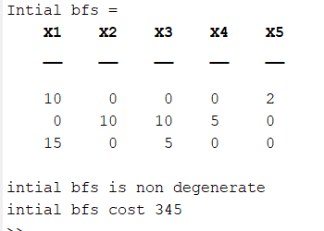

QUESTION 2:

%every balanced problem has feasible sol

%basic m+n-1

format short

clear all

clc

%obtain the intital bfs

cost = [3 11 4 14 15;

6 16 18 2 28 ;

10 13 15 19 17;

7 12 5 8 9];

%supply

A = [ 15 25 10 15];

%demad

B = [20 10 15 15 5];

%check if balanced or not

if sum(A) == sum(B)

fprintf('given transportation problem is balanced\n');

else

fprintf('given transportation problem is not balanced\n');

if sum(A) < sum(B)

%ek row add krenge

cost(end + 1,:) = zeros(1,size(cost,2));

A(end+1) = sum(B) - sum(A);

elseif sum (B) < sum(A)

%column add krenge

cost(:,end + 1) = zeros(size(cost,1),1);

B(end+1) = sum(A) - sum(B);

end

end

Icost = cost;

%initial allocation

X = zeros(size(cost));

%finding no of rows and cols

[m , n] = size(cost);

Bfs = m+n-1;

%finding the cell with min cost

for i = 1: size(cost , 1)

for j = 1:size(cost,2)

hh = min(cost(:));

[rowind , colind] = find(hh==cost);

%to give allocations

x11 = min(A(rowind) , B(colind));

%find max allocation

[val , ind] = max(x11);

%identify the row and col position

ii = rowind(ind);

jj = colind(ind);

y11 = min(A(ii) , B(jj));

%assign allocation

X(ii , jj) = y11;

%reducing the values

A(ii) = A(ii) - y11;

B(jj) = B(jj) -y11;

cost(ii, jj) = Inf;

end

end

%print inital bfs

fprintf('Intial bfs = \n')

ib = array2table(X);

disp(ib);

%check for degenerate

totalbfs = length(nonzeros(X));

if totalbfs == Bfs

fprintf('intial bfs is non degenerate\n');

else

fprintf('degenerate');

end

%computing the cost

initialcost = sum(sum(Icost.*X));

fprintf('intial bfs cost %d\n' , initialcost);

