Business Intelligence (Tableau)

ENTERPRISE SYSTEMS

UCT642

Submitted to: Submitted by:

Dr. Tanya Garg Himanshi (102018009)

Divija (102018056)

**Data Source**

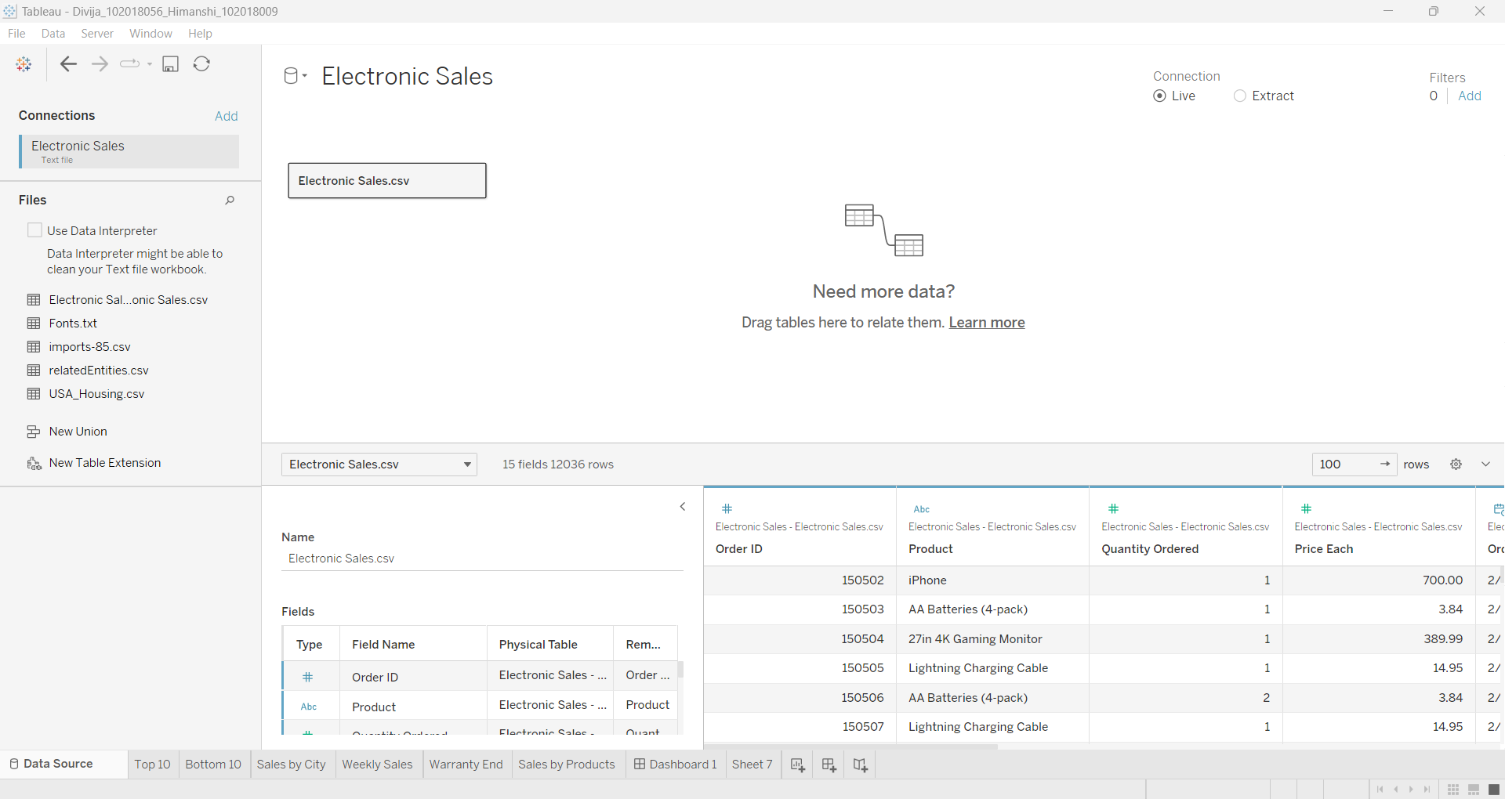

**Task 1: Using the parameter function, display a chart showing ten top-selling and ten low-selling products.**

Top 10:

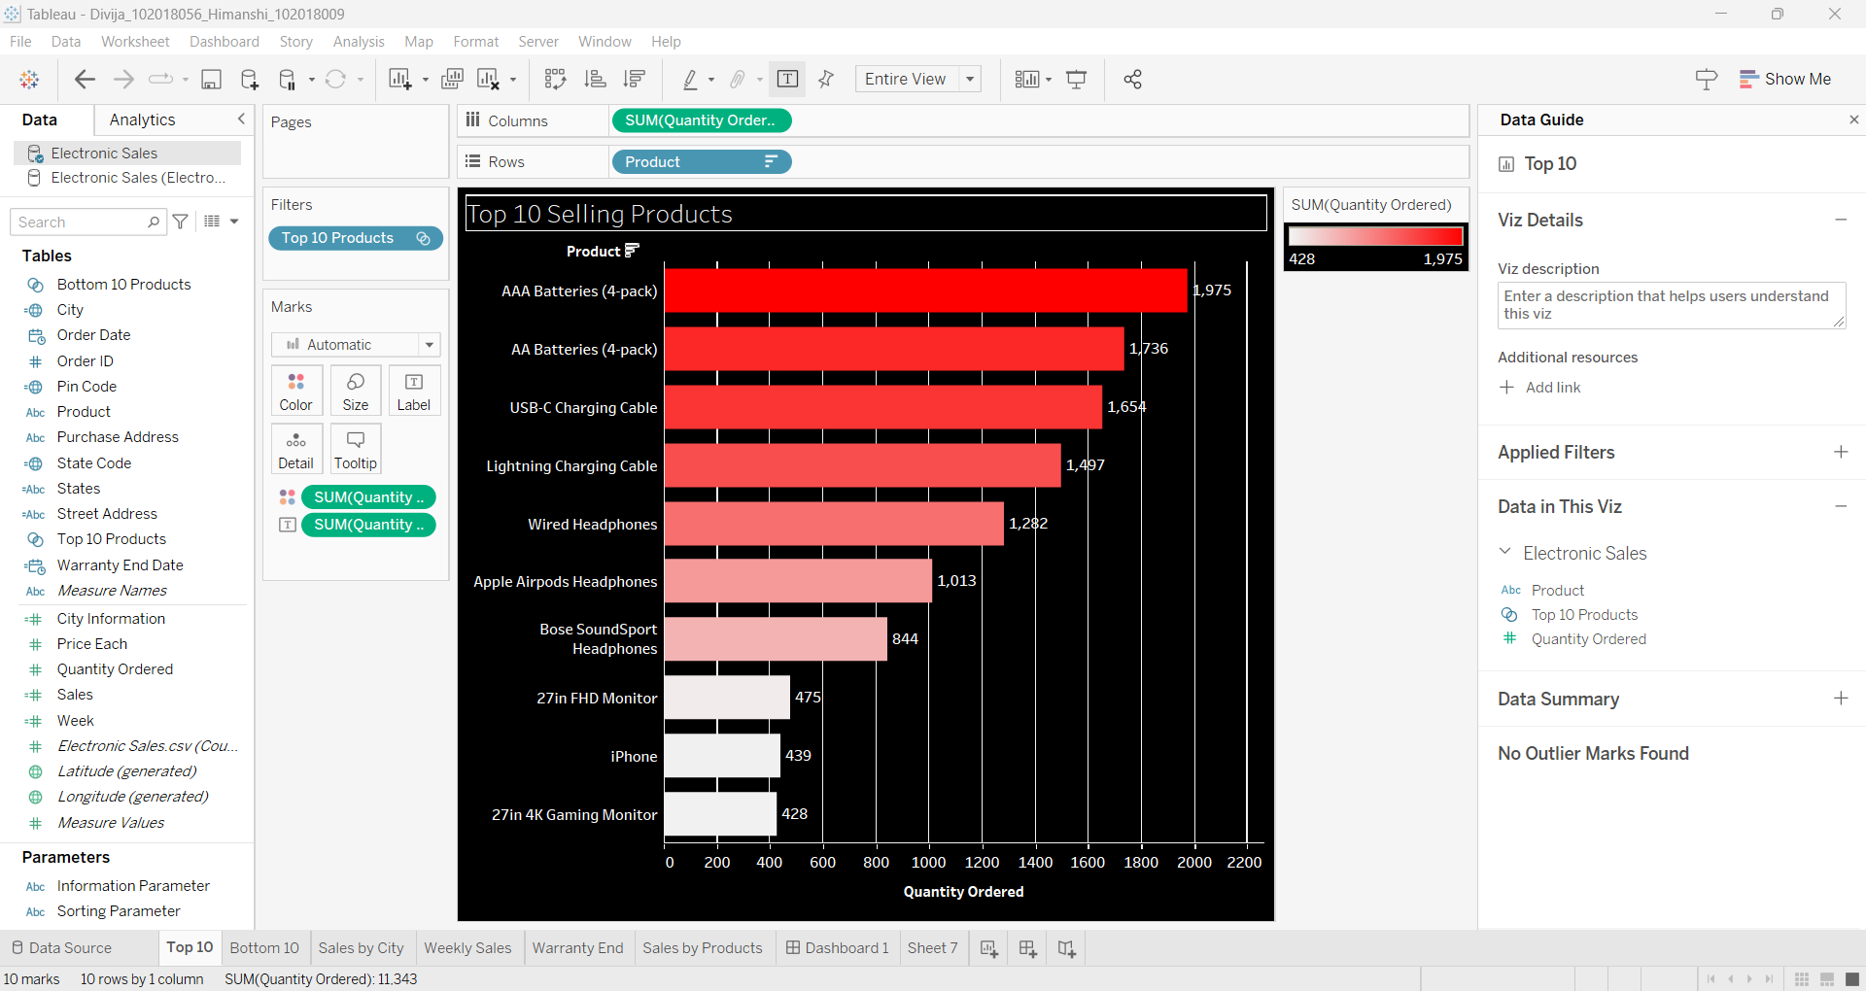

Bottom 10:

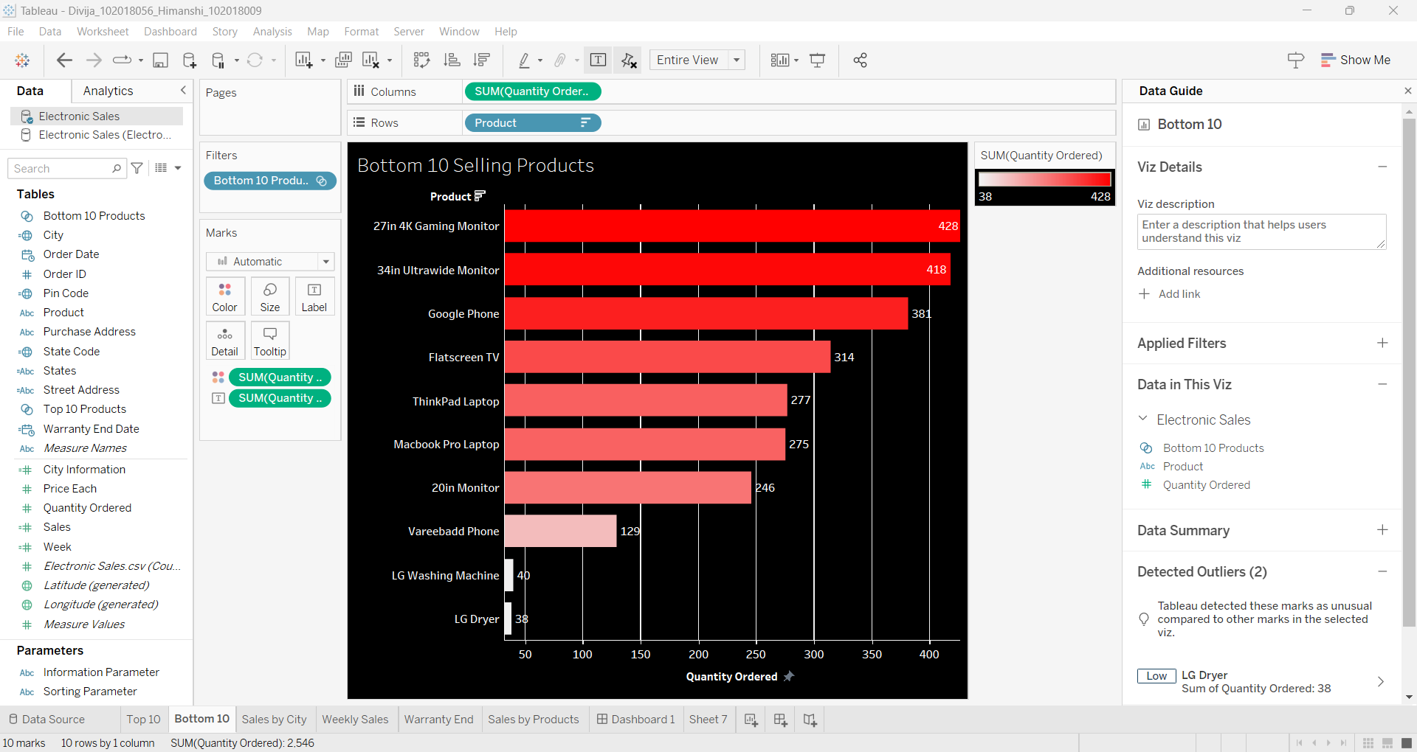

**Task 2: Using an appropriate chart, display the Total/Average sales made in each**

**city. The chart should allow the user to switch between the Sum and Average Sales. Place the result in descending order.**

SUM:

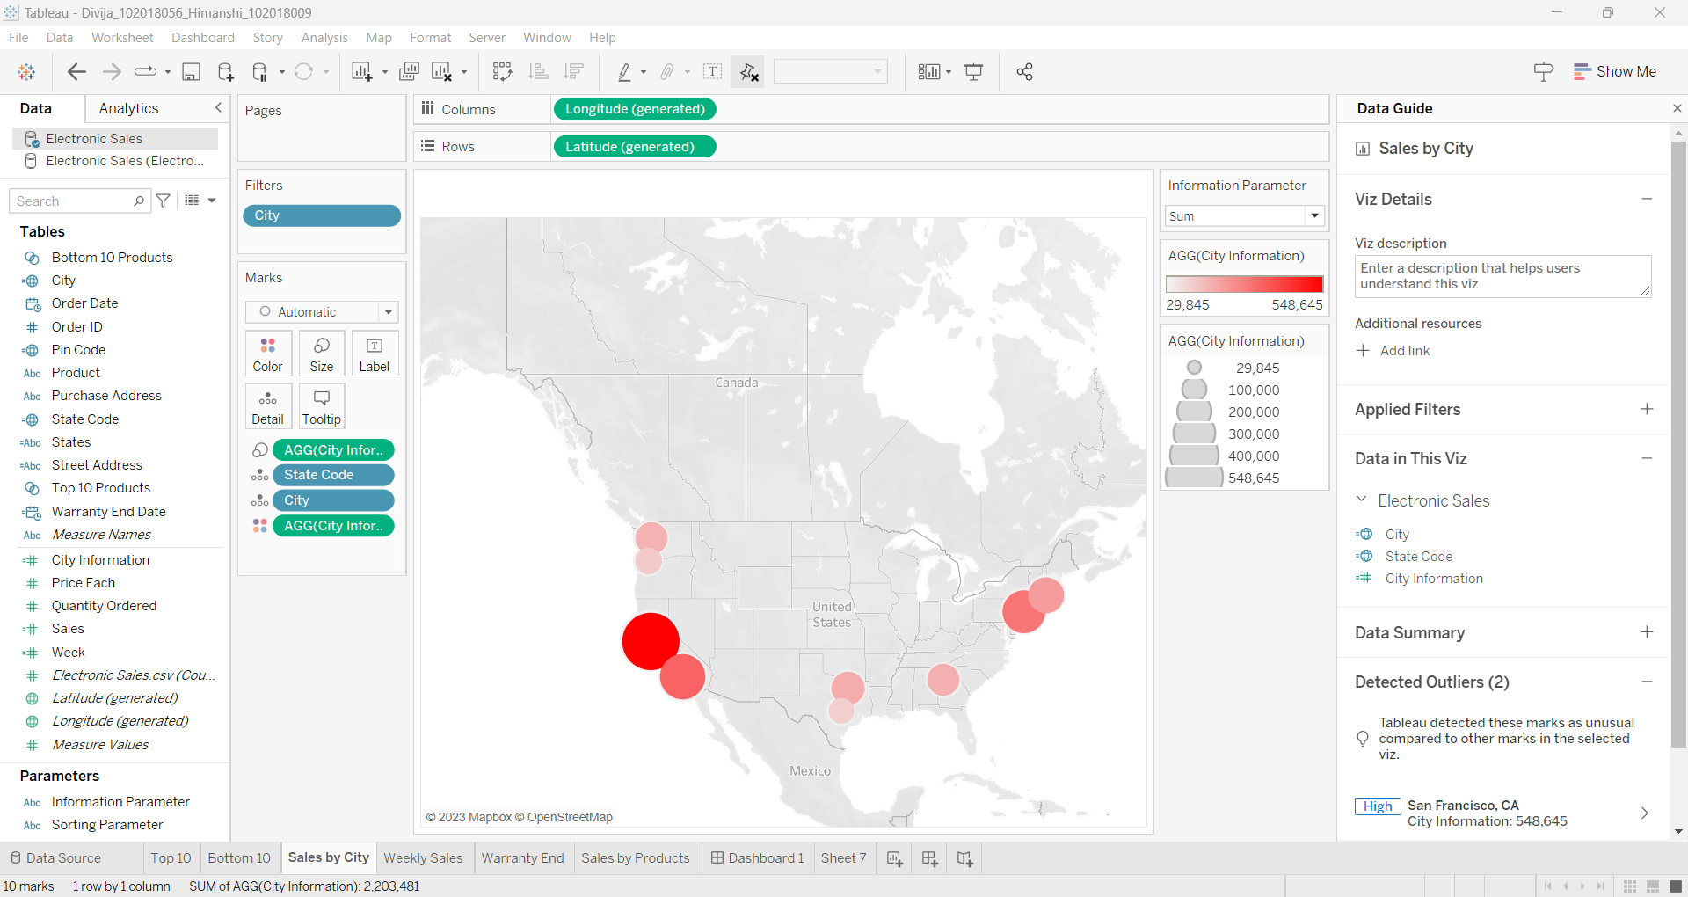

AVERAGE:

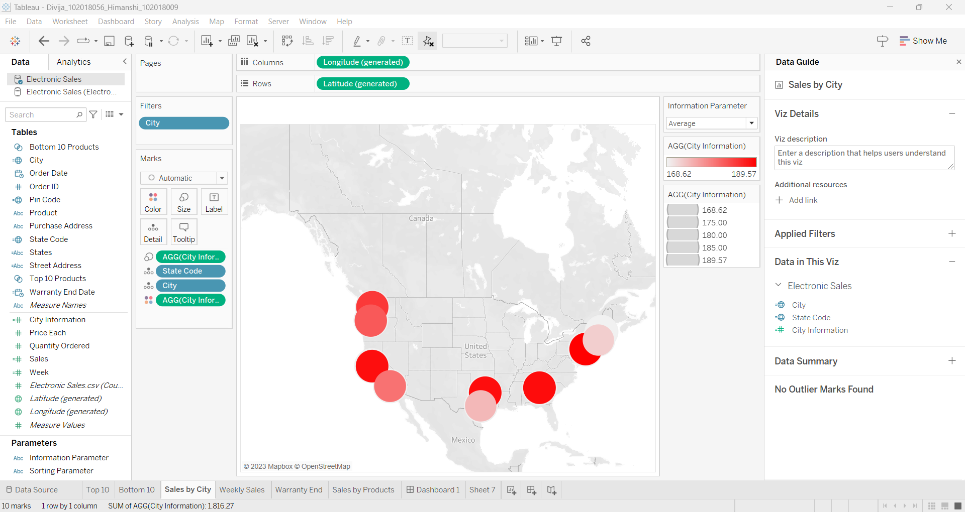

**Task 3: You are asked to provide the stores’ performance on a weekly basis. These charts should demonstrate the average and total sales.**

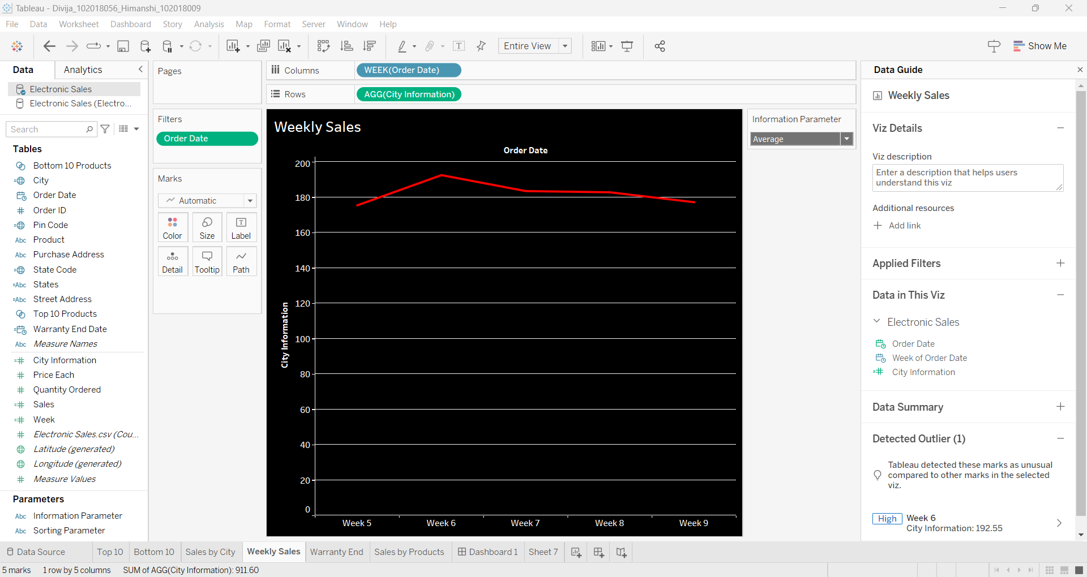

SUM:

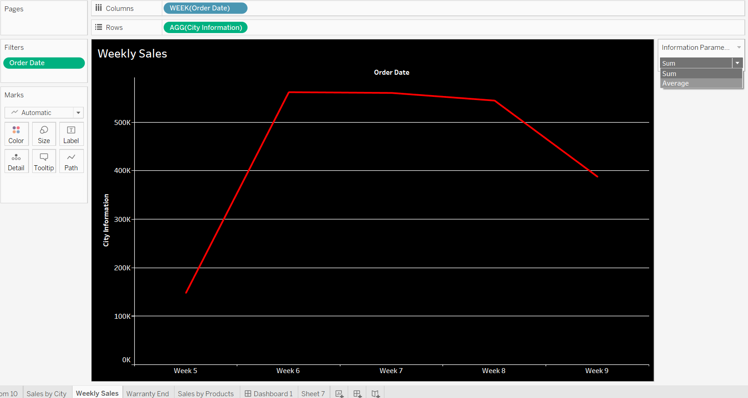

**Task 4: The ordered items come with 6 months warranty from the date of purchase. Use the Date function to calculate the Warranty End date.**

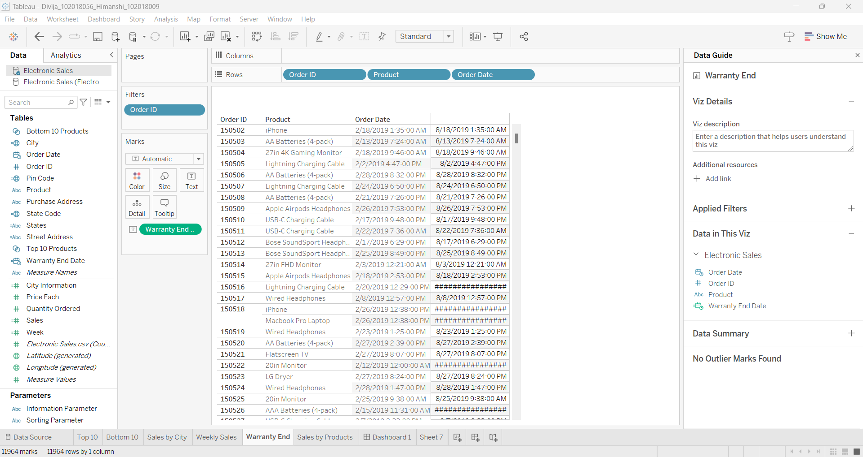

**SALES BY PRODUCT:**

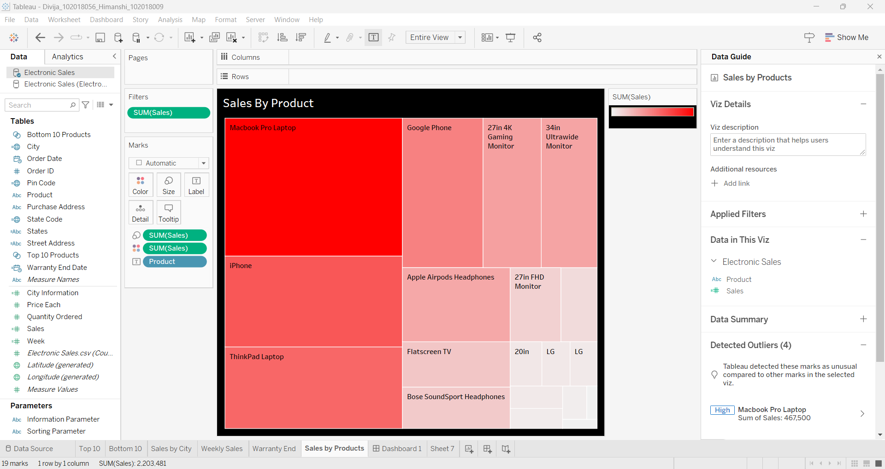

**Task 5: Create an interactive dashboard with at least four sheets. The interactivity**

**means that if you click on any sheet of the dashboard, the other sheets should**

**simultaneously display the related information.**

AVERAGE PARAMETER:

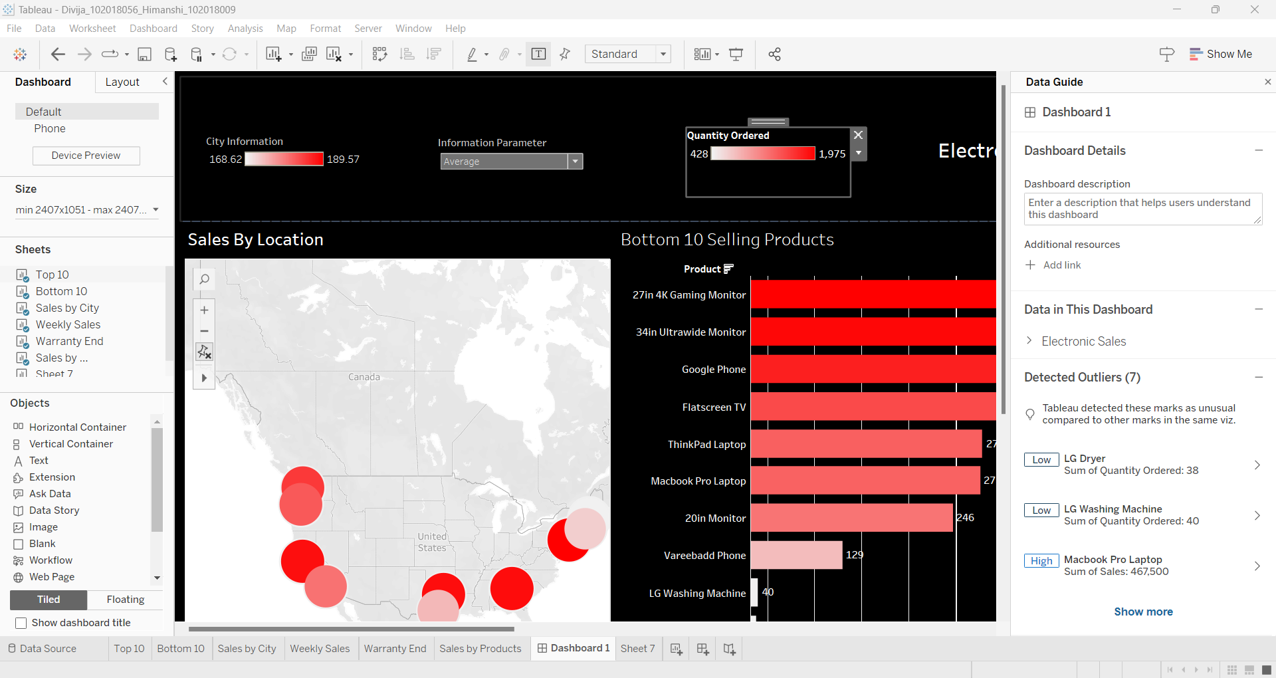

SUM PARAMETER:

