**______________________________________________________**

**UCT 603**

**ARTIFICIAL INTELLIGENCE**

**Cocktail Recommender Expert System using Prolog**

**______________________________________________________**



**Submitted to: Ms. Sujata Rani**

**DIVIJA 102018056 CSBS3**

**Summary:**

The system asks a series of yes or no questions to understand the user's tastes and preferences. It considers different parameters like the type of spirit, the time of day the cocktail will be consumed, the preference for citrus, the user's pallet (whether sweet or savory), flavor preference (such as ginger or coconut), and even the user's personality type.

Based on the user's inputs, the system suggests a cocktail that best matches their preferences. Overall, the Cocktail Expert System aims to simplify the process of finding a cocktail that the user will enjoy. The system is designed to be user-friendly and intuitive, making it accessible to a wide range of users

**Code Screenshots:**

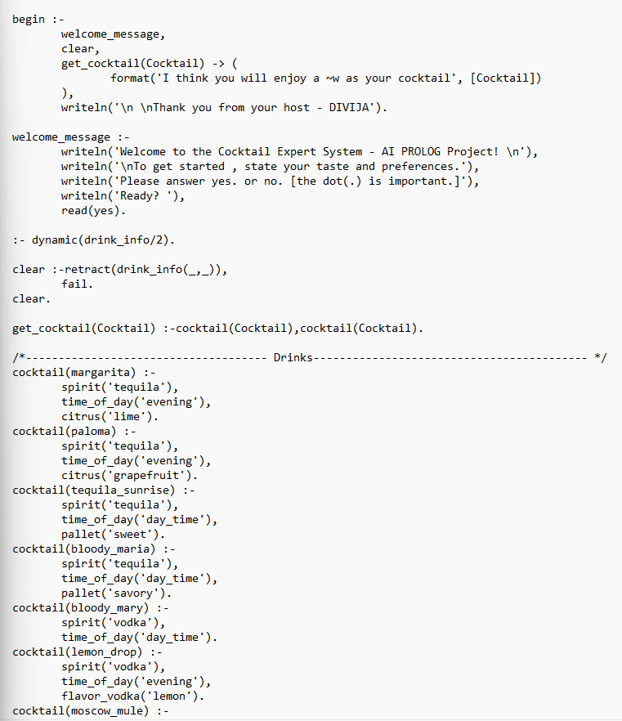

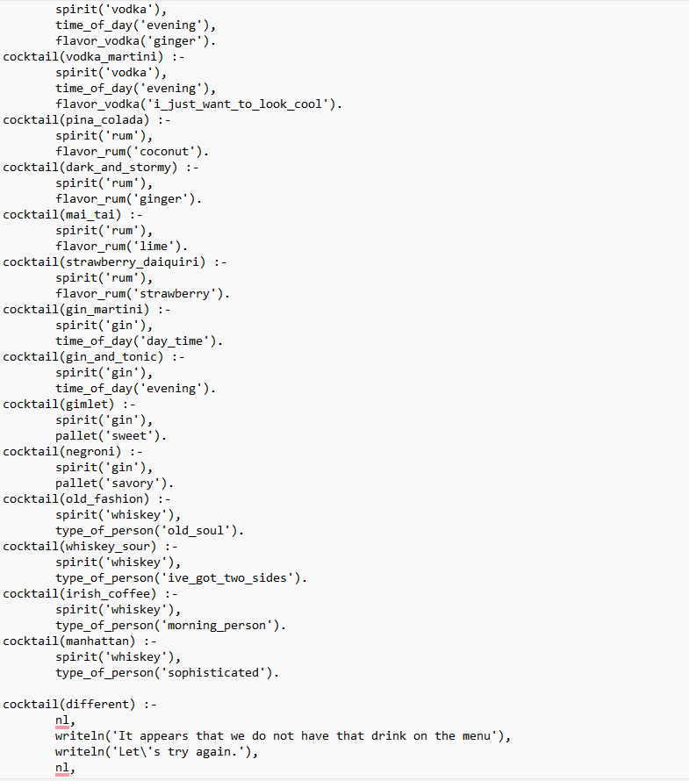

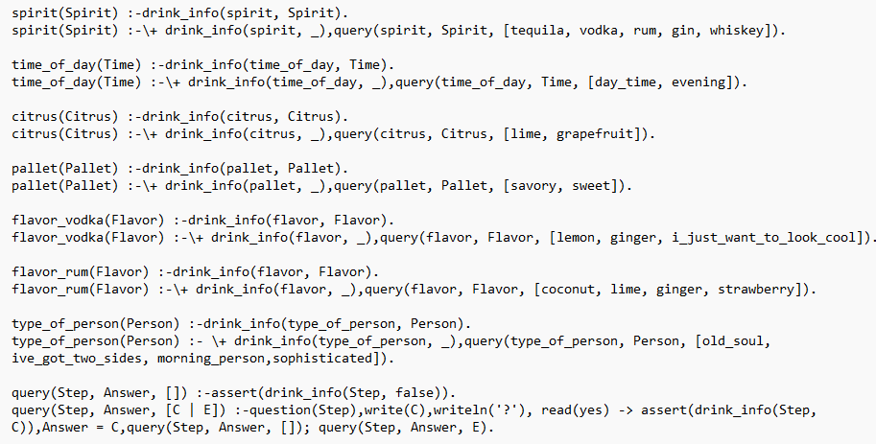

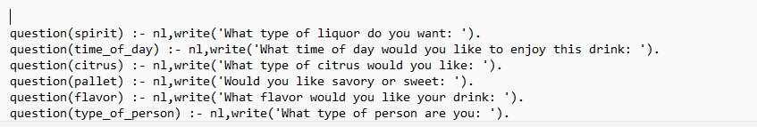

**Output Screenshot:**

Run #1

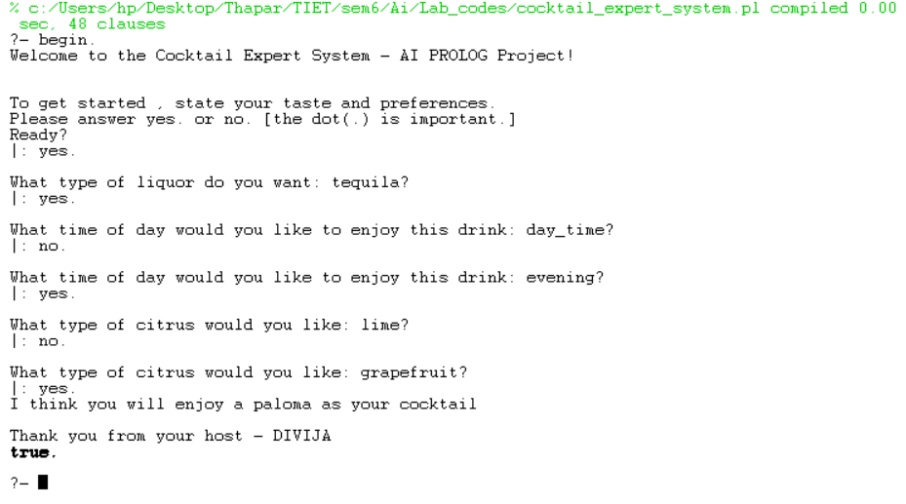

Run #2

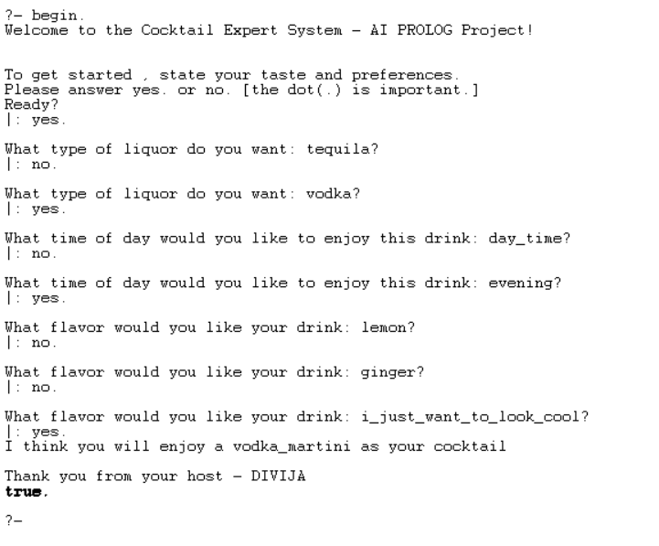

Run #3

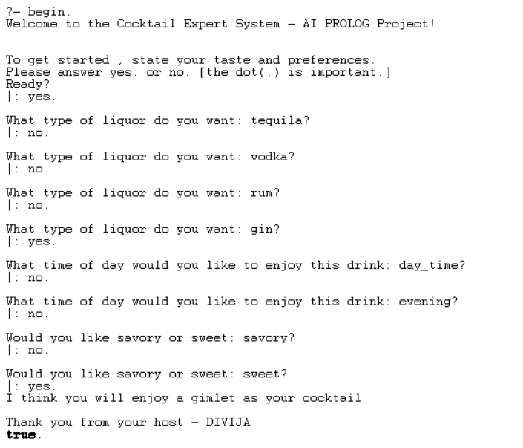

Run #4

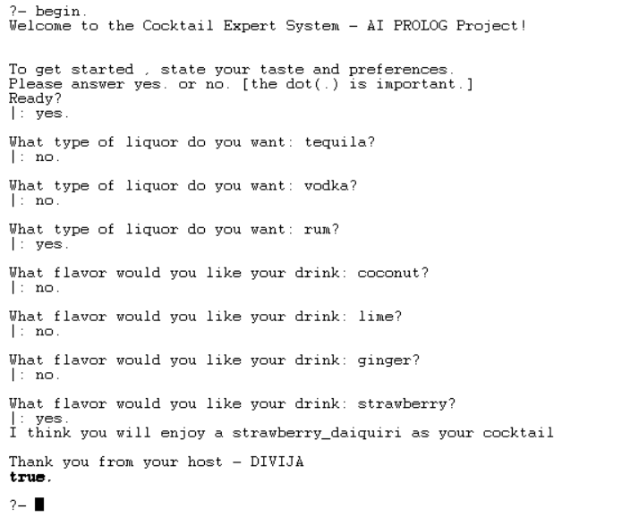

Run #5

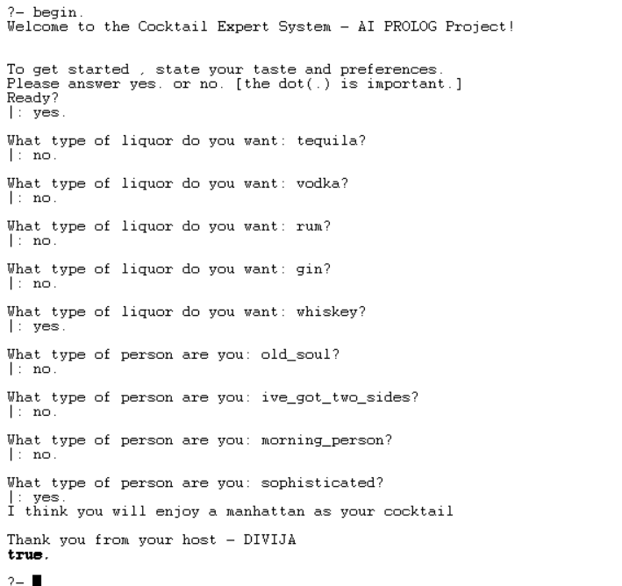

Run #6

