Cloud, Microservices, and application

LAB ASSIGNMENT



Submitted to: Dr. Sumana maiti

Submitted by: Divija 102018056 CSBS-3

**Module 1- Global Infrastructure**

**Module 2- Structure of the cloud**

**Module 3- AWS console**

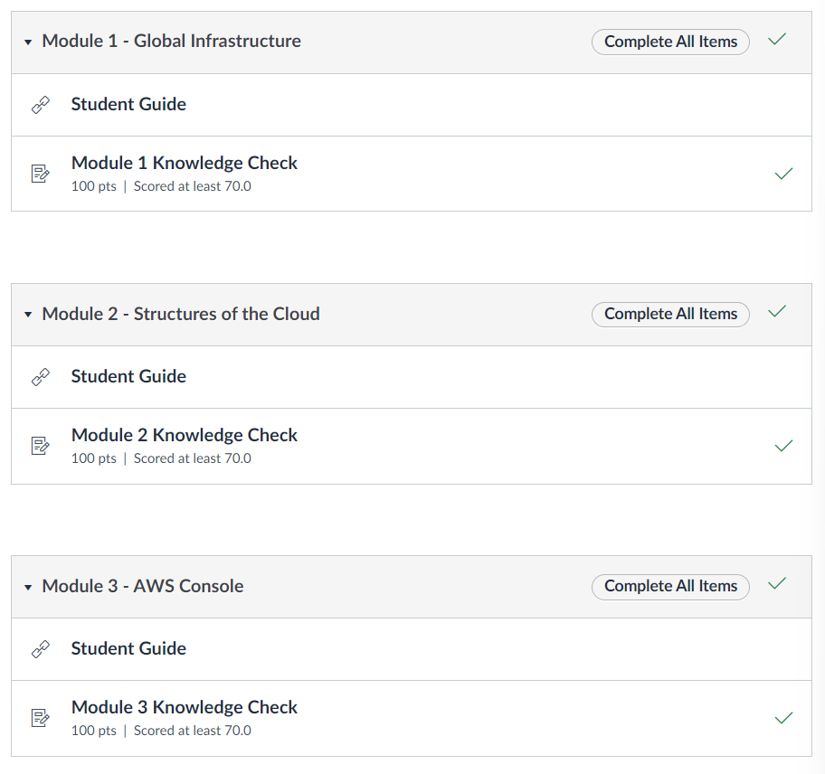

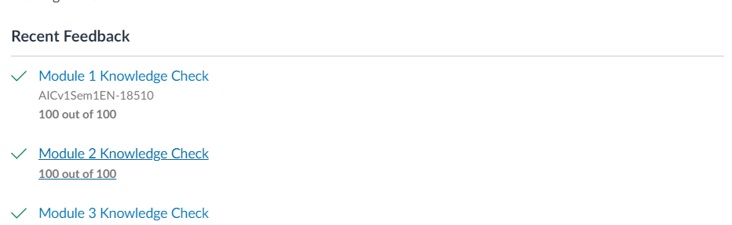

**Module 4 – Virtual Servers**

1. Lab 4.1 EC2

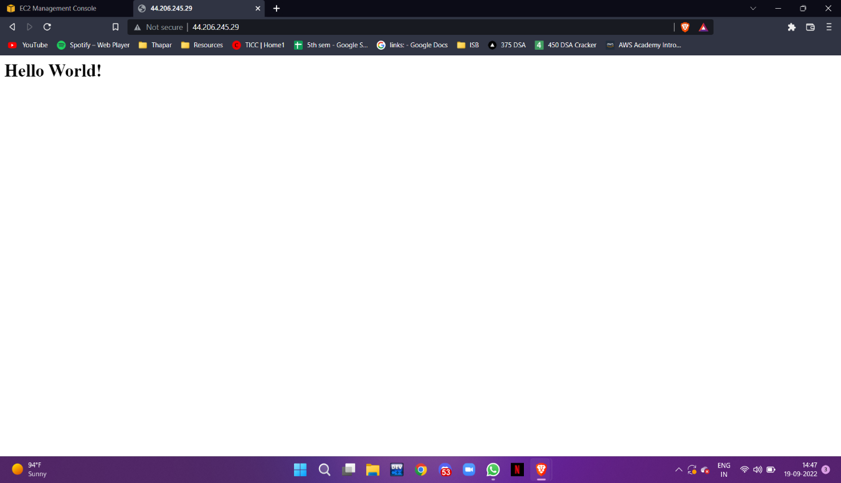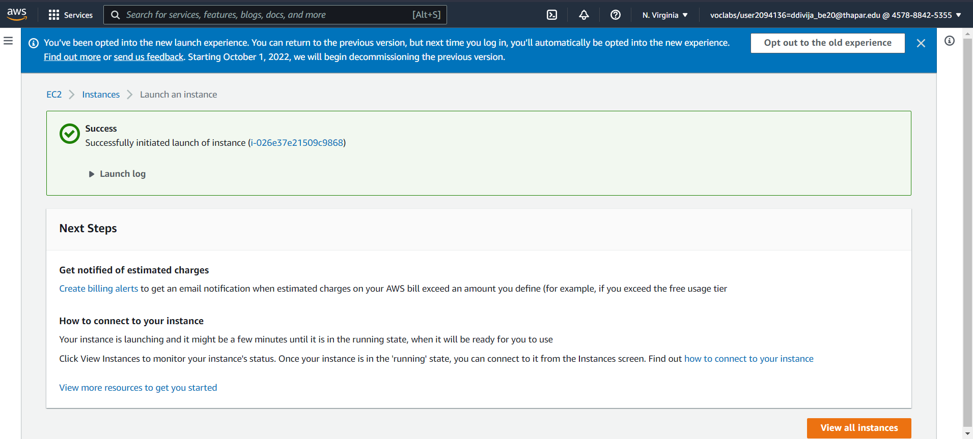

1. 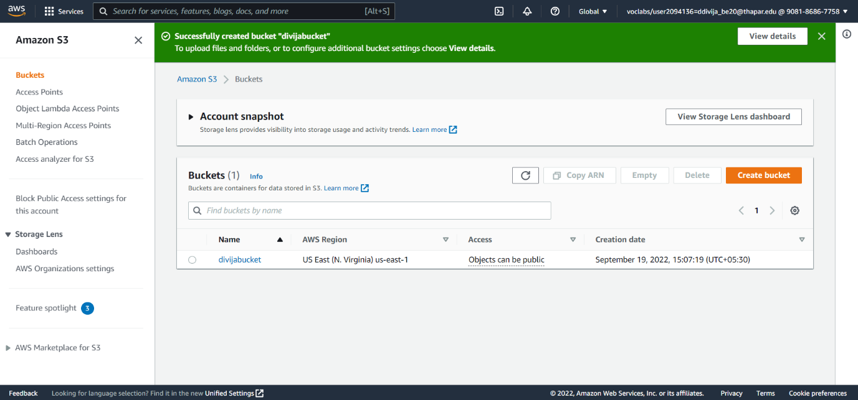Lab 4.2 S3

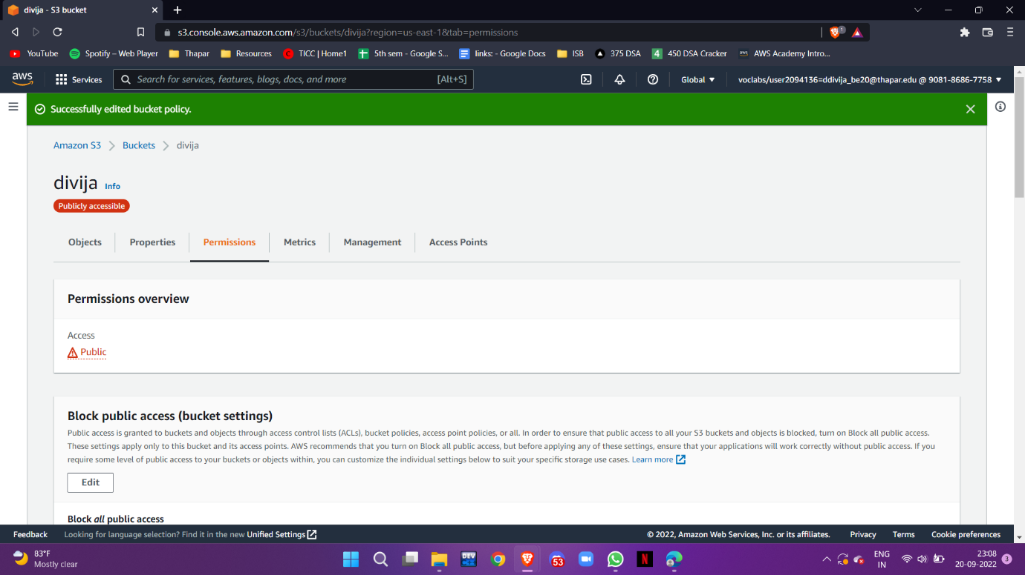

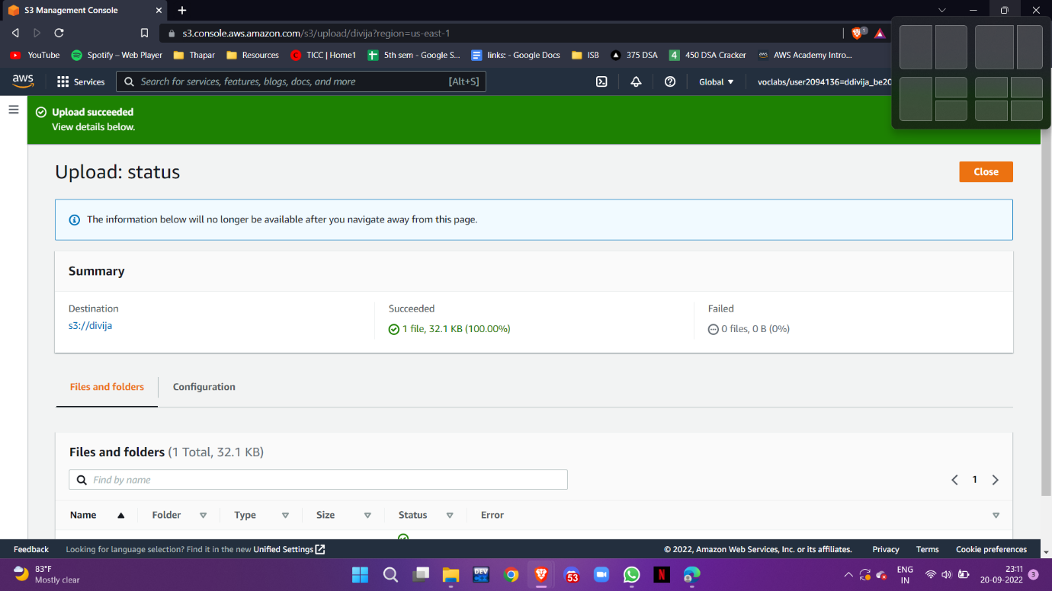

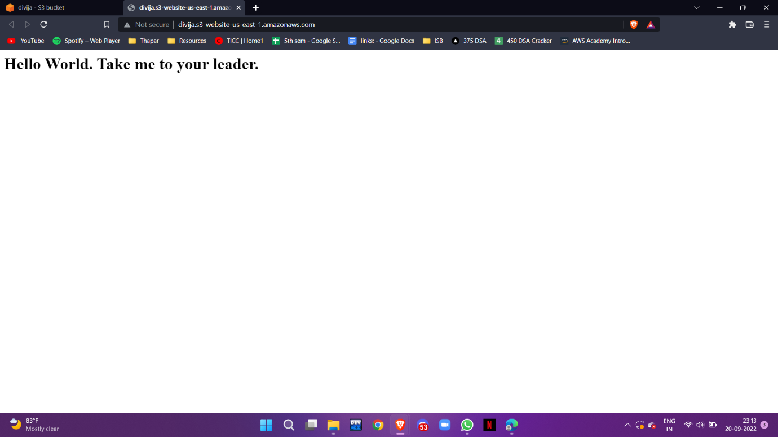

**Module 5- Content Delivery**

Lab 5 – CloudFront

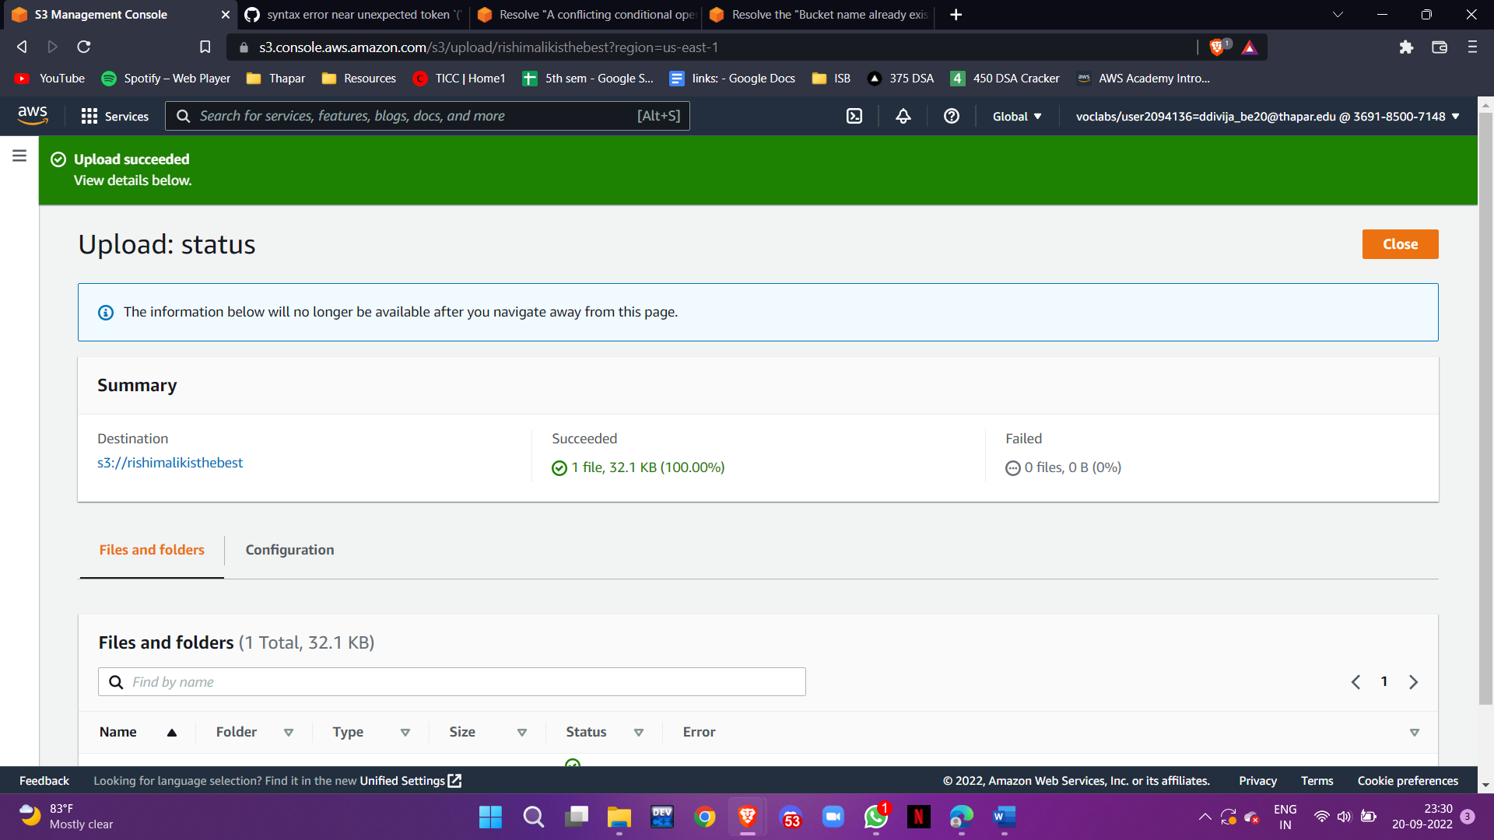



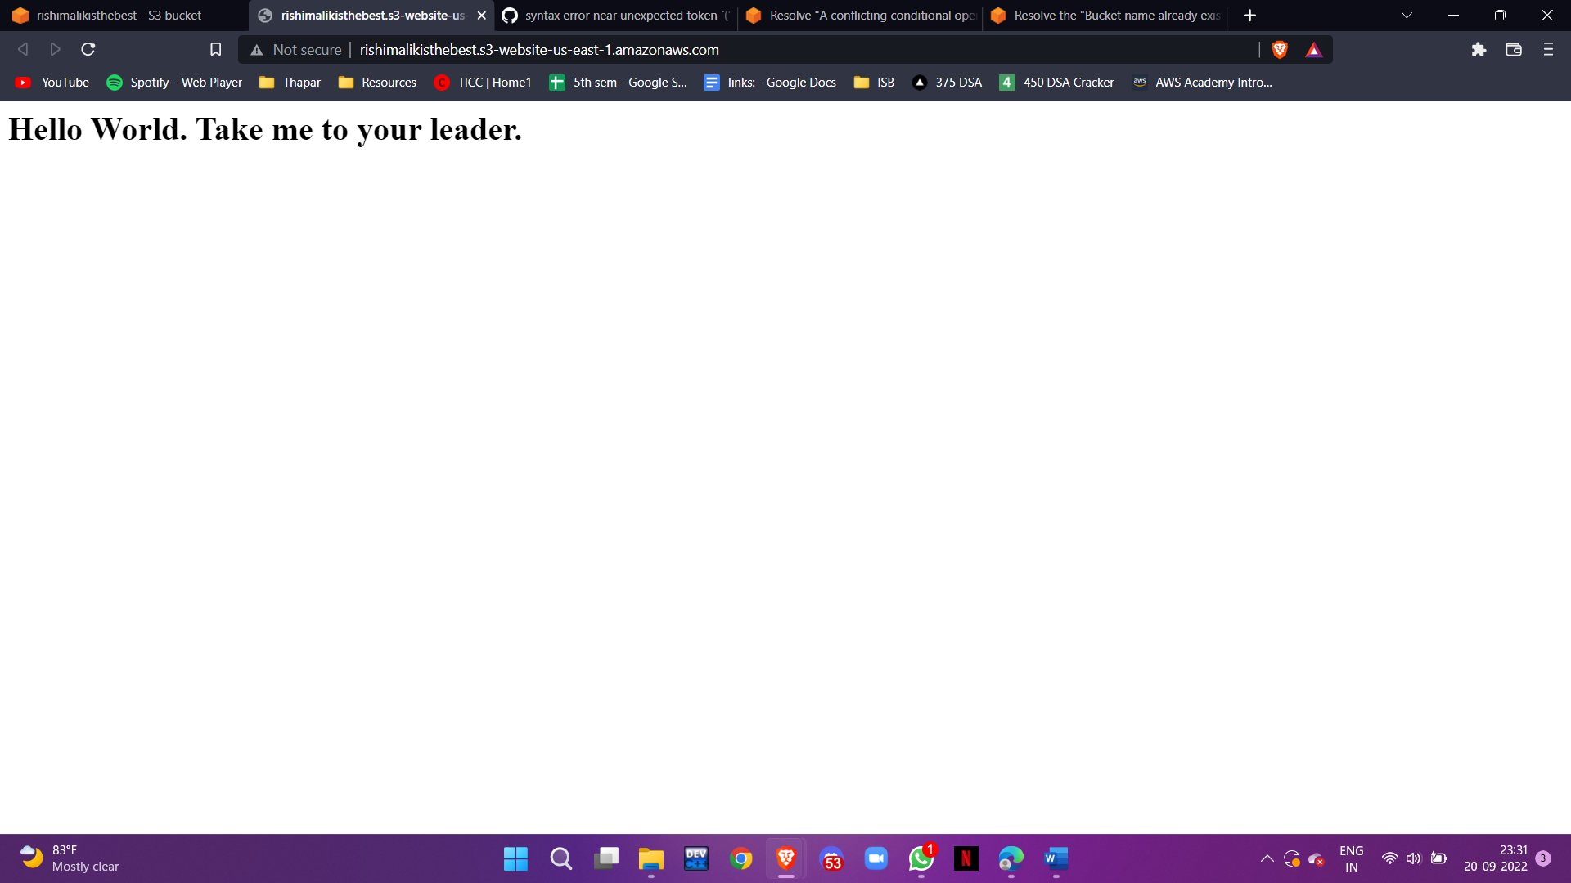

**Module 6 – Virtual Storage**

Lab 6 – EBS

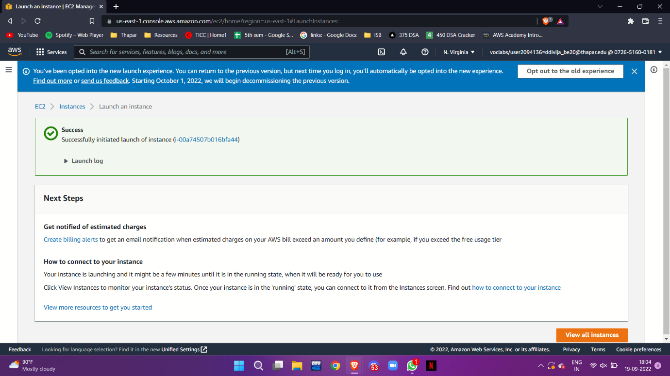

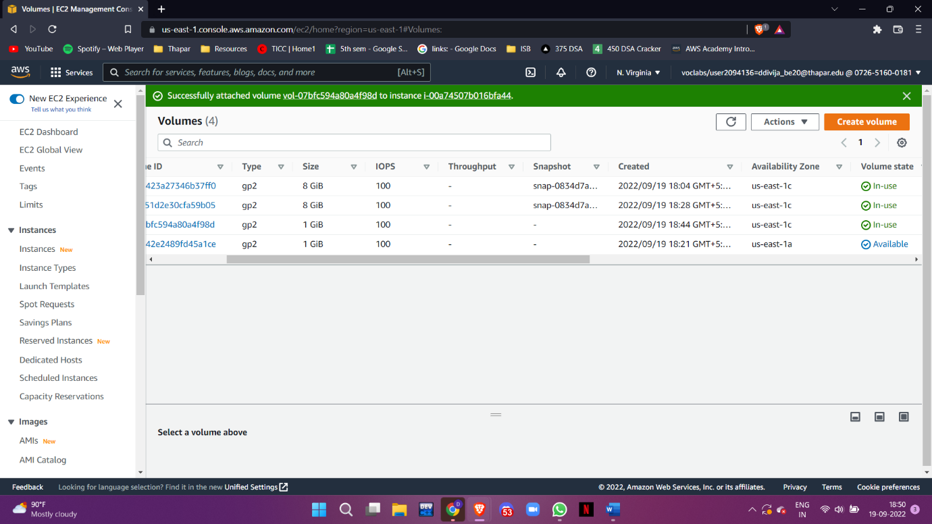

**Module 7 – Security1**

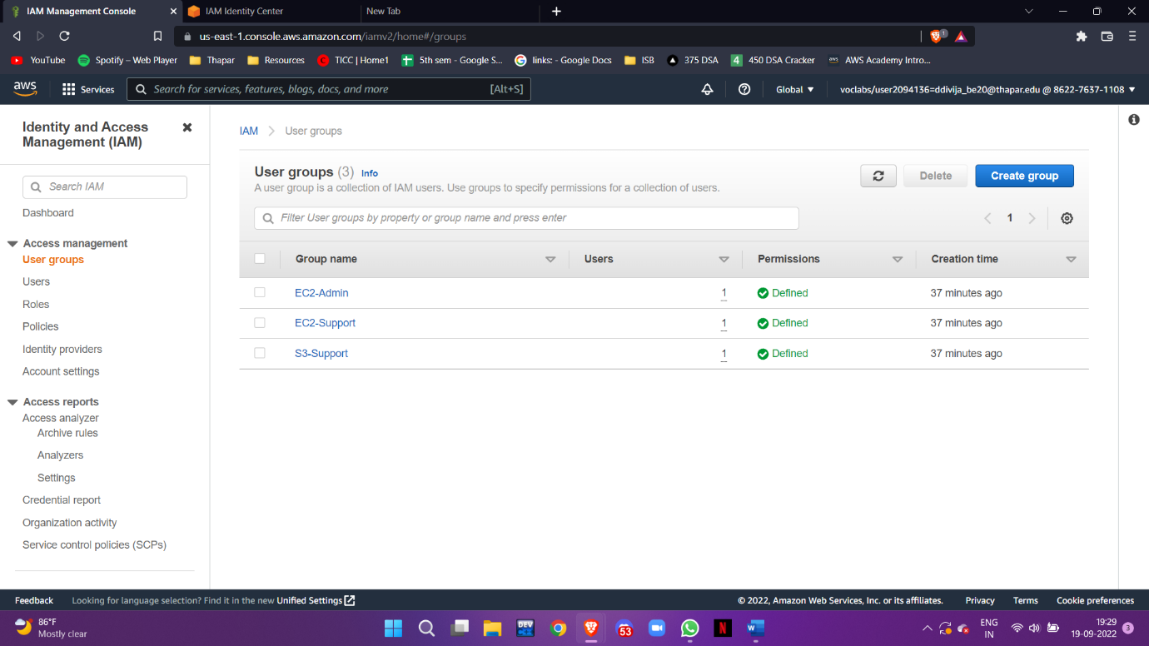Lab 7 - IAM

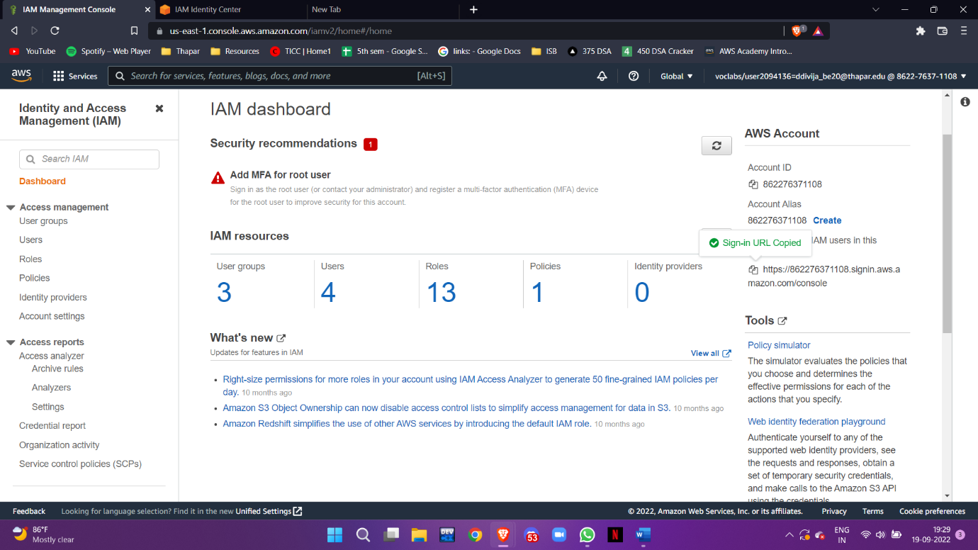

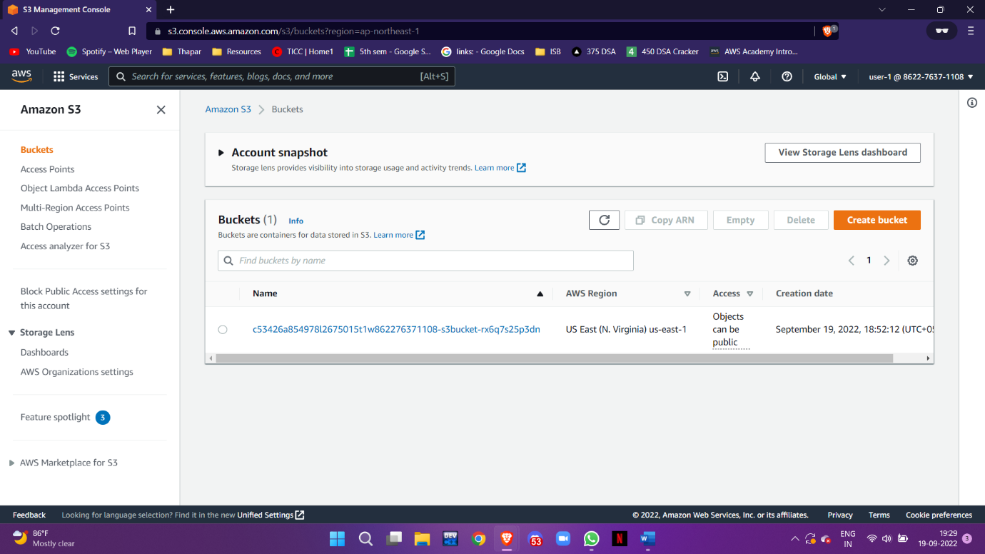

**Module 9 – Monitoring the Cloud**

Lab 9- Monitoring

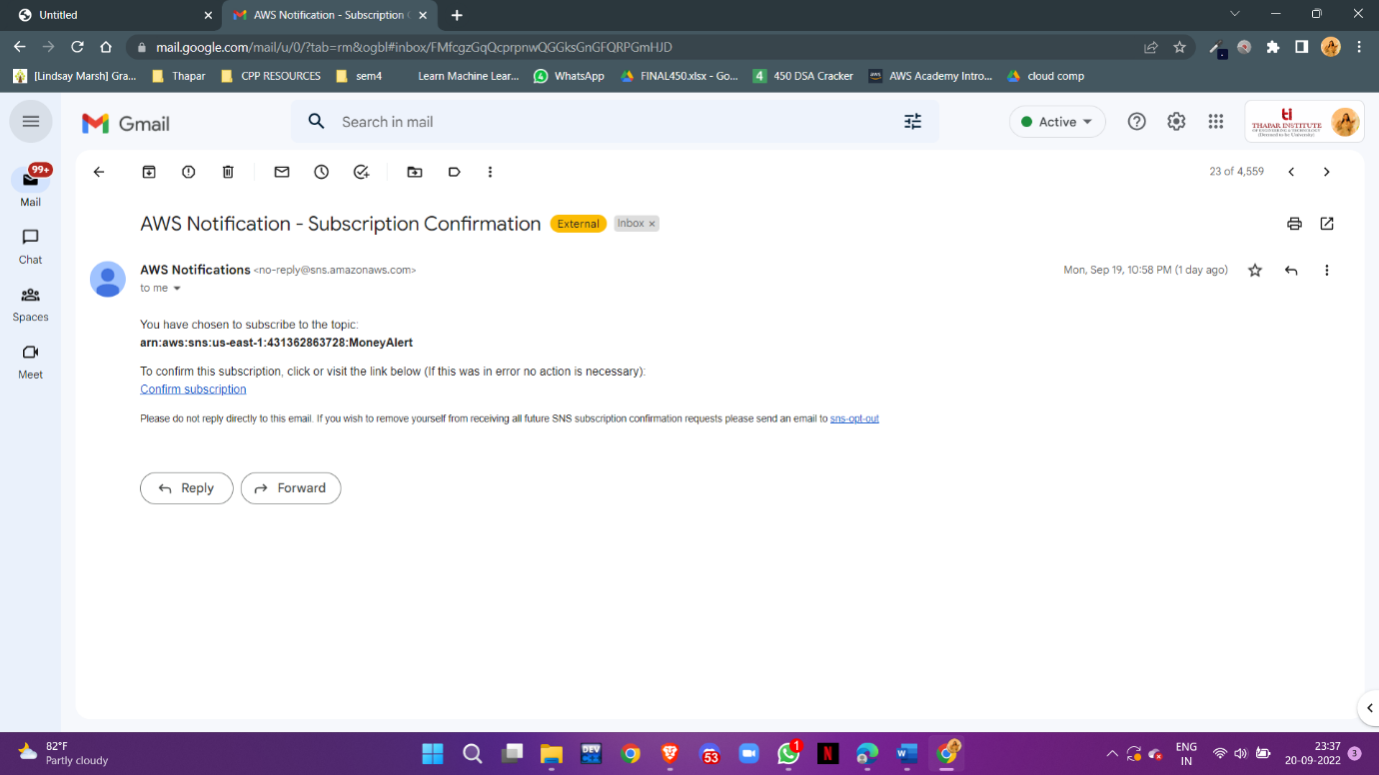

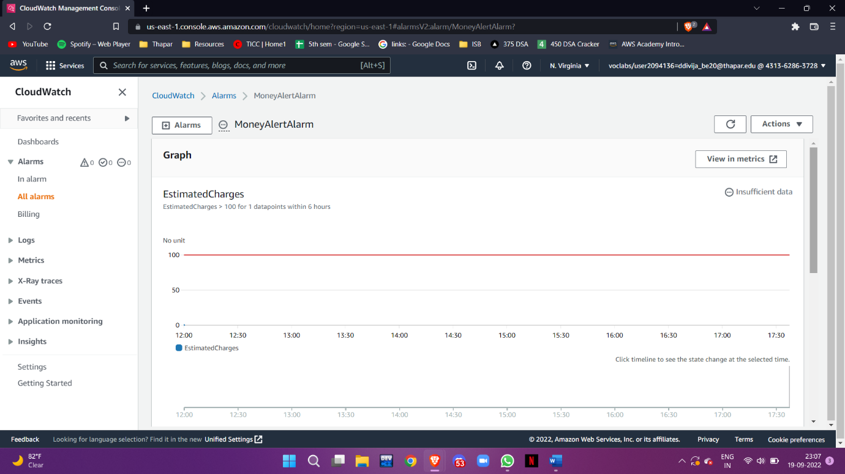

Thank you